GFIS: Physics-Informed Hybrid AI and Digital-Twin-Ready Coordination for Methane Yield Forecasting, VFA/ALK Soft Sensing, and Stability-Aware Anaerobic Digestion Simulation
Original Research Article - Nature/Springer-style Working Draft v04
Akash S. Chatake1* and Dr. Dipti Jadhav2
1. M.Tech Artificial Intelligence and Machine Learning, BITS Pilani WILP, India; Shri Siddheshwar Women's Polytechnic, Solapur, Maharashtra, India.
2. Academic supervisor / guide for dissertation work.
*Corresponding author: Akash S. Chatake; BITS ID: 2024AB05226.

Abstract
Anaerobic digestion is a nonlinear biochemical conversion process in which methane production depends on substrate composition, process variables, microbial stability, and reactor history. Purely data-driven methane-yield predictors can learn useful nonlinear patterns, but they may produce physically implausible outputs under extrapolated or disturbed conditions. This manuscript presents the Green Fuel Intelligence System (GFIS), a physics-informed hybrid artificial intelligence framework for methane-yield forecasting, VFA/ALK soft sensing, stability classification, and digital-twin-ready scenario simulation in anaerobic digestion.
GFIS combines an XGBoost tabular learner, an LSTM temporal branch, validation-weighted ensemble logic, a volatile-solids-based methane feasibility bound, and a browser-based control-room-to-simulator coordination workflow. The mid-semester implementation uses a controlled synthetic/literature-inspired anaerobic digestion dataset containing 2400 hourly records and 13 process/stability variables. The current XGBoost model obtains R2 = 0.7556, RMSE = 6.7933, and MAE = 5.5517, while the physics-guided ensemble records zero methane-bound violations in the current evaluation.
A key contribution of the v04 prototype is a coordinated digital-twin-ready interaction pattern in which process variables modified in the AI model control room are transferred into a 48-hour industrial simulation engine. The simulator then updates VFA/ALK pressure, methane yield, methane quality, and warning/critical behavior. This work is deliberately presented as a digital-twin-ready simulation prototype rather than a fully synchronized industrial digital twin, because continuous IoT/SCADA integration with a physical plant remains the next stage.
Keywords: anaerobic digestion; methane yield prediction; physics-informed machine learning; digital twin; XGBoost; LSTM; VFA/ALK soft sensor; biogas; process stability; AWS deployment.

1. Introduction
Anaerobic digestion (AD) converts organic waste into methane-rich biogas under oxygen-limited conditions. The technology supports renewable energy generation, organic waste valorization, circular bioeconomy, and greenhouse-gas mitigation. However, AD remains operationally sensitive because hydrolysis, acidogenesis, acetogenesis, and methanogenesis respond differently to feedstock variation, organic loading, temperature, pH, hydraulic retention time, volatile solids, and microbial state.
Methane yield is the central energy-output indicator, but it cannot be interpreted independently from stability. A reactor may temporarily generate useful methane while also accumulating volatile fatty acids or losing alkalinity buffer. Conversely, a purely statistical model may predict a high methane value that exceeds substrate-driven biochemical feasibility. GFIS addresses this gap by combining machine-learning prediction with process-aware feasibility checking and soft sensing.
During the BITS Pilani abstract evaluation, Prof. Mohanamurali G. suggested and strengthened the Physics-Informed Machine Learning framing for GFIS. The present manuscript acknowledges this academic guidance while using PIML in its established meaning of Physics-Informed Machine Learning.

2. Contributions
- A hybrid methane-yield prediction workflow combining XGBoost, LSTM, ensemble evaluation, and physics-guided auditing.
- A volatile-solids-based methane feasibility bound that penalizes negative methane estimates and predictions exceeding substrate-driven potential.
- A VFA/ALK soft-sensor formulation that maps measurable operating variables into Stable, Warning, and Critical stability states.
- A control-room-to-industrial-simulator coordinator that transfers process variables into a 48-hour simulated plant response.
- A reproducible mid-semester evidence pack containing datasets, metrics, dashboard screenshots, simulator screenshots, and deployed AWS links.

3. Materials and Methods

3.1 Dataset and feature space
The current mid-semester validation dataset contains 2400 hourly records and 13 columns. It is synthetic/literature-inspired and is used for controlled prototype validation rather than final industrial claims. The soft-sensor extract contains 250 records for presentation and inspection.
Dataset | Rows | Columns | Purpose
GFIS_raw_synthetic_anaerobic_digestion.csv | 2400 | 13 | Controlled AD operating records
GFIS_processed_synthetic_anaerobic_digestion.csv | 2400 | 13 | Processed model-ready records
GFIS_soft_sensor_dataset_extract.csv | 250 | 13 | Compact VFA/ALK soft-sensor evidence extract

The variables are timestamp, temperature, pH, OLR, HRT, TS, VS, C/N ratio, ambient temperature, moisture, methane yield, VFA/ALK ratio, and stability label.

3.2 GFIS architecture
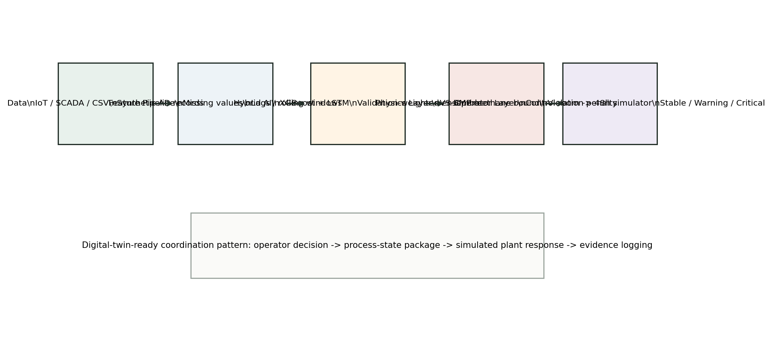
Fig. 1. GFIS architecture linking data, feature engineering, hybrid AI, physics constraints, soft sensing, and operator-facing simulation.

3.3 Physics-informed objective
The input vector is formed from measurable and derived anaerobic digestion variables.
x_i = [T_i, pH_i, OLR_i, HRT_i, TS_i, VS_i, C/N_i, moisture_i, ambient_i, lagged states_i]
The full GFIS objective combines methane prediction, feasibility regularization, soft-sensor loss, stability classification loss, and regularization:
L_GFIS = L_CH4 + lambda_phys L_feas + lambda_soft L_VFA/ALK + lambda_stab L_stab + lambda_reg ||theta||_2^2
L_CH4 = (1/N) sum_i (y_i - y_hat_i)^2
L_feas = (1/N) sum_i [max(0, y_hat_i - Ymax_i)^2 + max(0, -y_hat_i)^2]
The methane feasibility bound is represented as:
Ymax_i = VS_i x BMP_feedstock(i) x eta_T(T_i)
This bound is a practical feasibility audit, not a complete biochemical closure. In the final phase it can be extended with pH, HRT, alkalinity, feedstock class, and uncertainty terms.

3.4 VFA/ALK soft sensor and stability logic
r_hat_i = g_phi(x_i)
r_hat_i = exp(beta_0 + beta_1 OLR_i + beta_2 VS_i/TS_i + beta_3 HRT_i^-1 + beta_4 |T_i - T_opt| + beta_5 max(0, pH_opt - pH_i))
VFA/ALK estimate | Stability state | Operational meaning
r < 0.30 | Stable | Normal operating tendency
0.30 <= r < 0.40 | Warning | Acidification or overload tendency
r >= 0.40 | Critical | High inhibition/collapse risk

3.5 Control-room-to-simulator coordinator
The v04 implementation adds a coordinated cyber-physical handoff between the AI model control room and the industrial 48-hour simulator. The control room publishes a scenario package containing process variables such as OLR, pH, temperature, HRT, TS and VS. The simulator imports this package through browser storage and URL parameters, then recalculates VFA/ALK pressure and methane behavior during the 48-hour run.
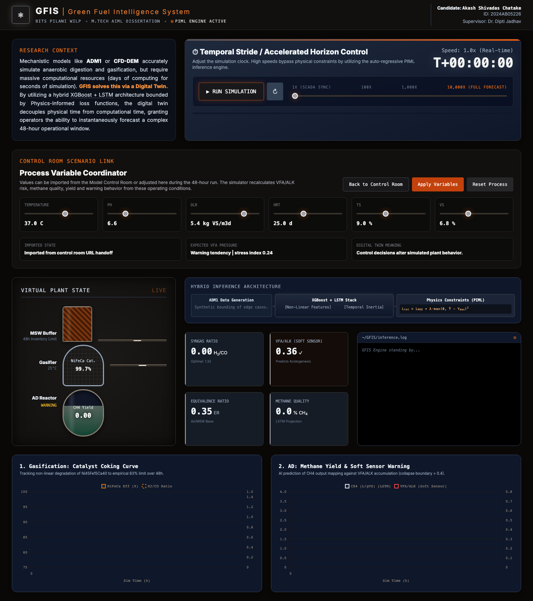
Fig. 2. Local validation of the control-room-to-industrial-simulator coordinator with imported OLR and pH state.
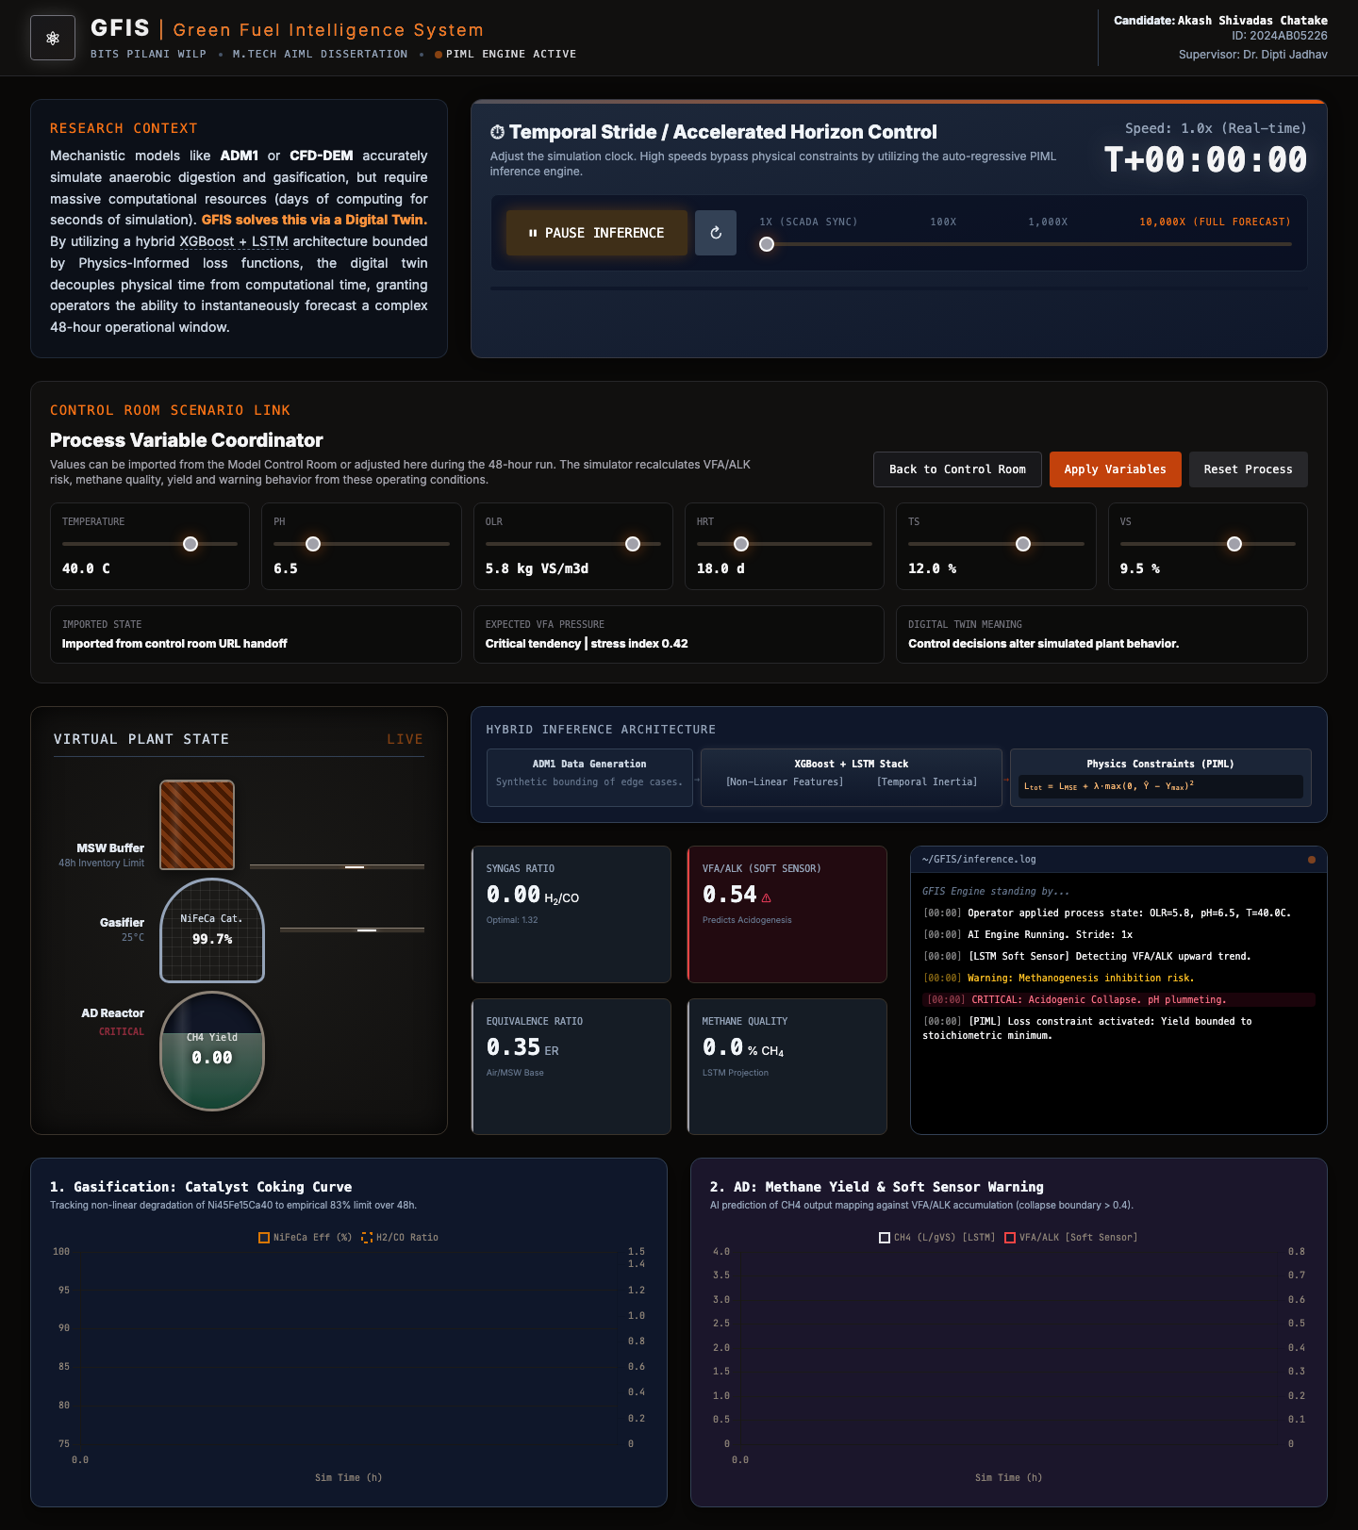
Fig. 3. Direct scenario loading in the industrial simulator showing elevated risk under stressed OLR, pH and HRT conditions.

4. Implementation
The GFIS prototype uses Python, Pandas, NumPy, Scikit-learn, XGBoost, PyTorch, FastAPI, Streamlit, Chart.js, HTML/CSS/JavaScript, SQLite-ready persistence, Docker-ready service packaging, and AWS deployment components. The Level 2 portal is served through CloudFront, while the Streamlit dashboard and FastAPI backend are deployed as App Runner services.
Interface | Role | Deployment status
Level 2 portal | Research navigation, documentation, dashboard launch | AWS CloudFront
AI model control room | Prediction controls, OLR sweep, process-state coordinator | Local v04, AWS previous version
Industrial simulator | 48-hour plant response, telemetry, risk visualization | Local v04, AWS previous version
Streamlit dashboard | Research workflow and model inspection | AWS App Runner
FastAPI backend | Prediction/simulation/evaluation endpoints | AWS App Runner

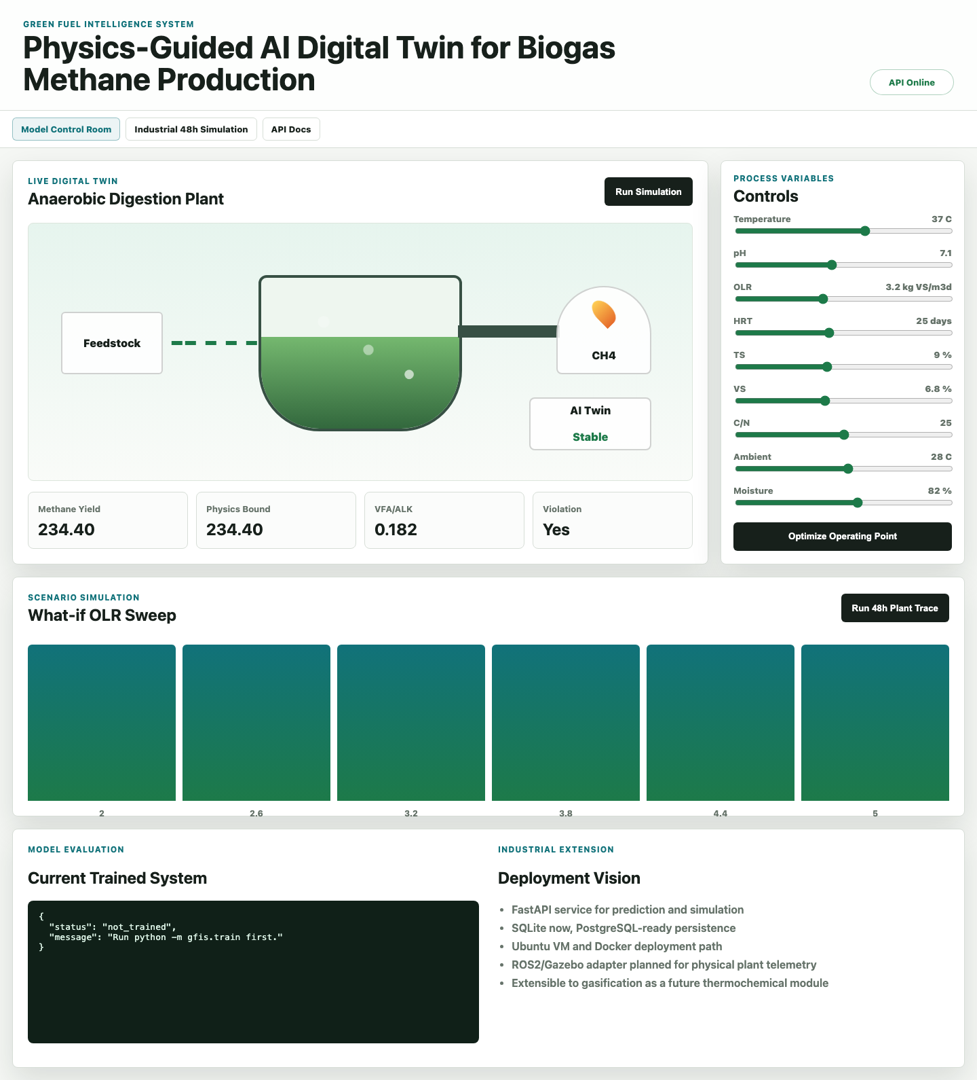
Fig. 4. GFIS model control room used as the decision layer for process variables and simulation initiation.
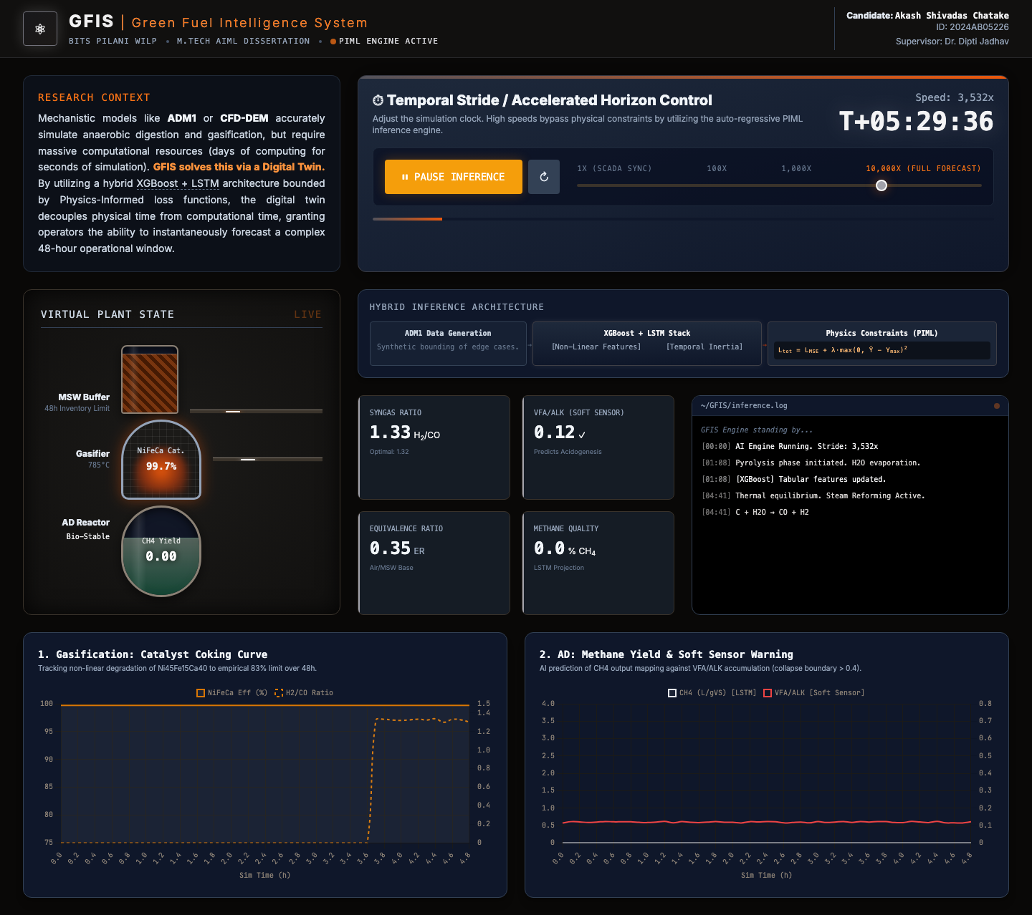
Fig. 5. Industrial simulation engine during an active 48-hour accelerated scenario run.
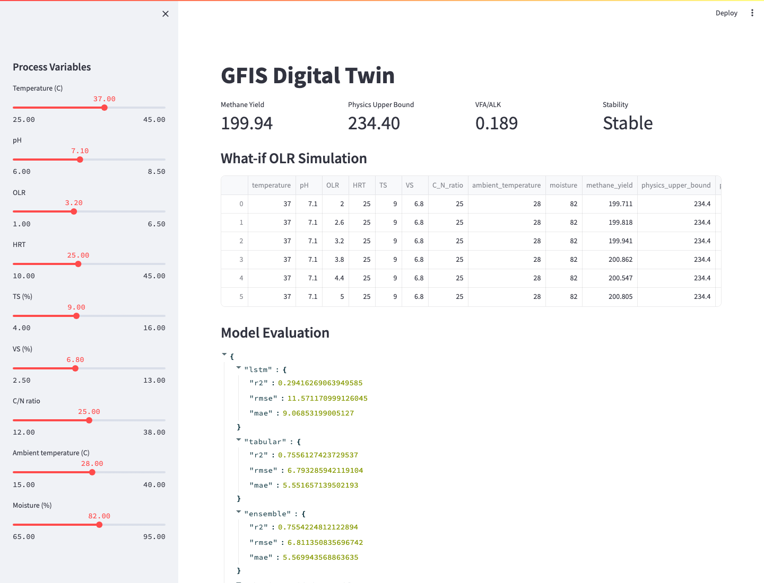
Fig. 6. Streamlit research dashboard for inspecting the model workflow and outputs.

5. Results
The current evaluation is preliminary and based on controlled synthetic/literature-inspired data. It is used to validate the GFIS pipeline and interface behavior before real plant or public benchmark data are integrated.
Model | R2 | RMSE | MAE
LSTM | 0.2942 | 11.5712 | 9.0685
XGBoost tabular | 0.7556 | 6.7933 | 5.5517
Validation-weighted ensemble | 0.7554 | 6.8114 | 5.5699
Physics-guided ensemble | 0.7554 | 6.8114 | 5.5699

The physics violation count recorded during evaluation is 0. The XGBoost tabular model is currently strongest because the validation data are primarily structured/tabular. The LSTM branch is retained for the final phase, where continuous real plant time-series data should make temporal dependencies more meaningful.
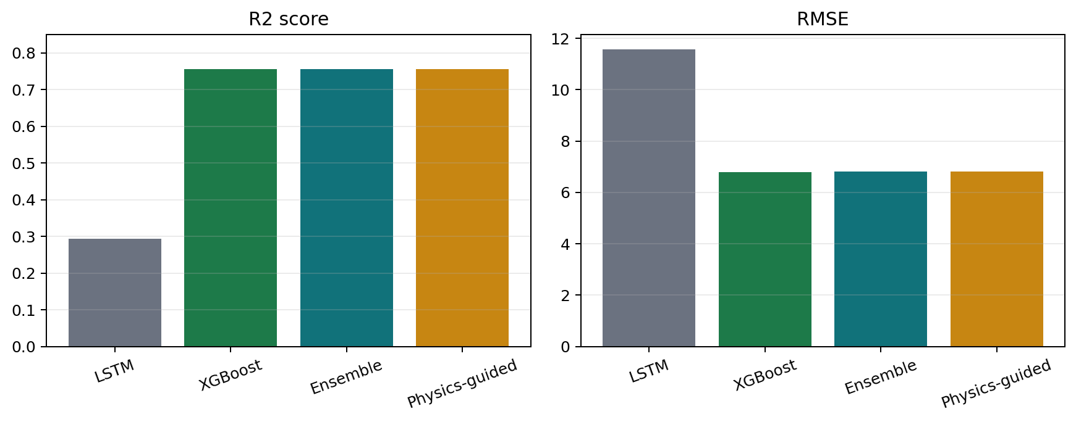
Fig. 7. Current model comparison on the mid-semester GFIS dataset.

6. Discussion
The v04 GFIS prototype demonstrates a practical bridge between model prediction and operator-facing simulation. Instead of treating the dashboard as a static display, the control room now functions as a decision layer and the industrial simulator functions as a virtual response layer. This matters for dissertation evaluation because it directly responds to the concern that a digital twin requires dynamic coupling rather than only visualization.
The present system should still be described carefully. It is a digital-twin-ready coordination pattern, not a fully synchronized industrial twin. A complete industrial digital twin would require continuous live data ingestion from a physical biogas plant, sensor calibration, real-time state estimation, and closed-loop validation against plant behavior.
The dataset remains the primary limitation. The current results are useful for pipeline validation but not yet enough for publication-level industrial generalization. The next phase should incorporate plant IoT data, public anaerobic digestion datasets, ADM1/benchmark simulation data, and documented feedstock-specific BMP priors.

7. Limitations and Future Work
- Replace controlled synthetic/literature-inspired data with plant IoT, SCADA, laboratory or public benchmark datasets.
- Calibrate the methane feasibility bound using feedstock-specific BMP and uncertainty intervals.
- Train the LSTM branch on real chronological windows with leakage-safe temporal splits.
- Add SHAP-based local explanations for high-risk operator scenarios.
- Move the v04 local coordinator into production after presentation review and regression testing.
- Extend the simulator toward live plant synchronization through MQTT/OPC-UA/SCADA adapters in the final dissertation phase.

8. Conclusion
GFIS v04 advances the project from a prediction dashboard toward a coordinated physics-informed process-intelligence prototype. It integrates methane-yield prediction, VFA/ALK soft sensing, stability classification, methane feasibility constraints, AWS-deployed research services, and a local control-room-to-simulator workflow. The work is suitable as a strong dissertation prototype and as a journal working draft, provided final claims are later backed by real or public benchmark data.

Acknowledgements
The authors acknowledge Prof. Mohanamurali G., BITS Pilani WILP evaluator, for suggesting and strengthening the Physics-Informed Machine Learning framing for GFIS during abstract evaluation. The authors also acknowledge BITS Pilani WILP and the academic supervision supporting this dissertation work.

Data and Code Availability
The current mid-semester evidence pack includes the synthetic/literature-inspired GFIS dataset, soft-sensor extract, evaluation metrics, screenshots, and dashboard source files. Real plant data will be added only after acquisition permissions and validation procedures are complete.

Ethics and Competing Interests
No human or animal subject data are used in the current prototype dataset. The present manuscript is a working draft for academic development and is not a final journal submission.

References
- Batstone, D. J. et al. The IWA Anaerobic Digestion Model No. 1 (ADM1). Water Science and Technology, 45(10), 65-73 (2002).
- Chen, Y., Cheng, J. J. & Creamer, K. S. Inhibition of anaerobic digestion process: a review. Bioresource Technology, 99(10), 4044-4064 (2008).
- Chen, T. & Guestrin, C. XGBoost: A scalable tree boosting system. Proceedings of the 22nd ACM SIGKDD International Conference on Knowledge Discovery and Data Mining (2016).
- Hochreiter, S. & Schmidhuber, J. Long short-term memory. Neural Computation, 9(8), 1735-1780 (1997).
- Lundberg, S. M. & Lee, S.-I. A unified approach to interpreting model predictions. Advances in Neural Information Processing Systems (2017).
- Raissi, M., Perdikaris, P. & Karniadakis, G. E. Physics-informed neural networks: A deep learning framework for solving forward and inverse problems involving nonlinear partial differential equations. Journal of Computational Physics, 378, 686-707 (2019).
- Ward, A. J., Hobbs, P. J., Holliman, P. J. & Jones, D. L. Optimisation of the anaerobic digestion of agricultural resources. Bioresource Technology, 99(17), 7928-7940 (2008).
- Weiland, P. Biogas production: current state and perspectives. Applied Microbiology and Biotechnology, 85, 849-860 (2010).

