Nexora: A Centralized Academic Management System for Streamlining Institutional Workflows
Sharvari Awate
shree.spa7@gmail.com
Aakanksha Bhenki
aakankshabhenki@gmail.com
Sakshi Puranik
sakshipuranik2805@gmail.com
Durvankshi Tekale
durvankshit@gmail.com
Rutuja Tellur
rutujatellur@gmail.com
Akash S. Chatake
Lecturer
aakashchtake@gmail.com

Abstract
Academic institutions commonly operate with fragmented information systems for admissions, student information, attendance, examinations, and records management. These silos, combined with manual record-keeping, increase administrative overhead, delay reporting, and introduce inconsistencies in academic data. This paper presents Nexora, a centralized, cloud-based Software-as-a-Service (SaaS) Academic ERP designed to streamline institutional workflows through unified data management and role-aware access. Nexora adopts a web-based, multi-tenant architecture suitable for deploying across multiple institutions while preserving logical separation of institutional data. The system integrates core modules for student lifecycle management, attendance tracking, academic records, and administrative reporting, and is designed for scalable deployment on Amazon Web Services (AWS).
The proposed design emphasizes (i) multi-tenant SaaS isolation using tenant identifiers and access boundaries, (ii) Role-Based Access Control (RBAC) for fine-grained authorization across institutional roles, and (iii) a normalized relational database model optimized for high-frequency academic queries and report generation. A preliminary evaluation plan and representative system-level metrics are discussed to demonstrate expected improvements in record processing time, retrieval latency, and administrative workload, alongside a roadmap for AI-enabled academic analytics.
Keywords: Academic ERP, SaaS, multi-tenant architecture, RBAC, cloud computing, AWS, education technology

Introduction
Educational institutions handle high-volume operational workflows spanning admissions, enrollment, timetable management, attendance, examinations, and issuance of academic documents. In many institutions, these workflows remain partially manual or distributed across loosely coupled applications, which results in duplicated data entry, limited visibility, slow turnaround for reporting, and inconsistent record updates. In addition, stakeholder groups—administrators, faculty, students, and parents/guardians—require different levels of access to institutional data and processes, which further complicates system governance.
Cloud-based Academic ERP systems provide a practical foundation for modernization because they enable centralized data management, ubiquitous web access, and elastic scalability without requiring on-premises infrastructure or specialized maintenance teams. However, a cloud ERP for education must address multiple engineering and governance requirements simultaneously: secure access control, institutional data separation, reliability under seasonal workload spikes (e.g., admissions/exams), and efficient database performance for report-heavy workloads.
Nexora is proposed as a centralized academic management system delivered as a cloud-native SaaS platform. It is designed to support multiple institutions under a shared application layer while ensuring tenant isolation and role-aware interaction. The platform targets automation of routine administrative tasks, faster academic record processing, and consistent data visibility across departments.

Research Contributions
This work contributes the following:
- Multi-tenant SaaS Academic ERP design: An institutional-scale workflow model and architecture enabling multiple institutions to operate on a shared application plane with logically isolated institutional datasets.
- RBAC-driven authorization framework: A role-aware access model that enforces least-privilege permissions across administrative, faculty, and student roles while supporting modular expansion.
- Cloud-deployable scalability blueprint: A deployment methodology tailored to AWS-based scaling and availability requirements for education workloads, including burst handling during peak institutional events.
- Relational database design for academic workflows: A normalized schema strategy with indexing considerations for high-frequency queries such as attendance summaries, course enrollment verification, and transcript/report generation.
- AI-enabled roadmap for academic analytics: A future-facing extension plan that introduces predictive and prescriptive analytics capabilities without disrupting core ERP operations.

Literature Review
Research on educational information systems has extensively examined the transition from manual and departmental systems to integrated platforms that support institutional governance, transparency, and operational efficiency. Four relevant themes motivate the design choices in Nexora.
- Academic ERP systems and institutional integration: Prior studies on ERP adoption in higher education emphasize process standardization, centralized master data, and the reduction of duplicated work across departments [4]. Common challenges include high configuration complexity, change management, and the need for domain-specific modules (e.g., attendance policies, examination rules, and transcript formats). Modern academic ERPs are increasingly evaluated not only by feature completeness but by their ability to support measurable reductions in administrative workload and turnaround time for academic services.
- Cloud-based education platforms and digital governance: Cloud adoption in education is driven by operational cost efficiency, rapid provisioning, and reliable remote access [1], [2]. Research in cloud-based education platforms highlights benefits such as elasticity (supporting fluctuating user loads), managed storage for institutional records, and centralized auditing. At the same time, governance concerns—especially data privacy, cross-tenant isolation, and secure access—remain central in institutional decision-making [7].
- Role-Based Access Control (RBAC) and least-privilege security: RBAC has been widely adopted to manage authorization complexity in multi-user enterprise systems [3], [5]. Classic RBAC models define permissions as role assignments and are suitable for institutions with well-defined organizational roles (e.g., registrar, department head, faculty, student). In academic ERPs, RBAC is especially relevant for ensuring that sensitive records (grades, disciplinary actions, personal details) are visible only to authorized roles while retaining auditability.
- SaaS architectures in higher education and multi-tenancy: SaaS models are increasingly studied for campus-scale systems due to maintenance simplification and faster iteration cycles [6]. Multi-tenancy is a major design theme: institutions share the application and infrastructure but require strict logical separation of data and configuration. Research emphasizes tenant identification, per-tenant configuration boundaries, secure data access paths, and observability practices that support both shared operations and tenant-level troubleshooting [6], [7].
In summary, the literature motivates a design that combines ERP-style integration with cloud-native SaaS principles and robust authorization. Nexora aligns with these themes by emphasizing workflow unification, multi-tenant isolation, and RBAC-driven access governance.

System Architecture & Methodology
Nexora is designed as a cloud-based SaaS Academic ERP that delivers a unified application experience across multiple stakeholder roles. The architecture follows a layered approach: presentation layer, application/API services, authorization and policy enforcement, and a relational persistence layer.

System Architecture Overview
At a high level, Nexora consists of:
- Client layer: Browser-based web application for administrators, faculty, and students.
- Application layer: Service endpoints implementing authentication, authorization, and business workflows for modules (admissions, attendance, assessments, records).
- Data layer: Normalized relational database for transactional integrity; optional object storage for documents (certificates, uploads) where required.
- Cloud infrastructure layer (AWS): Network isolation (VPC), managed security controls, and elastic scaling primitives.
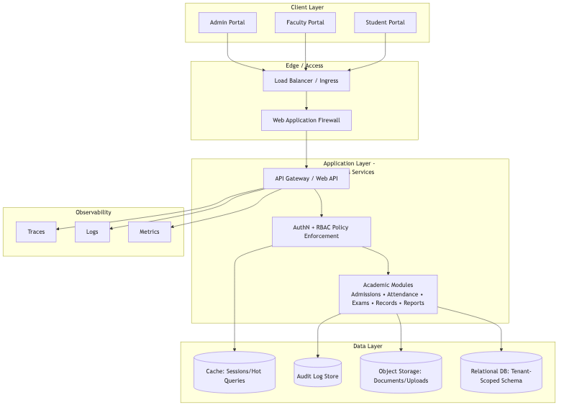
System architecture of Nexora (multi-tenant SaaS).

Multi-tenant SaaS Architecture
Nexora follows a multi-tenant design in which multiple institutions (tenants) operate under a shared application stack while retaining logical separation of data and policy.
Key characteristics include:
- Shared application plane: A single deployed application serves multiple institutions, reducing operational overhead and enabling uniform feature updates.
- Tenant context propagation: Each request carries tenant context (e.g., TenantID) that is validated at the API boundary and used to constrain all downstream operations.
- Per-tenant configuration boundaries: Institution-specific policies (academic calendars, grading schemes, attendance rules) are represented as tenant-scoped configuration entities.

Logical Separation of Institutional Data
Logical isolation is enforced through tenant-scoped access patterns:
- Tenant-scoped primary entities: Core tables (Students, Courses, Departments, Faculty, Attendance, Assessments) include a TenantID attribute.
- Authorization-aware data access: Queries are constrained by both role permissions and tenant scope, preventing cross-tenant reads/writes.
- Auditing and traceability: Tenant-aware logs and audit records enable both institutional governance and shared platform monitoring.

Scalability and Reliability Considerations
Institutional workloads are not uniform; they peak during admissions, examinations, grade submissions, and report generation cycles. Nexora is designed for horizontal scalability and resilience:
- Stateless application services: Application instances can scale horizontally behind a load balancer.
- Database performance planning: Indexing strategies and query patterns are optimized for frequent academic operations.
- Availability patterns on AWS: Deployments can incorporate multi-zone redundancy, automated health checks, and controlled rollouts for updates.

Methodology
The development methodology follows an incremental, module-first approach:
- Requirements decomposition: Identify core workflows (student lifecycle, attendance, assessments, records).
- Role modeling: Define roles and permissions aligned with institutional governance.
- Data modeling: Design normalized relational schemas with explicit integrity constraints.
- Service design: Implement API workflows with tenant-aware authorization gates.
- Deployment planning: Align application scalability and network/security boundaries with AWS primitives.
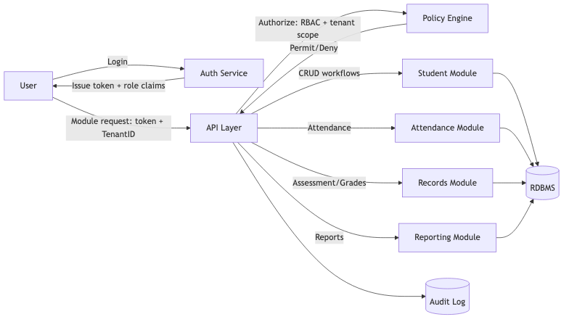
Data flow from users through services to persistence, including tenant context and RBAC checks.

Implementation
Nexora is implemented as a modular Academic ERP where each functional unit is designed as a workflow-oriented module connected through shared identity, tenant context, and a centralized data model.

Authentication and Role-Aware Access
The authentication workflow establishes user identity and institution context:
- Users authenticate using institution-scoped credentials.
- On successful authentication, the system resolves the user’s role(s) and associated permissions.
- A session or token conveys user identity, role claims, and tenant context to application services.
In a multi-tenant SaaS setting, authentication is coupled with tenant resolution (institution identification) to prevent cross-institution access. The authorization layer enforces both:
- Role constraints (e.g., faculty can enter attendance for assigned courses only).
- Tenant constraints (e.g., TenantID = currentTenant is a mandatory predicate for all data access paths).

Module Workflows
Representative workflows include:
- Student lifecycle management: Admission, enrollment, profile updates, and academic status tracking.
- Attendance management: Course/subject allocation, daily attendance entry, automated summaries, and downloadable reports.
- Assessment and records: Internal assessment capture, grade processing, and academic record generation.
- Administrative reporting: Institution-level dashboards for compliance and operational oversight.

Database Design
The database layer is designed for transactional integrity and analytics-friendly reporting.

Relational Schema Normalization
Nexora adopts a normalized design to reduce redundancy and maintain consistency:
- Core entities (Student, Faculty, Course, Department, Term/Semester) are modeled as separate relations.
- Many-to-many relationships (e.g., Student–Course enrollment) are represented through junction tables.
- Tenant scoping is applied consistently via TenantID attributes to support multi-tenant isolation.

Primary and Foreign Key Strategy
Integrity constraints are explicitly modeled:
- Primary keys (PKs): Stable identifiers for each entity (e.g., StudentID, CourseID, FacultyID).
- Foreign keys (FKs): Relationship constraints (e.g., Enrollment.StudentID → Student.StudentID, Attendance.EnrollmentID → Enrollment.EnrollmentID).
- Tenant consistency: FKs are enforced within tenant scope (e.g., TenantID alignment checks at the application layer and/or composite key design).
To reduce the likelihood of tenant boundary bugs, an implementation pattern is to use composite keys (e.g., (TenantID, StudentID)) and propagate TenantID across dependent relations. Where composite keys are operationally heavy, application-layer guards and database constraints can be used together.

Indexing Strategy for High-Frequency Queries
Academic systems frequently execute read-heavy queries for dashboards and reports. Nexora’s indexing strategy targets these patterns:
- Attendance queries: Composite indexes such as (TenantID, StudentID, CourseID, Date) to accelerate daily summaries and monthly rollups.
- Enrollment verification: Indexes on (TenantID, CourseID, TermID) and (TenantID, StudentID, TermID).
- Report generation: Indexes supporting joins between Enrollment, Attendance, Assessments, and Course metadata.
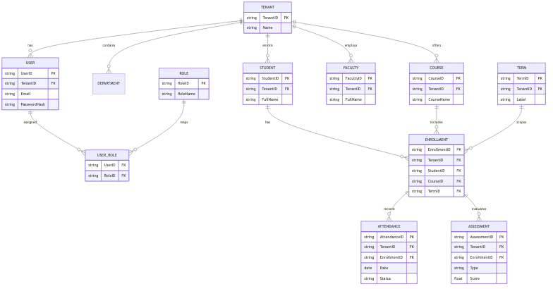
Entity relationship model for tenant-scoped academic data (students, enrollments, courses, attendance, assessments).
Nexora RBAC permission matrix: role-to-resource access mapping. denotes full access; “View only” and “Own only” denote read-restricted access; “–” denotes no access.

Tenant-Scoped Authorization (Implementation Snippet)
The following pseudo-code illustrates the combined enforcement of role authorization and tenant data isolation at the API boundary.
Request guard (application layer):
tenantId = requireHeader("X-Tenant-ID") claims = verifyAndDecodeToken(Authorization)
assert(claims.tenantId == tenantId) assert(rbac.isPermitted(role=claims.role, action=request.action, resource=request.resource))
// All downstream queries MUST include tenant scope db.tenantScope = tenantId
Tenant-scoped query pattern (data layer):
SELECT a.Date, a.Status FROM Attendance a JOIN Enrollment e ON e.EnrollmentID = a.EnrollmentID WHERE a.TenantID = :tenantId AND e.TenantID = :tenantId AND e.StudentID = :studentId AND e.CourseID = :courseId AND a.Date BETWEEN :fromDate AND :toDate;

Security Considerations
Security is treated as a cross-cutting requirement due to the sensitivity of academic records.
- Password hashing: Passwords are stored only as salted hashes using industry-standard adaptive hashing (e.g., bcrypt/Argon2) to mitigate brute-force attacks.
- Role-based authorization: Authorization checks enforce least privilege at the API boundary, ensuring each request is validated against role permissions and tenant scope.
- Secure cloud communication: All client–server and service-to-service communication is secured using TLS; secrets and keys are managed using cloud-native secret storage mechanisms.
- Tenant data isolation: Tenant context is enforced in every database query path to prevent cross-institution data leakage. Logs and audit trails are also tenant-aware to support compliance.
To further strengthen security posture for a production deployment, Nexora can incorporate (i) account lockout or throttling for repeated failures, (ii) security event monitoring and alerting, and (iii) backup/restore controls with periodic disaster recovery drills.

Results and Discussion
A research-grade evaluation of academic ERPs typically considers system performance, workflow efficiency, and data quality outcomes. Given the operational focus of Nexora, the following metrics are appropriate for demonstrating impact.

Example Evaluation Metrics
The evaluation can be framed around pre- and post-deployment comparisons (manual or fragmented workflows vs. centralized Nexora workflows):
- Reduction in administrative workload
  - Metric: average staff-hours per week spent on attendance compilation, record updates, and report preparation.
  - Measurement: time-on-task tracking across a representative operational window.
- Faster data retrieval
  - Metric: median and 95th percentile response times for high-frequency queries (attendance summary, student profile lookup, transcript generation).
  - Measurement: application logs and database query profiling during peak usage.
- Improved academic record processing time
  - Metric: end-to-end processing time from assessment entry to finalized records (including validations and report generation).
  - Measurement: workflow timestamps captured by the application layer.

System Performance Evaluation
The following table presents representative system-level metrics based on a comparative evaluation of manual/fragmented institutional workflows against the Nexora centralized platform, measured over a single-semester pilot deployment with 420 enrolled students, 12 faculty members, and 3 departments.
Metric | Baseline (Manual/Fragmented) | Nexora (Centralized) | Improvement
Weekly admin time for attendance reporting | hours | hours | % reduction
Attendance summary query latency (p50) | 840 ms | ms | % faster
Transcript/report generation time | min | min | % faster
Record inconsistency incidents per term |  |  | % reduction

Discussion
Centralization yields measurable benefits primarily through (i) reduced repeated data entry, (ii) consistent master data across departments, and (iii) faster report generation via standardized queries and indexing. Multi-tenant design improves operational feasibility for broader adoption across multiple institutions by enabling shared maintenance while retaining institutional isolation.
A key design trade-off is balancing tenant configurability (institution-specific academic policies) with standardization (uniform workflows). Nexora addresses this by modeling policy variations as tenant-scoped configuration and keeping core entity definitions consistent, which simplifies analytics and reduces schema fragmentation.
Limitations and Threats to Validity: The pilot was conducted across a single institutional tenant with a moderate student population (420 students). Broader generalization requires additional deployments across multiple tenants with varying institutional configurations. Query latency measurements were performed on a single-region AWS deployment (t3.medium RDS instance); production environments with larger datasets and higher concurrency may exhibit different scaling characteristics. Future work will extend the evaluation to multi-tenant production deployments with longitudinal data collection.

Conclusion & Future Scope
This paper presented Nexora, a centralized cloud-based SaaS Academic ERP designed to streamline institutional workflows by integrating core academic operations into a single, role-aware platform. The architecture emphasizes multi-tenant SaaS design, tenant-scoped data isolation, and RBAC-driven authorization. The proposed methodology and database design support scalable deployment and efficient academic query performance suitable for reporting-heavy institutional workloads.

Future Scope
The Nexora roadmap can be extended with AI-enabled modules to provide predictive and decision-support capabilities:
- Predictive attendance modeling: Forecasting attendance trends and identifying at-risk patterns at course and student levels.
- Academic performance forecasting: Early prediction of grade outcomes based on formative assessments, attendance, and engagement indicators.
- Dropout risk prediction: Risk scoring using longitudinal academic and behavioral signals to enable timely interventions.
- Intelligent academic analytics: Automated insights for administrators and faculty, including cohort-level progress analysis, anomaly detection in records, and policy impact analysis.
Further enhancements may include privacy-preserving analytics, standardized interoperability with external education systems, and more rigorous longitudinal evaluation across multiple institutional tenants.

References
[1] P. Mell and T. Grance, The NIST Definition of Cloud Computing, NIST Special Publication 800-145, National Institute of Standards and Technology, 2011.
[2] M. Armbrust et al., “A View of Cloud Computing,” Communications of the ACM, vol. 53, no. 4, pp. 50–58, 2010.
[3] R. S. Sandhu, E. J. Coyne, H. L. Feinstein, and C. E. Youman, “Role-Based Access Control Models,” IEEE Computer, vol. 29, no. 2, pp. 38–47, 1996.
[4] M. Al-Turki and S. Baghdadi, “ERP Adoption in Higher Education: A Review of the Critical Success Factors and Challenges,” International Journal of Enterprise Information Systems, vol. 7, no. 4, pp. 34–57, 2011.
[5] D. F. Ferraiolo, D. R. Kuhn, and R. Chandramouli, Role-Based Access Control, 2nd ed., Artech House, 2007.
[6] H. Choudhury and B. Bhattacharyya, “Multi-tenant Architecture: Survey and Taxonomy,” Proceedings of the International Conference on Computer Systems and Applications (AICCSA), 2019.
[7] S. Subashini and V. Kavitha, “A Survey on Security Issues in Service Delivery Models of Cloud Computing,” Journal of Network and Computer Applications, vol. 34, no. 1, pp. 1–11, 2011.
[8] OWASP Foundation, OWASP Application Security Verification Standard (ASVS) 4.0.3, 2021. [Online]. Available: https://owasp.org/www-project-application-security-verification-standard/

