# CS 255 System Design Document

Aakash Thapa

## UML Diagrams

### UML Use Case Diagram

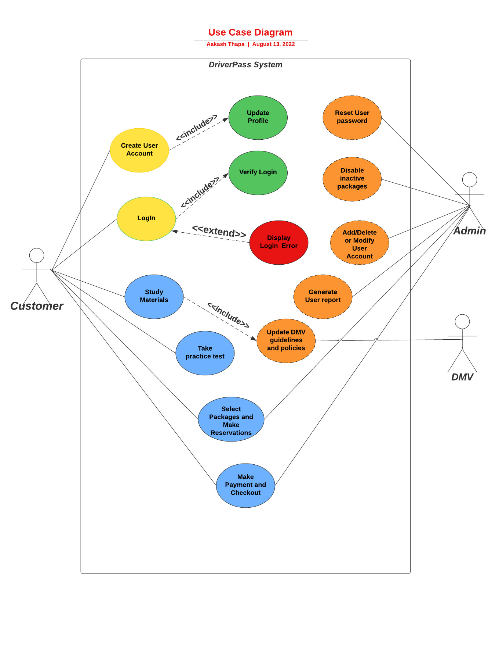

### UML Activity Diagrams

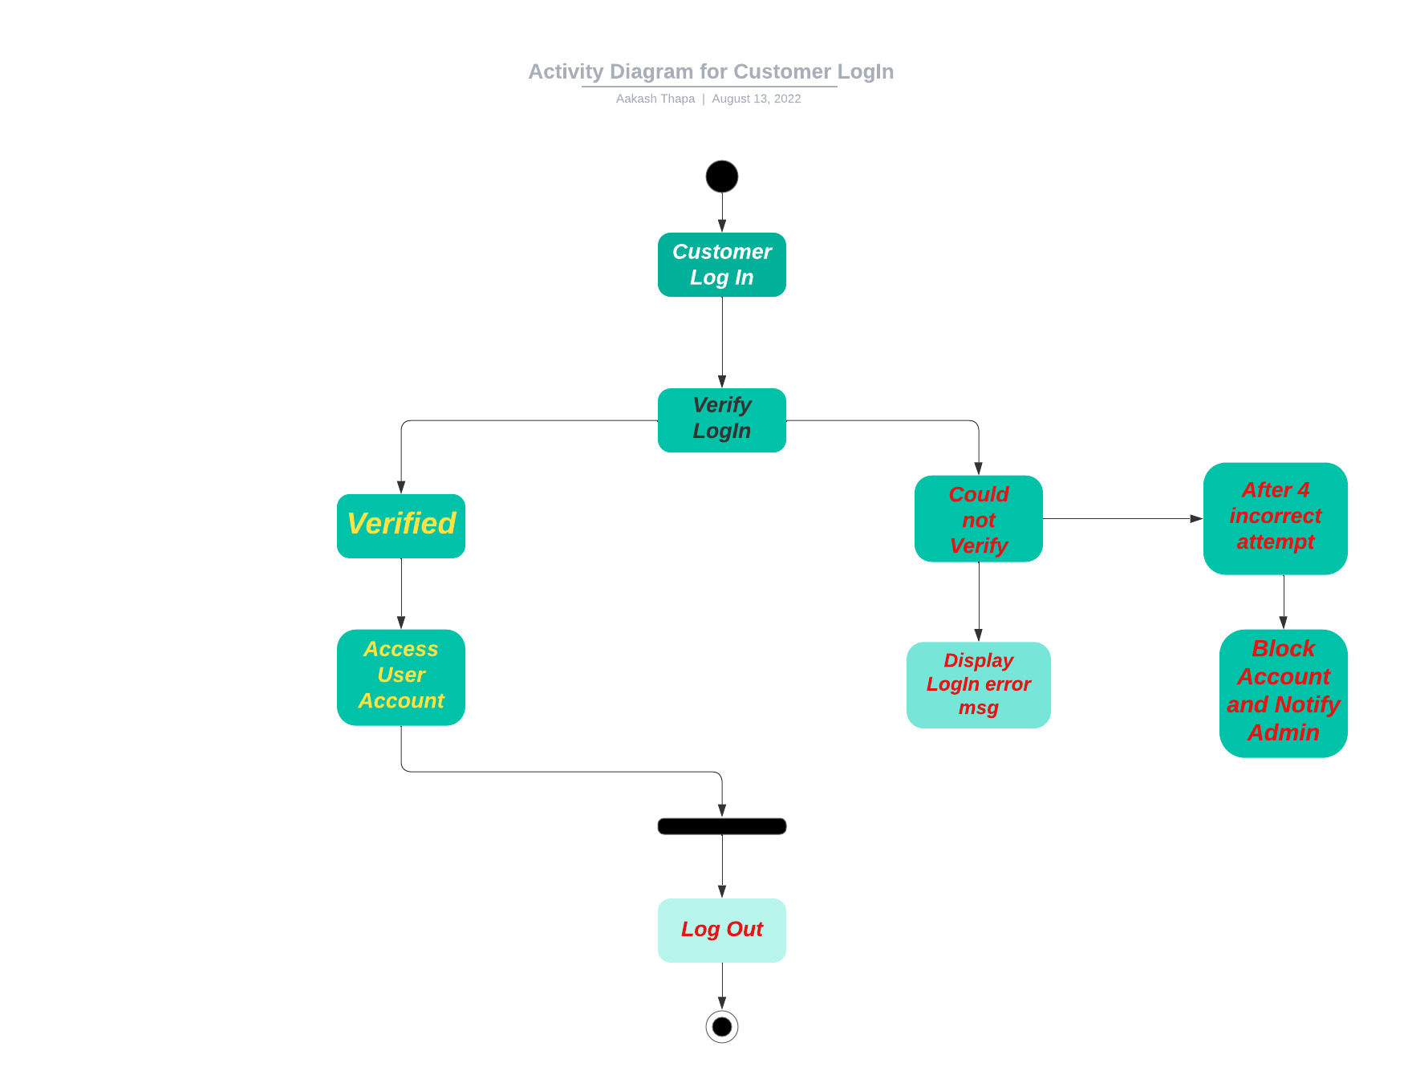

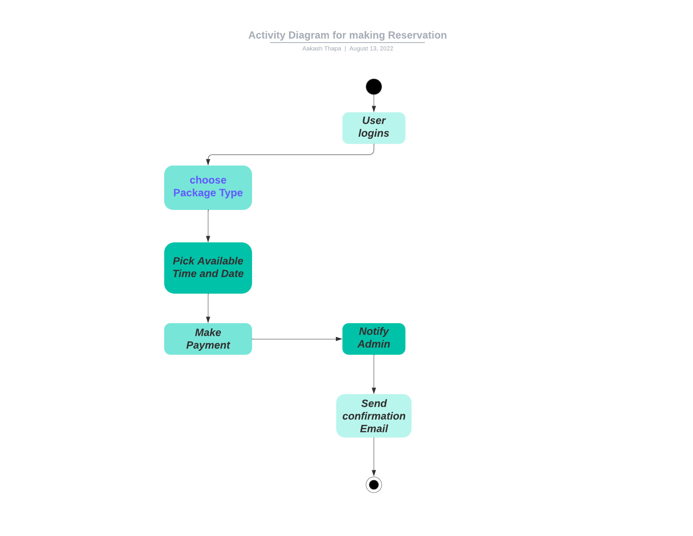

### UML Sequence Diagram

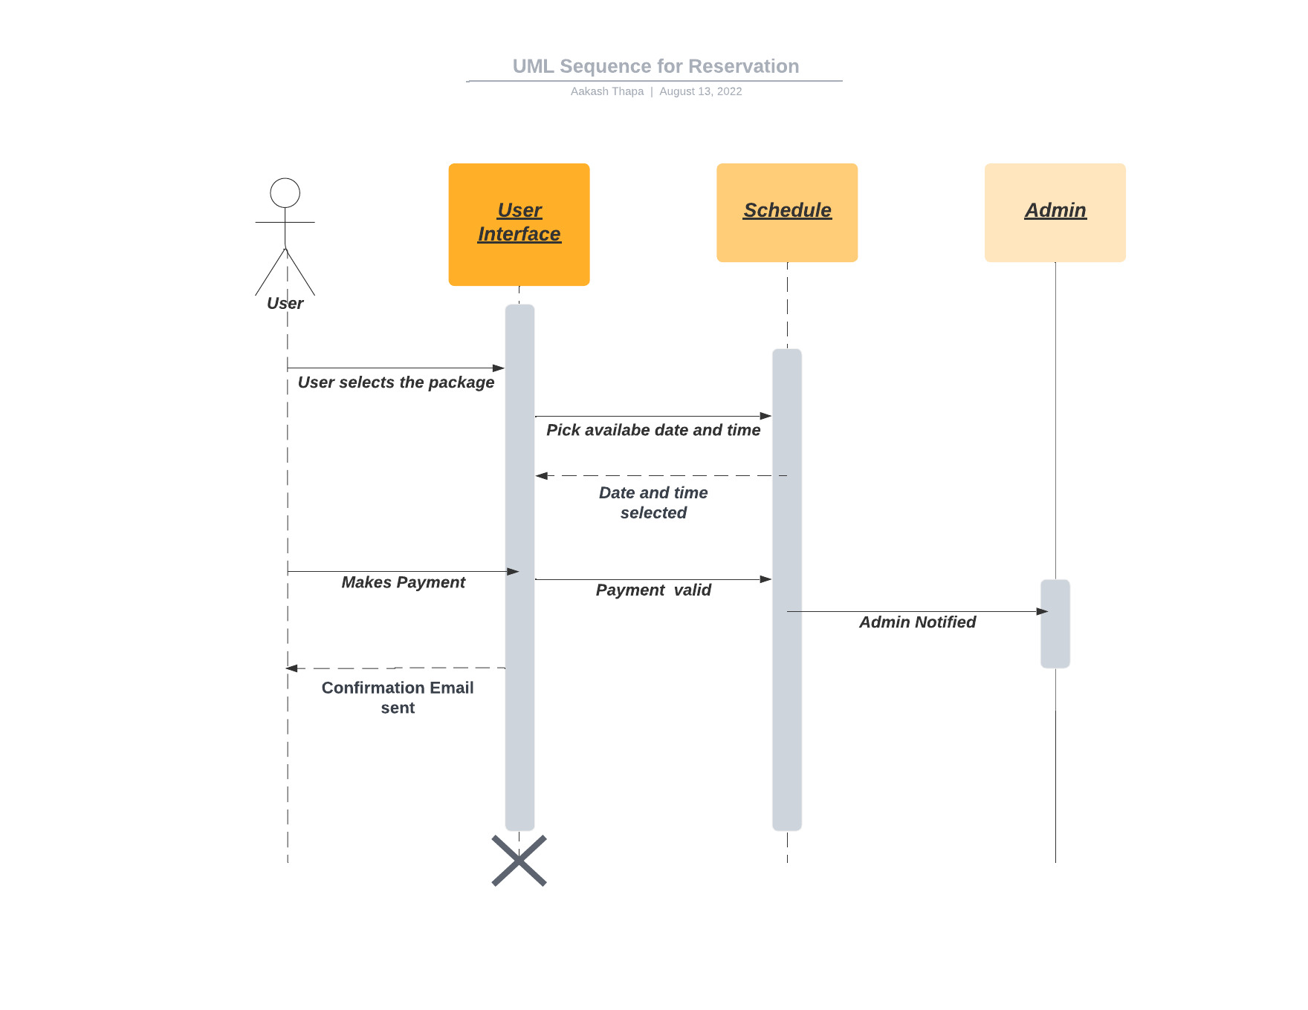

### UML Class Diagram

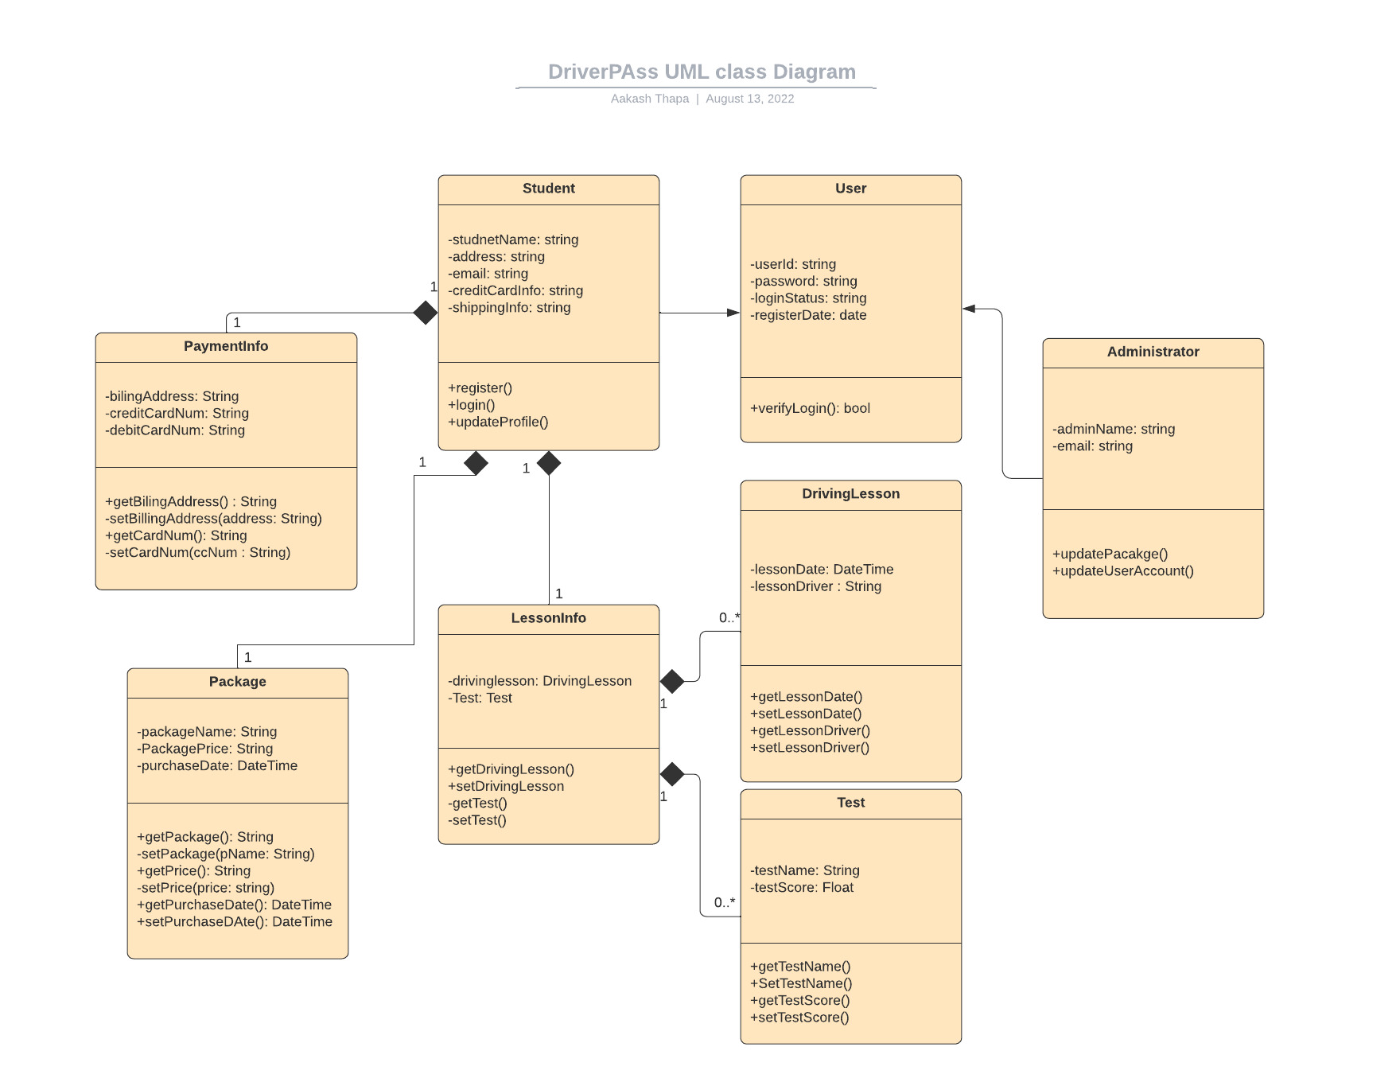

## Technical Requirements

Hardware Requirements

* Cloud server for hosting
* Devices like Laptop, Desktop, Tablet or Smart Phone for clients to run a modern web browser

Software Requirements

* Operating System
* Driver-pass Software
* Security software

Tools

* Lucid charts to create UML diagrams
* IDE like Eclipse, IntelliJ, and Studio for Developers
* Computers (laptops, desktops, monitors, keyboards, mouse)

Infrastructure

* High-speed Internet
* Server location