Practical-4
2520030337
Aakash Dadhirao
S-7

C File for the Wait program-
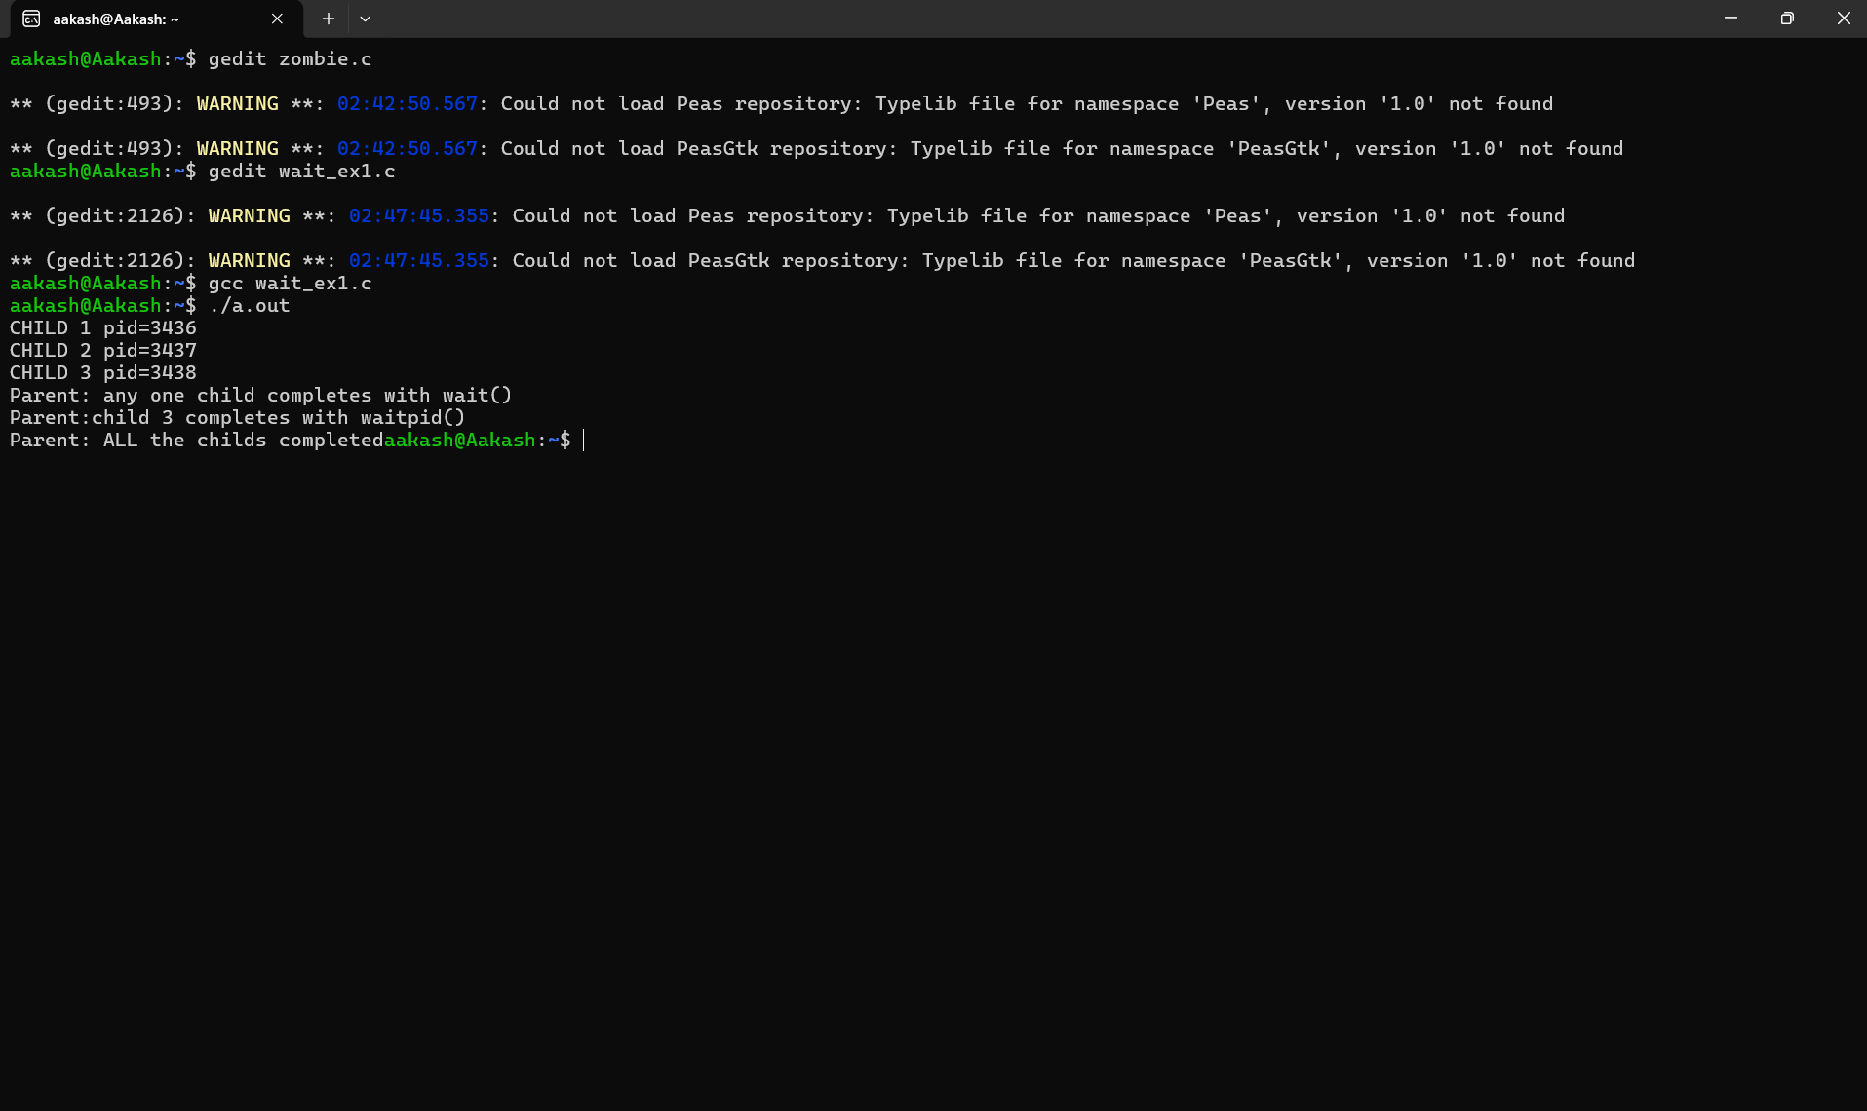

Output for the Zombie process experiment:

