Practical-2
2520030337
Aakash Dadhirao
S-7

C file(the program):

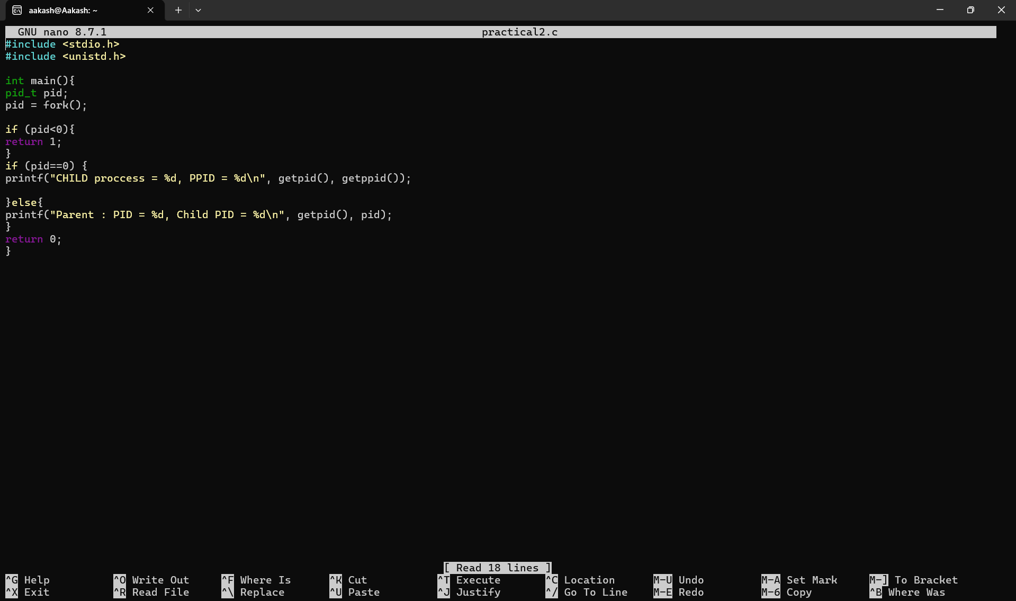

Output:

