OSINT Assignment 1 Scenario B Media Verification
Verification of the Hurricane Harvey Shark Image
Student | Aakash Gudimati
Scenario | Scenario B Verifying the Authenticity of Online Media
Investigation date | 25 October 2026
Conclusion The image does not authentically show a shark on a flooded Houston freeway during Hurricane Harvey. It is a manipulated composite that uses a shark from Thomas P. Peschak's genuine shark-and-kayak photograph. I assess this conclusion with high confidence because the provenance is independently supported by the photographer, PolitiFact, Africa Check, and National Geographic.

Part 1 Scenario Selection
I selected Scenario B because online images can be technically genuine, edited, or attached to the wrong event. This case tests both image-level analysis and source verification. The subject is a widely circulated picture claiming that a shark was swimming beside a car on a Houston freeway during Hurricane Harvey. The claim is specific, publicly documented, and can be investigated without contacting a person or accessing restricted data.

Part 2 Investigation Report

Investigation Question
My question was: Does the image authentically depict a shark on a flooded Houston freeway during Hurricane Harvey, or is it manipulated or misattributed? I defined the scope before collecting data. The investigation covered the downloaded claim file, its technical characteristics, the origin of the shark, earlier appearances of the composite, and independent reporting. It excluded identifying or profiling the people who shared it. This follows the planning stage of the intelligence cycle from Session 1 [1].

Why the Standard Tools Were Not Enough
HaveIBeenPwned, WHOIS, and Shodan answer questions about breaches, domains, hosts, and exposed services. They cannot determine whether pixels were combined from different photographs. Session 1 also introduced Google Images, TinEye, InVID, and ExifTool [1]. Those tools can help locate earlier copies, extract metadata, or inspect video, but the assignment required at least one tool not introduced in class. I therefore needed a new image-forensics tool that could examine the file itself while I used independent sources to establish provenance.

Tool Discovery Process
I searched for phrases including free online image forensics metadata ELA tool, browser image manipulation analysis tool, and OSINT verify edited image. I considered FotoForensics, Ghiro, ExifTool, and InVID. ExifTool and InVID were already covered in class. Ghiro required more setup than this investigation needed, while FotoForensics was narrower. I chose Forensically, a free browser-based toolkit created by Jonas Wagner, because it combines metadata inspection, JPEG analysis, error level analysis, clone detection, and other visual checks without requiring an account [2]. It was not listed in the Session 1 tool overview.
Forensically was appropriate as a technical inspection layer, not as an automatic truth detector. Guidance in the Bellingcat toolkit warns that its results can be difficult to interpret and should not be used alone to decide whether an image was manipulated [3]. I therefore treated its output as supporting evidence and gave greater weight to the provenance trail.

Methodology
- Collection. I saved the claim image as E01_claim_harvey_shark.jpg and recorded its source, access time, dimensions, and SHA-256 hash. I also preserved the photographer's source image as E02 and an Africa Geographic scan as E03.
- Processing. I used evidence IDs, stored screenshots separately, and recorded exact URLs, timestamps, filenames, hashes, observations, and confidence levels in the CSV evidence log. This implements the documentation requirements from Session 1 [1].
- Technical analysis. I loaded E01 into Forensically. Metadata returned No Metadata Found. JPEG Analysis reported no JPEG comment and a standard JPEG table quality of 85. For ELA, I used JPEG Quality 90 and reviewed Error Scales 20 and 80. The ELA view was mostly dark and did not provide a decisive localized anomaly.
- Provenance and corroboration. I compared the claim against the photographer's account, PolitiFact, Africa Check, and National Geographic. These sources independently connect the shark to Peschak's real South African shark-and-kayak image and document its later reuse in false disaster scenes [4]-[7].
- Assessment. I separated observations from conclusions and rated each finding according to the strength and independence of the supporting evidence.

Findings
Finding | Evidence | Confidence
The downloaded claim copy contains no usable EXIF metadata. | Forensically metadata result and screenshot S02. | High for this copy
JPEG encoding characteristics and ELA do not independently establish authenticity. | JPEG quality 85; ELA at quality 90 and scales 20 and 80 was inconclusive. | High for observation, low for proof
The shark came from Peschak's genuine shark-and-kayak photograph made during research in South Africa. | Photographer's account, Africa Check, and National Geographic [5]-[7]. | High
The shark was inserted into a flooded-road scene, and the composite circulated before Hurricane Harvey. | PolitiFact, Peschak, Africa Check, and National Geographic [4]-[7]. | High
The image is manipulated and misattributed, not authentic Hurricane Harvey media. | Converging provenance and independent fact-checks. | High

Confidence Assessment
The overall conclusion is High confidence. Four independent public sources agree on the shark's provenance and its reuse in false flood images. The image-forensics results are narrower: metadata absence and JPEG quality are high-confidence observations about the downloaded file, but they cannot show what earlier versions contained. The ELA result receives Low confidence as independent proof because recompression and resizing can hide or create patterns. The final judgment therefore rests on provenance and corroboration rather than ELA alone.

Part 3 Ethics and OPSEC Reflection
I kept the investigation in the green zone described in Session 1 [1]. Every source was publicly available: news reports, the photographer's portfolio, a fact-checking site, the public image file, and a public analysis tool. I did not access private accounts, guess credentials, bypass access controls, scrape a service against its terms, scan infrastructure, or contact anyone connected with the claim. The task concerned the provenance of an image, so I did not collect personal information about the users who shared it. This avoided the grey-zone risk of aggregating public details into a personal profile and all red-zone activity.
OPSEC influenced the decision to use passive methods and avoid login-dependent services or direct contact. The investigation required no personal account and no active scanning. I kept the case files in an organised local folder, separated evidence from screenshots and notes, and calculated hashes so later changes can be detected. For a higher-risk case, I would improve separation further by using a dedicated browser profile or virtual machine and, where justified, a VPN or Tor. Session 1 recommends these controls to reduce identity leakage and unwanted contact with a target [1].
Documentation matters because online pages and files can change or disappear. Exact URLs, access times, screenshots, local filenames, hashes, and confidence ratings make the work reproducible and support chain of custody. They also allow another investigator to distinguish what I directly observed from what a source reported. The evidence log is therefore part of the method, not an administrative extra.

Part 4 Personal Academic and Professional Relevance
For personal digital security, this workflow gives me a repeatable way to check dramatic images before sharing them. I can preserve the file, inspect available metadata, search for earlier versions, compare it with reliable sources, and state uncertainty when the evidence is incomplete. This reduces the chance of amplifying scams, panic, or false disaster information.
For academic research, the same process helps evaluate whether an image is suitable evidence. A picture can be genuine but used in the wrong context, and metadata can be absent without proving deception. Recording provenance, timestamps, hashes, and confidence levels makes visual-source analysis more transparent and reproducible. Forensically is useful because it adds technical observations, but its limitations also reinforce the need to cite original sources and corroborate claims.
For professional cybersecurity practice, image verification can support incident response, threat intelligence, fraud analysis, and investigations of manipulated screenshots or social-media claims. The most transferable lesson is to combine tools rather than depend on one result. Forensically can flag details for review, while provenance research, independent reporting, and evidence handling establish a defensible conclusion. Confidence labels help communicate what is known, what is only indicated, and what remains uncertain.

References
[1] Nobakht, K. Open Source Intelligence Session 1. SRH University of Applied Sciences, 2026. Slides 3, 6-7, 15-18, and 26-27.
[2] Wagner, J. Forensically photo forensics tools. https://29a.ch/photo-forensics/ Accessed 25 October 2026, 21:49 CET.
[3] Bellingcat Toolkit. Forensically. https://github.com/bellingcat/toolkit/blob/main/gitbook/tools/forensically/README.md Accessed 25 October 2026, 21:49 CET.
[4] PolitiFact. There are no sharks swimming in the streets of Houston or anywhere else. 28 August 2017. https://api.politifact.com/factchecks/2017/aug/28/blog-posting/there-are-no-sharks-swimming-streets-houston-or-an/ Accessed 25 October 2026, 21:24 CET.
[5] Peschak, T. P. White Shark Kayak. https://www.thomaspeschak.com/kayak-great-white-sharks- Accessed 25 October 2026, 21:24 CET.
[6] Africa Check. Shark swimming on flooded highway No image photoshopped. 21 February 2020. https://africacheck.org/fact-checks/meta-programme-fact-checks/shark-swimming-flooded-highway-no-image-photoshopped Accessed 25 October 2026, 21:25 CET.
[7] Peschak, T. P. My shark photo took over the internet inspiring countless fakes and real awareness. National Geographic, 10 June 2021. https://www.nationalgeographic.com/magazine/article/my-shark-photo-took-over-the-internet-inspiring-countless-fakes-and-real-awareness Accessed 25 October 2026, 21:24 CET.

Appendix A Evidence Inventory
ID | File or source | SHA-256 or record | Purpose
E01 | E01_claim_harvey_shark.jpg | d598ba0c092223a2eede8ae55817c4cfb65c00f66626bfbf6aaea6bbd366a809 | Claim file
E02 | E02_original_shark_kayak.jpg | 4681fb1da1ebcc0b631f9a5ff9b5fd1777c2a4432c56de68491c971a60d73b71 | Photographer source image
E03 | E03_africa_geographic_scan.jpg | 690f85a162d39cf65084a51a3b8270cf5b96d9653ad28f24c67b3e90427c3928 | Publication scan
S01 | S01_claim_context.png | Screenshot record | Claim and fact-check context
S02 | S02_forensically_metadata.png | Screenshot record | Metadata result
S03 | S03_forensically_ela.png | Screenshot record | ELA settings and output
The complete evidence log is stored as evidence/scenario-b-evidence-log-plain.csv and contains exact URLs, access dates, access times, settings, observations, filenames, screenshots, and confidence levels.

Appendix B Screenshots
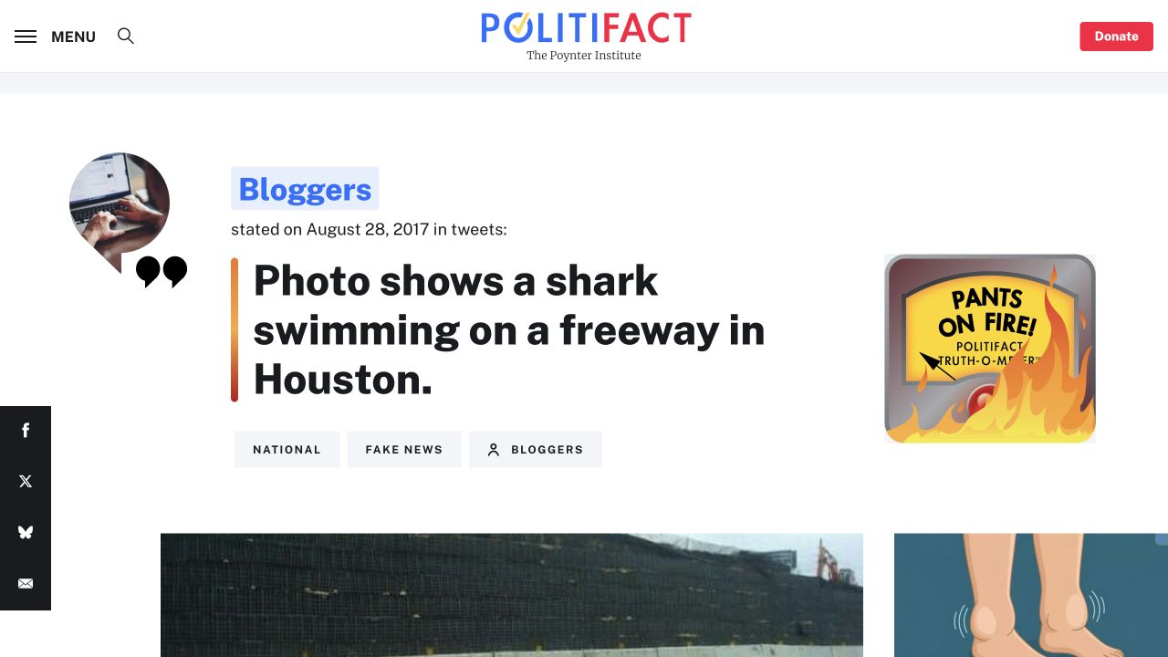
Figure 1 PolitiFact page documenting the Houston freeway shark claim and its false rating
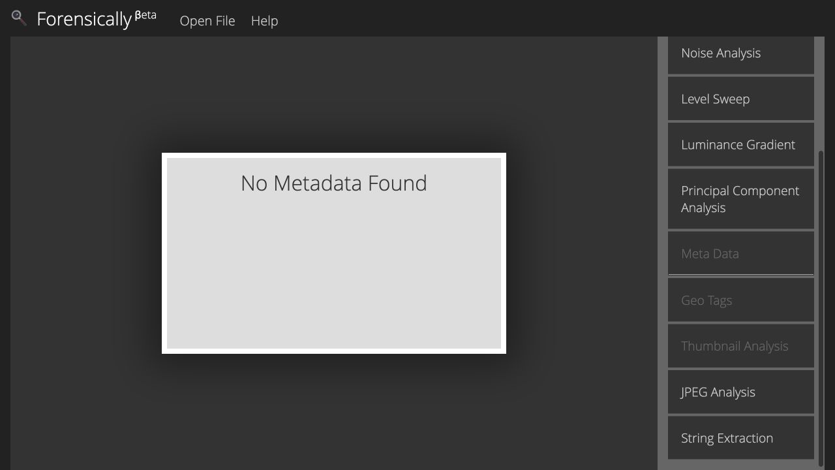
Figure 2 Forensically metadata result showing No Metadata Found for the downloaded claim copy

Appendix B Screenshots Continued
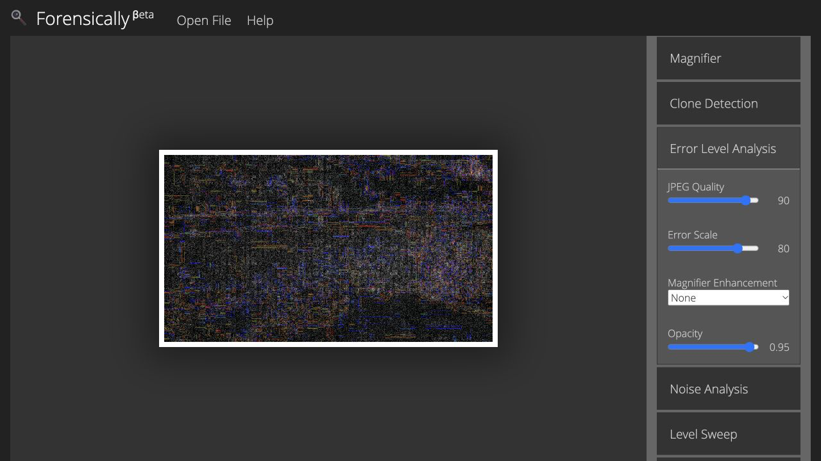
Figure 3 Forensically error level analysis at JPEG Quality 90 and Error Scale 80

