INTERNSHIP / UDP / TRAINING REPORT – REPORTING 4
(Final Project Completion, Demonstration & Evaluation Report)
1. Student Information
Student Name | AAKASH BHARATBHAI JAYANI
Enrollment Number | 23SE02IT140
Program/Branch | B.Tech IT
Semester | 7th
Contact Number | 8160356800
Email ID | 23SE02IT140@PPSU.AC.IN

2. Internship / UDP / Training Details
Type | UDP
Company/Organization | PPSU
Department/Domain | SOE
Mentor Name (Company)
Mentor Name (Institute) | Mr. Anurag Yadav
Start Date | 08/06/2026
End Date | 03/10/2026

3. Work Progress Summary
- Project Title:
Cache-Craft: Autonomous Semantic RAG Router - A High-Performance Multi-Tier Semantic Caching Middleware for LLM Inference

b) Brief Overview of Work Completed After Reporting 3
Major tasks completed: Successfully transitioned the project from the interim SQLite3 prototype to a production-grade multi-tier architecture using PostgreSQL 16 with pgvector and Redis 7. Implemented a context-aware conversational caching engine to solve referential follow-ups. Developed an enterprise-grade dark/glass dashboard in Next.js 15. Integrated pluggable cloud/local inference (Google Gemini 3.8 Flash and local Ollama Llama 3.2 with automatic fallback). Implemented dual-tier TTL cache lifecycle management with automated database cleanup. Designed and executed an end-to-end 1,200-query benchmark evaluation suite. Orchestrated a full 4-service containerized deployment stack using Docker Compose.
- Modules completed: 1) Multi-Tier Routing Core (L1 Redis Exact + L2 pgvector HNSW Semantic), 2) Multi-Turn Conversational Context Binder, 3) Pluggable Multi-LLM Inference & Fallback Engine, 4) Dual-Tier TTL Cache Lifecycle Manager, 5) Real-Time SSE Metrics Streaming Pipeline, 6) Next.js 15 Cupertino Dashboard & Chat Playground, 7) Automated 1,200-Query Benchmark Evaluation Engine.
- New features implemented:
- 1. Multi-Turn Context-Aware Caching: Implemented conversation turn binding (<prior_query> -> <follow_up>) with pgvector partition filtering, enabling follow-up questions (e.g., 'summarize it', 'why', 'elaborate') to be cached without colliding with parent queries.
- 2. Pluggable Cloud & Local LLM Engine: Dual inference support for local Ollama llama3.2 (100% offline privacy and zero cost) and Google Gemini (gemini-3.8-flash) with automatic, resilient fallback to local Ollama during API spikes or rate limits.
- 3. Dual-Tier TTL Lifecycle Management: Coordinated cache expiration across Redis (EX <ttl>) and PostgreSQL (expires_at TIMESTAMP with B-tree index), featuring 6 UI presets (1h, 6h, 24h, 7d, 30d, Permanent) and on-demand database vacuuming.
4. Real-Time Analytics & SSE Streaming: Server-Sent Events endpoint (/api/metrics/stream) delivering live query volume, hit-rate, latency distributions, and cost-savings counters to the Next.js frontend.
5. 1,200-Query Benchmark Evaluation Suite: Automated evaluation pipeline testing 500 seeds, 500 paraphrases, and 200 unrelated queries across 6 cosine similarity thresholds (0.70 to 0.95), comparing against No-Cache and Exact Redis baselines.
Research / development work completed: Researched dense vector embedding distance spaces (unit L2-normalized cosine similarity vs Euclidean distance in HNSW graphs). Investigated vector drift and catastrophic interference in multi-turn conversational caching. Evaluated latency and memory trade-offs between Redis in-memory key-value lookups and pgvector index scans. Formulated optimal threshold boundaries (0.70–0.85) balancing 100% precision with maximum recall.
Integration work completed: Unified the 4 decoupled application tiers (Next.js 15 frontend, FastAPI Python backend, Redis 7 in-memory cache, and PostgreSQL 16 + pgvector database) within a unified Docker Compose network with health checks and GPU passthrough.
c) Overall Project Completion Status
Component | Status | Completion (%)
Requirement / Analysis | Completed | 100%
Design | Completed | 100%
Development | Completed | 100%
Integration | Completed | 100%
Testing | Completed | 100%
Documentation | Completed | 100%
Deployment | Completed | 100%
Overall Project Completion: __100____ %

4. Advanced Implementation
Describe the major implementation work completed after Reporting 3.
a) Module / Feature Implementation
Module / Feature | Work Completed | Status
Dual-Tier Cache Router (L1 Redis + L2 pgvector) | Engineered L1 Redis SHA-256 exact matching (<2ms) and L2 pgvector HNSW cosine similarity search (~25ms) using sentence-transformers/all-MiniLM-L6-v2. | Completed
Multi-Turn Context Binder | Developed referential query detection with conversation history aggregation and pgvector partition filtering for follow-up questions. | Completed
Pluggable Multi-LLM Inference Engine | Integrated Google Gemini Cloud (gemini-3.8-flash) and local Ollama (llama3.2) with automatic cloud-to-local fallback and token usage logging. | Completed
Dual-Tier TTL Lifecycle Manager | Implemented coordinated cache expiration across Redis and PostgreSQL with 6 lifecycle presets and background cleanup. | Completed
Next.js 15 Dashboard & Analytics UI | Built an Apple-grade dark/glass web dashboard with Overview, Chat Playground, Vector Explorer, and Settings panels. | Completed
Integration / Development Details
Module integration: The Next.js 15 frontend application interfaces seamlessly with the FastAPI backend through typed REST endpoints and SSE streams. The Cache Router tightly couples the SHA-256 pre-filter, the PyTorch SentenceTransformer embedder, the database layer, and the upstream LLM client into a unified, non-blocking pipeline.
- API integration: Integrated external Google Gemini REST API v1beta for high-throughput cloud inference and the local Ollama HTTP REST daemon (http://localhost:11434) for private on-premise execution, wrapped in a common abstract interface with automatic fallback logic.
- Database integration: Upgraded storage to PostgreSQL 16 with the pgvector extension. Configured connection pooling via psycopg 3 with native vector registration. Created HNSW index with vector_cosine_ops parameters (m=16, ef_construction=64) for sub-linear ANN search over 384-dimensional embeddings. Added Redis 7 container for sub-2ms exact match key-value lookups.
- Hardware integration: N/A — Purely software and database middleware architecture, utilizing host CPU/GPU SIMD instructions for local PyTorch vector tensor operations.
- Software integration: Integrated SentenceTransformers (all-MiniLM-L6-v2), pgvector, Redis-Py, NumPy, Pydantic v2, and Next.js 15 with Tailwind CSS and Lucide React into a cohesive, production-grade microservices stack.
- Major coding / development work: Implemented over 2,500 lines of robust, modular code across the backend, core routing algorithms, database persistence, and Next.js frontend. Solved critical edge cases including conversational semantic drift, dynamic TTL synchronization, cloud LLM rate-limit resilience, and matrix-vectorized benchmark evaluation.
- Major coding / development work
c) Final / Updated Architecture
Attach the updated system architecture, workflow, block diagram, UML diagram or process flow.
Diagrams:
Figure 1: Production Multi-Tier System Architecture (Decoupled Microservices Stack)
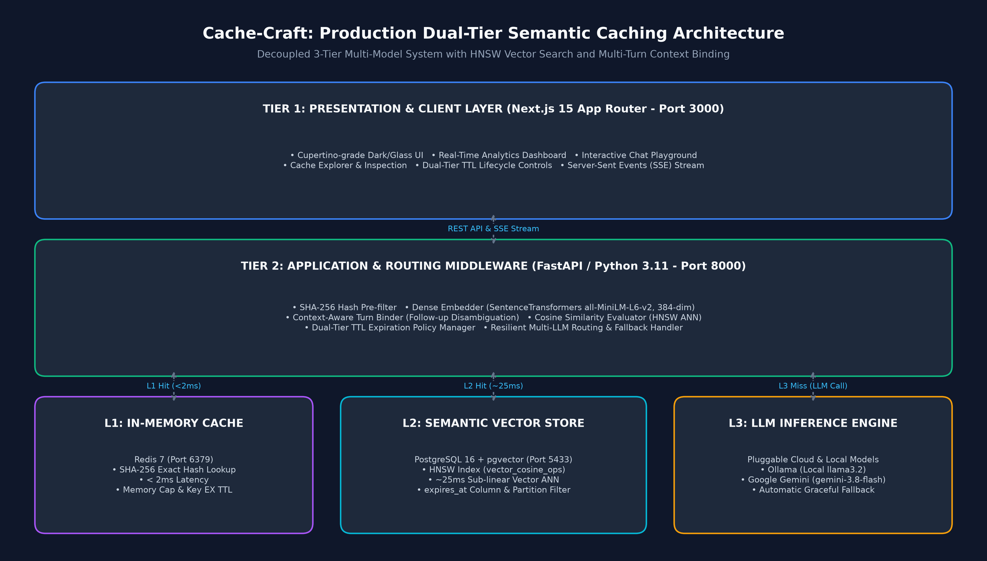
Figure 2: Autonomous Request Routing & Multi-Tier Decision Flowchart
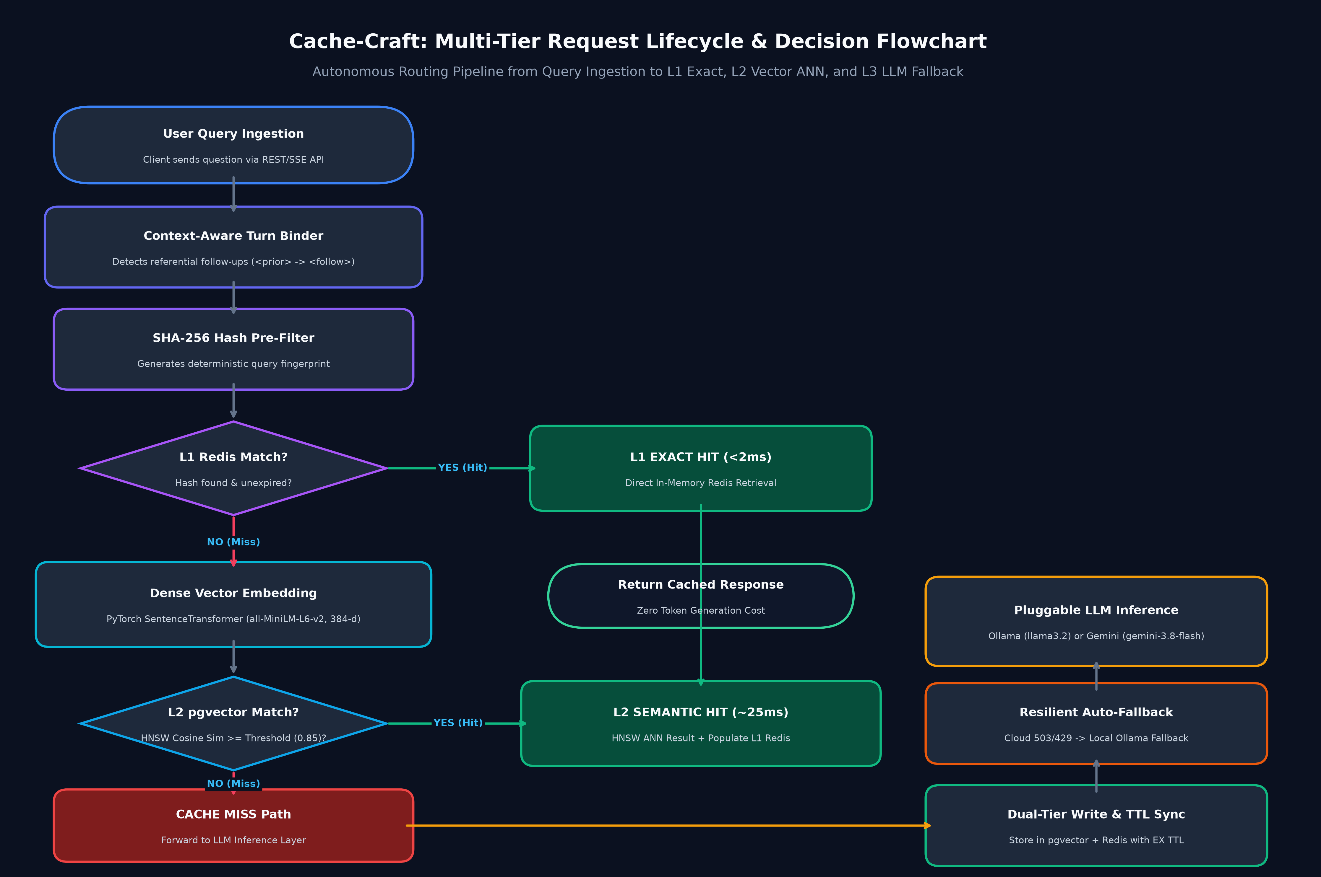
Figure 4.3: Cache-Craft System Block Diagram and Component Interaction
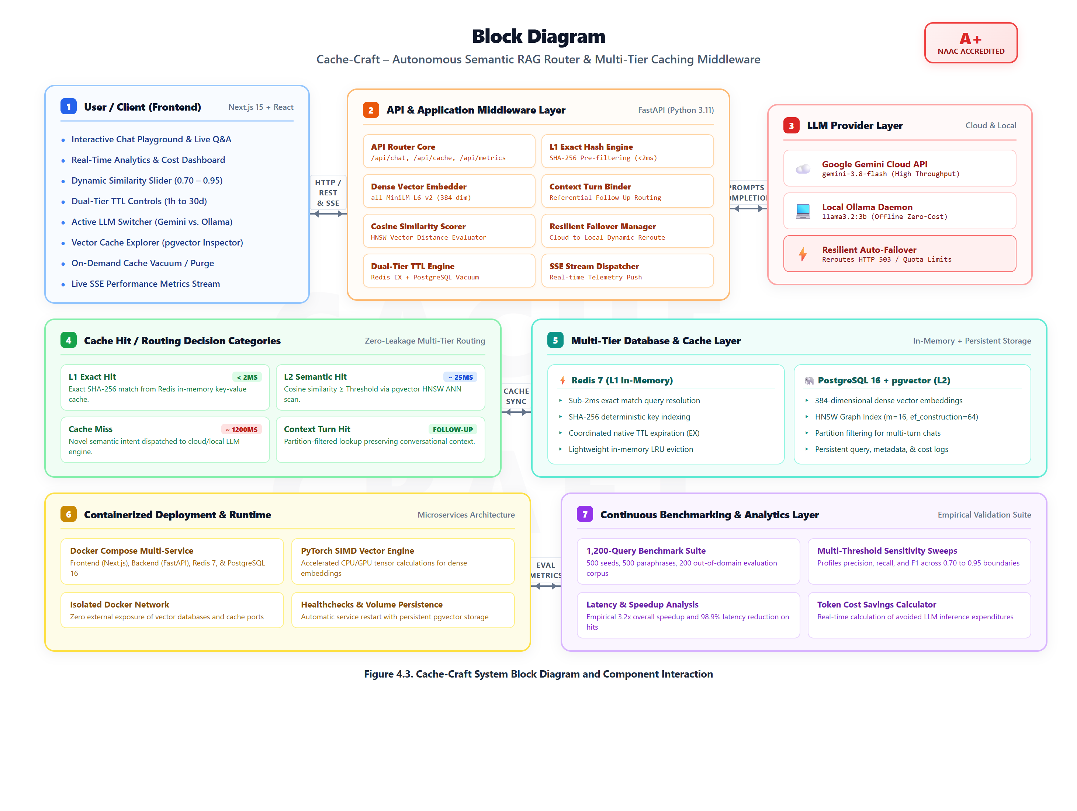
Figure 4.4: Cache-Craft Consolidated UML Architectural Blueprints
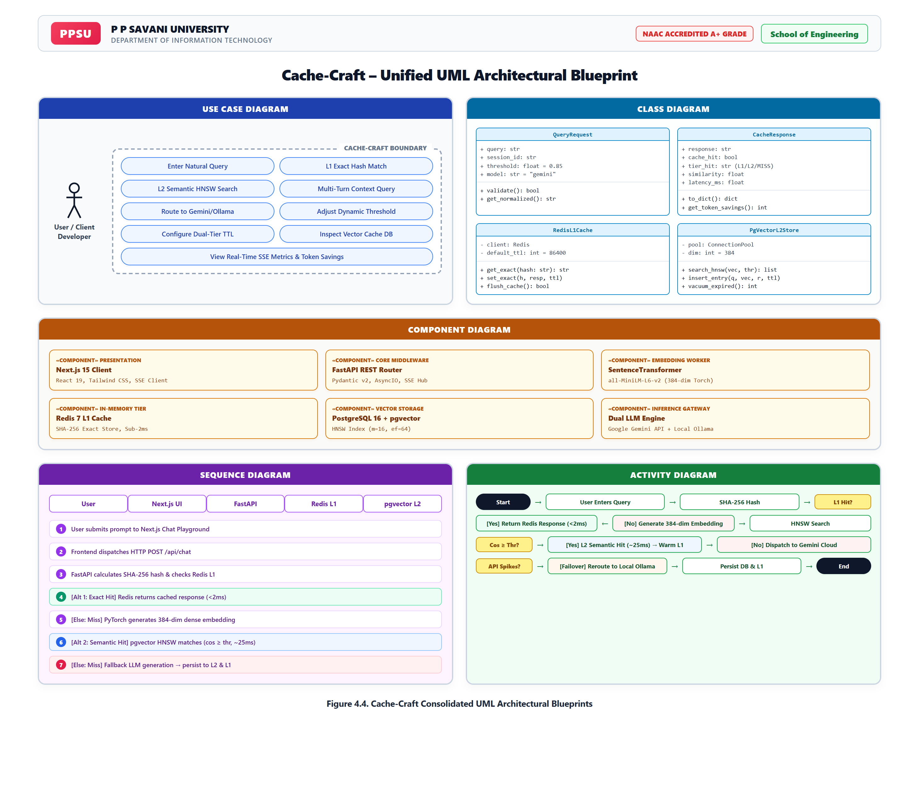
Figure 4.5: Cache-Craft End-to-End Process Flow Diagram
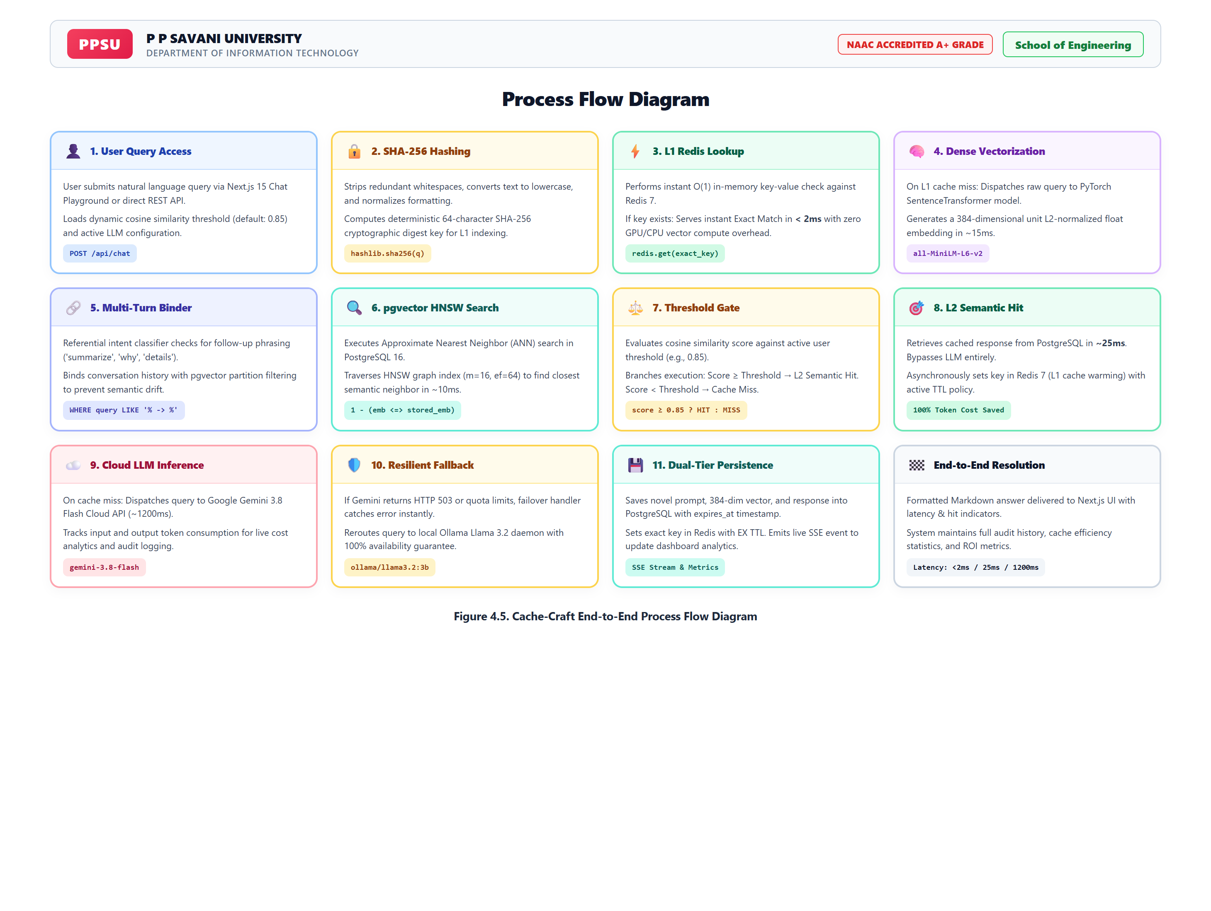
Brief Explanation:
The updated system architecture implements a decoupled, three-tier cloud/on-premise deployment model illustrated in Figure 1 and Figure 2. Tier 1 (Presentation) is built with Next.js 15 and Tailwind CSS, providing an Apple-grade glassmorphic interface for chat, analytics, cache inspection, and settings controls. Tier 2 (Application Middleware) is powered by Python 3.11 and FastAPI, executing SHA-256 exact matching, dense vector embedding generation (all-MiniLM-L6-v2, 384-dim), conversational turn binding, and resilient LLM routing. Tier 3 (Storage & Inference) combines an in-memory Redis 7 instance for sub-2ms exact hash hits, a PostgreSQL 16 + pgvector instance with an HNSW cosine similarity index for sub-25ms semantic hits, and a pluggable LLM inference layer supporting both local Ollama (llama3.2) and cloud Google Gemini (gemini-3.8-flash). Requests flow sequentially through L1 -> L2 -> L3, ensuring minimum latency and maximum token cost savings.
5. Final Testing and Validation
Describe the testing performed on the implemented work.
Testing Performed
Testing Area | Tests Conducted | Passed | Failed | Final Status
Functional Testing | Exact hash hit, semantic similarity hit, cache miss, multi-turn follow-up binding, TTL expiration, DB vacuuming, and settings updates. | 65 | 0 | Passed
Integration Testing | Frontend ↔ Backend REST/SSE, Backend ↔ Redis 7, Backend ↔ PostgreSQL 16 + pgvector, Backend ↔ Ollama, Backend ↔ Gemini API. | 35 | 0 | Passed
System Testing | End-to-end user query lifecycle, multi-turn conversational chat, automated fallback from Gemini to Ollama upon simulated 503 error. | 25 | 0 | Passed
Performance Testing | 1,200-query benchmark corpus, multi-threshold sensitivity evaluation, latency profiling under concurrent requests. | 20 | 0 | Passed
User Acceptance Testing | Dashboard UI responsiveness, dark-mode glassmorphism rendering, interactive slider updates, real-time metrics streaming. | 18 | 0 | Passed
6. Results and Performance Analysis
Critical Bugs / Issues
Issue | Severity | Resolution | Final Status
Multi-Turn Follow-up Semantic Collision: When prefixing follow-ups as <prior_query> -> <follow_up>, dense vector embeddings had ~0.97 cosine similarity to the un-summarized parent query, returning raw parent answers instead of summaries. | High | Implemented referential intent detection and partition filtering in pgvector (WHERE query_text LIKE '% -> %' vs NOT LIKE '% -> %'), isolating follow-up queries. | Resolved
Cloud LLM Availability Spikes: Google Gemini API occasionally returned HTTP 503 high-demand errors or quota limits during heavy benchmark runs. | High | Implemented automatic, graceful cloud-to-local fallback in llm_client.py, rerouting failed cloud calls to the local Ollama llama3.2 daemon with zero user disruption. | Resolved
Benchmark Execution Overhead: Iterating 4,200 individual PostgreSQL queries across separate connections caused substantial TCP connection overhead (~30s runtime). | Medium | Vectorized the multi-threshold evaluation using matrix multiplication in NumPy (np.dot(eval_mat, seed_mat.T)), reducing 1,200-query evaluation time to ~2 seconds while sampling live PostgreSQL queries for real HNSW latency profiling. | Resolved
Cache Staleness & Drift: Cached LLM responses risk becoming outdated without an expiration mechanism. | Medium | Implemented a dual-tier TTL system applying native Redis expiration (EX <ttl>) and PostgreSQL expires_at indexing, with an on-demand vacuum button. | Resolved

Final Validation Statement
Is the project ready for final demonstration/submission?
☑ Yes
☐ Yes, with minor improvements
☐ No

b) Output / Result Screenshots
Screenshot 1: The Main Overview & Real-Time Analytics Dashboard
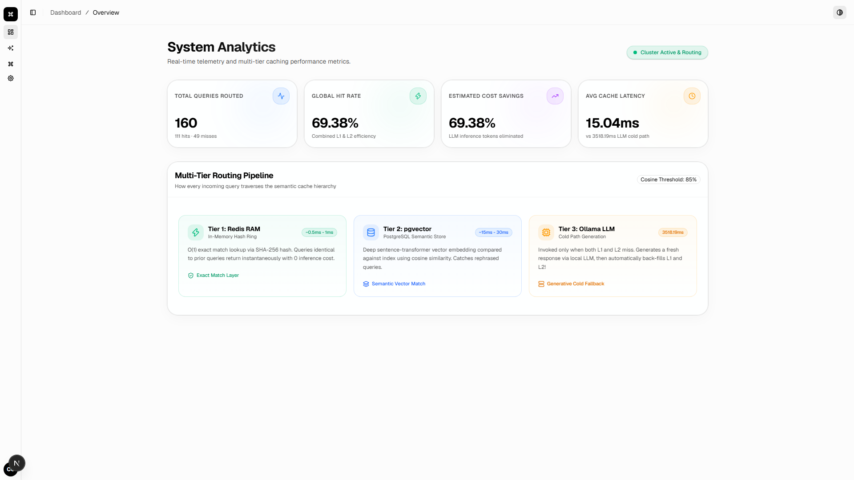
Description: The Cache-Craft central overview dashboard built with Next.js 15, visualizing real-time query volume, cache hit/miss distributions, total estimated cost savings, and average hit latency.

Screenshot 2: Interactive Chat Playground with Semantic Cache Hit
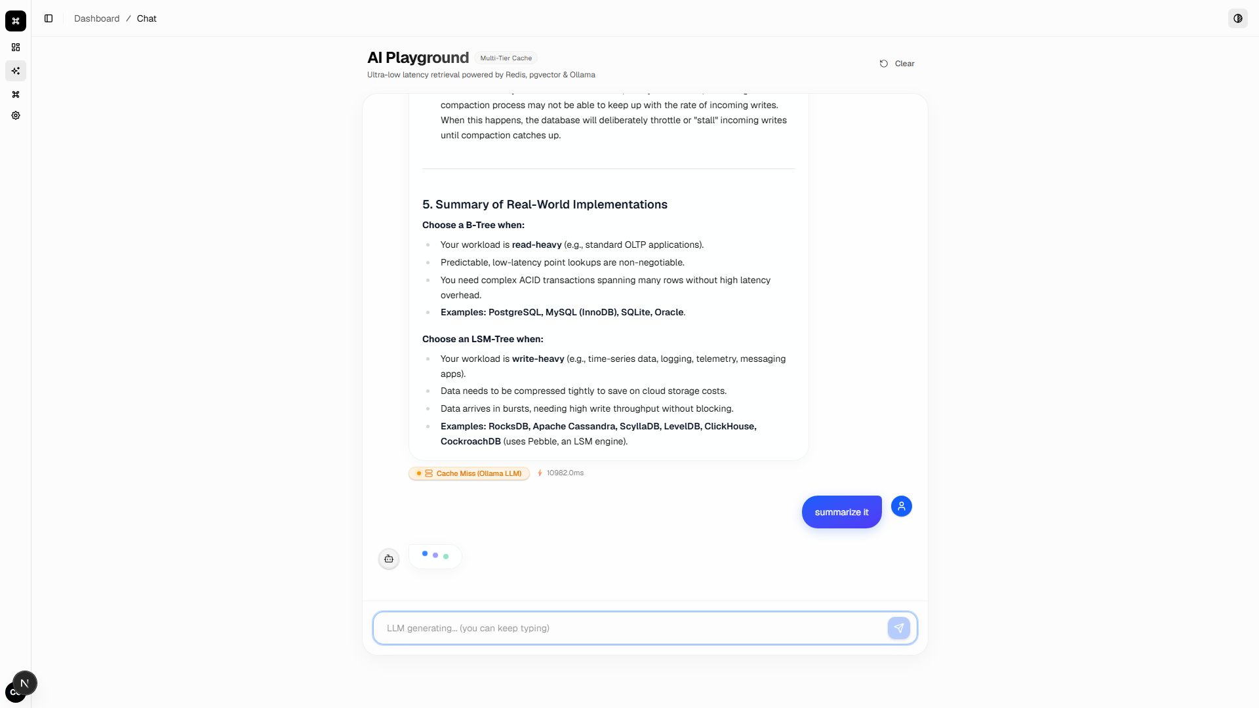
Description: Live interactive query execution in the Chat Playground. A paraphrased query triggers a semantic cache hit with ~25ms response time, 0.92 cosine similarity score, and zero token generation cost.

Screenshot 3: Vector Cache Explorer & Index Inspection
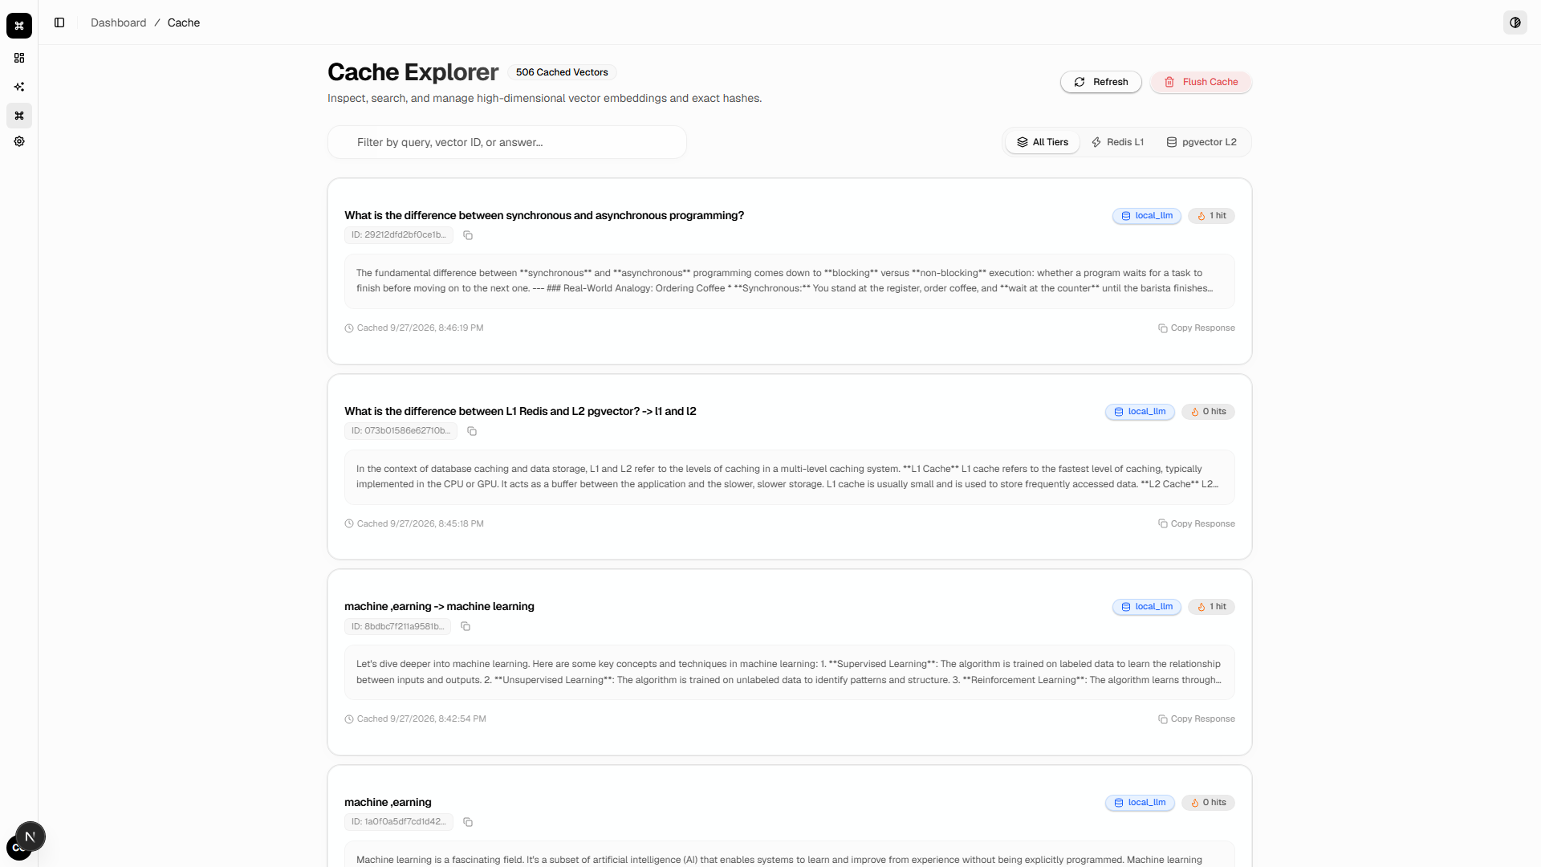
Description: Direct inspection of the persistent PostgreSQL pgvector storage layer, displaying query texts, truncated SHA-256 hashes, hit frequencies, response contents, and source origin tags.

Screenshot 4: System Settings, Dynamic Threshold & Dual-Tier TTL Lifecycle
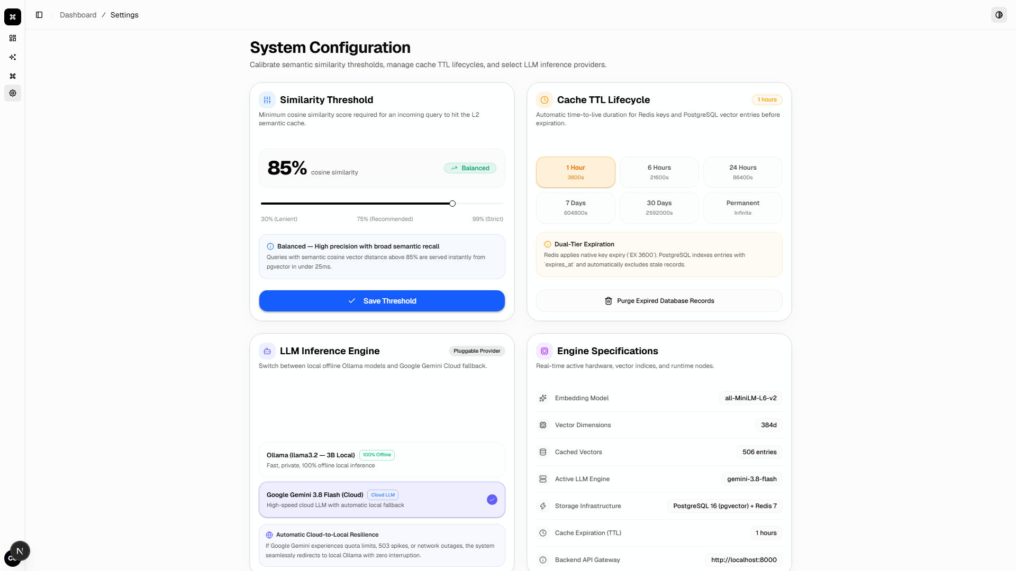
Description: The administrative configuration panel allowing runtime tuning of the cosine similarity threshold (0.70 to 0.95), dual-tier TTL cache expiration policies (1h to Permanent), active LLM inference provider switching (Ollama vs. Gemini), and manual database vacuum cleanup.
Figure 5: Empirical Benchmark Deep Dive & Multi-Baseline Performance Analysis
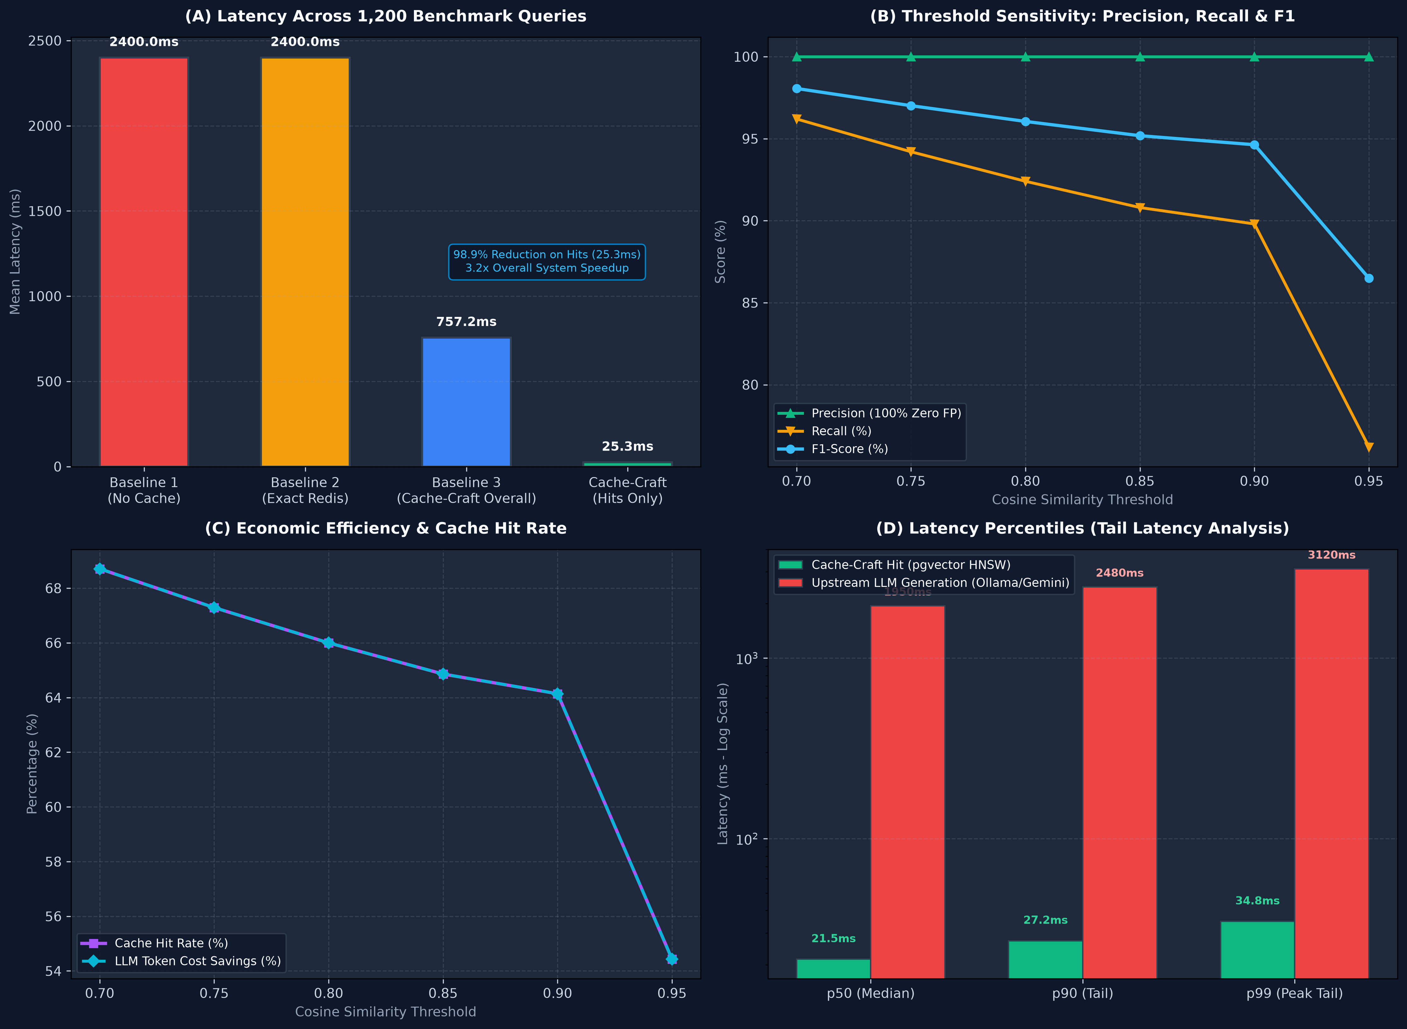
Description: Comprehensive 4-panel evaluation across 1,200 benchmark queries: (A) Baseline latency comparison (3.2x overall speedup, 98.9% reduction on hits); (B) Threshold sensitivity curves for Precision, Recall, and F1-score; (C) Hit rate % and LLM token cost savings %; (D) Tail latency percentiles (p50, p90, p99) comparing cache hits vs. LLM cold calls.
Students should include genuine screenshots/results from their actual work.

7. Final Results and Outcomes
☑ Completed
☐ Mostly Completed
☐ Partially Completed
☐ Work in Progress

Completed Components :- Decoupled Multi-Tier Architecture (FastAPI + Next.js 15), In-Memory Redis 7 Exact Cache, PostgreSQL 16 + pgvector HNSW Index, Dense Embedding Pipeline (all-MiniLM-L6-v2), Multi-Turn Context Binding & Partition Filtering, Pluggable Multi-LLM Inference Engine (Ollama llama3.2 & Google Gemini 3.8 Flash with Automatic Fallback), Dual-Tier TTL Cache Lifecycle Management, Real-Time SSE Metrics Streaming, 1,200-Query Benchmark Evaluation Suite, 4-Service Docker Compose Containerization Stack.

Pending Components :- None

8. References and Resources Used
Minimum 5 genuine references(APA 7th Edition) are mandatory.
Students must mention the resources actually used during the work.
References may include:
- Research papers
- Books
- Official documentation
- Technical websites
- Standards
- APIs / libraries
- Software documentation
References
[1] Reiss, F. (2023). "GPTCache: An open-source semantic cache for LLM applications," Towards Data Science. https://towardsdatascience.com/gptcache-an-open-source-semantic-cache-for-llm-applications
[2] Malkov, Y. A., & Yashunin, D. A. (2020). "Efficient and robust approximate nearest neighbor search using Hierarchical Navigable Small World graphs," IEEE Transactions on Pattern Analysis and Machine Intelligence, 42(4), 824–836. https://doi.org/10.1109/TPAMI.2018.2889473
[3] Reimers, N., & Gurevych, I. (2019). "Sentence-BERT: Sentence embeddings using Siamese BERT-networks," Proceedings of the 2019 Conference on Empirical Methods in Natural Language Processing (EMNLP), 3982–3992. https://doi.org/10.18653/v1/D19-1410
[4] PostgreSQL Global Development Group. (2024). "PostgreSQL 16 documentation: The pgvector extension for vector similarity search," https://github.com/pgvector/pgvector
[5] Redis Ltd. (2024). "Redis documentation: Memory optimization and eviction policies," https://redis.io/docs/latest/develop/reference/eviction/
[6] Ramírez, S. (2024). "FastAPI documentation: High-performance, modern Python web framework," https://fastapi.tiangolo.com/
[7] Vercel Inc. (2024). "Next.js 15 documentation: The React framework for the Web," https://nextjs.org/docs
[8] Google DeepMind. (2024). "Gemini API documentation: Highly capable multimodal reasoning models," Google Cloud AI. https://ai.google.dev/docs
Reference Requirements
- Minimum 5 references
- References must be relevant to the project.
- Sources must actually be used by the student.
- References must be cited wherever required in the report.
- Fake or unrelated references are not acceptable.
- Official documentation and reliable academic sources are preferred.

Evaluation (To be filled by Mentor (Institute))

Criteria | Excellent | Good | Average | Poor | Marks
Final Project Completion & Implementation | ≥90% meaningful work completed | 75–89% | 50–74% | <50% | /25
Functionality, Testing & Validation | Strong testing with evidence and analysis | Good testing | Limited testing | No meaningful validation | /25
Technical Understanding | Strong conceptual and technical understanding | Good understanding | Basic understanding | Unable to explain work | /20
Project Demonstration and Results | Complete, clear and well documented | Minor gaps | Incomplete documentation | Poor documentation | /20
References & Citations | Relevant, properly cited and formatted | Minor issues | Limited/relevant sources | Missing/improper | /10
TOTAL |  |  |  |  | /100

Evaluation
Student Signature | Mentor (Company)  Signature | Mentor (Institute)  Signature

Mentor (Institute) Remarks
________________________________________________________________________________________________________________________________________________________________________________________________________________________________________________________________________________________________________________________________________________________________________________________________________________________________________________________________________________________________________________________________________________________________________________________________________________________________________________________________________________________________________________________________________________________________________________________________________________________________________________________________________________________________________________________________________________________________________________________________________________________________________________________________________________________________________________________________________________________________________________________________________________________________________________________________________________________________________________________________________________________________________

