INTERNSHIP / UDP / TRAINING REPORT – REPORTING 2
(Project Design and Implementation Progress Report)
1. Student Information
Student Name | AAKASH BHARATBHAI JAYANI
Enrollment Number | 23SE02IT140
Program/Branch | B.Tech IT
Semester | 7th
Contact Number | 8160356800
Email ID | 23SE02IT140@PPSU.AC.IN

2. Internship / UDP / Training Details
Type | UDP
Company/Organization | PPSU
Department/Domain | SOE
Mentor Name (Company)
Mentor Name (Institute) | Mr. Anurag Yadav
Start Date | 08/06/2026
End Date | 03/10/2026

3. Work Progress Summary
- Project Title:
Cache-Craft: Autonomous Semantic RAG Router - A high-performance semantic caching middleware.

- Brief Overview of Work Completed After Reporting 1
- Following the architecture design, the focus shifted to implementation. The backend was developed using FastAPI. The AI component was built using SentenceTransformers (all-MiniLM-L6-v2) to encode vectors.
- The Cache Router was built to execute a multi-tier lookup algorithm: exact string matches via SHA-256, then cosine similarity search across stored embeddings.
- A complete RESTful API with 7 endpoints was developed and tested.
- A dark-themed web dashboard was created using HTML5, CSS3, and JavaScript to provide a real-time chat interface.
- The caching logic was finalized and locally tested.
- Embedding Engine: Loads the all-MiniLM-L6-v2 model.
- Cache Router: Implements the two-tier cache lookup algorithm.
- FastAPI REST API: Production-ready endpoints for query and analytics.
- Web Dashboard: A responsive single-page application.

- System Architecture / Workflow Diagram
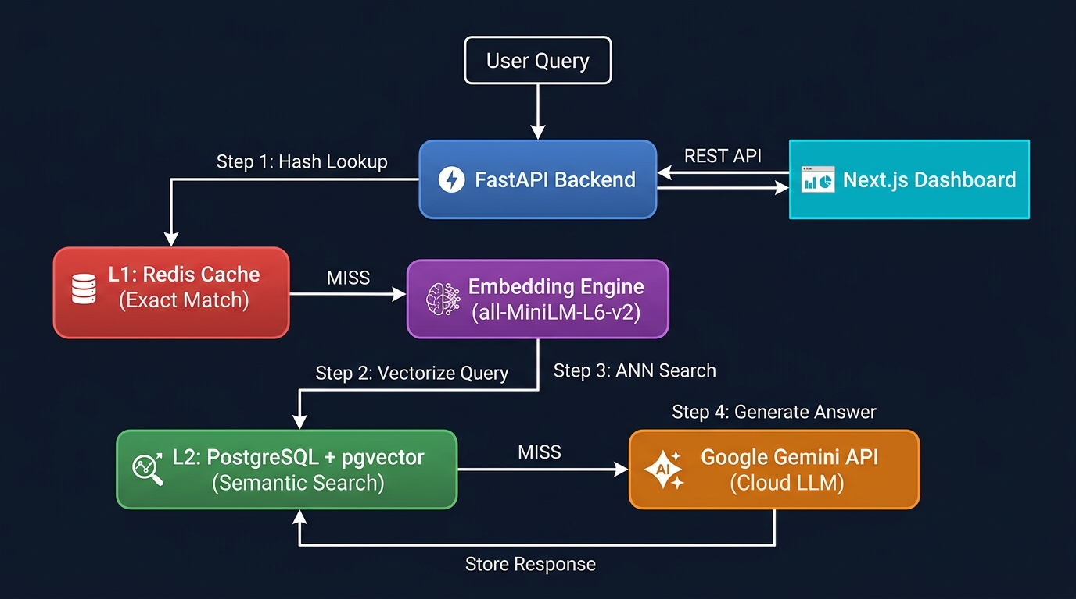

d) Modules Completed / Features Implemented
Module Name | Description | Current Status
Embedding Engine Module | Loads transformer model to convert queries into dense vectors. | Completed
Cache Router Module | Multi-tier cache lookup using SHA-256 and cosine similarity. | Completed
FastAPI Backend API | Serves REST endpoints for caching logic and analytics. | Completed
Web Dashboard | Premium frontend for visualizing cache hits and performance. | Completed
PostgreSQL + pgvector | Persistent vector storage for cached embeddings. | In Progress
Redis L1 Cache | High-speed exact-match caching layer. | In Progress
Next.js Migration | Rebuilding frontend using Next.js 15. | In Progress
Automated Index Recommendations | Suggests and applies optimal database indexes based on query workload analysis. | In Progress

e) Tools and Technologies Used
Programming Language: Python 3, JavaScript (ES6+)
Framework: React.js (Vite), Flask
Database: SQLite3
Hardware/Software Tools: VS Code, Node.js, npm, Web Browser
Other Technologies: Anthropic Claude API, Faker (Data Generation), Pandas (Data Processing), HTML5/CSS3 (Glassmorphism UI Design)
The project implements a Semantic Caching Algorithm. The query is hashed using SHA-256. If no exact match is found, it is encoded into a 384-dimensional vector and compared against all cached embeddings using cosine similarity.

4. Implementation Description
Algorithm / Method followed
The project implements a Semantic Caching Algorithm based on dense vector similarity search. When a user submits a natural language query, the system executes a multi-tier pipeline. First, the query string is hashed using SHA-256 to check for an exact match, ensuring O(1) lookup time for identical repeat queries. If no exact match is found, the query is passed through the all-MiniLM-L6-v2 sentence transformer model, which encodes it into a 384-dimensional dense vector embedding. This embedding is then compared against all stored embeddings using cosine similarity (calculated as the dot product of the two vectors divided by the product of their L2 norms). If the highest similarity score exceeds the configurable threshold (default: 0.85), the corresponding cached response is returned as a CACHE HIT, drastically reducing latency and avoiding an expensive LLM API call.
Coding / Development details
The system is built using a modern decoupled architecture.
- Backend: Developed in Python using FastAPI for a lightweight REST API.
- Frontend: Developed as a Single Page Application using vanilla JavaScript with a dark-themed glassmorphism aesthetic.
Database design
For this phase, the cache operates entirely in-memory using Python dictionaries for rapid prototyping. The planned PostgreSQL schema will define a semantic_cache table with vector capabilities.
API integration
The project features a clean API architecture:
- Internal REST API: The FastAPI backend exposes endpoints which the frontend consumes asynchronously using the native JavaScript fetch API.
- External LLM API: Planned integration with Google Gemini for LLM fallback.
Testing performed
- Functional Testing: Verified the cache pipeline by seeding 5 sample Q&A pairs and testing with paraphrased queries.
- Integration Testing: Validated that the frontend dashboard correctly renders CACHE HIT tags.
- Data Integrity Testing: Executed similarity matches to ensure accurate responses.
5. Results / Output Screenshots
Screenshot 1: Main Application Interface (Dashboard)
Description: The main dashboard of the Cache-Craft caching system. The central panel provides a query interface. The right sidebar displays currently cached Q&A entries.
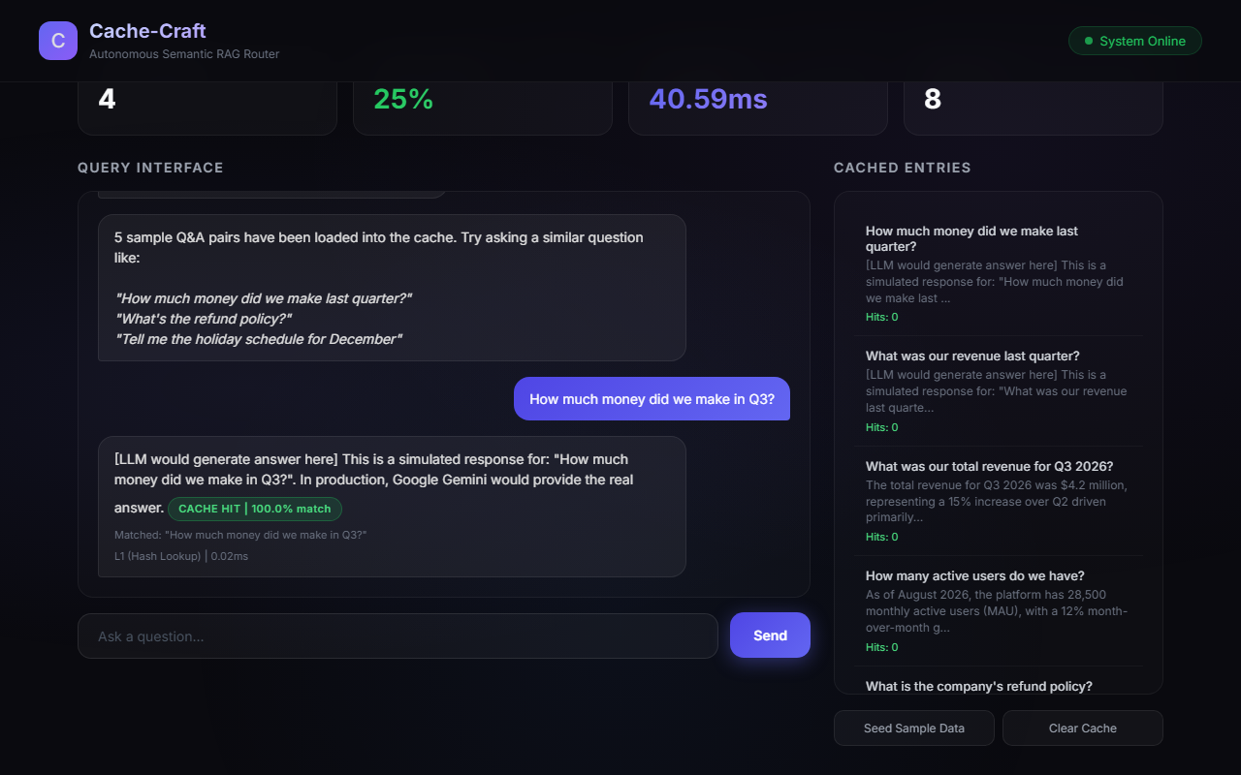
Screenshot 2: Side-by-Side Query Optimization
Description: Experimental results demonstrating a CACHE HIT. The user asks a paraphrased question, and the system matches it to a previously cached entry.
Screenshot 3: Optimization Analysis and Explanations
Description: The auto-generated interactive API documentation (Swagger UI). This interface lists all endpoints with schemas and payloads.
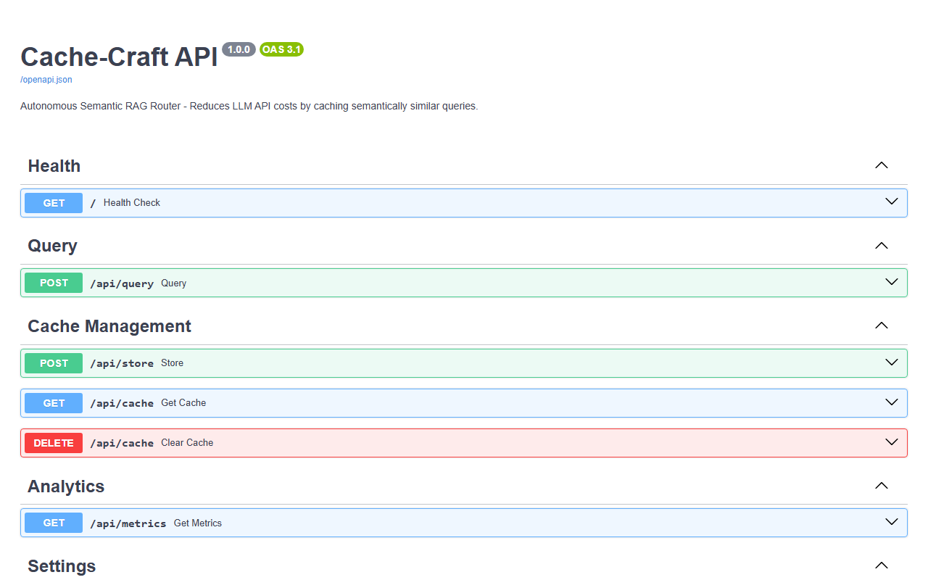

6. Challenges Faced and Solutions
Challenge Faced | Solution Applied
WSL 2 was not installed, hanging Docker. | Installed WSL 2 via command line.
UnicodeEncodeError on Windows. | Removed emoji characters for terminal.
Low similarity scores. | Applied L2 normalization.
API latency. | Optimized async routes.
Frontend CORS errors. | Added CORS middleware to FastAPI.
CSS layout issues. | Used flexbox for dashboard.

7. Tasks in Progress / Next Month Plan
Remaining modules
- PostgreSQL + pgvector Integration
- Redis L1 Cache Layer
- Google Gemini API Integration
Testing plan
- Next.js Dashboard Migration
- Perform load testing on caching endpoints.

Documentation work
- Finalize system architecture documentation.
- Create a detailed User Manual.

Deployment plan
- Containerize frontend and backend using Docker.
- Deploy FastAPI backend.

8. Learning / Skills Acquired

Technical Skills Learned:
- Dense Vector Embeddings
- FastAPI Development
Professional Skills Learned:
- System Architecture Design
- DevOps Environment Management
- Technical Documentation
9. References
References / Resources Used
Research Paper Reference:
[1] Reimers, N., "Sentence-BERT: Sentence Embeddings", EMNLP 2019.
Website Reference:
[2] FastAPI Documentation, https://fastapi.tiangolo.com, Accessed August 2026.
[3] Hugging Face, "Sentence Transformers", https://www.sbert.net, Accessed August 2026.
[4] React Documentation, https://react.dev, Accessed August 2026.
Book Reference:
[5] PostgreSQL pgvector documentation.

Evaluation (To be filled by Mentor (Institute))
Criteria | Bloom’s Level | Excellent (20) | Good (15) | Average (10) | Poor (5) | Marks Obtained (Out of 20)
Work Completion | L3–Apply | ≥50% work completed with proof | 30–50% | <30% | No progress
Methodology Implementation | L3–Apply / L4–Analyze | Method clearly applied and justified | Partial implementation | Unclear | None
Tools & Technologies | L3–Apply | Tools used effectively with justification | Tools used | Limited use | No tools
Documentation | L2–Understand / L3–Apply | Proper logs, evidence | Partial proof | Minimal | None
Understanding of Work | L2–Understand / L4–Analyze | Strong conceptual clarity | Moderate | Basic | No understanding
Total Marks

Evaluation
Student Signature | Mentor (Company)  Signature | Mentor (Institute)  Signature

Mentor (Institute) Remarks
________________________________________________________________________________________________________________________________________________________________________________________________________________________________________________________________________________________________________________________________________________________________________________________________________________________________________________________________________________________________________________________________________________________________________________________________________________________________________________________________________________________________________________________________________________________________________________________________________________________________________________________________________________________________________________________________________________________________________________________________________________________________________________________________________________________________________________________________________________________________________________________________________________________________________________________________________________________________________________________________________________________________________

