Part 1.3: Data Analysis
Machine Learning Insights using XGBoost and Multilayer Perceptron (MLP)
Datasets: Bank Marketing (DS1) and Credit Card Default (DS2)

1. Approach
Two machine learning algorithms were applied to gain insights into the data: XGBoost (gradient-boosted decision trees) and a Multilayer Perceptron (MLP) neural network (scikit-learn MLPClassifier with hidden layers 64→32). At least one of these models differs from algorithms commonly used in earlier coursework (e.g. basic decision trees or kNN), satisfying the requirement for methodological diversity.
The two datasets were analysed separately rather than integrated. They share a banking domain but measure different outcomes—term-deposit subscription versus credit-card default—so a joint predictive model would not be meaningful. Running the same two algorithms on each source allows comparison of insights and model effectiveness across complementary banking decisions.
Both datasets were split using a stratified 80/20 train–test holdout (random_state=42) to preserve class imbalance. Categorical features were one-hot encoded. For XGBoost, scale_pos_weight was set to the negative/positive class ratio. For the MLP, numeric features were standardised and early stopping was used.

2. Data Overview
Dataset | Target | Rows | Positive rate
DS1 – Bank Marketing | Subscribe to term deposit (y = yes) | 45,211 | 11.7%
DS2 – Credit Card Default | Default payment next month | 30,000 | 22.1%
Both problems are imbalanced binary classification tasks in a banking context, where false negatives are costly (missed campaign opportunity or missed credit risk).
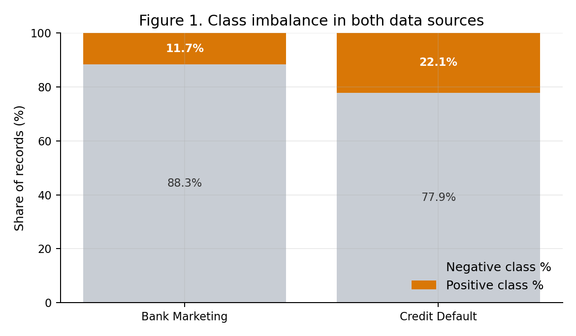
Figure 1. Class imbalance motivates metrics beyond accuracy.

3. Evaluation Metrics and Justification
Evaluation metrics were chosen to align with the banking case study. Because both datasets are imbalanced (Figure 1), overall accuracy is a weak primary metric: a model can achieve high accuracy by predicting the majority class while failing to identify subscribers or defaulters.
PR-AUC (Average Precision). Measures ranking quality with emphasis on the rare positive class—appropriate when the business must prioritise likely subscribers or likely defaulters.
Recall of the positive class (Recall+). Aligns with asymmetric cost: missing a potential subscriber wastes opportunity; missing a defaulter creates financial loss.
F1-score of the positive class (F1+). Balances precision and recall under finite contact-centre / collections capacity.
ROC-AUC and balanced accuracy are secondary. Accuracy is reported only to show why it can mislead: on Bank Marketing, MLP accuracy (~0.91) exceeds XGBoost (~0.86), yet subscriber recall is 0.48 versus 0.88 (Figure 3).

4. Model Effectiveness Results
Table 1 summarises holdout performance at the default probability threshold of 0.5. An ablation without call duration is included for Bank Marketing because duration is only known after the call and would leak information if used for pre-call targeting (Figure 5).
Table 1. Holdout evaluation metrics for XGBoost and MLP
Dataset | Model | ROC-AUC | PR-AUC | F1+ | Recall+
Bank Marketing | XGBoost | 0.933 | 0.633 | 0.589 | 0.876
Bank Marketing | MLP | 0.919 | 0.588 | 0.545 | 0.483
Bank (no duration) | XGBoost | 0.804 | 0.471 | 0.452 | —
Bank (no duration) | MLP | 0.792 | 0.436 | 0.337 | —
Credit Default | XGBoost | 0.774 | 0.552 | 0.535 | 0.614
Credit Default | MLP | 0.765 | 0.540 | 0.474 | 0.372
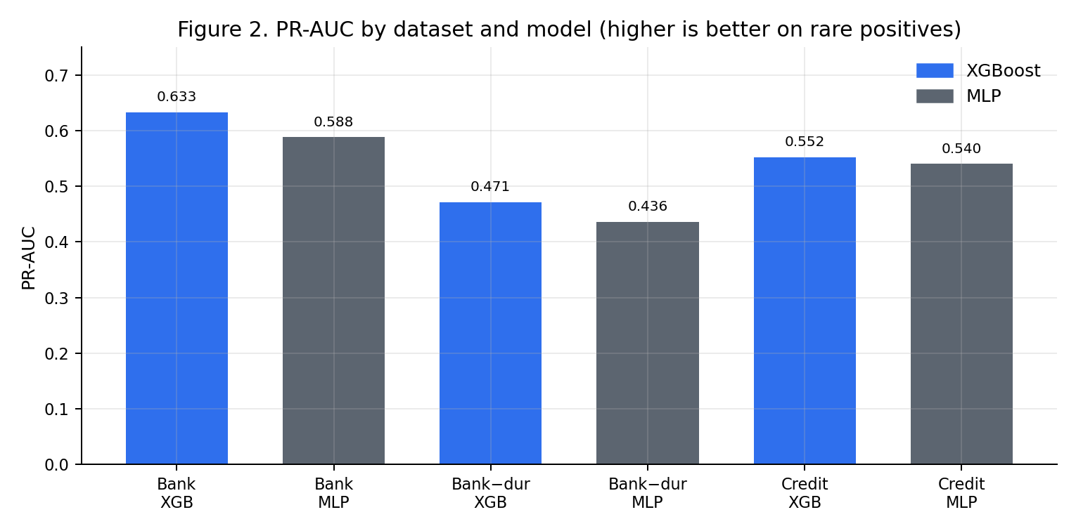
Figure 2. PR-AUC comparison — XGBoost leads on both data sources.
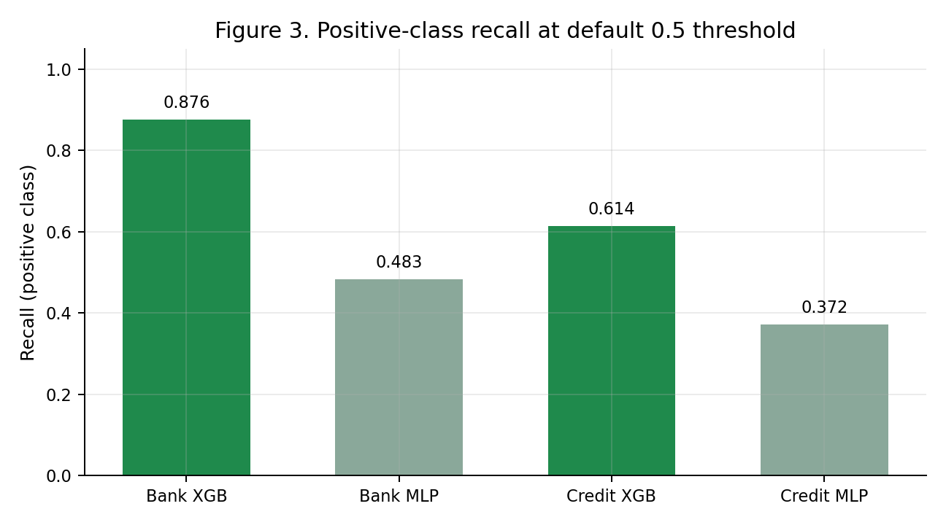
Figure 3. Positive-class recall — XGBoost recovers far more rare positives.
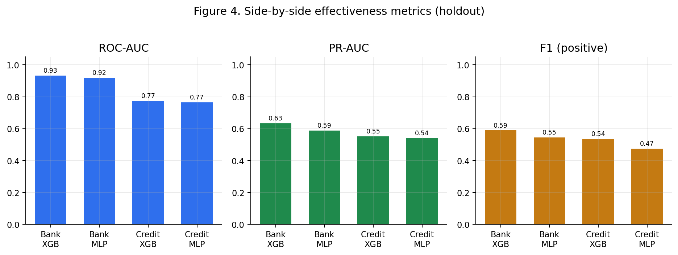
Figure 4. ROC-AUC, PR-AUC, and F1+ side by side.
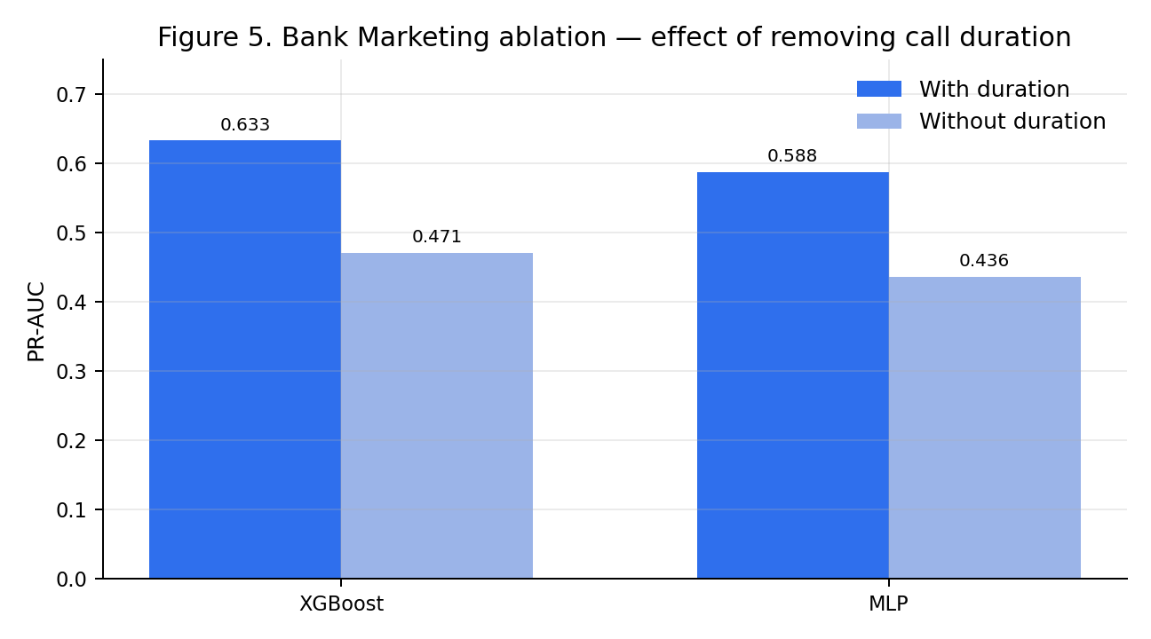
Figure 5. Removing duration reduces Bank Marketing PR-AUC (leakage awareness).
Across both data sources, XGBoost outperformed the MLP on PR-AUC, positive-class F1, and positive-class recall (Figures 2–4). The MLP remained competitive on ROC-AUC and often achieved higher precision, but missed many true positives at the default threshold. For identifying rare, costly events, XGBoost is the more effective model.

5. Insights from the Machine Learning Algorithms

5.1 Bank Marketing (DS1)
XGBoost feature importance indicates that subscription is driven primarily by campaign and engagement context rather than by demographics alone.
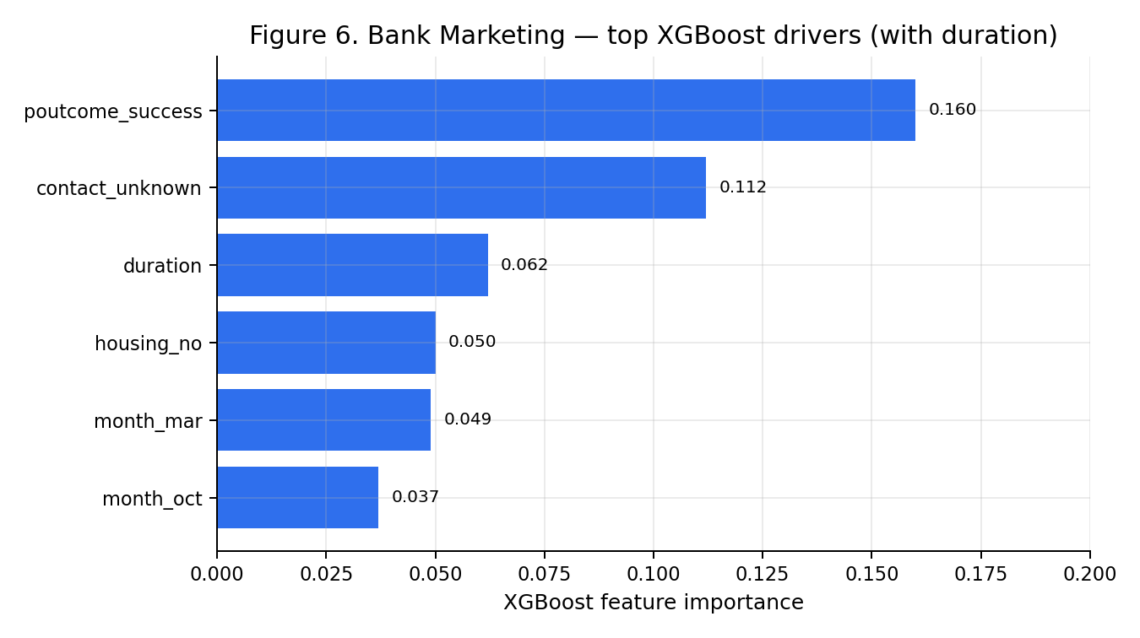
Figure 6. Top Bank Marketing drivers from XGBoost.
- Previous campaign outcome success (poutcome_success) — prior converters are much more likely to subscribe again.
- Contact channel (especially contact_unknown) — how the client was contacted carries strong signal.
- Call duration — associated with subscription, but only known after the call (see Figure 5).
- Housing loan status — clients without a housing loan appear more likely to subscribe.
- Seasonality (e.g., March, October) — campaign month contributes meaningful signal.
When duration is removed (pre-call targeting), predictive performance drops (XGBoost PR-AUC from 0.633 to 0.471; Figure 5), and prior campaign success, contact channel, housing loan status, and seasonal months remain the dominant drivers.

5.2 Credit Card Default (DS2)
On the credit default data, both algorithms learn a clear risk signal, but absolute performance is lower than on the marketing data (best PR-AUC ≈ 0.55).
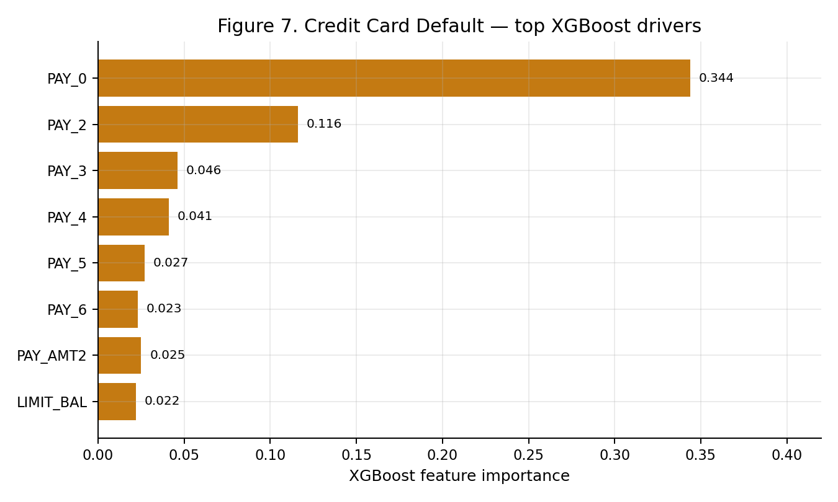
Figure 7. Top Credit Default drivers from XGBoost.
- Most recent repayment status (PAY_0) is by far the strongest predictor.
- Earlier repayment statuses (PAY_2–PAY_6) add signal along a delinquency trajectory.
- Payment amounts and credit limit matter, but less than repayment status.
- Demographics are comparatively weak once repayment history is available.
For credit-risk monitoring, recent payment behaviour should be the primary focus of early-warning systems, with limit and payment amount as supporting features.

5.3 Do all data sources give insights?
Yes. Both sources produce actionable insights of different kinds and strength. Bank Marketing yields stronger predictive performance and clear campaign-targeting insights (Figure 6). Credit Default yields a harder risk-ranking problem focused on repayment delinquency (Figure 7). Neither source is redundant for a banking case study.

5.4 Are the insights complementary or contradicting?
Complementary. Marketing data informs opportunity (whom to contact for a term deposit); credit data informs risk (who is likely to default). Together they describe growth versus risk control, not competing explanations of the same outcome.
Methodologically, insights are consistent: on both datasets XGBoost edges the MLP on minority-class metrics and provides interpretable feature rankings, while the MLP confirms the signal is learnable. There is no contradiction in model ranking across sources.
Bank models appearing stronger than credit models is expected, not a contradiction: subscription is partly explained by campaign context (and duration if included), whereas default prediction is intrinsically harder. Figure 5 shows that part of the bank-model advantage is information availability (duration leakage), not conflict with credit-risk findings.

6. Conclusion
XGBoost and MLP both extract useful structure from the two banking datasets. XGBoost is the more effective model under case-aligned metrics (PR-AUC, Recall+, F1+) on both sources, and its feature importances provide transparent business insights: campaign history and contact context for term-deposit marketing, and recent repayment status for credit default risk. The two data sources give complementary insights—opportunity versus risk—rather than contradicting ones. Evaluation focused on imbalanced-class metrics rather than accuracy, matching the asymmetric costs of the banking case study.

7. Implementation Note
Analysis was implemented in Python using pandas, scikit-learn, XGBoost, and matplotlib. Full experimental configuration and numeric outputs are stored in part1_3_ml_analysis.py and part1_3_results.json for reproducibility. Figures in this document correspond to the visual analysis produced alongside the machine learning experiments.

