OUTPUT

TASK 1 :

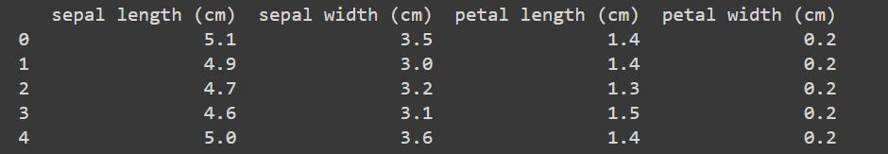

TASK 2 :

SUMMARY STATISTICS

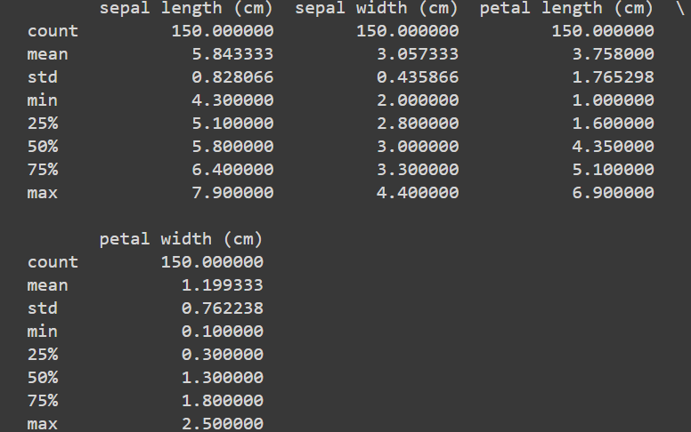

MISSING VALUES

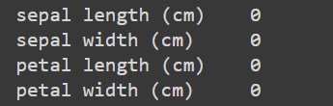

HISTOGRAMS

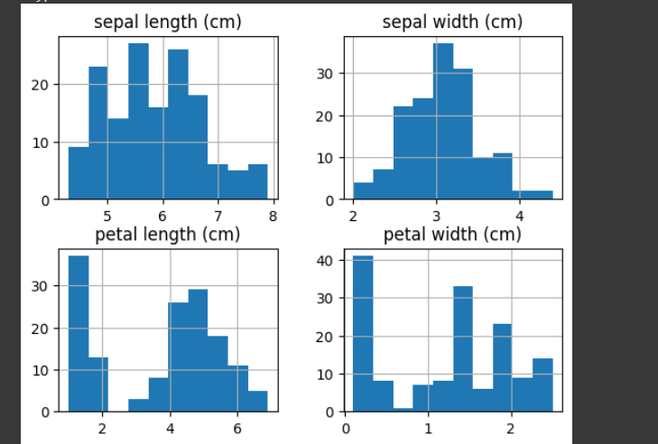

PAIR PLOT

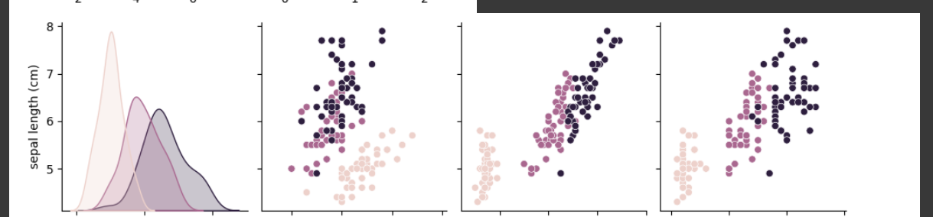

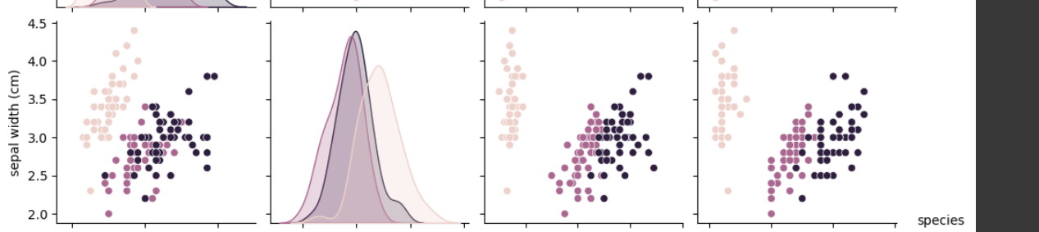

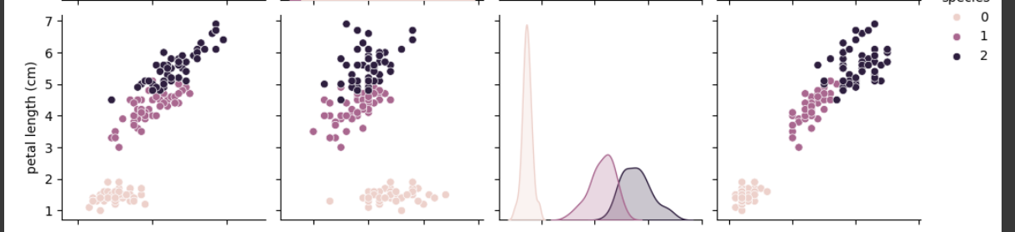

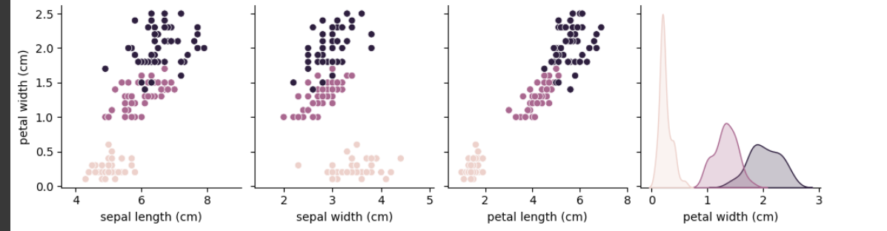

TASK 3 :

STANDARIZING DATAFRAME

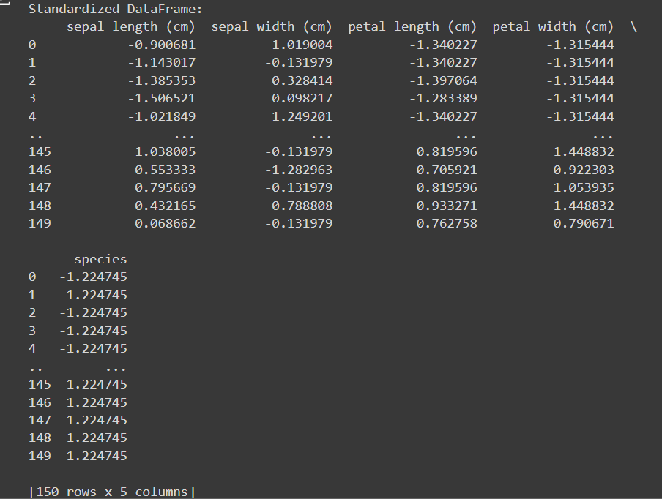

MIN MAX SCALING

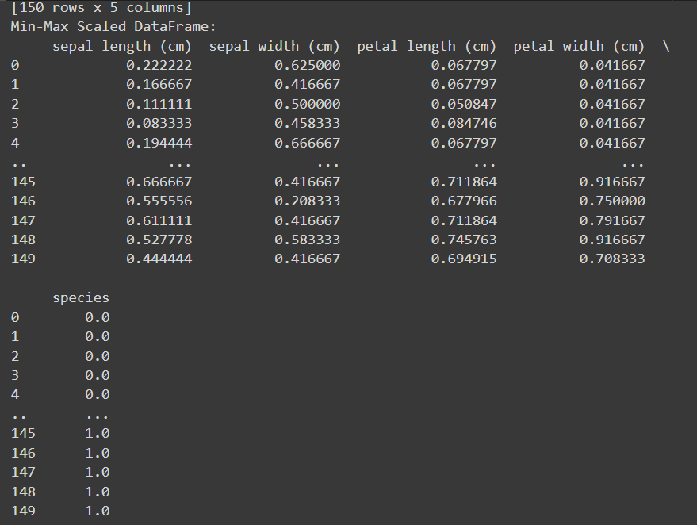

ENCODING THE TARGET VARIABLE

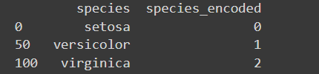

TASK 4 : DATA SPLITTING

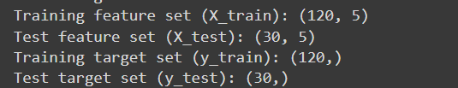

BONUS TASK : PCA

PLOTTING THE DATA POINTS

