**Comparison of Securities: SBI, TCS & CIPLA**

(**Financial Management**)

Aakash Khandelwal 2012IPG-001   
Anshika Singh 2012IPG-017

Shubhankit Nigam 2015MBA-011



**ABV INDIAN INSTITUTE OF INFORMATION TECHNOLOGY AND**

**MANAGEMENT GWALIOR-474 015**

21st April 2016

**Comparison of Securities: SBI, TCS & CIPLA**

The closing values of the above mention securities was collected from 15th January 2016 to 13Th April,2016.Their returns were calculated and compared with the market [NIFTY 50].Their performance was analyzed and here are the observations:

**Introduction of the NIFTY50:** The market performance for the last three months can be graphically displayed as

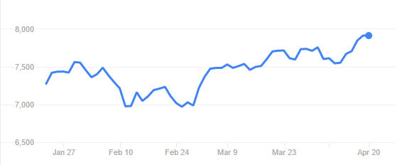

In these three months, the market reached an all low of 6970.6 points on 25th February, 2016.Although after that, the market has been growing and has been rather consistent.

**SBI:**

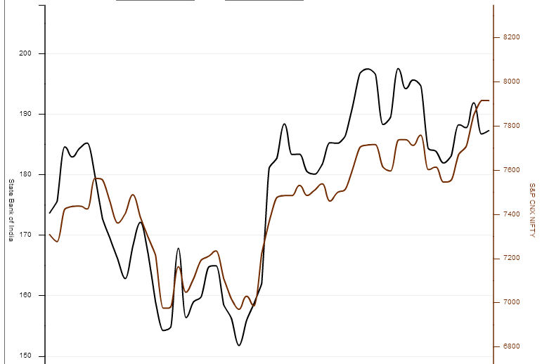

SBI being one of the top national banks in India has shown quite a consistent trend in the stock market. With the mean returns being **0.1172606%,** SBI returns have ranged from **-0.068215669 to 0.117864857.** The maximum was reached on the day when the closing price was **181.15.**

**According to the** data, negative alpha of 0**.000556924** indicates an underperformance of SBI with respect to NIFTY50, whereas the beta is **1.742816498** , which proves that it's theoretically more volatile—subject to big swings in prices or sales—than the market. The variability occurring in the returns of SBI explained by the market (explained by R2) is **0.471750785**

We can also very well see that the share of unsystematic risk is more than that of systematic risks. This is a clear indication that the security can reduce its fare amount of risks and perform better.

**CIPLA**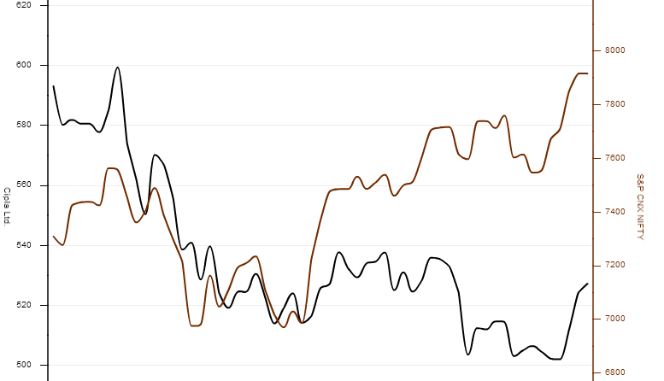CIPLA, a medical giant in the Indian market, has been showing some highly varied performance as compared to the market. With the mean returns being **-0.2809591%,** CIPLA returns have ranged from **-0.042455584 to 0.035882994,** which is slightly higher than SBI.

According to the data, negative alpha of **0.003558618** indicates an underperformance of CIPLA with respect to NIFTY50, whereas the beta is 0.754781528, which proves that the security experiences less severe price swings than the market. The variability occurring in the returns of CIPLA explained by the market (explained by R2) is **0.331881997.**

As far as the risks are concerned, the amount of risks related to CIPLA is much less as compared to SBI. Here also, the share of unsystematic risk is more than that of systematic risks. This is a clear indication that the security can reduce its fare amount of risks and perform better.

**TCS**

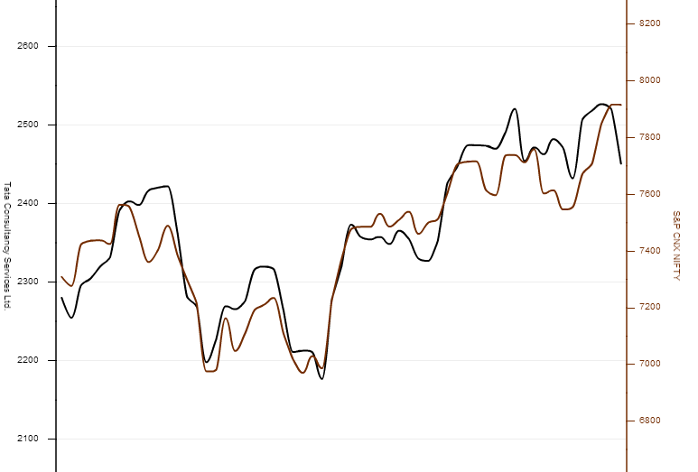

TCS has been running quite in sync with the market for the past few months. With the mean returns being **0.198976%,** TCS returns have ranged from **-0.034511945 to 0.045870085 which results in the highest range as compared to the other two securities.**

According to thedata, alpha of **0.001126163** indicates an outperformance of TCS with respect to NIFTY50, thus making it the only security among the three. Whereas the beta is **0.870230958,** which proves TCS has experienced lesser risks as compared to SBI but is more risky as compared to CIPLA. The variability occurring in the returns of SBI explained by the market (explained by R2) is **0.533336597**

The systematic risks of TCS is quite at par with the other securities but the unsystematic risks have the least figure in comparison to SBI and CIPLA.