Slope Unit Segmentation Analysis
GH-Based Optimal Parameter Selection | r.slopeunits

Table 2. Number of Slope Units at Different Scales
The table below shows the total number of slope units produced by every combination of minimum area (a) and circular variance (c). Maximum: 23,498 (a=0.5×10⁵, c=0.1); Minimum: 2,182 (a=3×10⁵, c=0.4).
Number of Slope Units | a (10⁵ m²)
c | 0.5 | 1 | 1.5 | 2 | 2.5 | 3
0.1 | 23,498 | 16,906 | 13,444 | 11,132 | 9,537 | 8,425
0.15 | 11,466 | 9,499 | 8,208 | 7,217 | 6,439 | 5,882
0.2 | 6,181 | 5,624 | 5,132 | 4,770 | 4,476 | 4,237
0.25 | 3,840 | 3,635 | 3,481 | 3,362 | 3,428 | 3,154
0.3 | 2,734 | 2,810 | 2,734 | 2,684 | 2,635 | 2,547
0.35 | 2,450 | 2,400 | 2,358 | 2,356 | 2,308 | 2,242
0.4 | 2,268 | 2,226 | 2,206 | 2,190 | 2,182 | 2,182
* Values in green row = optimal combination from GH analysis (a = 300,000 m², c = 0.35)

Figure 8. Number of Slope Units vs. Parameters
Influence of different a and c combinations on the number of slope units. (a) Fixed a values plotted against c; (b) Fixed c values plotted against a.
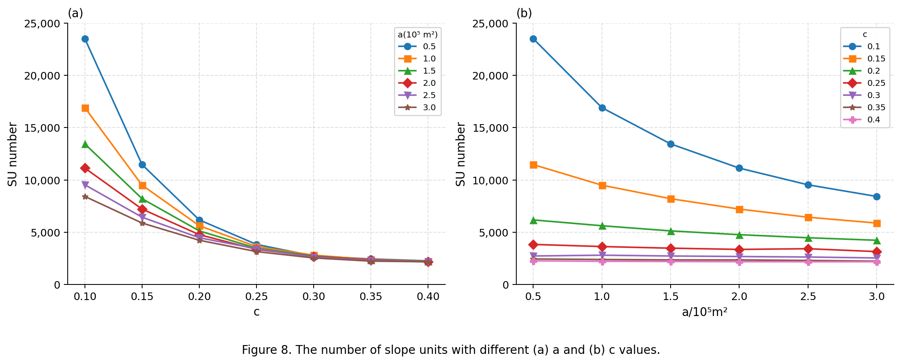
Figure 8. The number of slope units with different (a) a and (b) c values.

Figure 9. AUC, F1 and GH Values Under Different Slope Units
(a) AUC and (b) F1 values are from the paper (Deng et al., 2022) for 23 selected parameter combinations. (c) GH scores are computed from your data for all 42 combinations — the optimal point (a = 300,000 m², c = 0.35, GH = 0.9996) is annotated.

Figure 9. AUC, F1 and GH values under different slope units: (a) AUC, (b) F1 and (c) GH.

GH Results — All 42 Configurations (sorted by GH ascending)
All 42 a × c combinations ranked by GH score. The optimal configuration (highlighted in green) is a = 300,000 m², c = 0.35 with GH = 0.9996, yielding 9,952 slope units with the best balance of internal homogeneity and external heterogeneity.
a (m²) | c | Slope Units | V | wMI | GH | Status
300,000 | 0.35 | 9,952 | 0.740037 | 0.999558 | 0.999641 | Success (OPTIMAL)
300,000 | 0.4 | 9,702 | 0.758843 | 0.999546 | 1.000000 | Success
50,000 | 0.1 | 79,010 | 0.109288 | 0.999953 | 1.000000 | Success
300,000 | 0.3 | 10,444 | 0.708780 | 0.999581 | 1.008401 | Success
100,000 | 0.1 | 61,503 | 0.138276 | 0.999938 | 1.009035 | Success
50,000 | 0.15 | 53,730 | 0.155399 | 0.999928 | 1.009960 | Success
300,000 | 0.25 | 11,464 | 0.648804 | 0.999620 | 1.012848 | Success
50,000 | 0.2 | 46,857 | 0.176039 | 0.999916 | 1.012990 | Success
50,000 | 0.25 | 44,484 | 0.184800 | 0.999911 | 1.014645 | Success
150,000 | 0.1 | 54,235 | 0.156230 | 0.999929 | 1.015590 | Success
50,000 | 0.3 | 43,488 | 0.189171 | 0.999909 | 1.016496 | Success
50,000 | 0.35 | 43,007 | 0.191049 | 0.999908 | 1.016578 | Success
50,000 | 0.4 | 42,742 | 0.192274 | 0.999908 | 1.017092 | Success
150,000 | 0.35 | 16,693 | 0.454797 | 0.999744 | 1.018685 | Success
150,000 | 0.25 | 18,170 | 0.420114 | 0.999766 | 1.019888 | Success
150,000 | 0.4 | 16,446 | 0.461759 | 0.999740 | 1.020023 | Success
200,000 | 0.1 | 48,760 | 0.172618 | 0.999921 | 1.020025 | Success
100,000 | 0.15 | 34,647 | 0.232289 | 0.999884 | 1.020575 | Success
150,000 | 0.3 | 17,197 | 0.443321 | 0.999753 | 1.022171 | Success
200,000 | 0.35 | 13,453 | 0.559345 | 0.999680 | 1.022199 | Success
250,000 | 0.35 | 11,453 | 0.653118 | 0.999622 | 1.022985 | Success
150,000 | 0.2 | 20,706 | 0.372450 | 0.999797 | 1.023188 | Success
250,000 | 0.4 | 11,200 | 0.667529 | 0.999613 | 1.023454 | Success
200,000 | 0.4 | 13,207 | 0.569965 | 0.999674 | 1.024041 | Success
250,000 | 0.1 | 45,457 | 0.184731 | 0.999915 | 1.024057 | Success
100,000 | 0.25 | 25,143 | 0.311825 | 0.999836 | 1.024341 | Success
100,000 | 0.35 | 23,598 | 0.330715 | 0.999824 | 1.024786 | Success
100,000 | 0.3 | 24,117 | 0.324325 | 0.999828 | 1.025297 | Success
100,000 | 0.2 | 27,499 | 0.287750 | 0.999851 | 1.025469 | Success
300,000 | 0.1 | 42,465 | 0.196493 | 0.999909 | 1.026003 | Success
250,000 | 0.3 | 11,937 | 0.628828 | 0.999639 | 1.026656 | Success
100,000 | 0.4 | 23,329 | 0.334923 | 0.999822 | 1.026731 | Success
200,000 | 0.25 | 14,958 | 0.507046 | 0.999715 | 1.026800 | Success
150,000 | 0.15 | 27,890 | 0.285235 | 0.999854 | 1.028728 | Success
200,000 | 0.3 | 13,978 | 0.541818 | 0.999694 | 1.029801 | Success
200,000 | 0.2 | 17,536 | 0.437595 | 0.999760 | 1.030390 | Success
250,000 | 0.25 | 12,932 | 0.583806 | 0.999668 | 1.030994 | Success
200,000 | 0.15 | 24,770 | 0.319665 | 0.999835 | 1.034572 | Success
300,000 | 0.2 | 14,077 | 0.539900 | 0.999698 | 1.035257 | Success
300,000 | 0.15 | 20,876 | 0.374861 | 0.999802 | 1.038192 | Success
250,000 | 0.15 | 22,429 | 0.351143 | 0.999817 | 1.038217 | Success
250,000 | 0.2 | 15,537 | 0.495000 | 0.999729 | 1.044035 | Success
Note: AUC and F1 values require running the IV-RF model on each configuration and are not included here. V = global aspect variance; wMI = global weighted Moran's Index; GH = normalised heterogeneity score (lower = better).

