**PRACTICAL NO: 6**

**AIM: Write RMI application to read contain of file on server and send length of file to the client.**

**Code:**

**Client.java**

import java.rmi.*;

public class MyClient{

public static void main(String args[]){

try{

Adder stub=(Adder)Naming.lookup("rmi://localhost:5000/sonoo");

System.out.println(stub.add("jiji.java"));

}catch(Exception e){System.out.println(e);}

}

}

**Server.java**

import java.rmi.*;

import java.rmi.registry.*;

public class MyServer{

public static void main(String args[]){

try{

Adder stub=new AdderRemote();

Naming.rebind("rmi://localhost:5000/sonoo",stub);

}catch(Exception e){System.out.println(e);}

}

}

**Interface**

import java.rmi.*;

public interface Adder extends Remote{

public byte add(String s)throws RemoteException;

}

**Interface Class**

import java.rmi.*;

import java.rmi.server.*;

import java.util.*;

import java.io.*;

public class AdderRemote extends UnicastRemoteObject implements Adder{

AdderRemote()throws RemoteException{

super();

}

public byte add(String s){

File f=new File(s);

byte a=(byte)f.length();

return a;

}

}

**Output:**

**Client:**

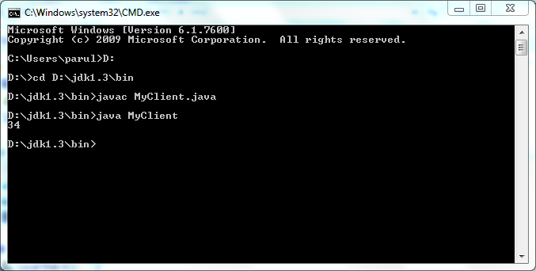

**Server:**

