PRACTICAL 1
AIM: Introduction to Android.
History:
Android, Inc. was founded in Palo Alto, California in October 2003 by Andy Rubin (co-founder of Danger), Rich Miner (co-founder of Wildfire Communications, Inc.), Nick Sears (once VP at T-Mobile), and Chris White (headed design and interface development at WebTV) to develop, in Rubin's words "smarter mobile devices that are more aware of its owner's location and preferences".
What is android?
Android is a software stack for mobile devices that includes an operating system, middleware and key applications. Android is a mobile operating system (OS) based on the Linux kernel that is currently developed by Google. With a user interface based on direct manipulation, Android is designed primarily for touchscreen mobile devices such as smartphones and tablet computers, with specialized user interfaces for televisions (Android TV), cars (Android Auto), and wrists (Android Wear). The OS uses touch inputs that loosely correspond to real-world actions, like swiping, tapping, pinching, and reverse pinching to manipulate on-screen objects, and a virtual keyboard. Despite being primarily designed for touchscreen input, it also has been used in game consoles, digital cameras, and other electronics.
Features of Android:
- Messaging
  - SMS and MMS are available forms of messaging, including threaded text messaging and Android Cloud To Device Messaging (C2DM) and now enhanced version of C2DM, Android Google Cloud Messaging (GCM) is also a part of Android Push Messaging service.
- Web browser
  - The web browser available in Android is based on the open-source Blink (previously WebKit) layout engine, coupled with Chrome's V8 JavaScript engine. The browser scores 100/100 on the Acid3test on Android 4.0.

- Voice based features
  - Google search through voice has been available since initial release. Voice actions for calling, texting, navigation, etc. are supported on Android 2.2 onwards. As of Android 4.1, Google has expanded Voice Actions with the ability to talk back and read answers from Google's Knowledge Graph when queried with specific commands. The ability to control hardware has not yet been implemented.
- Multi-touch
  - Android has native support for multi-touch which was initially made available in handsets such as the HTC Hero. The feature was originally disabled at the kernel level (possibly to avoid infringing Apple's patents on touch-screen technology at the time). Google has since released an update for the Nexus One and the Motorola Droid which enables multi-touch natively.
- Multitasking
  - Multitasking of applications, with unique handling of memory allocation, is available.
- Screen capture
  - Android supports capturing a screenshot by pressing the power and volume-down buttons at the same time. Prior to Android 4.0, the only methods of capturing a screenshot were through manufacturer and third-party customizations or otherwise by using a PC connection (DDMS developer's tool). These alternative methods are still available with the latest Android.
- Video calling
  - Android does not support native video calling, but some handsets have a customized version of the operating system that supports it, either via the UMTS network (like the Samsung Galaxy S) or over IP. Video calling through Google Talk is available in Android 2.3.4 and later. Gingerbread allows Nexus S to place Internet calls with a SIP account. This allows for enhanced VoIP dialing to other SIP accounts and even phone numbers. Skype 2.1 offers video calling in Android 2.3, including front camera support. Users with the Google+ Android app can video chat with other google+ users through hangouts.
- Multiple language support
  - Android supports multiple languages.
- Accessibility
  - Built in text to speech is provided by Talk back for people with low or no vision. Enhancements for people with hearing difficulties are available as are other aids.
- Connectivity
  - Android supports connectivity technologies including GSM/EDGE, Wi-Fi, Bluetooth, LTE, CDMA, EV-DO, UMTS, NFC, IDEN and WiMAX.
- Bluetooth
  - Supports voice dialing and sending contacts between phones, sending files (OPP), accessing the phone book (PBAP), A2DP and AVRCP. Keyboard, mouse and joystick (HID) support is available in Android 3.1+, and in earlier versions through manufacturer customizations and third-party applications.
- Tethering
  - Android supports tethering, which allows a phone to be used as a wireless/wired Wi-Fi hotspot. Before Android 2.2 this was supported by third-party applications or manufacturer customizations.

Architecture of Android:
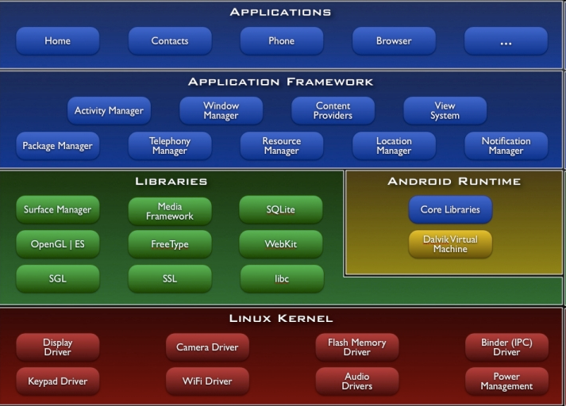

Application:
These are the basics of Android applications:
• Android applications are composed of one or more application components (activities, services, content providers, and broadcast receivers)
• Each component performs a different role in the overall application behavior, and each one can be activated individually (even by other applications)
• The manifest file must declare all components in the application and should also declare all application requirements, such as the minimum version of Android required and any hardware configurations required
• Non-code application resources (images, strings, layout files, etc.) should include alternatives for different device configurations (such as different strings for different languages)

Versions of Android:
- Android 1.0
- Android 1.1
- Android 1.5 Cupcake
- Android 1.6 Donut
- Android 2.0 Eclair
- Android 2.0.1 Eclair
- Android 2.1 Eclair
- Android 2.2–2.2.3 Froyo
- Android 2.3–2.3.2 Gingerbread
- Android 2.3.3–2.3.7 Gingerbread
- Android 3.0 Honeycomb
- Android 3.1 Honeycomb
- Android 3.2 Honeycomb
- Android 4.0–4.0.2 Ice Cream Sandwich
- Android 4.0.3–4.0.4 Ice Cream Sandwich
- Android 4.1 Jelly Bean
- Android 4.2 Jelly Bean
- Android 4.3 Jelly Bean
- Android 4.4 KitKat
Advantages of Android:
- Android is open, because it is linux based open source so it can be developed by anyone.
- Easy access to the Android App Market: Android owners are people who love to learn the phone, with Google's Android App Market you can download applications for free.
- Populist Operating System: Android Phones, different from the iOS is limited to the iphone from Apple, then Android has many manufacturers, with their respective flagship gadget from HTC to Samsung.
- USB full facilities. You can replace the battery, mass storage, DiskDrive, and USB tethering.
- Easy in terms of notification: the operating system is able to inform you of a new SMS, Email, or even the latest articles from an RSS Reader.
- Supports all Google services: Android operating system supports all of google services ranging from Gmail to Google reader. all google services can you have with one operating system, namely Android.
- Install ROM modification: There are many custom ROM that you can use on Android phones, and the guarantee will not harm your device.
Disadvantages of Android
- Connected to the Internet: Android can be said is in need of an active internet connection. At least there should be a GPRS internet connection in your area, so that the device is ready to go online to suit our needs.
- Sometimes slow device company issued an official version of Android your own.
- Android Market is less control of the manager, sometimes there are malware.
- As direct service providers, users sometimes very difficult to connect with the Google.
- Sometimes there are ads: because it is easy and free, sometimes often a lot of advertising. In appearance it does not interfere with the performance of the application itself, as it sometimes is in the top or bottom of the application.
- Wasteful Batteries, This is because the OS is a lot of "process" in the background causing the battery quickly drains.

