PRACTICAL-2

AIM: Create Simple Hello World Application in Android.

Graphical Layout

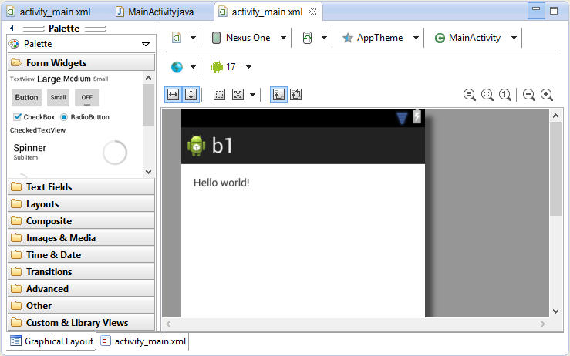
Fig 2.1 Graphical Layout

- Activity_main.xml
<RelativeLayout xmlns:android="http://schemas.android.com/apk/res/android"
xmlns:tools="http://schemas.android.com/tools"
android:layout_width="match_parent"
android:layout_height="match_parent"
android:paddingBottom="@dimen/activity_vertical_margin"
android:paddingLeft="@dimen/activity_horizontal_margin"
android:paddingRight="@dimen/activity_horizontal_margin"
android:paddingTop="@dimen/activity_vertical_margin"
tools:context=".MainActivity" >

<TextView
android:layout_width="wrap_content"
android:layout_height="wrap_content"
android:text="@string/hello_world" />

</RelativeLayout>

- MainActivity.java
package com.example.b1;

import android.os.Bundle;
import android.app.Activity;
import android.view.Menu;

public class MainActivity extends Activity {

@Override
protected void onCreate(Bundle savedInstanceState) {
super.onCreate(savedInstanceState);
setContentView(R.layout.activity_main);
}

@Override
public boolean onCreateOptionsMenu(Menu menu) {
// Inflate the menu; this adds items to the action bar if it is present.
getMenuInflater().inflate(R.menu.main, menu);
return true;
}

}

Output

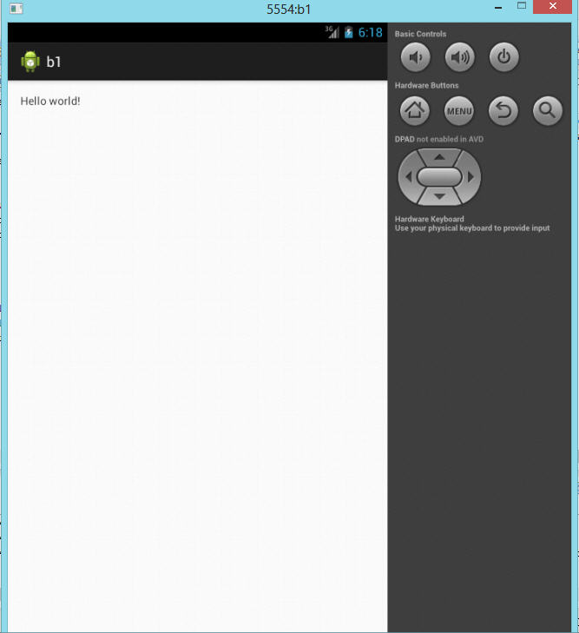
Fig 2.3 Output Window

PRACTICAL-3

AIM: Create an Android application to check which button you have clicked.

Graphical Layout

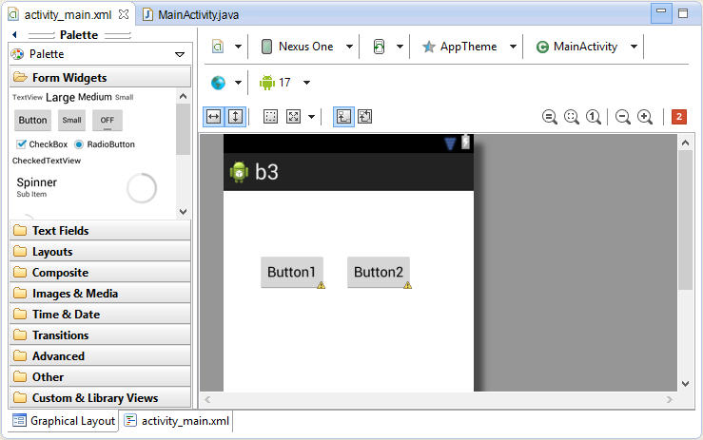
Fig 3.1 Graphical Layout

- Activity_main.xml
<RelativeLayout xmlns:android="http://schemas.android.com/apk/res/android"
xmlns:tools="http://schemas.android.com/tools"
android:layout_width="match_parent"
android:layout_height="match_parent"
android:paddingBottom="@dimen/activity_vertical_margin"
android:paddingLeft="@dimen/activity_horizontal_margin"
android:paddingRight="@dimen/activity_horizontal_margin"
android:paddingTop="@dimen/activity_vertical_margin"
tools:context=".MainActivity" >

<Button
android:id="@+id/button2"
android:layout_width="wrap_content"
android:layout_height="wrap_content"
android:layout_alignBaseline="@+id/button1"
android:layout_alignBottom="@+id/button1"
android:layout_marginLeft="23dp"
android:layout_toRightOf="@+id/button1"
android:onClick="onMyButton2Click"
android:text="Button2" />

<Button
android:id="@+id/button1"
android:layout_width="wrap_content"
android:layout_height="wrap_content"
android:layout_alignParentLeft="true"
android:layout_alignParentTop="true"
android:layout_marginLeft="28dp"
android:layout_marginTop="64dp"
android:onClick="onMyButton1Click"
android:text="Button1" />

</RelativeLayout>

- MainActivity.java
package com.example.b3;
import android.os.Bundle;
import android.app.Activity;
import android.view.Menu;
import android.view.View;
import android.widget.Toast;

public class MainActivity extends Activity {

@Override
protected void onCreate(Bundle savedInstanceState) {
super.onCreate(savedInstanceState);
setContentView(R.layout.activity_main);
}

@Override
public boolean onCreateOptionsMenu(Menu menu) {
// Inflate the menu; this adds items to the action bar if it is present.
getMenuInflater().inflate(R.menu.main, menu);
return true;
}
public void onMyButton2Click(View view)
{
Toast.makeText(this, "Button 2 clicked!", Toast.LENGTH_SHORT).show();
}
public void onMyButton1Click(View view)
{
Toast.makeText(this, "Button 1 clicked!", Toast.LENGTH_SHORT).show();
}
}

Output:

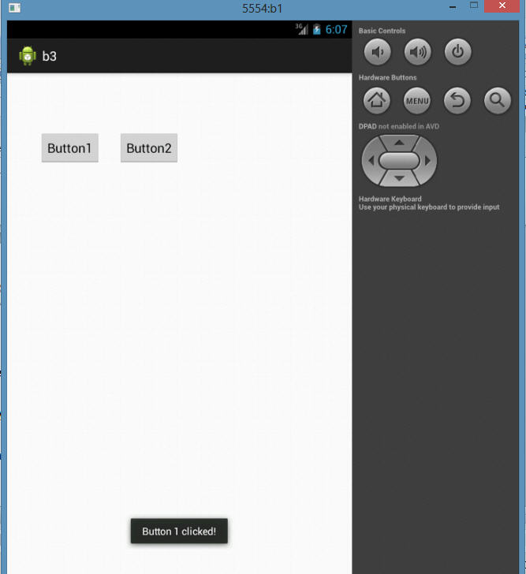
Fig 3.3 Output Window 1

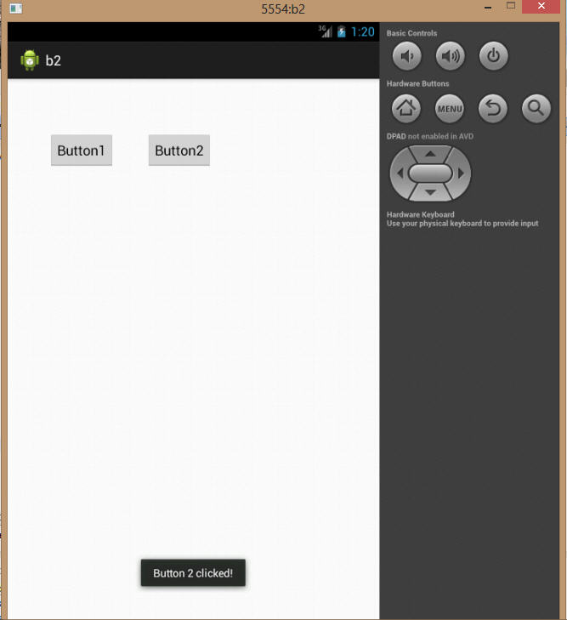

Fig 3.4 Output Window 2

PRACTICAL-4

AIM: Create a Dialog Box in Android.

Graphical Layout

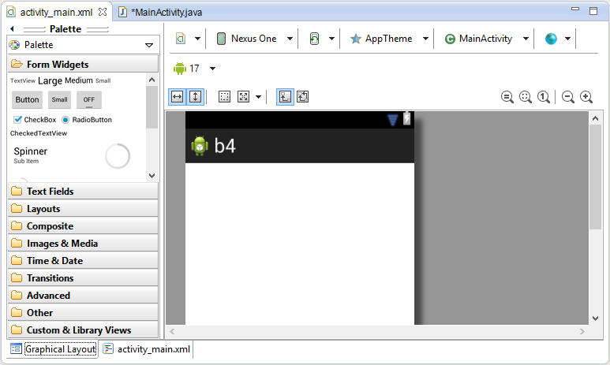
Fig 4.1 Graphical Layout

- Activity_main.xml

<RelativeLayoutxmlns:android="http://schemas.android.com/apk/res/android"
xmlns:tools="http://schemas.android.com/tools"
android:layout_width="match_parent"
android:layout_height="match_parent"
android:paddingBottom="@dimen/activity_vertical_margin"
android:paddingLeft="@dimen/activity_horizontal_margin"
android:paddingRight="@dimen/activity_horizontal_margin"
android:paddingTop="@dimen/activity_vertical_margin"
tools:context=".MainActivity">
</RelativeLayout>

- MainActivity.java
package com.example.b4;

import android.os.Bundle;
import android.app.Activity;
import android.app.AlertDialog;
import android.content.DialogInterface;
import android.view.Menu;
import android.widget.Toast;

publicclass MainActivity extends Activity
{
protectedvoid onCreate(Bundle savedInstanceState)
{
super.onCreate(savedInstanceState);
setContentView(R.layout.activity_main);

AlertDialog.Builder adb=new AlertDialog.Builder(this);
adb.setTitle("Alert Dialog...");
adb.setMessage("Are You Sure?");
adb.setPositiveButton("Yes",new DialogInterface.OnClickListener()
{
publicvoid onClick(DialogInterface arg0, int arg1)
{
Toast.makeText(getApplicationContext(), "You Pressed Yes..", Toast.LENGTH_LONG).show();
}
});
adb.setNegativeButton("No",new DialogInterface.OnClickListener()
{
publicvoid onClick(DialogInterface arg0, int arg1)
{
Toast.makeText(getApplicationContext(), "You Pressed No..", Toast.LENGTH_LONG).show();
}
});
adb.show();
}
publicboolean onCreateOptionsMenu(Menu menu)
{
getMenuInflater().inflate(R.menu.main, menu);
returntrue;
}

Output

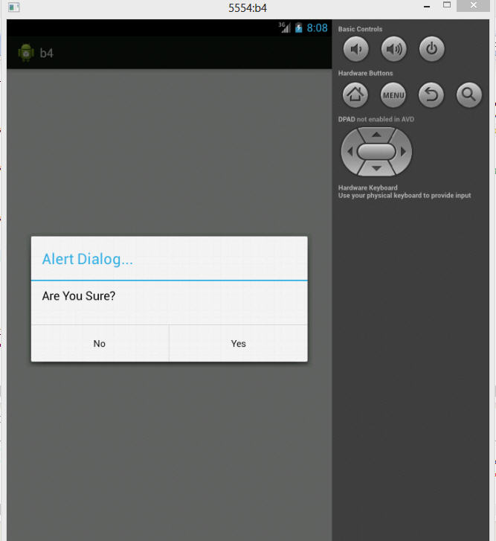
Fig 4.2.1 Output Window

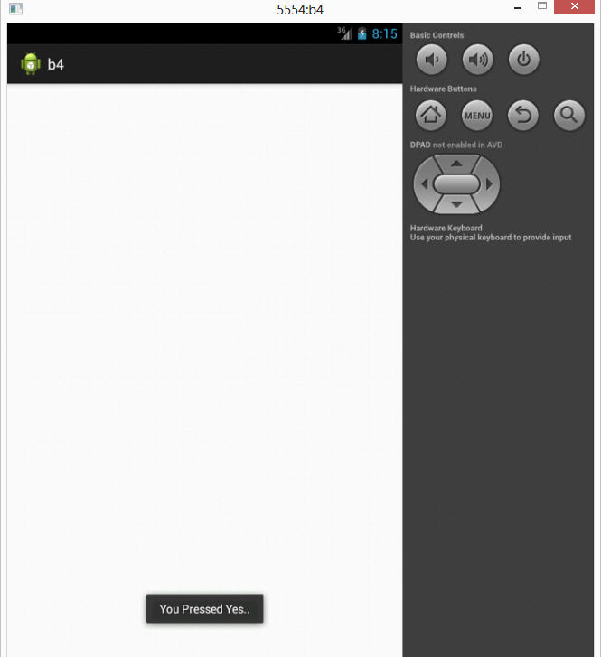
Fig 4.2.2 Output Window

PRACTICAL-5

AIM: Generate a simple Calculator.

Graphical Layout

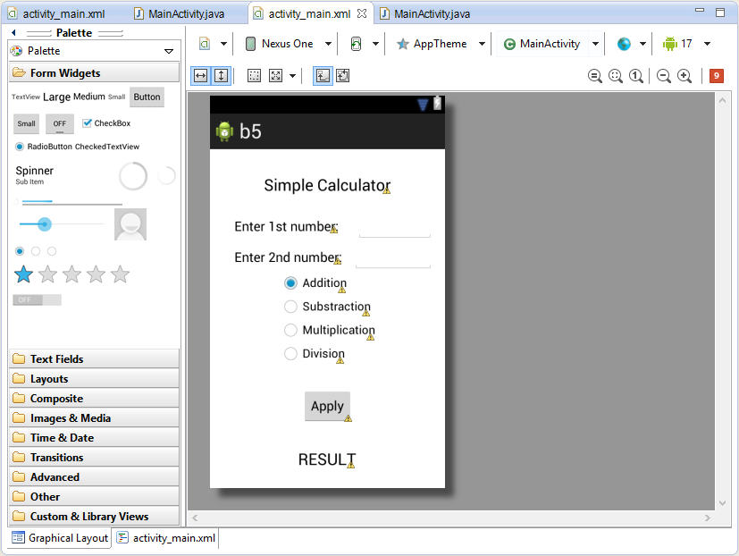
Fig 5.1 Graphical Layout

- Activity_main.xml
<RelativeLayoutxmlns:android="http://schemas.android.com/apk/res/android"
xmlns:tools="http://schemas.android.com/tools"
android:layout_width="match_parent"
android:layout_height="match_parent"
android:paddingBottom="@dimen/activity_vertical_margin"
android:paddingLeft="@dimen/activity_horizontal_margin"
android:paddingRight="@dimen/activity_horizontal_margin"
android:paddingTop="@dimen/activity_vertical_margin"
tools:context=".MainActivity">

<RadioGroup
android:id="@+id/radioGroup1"
android:layout_width="wrap_content"
android:layout_height="wrap_content"
android:layout_centerHorizontal="true"
android:layout_centerVertical="true">

<RadioButton
android:id="@+id/add"
android:layout_width="wrap_content"
android:layout_height="wrap_content"
android:checked="true"
android:text="Addition"/>

<RadioButton
android:id="@+id/sub"
android:layout_width="wrap_content"
android:layout_height="wrap_content"
android:text="Substraction"/>

<RadioButton
android:id="@+id/mul"
android:layout_width="wrap_content"
android:layout_height="wrap_content"
android:text="Multiplication"/>

<RadioButton
android:id="@+id/div"
android:layout_width="wrap_content"
android:layout_height="wrap_content"
android:text="Division"/>
</RadioGroup>

<TextView
android:id="@+id/textView4"
android:layout_width="wrap_content"
android:layout_height="wrap_content"
android:layout_alignParentTop="true"
android:layout_centerHorizontal="true"
android:layout_marginTop="20dp"
android:text="Simple Calculator"
android:textAppearance="?android:attr/textAppearanceLarge"/>

<TextView
android:id="@+id/textView1"
android:layout_width="wrap_content"
android:layout_height="wrap_content"
android:layout_above="@+id/editText2"
android:layout_alignRight="@+id/button1"
android:layout_marginBottom="14dp"
android:layout_marginRight="19dp"
android:text="Enter 1st number:"
android:textAppearance="?android:attr/textAppearanceMedium"/>

<EditText
android:id="@+id/editText1"

android:layout_width="wrap_content"
android:layout_height="wrap_content"
android:layout_alignBaseline="@+id/textView1"
android:layout_alignBottom="@+id/textView1"
android:layout_alignRight="@+id/editText2"
android:layout_toRightOf="@+id/textView3"
android:ems="10"
android:inputType="number"/>

<TextView
android:id="@+id/textView3"
android:layout_width="wrap_content"
android:layout_height="wrap_content"
android:layout_below="@+id/button1"
android:layout_centerHorizontal="true"
android:layout_marginTop="35dp"
android:text="RESULT"
android:textAppearance="?android:attr/textAppearanceLarge"/>

<TextView
android:id="@+id/textView2"
android:layout_width="wrap_content"
android:layout_height="wrap_content"
android:layout_alignBaseline="@+id/editText2"
android:layout_alignBottom="@+id/editText2"
android:layout_alignLeft="@+id/textView1"
android:text="Enter 2nd number:"
android:textAppearance="?android:attr/textAppearanceMedium"/>

<EditText
android:id="@+id/editText2"
android:layout_width="wrap_content"
android:layout_height="wrap_content"
android:layout_above="@+id/radioGroup1"
android:layout_toRightOf="@+id/textView1"
android:ems="10"
android:inputType="number"/>

<Button
android:id="@+id/button1"
android:layout_width="wrap_content"
android:layout_height="wrap_content"
android:layout_below="@+id/radioGroup1"
android:layout_centerHorizontal="true"
android:layout_marginTop="31dp"
android:text="Apply"/>

</RelativeLayout>

- MainActivity.java
package com.example.b5;

import android.os.Bundle;
import android.app.Activity;
import android.view.Menu;
import android.view.View;
import android.view.View.OnClickListener;
import android.widget.Button;
import android.widget.*;
import android.widget.TextView;
import android.widget.Toast;

public class MainActivity extends Activity
{
Protected void onCreate(Bundle savedInstanceState)
{
super.onCreate(savedInstanceState);
setContentView(R.layout.activity_main);
final EditText num1=(EditText)findViewById(R.id.editText1);
final EditText num2=(EditText)findViewById(R.id.editText2);
final TextView result=(TextView)findViewById(R.id.textView3);
final RadioGrouprg=(RadioGroup)findViewById(R.id.radioGroup1);
final Button b1=(Button)findViewById(R.id.button1);
b1.setOnClickListener(newOnClickListener()
{
Public voidonClick(View arg0)
{
if(num1.getText().toString().isEmpty() || num2.getText().toString().isEmpty())
{
Toast.makeText(getApplicationContext(), "Please Enter Values..", Toast.LENGTH_LONG).show();
}
else
{
Double n1=Double.parseDouble(num1.getText().toString());
Double n2=Double.parseDouble(num2.getText().toString());
Int selectoperation=rg.getCheckedRadioButtonId();
RadioButton op=(RadioButton)findViewById(selectoperation);
String s=newString(op.getText().toString());

if(s.equals("Addition"))
{
result.setText(String.valueOf(n1+n2));
}
elseif(s.equals("Substraction"))
{
result.setText(String.valueOf(n1-n2));
}
elseif(s.equals("Multiplication"))
{
result.setText(String.valueOf(n1*n2));
}
elseif(s.equals("Division"))
{
if(n2==0)
{
result.setText("DIVIDE BY 0 ERROR!!!");
}
else
{
result.setText(String.valueOf(n1/n2));
}
}
}
}
});
}
Public booleanon Create OptionsMenu(Menu menu) {
getMenuInflater().inflate(R.menu.main, menu);
return true;
}
}

Output
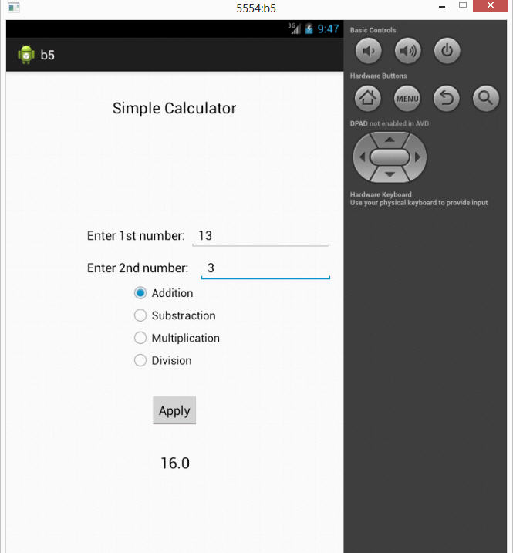

Fig 5.2.1 Output Window Addition

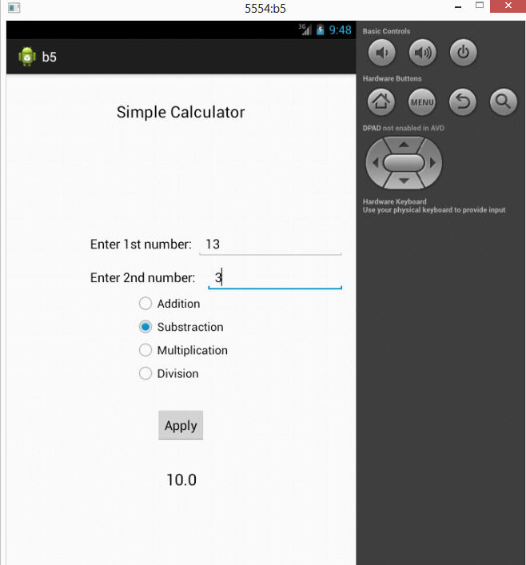

Fig 5.2.2 Output Window Subtraction

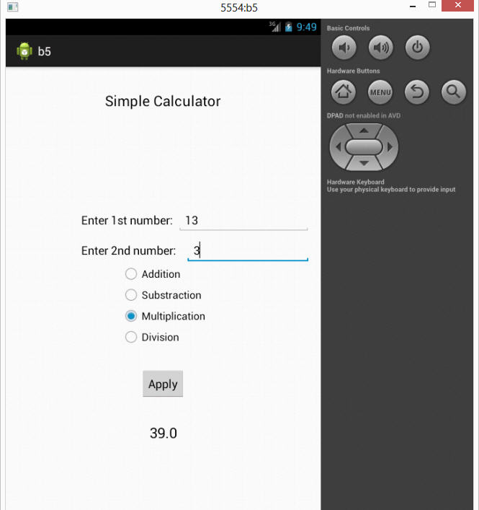

Fig 5.2.3 Output Window Multiplication

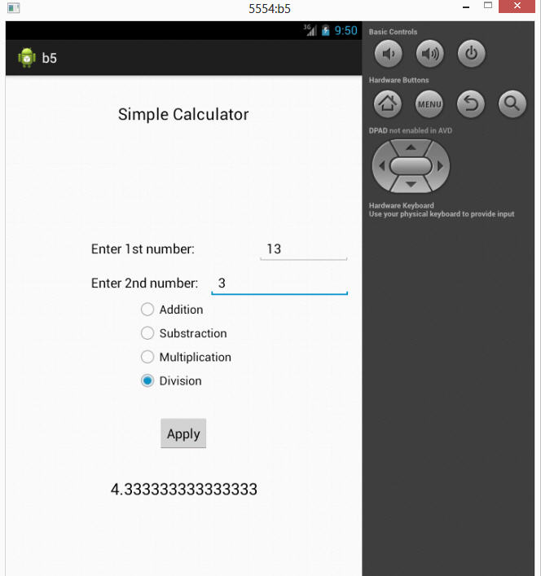
Fig 5.2.4 Output Window Division

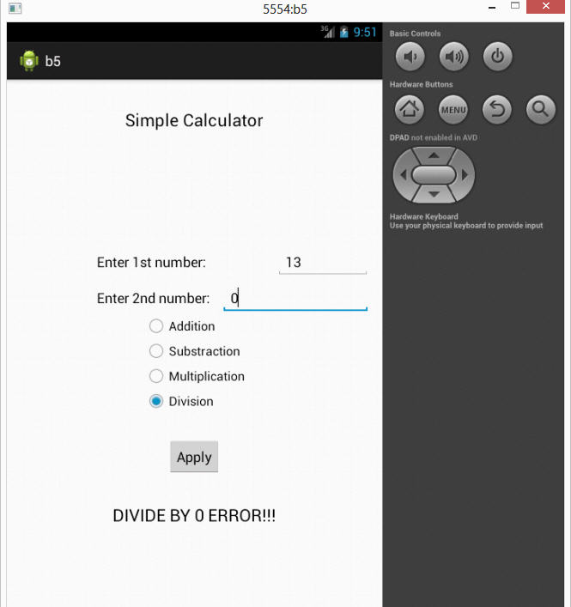
Fig 5.2.5 Output Window Divide/0

PRACTICAL - 6

AIM: Create an android application that contains multiple tabs.

- MainActivity.java
package com.example.tabapp1;

import android.os.Bundle;
import android.app.Activity;
import android.view.Menu;
import android.widget.TabHost;
import android.widget.TabHost.TabSpec;

public class MainActivity extends Activity {

@Override
protected void onCreate(Bundle savedInstanceState) {
super.onCreate(savedInstanceState);
setContentView(R.layout.activity_main);

TabHost tbhst1=(TabHost)findViewById(android.R.id.tabhost);
tbhst1.setup();
TabSpec spec1=tbhst1.newTabSpec("Tab 11");
spec1.setIndicator("ANALOG CLOCK");
spec1.setContent(R.id.analogClock1);
TabSpec spec2=tbhst1.newTabSpec("Tab 22");
spec2.setIndicator("DIGITAL CLOCK");
spec2.setContent(R.id.digitalClock1);
tbhst1.addTab(spec1);
tbhst1.addTab(spec2);

}

@Override
public boolean onCreateOptionsMenu(Menu menu) {
// Inflate the menu; this adds items to the action bar if it is present.
getMenuInflater().inflate(R.menu.main, menu);
return true;
}

}

- Activity_main.xml
<RelativeLayout xmlns:android="http://schemas.android.com/apk/res/android"
xmlns:tools="http://schemas.android.com/tools"
android:layout_width="match_parent"
android:layout_height="match_parent"
android:paddingBottom="@dimen/activity_vertical_margin"
android:paddingLeft="@dimen/activity_horizontal_margin"
android:paddingRight="@dimen/activity_horizontal_margin"
android:paddingTop="@dimen/activity_vertical_margin"
tools:context=".MainActivity" >

<TabHost
android:id="@android:id/tabhost"
android:layout_width="match_parent"
android:layout_height="match_parent"
android:layout_alignParentLeft="true"
android:layout_alignParentTop="true" >

<LinearLayout
android:layout_width="match_parent"
android:layout_height="match_parent"
android:orientation="vertical" >

<TabWidget
android:id="@android:id/tabs"
android:layout_width="match_parent"
android:layout_height="wrap_content" >
</TabWidget>

<FrameLayout
android:id="@android:id/tabcontent"
android:layout_width="match_parent"
android:layout_height="match_parent" >

<LinearLayout
android:id="@+id/tab1"
android:layout_width="match_parent"
android:layout_height="match_parent" >

<AnalogClock
android:id="@+id/analogClock1"
android:layout_width="wrap_content"
android:layout_height="wrap_content" />

</LinearLayout>

<LinearLayout
android:id="@+id/tab2"
android:layout_width="match_parent"
android:layout_height="match_parent"
tools:ignore="Orientation" >

<DigitalClock
android:id="@+id/digitalClock1"
android:layout_width="wrap_content"
android:layout_height="wrap_content"
android:text="DigitalClock"
tools:ignore="HardcodedText" />

</LinearLayout>

</FrameLayout>
</LinearLayout>
</TabHost>

</RelativeLayout>

Output:

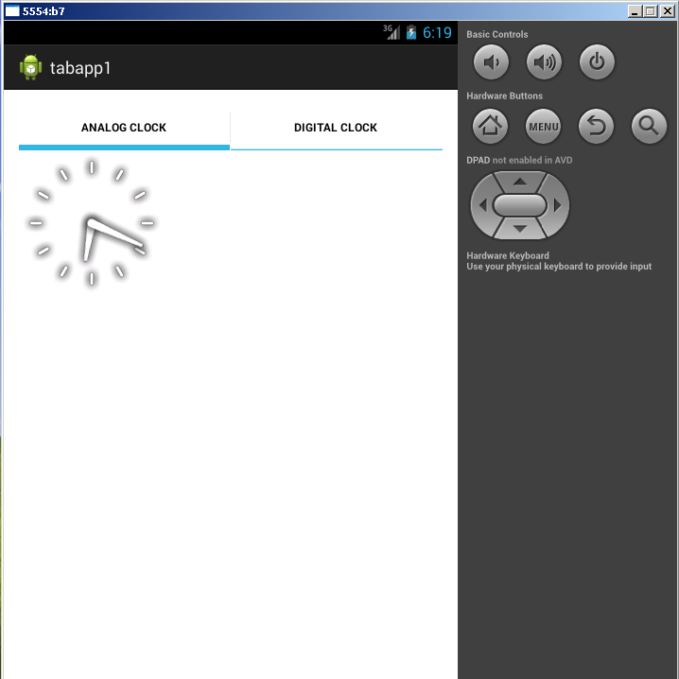

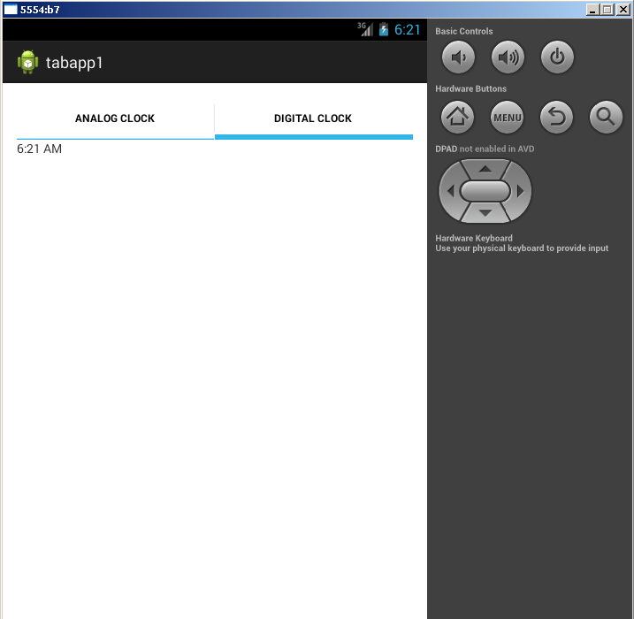

PRACTICAL – 7

AIM: Create listview with multiple choice in android.

- Activity_main.xml
<manifest xmlns:android="http://schemas.android.com/apk/res/android"
package="com.example.listviewexample"
android:versionCode="1"
android:versionName="1.0" >

<uses-sdk
android:minSdkVersion="8"
android:targetSdkVersion="15" />

<application
android:icon="@drawable/ic_launcher"
android:label="@string/app_name"
android:theme="@style/AppTheme" >
<activity
android:name=".MainActivity"
android:label="@string/title_activity_main" >
<intent-filter>
<action android:name="android.intent.action.MAIN" />

<category android:name="android.intent.category.LAUNCHER" />
</intent-filter>
</activity>
</application>
</manifest>

- MainActivity.java
import android.app.ListActivity;
import android.os.Bundle;
import android.view.ActionMode;
import android.view.Menu;
import android.view.MenuInflater;
import android.view.MenuItem;
import android.view.View;
import android.widget.AdapterView;
import android.widget.AdapterView.OnItemLongClickListener;
import android.widget.Toast;

public class MyListActivityActionbar extends ListActivity {

protected Object mActionMode;
public int selectedItem = -1;
public void onCreate(Bundle icicle) {
super.onCreate(icicle);
setContentView(R.layout.main);
String[] values = new String[] { “Mercury",”Venus”,”Mars”,”Jupiter”,”Saturn”,”Uranus”,”Neptune”};
MySimpleArrayAdapter adapter = new MySimpleArrayAdapter(this, values);
setListAdapter(adapter);
getListView().setOnItemLongClickListener(new OnItemLongClickListener() {
@Override
public boolean onItemLongClick(AdapterView<?> parent, View view,
int position, long id) {
if (mActionMode != null) {
return false;
}
selectedItem = position;
mActionMode = MyListActivityActionbar.this
.startActionMode(mActionModeCallback);
view.setSelected(true);
return true;
}
});
}

private ActionMode.Callback mActionModeCallback = new ActionMode.Callback() {
public boolean onCreateActionMode(ActionMode mode, Menu menu) {
MenuInflater inflater = mode.getMenuInflater();
inflater.inflate(R.menu.rowselection, menu);
return true;
}
public boolean onPrepareActionMode(ActionMode mode, Menu menu) {
return false; // Return false if nothing is done
}
public boolean onActionItemClicked(ActionMode mode, MenuItem item) {
switch (item.getItemId()) {
case R.id.menuitem1_show:
show();
mode.finish();
return true;
default:
return false;
}
}
public void onDestroyActionMode(ActionMode mode) {
mActionMode = null;
selectedItem = -1;
}
};

private void show() {
Toast.makeText(MyListActivityActionbar.this,
String.valueOf(selectedItem), Toast.LENGTH_LONG).show();
}
}

OUTPUT

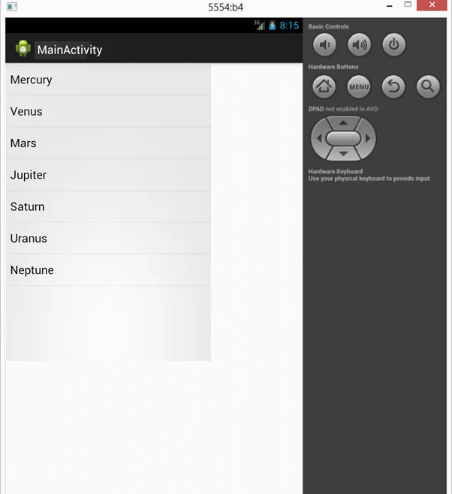

Figure 7.1 – ListView

PRACTICAL – 8

AIM: Create an application in android for slideshow animation.

Graphical Layout

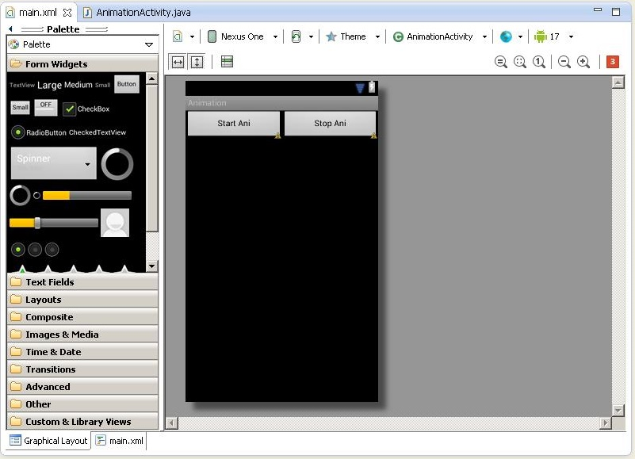
Figure 8.1 – Main layout

- Activity_main.xml
<?xml version="1.0" encoding="utf-8"?>
<TableLayout android:id="@+id/TableLayout1" xmlns:android="http://schemas.android.com/apk/res/android"
android:layout_width="fill_parent"
android:layout_height="fill_parent"
>
<TableRow android:id="@+id/tableRow1" android:layout_width="wrap_content" android:layout_height="wrap_content">

<Button
android:id="@+id/button1"
android:layout_width="wrap_content"
android:layout_height="wrap_content"
android:layout_weight="1"
android:text="Start Ani" >
</Button>

<Button
android:id="@+id/button2"
android:layout_width="wrap_content"
android:layout_height="wrap_content"
android:layout_weight="1"
android:text="Stop Ani" >
</Button>
</TableRow>
<ImageView android:layout_height="wrap_content" android:id="@+id/imageView1" android:layout_width="wrap_content"></ImageView>
</TableLayout>

- MainActivity.java
package sl.mc;

import android.app.Activity;
import android.graphics.drawable.AnimationDrawable;
import android.os.Bundle;
import android.view.View;
import android.view.View.OnClickListener;
import android.widget.Button;
import android.widget.ImageView;

public class AnimationActivity extends Activity {
Button b1,b2;
ImageView i1;
AnimationDrawable ad;

@Override
public void onCreate(Bundle savedInstanceState) {
super.onCreate(savedInstanceState);
setContentView(R.layout.main);

b1=(Button)findViewById(R.id.button1);
b2=(Button)findViewById(R.id.button2);
i1=(ImageView)findViewById(R.id.imageView1);

i1.setBackgroundResource(R.drawable.framebyframe);

b1.setOnClickListener(new OnClickListener() {
public void onClick(View arg0) {
ad=(AnimationDrawable)i1.getBackground();
ad.start();
}
});

b2.setOnClickListener(new OnClickListener() {
public void onClick(View arg0) {
.stop();
}
});
}
}

OUTPUT

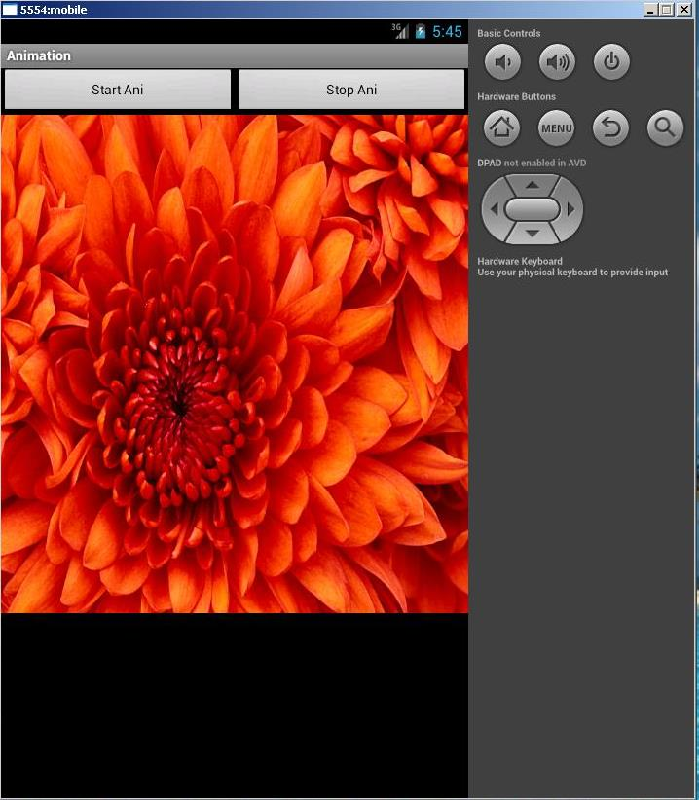
Figure 8.2.1 - First Slide

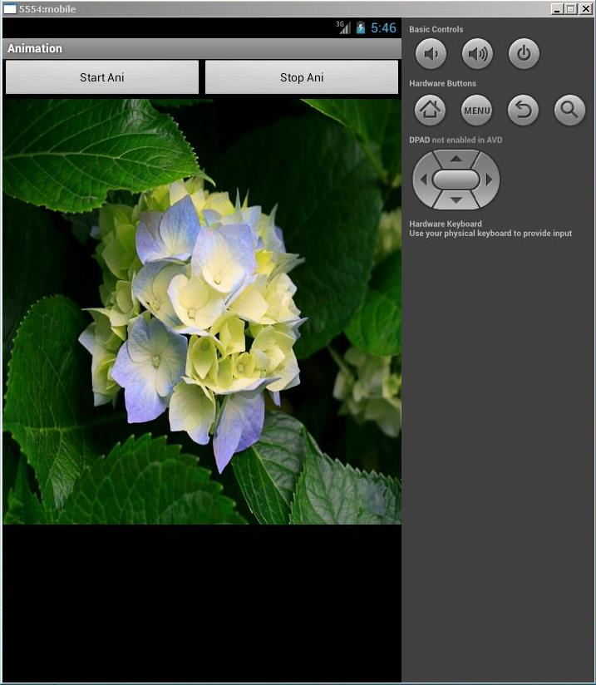
Figure 8.2.2 – Second Slide

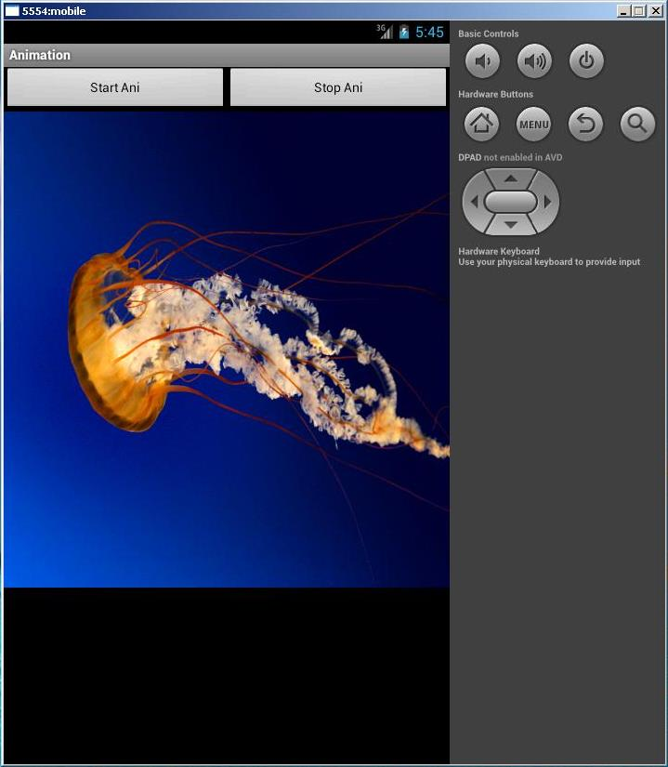
Figure 8.2.3 - Third Slide
PRACTICAL – 9

AIM: Create an application in android to find factorial of a number using OnClick event.

Graphical Layout

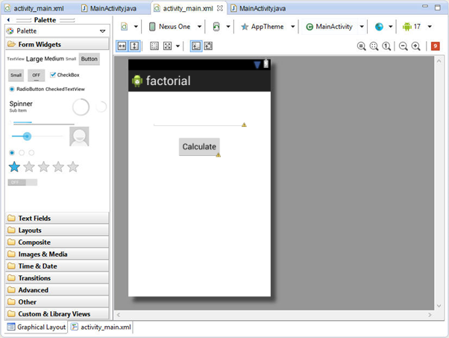

- Activity_main.xml
<LinearLayout xmlns:android="http://schemas.android.com/apk/res/android"
android:layout_width="fill_parent"
android:layout_height="fill_parent"
android:orientation="vertical" >

<TextView
android:id="@+id/txtView"
android:layout_width="150dp"
android:layout_height="150dp"
android:text="@string/hello" />

<Button
android:id="@+id/mybtn"
android:layout_width="50dp"
android:layout_height="30dp" />

<TextView
android:id="@+id/viewwidth"
android:layout_width="fill_parent"
android:layout_height="wrap_content" />

<TextView
android:id="@+id/viewheight"
android:layout_width="fill_parent"
android:layout_height="wrap_content" />

</LinearLayout>

- MainActivity.java
import android.app.Activity;
import android.os.Bundle;
import android.view.View;
import android.widget.Button;
import android.widget.EditText;
import android.widget.TextView;

import com.droidacid.apticalc.R;

public class AptiFactorial extends Activity implements android.view.View.OnClickListener{
EditText number;
TextView answer;
Button calculate;

@Override
protected void onCreate(Bundle savedInstanceState) {
super.onCreate(savedInstanceState);
setContentView(R.layout.apti_factorial);
initialize();
}

private void initialize() {
number = (EditText) findViewById(R.id.et_apti_number);
number.setHint("Enter number to be factorialized :P")
answer = (TextView) findViewById(R.id.tv_apti_answer);
calculate = (Button) findViewById(R.id.b_apti_calc);
calculate.setOnClickListener(this);
}

private long calcFactorial() {

long factorial = 1;
try {
factorial = Long.parseLong(number.getText().toString());
for(int i=factorial-1; i>0; i--){
factorial = i * factorial;
}
} catch (NumberFormatException e) {
Toast.makeText(this, "Incorrect Input", Toast.LENGTH_LONG).show();
} finally {}

return factorial;
}

@Override
public void onClick(View v) {
answer.setText("Factorial of " + number.getText().toString() + " is : " + calcFactorial());
}

OUTPUT

