**NOTE: This document does not have application code. It only has the screenshots, description and steps followed to reach the conclusion. Application code is in another attached file named “FinalCode_ArchGarch.R”.**

1. **Set a value of p and fit an AR(p) model to the data using the arima() function in R.**

**Response: -** Below are steps performed to find the value of p

A). In order to perform ARIMA, we first need to check whether our data is stationary or not. Stationary means **Variance & Mean** of data is stationary or not. From below screenshot we can see that it is not stationary.

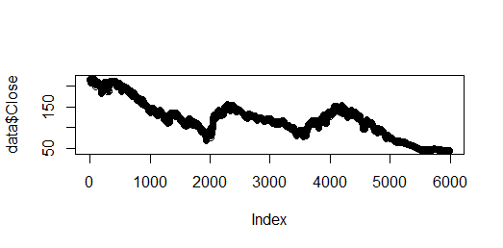

B). Let us make it stationary using “diff” function and again check. So now we can see from below screenshot, mean is stationary and also variance. So that means we require differencing in our data during ARIMA modeling.

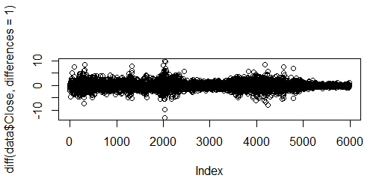

C). Let us perform PACF (Partial Auto Correlation) to get a sense of possible “p” value. From below screenshot we can see that after **Lag 7** value has dropped to **zero.**

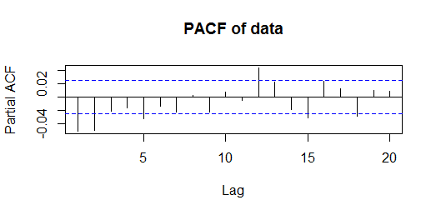

D). Since partial correlogram tails off to zero after lag 7, possible AR models are **AR (7,0,0), AR (7,1,0)**. Selection of model depends on **AIC** value of models. Model with low **AIC** value will be used for further analysis. Since **AR (7,1,0)** has lowest AIC value so we will use it for next steps. Hence, value of **p** is “**7**”

E). Fit the chosen model on data and cross validate the model using “Ljung-Box” test on residuals. From below screenshot we can see that P-Value for the Box-test is “0.9”, we can conclude that there is very little evidence for non-zero autocorrelation between residuals, and this means selected model is **best-fit**.

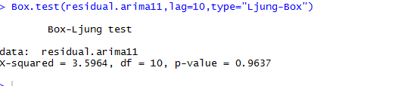

1. **Obtain a new time series consisting of the squared residuals from the fit in 1. Now set a value of q and fit an AR(q) model of the squared residuals.**

**Response: -** Let us check below steps

A). Image below shows the residual plot. From here we can observe that there is cluster of volatility at some point which is marked in circle. So this volatility can also be considered as an evidence of ARCH/GARCH effect. But that we will prove in coming steps.

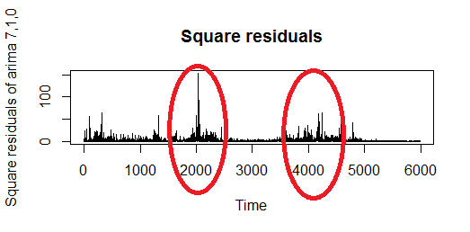

B). Let us perform PACF (Partial Auto Correlation) on squared residual to get a sense of possible “q” value. From below screenshot we can see that after **Lag 11** value has dropped to **zero.**

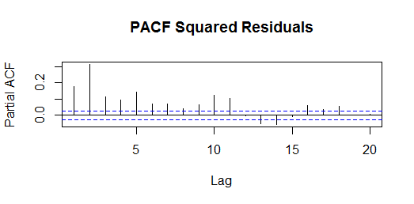

C). Since partial correlogram tails off to zero after lag 11, possible AR models are **AR (11,0,0), AR (11,1,0)**. Selection of model depends on **AIC** value of models. Model with low **AIC** value will be used for further analysis. Since **AR (11,0,0)** has lowest AIC value so we will use it for next steps. Hence, value of **q** is “**11**”.

Now it’s time to verify the ARCH or GARCH effects on **daily closing prices** using Engle’s Methodology. For that let us check coefficients of parent model which is AR (7) & squared residuals model which is AR (11). From below image we can see that coefficients of both the selected models are not zero.

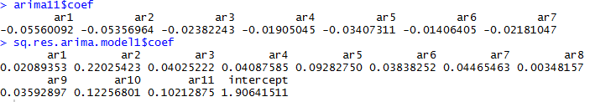

**Conclusion: -** Coefficients of both the models are not all zero. Which shows original time series of daily closing prices exhibits ARCH or GARCH effects. Also residuals plot showing volatility has proved the existence of ARCH or GARCH effect.