FAA Wildlife Damage to Aircraft Lab 3

1. Partner up!
2. Open Tableau – load **StrikeReport-3.csv**
3. Assume you have repair cost and weather data. ***You are responsible for providing guidance to a plan whose goal is to minimize the cost and impact of wildlife strikes***.

Things to keep in mind:

* What should your strategy be?
* What questions should you ask?
* What results do you expect?
* How will you handle getting different results?

Note: We will go over visual representations in detail on session 6 Tasks & Prototypes). After session 6, try coming back to this lab and see what aspects of your visual display you could improve. Iteration is necessary for visual analytics, so it’s good to make evaluation (and reevaluation) a habit.

Note 2: Speaking of data quality, Tableau guesses the latitude and longitude (of the airports where the wildlife strikes were reported) wrong; it's supposed to be a geographical location but it thinks it's a string.

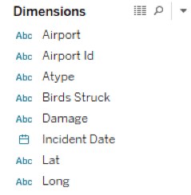

If you look under “Lat” and “Long” under Dimensions, notice that you see an Abc icon on the left. That means Tableau thinks the data is a string. We need to change it so that Tableau recognizes that they are latitude and longitude values. Here’s how to fix it:

Right click on **Lat** and select **Change data type > Number (decimal)**.

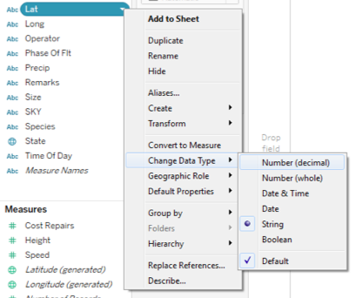

Notice that the Abc icon next to the Lat turns into a #.

Next, right click on Lat and select **Geographic role > Latitude.**

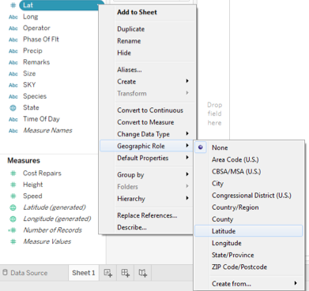

Now **Lat** should have a globe icon next to it.

Do the same thing with **Long** (except for the geographic role should be **Longitude** instead of Latitude)

...and you’re done!

(FAQ: What’s the difference between **Lat** and **Long** and *Latitude (generated)* and *Longitude (generated)?* In this dataset, Lat and Long are the coordinates of all the airports. Aside from that, Tableau *generates* latitude and longitude based on the dimension “**State**.” Tableau is smart enough to recognize States, Provinces and Counties so it generates the latitude and longitude in order to make shapes so that you can create filled maps.)