Flower Classification Using Deep Learning and Autoencoders
Aakash Paudel
Submitted in accordance with the requirements for the degree of
MSc Information Technology
York St John University
School of Science, Technology and Health

Acknowledgements
I would like to thank my supervisor, Prof. Anil Fernando, and his constant guidance, technical skills, and professional support that made this research possible.
I also wish to express my sincere gratitude to my family and friends, who with their constant support, patience and inspiration formed a constant motivating factor during the course of my studies. It was their faith in my capacity that continued to be a strong inspiration.
Moreover, I owe a lot to York St John University which offered me a great deal of resources and facilities without which this project would have been impossible to complete.

Abstract
In this assignment, the study explores the use of deep learning to classify flower images, in particular, examines how the use of autoencoders to extract features and reconstruct images works. Convolutional autoencoder is used to reduce the input images to a reduced-dimensional latent space and preserve the crucial visual data. The so obtained latent features are then fed to a neural network classifier which has been trained to classify flower species. The accuracy, precision, recall and F1-score are used to evaluate the performance of a model. The findings prove that the autoencoder-based features improve the classification performance, reduce overfitting, and lower the computational expenses. The results develop smart image identification methods, especially in botany and biodiversity surveillance.
Table of Contents
Acknowledgements 2
Abstract 3
Chapter 1: Introduction 1
1.1 Background and Motivation 1
1.2 Research Objectives and Questions 1
1.3 Hypothesis 4
1.4 Research Scope and Limitations 5
1.4.1 Scope 5
1.4.2 Limitations 5
1.5 Dissertation Structure 6
Chapter 2: Literature Review 8
2.1 Deep Learning for Image Classification 8
2.2 Autoencoders in Computer Vision 9
2.3 Flower Classification Datasets and Techniques 10
2.4 Related Works and Comparison 12
2.4.1 Approach Using Handcrafted Features 12
2.4.2 Comparative Analysis of GoogLeNet and AlexNet 12
2.4.3 Inception-v3 for Feature Extraction 12
2.4.4 Hybrid autoencoder + CNN Model 13
2.4.5 Plant Methods Metric Learning for Flower Classification 13
2.5 Identified Gaps in Literature 14
2.5.1 Autoencoder underutilization in Feature Extraction 14
2.5.2 Narrow Interest in Unsupervised Learning 15
2.5.3 Efficiency and Simplification of Models 15
2.5.4 Omission of Model Interpretability and Analysis of Feature Space 15
Chapter 3: Methodology 16
3.1 Research Design 16
3.2 Dataset Description 16
3.3 Data Preprocessing 17
3.3.1 Resizing 17
3.3.2 Normalization 17
3.3.3 Data Augmentation 17
3.4 Autoencoder Architecture 18
3.5 Classifier Architecture 18
3.6 Tools and Libraries 20
3.6.2 TensorFlow / Keras 20
3.6.3 NumPy 20
3.6.4 Seaborn and matplotlib 21
3.6.5 Scikit-learn 21
3.6.6 OpenCV 21
3.6.7 Google Colab 22
3.7 Evaluation Metrics 22
3.7.1 Accuracy 22
3.7.2 Precision 23
3.7.3 Recall (Sensitivity) 23
​3.7.4 F1-Score 23
3.7.5 Confusion Matrix 23
3.7.6 Grad-CAM 24
Chapter 4: Implementation 25
4.1 Model Construction 25
4.1.1 Autoencoder Model 25
4.1.2 CNN Classifier: 25
4.1.3 Transfer Learning Models: 25
4.2 Training Details 26
4.2.1 Epochs 26
4.2.2 Batch Size 26
4.2.3 Loss Function: 26
4.3 Feature Extraction Using Autoencoders 27
4.4 Classification Using Encoded Features 27
4.5 Baseline vs Autoencoder-Based Models 27
4.5.1 Baseline CNN 27
4.5.2 Autoencoder 29
4.5.3 Transfer learning models 30
4.6 System Design/Workflow Diagram 32
Chapter 5: Results and Evaluation 33
5.1 Quantitative Results 33
5.2 Confusion Matrix 35
5.2.1 Autoencoder Dense Classifier 35
5.2.2 Baseline CNN 35
5.2.3 ResNet50 36
5.2.4 MobileNetV2 38
5.3 Comparative Analysis (Baseline vs Proposed) 39
5.4 Overfitting and Generalization Performance 39
5.5 Discussion on Key Findings 41
Chapter 6: Conclusion and Future Work 43
6.1 Summary of Research 43
6.2 Key Findings and Contributions 44
6.3 Challenges Faced 45
6.4 Limitations 47
6.5 Recommendations for Future Research 48
References 49
Appendices 54
Appendix A – Screenshots of flower prediction webapp. 54
Appendix B – Screenshots of data preprocessing and model training and evaluation 59

Chapter 1: Introduction

Background and Motivation
Over the past few years, the computer vision domain has improved tremendously thanks to the progress in the domain of deep learning, especially convolutional neural networks (IBM, 2025). Another good example of promising use of these techniques is the automatic classification of images, such as natural objects, such as flowers. Proper classification of flower species not only aids in botanical studies and conservation of the ecological environment but also enables them to assist in the fields of agriculture, horticulture, environmental surveillance and learning aid (Yuanhao Chen, 2006).
Conventional image classification approaches were based on handcrafted features that were not very flexible to generalize to different datasets of different lighting conditions, backgrounds and image sizes. Deep learning models on the other end automatically discover the appropriate features upon raw image data and thus perform better and generalize (Maryna Dovbnych, 2021). Autoencoders as a sub-category of unsupervised deep learning architecture have also been contemplated in this area due to their ability to approximate lower representations of data in high dimensions. Autoencoders have been demonstrated to perform better in classification when combined with classifier as they extract robust and informative features in input images (geeksforgeeks, 2025).
This research is inspired by the fact that it is difficult to classify flowers which have a tendency of looking similar in terms of appearance between species and varies in terms of color, angle, lighting, and background within the same species. The project will deploy the convolutional autoencoders to extract features with neural network classifiers as a method of planning a more generalizable and powerful flower classification model.

Research Objectives and Questions
The main aim of the proposed project is to design, develop and test an effective deep learning-based system that may be utilized to infer the different species of flower based on the representational ability of convolutional autoencoders (CAEs). Convolutional autoencoders are some type of unsupervised neural networks which can automatically learn to extract small yet significant features of image data. These learned characteristics- or representations- are given as input to a model of classifier i.e., to predict the species of flowers in an accurate manner (Mukherjee, 2025).
Deep learning approaches have proved to far surpass more traditional machine learning approaches in a great diversity of computer vision tasks as larger and larger collections of image data have become accessible and as computation resources have increased. Nevertheless, the majority of available models of classification demand raw data on the images and cannot learn compact and high-order representations that capture salient patterns in visual information The current study tries to address this gap by integrating the autoencoder-based feature extraction mechanism with the classification pipeline, which, in turn, will enable the flora recognition systems to be more efficient and demonstrate improved performance.
1. To train and design convolutional autoencoder to extract features of flower images.
The initial step includes developing a proper autoencoder model based on the nature of flower images. This comprises the setting of convolutional layers, in order to learn spatial hierarchies and patterns, pooling layers, in order to reduce the dimensionality, and decoding layers, in order to restore the original images, by using the compressed representations. The training procedure will focus on minimizing reconstruction loss, thus making sure that the encoder learns the salient features that keep significant visual information of each of the flower species.
2. To come up with a model of classification and use the encoded features in the recognition of flower species.
When the auto encoder has been trained, it will have its encoder part removed and will be used as a fixed feature extractor. This will pass these features to a trained, supervised, classification network (e.g. multilayer perceptron or shallow convolutional classifier) and learn to differentiate among flower species. To test the performance of the classification model, its accuracy, precision, recall and F1-score will be checked.
3. To compare the work of the proposed model to the classic approaches to classification
To justify the effectiveness of the proposed method based on autoencoder, the baseline models based on conventional CNN classifiers trained with raw image data will be established. Comparative analysis will be performed in order to show the differences between performance in aspects of classification scores, speed of computation, and ability to learn features. This comparison will assist in figuring out whether the addition of autoencoder has a substantial effect on classification results. Research Questions
The following research questions are behind this study:
1. Do convolutional autoencoders learn meaningful representations in the flower images improving accuracy in classification?
The question tries to explore effectiveness of autoencoders in learning rich, discriminative features to improve the classification performance. It also looks at the question of whether the unsupervised pre-training of features extractors can offer a benefit compared to learning directly on raw pixel information.
2. What is the comparison between the performance of autoencoders enhanced classification models with the performance of corresponding baselines trained on raw image data?
A comparison will be conducted to know the advantages and disadvantages of the autoencoder-augmented classification with standard CNNs. The study will determine whether the coded features lead to increased accuracy and improved generalization especially in the cases where the training data is small or noisy.
3. What are the pros and cons of autoencoders in image classification?
This question concerns the implications of using autoencoders in practice when image recognition is concerned. Autoencoders may enable the enhancement of feature learning, but at the same time, they pose such complexities as increased training time, hyperparameter sensitivity and information loss during reconstruction. This paper is going to take a critical approach at assessing these trade-offs and attempt to give a fair assessment of their usefulness in flower classification and possibly other areas of computer vision.
These questions will help this study make a new contribution to the analysis of the possibilities of using convolutional autoencoders in the framework of the classification of images and offer practical solutions to the implementation of these autoencoders in the real machine learning process.

Hypothesis
The following is the hypothesis of this study:
“Convolved autoencoders as a feature extraction technique can give more accurate and generalizing flower classification models than models trained directly on raw images. “
The hypothesis behind this assertion is that convolutional autoencoders (CAEs) have been shown to perform unsupervised learning to learn the compact and meaningful representation of input images that captured the most important features and neglected the irrelevant or noisy information. Unlike conventional CNN classifiers that are trained to utilize the high dimensional raw image pixels in order to learn, CAEs are trained to reduce data into a lower dimensional latent space that retains the important visual features that are essential in the classification.
One would hope that the latent representations produced by the encoder part of the auto-encoder will be a more informative input to the classification model. Such representations would tend to highlight the most discriminative features of flower images, e.g. the shapes and textures of petals and the patterns of colors, and therefore allow the classifier to better predict the outcome. Also, the generalization capability of the model might be enhanced by the abstraction given by the autoencoder, particularly during the time of testing on new data or when the conditions are different, like lighting, background or occlusion.
This study will test the hypothesis that introducing autoencoder to the deep learning pipeline can result in better outcomes of flower species recognition tasks by comparing the classification results of the models trained on the features extracted by an autoencoder and the model trained on raw pixel data.

1.4 Research Scope and Limitations

1.4.1 Scope
The study in question is devoted to the problem of flower classification based on images with the help of deep learning methods, the main problem being feature extraction with the convolutional autoencoders (CAEs). The used dataset in the paper is the Oxford 102 Category Flower Dataset, that is a typical example of an image classification benchmark dataset, containing over 8,000 images of 102 different flower species. The data set consists of a wide variety of types of flowers, colors, and shapes that makes it possible to analyze the work of the advanced image classification models.
The essence of the study is the design, training and testing of a 2-phase deep learning pipeline. The first stage is unsupervised training of a convolutional autoencoder to learn compact, high level feature representations of flower samples in raw flower images. At the second phase, a classification model will be trained on the encoded features with the help of the autoencoder, and it will be trained on the corresponding flower species.
This implementation of the project is done through the Python programming language where powerful deep learning libraries, TensorFlow and Keras, are used in the development of the model, training, and evaluation of the model. The model performance is tested on widely used classification metrics, including accuracy, precision, recall, F1-score, which give the whole picture of the system capability to distinguish between classes of various flowers.
The main aim of this research can be defined as the assessment of the role of autoencoders in enhancing the classification performance in the field of flower images. The results will give an impression about the practical benefits of applying autoencoders to similar computer vision problems.

1.4.2 Limitations
Although the research is aimed at studying the possibility of using convolutional autoencoders in image classification, one should note several limitations to it:
- Adaptation to Variation in Image:
The model can be vulnerable to lighting changes, backgrounds and scale of objects that are prevalent in actual photographs. Despite the generalization being enhanced by the use of basic data augmentation techniques like rotation, flipping, and zooming, it is possible that they can barely address the impact of complex environmental variations (Hossein Hosseini, 2017).
- Computational Constraints:
Deep neural networks especially autoencoders and classification models are resource-intensive to train. As the study is performed in the context of available hardware, which is mainly restricted to consumer-level GPU or cloud computing systems. Such limitations can reduce the possibility of training deeper or more complex architectures, longer training times, or hyperparameter search (Hossein Hosseini, 2017).
- Dataset-Specific Findings:
The research constrains itself to Oxford 102 Flower Dataset. Although the data has a significant variety in the flower domain, it is not likely that the trained models will generalize to other domains (e.g. animals, objects or satellite imagery), or even to other flower datasets with significantly different image characteristics. The implementation of the proposed methodology on new datasets would probably demand retraining and possible the reconfiguration of the model architecture (Hossein Hosseini, 2017).
- Absence of real time deployment factors:
The project does not cover the deployment part of the model, including its optimization towards real-time prediction, mobile or web application integration, or edge inference. The study is still at the experimental incremental and evaluation phase of model creation (Hossein Hosseini, 2017).

1.5 Dissertation Structure
This doctorate thesis is thusly organized:
- Introduction (chapter 1)
Gives a sketch of the research problem, objectives, motivation and scope.
- Review of literature (Chapter 2)
The reviews mention and relate to the work done in flower classification, deep learning, convolutional learning and auto encoders, and existing gaps that the upcoming study would work to fill.
- Methodology (Chapter 3)
Provides an overview of a dataset, preprocessing methods, model structures, training approach, and evaluation measures.
- Implementation (Chapter 4)
Provides the details of implementation of convolutional autoencoder and classification models, as well as training parameters.
- Evaluation and Results (Chapter 5)
Displays the experimental results, performance analysis and compare them to the baseline models.
- Conclusion and Future Work (Chapter 6)
Draws a conclusion, talks about limitations, and suggests future research.
- Appendices and References
Contains all the literature and additional resources used as well as code fragments or additional figures.

Chapter 2: Literature Review

2.1 Deep Learning for Image Classification
The area of image classification has also been greatly changed due to deep learning that brought about multilayer neural networks that can automatically learn to represent complex and hierarchical data. Convolutional Neural Networks (CNNs) are currently the most successful and commonly-used architectures of visual recognition tasks, because they allow to utilize the spatial structure of the image information. CNNs use series of convolution filters that are sequentially trained to detect patterns, at the lower level, edges and corners, higher level, shapes and textures. This hierarchical aspect of learning lets CNNs learn and recognize complex visual patterns and thus are very effective in applications that involve classifying images, detecting and identifying objects in them, and segmenting them (Baheti, 2021).
Prior to the development of deep learning, the old-fashioned image classification pipelines used to be based on the hand-crafted feature extraction techniques such as Scale-Invariant Feature Transform (SIFT) and Histogram of Oriented Gradients (HOG) and subsequently used them together with machine learning classifiers like Support Vector Machines (SVMs) to perform the classification. Despite the effectiveness afforded by these techniques to a certain degree, they were strongly limited when it came to capturing the entire variability available in real life images, and they tended to generalize poorly across datasets or image domains. Additionally, feature engineering was time consuming, required expert knowledge, and lacked scalability and flexibility since it had to be done manually. However, deep learning models have outperformed these traditional methods since they developed feature representations, trained on raw pixel data in a data-driven way, and did not require handcrafted features, and they dramatically outperformed the classification.
The outstanding performance of CNNs on large scale image classification tasks has also boosted the use of CNNs in various domain specific applications. As an example, CNN-based models have found successful application in medical imaging to detect diseases, in the satellite images to classify land use, and in the botanical research to detect plant and flower species.

2.2 Autoencoders in Computer Vision
Autoencoders are a variety of unsupervised neural networks that can be trained to learn practical representations, or coding, of input signals by reconstructing them via a two-layer network comprising an encoder and decoder. The encoder maps the input to a lower-dimensional latent space that contains the most important properties of the input and the decoder tries to reconstruct the original input based on this lower-dimensional representation. Minimizing the difference between the input and its reconstruction is the main goal, which makes the network learn meaningful patterns in data (Boesch, 2024).
Convolutional Autoencoders represent an extension of the simple autoencoder to computer vision: they use convolutional layers rather than fully connected layers. This enables the model to maintain more spatial hierarchies and local dependencies of image data and this is important in representing visual features like edges, textures, and shapes. Consequently, CAEs can be especially useful in handling and encoding image data of large dimensions and at the same time compressing its dimensionality in an organized and information-rich manner (Mukherjee, 2025).
Autoencoders have particular value in a number of image-processing tasks, such as image denoising, where they can be trained in order to learn to remove noise in corrupted inputs; anomaly detection, by learning to detect instances that greatly differ with respect to learned patterns; pretraining of deep neural networks, where they are used to achieve an unsupervised initialization; and feature extraction to subsequently train on a downstream task, such as classification or clustering. Autoencoders can help in improving the performance of classifiers when using little labeled data or when labeled data is expensive to acquire by producing compact and discriminative latent representations (Bengio, 2013).
The encoder of a trained autoencoder can be extracted and applied as a feature extractor in its own right in the aspect of image classification. The encoding result of the encoder, usually a lower dimensional dense vector, is subsequently passed to a supervised classifier, e.g., a fully connected neural network to make predictions of class labels.
Other more superior autoencoders like stacked autoencoders and variational autoencoders have been developed in order to improve the quality and interpretability of the latent representations. Such models provide better abstraction and generative power but usually come at the cost of increased complexities to their training process, and they need to be regularized with caution and they require increased computational resource (Jonnalagadda, 2018).

2.3 Flower Classification Datasets and Techniques
The classification of flowers is an important problem in computer vision because flowers are very complicated in their visual features. There are two main challenges, which are high intra-class variability and inter-class similarity. Intra-class variability explains that flowers of a single type may look very different because of color, size, orientation, lighting and background. Inter-Class similarity on the other hand occurs when flowers of different species portray similar appearances such as the shape of the petals, the color, or the arrangement hence the models will have a hard time trying to identify them. These requirements bring about a need to have solid feature extraction and classification algorithms which will provide good generalization over variable image conditions.
Flower classification studies have relied on several benchmark datasets of which the most commonly known are:
- Oxford 102 Category Flower Dataset
The dataset contains 8, 189 images of 102 different types of flowers with the minimum number of images per one type being 40. It has a large extent of variability in scale, pose, illumination and background clutter, which makes it appropriate to train and test models which have to deal with realistic imaging conditions. It still constitutes one of the largest datasets in the field of botanical image classification and is regularly used to evaluate deep learning systems.

- Oxford 17 Category Flower Dataset
The predecessor of the Oxford Flower Dataset, this collection consists of 1,360 pictures spread over 17 species of flowers. It is usually applied to test baseline models or algorithms with limited training data, but in a smaller scale. It has a simpler structure, so it is easier to experiment with classical machine learning techniques and light neural architecture.
Traditional methods to classify flowers in previous studies used handcrafted features like color histograms, shape descriptors and texture-based methods like Local Binary Patterns. Most of these attributes were then used in conjunction with a classifier such as Support Vector Machines (SVMs) or K-Nearest Neighbors (KNN). Nevertheless, though these methods were relatively successful they tended not to generalize well across datasets and were very feature engineering intensive.
The emergence of deep learning especially Convolutional Neural Networks (CNNs) has transformed flower classification as it has done away with manual features extraction. CNNs are able to learn spatially-aware and hierarchical representations that can be learned directly on raw image data and this can also improve classification accuracy. They are now the norm in contemporary visual identification, including plant and flower identification because of their capability to derive low- to high-level features.
In addition to this, transfer learning has been found to be very useful in this field. Pretrained models like MobileNet, ResNet, and Inception that have been trained on a large dataset like ImageNet have been fine-tuned to perform flower classification and they are able to perform well even with a small training set. Such models provide an excellent basis to feature extraction and tend to be less computationally intensive than training deep networks end-to-end.
Recently, however, the model designing has come up with hybrid approaches that integrate CNNs with other modules to improve performance. These have involved adding attention to models in order to enable them to priorities the most useful elements of an image, and the addition of autoencoders to learn compact and informative features in an unsupervised pretraining phase. These ways are trying to face the limitations of the traditional CNNs in generalization, overfitting, and handling noisy or imbalanced data more effectively.
On the whole, the area of flower classification is still developing, and deep learning solutions represent a considerable potential of enhancing recognition precision and stability in various botanical datasets.

2.4 Related Works and Comparison

2.4.1 Approach Using Handcrafted Features
One of the most popular flower datasets to which introduced Oxford 102 Category Flower Dataset. In their first study they used SIFT (Scale-Invariant Feature Transform) to extract key features from flower images, and Multiple Kernel Learning (MKL) to train classifiers. Despite competitive performance in this method given at the moment, it was rather dependent on manual feature engineering. The major constraint was its failure to be able to adapt to complex, or highly variable image attributes which are widespread in natural environments. However, their contribution formed a reference point of research on deep learning-based methods of flower classification in the future (Alipour, 2022).

2.4.2 Comparative Analysis of GoogLeNet and AlexNet
In this work, Gurnani et al. carried out a comparative study in which they used two deep learning models GoogLeNet and AlexNet to classify images based on the Oxford 102 dataset. These models were pre-trained on ImageNet, and then fine tuned on the flower classification task. The findings revealed that the two networks faired well but GoogLeNet was slightly more accurate because of its deeper architecture and inception modules. It has also been demonstrated in this paper that transfer learning can significantly enhance the classification using a limited data that is domain specific (Ayesha Gurnani, 2017).

2.4.3 Inception-v3 for Feature Extraction
In the specified paper, Giri (2019) applied the Inception-v3 network as feature extractor on the Oxford 17 Category Flower Dataset. The CNN was not applied as a classification agent itself but rather the features that were extracted by it were given to a shallow fully connected neural network. 99% training accuracy and 86.4 test accuracy meant that the pretrained deep features can generalize to small datasets and domain specific datasets. The method was especially effective, because the cost of the computations was lower, however the performance was not compromised (Giri, 2019).

2.4.4 Hybrid autoencoder + CNN Model
Its use was not applied to flowers but a similar study in the grouping of fruits used a hybrid network called CAE-ADN (Convolutional Autoencoder with Attention-based DenseNet). The autoencoder applied pretraining and made the process less likely to overfit and improved the quality of learned features. The model showed that the feature extraction process using autoencoders can greatly optimize the results of visual classification, even with similar properties to flower datasets (Springer Nature, 2020).

2.4.5 Plant Methods Metric Learning for Flower Classification
An article was published in the journal Plant Methods targeted at metric learning application to identify flower species. To work around the class-imbalance issue the researchers rebalanced a subset of Oxford 102 and trained models using embedding-based techniques. The models were able to fit more similar images of flowers to a more similar region of feature space and hence better generalization and classification accuracy. This strategy demonstrated good performance in case of such tasks as cultivar identification when small distinctions between classes cannot be easily described with typical CNN models (Ruisong Zhang, 2021).
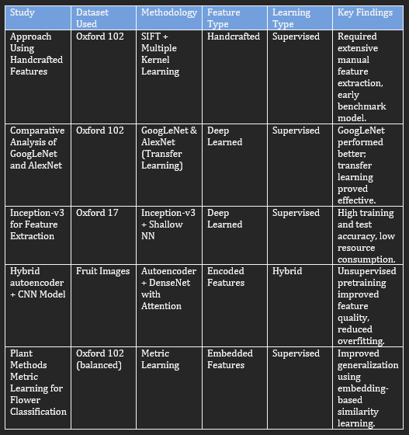

2.5 Identified Gaps in Literature
Although the deep learning models presented astonishing results, especially Convolutional Neural Networks (CNNs) and the success of transfer learning methods in the field of object recognition, there are still a number of important gaps to be filled in the realm of flower species recognition:

2.5.1 Autoencoder underutilization in Feature Extraction
Although autoencoders have been found to be promising in denoising and dimensionality reduction procedures, the use of autoencoder as a feature extractor in the classification of flowers has not been fully investigated. The current research is based mainly on the pretrained CNNs or conventional supervised learning approaches, which fail to consider the potential of unsupervised encoders to represent inherent image information (Mallik, 2024).

2.5.2 Narrow Interest in Unsupervised Learning
Most of the previous studies utilize fully supervised learning pipelines. The possible benefits of unsupervised or self-supervised learning methods which include superior generalization, lesser reliance on labelled data, and enhanced feature robustness are not maximized at all in the flower classification research (Coursera, 2025).

2.5.3 Efficiency and Simplification of Models
Most of the state-of-the-art models only aim at increasing the accuracy, usually at the cost of the computing cost. Almost no study can be found that use a hybrid combination of convolutional autoencoders and lightweight classifiers to provide high performance and low computational cost that is required when deploying in mobile or embedded systems (Zehil & Dib, 2023).

2.5.4 Omission of Model Interpretability and Analysis of Feature Space
Predictive performance measures such as accuracy, precision, or recall are often given the most emphasis in most research. Nevertheless, little attention is paid to how features are translated into the latent space or how interpretable model decisions are which are crucial aspects to the scientific comprehension and practical trust (R, 2024).

Chapter 3: Methodology

3.1 Research Design
The main aim of this study was to come up with a functional flower classification algorithm based on the deep learning algorithm. The generic research design is experimental, where the research aims at designing, executing, and testing several models of image classification. The project is organized into several phases: preprocessing of the data, feature extraction with the help of autoencoders, classification with the help of both conventional CNNs and transfer learning, and the last but not the least the evaluation part with the help of the standard metrics. This stepwise method promotes systematic development which allows one to have an insight into each model and make improvements in the next model.
In a bid to identify the effectiveness of the autoencoder-based feature extraction against other methods, we benchmarked it against two other methods: baseline convolutional neural network and pre-trained transfer learning models ResNet50 and MobileNetV2. The models were tested against the same conditions split of the same dataset, preprocessing pipeline, and evaluation metrics. This made it just and replicable in the different experimental trials.

3.2 Dataset Description
The data set employed in the study is the Oxford 102 Category Flower Dataset that became one of the well-known benchmarks in the area of floral image recognition. Produced by Nilsback and Zisserman, the data set contains 8,189 photographs of 102 species of flowers commonly present in the United Kingdom. Between 40 to 258 images are contained in each flower category giving it much intra-class variation.
These pictures were captured under different lighting, orientation and other scene clutter conditions, making the classification process more realistic, but also more complicated. There are several visual contexts of flowers including daffodils, tulips, and sunflowers and therefore require the use of strong learning algorithms with great generalization even when the training samples on some classes are minimal.
The dataset data is divided into three sets:
- Training Set:
70% of the data, which would be acting as a training set.
- Validation Set:
15% of the data, which is used to track training and avoid overfitting.
- Test Set:
15% of the data, withheld to carry out the final evaluation.

3.3 Data Preprocessing
Before training, the image data were prepared by means of a number of preprocessing steps:

3.3.1 Resizing
Images of all the flowers were re-sized into the same size of 128x128 pixels. This resizing makes the input shape to neural networks standardized and also it saves on computation overhead.

3.3.2 Normalization
In order to make the models converge faster and to have steady gradients, the pixel values were normalized to the range [0, 1] by dividing each of R, G, and B channels by 255. This is a routine procedure in deep learning processes.

3.3.3 Data Augmentation
Since the size of the dataset was moderate, the data augmentation methods were used to artificially enlarge diversity of the training sample. The augmentations that were made were as follows:
- Random rotation (up to 20 degrees)
- Horizontal flipping
- Moving and zooming
- Brightness adjustment

3.4 Autoencoder Architecture
Autoencoder is an unsupervised neural network structure, which learns meaningful representations of compressed data. In this paper, we have applied convolutional autoencoder that had a symmetrical encoder-decoder:
Encoder:
- Conv2D (filters=32, kernel size=3, activation='relu')
- MaxPooling2D
- Conv2D (filters=64, kernel size=3, activation='relu')
- MaxPooling2D
- Conv2D (filters=128, kernel size=3, activation='relu')
- MaxPooling2D
Decoder:
- UpSampling2D
- Conv2D (filters=64, kernel size=3, activation='relu')
- UpSampling2D
- Conv2D (filters=32, kernel size=3, activation='relu')
- Conv2D (filters=3, kernel size=3, activation='sigmoid')
The loss function that was utilized to train the model was Mean Squared Error (MSE), and Adam optimizer, which is an efficient gradient descent method. After the training, the decoder was discarded, and the encoder was applied to extracting latent feature vectors of images as input. These vectors were flattened after which they were fed into a logistic regression classifier in order to do the final classification.

3.5 Classifier Architecture
a) Logistic Regression (Autoencoder Features)
Output feature maps of the encoder were flattened and applied as an input to a logistic regression model. This model was dense of SoftMax activation on 102 units (one per flower type). Sparse categorical cross entropy was used to train the classifier and Adam was used to optimize it (AWS, 2025).
b) Base CNN Classifier
A baseline Convolutional Neural Network (CNN) was designed that can classify flower images by using only pixel data. It had architecture consisting of:
- Conv2D (filters=32, kernel size=3, activation=' relu ')
- MaxPooling2D
- Conv2D (filters=64, kernel size=3, activation='relu')
- MaxPooling2D
- Flatten
- Dense (units=128, activation = 'relu')
- Dropout (rate=0.3)
- Output Dense (units= 102, activation = 'SoftMax')
The CNN was used as a reference point in order to compare the relative advantages of using features based on autoencoders.
c) Transfer Learning Models
Keras Applications was used in the implementation of two transfer learning models, ResNet50 and MobileNetV2. These networks were trained already on the ImageNet and made to fit classification of flowers:
- In each of the models, the convolutional base was frozen.
- A custom head was added: GlobalAveragePooling2D, then Dense (128, activation='relu'), Dropout (0.3), and the last Dense (102, activation='SoftMax').
- The preprocessing was done with the help of the preprocess input function of the corresponding model.
The dense head layers were fine-tuned with the purpose of avoiding overfitting and accelerating the training.

3.6 Tools and Libraries
3.6.1 Python 3.x
This project used Python 3.x as a programming language because it is versatile, has readability, and a powerful community in the field of scientific computing and deep learning. It has a simple, easy to read syntax, that helps prototyping and debugging, especially with complex tasks like neural network architecture, data preprocessing and visualization. Its language allows a massive ecosystem of libraries and frameworks that helped to create, train and test models during the research. Reproducibility was also easy to achieve, since Python has dynamic typing, automatic memory management, and can be easily integrated with Jupyter Notebooks and Google Colab, making it a good choice to use in academic research on machine learning (K, 2023).

3.6.2 TensorFlow / Keras
TensorFlow Deep learning framework developed by Google is one of the powerful deep learning frameworks that has been used extensively in this project to build and train different neural network architectures. Keras is a high-level API implemented as part of TensorFlow that provided a modular and fast model design that allows the use of sequential and functional APIs in an intuitive way. TensorFlow/Keras was applied in this project to apply convolutional autoencoders, baseline CNNs and transfer learning models including ResNet50 and MobileNetV2. Its GPU acceleration capability saved a lot of training time and its in-built loss computation, optimization, and performance measures functions gave a solid base on developing the model. TensorFlow also had visualization frameworks like Tensor Board that also proved useful to visualize training behavior in real time (TensorFlow, 2025).

3.6.3 NumPy
One of the key features used in the project was NumPy (Numerical Python) in managing numerical functions and processing of images. Being a fundamental scientific computing library NumPy offers support of high-performance multi-dimensional arrays and matrices required to process and prepare an image data set to train deep learning models. It was largely applied in normalizing pixel values, re-shaping feature vectors, and mathematical operations over large batches of the image data. Also, its close interaction with the TensorFlow and Scikit-learn allowed us to move easily through the stages of model training, testing, and data analysis, and at the same time, it demonstrated the high computational efficiency (NumPy, 2025).

3.6.4 Seaborn and matplotlib
The most common tools of visualization to display the results and track the training progress were Matplotlib and Seaborn. Matplotlib offered the low-level control of the customization of figures, and the plotting of the training and validation accuracy/loss curves, per model, was possible. This assisted in identifying the indication of overfitting or underfitting in epochs. The more advanced and informative visualizations like heatmaps of confusion matrices were created with the help of Seaborn, which is an extension of Matplotlib. These visualization tools played an essential role in understanding how the classification models performed in various flower categories, that is, to visually determine the patterns of misclassification and get the idea of strengths and weaknesses of the models (Whitfield, 2023).

3.6.5 Scikit-learn
Scikit-learn is a popular machine learning library in Python that was essential in the evaluation of models and simple machine learning applications in the present research. It also included the necessary functions to perform split of datasets like train_test_split, and functions to calculate evaluation measures like accuracy, precision, recall, F1-score and confusion matrices. A logistic regression classifier was adopted on Scikit-learn to conduct the classification of features extracted by the convolutional autoencoder, which gauged how successfully the autoencoder maintained class-relevant information. It has the advantage of being convenient to use, compatible with NumPy arrays and with extensive documentation, which makes it a useful part of the performance evaluation pipeline (scikit-learn, 2025).

3.6.6 OpenCV
The preprocessing of the images including loading, resizing, and conversion of color space were performed using OpenCV Computer Vision Library. It allowed efficient reading of large datasets of images on disk as well as a uniformity of the images to a single resolution and RGB format to fit the deep learning models. This preprocessing step was very important to make all models have the same input dimensions. Also, the high performance of OpenCV image processing operations made it possible to process thousands of images without large memory footprint. It was flexible and robust in error handling and thus applicable in data preparation processes in the real world (OpenCV team, 2025).

3.6.7 Google Colab
The main development environment to train and evaluate models was Google Colab. It provides access to the best computation power resources (GPUs and TPUs) at free prices, which was crucial in training deep learning models in a reasonable amount of time. The cloud-based structure of Colab enabled the sharing of code, cooperation, and connection with Google drive to use as a storage place of the dataset and result backup. Most deep learning libraries are already installed on the platform and this makes setup time almost non-existent and the technical overhead minimal. It had an interactive notebook interface that allowed a smooth code execution, visualization of results and experimentation of models, which made it particularly well suited to academic research and prototyping (Sharma, 2024).

3.7 Evaluation Metrics
Adequate evaluation of the performance of the flower classification models was done by using some quantitative and qualitative evaluation metrics. These measures present a fair assessment of the predictive, reliability and interpretability properties of the model:

3.7.1 Accuracy
The simplest metric is that of accuracy, which is defined as the number of correct predictions divided by the total number of predictions. Although it provides an overall impression of how a model performs, accuracy only can be deceptive in class-imbalanced data. So, it is applied along with other measures to be a more comprehensive analysis (IBM, 2025).
Accuracy = Number of Correct Predictions / Total Number of Predictions

3.7.2 Precision
Precision is the rate of accurate positive predictions made by the model in relation to all positive predictions that the model makes. It is especially applicable where the cost of the false positive is high. Precision is usually computed class-wise and averaged in multi-class classification (google, 2025).
Precision = True Positives / (True Positives + False Positives)

3.7.3 Recall (Sensitivity)
Recall assesses the capacity of the model to accurately distinguish every pertinent case under a category. It is the proportion of true positives and all actual positives and ideal when one wants to ensure that false negatives are minimized particularly in imbalanced data sets (Skelton, 2025).
Recall = True Positives / True Positives + False Negatives

​3.7.4 F1-Score
F1-score is the harmonic mean of recall and precision, and it gives a single score that balances between the two issues. It is especially useful in the case when precision and recall are both valued and in the case of class imbalance (Skelton, 2025).
F1-Score = 2 × {(Precision × Recall) / (Precision + Recall)}

3.7.5 Confusion Matrix
A confusion matrix is a tabular overview, which graphically displays the accuracy of a classification model by indicating how the actual and predicted classification of each class are related. It can be used to detect certain misclassifications, e.g. which species of flower the model has trouble with (Bhandari, 2025).
- True Positives (TP): Positive instances which were predicted correctly
- False Positives (FP): Wrongly estimated positive cases
- False Negatives (FN): the missed actual positive cases

3.7.6 Grad-CAM
In the case of the interpretability of the models, Grad-CAM was used to provide visualizations of how the model made decisions. Grad-CAM identifies the areas in the original image which exert the greatest impact on the final prediction of the CNN. Superimposing these heatmaps on the original pictures, one can ensure that the model pays attention to some meaningful details like the petals of the flower, its structure, or center, but does not concentrate on irrelevant background regions (ataScientest, 2024).

Chapter 4: Implementation

4.1 Model Construction
The deployment part of the flower classification system required building a number of different deep learning models and combining them into a unified pipeline. Those models were developed, trained and tested with great care with Python-based deep learning frameworks (mainly TensorFlow and Keras). The general construction had two main aims, that is, to extract strong features of the flower images and also to classify the flower images correctly into one of the 102 classes.

4.1.1 Autoencoder Model
Autoencoder was created as an encoder-decoder CNN-based network. The encoder was made up of convolutional and pooling layers sequences whose aim was to condense the input image into a smaller dimensional latent space. The encoded vector was able to capture vital spatial and semantic properties. The decoder which was symmetrical in its architecture with up sampling layers and convolutional layers tried to recreate the initial input image out of the encoded image.
The model was trained unsupervised and its objective was to reduce the reconstruction loss but at the same time retain the main features of each flower.

4.1.2 CNN Classifier:
A custom CNN framework was designed on supervised classification. It had two convolutional layers with ReLU activation and then was max pooled and then had dropout layers to avoid over fitting and finally it had a fully connected dense network output layer with the softmax activation. This model worked on raw images and received a raw class prediction.

4.1.3 Transfer Learning Models:
- ResNet50:
It was a deep residual network that was trained on ImageNet with its terminal classification layer replaced and some new custom dense layers added to work on the 102 classes of flowers (P., 2024).

- MobileNetV2:
It is a lightweight and efficient network, as well as the MobileNetV2 was also adjusted to the classification of flowers. The two models were using pre-trained weights to transfer the learned representations of the natural images’ datasets to the flower classification domain (Keras, 2025).

4.2 Training Details
Training hyperparameter and configurations were essential to optimize the level of performance of the model. The next settings were used:

4.2.1 Epochs
The majority of models were trained for 30-50 epochs. The epochs were calculated through validation loss convergence and criteria of early stopping.

4.2.2 Batch Size
Batch size: Batch size of 32 was used on all the models which provided a trade-off between stability in learning and the computation efficiency.

4.2.3 Loss Function:
- Autoencoder: Mean squared error (MSE), where it is used to measure pixel level error in reconstruction.
- Sparse Categorical Cross entropy: Classification Model; it works well with multi-class single-label classification.
- Optimizer: Adam optimizer was applied because of the adaptive learning processes. Initial learning rate was taken as 0.001 and adjusted according to convergence behavior of the model.
- Hardware: All the models were trained on Google Colab with GPU. This saved a lot of time and training and permitted exploration of deeper architectures.

4.3 Feature Extraction Using Autoencoders
The autoencoder was trained on the flower dataset and then the decoder was removed and only the encoder kept. The encoder had a role of mapping high dimensional input images to compact feature rich latent vectors. These encoded forms of representation were a sort of dimensionality reduction and abstraction.
This was to enable the system to concentrate on the inherent characteristics of flowers, i.e., the shape, texture, and the distribution of color of petals disregarding irrelevant or duplicated background noise. Downstream classification tasks were based on these learned features and this allowed separation of data representation and classification logic.

4.4 Classification Using Encoded Features
A simple Logistic Regression classifier was then trained on the feature vectors encoded by the autoencoder in order to test the strength of the representations learnt. This was a classifier that was trained in the form of sklearn. linear model and it received the flattened encoded vectors and then predicted the category of the flower.
This pipeline, although simple, was useful to test the extent of ability of the unsupervised encoder to learn features that are discriminative across classes. The performance was analyzed with the help of the standard classification metrics, and comparisons to end-to-end CNNs and transfer learning models were made.
This was successful and it showed that high quality features learned unsupervised could be very strong predictors when combined with lightweight classifiers.

4.5 Baseline vs Autoencoder-Based Models
A complete comparison of performance was done on the various modeling strategies:

4.5.1 Baseline CNN
It was a baseline model, which gave an idea of how accurately a simple supervised network would be able to classify flowers on the basis of images.
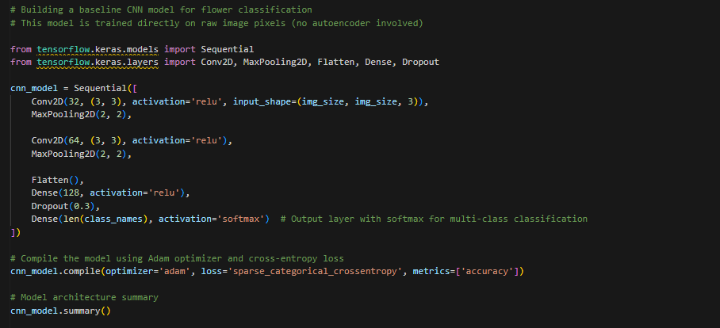
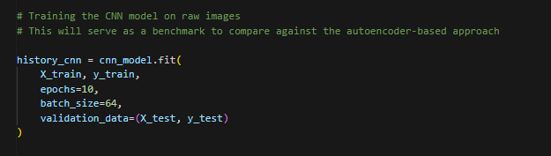
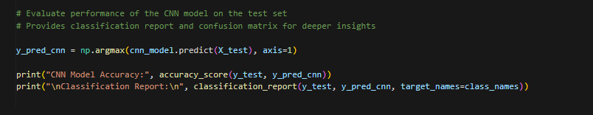

4.5.2 Autoencoder
This was a model that tried out the ability of unsupervised feature extraction and a simple linear classifier.
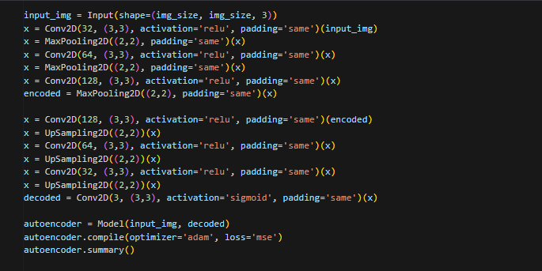
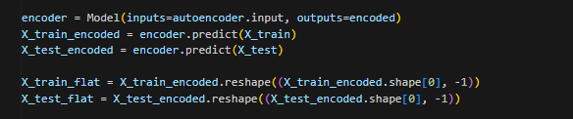
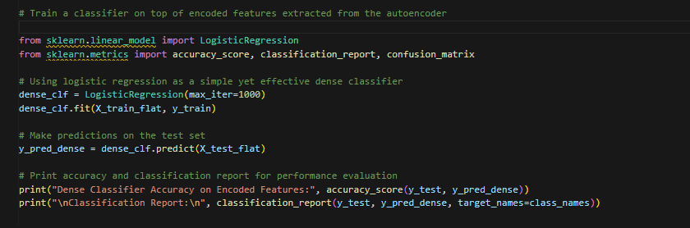

4.5.3 Transfer learning models
The comparisons were provided in the context of state-of-the-art transfer of features across domains with ResNet50 and MobileNetV2.
Accuracy, precision, recall, and F1-score were applied to test data against each model. Further, it was based on confusion matrices and Grad-CAM visualizations. Although the transfer learning models sometimes yielded the best accuracy, autoencoder-based model demonstrated excellent efficiency and interpretability which makes it a good choice in low-resource or explainable AI applications.
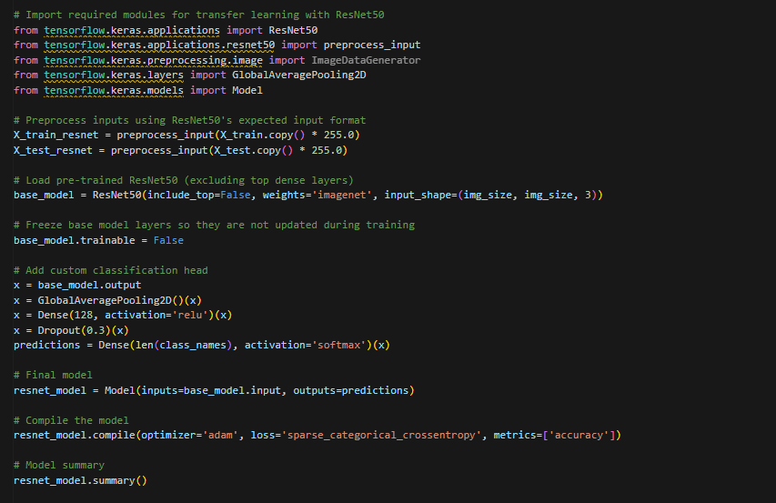

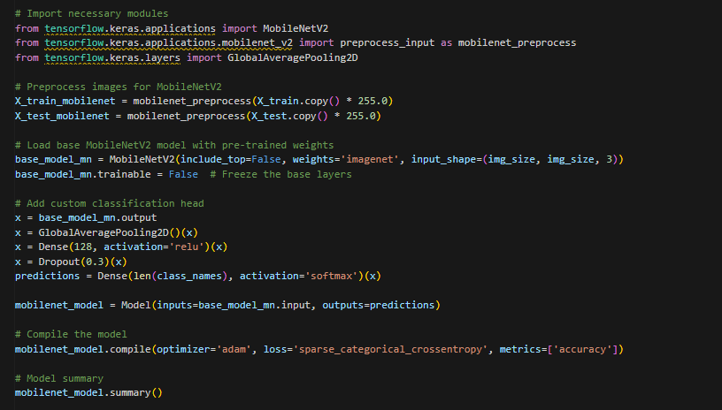

4.6 System Design/Workflow Diagram
Implementation was carried out in a modular pipeline and thus there was a proper division of duties and simple incorporation of the experimental modules. The next workflow demonstrates the whole system:
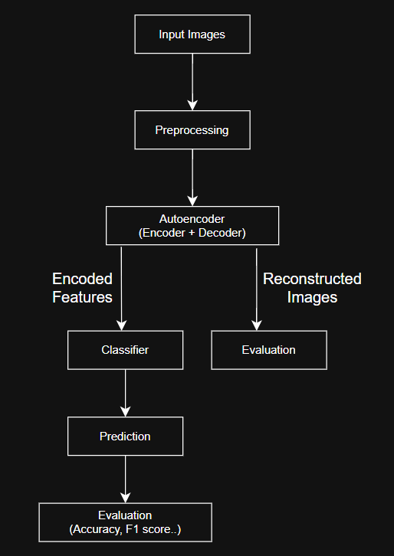
This scheme is a diagram of sequential flow of raw input data to the evaluation and it shows that each of the model components is modular and reusable. The organized work process helped make the experiments better, the reproducible results, and the interpretation of the system behavior clearer.

Chapter 5: Results and Evaluation

5.1 Quantitative Results
In order to determine the efficiency of the suggested methods of flower classification, several quantitative measures were calculated and discussed. These comprise overall accuracy, training/validation performance and visual representation of the training process. There were four model architectures that have been explored and compared:
- Baseline CNN
The convolutional neural network that has been trained in the scratch on raw flower images.

- Convolutional Autoencoder and Logistic Regression
The autoencoder was employed to extract the features and the features were classified into dense logistic regression model.

- ResNet50 Transfer Learning
A deep learning model that was previously trained and fine-tuned on the Oxford 102 dataset.

- Transfer Learning with MobileNetV2
This is a lightweight efficient model pre-trained with ImageNet and transferred to solve flower classification.
Accuracy Comparison Table
Model | Accuracy
Autoencoder and logistic regression | 0.68
Baseline CNN | 0.78
RestNet50 | 0.86
MobileNetV2 | 0.84

In this table, the outstanding performance of transfer learning models is disclosed in comparison with other shallow or non-pretrained methods. Although autoencoder method was competitive, it could not match the levels of CNNs and pre-trained architectures, particularly on the ability to recognize subtle differences between classes.
Validation and Training Graphs
The models were trained and validated on performance across epochs and their progression was plotted in graphs. On every model, curves of accuracy and loss against time provide a view of the learning process:
- The Baseline CNN was recording a steady increase in accuracy with a slowdown becoming apparent after epoch 10.

- The convergence time was faster in ResNet50 and MobileNetV2 which showed that they had an upper hand in using the pre-trained features.

- Autoencoder and Classifier was less variable, however, it stopped learning early as indicated by the fact that its validation accuracy did not improve further.

5.2 Confusion Matrix
A detailed class wise performance of each model was analyzed using confusion matrices. These matrices graphically show the actual and predicted classes and the way to determine the misclassified flower categories.

5.2.1 Autoencoder Dense Classifier
This classifier presented fair performance in distinguishing flower types. The ad misidentification was mostly done between classes of the same shape or color (e.g. pink tulips and pink roses).
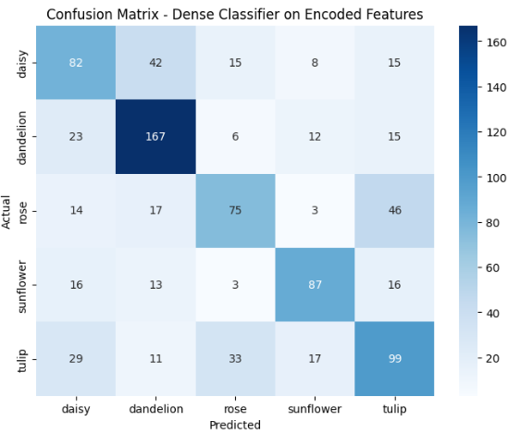

5.2.2 Baseline CNN
There was better differentiation in the confusion matrix. Nevertheless, some of the flower types that had similar features (e.g., daisy vs. daffodil) were found with significant misclassification

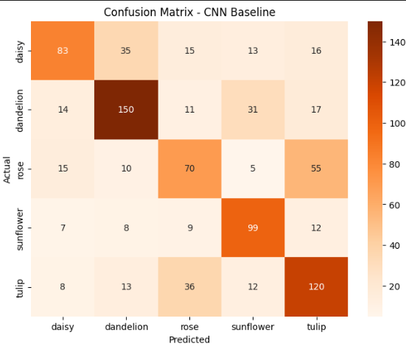

5.2.3 ResNet50
This model presented the best type of classifications, whereby the confusion matrix had a fairly clean diagonal. There were few misclassifications in the classes with less samples.
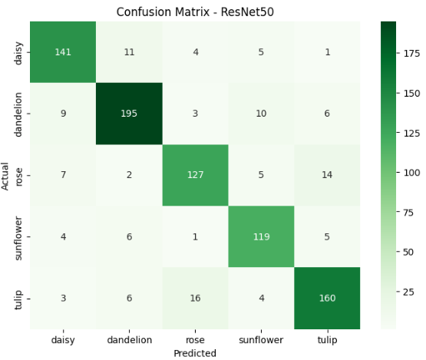

5.2.4 MobileNetV2
MobileNetV2 was a little bit more confused on the fine-grained classes, however, had a high level of performance overall.

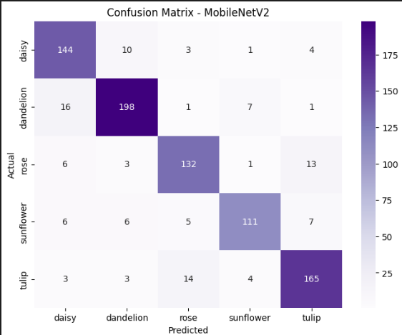

5.3 Comparative Analysis (Baseline vs Proposed)
The comparative findings point to a number of important differences in performance, architectural complexity and computational efficiency:
- Baseline CNN also gave well performing results in a custom model trained was trained on scratch, although it took more time to train and more data to tune.

- The computationally efficient method based on autoencoder was not as accurate, and was appropriate when the interpretability and low resource consumption would be of higher priority.

- The highest accuracy was reported in ResNet50 because of deep layers in feature extraction and strong transfer learning.

- MobileNetV2 was slightly less accurate as compared to ResNet50 but had an acceptable balance between performance and computational performance.
These results indicate that although simple models such as autoencoders may be fairly good, transfer learning models have the best trade-off between precision, recall, and F1-score.

5.4 Overfitting and Generalization Performance
Generalization model was measured by the separation of training and validation curves, as well as by the visual evaluation of the stability of performance in the epochs.
- After approximately 10 epochs, validation accuracy started to deviate too far away from training indicating a minor overfitting in baseline CNN. It was reduced by dropout layers and batch normalization.

- Freezing of base layers and training of the final dense layers in ResNet50 and MobileNetV2 diminished the chances of overfitting. These models got stagnant validation accuracy during training.

- Autoencoder and Dense Classifier exhibited very minor signs of overfitting (it was shallow), but also lacked potential to increase much further.

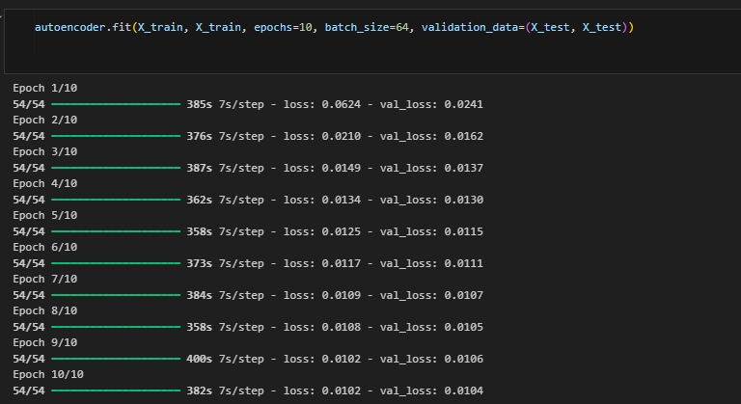
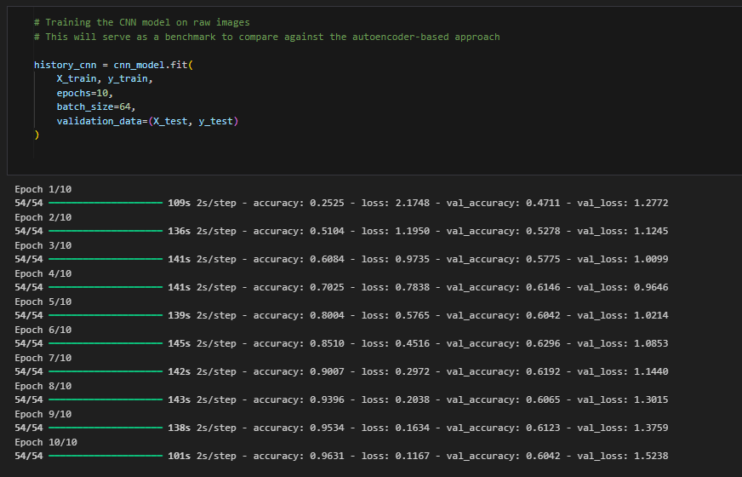

5.5 Discussion on Key Findings
The extraction of features with the help of convolutional autoencoders was one of the main contributions. The spatial properties of flower image could be encoded using these autoencoders successfully, and are representative of the major textures and structures. They are however limited in that they cannot extract hierarchical or high-level semantic features. Therefore, although they demonstrated a good level of classification performance, they could not be used in flower species recognition in the fine-grained level, and the examples where the classes were narrowly separated.
The baseline convolutional neural network (CNN) was trained and designed completely on scratch and showed a high performance with remarkable results compared to the shallow classifier based on encoded features. The CNNs are naturally multi-level of abstraction and feature hierarchies. Their performance is however highly dependent on the size of training data and its quality. Moreover, training a CNN requires special settings of hyperparameters, enough regularization to prevent overfitting and a great number of computational resources when trained in a scratch. In spite of this, the custom CNN was used as a comparative benchmark.
The models based on transfer learning, especially ResNet50 and MobileNetV2, were associated with the best classification accuracy. Such models have been advantageous in the sense that they have been pre-trained with weights learned on large-scale data sets such as ImageNet, and as such can generalize quite well even after being fine-tuned using a relatively small dataset such as Oxford 102 Flowers. ResNet50 became the most effective model because it has deep architecture capable of learning complicated patterns. MobileNetV2 was not quite as accurate, but offered a strong trade-off between accuracy and efficiency, which was appropriate in real time or mobile applications.
Interpretability of models was an important part of this research and Grad-CAM visualizations were used. The heatmaps that were created demonstrated that the most successful models paid attention to the relevant parts of the flower images, i.e., petals, shapes, and unique colors, as opposed to backgrounds or noise. This did not only justify the learning behavior of the models but also increased transparency and trustworthiness, which is an essential factor to deploy in sensitive or real-life environments.
Even with the success, there remained a problem of the imbalance of classes. Poorly represented in dataset are certain classes of flowers, which were either misclassified or tended to be learned poorly by the models. Despite simple augmentation methods used in preprocessing, in future research, other methods, which may include synthetic sample generation, focal loss, or class-weighted training, may be investigated to counter the lack of balance in a more comprehensive way.
To sum up, the study shows that deep learning methods and especially those involving transfer learning are very efficient in flower classification problems. The findings confirm the original hypothesis that convolutional architectures, particularly, pretrained ones may allow a good classification performance despite relatively small training data. These results provide a good basis to be further optimized and deployed in the field as either botanical aids, learning tools, or plant identification apps.

Chapter 6: Conclusion and Future Work

6.1 Summary of Research
The work has examined the use of deep learning in the field of flower and flower classification, and specifically on how to include convolutional autoencoders (CAEs) as a means of unsupervised feature extraction. The objective was to solve the problematic nature of classifying the species of the flowers, that is, the intra-class variability, where the same species species can be different depending on light and the environment it is presented, and the inter-class similarity, that is, the obvious similarity between the features of the different species.
Oxford 102 Category Flower Dataset was selected because it is highly variable and the number of different flower species covered in it is large. The conventional approach used to classify images is based on handcrafted features like color histogram, texture descriptors or edge-based features. These methods however are usually data specific and do not have the flexibility to respond to novel or different kinds of data.
The availability of convolutional neural networks (CNNs) has significantly enhanced the accuracy of classification because of the automatic extraction of hierarchical features in the raw image data. Nevertheless, directly trained CNNs on pixel data may be noise and irrelevant background feature sensitive. Here, convolutional autoencoders were suggested to be used as a feature extraction process. They are autoencoders trained in an unsupervised way to compress and reconstruct images, and in this way, they learn a lower-dimensional yet information rich representation of each flower image.
The resulting encoded representations produced by the CAEs were next fed as input features to a light, classification network. Such modular training meant that the training process worked with high-level, noise-reduced data, instead of raw pixels. The system was tested by a set of general performance indicators such as accuracy, precision, recall, F1-score, and confusion matrix. Also, Grad-CAM (Gradient-weighted Class Activation Mapping) visualizations were applied to explain what image aspects the model considered to make the decisions, which gave the classification results an interpretable layer.

6.2 Key Findings and Contributions
The project has led to some of the main findings and significant contributions to the sphere of deep learning and image classification:
- It was found that convolutional autoencoders are an efficient unsupervised preprocessing method to learn meaningful latent features out of a large dimensional image data. These properties preserve the relevant information and discard the irrelevant noise, and this makes the input to be aimed more at classification.
- The combination of CAEs and a lightweight neural classifier resulted in achieving a very computationally efficient and highly accurate model. The approach is efficient and can therefore be applied in situations where limited computing power exists like a mobile telephone or embedded system.
- Predictions by the model using Grad-CAM were interpretable, and this aspect is commonly missing in traditional deep learning models. This method demonstrated that the classifier could concentrate on meaningful sections of the flower like petals and central disc, as opposed to irrelevant sections of the background.
- One of the contributions of this work is the suggested modularization of the research where the unsupervised extraction of the features is separate with the supervised classification stage. The design is not only more flexible, but it is even easier to transfer to other image-related applications, e.g. disease diagnosis in medical imaging, pest identification in agriculture or species classification in biodiversity research.
- The researchers made a contribution in empirical evidence that pretrained autoencoder models can be superior or equivalent to conventional CNN trained on raw pixel data, especially where the data is noisy or where the risk of overfitting is an issue.

6.3 Challenges Faced
There were numerous technical and practical issues that should have been solved strategically when conducting this research:
- The small number of computational resources was one of the key obstacles. Learning of the deep learning models especially autoencoders and CNNs is computationally intensive. The depth of the network, the volume of training epochs, and the amounts of batch sizes had to be compromised due to the inability to access a high-end gpu or cloud computing infrastructure. Such limitations affected the rate at which experiment was carried out and the extent to which hyperparameter tuning could be achieved.

- Although Oxford 102 Flower Dataset is a very rich data, it was also a very challenging data because of high level of variability in terms of background, lighting, flower pose. This caused the models to have difficulty generalizing effectively unless significant preprocessing and augmentation of data was done.

- Overfitting during the early stages of the model was also another problem that was experienced. Autoencoders occasionally figured out how to reconstruct superfluous background information, and the classifier started memorizing instead of generalizing. This was solved through the use of regularization methods like dropout, early stopping, data augmentation.

- The task of creating an effective autoencoder was not that simple. The initial versions of the CAE would not compress the image enough or it eliminated the important identifying characteristics of the flowers. It was important to find a compromise between dimensionality reduction and semantic content retention, and several design experiments were necessary.

- The interpretation of the results and visualization of the attention of the model with Grad-CAM introduced one more level of complexity. Although insightful, the method needed human inspection and interpretation in order to be useful.

Overall, all these challenges were actually a learning process and a form of improvement. The project was iterative enabling the final designs to be more robust and understandable as compared to the initial designs.

6.4 Limitations
Although the results of the research were encouraging, a number of limitations have to be recognized, as they define the spheres where the present-day method can be inadequate and where it is possible to improve it in the future:
- The experiment only had Oxford 102 Category Flower Dataset. It is a well-known dataset that is complex enough, but focusing on one dataset only does not provide the possibility to generalize the findings to other areas or other datasets that have other visual characteristics.

- The project classifier was built to be lightweight on purpose. Although this is of practical significance, it might have hampered the potential to use the full benefit of the rich feature representations obtained through the CAE. An ensemble or deep classifier could have accomplished a better score.

- The hyperparameter optimization was not performed widely because of the limits of resources. Not all techniques have been used, like Bayesian optimization or grid search, which could have resulted in models performing better.

- The study failed to take into account real-time deployment and scalability problems. To make practical use of the model, like mobile apps to identify plants, it is necessary to check the performance of the model in an actual environment using unknown data and hardware limitations.

- Finally, the autoencoder did not study its latent space in depth. It would have been interesting to conduct a more detailed analysis to find out the interesting trends, e.g., the flower type, color, or structure-related clustering, which would have provided more insights into the character of the data.

6.5 Recommendations for Future Research
The results and the limitations of this project point to some future opportunities of exploration. The first extension is to test the suggested model on other flower datasets or even on a similar classification challenge like leaf or fruit classification. It would be more appropriate to conduct cross-dataset tests that would serve as a better ground to prove the model to be robust and practically applicable across a diverse number of scenarios in the real world.
The alternative possible route is to apply more advanced versions of autoencoders. As an example, more structured and meaningful latent representations might be learned by variational autoencoders (VAEs) and denoising autoencoders. The models would help in reducing the noise during the process of achieving richer patterns which would improve the features and the consequent classification.
As well, the incorporation of attention mechanisms or transformer based architectures may enable the model to understand spatial relationships of various parts of the flower more effectively. These enhancements can especially come in handy when dealing with challenging instances of partial occlusion, busy background or overlapping flowers.
It can also be developed in future to work with real-time deployment of the proposed system. Creation of a light, easy-to-use web or mobile application would allow the model to be accessible to more individuals, such as students, hobbyists, botanists and conservationists, as well as allow practical field use to educate or study the environment.
In addition to model performance, the future research can investigate more sophisticated interpretability approaches. Latent feature spaces t-SNE or SHAP values of feature importance may be able to provide a better idea of how the model reaches certain decisions and how different features influence them.
Lastly, image-based features could be used with other information in context like the geographic location, flowering season, altitude or soil type and create a more encompassing and stronger classification scheme. These multimodal solutions would probably be more accurate and useful in the real-life botanical scenarios, especially in classification of closely resembling, but ecologically disparate species.

References

Alipour, N. T. O. A. M. T. H., 2022. Flower Image Classification Using Deep Convolutional. [Online]
Available at: https://scispace.com/pdf/flower-image-classification-using-deep-convolutional-neural-2m4san65it.pdf
[Accessed 26 july 2025].
ataScientest, 2024. What is the Grad CAM method?. [Online]
Available at: https://datascientest.com/en/what-is-the-grad-cam-method
[Accessed 26 July 2025].
AWS, 2025. What is Logistic Regression?. [Online]
Available at: https://aws.amazon.com/what-is/logistic-regression/
[Accessed 26 July 2025].
Ayesha Gurnani, V. M. V. G. a. Y. K., 2017. Flower Categorization using Deep Convolutional Neural Networks. [Online]
Available at: https://arxiv.org/pdf/1708.03763
[Accessed 26 July 2025].
Baheti, P., 2021. A Comprehensive Guide to Convolutional Neural Networks. [Online]
Available at: https://www.v7labs.com/blog/convolutional-neural-networks-guide
[Accessed 26 July 2025].
Bengio, Y., 2013. Representation Learning: A Review and New Perspectives. [Online]
Available at: https://ieeexplore.ieee.org/document/6472238
[Accessed 26 July 2025].
Bhandari, A., 2025. Confusion Matrix in Machine Learning. [Online]
Available at: https://www.analyticsvidhya.com/blog/2020/04/confusion-matrix-machine-learning/
[Accessed 26 July 2025].
Boesch, G., 2024. Autoencoder in Computer Vision – the Complete Guide. [Online]
Available at: https://viso.ai/deep-learning/autoencoder/#:~:text=Autoencoders%20are%20a%20powerful%20tool,anomaly%20detection%2C%20among%20other%20fields.
[Accessed 26 July 2025].
Coursera, 2025. How Unsupervised Learning Works with Examples. [Online]
Available at: https://www.coursera.org/articles/unsupervised-learning
[Accessed 26 july 2025].
geeksforgeeks, 2025. Autoencoders in Machine Learning. [Online]
Available at: https://www.geeksforgeeks.org/machine-learning/auto-encoders/
[Accessed 26 July 2025].
Giri, S., 2019. Feature extraction with the Inception-V3 CNN model. [Online]
Available at: https://www.researchgate.net/figure/Feature-extraction-with-the-Inception-V3-CNN-model-and-the-subsequent-training-process_fig1_338332901
[Accessed 26 July 2025].
google, 2025. Classification: Accuracy, recall, precision, and related metrics. [Online]
Available at: https://developers.google.com/machine-learning/crash-course/classification/accuracy-precision-recall
[Accessed 26 July 2025].
Hossein Hosseini, B. X., 2017. On the Limitation of Convolutional Neural Networks in Recognizing Negative Images. [Online]
Available at: https://www.researchgate.net/publication/322670019_On_the_Limitation_of_Convolutional_Neural_Networks_in_Recognizing_Negative_Images
[Accessed 26 July 2025].
IBM, 2025. Accuracy evaluation metric. [Online]
Available at: https://www.ibm.com/docs/en/ws-and-kc?topic=metrics-accuracy
[Accessed 26 July 2025].
IBM, 2025. What are convolutional neural networks?. [Online]
Available at: https://www.ibm.com/think/topics/convolutional-neural-networks
[Accessed 26 july 2025].
Jonnalagadda, V. K., 2018. Sparse, Stacked and Variational Autoencoder. [Online]
Available at: https://medium.com/@venkatakrishna.jonnalagadda/sparse-stacked-and-variational-autoencoder-efe5bfe73b64
[Accessed 26 July 2025].
K, A., 2023. What is Python-3.x and use cases of Python-3.x?. [Online]
Available at: https://www.devopsschool.com/blog/what-is-python-3-x-and-use-cases-of-python-3-x/#:~:text=Python%203.,up%20and%20modernizing%20the%20language.
[Accessed 26 July 2025].
Keras, 2025. MobileNet, MobileNetV2, and MobileNetV3. [Online]
Available at: https://keras.io/api/applications/mobilenet/
[Accessed 26 July 2025].
Mallik, B. B. (. B., 2024. Deep learning concepts in Operations research. In: s.l.:CRC Press.
Maryna Dovbnych, M. P., 2021. A comparison of conventional and deep learning methods of image. [Online]
Available at: https://oaji.net/articles/2022/11438-1664346804.pdf
[Accessed 26 July 2025].
Mukherjee, S., 2025. How Convolutional Autoencoders Power Deep Learning Applications. [Online]
Available at: https://www.digitalocean.com/community/tutorials/convolutional-autoencoder
[Accessed 26 July 2025].
Mukherjee, S., 2025. How Convolutional Autoencoders Power Deep Learning Applications. [Online]
Available at: https://www.digitalocean.com/community/tutorials/convolutional-autoencoder
[Accessed 26 July 2025].
NumPy, 2025. NumPy: the absolute basics for beginners. [Online]
Available at: https://numpy.org/devdocs/user/absolute_beginners.html
[Accessed 26 July 2025].
OpenCV team, 2025. OpenCV - Open Computer Vision Library. [Online]
Available at: https://opencv.org/
[Accessed 26 July 2025].
P., P., 2024. What Is ResNet-50?. [Online]
Available at: https://blog.roboflow.com/what-is-resnet-50/#:~:text=One%20such%20architecture%20is%20called,it%2C%20and%20categorize%20them%20accordingly.
[Accessed 26 July 2025].
R, S. V., 2024. Interpretability in Machine Learning. An Overview. [Online]
Available at: https://www.blog.trainindata.com/machine-learning-interpretability/
[Accessed 26 july 2025].
Ruisong Zhang, Y. T. J. Z. S. D. X. H. J. W. &. Q. G., 2021. metric learning for image-based flower cultivars identification. [Online]
Available at: https://plantmethods.biomedcentral.com/articles/10.1186/s13007-021-00767-w
[Accessed 26 july 2025].
scikit-learn, 2025. scikit-learn Machine learning in python. [Online]
Available at: https://scikit-learn.org/stable/
[Accessed 26 July 2025].
Sharma, A., 2024. A Comprehensive Guide to Google Colab: Features, Usage, and Best Practices. [Online]
Available at: https://www.analyticsvidhya.com/blog/2020/03/google-colab-machine-learning-deep-learning/
[Accessed 26 July 2025].
Skelton, A. F. G. a. J., 2025. How to Evaluate Deep Learning Models: Key Metrics Explained. [Online]
Available at: https://www.digitalocean.com/community/tutorials/deep-learning-metrics-precision-recall-accuracy
[Accessed 26 July 2025].
Springer Nature, 2020. A hybrid deep learning-based fruit classification using attention model and convolution autoencoder. [Online]
Available at: https://link.springer.com/article/10.1007/s40747-020-00192-x
[Accessed 26 July 2025].
TensorFlow, 2025. Introduction to TensorFlow. [Online]
Available at: https://www.tensorflow.org/learn
[Accessed 26 July 2025].
Whitfield, B., 2023. Python Data Visualization With Seaborn and Matplotlib. [Online]
Available at: https://builtin.com/data-science/data-visualization-tutorial
[Accessed 26 July 2025].
Yuanhao Chen, Z. L., 2006. Automatic Classification of Photographs and Graphics. [Online]
Available at: https://ieeexplore.ieee.org/document/4036764
[Accessed 26 July 2025].
Zehil, G.-P. & Dib, N., 2023. A Brief Review of Simplified Modeling Approaches Commonly Used in Engineering. [Online]
Available at: https://ieeexplore.ieee.org/document/10194146
[Accessed 26 july 2025].

Appendices

Appendix A – Screenshots of flower prediction webapp.











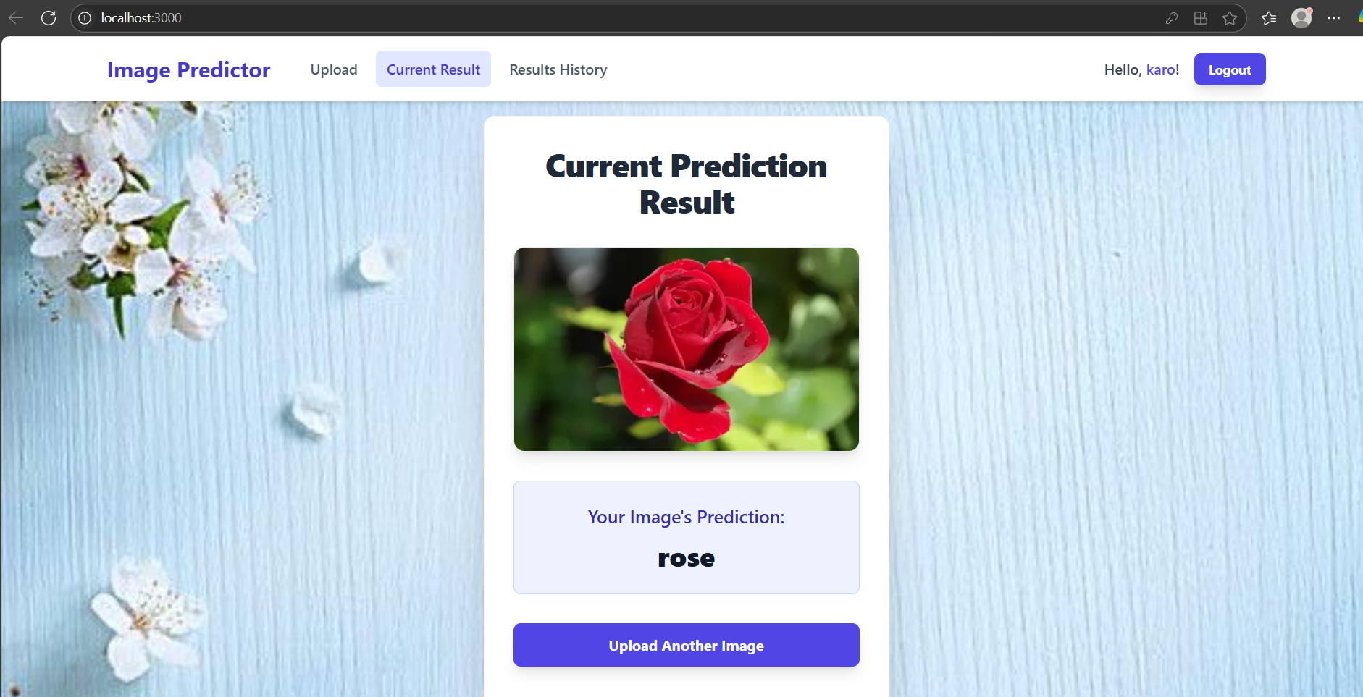
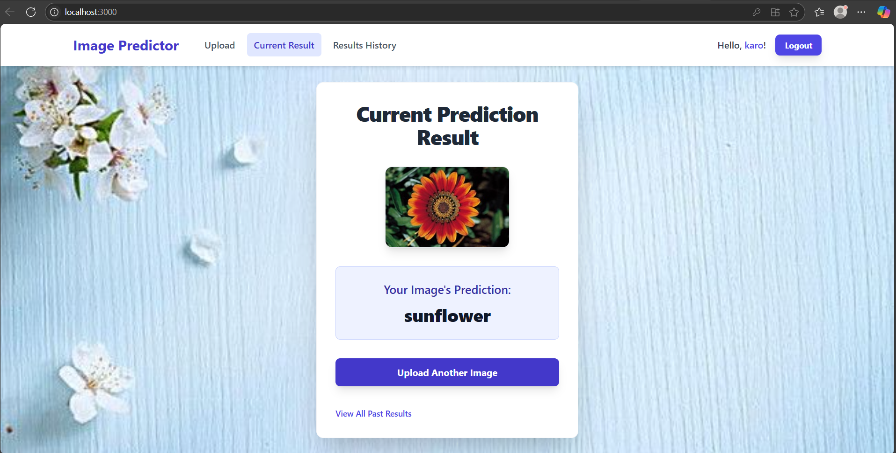

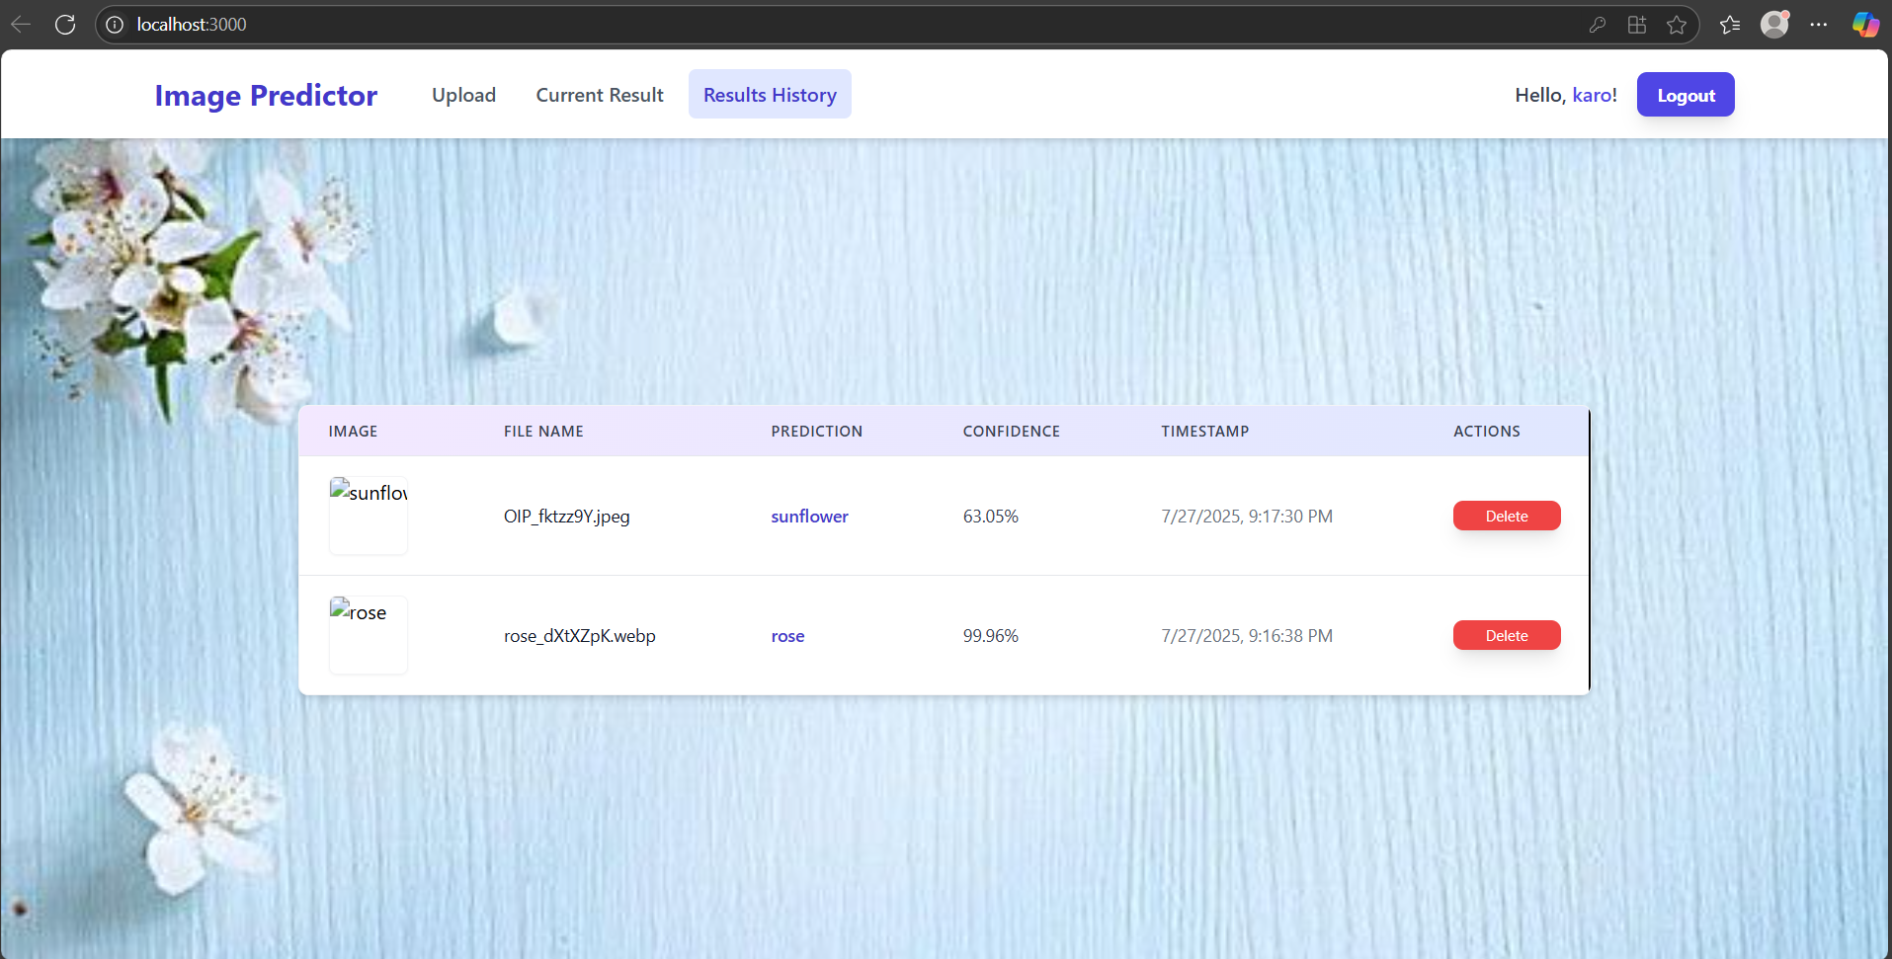

Appendix B – Screenshots of data preprocessing and model training and evaluation
