**Lesson 1. Course Introduction**

Typescript is wrapper around javascript with gives new features like interfaces, strongly typed, generic etc.

Typescript compiler (tsc) compiles typescript code to javascript code(es5,es6) and runs that javascript code.

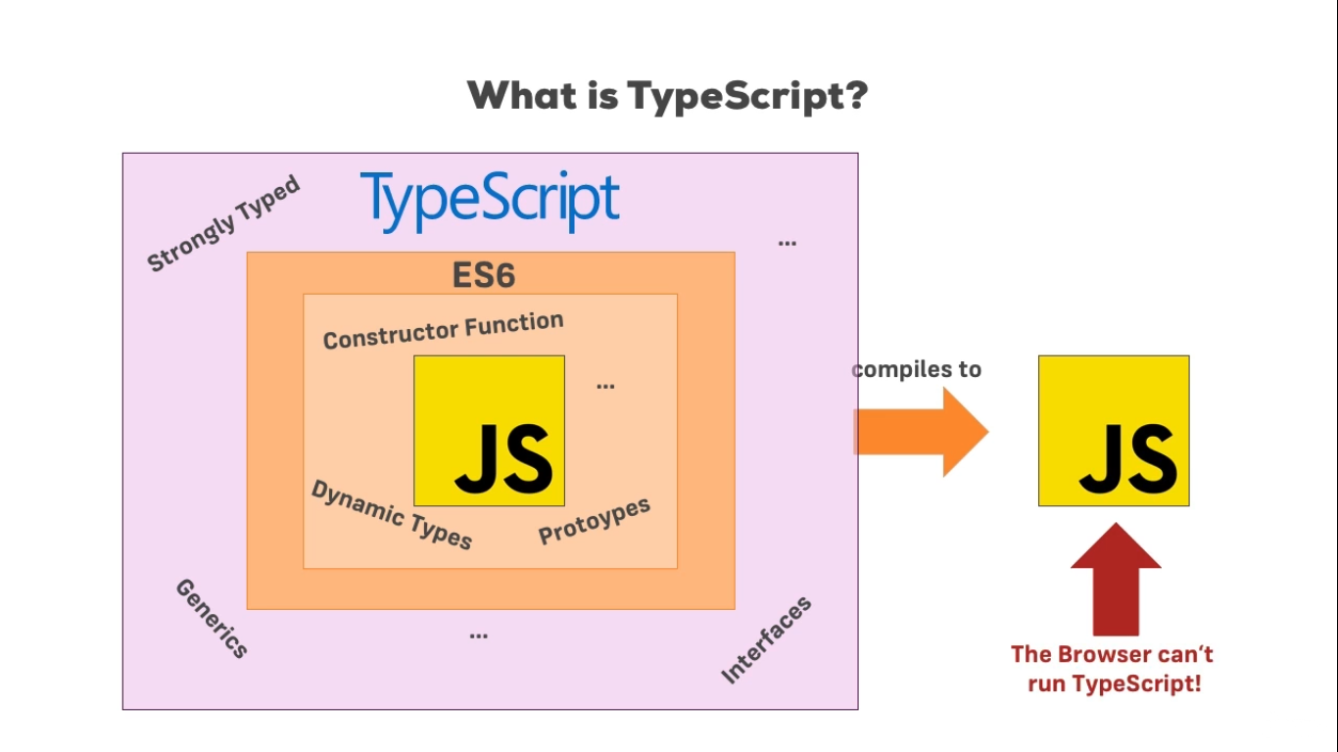

**Lesson 4. Installing TypeScript.mp4**

**To install typescript use following command. (Node must be installed )**

sudo npm -g install typescript

**Lesson 6. Setting up the Course Workspace**

In this we are installing **lite-server (npm i lite-server)** which launches server to run html file with js file.

**Lesson 8. Type Basics**

let myName=”aakash”

myName=10

Above program will run perfectly in javascript but it will give error in typescript since first we assigned variable with string and after that we are trying to assign a number.

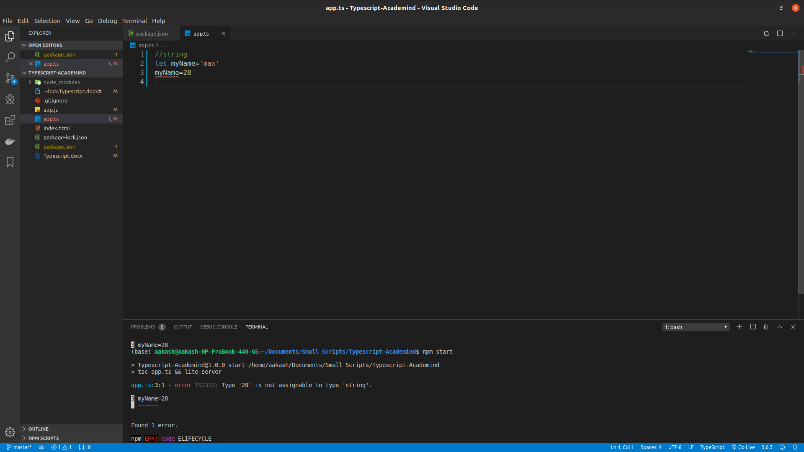

**Lesson 9. Numbers & Booleans**

