horizontal line

**Team Bastions**

pix2category

**23rd October 2017**

# OVERVIEW

MNIST datasets are a very popular way of learning, implementing and benchmarking various Machine Learning algorithms. The Zalando Research group basically made the Fashion MNIST dataset largely as a replacement to the original MNIST dataset. The main reason for the replacement as stated by Zalando is that the original MNIST dataset is too easy and easily yields over 99.7% accuracy. "[Most pairs of MNIST digits can be distinguished pretty well by just one pixel](https://gist.github.com/dgrtwo/aaef94ecc6a60cd50322c0054cc04478)."[1]. Thus, this replaces the original MNIST dataset in term of both baseline complexity and learning different Machine Learning algorithms

We plan on benchmarking a chosen set of Classification Algorithms and identifying other possible patterns in the dataset.

# GOALS

* Each training and test example is assigned to one of the following labels:
  1. **0 T-shirt/top**
  2. **1 Trouser**
  3. **2 Pullover**
  4. **3 Dress**
  5. **4 Coat**
  6. **5 Sandal**
  7. **6 Shirt**
  8. **7 Sneaker**
  9. **8 Bag**
  10. **9 Ankle boot**
* We aim to make a perfect workflow of major classification algorithms and its hyper parameters on TensorBoard/Matplotlib.
* The highest accuracy for this dataset is 89% by the makers of the Fashion MNIST dataset[2]. This is without using Deep Learning. We aim to achieve more than 90% on the same dataset.
* NOTE: Experimental results have gone up to 93% in accuracy by using Deep Learning however exhaustive testing of the same has not been done.
* We also aim to create a comprehensive confusion matrix that will allow a deeper understanding of what the algorithms get wrong and whether there is some pattern in that and to develop an intuitive understanding about the features.

# SPECIFICATIONS

## Data Set

Each image is 28 pixels in height and 28 pixels in width, for a total of 784 pixels in total. Each pixel has a single pixel-value associated with it, indicating the lightness or darkness of that pixel, with higher numbers meaning darker. This pixel-value is an integer between 0 and 255. The training and test data sets have 785 columns. The first column consists of the class labels (see above), and represents the article of clothing. The rest of the columns contain the pixel-values of the associated image.

* To locate a pixel on the image, suppose that we have decomposed x as x = i * 28 + j, where i and j are integers between 0 and 27. The pixel is located on row i and column j of a 28 x 28 matrix.

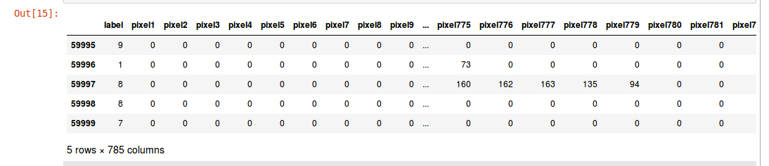

# 

# 

# MILESTONES

* We are using docker setup for python in our project
* We have gathered the Fashion MNIST data from the website – https://www.kaggle.com/zalando-research/fashionmnist/data, which includes both, the test data as well as the trained data for our project
* The meta column retrieved from the data is the pixel location in a 1-D array.
* On this dataset, we will apply the following classification algorithms – K-means, KNN, Experimental SVM and Naive Bayes.
  + We then choose Hyperparameters to tune our model.
  + We will be applying two more classification algorithms - Logistic Regression and Decision Tree
* We decided to shuffle our data, that is trained and test data to see if our algorithm is not biased
* We are applying the technique of preprocessing on our data by repeating the above process again
* After applying all the mentioned algorithms to our data, we will do analysis and calculate the accuracy of each algorithm

# TASKS AND RESPONSIBILITIES

|  |  |  |  |  |  |
| --- | --- | --- | --- | --- | --- |
|  | **Aakash** | **Eshika** | **Juhi** | **Yug** | **Aashti** |
| **Aakash** |  | Naive Bayes | KNN | Exp. SVM | Visualization II |
| **Eshika** | Data Shuffling II |  | K-Means | Decision Tree |  |
| **Juhi** | Bias vs Variance | Data Shuffling I |  | Logistic Regr. |  |
| **Yug** | Feature Analysis | Confusion Matrix | Preprocessing |  |  |
| **Aashti** | Visualization I |  |  |  |  |

1. "Comparing pairs of MNIST digits based on one pixel · GitHub." <https://gist.github.com/dgrtwo/aaef94ecc6a60cd50322c0054cc04478>. Accessed 24 Oct. 2017.
2. "Kaggle." http://fashion-mnist.s3-website.eu-central-1.amazonaws.com/#. Accessed 23 Oct. 2017.