**Usage Document - iAutomate**

1. **Objective**

Purpose of this document is to make Audience understand guidelines to use iAutomate. JAR while working on iAutomate Framework.

1. **Introduction**

This document will enable users of iAutomate to use the iAutomate framework, which is packaged in the jar file. This usage document will guide users on using the automaton framework, by using the Reference Implementation. Javadocs list all utility methods that we need for UI or API automation and can be used for reference.

1. **Prerequisites**

* JDK 1.7 or above
* Maven
* Eclipse or any other IDE which follows Maven Structure
* TestNG
* iAutomate JAR
* SVN Access of **iAutomate jar location:**

<https://192.168.77.176/svn/AX360/trunk/iAutomate-Jars>

* SVN Access of Reference Implementation location**:**

<https://192.168.77.176/svn/AX360/trunk/iAutomate-Ref-Implementation>

* **Access of Javadoc location:** iAutomate-Ref-implementation\doc\index.html

1. **Reference Implementation**

Please take reference of iAutomate-Ref-Implementation project for building UI and API Automation.

testNG.xml in this project has the testclasses that need to be executed as a sample.

Test Classes have 1 testcase automated for UI and 1 for API.

**Constants**.java – Contains a list of constants required for I and API Automation.

**Resources** folder – Contains chromeDriver.exe and Config.properties

**Config.properties** contains browser setting can be done in (browser=chrome / browser=firefox)

Jar contains methods to launch Browser, generating extent reports and logs. Also contains custom methods for control Actions, API Utility methods, miscellaneous support like excel Integraton, etc. Details of these methods can be found in JavaDocs.

1. **Implementation of iAutomate JAR**

**Please follow the following steps to use iAutomate.JAR**

1. Go to package explorer and select root folder of project into eclipse

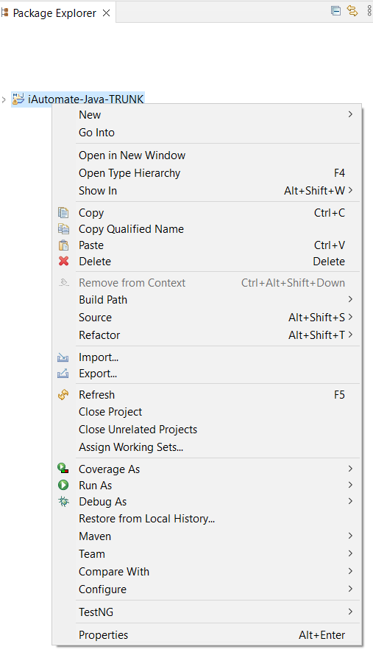

1. Click on properties and go to JAVA Build Path Property option.
2. Go to “Libraries” tab.
3. Add external JAR with name as iAutomate. JAR

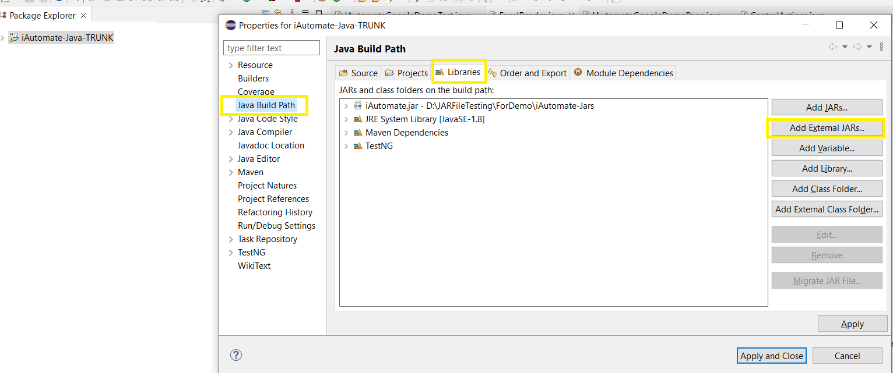

1. **Javadoc**

Please take reference of JAVA Doc for new projects who would use iAutomate, it is the documentation in a set of source file describing usage of following classes

**Troubleshooting tips**

While executing tests as a TestNG.xml or as ‘mvn test’ if you face following error:

[INFO] ------------------------------------------------------------------------[INFO] BUILD FAILURE[INFO] ------------------------------------------------------------------------[INFO] Total time: 15.775 s[INFO] Finished at: 2022-02-21T14:30:43+05:30[INFO] ------------------------------------------------------------------------[ERROR] Failed to execute goal org.apache.maven.plugins:maven-surefire-plugin:2.17:test (default-test) on project iAutomate-JavaRef: Execution default-test of goal org.apache.maven.plugins:maven-surefire-plugin:2.17:test failed: There was an error in the forked process[ERROR] java.lang.NoClassDefFoundError: com/project/testbase/TestBase

1. Ensure that iAutomate.jar is referenced correctly.
2. If you are still unable to utilize iAutomate.jar in your project and you get above error: Add a dependency in your pom.xml

