EKS – Elastic Kubernetes Service

Amazon Elastic Kubernetes Service (Amazon EKS) is a managed Kubernetes service that makes it easy for you to run Kubernetes on AWS and on-premises. Amazon EKS automatically manages the availability and scalability of the Kubernetes control plane nodes responsible for scheduling containers, managing application availability, storing cluster data, and other key tasks.

* Steps to Create Cluster.
* Search for EKS.
* Click on Clusters.
* Click Create Cluster.

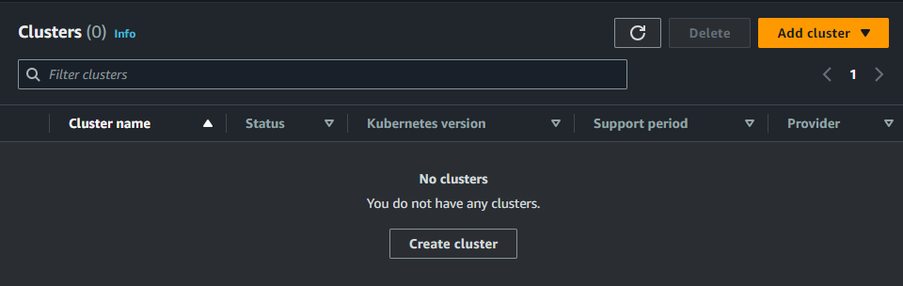

* Enter the name for the Cluster.

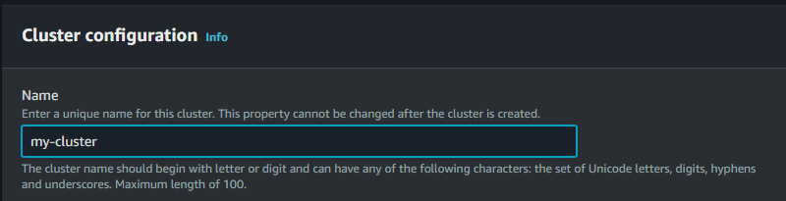

* Now we need a role to attach to the Cluster.
* Create a role for the EKS.
* Select the Role from the dropdown.
* Click Next.
* Add the Subnets and Security group.
* Set the Cluster endpoint access to public.
* Click Next.

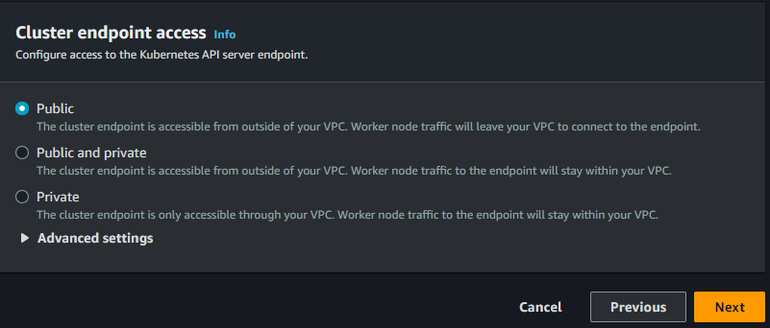

* Complete the remaining steps and Click Create.

