**Virtualization – Containerization**

**Virtualization:**

Virtualization is the process of creating a virtual version of something, such as an operating system, a server, a storage device, or network resources. This technology allows multiple virtual instances of these resources to run simultaneously on a single physical machine, effectively partitioning the hardware resources.

In the context of computing, virtualization enables the creation of virtual machines (VMs) or virtual environments that behave like independent physical machines but share the underlying hardware resources. This can lead to more efficient utilization of hardware, improved scalability, and easier management of resources.

A program called a hypervisor sits between the physical hardware and the virtual machines. It manages the resources and makes sure each VM gets what it needs.

**Hypervisor**:

A hypervisor, also known as a virtual machine monitor (VMM), is a software or firmware layer that enables the creation and management of virtual machines (VMs). It sits between the physical hardware of a computer system and the operating systems or software applications running on that hardware. The primary purpose of a hypervisor is to virtualize the underlying hardware resources, such as CPU, memory, storage, and networking, allowing multiple virtual machines to run concurrently on a single physical machine.

Hypervisors facilitate the abstraction of physical hardware, providing a virtualized environment where multiple operating systems or workloads can run independently of each other, as if they were running on separate physical machines. They manage the allocation of hardware resources among virtual machines, enforce isolation between VMs to prevent interference, and provide mechanisms for VM monitoring, control, and migration.

**There are two main types of hypervisors:**

**1. Type 1 Hypervisor (Bare Metal Hypervisor):**

* Runs directly on the physical hardware of the host system.
* Does not require a host operating system; interacts directly with hardware.
* Examples include VMware vSphere/ESXi, Microsoft Hyper-V Server, and KVM.

**2. Type 2 Hypervisor (Hosted Hypervisor):**

* Runs on top of a host operating system.
* Requires a host operating system to manage hardware resources.
* Examples include VMware Workstation, Oracle VirtualBox, and Parallels Desktop.

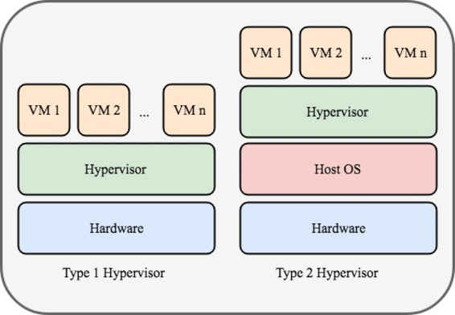

**What is Docker?**

Docker is a platform designed to ease the development, deployment, and running of applications. It achieves this by leveraging a concept called containerization.

**Containerization:**

Containerization is a lightweight form of virtualization that involves packaging an application and its dependencies into a standardized unit called a container. Containers encapsulate the application code, runtime, system tools, libraries, and settings, enabling the application to run consistently across different environments, such as development, testing, and production.



**Difference Between Virtualization and Containerization.**

**Level of Abstraction:**

* Virtualization: Virtualization creates virtual instances of the entire operating system, including its kernel, which runs on top of a hypervisor or host operating system. Each virtual machine (VM) is independent and runs its own operating system.
* Containerization: Containerization operates at the application level, abstracting the application and its dependencies into containers. Containers share the host operating system's kernel and resources, but each container has its own isolated filesystem, processes, and networking stack.

**Resource Utilization:**

* Virtualization: Virtual machines require a separate guest operating system for each VM, which can consume significant memory and disk space. VMs also have overhead associated with running multiple operating system kernels.
* Containerization: Containers are lightweight and share the host operating system's kernel, resulting in minimal overhead. They use resources more efficiently, as multiple containers can run on the same host without duplicating the operating system.

**Isolation**:

* Virtualization: Virtual machines provide strong isolation because each VM has its own operating system kernel. This makes VMs suitable for running different operating systems and ensures that applications running in one VM do not affect applications running in other VMs.
* Containerization: Containers provide process-level isolation, meaning each container runs as an isolated process on the host operating system. While containers offer good isolation for most use cases, they share the same kernel, so there may be some potential for security vulnerabilities or resource contention between containers.

**Deployment and Scalability:**

* Virtualization: Virtual machines can be slower to start up and consume more resources due to the overhead of running multiple operating systems. VMs are typically provisioned and managed individually.
* Containerization: Containers are lightweight and start up quickly, making them ideal for dynamic and scalable environments. Container orchestration platforms like Kubernetes enable automated deployment, scaling, and management of containerized applications across clusters of hosts.

**Use Cases:**

* Virtualization: Virtualization is well-suited for running multiple operating systems on a single physical machine, consolidating server workloads, and isolating applications with different resource requirements.
* Containerization: Containerization is commonly used for microservices architectures, cloud-native applications, and DevOps practices. Containers are portable, scalable, and facilitate rapid application development, deployment, and scaling.