

**NORTHEASTERN UNIVERSITY**

**COLLEGE OF ENGINEERING**

**INFO 6205 – Program Structures and Algorithms**

**Document Control**

|  |  |
| --- | --- |
| **Document Details** | |
| **Author** | **Aakash Shukla** |
| **Author** | **Kunjan Gala** |
| **Title** | **Pandemic Simulator** |

|  |  |  |  |
| --- | --- | --- | --- |
| **Version and Distribution History** | | | |
| **Version #** | **Date** | **Description of Change** | **Author** |
| **1.0** | 27/03/2021 | **Initial Draft** | **Aakash Shukla** |
| **1.1** | 19/04/2021 | **Updated the technical stack** | **Aakash Shukla** |
|  | Click here to enter a date. |  |  |

**Document Approvals**

|  |  |  |  |
| --- | --- | --- | --- |
| **Name** | **Title** | **Signature** | **Date** |
| **Prof. Robin Hillyard** | **Associate Professor** |  |  |

**Contents**

**Solution Overview** 4

Summary 4

Requirements 4

System Context 4

Architecture Overview 5

**Infrastructure Design** 5

Infrastructure Constraints 5

Hosting Infrastructure 5

End User Devices 5

Security and Privacy 6

Communication Rules 6

**Application Design** 6

Application Constraints and Deviations 6

Integrations 7

**Bill of Materials** 7

Licenses 7

**Appendix – A – References** 7

**Appendix – B – Glossary** 7

# **Solution Overview**

This solution simulates the spread of SARS – COVID-2, the pathogen behind COVID-19 and provides a medium to study the growth and spread of virus among people.

## Summary

The main purpose of this solution is to provide an interface to study the growth of SARS – COVID -2 and the effect that various remedial measures like contact tracing, vaccination etc. have on its growth rate.

## Requirements

The table below lists the main functional and non-functional requirements towards the solution design.

|  |  |  |
| --- | --- | --- |
| Req No. | Reference Areas | Description |
| REQ001 | Functional | Covid growth data |
| REQ002 | Functional | R – Factor and K – Factor of growth |
| REQ003 | Functional | Remedial Actions |
| REQ004 | Functional | Java GUI to simulate growth |
| REQ005 | Functional | Unit Tests |
| REQ006 | Non – Functional | Report – Conclusions |
| REQ007 | Functional | Comparison with SARS outbreak |

Table 1: Requirements

## System Context

The below diagram shows the system context diagram for the designed solution.

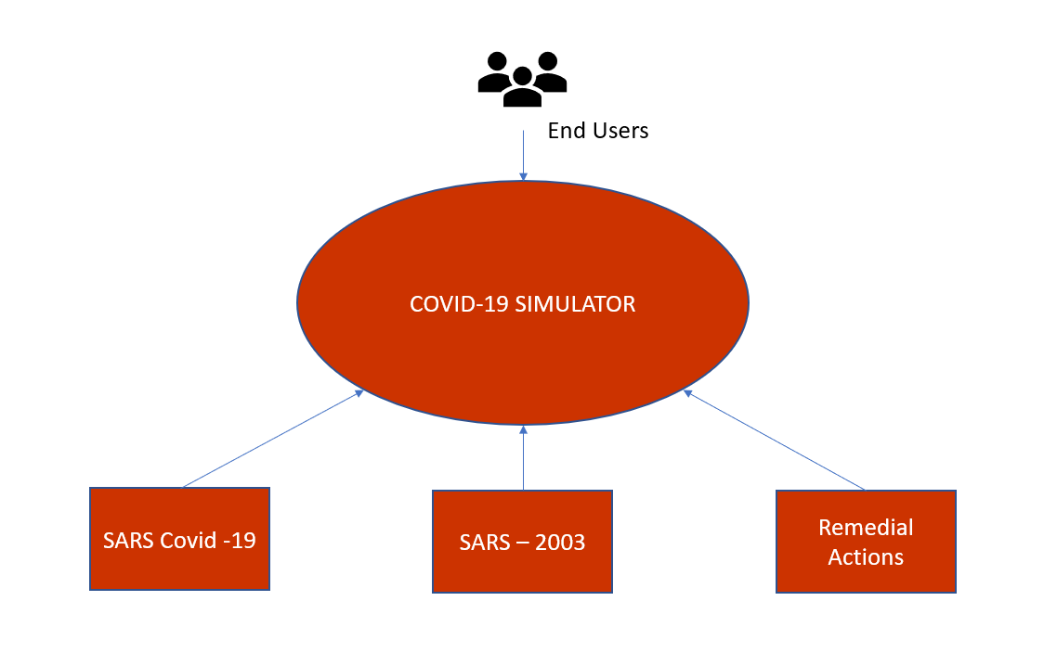

Figure 1: System Context

## Architecture Overview

The below diagram provides an architectural overview of the solution.

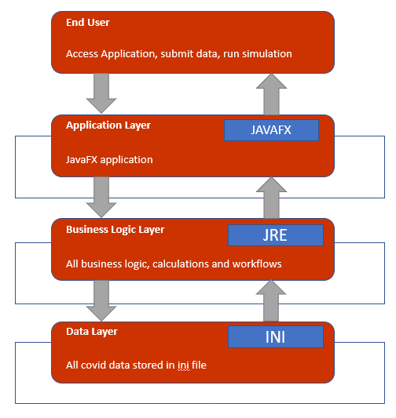

Figure 2: Architecture Overview

# **Infrastructure Design**

This chapter describes the infrastructure including hardware and software that the system must operate in and interact with.

## Infrastructure Constraints

There are no infrastructural constraints linked with the solution.

## Hosting Infrastructure

The application can run stand alone and does not require any separate hosting infrastructure.

## End User Devices

All end user devices are supported provided they have Java runtime environment and JavaFX installed on their system.

## Security and Privacy

No security constraints associated with the application as it does not interact with web and does not share any data over internet.

## Communication Rules

Not applicable as all the simulation data is stored within the application.

# **Application Design**

## Application Constraints and Deviations

Application requires a valid instance of JavaFX and JRE installed in user’s system to work.

To install JavaFx, add the path to JavaFx lib folder in the IDE and add the VM options as well.

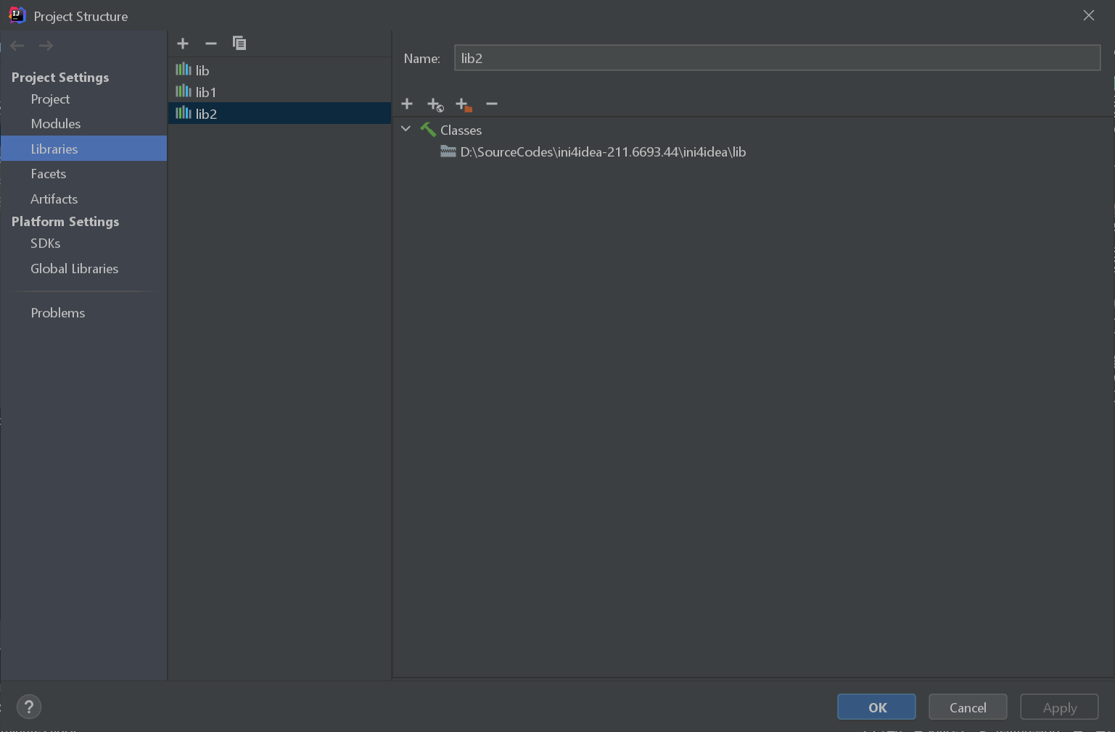

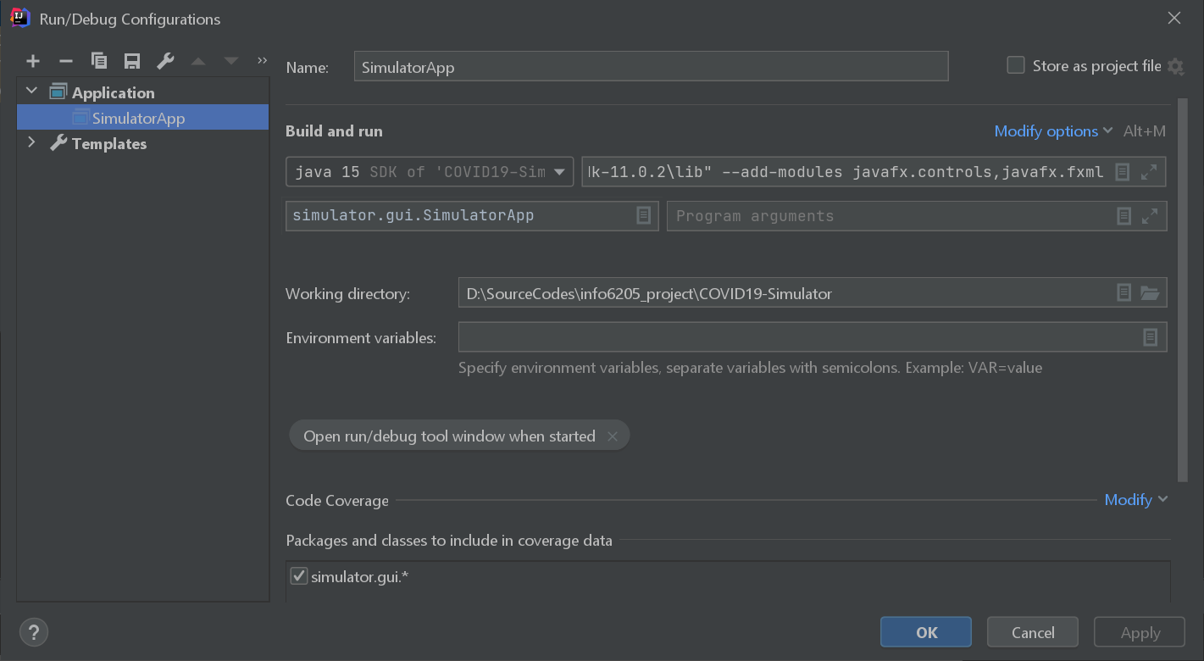

In the add VM options add the path as follows,

--module-path "Path to JavaFx \Java\javafx-sdk-11.0.2\lib" --add-modules javafx.controls,javafx.fxml

## Integrations

Application does not integrate with any other system.

# **Bill of Materials**

## Licenses

No licensing involved as it is a custom-built system.

# **Appendix – A – References**

|  |  |
| --- | --- |
| **Titles** | **Description/Link** |
| Java installation | https://java.com/en/download/help/download_options.html |
| JavaFX installation | https://openjfx.io/openjfx-docs/ |
|  |  |

# **Appendix – B – Glossary**

|  |  |
| --- | --- |
| **Item** | **Definition** |
|  |  |
|  |  |
|  |  |
|  |  |
|  |  |