

**NORTHEASTERN UNIVERSITY**

**COLLEGE OF ENGINEERING**

**INFO 6205 – Program Structures and Algorithms**

**Document Control**

|  |  |
| --- | --- |
| **Document Details** | |
| **Author** | **Aakash Shukla** |
| **Author** | **Kunjan Gala** |
| **Title** | **Pandemic Simulator** |

|  |  |  |  |
| --- | --- | --- | --- |
| **Version and Distribution History** | | | |
| **Version #** | **Date** | **Description of Change** | **Author** |
| **1.0** | 18/04/2021 | **Initial Draft** | **Aakash Shukla** |
| **1.1** | 19/04/2021 | **Unit Tests Added** | **Kunjan Gala** |
|  | Click here to enter a date. |  |  |

**Document Approvals**

|  |  |  |  |
| --- | --- | --- | --- |
| **Name** | **Title** | **Signature** | **Date** |
| **Prof. Robin Hillyard** | **Associate Professor** |  |  |

**Contents**

**Solution Overview** 4

Summary 4

**Covid 19** 4

Symptoms 4

Mode of transmission 4

**Experiment** 4

Assumptions 4

Running our experiment 5

How does the disease spread? 5

Count of infected people at given time 6

How many people can catch this disease? 7

Conclusions from the experiment 8

**Remedial Actions** 8

Social Distancing 8

Quarantine 9

Masks 9

Vaccination 10

**Observations** 10

Effect of remedial measures 10

Spread in hotspots 12

Community Transmission 14

Conclusion 15

Unit Tests 16

**Appendix – A – References** 17

**Appendix – B – Glossary** 17

# **Solution Overview**

This solution simulates the spread of SARS – COVID-2, the pathogen behind COVID-19 and provides a medium to study the growth and spread of virus among people.

## Summary

The main purpose of this solution is to provide an interface to study the growth of SARS – COVID -2 and the effect that various remedial measures like contact tracing, vaccination etc. have on its growth rate.

# **Covid 19**

COVID-19 also known as coronavirus is a contagious disease caused by severe acute respiratory syndrome coronavirus 2. Originating in Wuhan this disease has spread worldwide and has created the ongoing pandemic.

## Symptoms

The main symptoms of this disease include fever, cough, headache, fatigue, breathing difficulties and loss of smell and taste to name a few. At least one third of the population does not show symptoms of the disease.

## Mode of transmission

The virus spreads mainly when an infected person encounters another person, small droplets can spread from one person to another. The virus may also spread via contaminated surfaces although this is not thought to be the main source of transmission.

# **Experiment**

In our experiment we have used compartment modelling. Compartment modelling simplify the mathematical modelling of infectious diseases. The population is assigned to compartments with labels and people progress between the compartments. The order of labels shows the flow between the compartments.

In this experiment we have considered the SIR model where labels correspond to the below:

* S – Susceptible
* I – Infected
* R – Removed

## Assumptions

The first step involves identifying the independent and dependent variables. The independent variable or the invariant in our experiment is the time t. We consider the following dependent variables.

* S = S(t) -> number of susceptible individuals
* I = I(t) -> number of infected individuals
* R = R(t) -> number of removed individuals

The movement of the people in the space is random, that is the entropy of system. A person is free to move in the space based on the degree of social distancing being observed.

Initially we assume the following relations,

* S = S0
* I = I0
* R = 0

Considering the population to be constant, we can say the following

$$\frac{d\left(S+I+R\right)}{dt}=0→Equation 1$$

## Running our experiment

We consider the following items in our experiment:

1. Population is constant (invariant).
2. Rate of increase of I (infected) is directly proportional to rate of contact between the susceptible and infected group.
3. Rate of recovery is constant

We can thus define the rate of changes in our compartments as,

$$\frac{d\left(S\right)}{dt}= -rIS→Equation 2$$

Here r is the rate of contact.

$$\frac{d\left(R\right)}{dt}=aI→Equation 3$$

This is defined as the rate of recovery.

$$\frac{d\left(I\right)}{dt}= +rIS-aI→Equation 4$$

+rIS defines contact between infected and susceptible groups.

Now we know that at any point of time, the count of members in the susceptible group will decrease. Therefore, we can say that,

$$S≤S_{0}→Equation 5$$

## How does the disease spread?

We know from equation 4 that,

$$\frac{d\left(I\right)}{dt}=rIS-aI$$

$$=I\left(rS-a\right)→Equation 6$$

We also know from equation 5 that S is a decreasing function, so if (rS – a) (equation 6) is positive, the disease will spread.

$$∴if S_{0}>\frac{a}{r} disease will spread$$

$$S_{0}>\frac{a}{r}=\frac{1}{q}→Equation 7$$

We define q as the contact ratio, i.e., the fraction of population that encounters infected individuals during the period when they are infectious.

R0 is what we define as the basic reproductive number/ratio.

If the value of R0 is greater than 1 then we consider it a pandemic. Thus, we can define R0  as the number of secondary infections in the populations caused by one initial primary infection.

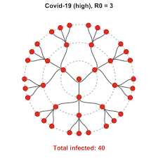

## Count of infected people at given time

Combining equations 2 and 4, we get the below relation.

$$\frac{dI}{dS}=\frac{rIS-aI}{-rIS}$$

$$\frac{dI}{dS}= -1+\left(\frac{a}{rS}\right)$$

Substituting equation 7 in above,

$$\frac{dI}{dS}= -1+\left(\frac{1}{qS}\right)→Equation 9$$

Integrating equation 9, we get,

$$\int{\frac{dI}{dS}}= \int{-1}+\int{\frac{1}{qS}}$$

$$∫ⅆI=∫-1ⅆS+∫\frac{1}{qS}ⅆS$$

$$I+S=\frac{1}{q}\ln{S}$$

Now this gives us the following relation,

$$I+S-\frac{1}{q}\ln{S}=I_{0}+S_{0}-\frac{1}{q}\ln{S_{0}}→Equation 10$$

From equation 9 we can say that I will be maximum when S = (1/q).

Thus, we can reduce to the following relation,

$$Imax=Io+So-\left(\frac{1}{q}\right)\left(1+\ln\left(qSo\right)\right) Since, qSo=Ro$$

We know that S0 is generally huge, but what happens when we vary the value of q.

$$f\left(q\right)=\left(\frac{1}{q}\right)\left(1+\ln\left(qSo\right)\right)$$

$$f\left(x\right)=\left(\frac{1}{x}\right)\left(1+\ln\left(xSo\right)\right)$$

If we plot this graph, we get a graph that looks somewhat like the one below, where we have f(x) on y axis and x on x axis.

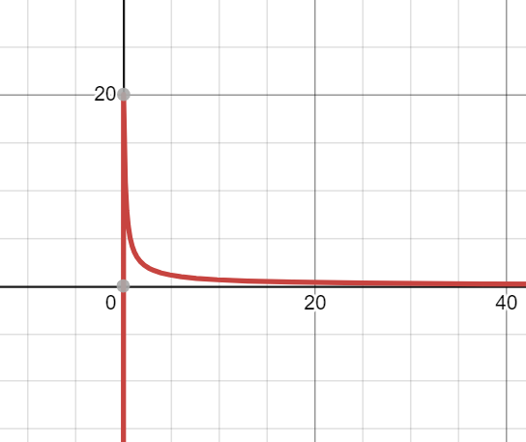

This means that q is very high for covid.

$$Imax=Io+So-\left(\frac{1}{q}\right)\left(1+\ln\left(qSo\right)\right)$$

$$\left(\frac{1}{q}\right)\left(1+\ln\left(qSo\right)\right) is small since q is huge$$

Therefore, we say that whole population becomes susceptible to covid.

## How many people can catch this disease?

Going with our assumption of overall population being constant, we can say that

$$R_{end}= -S_{end}+I_{0}+ S_{0}$$

$$Since, R+I+S= I_{0}+ S_{0}$$

$$S_{end}-\left(\frac{1}{q}\right)\ln\left(S_{end}\right)= I_{0}+ S_{0}-\left(\frac{1}{q}\right)\left(\ln\left(S_{0}\right)\right)$$

$$y-\left(\frac{1}{x}\right)\ln\left(y\right)= I_{0}+ S_{0}-\left(\frac{1}{x}\right)\left(\ln\left(S_{0}\right)\right)$$

Therefore, if q is large, Send is small.

Rend  = I0 + S0 - Send

This results in a very high value of S0.

What this means is that if not vast most of the population will catch the disease if q is sufficiently large. This can be termed as high value of R0.

## Conclusions from the experiment

We can derive the following conclusions from our experiments.

1. If R0  = qS0 > 1, disease will spread.
2. Imax = Total population – f(q). f(q) is small for large value of q.
3. Total infected = Total population – g(q). If q is large most population will catch the disease.

So, what these experiments mean, at the onset we can say that we cannot simply stop the spread. What we can do mathematically is the following

1. To reduce number of infected we need to make f(q) as large as possible, this is possible only when q is small i.e., the basic reproduction rate of virus is smaller.
2. We need to make g(q) as large as possible to make number of people contracting the disease smaller. This is again possible when q is smaller i.e., the basic reproduction rate is smaller.

# **Remedial Actions**

As this is a novel virus, we do not have a proper cure for it right now. But what is possible is that we can delay its spread. There are 4 effective ways to do so.

1. Social Distancing
2. Quarantine
3. Wearing masks
4. Vaccination

In our application we have defined all these parameters and how they affect the spread of the pandemic.

## Social Distancing

Firstly, taking social distancing into consideration, if we have an infected person and this person does not interact with others in susceptible group, it’s obvious that the infected person will not pass on the virus to a susceptible person. To demonstrate this, we can set the social distancing slider in our application (left pane). We can set the factor of 0 where everyone is free to roam about or set it 0, where people do not interact. This will show us that spread of disease can be controlled by social distancing.

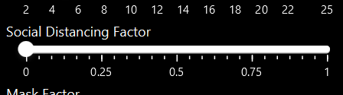

## Quarantine

Quarantine is the next important aspect of pandemic control. We try to isolate infected personnel to restrict the spread of pathogen amongst the susceptible group.

For this we have a slider and a checkbox. The checkbox is used to enable or disable the isolation and quarantine process. The slider controls after how many days an infected individual is isolated. Until then a person might be spreading the disease.

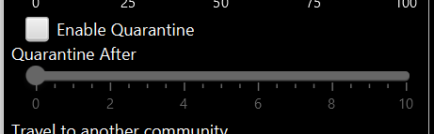

## Masks

Masks are so far one of the best ways to control this pandemic. In our application, we have a slider for the percentage of population wearing a mask. Our configuration file has mask efficacy rate which can be configured.

As per this [paper](https://journals.plos.org/plosone/article?id=10.1371/journal.pone.0237691) we can see that the effective value of R0 comes down when we mask up. This is demonstrated in our application and we have a slider in our application that controls the percentage of population that is wearing the mask.

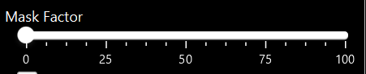

This slider can be used to demonstrate the lowering of covid spread as and when we start wearing masks.

Reduction is demonstrated using the formula, Reff = (1 – Meff)R0. Where Meff varies based on the proportion of people wearing a mask.

## Vaccination

Vaccination is the scientific way of controlling any disease. Our bodies develop antibodies against a particular virus. As we know that Covid 19 is a novel virus. We do not have any vaccine that provides a cent percent efficacy.

New vaccines are being administered to individuals that have a variable efficacy rate. In our simulation we have a slider for the percentage of vaccinated population and vaccine efficacy can be altered in the configuration file.

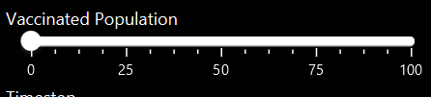

We can demonstrate the effect a widespread vaccination has in controlling the overall spread of the disease. We see that overall vaccination can be controlled by the factor Reff = (1 – Veff)R0 similar to the formula described for people wearing masks.

# **Observations**

The following observations were noted by our simulation.

## Effect of remedial measures

Initially we assume the entire population to be susceptible and introduce an infected person in the mix.

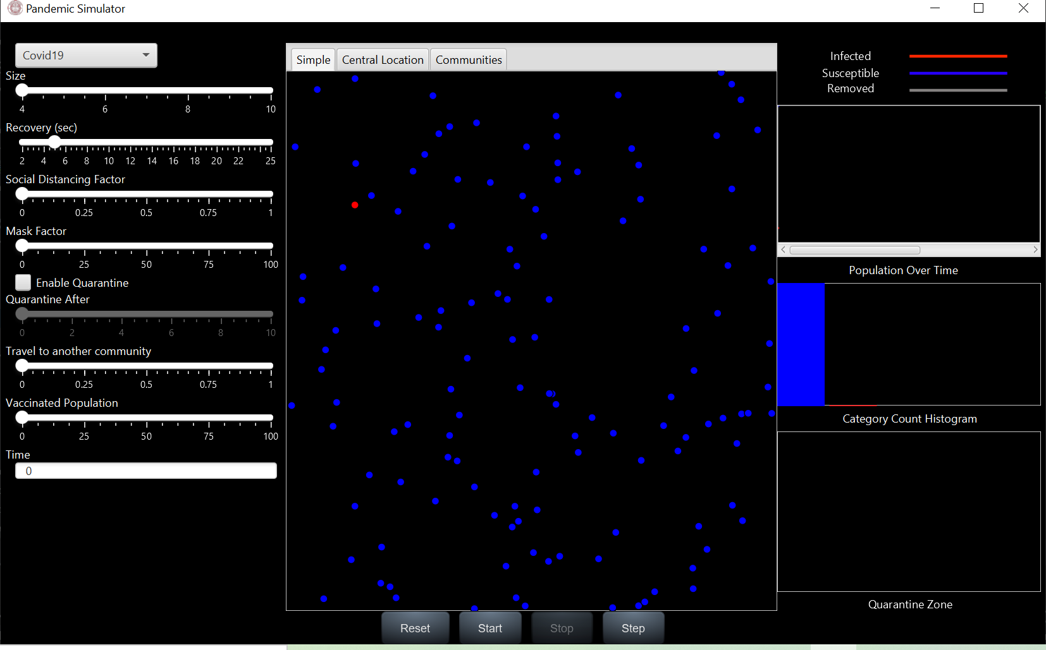

On running the simulation, we see that more people are infected with the disease.

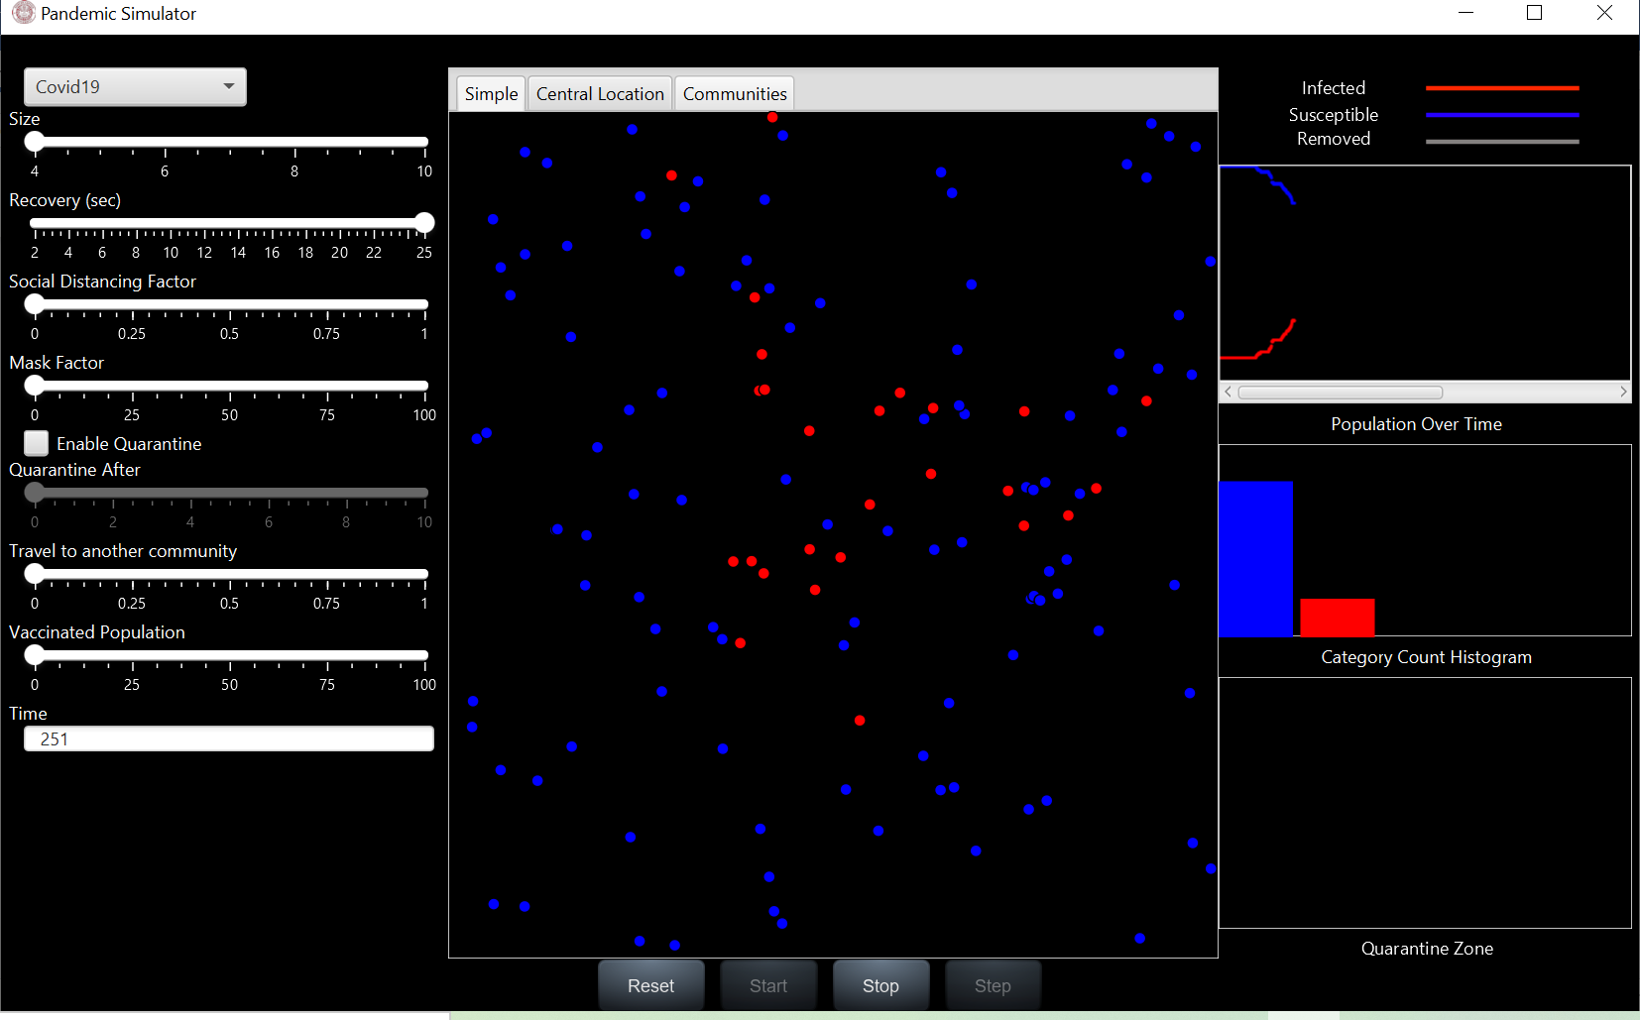

The graphs on the right pane of the application show the change that takes place because of this.

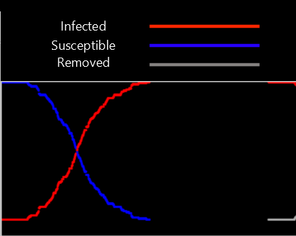

This is delayed by the introduction of quarantine zones, wearing masks and vaccinating the individuals.

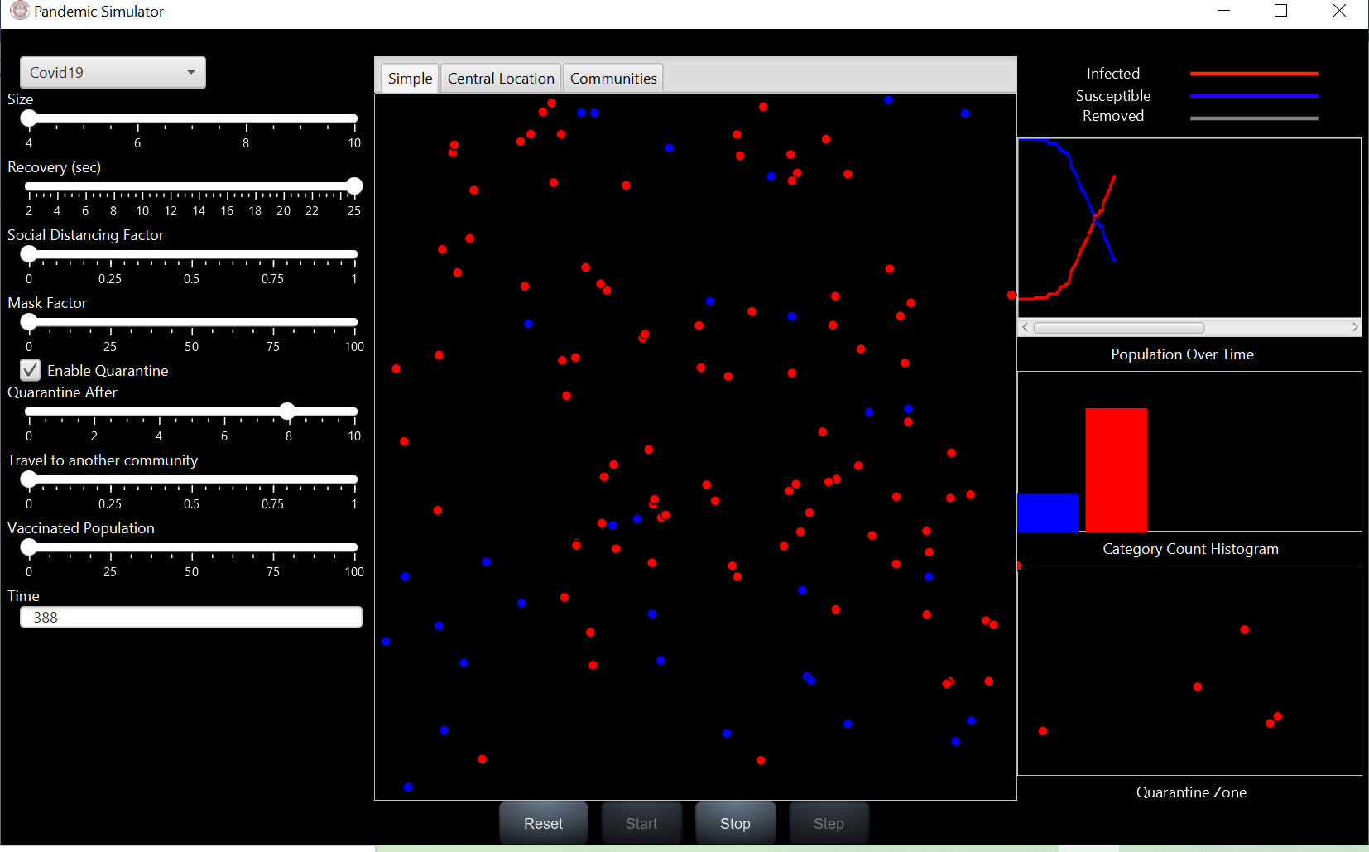

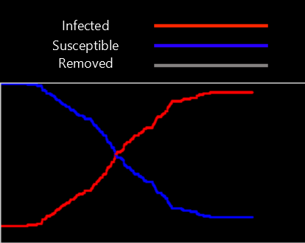

## Spread in hotspots

For this we have introduced a region in the simulation and called it a market. Population density seems to be higher at such places.

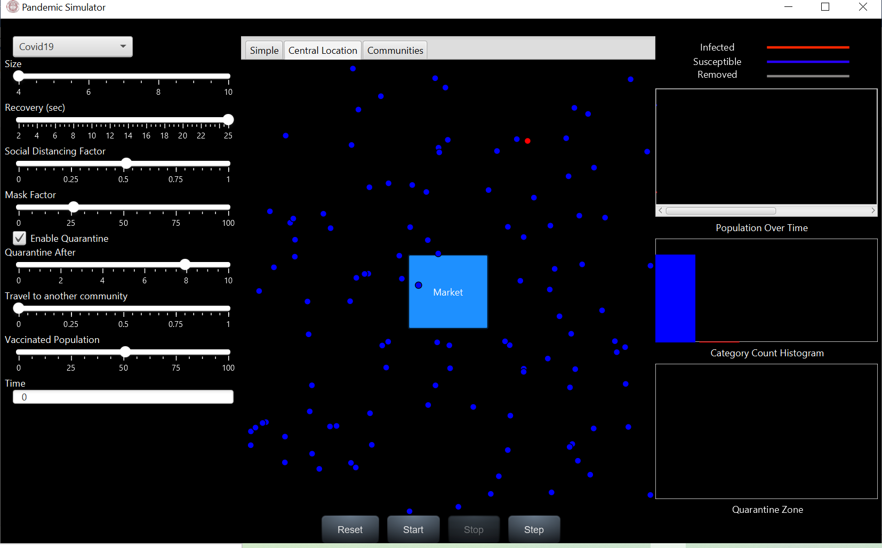

We see that people visiting such places are more susceptible to catch covid as they are near other individuals who might be infected.

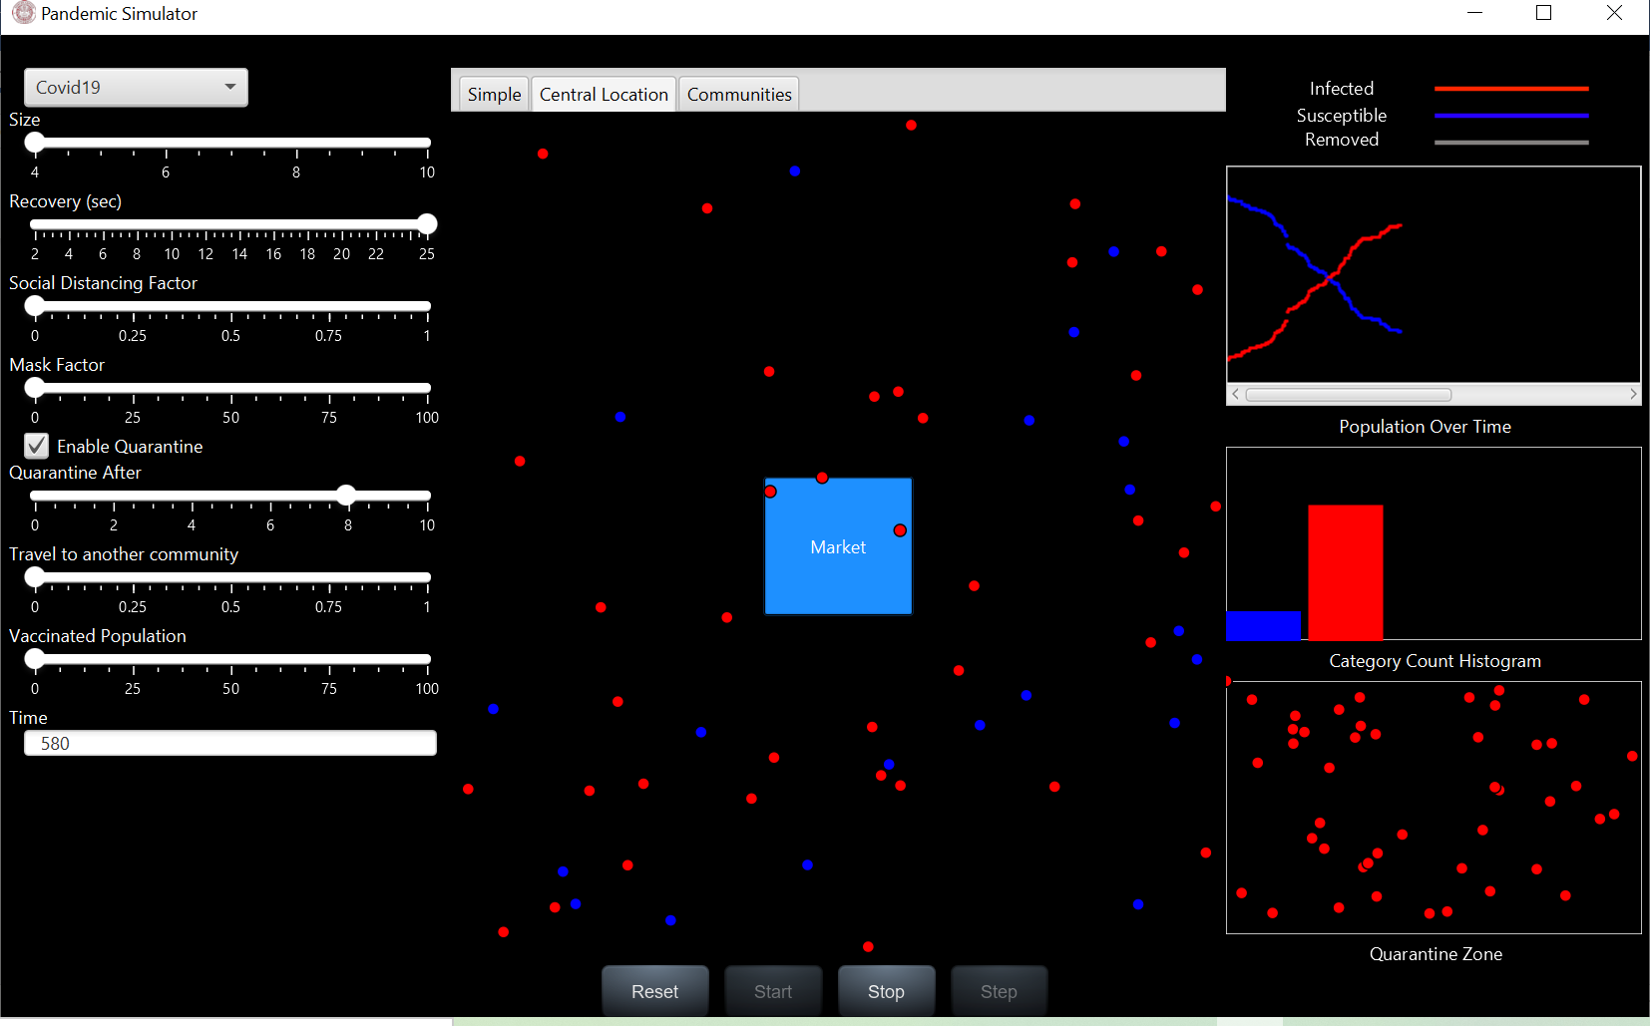

But maintaining proper protocols of social distancing, quarantining etc. can lead to an apparent reduction in the rate of transmission.

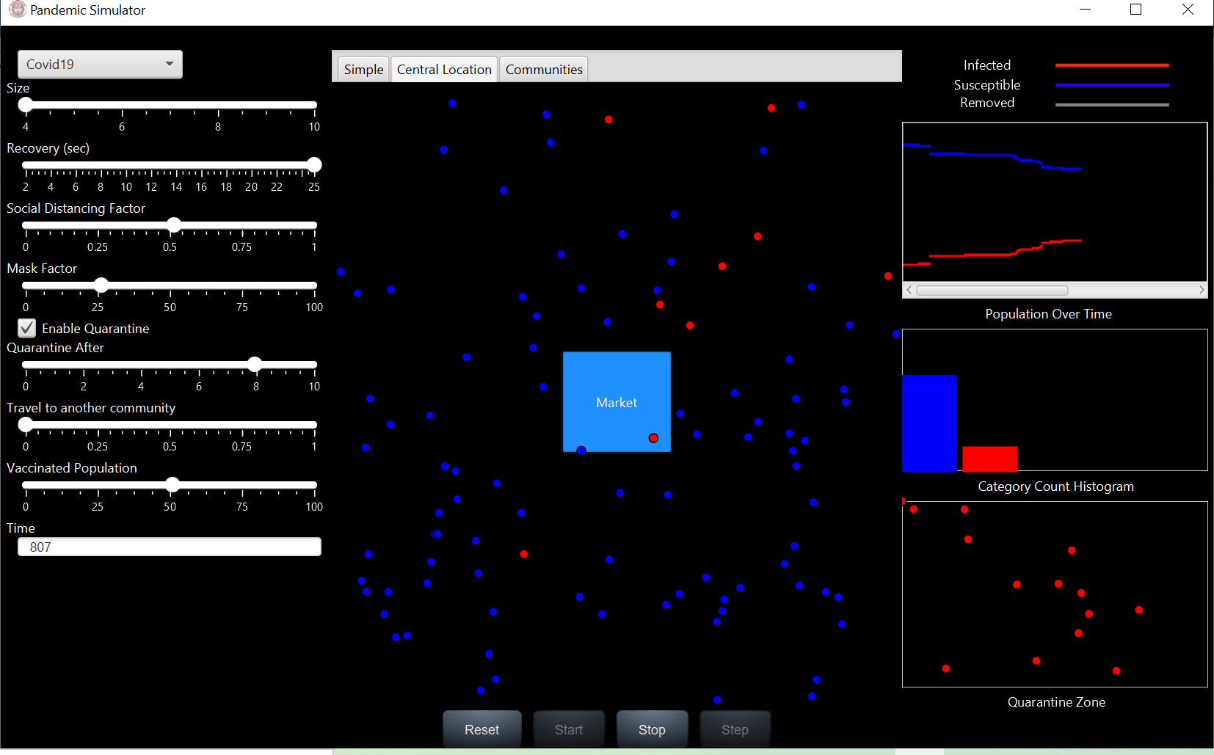

## Community Transmission

We have demonstrated another scenario where travel between communities tends to increase the case load in all communities. For this we have 4 different communities and people can travel between them. We notice that if people can travel, the virus tends to spread on to other communities as well.

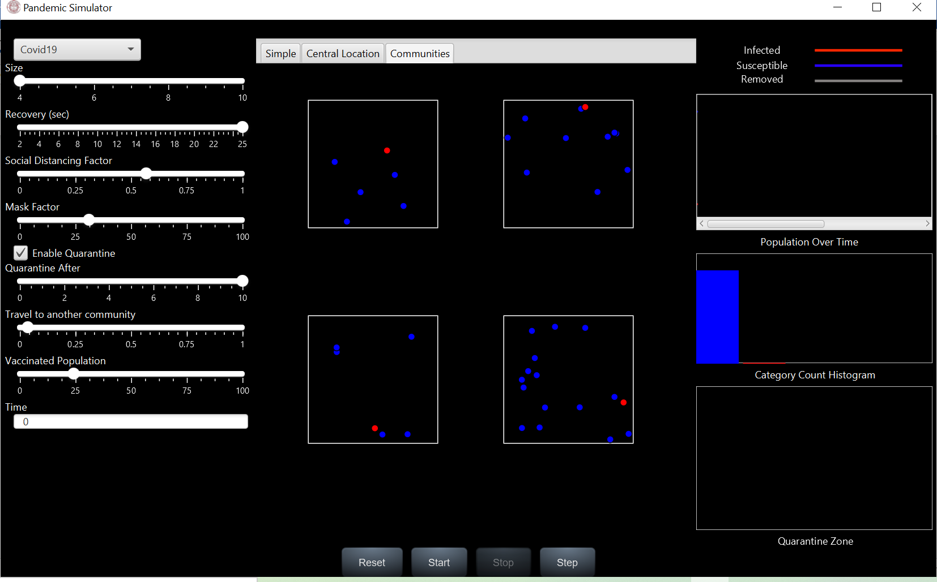

## Conclusion

As demonstrated in the previous section, our simulation seems to suggest that reduction in the effective reproduction value is only possible if we follow certain guidelines. To reduce effective transmission between the individuals we have demonstrated some valid measures and proven them both conceptually and mathematically.

# Unit Tests

The following unit tests will demonstrate the validity of our experiments.

# **Appendix – A – References**

|  |  |
| --- | --- |
| **Titles** | **Description/Link** |
| Mask or no mask for COVID-19 | https://journals.plos.org/plosone/article?id=10.1371/journal.pone.0237691 |
| COVID-19 | https://en.wikipedia.org/wiki/COVID-19 |
| What is R | https://www.healthline.com/health/r-nought-reproduction-number#covid-19-r-0 |
| Basic Reproduction Number | https://en.wikipedia.org/wiki/Basic_reproduction_number |
| Complexity of basic reproduction number | https://wwwnc.cdc.gov/eid/article/25/1/17-1901_article |

# **Appendix – B – Glossary**

|  |  |
| --- | --- |
| **Item** | **Definition** |
| S | Susceptible |
| I | Infected |
| R | Removed |
|  |  |
|  |  |