Session 1

Assignment 1 Question

*Session 1: Assignment 1*

**Table of Contents**

1. Introduction

2. Problem Statement

3. Output

**1. Introduction**

This assignment will help you to consolidate the concepts learnt in the session.

**2. Problem Statement**

**Task 1:**

1.

Install Jupyter notebook and run the first program and share the screenshot of the output.

**Source Code:**

print(m)

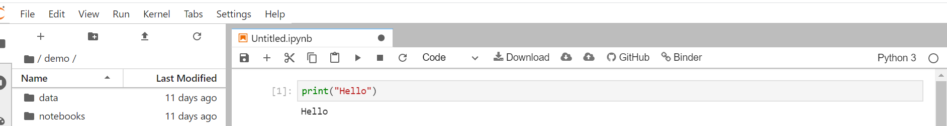

2.

Write a program which will find all such numbers which are divisible by 7 but are not a multiple

of 5, between 2000 and 3200 (both included). The numbers obtained should be printed in a

comma-separated sequence on a single line.

**Source Code:**

l = list(range(2000,3200))

m = []

length = len(l)

i = 0

while i < length:

if l[i] % 7 == 0:

if l[i] % 5 != 0:

m.append(l[i])

i += 1

print(m)

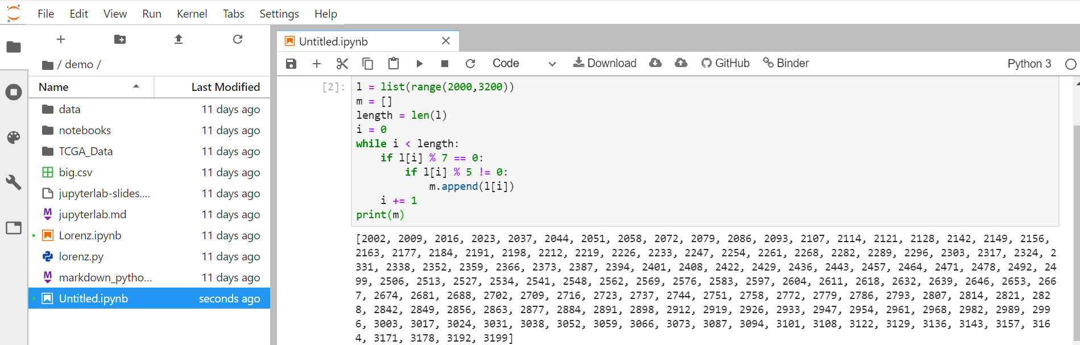

3.

Write a Python program to accept the user's first and last name and then getting them printed in

the the reverse order with a space between first name and last name.

**Source Code:**

l = "Good Morning"[::-1]

print(l)

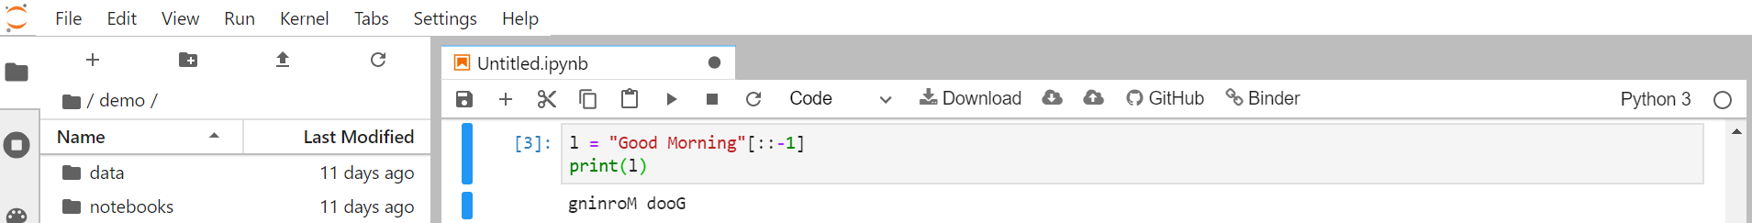

4.

Write a Python program to find the volume of a sphere with diameter 12 cm.

Formula: V=4/3 * π * r 3

**Source Code:**

d = 12

r = 12 / 2

print((4/3) * (22/7) * r * r * r)

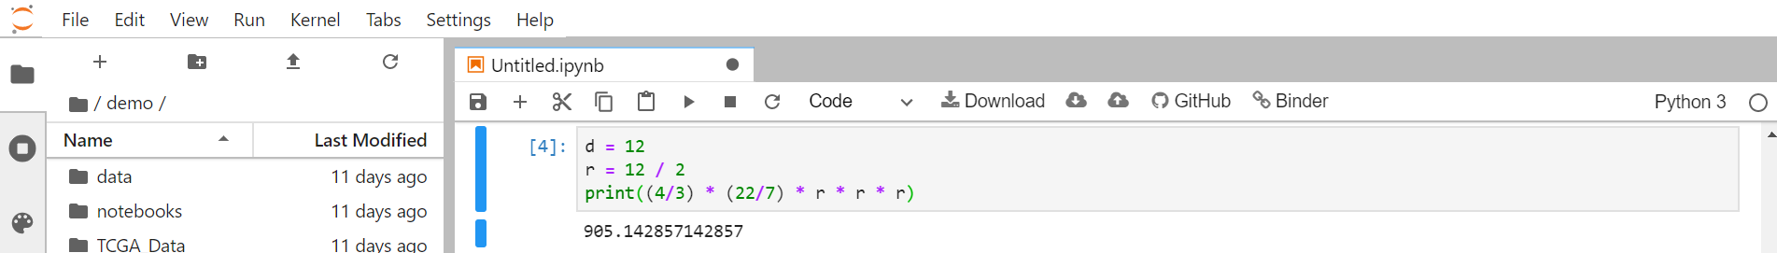

**Task 2:**

1.

Write a program which accepts a sequence of comma-separated numbers from console and

generate a list.

**Source Code:**

x = list(input())

print(x)

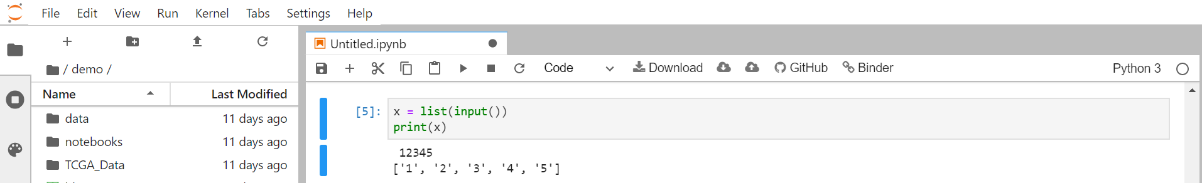

2.

Create the below pattern using nested for loop in Python.

*

* *

* * *

* * * *

* * * * *

* * * *

* * *

* *

*

**Source Code:**

for i in range(1,10):

if i <= 10/2:

for j in range(1,i+1):

print("* ",end="")

print("\n")

elif i > 10/2:

for j in range(i,10):

print("* ",end="")

print("\n")

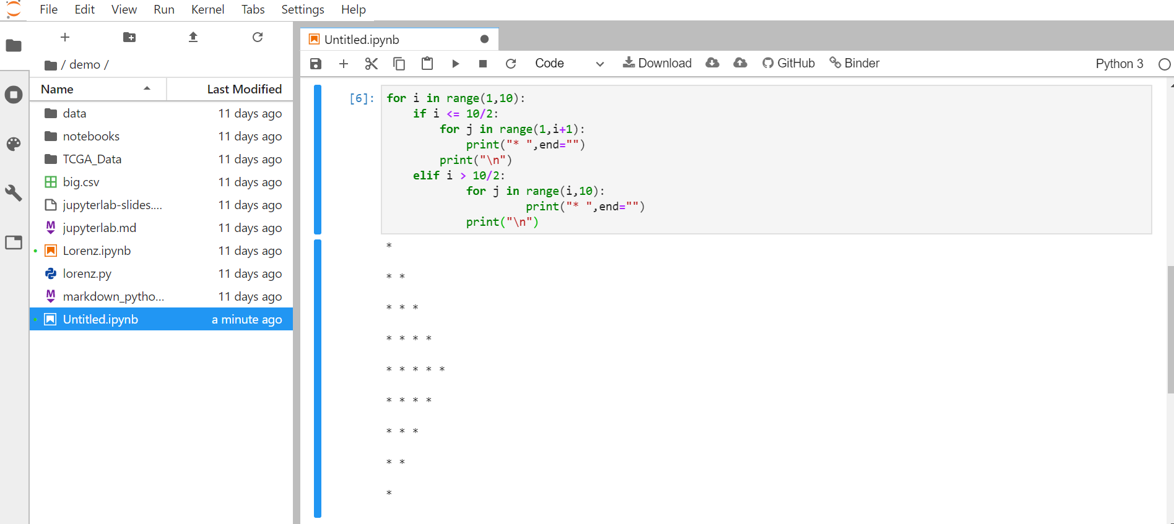

3.

Write a Python program to reverse a word after accepting the input from the user.

**Sample Output:**

Input word: AcadGild

Output: dilGdacA

**Source Code:**

l = input("")[::-1]

print(l)

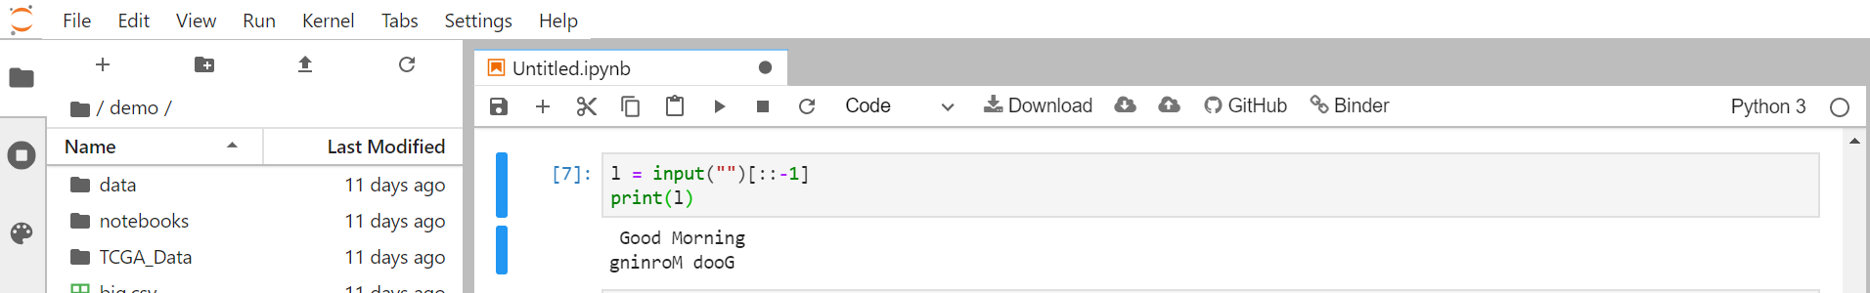

4.

Write a Python Program to print the given string in the format specified in the **sample output.**

WE, THE PEOPLE OF INDIA, having solemnly resolved to constitute India into a

SOVEREIGN, SOCIALIST, SECULAR, DEMOCRATIC REPUBLIC and to secure to all

its citizens

**Sample Output:**

WE, THE PEOPLE OF INDIA,

having solemnly resolved to constitute India into a SOVEREIGN, !

SOCIALIST, SECULAR, DEMOCRATIC REPUBLIC

and to secure to all its citizens

**Source Code:**

l = '''

WE, THE PEOPLE OF INDIA,

having solemnly resolved to constitute India into a SOVEREIGN, !

SOCIALIST, SECULAR, DEMOCRATIC REPUBLIC

and to secure to all its citizens

'''

print(l)

