PROJECT REPORT

CmdPrelude
A Context Free Grammar Based Shell Command Analyzer
and File Change Previewer
GitHub repository
https://github.com/aakashsi75/TOC-Project
Subject
Theory of Computation
Submitted by
Aakash Sinha
Register Number 24BIT0376
Harsheet Ranjan
Register Number 24BIT0365
Index
Aim of the project 3
Abstract 3
Tools used 4
Highlights or features of the project 4
Project Modules 5
Project Architecture 5
Module Description 6
Command input and tokenization 6
Grammar definition and validation 6
Grammar simplification and CNF conversion 6
CYK parsing and tree reconstruction 7
Command interpretation and file change simulation 7
Error detection and recovery 7
Workspace import and reviewed local file operations 8
Interface and API integration 8
Role of Team members 8
Software description 9
Coding 9
Basic command grammar 9
Grammar compilation 9
CYK recognition and tree reconstruction 10
Nested command groups 10
Error recovery and reparsing 10
Workspace snapshot and change detection 10
Simulation API 11
Testing and demonstration cases 11
Screenshot of the errors segments 12
Screenshot of the error recovered segments 13
Possible future work 14
Conclusion 14
References 15
Aim of the project
The aim of this project is to develop CmdPrelude, a tool that helps users understand supported shell commands and preview their effects on files and folders before applying changes. It uses a context-free grammar to describe valid command structures and the Cocke–Younger–Kasami (CYK) algorithm to check whether an entered command follows those rules.
The project also aims to identify syntax errors, explain them clearly, and suggest corrections for common mistakes such as unmatched parentheses, unfinished quotes, and misplaced connectors. By displaying grammar transformations, parse trees, and proposed file changes, it connects Theory of Computation concepts with a practical application and helps users understand both how a command is structured and what it would do.
Abstract
Shell commands offer a quick way to manage files and folders, but their effects are not always clear before execution. Beginners may struggle with command arguments, operators and nested groups. Syntax mistakes can cause failures, while a correctly written command may still produce unintended changes. Error messages alone often do not explain how to correct the input or what the command would do. This creates a need for a tool that explains both command structure and its expected effects before changes are made.
To address this problem, we propose CmdPrelude, a web application that analyses a supported subset of Bash-style commands and previews their effects on a workspace. The system separates the input into tokens and checks it against a selected context-free grammar. The grammar is simplified and converted into Chomsky Normal Form, after which the Cocke–Younger–Kasami (CYK) algorithm checks whether the command follows the grammar. A separate interpreter uses the resulting parse tree to check workspace conditions and calculate command output, errors and proposed file changes. This separates syntactic correctness from successful execution: a command may follow the grammar but still fail because a required file does not exist.
The application presents its analysis through grammar transformations, parse trees, step-by-step CYK computation and before-and-after file views. Basic mode supports simple file-management commands, while Advanced mode introduces selected flags, pipelines, conditional chains and nested command groups. Users can also modify grammar rules to observe how they affect command acceptance. For common syntax mistakes, the system suggests corrections and validates each candidate through the same parser.
Users can experiment with a sample workspace or preview operations on a selected folder. Supported changes to real files require explicit review before application. By combining formal parsing, limited syntax recovery and file-change simulation, CmdPrelude connects Theory of Computation concepts with a practical tool for understanding commands and reviewing their consequences.
The workflow also separates learning from applying changes. Users can inspect the grammar and proposed result, correct an input, and compare the new analysis before deciding whether to keep a virtual change or review a supported real-folder operation. The preview remains an explanation of the documented command subset; it does not claim to reproduce every behaviour of a complete shell.
Tools used
Tool or technology | Use in the project
JavaScript | Implements the grammar pipeline, command interpreter and browser behaviour.
Node.js and npm | Node.js runs the backend server, while npm manages dependencies and runs project scripts
Express 4 | Provides HTTP endpoints and serves the interface.
HTML and CSS | Builds the command editor, file trees and conversion views.
Node.js built-in modules | File operations, path handling, hashing and automated tests.
Git and a web browser | Tracks source changes and runs the local application.
The main algorithms are implemented in the project itself. Express is the external runtime dependency used for the web server; the parsing and interpretation logic uses JavaScript and Node.js built-in features. This makes it easier to follow the implementation during a project demonstration.
Highlights or features of the project
- Before and after file trees show which paths would be created, modified or deleted.
- Basic mode supports ls, mkdir, cp, mv and rm with simple arguments. Advanced mode adds selected flags, pipes, conditional chains and nested groups.
- The Command conversions tab shows the authored grammar, simplification stages, CNF, parse tree and actual CYK steps.
- Grammar presets and an editable grammar let users compare how rules change command acceptance.
- Syntax recovery suggests small corrections for unfinished quotes, unmatched parentheses and misplaced connectors.
- Local folders can be opened by browsing or pasting a path. Supported changes are applied only after review.
Users can inspect a command in two ways. Playground focuses on the practical result: what the command means, what output it produces and which paths change. Command conversions focuses on the formal steps behind that result. Both views refer to the same analysis, so the explanation remains connected to the actual input.
Virtual keep, undo and reset support repeated experiments on the sample workspace. The execution trace records successful steps, errors and branches that were skipped. For example, in a chain joined by &&, failure of the first command prevents the following command from running. A chain joined by || can instead demonstrate a fallback after failure.
For classroom demonstrations, these views connect each accepted or rejected command to the rules used to analyse it. Users can follow the same input from its token classes to its tree and execution trace, making the difference between valid syntax and successful workspace operations visible.
Project Modules
The project is organized into eight functional modules that handle command input, grammar processing, parsing, simulation, error recovery and user interaction. Command analysis and suggested syntax corrections use the same grammar pipeline
- Command input and tokenization
- Grammar definition and validation
- Grammar simplification and CNF conversion
- CYK parsing and tree reconstruction
- Command interpretation and file change simulation
- Error detection and recovery
- Workspace import and reviewed local file operations
- Interface and API integration
Project Architecture
The browser sends commands, grammar rules and workspace information to the Express backend. The diagram shows how the analysis modules work together and how reviewed operations reach a real folder.
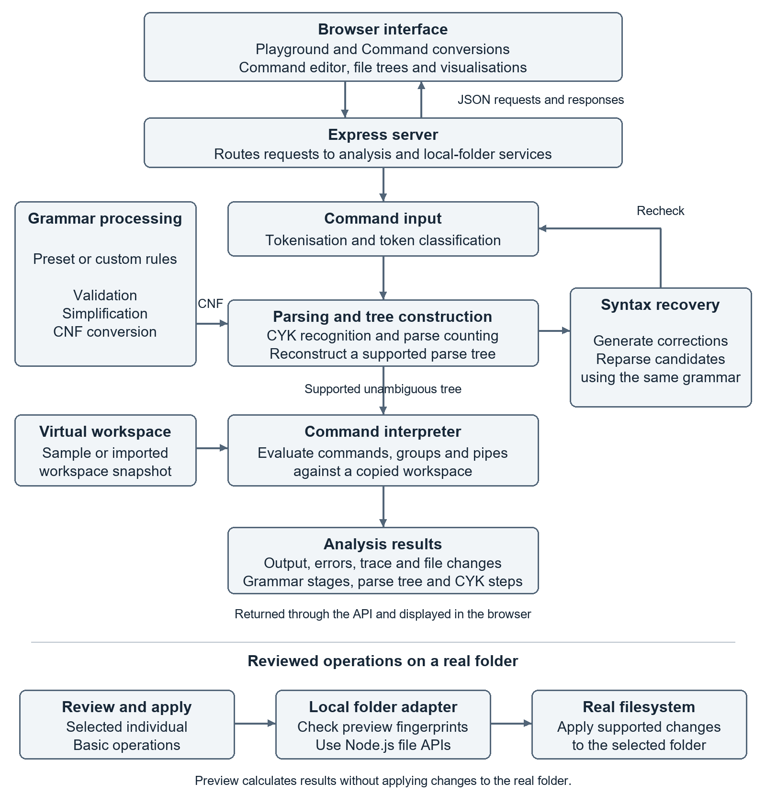
Figure 1. CmdPrelude architecture and command analysis flow.
Module Description
Command input and tokenization
The application first splits the entered command into meaningful units called tokens. It recognises command words, arguments, operators such as && and |, and parentheses used for grouping. Quoted text is kept as one argument, allowing filenames to contain spaces. Each token’s original text and position are recorded for error messages and highlighting.
The tokens are then classified according to their role in the command. For example, cp notes.txt backup/ is represented as cp path path for grammar checking. This identifies both arguments as paths; whether those paths exist is checked later during interpretation. The application also detects unfinished quotes and rejects unsupported shell syntax.
Grammar definition and validation
commandGrammar.js contains the Basic, Advanced, Copy-only and Read-only grammars. A grammar defines which token sequences are allowed. Custom rules are checked for unsupported token classes, invalid productions and size limits. Changing the grammar can change syntax acceptance, but it cannot make the interpreter support new commands or operations.
A context-free grammar can be written as G = (V, T, P, S), where V is the set of non-terminals, T is the set of terminals, P is the set of productions and S is the start symbol. In this project, names such as COMMAND and PATH are non-terminals, while cp and path are terminal token classes. The actual filename is stored with the token and checked later by the interpreter.
Presets provide a clear experiment. The Copy-only grammar accepts a copy command with a source and destination. A Read-only grammar leaves out write operations. If rm notes.txt is entered under that preset, the command is rejected by the selected language even though the application knows what rm means. This shows that the grammar controls acceptance.
Grammar simplification and CNF conversion
The grammarParser.js module reads and validates the grammar rules. The simplifier.js module then removes useless symbols, eliminates epsilon productions and removes unit productions. Finally, cnf.js converts the simplified grammar into Chomsky Normal Form (CNF), where ordinary productions have the form A → B C or A → a. These forms allow CYK parsing to build results for larger token spans by combining smaller ones.
Useless-symbol removal eliminates symbols that cannot produce terminal strings or cannot be reached from the start symbol. Epsilon elimination adjusts productions to account for symbols that can produce the empty string. Unit-production removal replaces rules such as A → B with the non-unit productions reachable through B. These transformations preserve the language, with special handling for the empty string where required.
CNF conversion introduces helper non-terminals to replace terminals within longer productions and split productions containing more than two symbols. For readability, these helper symbols are collapsed in the displayed parse tree, and the original command words replace their token classes. The resulting view shows a tree over the simplified grammar rather than the internal CNF grammar.
CYK parsing and tree reconstruction
The cyk.js module uses the Chomsky Normal Form grammar to build a table showing which non-terminals can produce each token span. It starts with individual tokens and works towards longer spans by trying different split positions and combining results through binary productions. The command is accepted if the start symbol appears in the table cell covering the complete input.
The parseTrees.js module reconstructs a parse tree and collapses the helper symbols introduced during CNF conversion. The original command words are restored for display, and the interpreter uses the tree to determine command grouping and operator structure. If the selected grammar produces multiple parses for an input, simulation is disabled rather than silently choosing one interpretation. Recorded CYK steps also support step-by-step playback in the interface.
For a fixed grammar, standard CYK recognition takes O(n³) time and O(n²) table space, where n is the number of input tokens. Parse-tree reconstruction and counting require additional processing. The application limits command length to keep analysis manageable.
Command interpretation and file change simulation
commandSimulator.js uses the parsed structure to model supported commands against a copy of the workspace. It checks paths, arguments and selected flags, then calculates output, errors and file changes. It also models conditional branches and pipelines. Grammar acceptance checks structure; the interpreter checks practical conditions such as whether a source file exists. Bash lists, pipelines and groups provide the behaviour reference [3-5].
The interpreter models commands on a copied state before comparing it with the original state. A new path is reported as created, a missing path as deleted and a changed entry as modified. A move is reflected through the paths that disappear and appear. Preview therefore explains a proposed state without immediately changing the selected real folder.
Pipelines pass the simulated standard output of one command to the next. Conditional chains use exit statuses to decide whether the following command runs: && continues after success, while || continues after failure. Parenthesized groups support nesting and keep changes to the current directory local to the group. The interpreter follows the grouping and operator structure obtained from the CFG parse tree
Error detection and recovery
The application reports errors during grammar validation, tokenisation, syntax checking and command interpretation. For common syntax mistakes, it generates possible corrections, such as closing an unfinished quote, balancing parentheses or removing a misplaced connector. Each candidate is checked again using the selected grammar. Only candidates that produce a supported, unambiguous interpretation are offered.
For example, cp notes.txt backup/ && is incomplete because && requires a command on both sides. Removing the trailing connector produces a candidate that can be parsed again. Similarly, (pwd has an unmatched opening parenthesis; the application can suggest (pwd) under the Advanced grammar.
The tool does not invent missing file paths or guarantee the smallest possible correction. If cp notes.txt lacks a destination, it explains the required command structure without guessing the destination. A suggested correction fixes syntax only; the corrected command may still fail during interpretation if a file is missing or another workspace condition is not satisfied. Reference [2] provides related background on error-correcting parsing.
Workspace import and reviewed local file operations
The workspaceImport.js module builds a virtual file and folder hierarchy from browser-selected metadata. The localWorkspace.js module reads the structure and metadata of a folder on the computer running the server. Previewing a command calculates proposed changes without modifying that folder.
For supported Basic operations, the application prepares a plan that the user must explicitly review and apply. Before making changes, it checks the folder metadata and relevant file-content fingerprints to detect changes since the preview. If these checks fail, a new preview is required. Approved operations are performed through Node.js file APIs [6], rather than by executing the entered command in a shell.
Supported local changes include creating a directory, copying a file, moving or renaming a file or directory, and deleting a file. Advanced chains, pipes and recursive operations remain preview-only for real folders. The local adapter excludes .git, node_modules and the application's old backup directory, and rejects symbolic links and special files. Sessions and preview plans are temporary, and each plan can be used only once. Applied changes have no automatic backup or real-folder undo.
Interface and API integration
The application provides two main views: Playground and Command conversions. Playground contains the command editor, workspace trees, proposed file changes, command output, errors and execution trace. Command conversions displays the selected grammar, simplification stages, CNF, parse tree and CYK computation for the same command.
The simulator.js module connects these interface elements to the backend. It sends the command, workspace information and selected grammar to the server, then displays the returned analysis. Users can select parse-tree nodes to highlight the corresponding command tokens and step through the recorded CYK computation.
The server.js module serves the interface and provides API endpoints for command simulation, local-folder selection, preview and reviewed application of supported changes. This connects the grammar-processing and interpretation modules with the browser interface, allowing users to inspect both the command’s structure and its proposed effects.
Role of Team members
Team member | Assigned work
Aakash Sinha  24BIT0376 | Grammar definition and integration; simplification, CNF and CYK pipeline; command interpretation; backend APIs and local-folder operations.
Harsheet Ranjan  24BIT0365 | Browser interface and file-tree display; conversion visualisations; error-recovery interaction; test cases, screenshots and project documentation.
Software description
CmdPrelude uses HTML, CSS and JavaScript for the browser interface and Node.js with Express for the backend [7]. The interface provides a command editor, file trees, output and grammar visualisations. Express serves the application and handles analysis requests. No database is required; virtual history, folder sessions and preview plans are held in memory.
The backend tokenises each input, validates the selected grammar, and processes it through simplification, CNF conversion and CYK parsing. A separate interpreter follows the reconstructed structure to calculate output, errors and file changes. Previewing does not execute command text in the operating system.
Inputs are limited to 512 characters and 40 tokens. Variables, wildcard expansion, command substitution, redirection and arbitrary external programs are unsupported. Advanced groups, chains and pipelines are modelled in previews. Automated checks cover the grammar pipeline, interpretation, recovery, tree rendering and local-folder operations.
Real-folder changes require explicit review and use Node.js filesystem functions. Only selected individual Basic operations can be applied. Preview fingerprints detect changes made since analysis. Virtual undo affects the virtual workspace and cannot reverse an operation already applied to a real folder.
Coding
The excerpts below show the main implementation stages. They are selected statements rather than complete source files; the existing grammar algorithms are reused throughout command analysis.
Basic command grammar
Source: src/core/commandGrammar.js. Basic mode defines ls, mkdir, cp, mv and rm. PATH represents a path argument; file existence is checked later by the interpreter.
export const BASIC_GRAMMAR = `
COMMAND -> LIST | MAKE | COPY | MOVE | DELETE
LIST -> ls | ls PATH
MAKE -> mkdir PATH
COPY -> cp PATH PATH
MOVE -> mv PATH PATH
DELETE -> rm PATH
PATH -> path`;
Grammar compilation
Source: src/core/commandGrammar.js. These statements parse, simplify and convert a grammar to CNF. The complete function validates each stage; error branches and result construction are omitted here.
const parsed = parseGrammar(
text, { strictNonTerminals: true });
const grammar = parsed.grammar;
const simplified = simplifyGrammar(grammar);
const cnf = convertToCNF(simplified.final);
The compiled result supplies the grammar stages shown in the interface. A cache holds up to eight compiled grammars, with size limits checked before and after simplification.
CYK recognition and tree reconstruction
Source: src/core/commandSimulator.js. parseCommand passes classified tokens to CYK. Tree reconstruction runs only after the rejection branch has returned for invalid input.
const tokens = classifyCommandTokens(lexical.tokens);
const normalized = tokens.map(
token => token.class).join(' ');
const cyk = cykParse(compiled.cnf.final, normalized);
// Only after the input has passed the rejection branch:
const raw = buildTrees(cyk, 1)[0];
const tree = collapseCNFArtifacts(
raw, compiled.cnf.trace);
Parsing checks cp path path; interpretation checks the actual workspace. Original words and token indexes connect the reconstructed tree to input occurrences, including repeated words. The interpreter uses this structure for grouping.
Nested command groups
S -> PIPELINE | S and PIPELINE | S or PIPELINE
PIPELINE -> FACTOR | PIPELINE pipe FACTOR
FACTOR -> COMMAND | lparen S rparen
These Advanced rules map and, or, pipe, lparen and rparen to &&, ||, |, ( and ). Recursion through FACTOR permits nested groups, while PIPELINE makes pipes bind more tightly than conditional chains.
Error recovery and reparsing
Source: src/core/commandSimulator.js. suggestRepairs generates candidates for unfinished quotes, unmatched parentheses and misplaced connectors. This filter removes duplicates and reparses each candidate using the active grammar.
const seen = new Set();
return candidates.filter(candidate => {
if (seen.has(candidate.command)) return false;
seen.add(candidate.command);
const parsed = parseCommand(
candidate.command, false, grammarText);
return parsed.accepted && !parsed.interpretationError;
}).slice(0, 3);
Up to three supported, unambiguous candidates are offered for explicit selection and re-preview. They validate syntax, not file existence. Reference [2] provides related background; the project does not implement its complete minimum-distance algorithm.
Workspace snapshot and change detection
Source: src/core/commandSimulator.js. These selected statements clone the snapshot and calculate the final differences. Command evaluation and rebuilding state.entries occur between setup and comparison.
const state = structuredClone(before);
let fs = new Map(state.entries.map(entry => [entry.path, entry]));
const changes = diffWorkspaces(before, state);
Comparison identifies created, deleted and modified paths. Trace entries also record each step’s output, exit status and changes, so previews can explain their results.
Simulation API
Source: src/server.js. This endpoint passes the command, workspace, watched paths and selected grammar to simulateCommand, then returns JSON. Line wrapping is adjusted for readability.
app.post('/api/simulate', (req, res) => {
try {
const { command, workspace,
protectedPaths, grammarText } =
req.body || {};
const result = simulateCommand(
command, workspace, protectedPaths, grammarText);
res.json(result);
} catch (error) {
res.status(400).json({
accepted: false,
error: error.message,
repairs: []
});
}
});
The result includes analysis, output, errors, execution trace and workspace states. Expected input failures are structured results; thrown errors return HTTP 400. Separate local-folder endpoints handle reviewed changes.
Testing and demonstration cases
Automated checks cover the grammar pipeline, simulation and local-folder operations. Use Advanced mode for quotes, connectors and groups; use the sample workspace for the copy examples below.
Input or action | Expected behaviour
cp notes.txt backup/ | Previews a copy when the sample source and destination exist.
cp notes.txt backup/ && | Rejects the unfinished chain; can offer removal of &&.
echo "hello | Reports the unfinished quote; can offer echo "hello".
(pwd | Reports the unmatched group; can offer (pwd).
cp notes.txt | Rejects the missing destination and asks for a path.
Modify a real folder after preview | Invalidates the old plan and requires a new preview.
These cases distinguish successful previews, recoverable syntax errors and valid commands that fail workspace checks. Local-folder tests also check for changes made after a preview.
Screenshot of the errors segments
A directory-isolation error in commandSimulator.js caused commands outside a parenthesised group to use the wrong working directory. The group changed the shared current directory, but the interpreter did not restore the caller’s directory when the group finished.
For the valid command (cd src && pwd) && pwd, the first pwd should print /src and the second should print /. The faulty interpreter printed /src twice. Parsing succeeded and the command returned exit status 0, so the incorrect behaviour had to be detected by checking the result against its expected meaning.
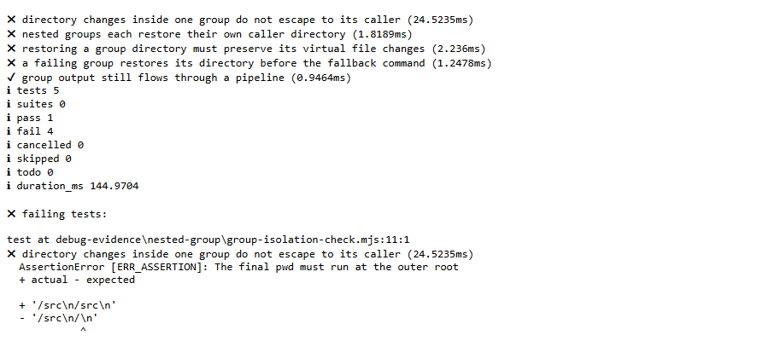
Figure 2. Four failed regression checks and the incorrect directory output.
The website showed the same error in its Virtual output panel. For (cd src && pwd) && pwd, both lines displayed /src, although the second command was outside the group. The exit status was still 0, so the problem was visible in the output rather than as an error warning.
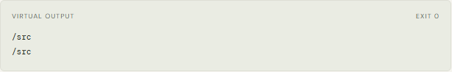
Website before the fix. The second directory output is incorrectly /src.
The cropped screenshot shows actual automated test output. The assertion reports the unexpected /src result outside the group. Four of five checks failed, covering ordinary groups, nested groups, file-changing groups and a group followed by a fallback command. This identified a state-management problem in interpretation rather than an error in the grammar or CYK parser.
Screenshot of the error recovered segments
The correction saves the caller’s current directory before evaluating a group and restores it in a finally block. Each nested group therefore restores its own caller’s directory. Only the directory is restored; the group’s output and intended virtual file changes are preserved.
if (node.type === 'group') {
const savedCwd = state.cwd;
try { return evaluate(node.body, stdin, inPipe); }
finally { state.cwd = savedCwd; }
}
After this correction, (cd src && pwd) && pwd prints /src followed by /, and the final current directory remains /. The same test cases were run again against the corrected interpreter.
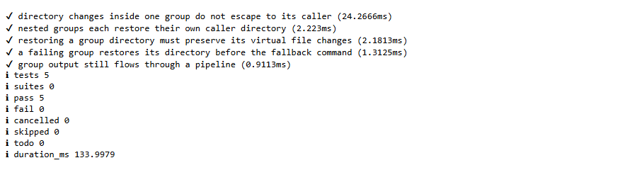
Figure 3. All five group-isolation regression checks pass after the correction.
After the fix, the same command produces /src on the first line and / on the second line in the website. The outer command now runs from the original directory. The interface layout stays the same; the change is in the interpreter result displayed to the user.
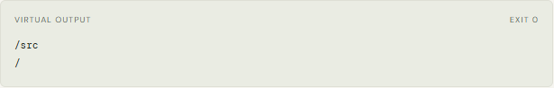
Website after the fix. The second directory output is correctly /.
The checks cover directory restoration, nested groups, preservation of virtual file changes, recovery after a failing group and output through a pipeline. All five targeted checks and all 32 existing simulator checks passed, giving 37 passes and no failures.
Restoring only the current directory is important because a group may also create or modify virtual files. Restoring the complete earlier workspace would discard those intended changes. The finally block restores navigation even when evaluation exits through an exception. Nested groups apply the same rule independently, and a fallback after a failed group therefore starts in the caller’s directory.
Possible future work
More helpful error explanations
The interface could highlight the smallest failing command segment and explain the expected rule. Recovery could rank a wider range of candidate edits, while continuing to show each suggestion for user selection.
Broader command support
Additional commands and flags could use explicit grammar and interpreter rules. Variables, redirection and wildcards would need careful modelling, documented limits and tests because their effects depend on the environment.
Recovery for real file changes
An optional backup and restore feature could record changed paths and help recover after an applied operation. This needs additional design because the current application applies changes directly without automatic rollback.
Improved learning and comparison tools
A guided mode could explain transformations using the entered command. Comparing two grammars could show why they accept different inputs. A classroom study could evaluate whether these explanations improve understanding.
Persistent workspaces and reports
Persistent workspaces, grammar presets and analysis history could support repeated experiments. Exported reports could include the parse tree, errors and proposed changes for demonstrations and assessment.
A future evaluation could ask students to predict outcomes for a fixed command set before and after using the application. Comparing accuracy and completion time would help identify useful explanations and areas for improvement.
Conclusion
CmdPrelude connects Theory of Computation with understanding a command before changing files. A CFG defines supported structures, grammar transformations prepare the rules for CYK, and the resulting tree records grouping. Recursive command groups make this connection especially clear.
A separate interpreter calculates output, errors and proposed file changes on a workspace copy. The interface displays these results alongside file trees and grammar views. Syntax corrections are checked through the same parser, keeping recovery consistent with the selected language.
The project demonstrates why tokenisation, parsing and interpretation have separate responsibilities. It remains a bounded learning and preview tool rather than a complete shell: valid syntax does not guarantee successful or safe real-world execution. Its contribution is making both the formal reasoning and the expected effects easier to inspect before the user decides what to apply.
References
The following papers provide the theoretical background. The official documentation links describe shell behaviour and the software APIs used in the implementation. Base papers and base links are highlighted below.
Base paper on context free recognition and parsing
[1] D. H. Younger, "Recognition and parsing of context-free languages in time n³," Information and Control, vol. 10, no. 2, pp. 189-208, 1967. DOI: 10.1016/S0019-9958(67)80007-X.
Relevance: theoretical background for the CYK-style recognition stage used by the project.
https://doi.org/10.1016/S0019-9958(67)80007-X
Base paper on error correcting parsing
[2] A. V. Aho and T. G. Peterson, "A Minimum Distance Error-Correcting Parser for Context-Free Languages," SIAM Journal on Computing, vol. 1, no. 4, pp. 305-312, 1972. DOI: 10.1137/0201022.
Relevance: related work on syntax correction. CmdPrelude uses a smaller candidate-and-reparse approach and does not implement this paper's complete algorithm.
https://doi.org/10.1137/0201022
Base links Shell language behaviour
[3] GNU Bash Reference Manual, "Lists." Reference for && and || command chains.
https://www.gnu.org/software/bash/manual/html_node/Lists.html
[4] GNU Bash Reference Manual, "Pipelines." Reference for pipe behaviour and pipeline exit status.
https://www.gnu.org/software/bash/manual/html_node/Pipelines.html
[5] GNU Bash Reference Manual, "Grouping Commands." Reference for parenthesised groups and subshell behaviour.
https://www.gnu.org/software/bash/manual/html_node/Command-Grouping.html
Software documentation
[6] Node.js Documentation, "File system." Reference for the local-folder adapter.
https://nodejs.org/api/fs.html
[7] Express Documentation, "4.x API Reference." Reference for HTTP routes and middleware.
https://expressjs.com/en/4x/api/

