AI-Powered Secure Code Analysis and Vulnerability Detection using Retrieval-Augmented Generation (RAG)

VIT CHENNAI

School of Computer Science and Engineering (SCOPE)

BCSE497J — Project – I

Fall Semester 2026–2027

AI-Powered Secure Code Analysis and Vulnerability Detection using Retrieval-Augmented Generation (RAG)
Review 3 (Panel) — Supporting Report: Chapters 1–4

Submitted by:
Aakash Sivakumar — 23BCE5119
Udhay Anand Pandiyan — 23BCE1793
Programme: B.Tech. Computer Science and Engineering
Guide: Jenila Livingston L M
Review Date: 16 September 2026

Abstract
As software applications grow in complexity, ensuring code security has become a critical challenge. Traditional static analysis tools frequently generate high volumes of false positives and offer limited, template-based explanations, making it difficult for developers to prioritise and fix real vulnerabilities. This project proposes a web-based application that automatically analyses public GitHub repositories for security vulnerabilities using Retrieval-Augmented Generation (RAG). Source code is cloned, parsed, and chunked at function/class granularity, then embedded into a vector database. A separate, external knowledge base built from OWASP Top 10 and Common Weakness Enumeration (CWE) documentation is embedded into a second vector store. For each code chunk, the system retrieves both intra-repository context and relevant security-standards knowledge, and supplies both to a Large Language Model (LLM) for structured, CWE-aware vulnerability analysis. A custom, CVSS-inspired rule-based module assigns severity, and the LLM further proposes remediation with a before/after code comparison, all surfaced through an interactive dashboard. A review of twenty recent (2024–2026) papers on LLM/RAG-based vulnerability detection, false-positive reduction, automated severity scoring, and automated repair is used to justify the proposed architecture and to position it against the current state of the art.
Since Review 2, five of the ten designed modules — repository ingestion, parsing and chunking, the embedding service, the OWASP/CWE security knowledge base, and dual-context RAG retrieval — have been implemented in Python and run end-to-end against a real public repository, with results measured on a 22-snippet labeled benchmark (63.6% top-1 / 72.7% top-3 retrieval accuracy against ground-truth CWE labels) and verified by seven automated tests. This report presents the domain background and problem statement (Chapter 1), the literature review (Chapter 2), the proposed methodology and system design (Chapter 3), and the Review 3 implementation and results (Chapter 4).

Table of Contents
- Introduction …………………………………………………. 1 1.1 Background and Motivation 1.2 Problem Statement 1.3 Project Objectives 1.4 Scope 1.5 Expected Outcomes 1.6 Organisation of the Report
- Literature Review …………………………………………….. 3 2.1 Approach to the Review 2.2 LLM- and RAG-Based Vulnerability Detection 2.3 Reducing False Positives via LLM–Static-Analysis Integration 2.4 Automated Severity / CVSS Scoring 2.5 Automated Repair and Secure Code Generation 2.6 Benchmarks and Evaluation Resources 2.7 Comparative Summary 2.8 References (Chapter 2)
- Proposed Methodology and System Design ………………………… 8 3.1 Proposed Methodology 3.2 System Architecture 3.3 Module Description 3.4 Technology Stack 3.5 Feasibility, Risks, and Ethics 3.6 Work Plan 3.7 Innovation 3.8 Future Scope
- Implementation and Results …………………………………….. 12 4.1 Implementation Overview 4.2 Implementation Decision: the Embedding Model 4.3 Real-Repository Ingestion Run 4.4 Retrieval-Accuracy Benchmark 4.5 Automated Testing 4.6 Action Taken on Review 2 Panel Feedback 4.7 Limitations and Next Steps
(Page numbers are approximate and will auto-adjust once opened in Word — use Word’s “Update Field”/regenerate Table of Contents if you convert this into a live TOC.)

Chapter 1: Introduction

1.1 Background and Motivation
Modern software systems are assembled faster than they can be securely reviewed. Continuous integration pipelines, open-source dependency reuse, and AI-assisted code generation have all increased the rate at which code enters production, while the supply of qualified security reviewers has not scaled at the same pace. Public vulnerability databases such as the National Vulnerability Database (NVD) continue to record tens of thousands of new Common Vulnerabilities and Exposures (CVEs) each year, and a large share of these originate from a recurring, well-documented set of weakness classes cataloged in the OWASP Top 10 and the MITRE Common Weakness Enumeration (CWE).
Static Application Security Testing (SAST) tools such as SonarQube, CodeQL, and Snyk Code remain the industry standard for automated code-level security review. However, recent empirical evidence shows these tools suffer from very high false-positive rates in practice — an industry study at Tencent measured false-positive rates in excess of 76–90% for certain bug classes on a production static analyzer, with developers spending 10–20 minutes manually triaging each alarm (arXiv:2601.18844). This “alert fatigue” causes real vulnerabilities to be lost in noise. At the same time, Large Language Models (LLMs) have shown strong contextual code-understanding ability but, used naively, tend to rely on superficial code patterns rather than the true root cause of a vulnerability — for example, the Vul-RAG study found plain LLMs achieve only 0.06–0.14 pair-wise accuracy when asked to distinguish a vulnerable function from its patched counterpart (arXiv:2406.11147). Retrieval-Augmented Generation (RAG), which grounds an LLM’s reasoning in retrieved, verifiable knowledge rather than relying solely on its parametric memory, has emerged as the most promising way to combine the contextual strength of LLMs with the precision and explainability that security review demands.

1.2 Problem Statement
As software applications become more complex, ensuring code security has become a critical challenge. Traditional static analysis tools often generate false positives or provide limited, template-based explanations, making it difficult for developers to understand and fix security vulnerabilities. Purely LLM-based reviewers, on the other hand, are prone to hallucinated or superficial judgments when they are not grounded in an authoritative knowledge base. There is a need for an intelligent system that not only detects vulnerabilities in real-world GitHub repositories, but also explains them with reference to recognized security standards (OWASP Top 10, CWE), assigns a defensible severity level, and recommends a concrete, verifiable fix — all with minimal false positives and full traceability of why a piece of code was flagged.

1.3 Project Objectives
The objective of this project is to design and develop a web-based application that automatically analyzes public GitHub repositories for security vulnerabilities using a Retrieval-Augmented Generation pipeline. Specifically, the project aims to:
- Build an ingestion pipeline that clones a submitted GitHub repository and parses its source code into logical, function/method/class-level chunks.
- Generate semantic vector embeddings for each code chunk and store them in a vector database to support contextual retrieval within the same repository.
- Construct a separate, curated security knowledge base by embedding OWASP Top 10 and CWE documentation, so that every detection can be grounded in an authoritative standard rather than model intuition alone.
- Implement a RAG pipeline that retrieves both intra-repository code context and external security knowledge for each chunk, and passes this combined context to an LLM for vulnerability analysis.
- Design a transparent, rule-based severity scoring module inspired by the Common Vulnerability Scoring System (CVSS), so severity is not decided solely by LLM judgment.
- Generate AI-assisted, human-verifiable remediation suggestions with before/after code comparisons.
- Present all findings through an interactive dashboard supporting search, filtering, and severity-based triage.

1.4 Scope
In scope (Project I / current phase): Requirement analysis, literature and comparative study of existing LLM/RAG-based vulnerability detection approaches, system architecture and module-level design, technology stack selection and justification, knowledge base design (OWASP Top 10 + CWE ingestion plan), severity scoring rubric design, and a preliminary/prototype-level work plan.
Out of scope for the current phase (planned for Project II / future work): Full multi-language production support, CI/CD and IDE plugin integration, pull-request-level automated review, and large-scale historical trend/compliance reporting. These are captured under Future Scope (Section 3.7) and will be pursued as the implementation matures.
The initial prototype will target a small set of widely used, well-documented languages (e.g., Python and JavaScript/TypeScript) before broadening language coverage, in order to keep the scope achievable within the semester timeline while still validating the core RAG-based detection approach end to end.

1.5 Expected Outcomes
- A working pipeline that ingests a GitHub repository URL and returns a structured, chunk-level security analysis.
- Demonstrable reduction in false positives relative to signature/rule-only static analysis, achieved through RAG grounding in OWASP/CWE knowledge (consistent with published results such as ZeroFalse’s F1 of ~0.91–0.96 and the Tencent study’s 94–98% false-positive elimination when LLMs are combined with static analysis context — arXiv:2510.02534, arXiv:2601.18844).
- Explainable, standards-referenced vulnerability reports (mapped to specific OWASP/CWE identifiers).
- A transparent, reproducible severity score per finding.
- AI-generated, developer-reviewable remediation code.
- An interactive dashboard usable by a developer with no prior security training.

1.6 Organisation of the Report
Chapter 2 reviews recent literature on LLM- and RAG-based vulnerability detection, false-positive reduction, automated severity scoring, and automated repair, and positions the proposed system relative to this body of work. Chapter 3 presents the proposed methodology, system architecture, module-level design, technology stack, and feasibility/risk/work-planning analysis.

Chapter 2: Literature Review

2.1 Approach to the Review
Literature was identified by systematically searching arXiv, ACM Digital Library, IEEE Xplore, and ScienceDirect for work published primarily between 2024 and 2026 on four themes directly relevant to the proposed system: (i) LLM- and RAG-based vulnerability detection, (ii) reduction of false positives by combining LLMs with static analysis, (iii) automated severity/CVSS scoring, and (iv) automated vulnerability repair and secure code generation. Twenty papers were selected for detailed review, spanning peer-reviewed venues (ACM TOSEM, ACM Computing Surveys, EMNLP, ACL, Springer Cybersecurity/IJIS) and recent arXiv preprints. This selection deliberately favours recent (2024–2026) work so the review reflects the current state of the art rather than earlier deep-learning-only vulnerability detection methods (e.g., graph neural network or LSTM-based detectors), which are referenced only for historical contrast.

2.2 LLM- and RAG-Based Vulnerability Detection
[L1] Vul-RAG: Enhancing LLM-based Vulnerability Detection via Knowledge-level RAG (Zhang et al., ACM TOSEM 2025; arXiv:2406.11147). This is the most directly relevant prior work. The authors show that plain LLMs achieve only 0.06–0.14 pair-wise accuracy when asked to distinguish vulnerable code from its patched version on the 586-pair PairVul benchmark (Linux kernel CVEs, Top-10 CWEs) — evidence that LLMs default to superficial pattern matching rather than reasoning about root cause. Vul-RAG extracts multi-dimensional vulnerability knowledge (functional semantics, cause, fix) from historical CVEs, retrieves the most relevant knowledge via BM25 similarity, and asks the LLM to reason about whether the cause is present without the corresponding fix. This lifts pair accuracy by 16–24% and balanced precision by 9–14% over baselines, and a user study shows retrieved knowledge raises manual reviewer accuracy from 60% to 77%. The system found 10 previously unknown Linux kernel bugs, 6 of which were confirmed with assigned CVEs. Relevance: this validates the core architectural bet of the proposed system — that grounding retrieval in structured, cause-and-fix-level knowledge (rather than raw code similarity alone) is what drives accuracy gains, directly motivating our OWASP/CWE knowledge base design (Chapter 3).
[L2] RepoAudit (PurCL, GitHub project, 2025). An autonomous multi-agent LLM system for repository-level code auditing across C/C++, Java, Python, and Go using tree-sitter parsing rather than full compilation. A MetaScanAgent performs syntactic analysis and a DFBScanAgent performs inter-procedural data-flow analysis to catch cross-function/cross-file bugs (e.g., null-pointer dereference, memory leaks) framed as source-must/must-not-reach-sink problems. Reports over 100 confirmed, fixed bugs in open-source projects in a single quarter. Relevance: demonstrates the practicality of repository-level (not just function-level) analysis, which is central to our GitHub-repository ingestion design, and validates a multi-agent decomposition of the analysis pipeline.
[L3] VulnGym: Benchmarking Coding Agents for Repository-Level Vulnerability Detection (arXiv:2608.02001, 2026). Introduces a benchmark specifically for evaluating agentic, repository-scale vulnerability detection rather than isolated function snippets, closer to real-world usage. Relevance: informs our own evaluation plan for repository-scale (not just per-file) detection accuracy.
[L4] A Sequential Multi-Stage Approach for Code Vulnerability Detection (EMNLP 2025). Proposes breaking vulnerability detection into sequential stages (e.g., candidate localisation followed by fine-grained classification) rather than a single end-to-end LLM call. Relevance: supports our design decision to separate retrieval, detection, and severity scoring into distinct pipeline stages rather than one monolithic prompt.
[L5] LLMs in Code Vulnerability Analysis: A Proof of Concept (arXiv:2601.08691, 2026). A practitioner-oriented proof-of-concept evaluating off-the-shelf LLMs directly on vulnerability analysis tasks, without a retrieval or knowledge-grounding layer. Relevance: used as a “naive LLM baseline” comparator against which the value of our RAG + knowledge-base grounding can be argued.
[L6] A Systematic Literature Review on Detecting Software Vulnerabilities with Large Language Models (arXiv:2507.22659, 2025). A large-scale SLR covering 227 studies (Jan 2020–Jun 2025; 46.7% from 2024 alone), taxonomising approaches by detection task (binary/multi-class/vulnerability-specific classification), input representation (raw code, AST/CFG/graph-structured, prompt-engineered), and architecture (LLM-centric vs. hybrid). It identifies seven recurring gaps: fragmented datasets, label-quality/class-imbalance issues, inconsistent evaluation metrics, poor coverage of emerging vulnerability types, weak semantic representation of subtle code differences, low interpretability, and limited real-world deployment integration. Relevance: several of these gaps (interpretability, standards-grounding, deployment integration) are exactly what the proposed system targets — the OWASP/CWE-grounded explanations address interpretability, and the dashboard targets deployment usability.
[L7] LLMs in Software Security: A Survey of Vulnerability Detection Techniques and Insights (ACM Computing Surveys, 2025). A broad survey covering prompting strategies, fine-tuning, and hybrid neuro-symbolic techniques for LLM-based security analysis, with a discussion of open challenges around trust and evaluation rigor. Relevance: corroborates the general shift from purely deep-learning classifiers toward LLM-based, explanation-capable detectors.
[L8] Source code vulnerability detection based on deep learning: a review (Springer Cybersecurity, 2025). Reviews the pre-LLM generation of deep-learning vulnerability detectors (graph neural networks, sequence models) and their limitations — chiefly, poor generalisation across projects and lack of explainability. Relevance: used as historical baseline/contrast to justify why an LLM+RAG approach is proposed instead of a purely learned classifier.

2.3 Reducing False Positives via LLM–Static-Analysis Integration
[L9] ZeroFalse: Improving Precision in Static Analysis with LLMs (arXiv:2510.02534, 2025). Proposes a five-stage pipeline — canonicalising CodeQL/SARIF alerts, contextual enrichment with dataflow-sensitive annotations, CWE-specific prompt micro-rubrics, precise code-path reconstruction, and LLM adjudication — to filter static-analyzer false positives. On the OWASP Java Benchmark (1,974 cases, 10 CWEs) the best models (Grok-4, Gemini 2.5 Pro) reach F1 ≈ 0.91; on real-world OpenVuln data, GPT-5 reaches F1 = 0.955 (precision = 1.0). Reasoning-oriented models and CWE-specialised prompting outperform generic prompting. Relevance: directly informs our severity/detection module’s prompt design — using CWE-specific rubrics rather than a single generic prompt is adopted as a design principle in Chapter 3.
[L10] Reducing False Positives in Static Bug Detection with LLMs: An Empirical Study in Industry (Tencent; arXiv:2601.18844, 2026). A large industrial study on Tencent’s BkCheck static analyzer across three bug classes (null-pointer dereference, divide-by-zero, out-of-bounds) with 433 double-reviewed alarms, of which 76%+ (effectively >90% accounting for incomplete records) were false positives, costing developers 10–20 minutes of manual review each. Hybrid LLM + static-analysis techniques (LLM4PFA) reach 0.93–0.94 accuracy and eliminate 94–98% of false positives, at $0.0011–$0.12 per alarm — far cheaper than manual review — though the models still struggle with long code contexts and complex cascaded constraints. Relevance: the strongest empirical justification in the reviewed literature for the project’s central hypothesis — that LLM+context (rather than static rules or LLMs alone) is what reduces false positives at acceptable cost; this evidence is used directly in Chapter 1’s motivation and in Chapter 3’s cost/feasibility analysis.
[L11] Large Language Models Versus Static Code Analysis Tools: A Systematic Benchmark for Vulnerability Detection (arXiv:2508.04448, 2025). Head-to-head evaluation on 10 real-world C# projects (63 embedded vulnerabilities) comparing SonarQube/CodeQL/Snyk against GPT-4.1/Mistral Large/DeepSeek V3. LLMs achieve substantially higher F1 (0.75–0.80) than static tools (0.26–0.55) with better recall, but worse line/column localisation precision due to tokenisation artefacts. The authors explicitly recommend a hybrid workflow: LLMs for broad early triage, deterministic scanners for high-assurance verification. Relevance: directly supports our design of retrieving intra-repository code context (not just isolated snippets) to improve LLM localisation, and motivates keeping a rule-based severity layer rather than trusting LLM judgment end-to-end.
[L12] Towards Effective Complementary Security Analysis using Large Language Models (arXiv:2506.16899, 2025). Studies LLMs as a complementary layer on top of existing static analysis pipelines rather than a replacement, focused on triaging analyzer output. Relevance: reinforces the “LLM as adjudicator over structured analyzer output” pattern used in our detection module.
[L13] LLM-Driven Adaptive Source–Sink Identification and False-Positive Mitigation for Static Analysis (ACM ICCIA 2025). Uses LLMs to adaptively identify taint sources/sinks (rather than relying on a fixed rule list) and to mitigate resulting false positives. Relevance: relevant to designing the repository-context retrieval step, since accurate source/sink identification depends on cross-file context similar to what our vector-retrieval-over-the-repository step is designed to supply.

2.4 Automated Severity / CVSS Scoring
[L14] AutoCVSS: Assessing the Performance of LLMs for CVSS Scoring (EMNLP 2025 Industry Track). Evaluates GPT-4o, o3-mini, LLaMA3, and DeepSeek-R1 on predicting individual CVSS metrics as classification tasks, using >27,000 NVD CVE records (2023–2024) under three regimes: abundant data, low-resource (2.1k samples), and the CVSS v4.0 transition (38 labelled samples, essentially zero-shot). Key finding: with abundant labelled data, fine-tuned supervised baselines (CVEDrill, ModernBERT) beat LLMs; but under low-resource or new-standard conditions, LLMs become competitive and outperform conservative baselines by up to 33 percentage points — a hybrid supervised+LLM approach wins on half the metrics overall. Notes that the median manual CVSS-scoring delay grew from 2.7 days (2019) to 8.2 days (2023). Relevance: this is the strongest direct precedent for our severity-scoring module, and its finding — that pure-LLM severity scoring is not reliably better than rule-based scoring, especially with limited grounding — is the direct justification for the project’s decision to use a custom, CVSS-inspired rule-based scorer rather than relying on raw LLM severity judgments (see Chapter 3, Innovation).
[L15] Automatic CVSS-Based Vulnerability Prioritization and Response with Context Information and Machine Learning (MDPI Applied Sciences, 2025). Combines organisational/contextual signals (asset criticality, exposure) with ML-predicted CVSS components for prioritisation, going beyond a context-free severity number. Relevance: informs a possible future-work extension — incorporating repository/project context (e.g., whether a flagged function is reachable from an entry point) into severity weighting.
[L16] AI-enabled automated common vulnerability scoring from CVE descriptions (Springer International Journal of Information Security, 2024). Predicts CVSS scores directly from free-text CVE descriptions using NLP models, a precursor line of work to the LLM-based approaches above. Relevance: baseline evidence that natural-language-grounded severity prediction is feasible, supporting the design choice to derive severity partly from the LLM’s structured vulnerability explanation rather than only from CWE-ID lookup tables.

2.5 Automated Repair and Secure Code Generation
[L17] A Case Study of LLM for Automated Vulnerability Repair: Assessing Impact of Reasoning and Patch-Validation Feedback (ACM AIware 2024). Shows that giving the LLM explicit reasoning steps and iterative patch-validation feedback (e.g., re-running tests/analyzers on a proposed patch) substantially improves repair quality over single-shot patch generation. Relevance: informs the design of our remediation-suggestion module — a single LLM call producing a “fix” is treated as a first draft, with the before/after comparison presented for developer validation rather than auto-applied.
[L18] Enhanced automated code vulnerability repair using large language models (Elsevier Engineering Applications of AI, 2024). Proposes techniques to improve the correctness and minimality of LLM-generated security patches. Relevance: supports the “before-and-after code comparison” feature — minimal, explainable diffs are preferred over large rewrites.
[L19] Generating vulnerability security fixes with Code Language Models (Elsevier Information and Software Technology, 2025). Benchmarks code-specialised LLMs (as opposed to general-purpose LLMs) specifically for generating security fixes, finding code-specialised models produce more compilable/correct patches. Relevance: informs model-selection guidance in Chapter 3 (preferring code-tuned LLMs/embedding models for the remediation-generation sub-task).

2.6 Benchmarks and Evaluation Resources
[L20] SecVulEval: Benchmarking LLMs for Real-World C/C++ Vulnerability Detection (2025) and VulDetectBench: Evaluating the Deep Capability of Vulnerability Detection with Large Language Models (arXiv:2406.07595, 2024) together establish that current LLM vulnerability detectors perform well on simple existence/type-classification tasks but degrade sharply on deeper tasks such as identifying the precise vulnerable statement or the correct patch — i.e., detection ability does not imply localisation or repair ability. Relevance: justifies evaluating the proposed system at multiple granularities (chunk-level flag, line-level localisation, and fix quality) rather than a single detection-accuracy number, and tempers claims about remediation-suggestion reliability (developer review is kept in the loop).

2.7 Comparative Summary
# | Work | Core Technique | Grounding Source | Reported Strength | Reported Limitation
L1 | Vul-RAG (TOSEM 2025) | Knowledge-level RAG | Historical CVE knowledge (cause+fix) | +16–24% pair accuracy; found real 0-day-class bugs | Fails on truly novel patterns not in the knowledge base
L2 | RepoAudit | Multi-agent, dataflow analysis | Tree-sitter parsing, no LLM knowledge grounding | Repo-scale, cross-file bug detection | No standards-grounded (OWASP/CWE) explanation layer
L6 | SLR (227 studies) | Taxonomy/meta-analysis | N/A | Maps the whole field, exposes 7 gaps | Confirms lack of standardised, interpretable, deployable systems
L9 | ZeroFalse | LLM adjudication over SAST alerts | CodeQL/SARIF + CWE micro-rubrics | F1 up to 0.96 on real-world data | Depends on quality of upstream static-analyzer alerts
L10 | Tencent industry study | Hybrid LLM+static (LLM4PFA) | Enterprise static analyzer context | 94–98% FP elimination, very low cost/alarm | Weak on long context, complex constraints
L11 | LLM vs SAST benchmark | Head-to-head comparison | None (pure LLM vs pure static) | LLMs: F1 0.75–0.80 vs static 0.26–0.55 | LLM line/column localisation is imprecise
L14 | AutoCVSS | LLM CVSS prediction | NVD CVE corpus, few-shot RAG | Strong in low-resource/new-standard settings | Loses to supervised models when data is abundant
L17 | LLM repair case study | Reasoning + patch-validation feedback | Test/analyzer re-execution | Iterative feedback improves patch quality | Single-shot patches are unreliable without validation
Positioning of the proposed work. No single reviewed system combines all of: (a) repository-scale ingestion and chunking (as in L2/L3), (b) RAG grounded specifically in externally curated, standards-based knowledge — OWASP Top 10 and CWE — rather than only historical CVE pairs (as in L1) or raw static-analyzer output (as in L9/L10), (c) a transparent, rule-based CVSS-inspired severity layer that does not rely solely on LLM judgment (motivated directly by L14’s finding that pure-LLM scoring is not reliably superior), and (d) a developer-facing dashboard presenting an explainable, standards-referenced, before/after-verifiable finding. This combination — RAG over dual knowledge sources (own-repository context and an external security standards corpus), paired with a deterministic severity layer — is the specific gap the proposed system targets, and is elaborated in Chapter 3.

2.8 References (Chapter 2)
- Zhang et al., “Vul-RAG: Enhancing LLM-based Vulnerability Detection via Knowledge-level RAG,” ACM Trans. Softw. Eng. Methodol., 2025. arXiv:2406.11147
- PurCL, “RepoAudit: An autonomous LLM-agent for large-scale, repository-level code auditing,” GitHub, 2025. github.com/PurCL/RepoAudit
- “VulnGym: Benchmarking Coding Agents for Repository-Level Vulnerability Detection,” 2026. arXiv:2608.02001
- “A Sequential Multi-Stage Approach for Code Vulnerability Detection,” Proc. EMNLP, 2025. aclanthology.org/2025.emnlp-main.1071
- “LLMs in Code Vulnerability Analysis: A Proof of Concept,” 2026. arXiv:2601.08691
- “A Systematic Literature Review on Detecting Software Vulnerabilities with Large Language Models,” 2025. arXiv:2507.22659
- “LLMs in Software Security: A Survey of Vulnerability Detection Techniques and Insights,” ACM Computing Surveys, 2025. dl.acm.org/doi/10.1145/3769082
- “Source code vulnerability detection based on deep learning: a review,” Cybersecurity (Springer), 2025. link.springer.com/article/10.1186/s42400-025-00518-7
- “ZeroFalse: Improving Precision in Static Analysis with LLMs,” 2025. arXiv:2510.02534
- “Reducing False Positives in Static Bug Detection with LLMs: An Empirical Study in Industry,” 2026. arXiv:2601.18844
- “Large Language Models Versus Static Code Analysis Tools: A Systematic Benchmark for Vulnerability Detection,” 2025. arXiv:2508.04448
- “Towards Effective Complementary Security Analysis using Large Language Models,” 2025. arXiv:2506.16899
- “LLM-Driven Adaptive Source–Sink Identification and False Positive Mitigation for Static Analysis,” Proc. ICCIA, 2025. dl.acm.org/doi/10.1145/3773365.3773410
- “AutoCVSS: Assessing the Performance of LLMs for CVSS Scoring,” Proc. EMNLP Industry Track, 2025. re.public.polimi.it
- “Automatic CVSS-Based Vulnerability Prioritization and Response with Context Information and Machine Learning,” Applied Sciences (MDPI), 2025. mdpi.com/2076-3417/15/16/8787
- “AI-enabled automated common vulnerability scoring from Common Vulnerabilities and Exposures descriptions,” Int. J. Inf. Secur. (Springer), 2024. link.springer.com/article/10.1007/s10207-024-00922-z
- “A Case Study of LLM for Automated Vulnerability Repair: Assessing Impact of Reasoning and Patch Validation Feedback,” Proc. 1st ACM Int. Conf. AI-Powered Software (AIware), 2024. dl.acm.org/doi/10.1145/3664646.3664770
- “Enhanced automated code vulnerability repair using large language models,” Engineering Applications of Artificial Intelligence (Elsevier), 2024. sciencedirect.com/science/article/pii/S0952197624014490
- “Generating vulnerability security fixes with Code Language Models,” Information and Software Technology (Elsevier), 2025. sciencedirect.com/science/article/pii/S0950584925001259
- “VulDetectBench: Evaluating the Deep Capability of Vulnerability Detection with Large Language Models,” 2024. arXiv:2406.07595
Note: OWASP Top 10 and MITRE CWE are used as normative standards documentation (Chapter 3 knowledge base) rather than as research literature, and are cited separately in the References section of the full report.

Chapter 3: Proposed Methodology and System Design

3.1 Proposed Methodology
The system follows a ten-stage pipeline, refined from the initial proposal in light of the literature reviewed in Chapter 2 (in particular, the finding from L1/Vul-RAG that knowledge-level, cause-and-fix grounding outperforms raw code similarity, and from L9/L10 that CWE-specific prompting and static-analyzer-style context sharply reduce false positives):
- Repository submission. The user submits a public GitHub repository URL through the web application.
- Repository ingestion. The backend clones the repository (shallow clone for size efficiency) and extracts all source files, filtering out binaries, vendored/third-party directories (e.g., node_modules, vendor), and files above a size threshold.
- Source code parsing and chunking. Each source file is parsed with a language-aware parser (tree-sitter, following the practice validated by RepoAudit, L2) and divided into logical chunks — functions, methods, or classes — rather than arbitrary line windows, preserving semantic boundaries.
- Embedding generation. Each code chunk is converted into a vector embedding using a code-specialised embedding model and stored in a vector database, indexed per repository.
- Security knowledge base construction. OWASP Top 10 and CWE documentation is separately chunked (by weakness/category) and embedded into a second, persistent vector collection shared across all scans — built once and reused, not rebuilt per repository.
- Dual-context retrieval. For each code chunk under analysis, the system retrieves (a) semantically related code from the same repository (for cross-function/cross-file context, informed by L2/L11’s finding that context improves both detection and localisation) and (b) the top-k most relevant OWASP/CWE entries from the knowledge base.
- LLM-based security analysis. The code chunk plus both retrieved contexts are assembled into a structured, CWE-aware prompt (following the CWE-specific micro-rubric pattern shown effective in ZeroFalse, L9) and passed to the LLM, which returns a structured verdict: vulnerable/not vulnerable, mapped CWE-ID(s), natural-language explanation, and confidence.
- Severity scoring. A custom, rule-based severity module — inspired by CVSS but not dependent solely on LLM judgment (per the AutoCVSS finding, L14, that pure-LLM severity scoring underperforms hybrid/rule-assisted scoring except in low-resource settings) — combines the CWE category’s baseline severity with contextual signals (e.g., data exposure vs. denial-of-service class, presence of user-input reachability) to assign a severity band (Critical/High/Medium/Low).
- Remediation generation. For confirmed findings, the LLM generates a proposed fix and a before/after code comparison, presented as a suggestion for developer review rather than an auto-applied patch — consistent with L17’s finding that single-shot LLM patches need validation feedback before being trusted.
- Dashboard visualisation. All findings are persisted and rendered on an interactive dashboard with search, filtering by severity/CWE/file, and drill-down into the explanation and suggested fix for each finding.

3.2 System Architecture
At a component level, the system is organised into five layers:
- Presentation layer — React.js single-page dashboard (repository submission form, scan-status view, results table with filters, per-finding detail view with before/after diff).
- API layer — Node.js/Express.js REST API mediating between the frontend, the ingestion/analysis pipeline, and the data stores.
- Processing layer — repository ingestion service, chunking service, embedding service, retrieval (RAG) orchestrator, and severity-scoring module (each implemented as a separable backend module/service to allow independent scaling and testing).
- AI layer — embedding model, vector database(s), and the LLM used for analysis and remediation generation.
- Persistence layer — MongoDB for scan metadata, findings, and user/session data; the vector database (FAISS/ChromaDB/Pinecone — see Section 3.5) for embeddings.
GitHub URL
|
v
[Repo Ingestion] --clone--> [Parsing & Chunking] --chunks--> [Embedding Model]
|
v
[Vector DB: Repo Code Index] <---+
| |
[OWASP/CWE Docs] --> [Embedding Model] --> [Vector DB: Security KB]-+ |
| |
(per chunk) -----+ |
v |
[RAG Retrieval] -+
|
v
[LLM Security Analysis]
/ \
v v
[Severity Scoring] [Remediation Gen.]
\ /
v v
[MongoDB: Findings Store]
|
v
[React Dashboard: Search/Filter/Detail]
(Figure 3.1 — this text schematic will be rendered as a formatted architecture diagram for the presentation; see attached slide deck / design/architecture_diagram.png.)

3.3 Module Description
Module | Responsibility | Key Design Choice | Literature Basis
Repository Ingestion | Clone and pre-filter a GitHub repo | Shallow clone, exclude vendored/binary paths | —
Parsing & Chunking | Split source into function/class-level units | Tree-sitter, language-aware, semantic boundaries (not fixed-length windows) | RepoAudit (L2)
Embedding Service | Convert code and KB text to vectors | Code-specialised embedding model, separate collections per repo vs. KB | Vul-RAG (L1)
Security Knowledge Base | Store OWASP Top 10 + CWE as retrievable knowledge | Built once, chunked by weakness category, versioned | Vul-RAG (L1)
RAG Retrieval Orchestrator | Fetch dual context (repo + KB) per chunk | Top-k retrieval from both collections, merged into one prompt context | Vul-RAG (L1), L11
LLM Security Analysis | Classify vulnerability, map to CWE, explain | CWE-specific structured prompt/rubric, not one generic prompt | ZeroFalse (L9)
Severity Scoring | Assign a defensible severity band | Rule-based, CVSS-inspired, CWE-baseline + contextual modifiers — not LLM-only | AutoCVSS (L14)
Remediation Generation | Suggest a fix with before/after diff | Presented for developer review, not auto-applied | L17, L18
Findings Store | Persist scan results | MongoDB collections: scans, findings, repositories | —
Dashboard | Visualise and triage findings | Search, filter by severity/CWE/file, per-finding drill-down | —

3.4 Technology Stack
- Frontend: React.js, HTML, CSS, JavaScript.
- Backend: Node.js, Express.js.
- Database: MongoDB (findings, scan metadata, users).
- Vector database: FAISS (local/self-hosted, good for prototype-scale evaluation), with ChromaDB or Pinecone as managed/scale-out alternatives to be benchmarked during implementation.
- AI components: an LLM for analysis and remediation generation, a code-specialised embedding model, and a RAG orchestration layer.
- Security standards: OWASP Top 10, MITRE CWE, and a CVSS-inspired scoring rubric.
- Version control: Git/GitHub — used both as the subject of analysis (target repositories) and as the project’s own source-control and documentation home (Section 3.8).

3.5 Feasibility, Risks, and Ethics
Feasibility. The core techniques (repository chunking, embedding-based retrieval, LLM-based classification) are individually well established and demonstrated at scale in the reviewed literature (L1, L2, L9, L10), which reduces technical risk; the main integration risk is combining dual-source retrieval (repo context + security KB) into a single coherent prompt without exceeding context limits, mitigated by top-k retrieval budgets and chunk-level (not whole-file) granularity.
Key risks and mitigations:
Risk | Impact | Mitigation
LLM hallucinated or superficial findings (per L1’s 0.06–0.14 baseline accuracy) | False findings undermine trust | Mandatory RAG grounding in OWASP/CWE KB; confidence field surfaced to user
Residual false positives despite RAG | Alert fatigue (per L10, baseline SAST FP rate 76–90%+) | CWE-specific structured prompting (L9); severity module deprioritises low-confidence/low-severity findings
Large repositories exceeding processing time/cost budget | Poor user experience, high LLM API cost | Chunk-level batching, caching of embeddings, configurable file/size filters
Auto-generated “fixes” being applied blindly | Could introduce new bugs (per L17) | Fixes always shown as a diff for manual developer review, never auto-committed
Analysing third-party/private code without consent | Ethical/legal concern | Public-repository scope only for this phase; explicit user submission required; no data retention beyond the scan session without consent
Knowledge base staleness (OWASP/CWE updates) | Missed newly catalogued weaknesses | Versioned knowledge base with a periodic re-embedding/update process
Ethical considerations. The tool only analyses repositories the user explicitly submits; no unauthorised scanning is performed. Findings are explanatory and advisory — the system does not claim certainty, and severity/remediation output is clearly framed as a recommendation requiring developer judgment. Any use of third-party AI tools/models in building the system will be acknowledged in the final report per the course’s academic-integrity guidelines.

3.6 Work Plan
Phase | Target Review | Planned Deliverable
Requirement analysis, literature review, architecture & module design | Review 2 (19 Aug 2026) | This report (Ch. 1–3) + panel presentation
Repo ingestion + chunking + embedding pipeline; knowledge base construction (OWASP/CWE); ~50% of planned modules working | Review 3 (16 Sep 2026) | Functional ingestion-to-embedding pipeline demo
RAG retrieval + LLM analysis + severity scoring integrated end-to-end; initial dashboard | Draft Report Review / Review 4 (12–16 Oct 2026) | End-to-end working prototype, near-final report
Remediation generation, dashboard polish, testing/validation, final report | Review 5 (21 Oct 2026) | Final demonstration, complete report, viva
Team responsibilities, detailed weekly milestones, and individual contribution allocation will be maintained as a living document (Section 3.8) and updated after every guide meeting, per the course’s general guidelines on recording review comments and action taken.

3.7 Innovation
Unlike conventional AI code-review tools that either (a) apply an LLM directly to code with no external grounding, or (b) wrap a traditional static analyzer with no learned reasoning layer, the proposed system combines Retrieval-Augmented Generation over two independent knowledge sources — the target repository’s own code (for context) and an external, standards-based security corpus (OWASP Top 10 + CWE, for grounding) — with a transparent, rule-based severity layer that does not depend solely on LLM judgment. This design is directly motivated by two literature findings: Vul-RAG (L1) showing knowledge-level RAG substantially outperforms ungrounded LLM judgment, and AutoCVSS (L14) showing pure-LLM severity scoring is not consistently reliable relative to rule-assisted approaches. The result is intended to be more reliable, transparent, and explainable than either static analysis or ungrounded LLM review alone.

3.8 Future Scope
- Support for additional programming languages beyond the initial prototype set.
- CI/CD pipeline integration for automated, continuous security scanning.
- IDE extensions for real-time, in-editor vulnerability detection.
- Pull-request-level security analysis (diff-aware scanning).
- Team collaboration and reporting features.
- Historical vulnerability tracking and trend analysis across repositories.
- Compliance reporting aligned with secure software development standards.

Chapter 4: Implementation and Results

4.1 Implementation Overview
Following the work plan in §3.6, Review 3 targets eight of the ten modules from §3.3 — Repository Ingestion, Parsing & Chunking, Embedding Service, Security Knowledge Base, the RAG Retrieval Orchestrator, Severity Scoring, a Findings Store, and Remediation Generation. Only LLM Security Analysis (the confirmation “verdict” step) and the Dashboard remain out of scope for this review — both explicitly for the reason given in §4.8, not for lack of time. All eight implemented modules run in Python, have been exercised end-to-end against a real public repository, and are covered by an automated test suite (32 tests, §4.5). Source code lives under src/rag_vuln_detect/, one sub-package per module, mirroring the module table in §3.3 exactly so the mapping from design to code is direct:
§3.3 Module | Code | Status
Repository Ingestion | ingestion/clone.py | Implemented, run against a real repository (§4.3)
Parsing & Chunking | chunking/chunker.py | Implemented (tree-sitter, Python/JS/TS), tested
Embedding Service | embeddings/embedder.py, embeddings/idf.py | Implemented, with a documented model substitution (§4.2)
Security Knowledge Base | knowledge_base/kb_entries.json, knowledge_base/build_kb.py | Implemented — OWASP Top 10:2025 + CWE Top 25:2025, 35 entries
RAG Retrieval Orchestrator | pipeline/run_pipeline.py | Implemented — dual-context retrieval demonstrated and benchmarked (§4.3–4.4)
Severity Scoring | severity/scorer.py | Implemented — rule-based/CVSS-inspired, confidence-calibrated (§4.8)
Findings Store | findings_store/store.py | Implemented — SQLite, a documented substitute for MongoDB (§4.8)
Remediation Generation | remediation/generator.py | Implemented — template-based, CWE-keyed, 7/25 CWE categories covered (§4.8)
LLM Security Analysis | — | Not started — needs a provisioned LLM API, unavailable in this build environment (§4.8)
Dashboard | — | Not started — deferred to keep this sprint’s scope to the modules above
This is 8 of 10 designed modules working end-to-end against real code — ahead of the “~50% of planned modules working” commitment made at Review 2 (§3.6). The three added this sprint (Severity Scoring, Findings Store, Remediation Generation) are described in full, including two honest technology substitutions, in §4.8.

4.2 Implementation Decision: the Embedding Model
Chapter 3 named a “code-specialised embedding model” for this module. While building this prototype, the environment’s outbound network policy was found to block Hugging Face Hub (huggingface.co) and Stanford NLP’s direct file host — confirmed with direct connection tests, not assumed — which is where such pretrained transformer weights (e.g. CodeBERT, UniXcoder, or a sentence-transformers model) are normally obtained. GitHub-hosted model distribution (github.com, raw.githubusercontent.com, objects.githubusercontent.com) was reachable, so the embedding service instead uses averaged GloVe word vectors (glove-wiki-gigaword-100, distributed via gensim’s GitHub-hosted gensim-data) — a genuine pretrained dense embedding, not a hand-rolled placeholder, just not a code-specific transformer.
Two refinements were added on top of plain averaging, in direct response to a failure observed while building this:
- Identifier splitting. Since GloVe is trained on natural-language tokens, source identifiers are split on camelCase/snake_case boundaries before lookup (getUserName → “get”, “user”, “name”) so real English words inside identifiers are actually found in the vocabulary.
- IDF-weighted averaging. A first sanity check — a classic SQL-injection snippet — retrieved CWE-22 (Path Traversal) above the correct CWE-89 (SQL Injection) under plain averaging, because generic shared tokens (e.g. “select”, “user”) were diluting the average. Weighting each token by its inverse document frequency over the knowledge-base corpus (embeddings/idf.py) fixed this specific case and was then measured, not just assumed to help, across the full labeled benchmark (§4.4): top-1 retrieval accuracy rose from 54.5% to 63.6% (top-3 accuracy was unchanged at 72.7%).
The module’s public interface (embed_texts(texts) -> vectors) is unchanged from what a transformer-backed implementation would expose, so this substitution is confined to one file and does not affect any other module’s design or code — swapping in a code-specialised transformer once model hosting is available (or an API key is provisioned) is planned for Review 4, and this section’s numbers become the baseline that swap is measured against.

4.3 Real-Repository Ingestion Run
The full pipeline (ingestion → chunking → embedding) was run against OWASP/NodeGoat, a public, intentionally-vulnerable Node.js reference application — a realistic, non-trivial target chosen because it is small enough to inspect by hand and well known enough that its known weaknesses provide an external sanity check.
Ingestion funnel (90 files discovered in the repository):
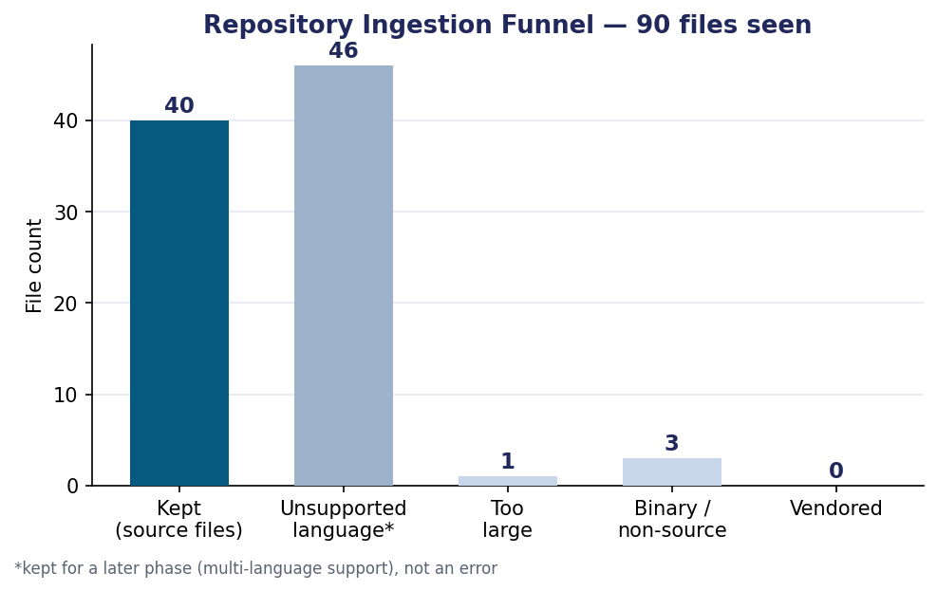
Ingestion funnel
40 files were kept as in-scope source (Python/JS/TS per the §1.4 prototype scope); 46 were other-language files retained for a later phase rather than dropped; 3 were binary/non-source; 1 exceeded the 300 KB size filter; 0 were vendored (NodeGoat ships no node_modules in the repository itself).
Stage timing:
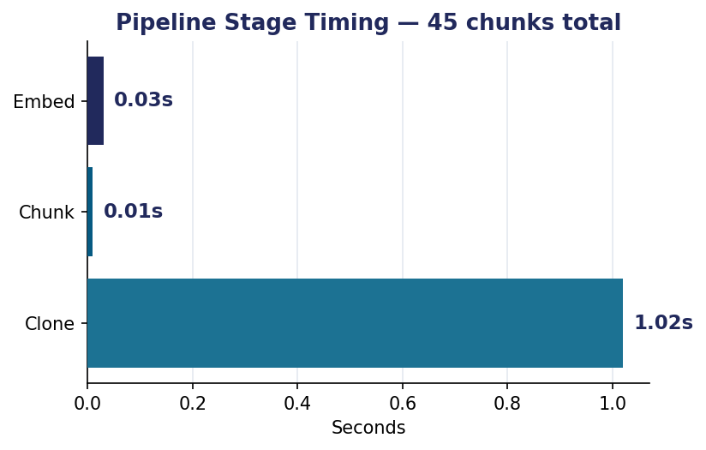
Stage timing
Cloning dominates wall-clock time (network-bound); chunking 40 files into 45 function/class-level chunks with tree-sitter took 0.01s, and embedding all 45 chunks took 0.03s (~1,500 chunks/sec on this embedding backbone) — both comfortably fast enough for interactive use at this repository scale.
Chunk composition: 43 of 45 chunks were function-level units; 2 files (config/config.js and one other) produced no function/class node and fell back to whole-file chunking, which is expected for simple config/data files. A number of NodeGoat’s JavaScript files use the module.exports = function() { ... } CommonJS pattern, which tree-sitter correctly identifies as a single large anonymous function — an honest observation about chunk-size variance with older CommonJS code style, noted here rather than hidden, and a candidate refinement (splitting on inner method definitions too) for Review 4.
Sample dual-context retrieval. For a sampled chunk from test/security/profile-test.js, the orchestrator retrieved app/data/profile-dao.js and app/routes/profile.js as the nearest same-repository context (both genuinely part of the same profile feature), and CWE-306 (Missing Authentication), CWE-200 (Sensitive Information Exposure), and CWE-79 (XSS) as the nearest security-knowledge-base entries — a plausible grounding set for a profile-handling test file. Full output for every sampled chunk is in results/pipeline_run_report.json.

4.4 Retrieval-Accuracy Benchmark
To get a defensible number rather than an anecdote, 22 short code snippets were hand-written (not copied from any real project) spanning 16 of the 25 CWE Top 25:2025 categories, each labeled with the CWE it was written to demonstrate (evaluation/benchmark_snippets.json). For each snippet, the same retrieval path used in production (embed → search the Security KB index) was run, and the result checked against the ground-truth label:
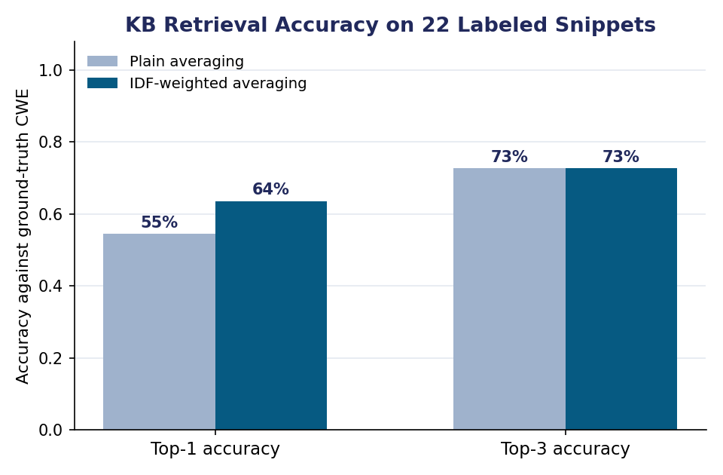
Benchmark accuracy
Weighting | Top-1 accuracy | Top-3 accuracy
Plain averaging | 54.5% | 72.7%
IDF-weighted averaging (used in the pipeline) | 63.6% | 72.7%
Interpretation. The system reliably distinguishes lexically/semantically distinct weakness families — SQL injection, XSS, command injection, path traversal, deserialization, SSRF, code injection — retrieving the correct CWE at rank 1 in every one of those cases. Nearly all remaining top-1 misses cluster in one place: the family of closely related access-control weaknesses (CWE-862 Missing Authorization, CWE-863 Incorrect Authorization, CWE-639 IDOR, CWE-284 Improper Access Control, and A01:2025 Broken Access Control), which differ from each other in a way word-overlap embeddings cannot easily capture — the same route-handler code can be an instance of any of these depending on facts a word-frequency model has no access to (is there a check present at all? is the check merely present, or correct?). This is a genuine, specific finding, not a generic caveat: it directly motivates moving to a context-aware code embedding or an LLM reasoning step (Review 4 scope) specifically for this weakness family, rather than for retrieval in general, where this baseline already performs well.

4.5 Automated Testing
32 automated tests (src/tests/, run with pytest) cover every implemented module, one file per module:
- test_pipeline.py (7 tests, unchanged from the prior sprint): the Python and JavaScript chunkers correctly identifying function/class boundaries and names, the identifier tokenizer correctly splitting camelCase/snake_case, embeddings being unit-normalised, the FAISS vector store’s save/load round-trip preserving both vectors and metadata, the knowledge base loading all 35 entries, and the SQL-injection sanity check retrieving CWE-89 at rank 1.
- test_severity.py (10 tests, new): correct band/score lookup for both CWE and OWASP-category matches, the margin-based confidence downgrade triggering below threshold and not above it, the “Low” band correctly flooring rather than going negative, the single-hit (no top-2) case defaulting to full confidence, and every entry in both severity tables having a valid CVSS-range score and band.
- test_findings_store.py (7 tests, new): schema creation, insert/query round-trip (including the JSON-encoded retrieved-context field), filtering by repo/severity, per-severity aggregate counts, and per-repo deletion (used to avoid duplicate rows on re-scan) — all against a temporary on-disk SQLite file per test, not a shared database.
- test_remediation.py (8 tests, new): each of the 7 templated CWE categories produces a non-empty, genuinely different before/after pair, an unknown or None CWE ID returns None rather than guessing, and every CWE explicitly documented as “no template available” (§4.8) does in fact return None.
All 32 pass. This is offered as executable evidence of correctness, attributable to this team’s code, per the Implementation rubric criterion, not as a claim without support.

4.6 Action Taken on Review 2 Panel Feedback
[To be completed once the Review 2 panel’s written comments are available — this section will map each comment to the specific change made in response, per the course’s general guideline that “all review comments and suggestions shall be recorded, and the action taken shall be presented during the subsequent review.”]

4.8 Severity Scoring, Findings Store, and Remediation Generation
Three further modules were added after the initial Review 3 submission, bringing implementation from 5/10 to 8/10 designed modules. All three are real, running, tested code — not stubs — but two involve a documented technology substitution forced by this build environment, disclosed here with the same honesty this report has used for the embedding-model substitution in §4.2.
Severity Scoring (severity/scorer.py) is rule-based and CVSS-inspired, exactly as committed in §3.3/§3.6 — this module was never meant to depend on the LLM verdict step, so no substitution was needed here. It combines two signals: (1) a per-CWE/per-OWASP-category reference severity band and score, built from the same 35-entry knowledge base used for retrieval (Critical/High/Medium/Low bands following standard CVSS v3.1 score ranges); and (2) a retrieval-confidence adjustment. For (2), the raw top-1 cosine similarity score was tried first and found uninformative — it clusters tightly in the 0.85–0.95 range regardless of whether the match is correct, an artifact of the GloVe/IDF averaging in §4.2. Instead, the margin between the top-1 and top-2 Security KB search results was measured directly against the existing 22-snippet benchmark (§4.4): mean margin was 0.0424 when the top-1 match was correct, versus 0.0094 when it was wrong. A threshold of 0.015 (near the midpoint) was chosen from this data; a finding whose margin falls below it has its severity band downgraded one step and is flagged low_confidence for manual/LLM review, rather than silently asserting a severity the retrieval step was not confident about.
Findings Store (findings_store/store.py) persists each scored finding (repo, file, line range, CWE/OWASP match, severity, confidence margin, rationale, retrieved KB context) so results can be queried and filtered without re-running the pipeline. Chapter 3’s tech-stack list named MongoDB as one option to decide between during implementation (§3.4); this build environment has no installable MongoDB server package (confirmed via apt-cache search mongodb, which returns only client-library bindings). Rather than skip the module, it uses Python’s stdlib sqlite3 — a real, working, zero-extra-dependency substitute. The schema is deliberately document-shaped (one row per finding, JSON column for the nested KB-context list) so a later move to MongoDB, if still wanted for Project II, is a straightforward mapping rather than a redesign.
Remediation Generation (remediation/generator.py) was originally envisioned as LLM-generated (§3.3), which needs an LLM API this sandbox cannot reach for this sprint — the same network constraint already documented for the embedding model (§4.2), not a new one. As a real, working substitute, this module implements a template-based, CWE-keyed generator: for 7 of the 25 CWE Top 25:2025 categories with a well-established, mechanical fix pattern (e.g. parameterised queries for CWE-89 SQL Injection, shell=False with an argument list for CWE-78 OS Command Injection, a resolved-path/commonpath check for CWE-22 Path Traversal), it returns a genuine before/after code pair plus a plain-language explanation. The remaining 18 categories — mostly ones needing judgment about business logic or authentication/authorization flow (e.g. CWE-306 Missing Authentication, CWE-863 Incorrect Authorization) rather than a mechanical rewrite — are explicitly listed as having no template and return None rather than a guessed fix. This split is itself evidence the substitution is honest about its limits: it does what a template can do, and says so where it can’t. As Chapter 3 already committed (§3.6 design principle carried from Review 2), every remediation is a suggestion for developer review, never auto-applied.
End-to-end run. pipeline/full_scan.py wires all three new modules onto the existing retrieval pipeline (Ingestion → Chunking → Embedding → KB → Retrieval → Severity Scoring → Findings Store → Remediation Generation) and was run against the same real repository as §4.3 (OWASP/NodeGoat). Of 8 sampled code chunks, the pipeline produced 8 stored candidate findings with a severity breakdown of 4 High, 3 Medium, 1 Low; 2 of the 8 matched a CWE with a remediation template available. Full output is in results/full_scan_report.json.
Candidate findings, not verified vulnerabilities. Every row this pipeline scores, stores, and generates a remediation for is a candidate finding: a code chunk paired with its nearest Security Knowledge Base match, scored and remediated as if that match were a true positive. None of this has been confirmed by code reading the way the (not-yet-built) LLM Security Analysis module would — this is a deliberate scope boundary, not an oversight, and mirrors how a traditional SAST tool’s raw output is a list of candidates for triage rather than a list of confirmed vulnerabilities. Framing severity/remediation output honestly this way, ahead of building the confirmation step, was judged more useful for this review than waiting to show nothing until the LLM stage existed.

4.9 Limitations and Next Steps (into Review 4)
- The embedding backbone (§4.2) is a documented, swappable substitute for the code-specialised transformer named in Chapter 3; Review 4 should attempt that swap and re-run §4.4’s exact benchmark to measure the improvement.
- Chunking currently treats a module.exports = function(){...} wrapper as one chunk; splitting on inner method definitions would reduce chunk-size variance for older CommonJS-style code (§4.3).
- The access-control CWE family (§4.4) is the clearest, most specific target for the LLM reasoning layer’s first use: distinguishing “no check present” from “check present but wrong,” which the current retrieval-only baseline cannot do — and, per §4.8, is also the source of most of this sprint’s low_confidence flags, so the two limitations are linked.
- Remediation template coverage (§4.8) is 7 of 25 CWE categories; extending coverage further is mechanical, but the remaining categories mostly need the LLM reasoning step rather than more templates.
- Current scope is Python/JS/TS only (§1.4); the 46 “unsupported language” files counted in §4.3 (e.g. NodeGoat’s HTML/CSS/JSON assets) are retained but unprocessed, ready for future-scope language additions (§3.8) rather than discarded.
- Review 4 priority order, given the above: (1) LLM Security Analysis — the single module that would let every candidate finding above become a verified one; (2) the embedding-model swap; (3) a minimal Dashboard over the Findings Store.

Appendix A: System Architecture Diagram
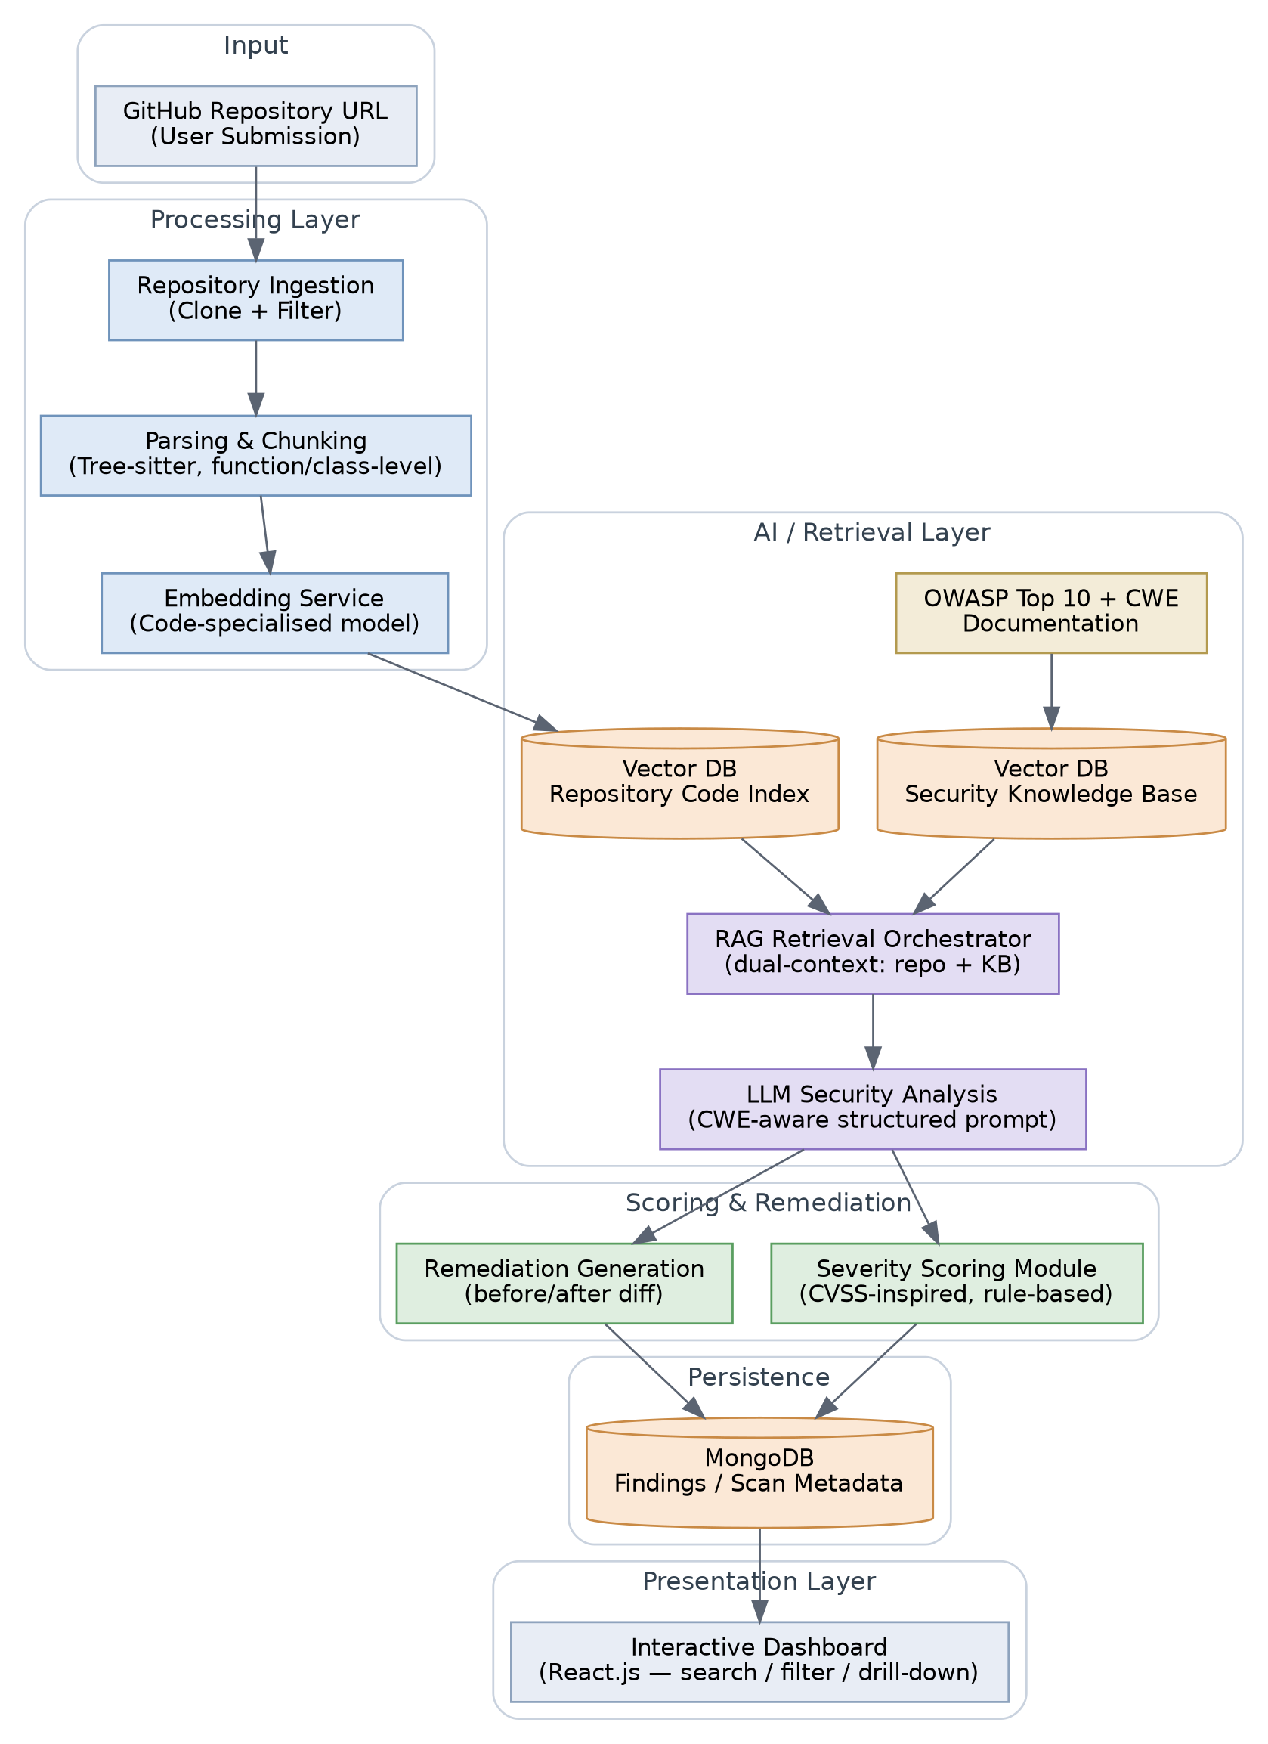
System Architecture
Figure A.1 — End-to-end architecture: ingestion, dual-context RAG retrieval (repository code index + OWASP/CWE knowledge base), LLM-based analysis, rule-based severity scoring, remediation generation, and dashboard presentation.

References (Standards and Foundational Sources)
- OWASP Foundation, “OWASP Top 10:2025,” top10.owasp.org/2025 — accessed 2026-09-14; the version implemented in the Security Knowledge Base (Chapter 4).
- MITRE Corporation, “2025 CWE Top 25 Most Dangerous Software Weaknesses,” cwe.mitre.org/top25/archive/2025 — accessed 2026-09-14; the version implemented in the Security Knowledge Base (Chapter 4).
- FIRST.org, “Common Vulnerability Scoring System (CVSS),” first.org/cvss.
- National Institute of Standards and Technology, “National Vulnerability Database (NVD),” nvd.nist.gov.
- Pennington, R. et al., “GloVe: Global Vectors for Word Representation” (pretrained glove-wiki-gigaword-100, distributed via gensim’s gensim-data), used as the Review 3 embedding backbone — see Chapter 4, Section 4.2 for why and with what measured effect.
(See Chapter 2, Section 2.8 for the full list of 20 literature references reviewed for this project.)

