1. **OverView**

The given exercise is developed using VS 2012.It highlights the usage of OOP concepts along with dot net programming.

The project highlights the following concepts of OOPs primarily and is a totally Open System for further modifications.

* Classes And Objects :
  + Usage of domain driven design
  + Usage of **enums**
  + Usage of **Access Modifiers like internal** to restrict direct calling from other layers
* Abstraction: By Usage of interfaces and abstract classes
* Polymorphism: By means of Constructor overloading
* Inheritance: Usage of ValidationBase class
* Run time polymorphism :Usage of override for Validation Method
* Encapsulation
  + Using Interfaces
  + Using Abstract classes

1. **Development Approach**
   * Domain Driven
   * Partial Test Driven
2. **Extension**

Since the project uses interfaces and very abstracted way of working , the system is open to any extension to existing game or also adding a new game altogether to this exercise.

1. **Project Architecture:**

Solution consists of 4 main layers.

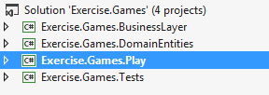

* Play: Console App for running the project
* Business Layer: For supporting the game operations
* Domain Entities: For data transfer amongs app and operations
* Tests: Tests for all the Methods with 98.5% code coverage

1. **Major Classes**

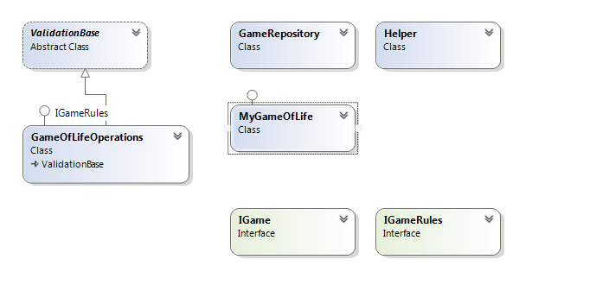

1. **Unit Tests and Code Coverage**

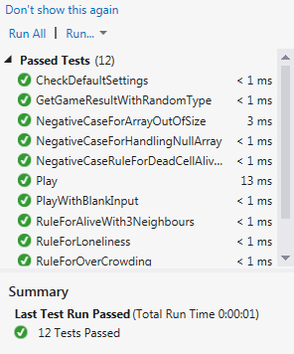

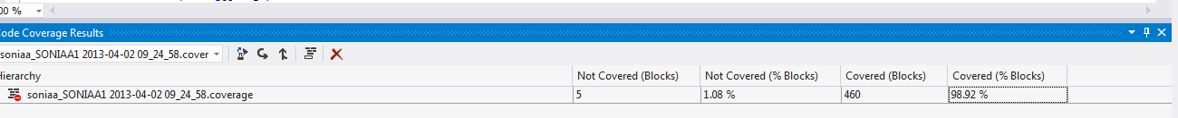

1. **Sequence Diagram**

