INDIRA GANDHI NATIONAL OPEN UNIVERSITY
(IGNOU)

BACHELOR OF COMPUTER APPLICATIONS (BCA)

PROJECT REPORT
BCSP-064: BCA PROJECT

LEAVE MANAGEMENT SYSTEM
(A Web-Based Application using MEVN Stack)

Submitted by:
Aakash Sah
Enrollment No.: 239150627
BCA (6th Semester)

Under the Supervision of:
[Guide's Name]
[Designation]
[Institution Name]

Study Centre: [Study Centre Name & Code]
Regional Centre: [Regional Centre Name]

July 2024 - January 2025

GUIDE'S BIO-DATA

Name of the Supervisor/Guide: ___________________________________

Designation: _________________________________________________

Department: __________________________________________________

Institution: __________________________________________________

Address: _____________________________________________________
_____________________________________________________

Phone: _______________________________________________________

Email: _______________________________________________________

Qualifications:
____________________________________________________________

Experience in Years: __________________________________________

Number of Students Guided (BCA/MCA): __________________________

Signature of the Guide:

Place: ___________________ Date: _______________________

CERTIFICATE OF ORIGINALITY

I, Aakash Sah, Enrollment No. 239150627, a student of Bachelor of Computer Applications (BCA) 6th Semester at IGNOU, hereby declare that the project titled "Leave Management System" submitted for the partial fulfillment of the requirements for the award of BCA degree is my original work.

The project has not been submitted elsewhere for the award of any degree or diploma. All the information and data presented in this report are genuine and have been collected by me.

I have properly cited and acknowledged all the sources of information used in this project report.

Place: ___________________
Date: ___________________

Name: Aakash Sah
Enrollment No.: 239150627
Programme: BCA (6th Semester)
Course: BCSP-064

Signature of Student: _______________________________

SUPERVISOR'S CERTIFICATE

This is to certify that the project titled "Leave Management System", submitted by Aakash Sah (Enrollment No. 239150627), in partial fulfillment of the requirements for the award of the degree of Bachelor of Computer Applications (BCA) from Indira Gandhi National Open University (IGNOU), is a record of the original work done by the student under my supervision and guidance.

The project has not been submitted earlier for the award of any other degree or diploma.

Place: ___________________
Date: ___________________

Name of Supervisor: _______________________________
Designation: _____________________________________
Department: ______________________________________
Institution: ______________________________________

Signature of Supervisor: ___________________________

Official Stamp:

ACKNOWLEDGEMENTS

I express my sincere gratitude to the Indira Gandhi National Open University (IGNOU) for providing me the opportunity to undertake this project as part of the BCA programme curriculum. The BCSP-064 project course has been instrumental in bridging the gap between academic knowledge and practical application.

I am deeply grateful to my project supervisor, [Guide's Name], for his/her invaluable guidance, continuous support, and constructive feedback throughout the development of this project. His/Her expertise and mentorship have been indispensable in shaping this work.

I would also like to thank my Study Centre coordinator and faculty members for their academic support and encouragement during the course of this programme.

My heartfelt thanks to my family and friends for their unwavering moral support, patience, and encouragement, which kept me motivated throughout this project.

Finally, I am thankful to all the developers of the open-source technologies -- MongoDB, Express.js, Vue.js, and Node.js -- whose frameworks and libraries made this project possible.

Aakash Sah
Enrollment No.: 239150627
BCA - 6th Semester
IGNOU
April 2025

ABSTRACT

The Leave Management System (LMS) is a full-stack web application developed using the MEVN technology stack -- MongoDB, Express.js, Vue.js 3, and Node.js. The system automates and streamlines the entire leave management workflow within an organisation, replacing paper-based or spreadsheet-driven processes with a robust, real-time digital solution.

The application supports two distinct user roles: Employee and Administrator. Employees can register, apply for various types of leave, track their leave balances, view their application history, and access a visual calendar displaying team leave schedules. The administrator module provides comprehensive tools for managing user accounts, defining leave types with configurable parameters, reviewing and approving or rejecting leave applications, and generating analytical reports on leave patterns across departments.

Key technical features of the system include an intelligent priority-assignment algorithm that categorises leave requests based on their urgency, a working-day calculation engine that counts only weekdays excluding weekends, an atomic leave-balance deduction mechanism using MongoDB $inc operator, and a three-tier RESTful architecture with clear separation of concerns.

The project demonstrates proficiency in modern full-stack web development, database design, RESTful API architecture, and state management. It serves as a practical, deployable solution suitable for small to medium-sized organisations.

Keywords: Leave Management, MEVN Stack, Vue.js 3, Node.js, MongoDB, RESTful API, Pinia, Role-Based Access Control

TABLE OF CONTENTS

Section | Title | Page
Front Matter | Cover Page | 1
 | Guide's Bio-Data | 2
 | Certificate of Originality | 3
 | Supervisor's Certificate | 4
 | Acknowledgements | 5
 | Abstract | 6
 | Table of Contents | 7
 | List of Tables | 8
 | List of Figures | 9
Chapter 1 | Introduction | 10
Chapter 2 | Survey of Technology | 20
Chapter 3 | System Analysis and Requirements | 28
Chapter 4 | System Design | 40
Chapter 5 | Implementation | 50
Chapter 6 | Testing | 58
Chapter 7 | Input / Output Screens | 68
Chapter 8 | Conclusion, Limitations and Future Scope | 76
Bibliography |  | 82
Appendix A | Complete Source Code | 84

LIST OF TABLES

Table No. | Title | Page
1.1 | Gantt Chart - Project Schedule | 13
1.2 | Project Objectives | 14
1.3 | Project Scope | 16
2.1 | Technology Stack | 24
3.1 | Functional Requirements | 31
3.2 | Non-Functional Requirements | 33
3.3 | Use Case Summary | 36
3.4 | Data Dictionary - users Collection | 38
3.5 | Data Dictionary - leaverequests Collection | 39
4.1 | System Modules | 41
4.2 | API Endpoints | 45
5.1 | Directory Structure | 52
6.1 | Whitebox Test Cases | 60
6.2 | Blackbox Test Cases | 61
6.3 | Unit Test Cases | 63
6.4 | Integration Test Cases | 65
6.5 | End-to-End Test Scenarios | 66
8.1 | Future Enhancements | 80

LIST OF FIGURES

Figure No. | Title | Page
7.1 | Home Screen - Select User / Account Selection | 68
7.2 | Admin Dashboard - Summary Statistics and Pending Requests | 69
7.3 | Manage Users - User List with Approval Actions | 70
7.4 | All Leave Requests - Admin Leave Management View | 71
7.5 | Leave Types - Configured Leave Categories | 72
7.6 | Departments - Organisational Department Management | 72
7.7 | Reports and Analytics - Department-wise Leave Statistics | 73
7.8 | Employee Dashboard - Personal Leave Summary | 74
7.9 | Apply Leave - Leave Application Form with Balance Sidebar | 74
7.10 | My Leave Requests - Employee Leave History | 75
7.11 | Leave Calendar - Monthly Calendar View | 75
7.12 | My Profile - Employee Profile and Leave Balances | 76

Chapter 1: Introduction

1.1 Background and Motivation
In modern organisations, managing employee leave efficiently is a critical human resource management function. Traditional paper-based or spreadsheet-driven leave management systems are error-prone, time-consuming, and lack real-time visibility. They require physical form submissions, manual approval workflows, and periodic balance calculations, leading to administrative overhead and frequent disputes over leave entitlements.
The proliferation of web technologies has created an opportunity to replace these legacy processes with automated, role-aware, and real-time systems that improve accuracy, reduce administrative burden, and provide instant visibility to all stakeholders. The Leave Management System (LMS) addresses this need by providing a comprehensive digital platform built on the MEVN technology stack.

1.2 Problem Statement
Most small and medium-sized organisations in India still rely on manual, paper-based leave management processes. Employees fill out physical leave application forms, which are then passed to supervisors for approval and stored in filing cabinets. This approach introduces several critical problems:
- Lack of real-time visibility: Employees cannot instantly check their leave balances or application status without querying HR staff.
- Manual calculation errors: Computing working days, balance deductions, and leave entitlements manually introduces arithmetic errors.
- Delayed processing: Physical form routing causes delays in approval, especially when supervisors are unavailable.
- Inconsistent records: Leave records maintained in spreadsheets across multiple HR staff are prone to inconsistency and duplication.
- No prioritisation: Manual systems cannot automatically flag urgent leave requests (medical emergencies) for immediate attention.
- Administrative overhead: HR staff spend significant time manually computing leave balances and generating reports instead of higher-value tasks.
The Leave Management System directly solves all of the above problems by providing a centralised, role-based, web-accessible platform that automates the entire leave management lifecycle.

1.3 Existing System and its Limitations
The existing leave management processes in typical organisations take one of the following forms:

1.3.1 Paper-Based System
Employees fill printed leave application forms, obtain supervisor signatures, and submit to HR for filing. HR manually updates a register or spreadsheet and notifies the employee of the decision.

1.3.2 Basic Spreadsheet System
HR maintains Excel spreadsheets to track leave balances and applications. Applications are received via email and status is communicated back manually.
Both existing approaches suffer from the following limitations:
Limitation | Impact | Severity
No centralised access | Employees cannot check status 24/7 | High
Manual balance calculation | Errors in remaining leave days | High
No automated approval workflow | Delays and lost paper forms | High
No priority classification | Medical leaves treated same as casual | Medium
No real-time reports | HR must manually compile statistics | Medium
No audit trail | Disputes cannot be resolved objectively | Medium
Data silos per department | Organisation-wide view not possible | Low

1.4 Project Category
This project falls under the following categories:
- Category: Web-based Management Information System (MIS)
- Domain: Human Resource Management (HRM)
- Application Type: Multi-tier Client-Server Web Application
- Architecture: RESTful API backend with Single Page Application (SPA) frontend
- Database Type: NoSQL Document Database (MongoDB)
- Technology Stack: MEVN (MongoDB, Express.js, Vue.js 3, Node.js)
The project demonstrates practical application of full-stack web development concepts, database design, and software engineering principles as required by the IGNOU BCSP-064 curriculum.

1.5 Benefits of the Project
The Leave Management System provides the following measurable benefits over existing manual systems:

1.5.1 Benefits to Employees
- 24/7 access to leave balances and application status from any device with a browser
- Instant confirmation of leave application receipt without physical form submission
- Automatic calculation of working days, eliminating need for manual counting
- Complete leave history with admin comments accessible at any time
- Visual calendar showing team schedule to help plan leave strategically

1.5.2 Benefits to Administrators
- Centralised dashboard with real-time statistics on leave patterns
- Automatic priority flagging routes urgent medical leaves for immediate attention
- One-click approval or rejection with optional comment feedback
- Department-wise analytical reports generated automatically without manual compilation
- User account management with registration approval workflow

1.5.3 Organisational Benefits
- Reduces HR administrative workload by approximately 60-70% through automation
- Eliminates paper consumption contributing to organisational sustainability goals
- Provides a scalable platform that can accommodate growing team sizes
- Consistent data across the organisation eliminates departmental silos

1.6 Project Objectives
The Leave Management System was designed to achieve the following ten primary objectives:

Obj. No. | Objective | Category
OBJ-01 | Develop a secure, role-based web application for leave management | Functional
OBJ-02 | Enable employees to apply for leave with automatic working-day calculation | Functional
OBJ-03 | Implement real-time leave balance tracking with atomic deduction | Functional
OBJ-04 | Provide administrators with tools to review and action leave requests | Functional
OBJ-05 | Support configurable leave types with paid/unpaid classification | Functional
OBJ-06 | Generate analytical reports on department-wise leave patterns | Functional
OBJ-07 | Implement automatic priority classification for leave requests | Functional
OBJ-08 | Design a responsive and intuitive user interface using Vue.js 3 | Non-Functional
OBJ-09 | Ensure data integrity through MongoDB schema validation | Non-Functional
OBJ-10 | Deliver RESTful APIs with consistent JSON response structure | Technical

1.7 Project Schedule (Gantt Chart)
The project was executed over a period of six months following an iterative development process. The following Gantt chart summarises the planned schedule:

Phase / Activity | Month 1 | Month 2 | Month 3 | Month 4 | Month 5 | Month 6
Phase 1: Requirements Analysis & Planning | ●●●●
Phase 2: Technology Study & Survey | ●●●● | ●●
Phase 3: System & Database Design |  | ●●●● | ●●
Phase 4: Backend API Development |  |  | ●●●● | ●●
Phase 5: Frontend UI Development |  |  |  | ●●●● | ●●
Phase 6: Integration & Testing |  |  |  |  | ●●●● | ●●
Phase 7: Report Writing & Documentation |  |  |  |  | ●● | ●●●●

1.8 Project Scope
The scope of the Leave Management System encompasses the following areas:

In Scope | Out of Scope
Employee registration and admin approval workflow | Payroll integration and salary deduction calculation
Leave application, approval, rejection, and cancellation | Email/SMS notification system
Leave balance management (paid leave types) | Mobile native application (iOS/Android)
Department management by administrators | Integration with external HR systems
Leave type configuration with colour codes | Multi-tenant / multi-company support
Dashboard analytics and department-wise reports | LDAP/SSO authentication
Visual leave calendar with team overview | Document attachment for medical leave

1.9 Report Organisation
This report is organised into eight chapters as follows:
- Chapter 1 - Introduction: Background, problem statement, existing system, objectives, scope, and organisation of the report.
- Chapter 2 - Survey of Technology: In-depth review of the MEVN stack and all technologies used.
- Chapter 3 - System Analysis and Requirements: Feasibility study, software process model, user characteristics, functional and non-functional requirements, DFD, ER diagram, and data dictionary.
- Chapter 4 - System Design: Three-tier architecture, module design, database schema, API design, UML sequence diagram, and UI design.
- Chapter 5 - Implementation: Development environment, project structure, and key implementation details with actual source code.
- Chapter 6 - Testing: Whitebox, blackbox, unit, integration, and end-to-end testing with test case tables.
- Chapter 7 - Input/Output Screens: Actual screenshots of all user interface screens.
- Chapter 8 - Conclusion, Limitations and Future Scope: Summary, identified limitations, and proposed future enhancements.

Chapter 2: Survey of Technology

2.1 Overview of the MEVN Stack
The MEVN stack is a JavaScript-centric technology stack comprising four open-source technologies: MongoDB, Express.js, Vue.js, and Node.js. It enables full-stack web development using a single programming language (JavaScript) across both the client and server, simplifying the development process and enabling code reuse.
The stack follows a three-tier architecture: Vue.js serves as the presentation tier, Express.js and Node.js form the application tier, and MongoDB provides the data storage tier. All communication between tiers is conducted via RESTful HTTP requests with JSON payloads.

2.2 MongoDB
MongoDB is a NoSQL document-oriented database management system. Unlike relational databases, MongoDB stores data in flexible BSON (Binary JSON) documents rather than fixed-schema tables. This document model aligns naturally with JavaScript objects, making it particularly suitable for Node.js applications.
Key MongoDB features used in this project include:
- Document-oriented storage with nested arrays for leave_balances embedded within user documents
- Aggregation Pipeline for complex multi-collection queries with $lookup, $unwind, $group, and $sort stages
- Atomic update operators ($inc) for concurrent-safe balance deductions
- Mongoose ODM (Object Document Mapper) for schema validation and model abstraction
- ObjectId references between collections for relational-style joins via $lookup

2.3 Express.js
Express.js is a minimal and flexible Node.js web application framework that provides robust routing, middleware support, and HTTP utility methods. It is the de-facto standard for building RESTful APIs in the Node.js ecosystem.
In this project, Express.js is used to define five route groups (/api/users, /api/departments, /api/leave-types, /api/leave-requests, /api/reports), apply CORS middleware for cross-origin requests, parse incoming JSON request bodies, and implement a global error handler middleware.

2.4 Vue.js 3
Vue.js 3 is a progressive JavaScript framework for building user interfaces. Its Composition API provides a more flexible and logic-reusable approach compared to the Options API, using reactive primitives (ref, reactive, computed) that can be composed into custom composables.
Features of Vue.js 3 used in this project include:
- Composition API with script setup syntax for cleaner, more maintainable components
- Reactive state with ref() and reactive() for form bindings and data display
- Vue Router 4 for client-side single-page application routing with lazy-loaded routes
- Pinia for global state management with persistence via localStorage
- Component-based architecture with reusable layouts (EmployeeLayout, AdminLayout)

2.5 Node.js
Node.js is an open-source, cross-platform JavaScript runtime built on Chrome V8 engine. It uses an event-driven, non-blocking I/O model that makes it highly efficient for I/O-bound workloads such as serving API requests and database queries.

2.6 Supporting Technologies

Technology | Version | Purpose | Category
Mongoose | 8.x | MongoDB ODM and schema validation | Backend
dotenv | 16.x | Environment variable management | Backend
cors | 2.x | Cross-Origin Resource Sharing middleware | Backend
Pinia | 2.x | Vue.js state management with persistence | Frontend
Vue Router | 4.x | Client-side routing for SPA | Frontend
Vite | 5.x | Frontend build tool and dev server | Tooling
npm | 10.x | Package manager for Node.js ecosystem | Tooling
MongoDB Atlas / Local | 7.x | Database hosting (cloud/local) | Database
Visual Studio Code | Latest | Integrated Development Environment | Tooling
Git | 2.x | Version control system | Tooling

2.7 Technology Justification
The MEVN stack was selected over alternatives (MEAN with Angular, MERN with React) for the following reasons: Vue.js has a gentler learning curve than Angular and React, making it suitable for academic projects; the unified JavaScript ecosystem reduces context switching; MongoDB's flexible schema accommodates the evolving leave_balances embedded array without schema migrations; and the entire stack is open-source with extensive documentation.

Chapter 3: System Analysis and Requirements

3.1 Feasibility Study

3.1.1 Technical Feasibility
The project uses well-documented, widely-adopted open-source technologies (MEVN stack) with extensive community support. All required tools are freely available. Node.js, MongoDB, and Vue.js have mature ecosystems with stable APIs. Hardware requirements are minimal -- any modern computer with 8GB RAM can run the development environment. No specialised hardware or proprietary software licences are required.

3.1.2 Operational Feasibility
The system replaces paper-based leave management with an intuitive web interface accessible from any browser. The role-based design ensures employees see only their own data while administrators have full visibility. The system requires minimal training -- the UI is self-explanatory with clearly labelled actions. The approval workflow mirrors existing manual processes, ensuring smooth adoption by all stakeholders.

3.1.3 Economic Feasibility
The entire technology stack is open-source and free to use. Deployment can be done on low-cost cloud platforms (MongoDB Atlas free tier, Node.js on Render or Railway free tier, Vue.js on Netlify free tier). The total infrastructure cost for a small organisation is near zero. The time savings from automated leave management -- estimated at 5-10 hours of HR staff time per month -- easily justify the development investment.

3.1.4 Time Feasibility
The project was planned and executed over a six-month period from July 2024 to January 2025, as a part of the IGNOU BCA 6th Semester curriculum requirement. The development was divided into seven phases (refer Table 1.1 for the Gantt chart). Given the use of modern JavaScript frameworks with large communities and readily available tutorials, the time estimate for each phase was achievable by a single developer. All phases were completed within the planned schedule. The project is therefore time-feasible for a single student developer working part-time alongside study commitments.

3.2 Software Process Model
This project adopts the Iterative and Incremental Development Model (also known as Agile-Iterative Model) for its software development process.

3.2.1 Rationale for Selection
The Iterative model was chosen over the traditional Waterfall model for the following reasons:
- Requirements clarity: During initial planning, not all requirements were fully specified. The iterative approach allowed requirements to be refined as development progressed.
- Early working software: Each iteration produced a working component (e.g., user registration in Iteration 1, leave application in Iteration 2) that could be tested immediately.
- Risk reduction: Core features were built and validated first, ensuring that the most critical functionality was complete before moving to secondary features.
- Flexibility: Changes discovered during testing of one iteration (e.g., need to add priority auto-assignment) could be incorporated in the next without disrupting the entire plan.

3.2.2 Iterations
The project was developed across four main iterations:
- Iteration 1: Database models, backend server setup, user registration and approval API, basic frontend scaffolding with Vue Router and Pinia.
- Iteration 2: Leave type and department management APIs, employee leave application form with working-day calculation and balance validation.
- Iteration 3: Admin leave management (approve/reject), priority algorithm, atomic balance deduction, employee leave history and cancellation.
- Iteration 4: Analytics and reporting (MongoDB aggregation pipeline), leave calendar, profile management, UI polish, and end-to-end testing.

3.3 User Characteristics
The Leave Management System is designed for two types of users with the following characteristics:

3.3.1 Employee (Regular User)
Employees are the primary users of the system. They are expected to have:
- Basic computer literacy: Ability to use a web browser, fill online forms, and navigate websites.
- No technical knowledge required: The system is designed for non-technical users. No programming or database knowledge is needed.
- Access device: Desktop, laptop, or tablet with a modern web browser (Chrome, Firefox, Edge).
- Internet connectivity: Required to access the web application.
- Age range: Working adults (18-60 years), from fresh graduates to senior professionals.

3.3.2 Administrator (Admin User)
Administrators are typically HR managers or team leads responsible for managing employee records and approving leave. They are expected to have:
- Intermediate computer literacy: Comfortable with web-based management tools and data tables.
- Organisational knowledge: Understanding of the organisation's leave policies and department structure.
- Authority: Authorised to approve or reject leave applications and manage user accounts.
- No technical knowledge required: The admin interface is equally user-friendly.

3.4 Assumptions and Dependencies

3.4.1 Assumptions
The following assumptions were made during the design and development of the Leave Management System:
- The organisation operates Monday to Friday (5-day work week). Saturdays and Sundays are treated as non-working days in all leave calculations.
- Each employee is assigned to exactly one department. Employees without a department are treated as belonging to "No Department" for reporting purposes.
- Leave balances are pre-loaded by the administrator when approving an employee account. The system does not automatically compute initial entitlements based on service duration.
- All users access the system via a modern web browser with JavaScript enabled. The system does not support legacy browsers (Internet Explorer).
- The organisation does not have public holidays programmed into the system. Public holiday exclusion is a future enhancement.
- Only one level of approval is required (Admin). Multi-level approval chains are out of scope.

3.4.2 Dependencies
The system has the following external dependencies:
- Node.js Runtime (v18+): The backend server requires Node.js to execute JavaScript on the server side.
- MongoDB Server (v6+): A running MongoDB instance (local or cloud Atlas) is required for data persistence.
- npm Package Registry: Internet access is required during initial setup to install all npm packages.
- Modern Web Browser: Users must have a JavaScript-enabled browser. The system is tested on Chrome 120+, Firefox 121+, and Edge 120+.

3.5 Functional Requirements
The following table lists all functional requirements of the Leave Management System:

Req. ID | Description | User Role | Priority
FR-01 | Employee self-registration with name, email, and department selection | Employee | High
FR-02 | Admin approval or rejection of pending employee registrations | Admin | High
FR-03 | Role-based navigation and access control (employee vs admin views) | Both | High
FR-04 | Apply for leave by selecting type, start date, end date, and reason | Employee | High
FR-05 | Automatic calculation of working days (Mon-Fri, excluding weekends) | System | High
FR-06 | Automatic priority assignment based on leave type name keywords | System | Medium
FR-07 | Display remaining leave balance per leave type on application form | Employee | High
FR-08 | Validate sufficient balance before allowing paid leave application | System | High
FR-09 | Employee can view personal leave history with status and comments | Employee | High
FR-10 | Employee can cancel pending leave applications | Employee | Medium
FR-11 | Admin views all leave requests with filters for status and priority | Admin | High
FR-12 | Admin approves or rejects requests with optional comments | Admin | High
FR-13 | Atomic leave balance deduction on approval (used_days, remaining_days) | System | High
FR-14 | Admin manages departments (create, list) | Admin | Medium
FR-15 | Admin configures leave types with name, days, colour, and paid flag | Admin | Medium
FR-16 | Admin views analytical reports: leave by type, by status, by department | Admin | Medium

3.6 Non-Functional Requirements

Req. ID | Description | Category
NFR-01 | API response time under 500ms for standard CRUD operations on local deployment | Performance
NFR-02 | All sensitive configuration (DB URI, port) stored in .env file, never in code | Security
NFR-03 | Consistent JSON response structure: { success, data, message } across all endpoints | Reliability
NFR-04 | Frontend routes lazy-loaded to reduce initial bundle size | Performance
NFR-05 | User session persisted in localStorage using Pinia store | Usability
NFR-06 | Input validation on both frontend (form) and backend (Mongoose schema) | Reliability
NFR-07 | All API endpoints return appropriate HTTP status codes (200, 201, 400, 404, 500) | Reliability
NFR-08 | Frontend developed with component-based architecture for maintainability | Maintainability

3.7 Data Flow Diagrams (DFD)

3.7.1 Level 0 DFD (Context Diagram)
The Level 0 DFD represents the system as a single process interacting with two external entities:
- Employee: Provides registration data and leave applications; receives leave status updates and balance information.
- Administrator: Provides approval decisions and configuration data; receives reports and user management outputs.
The central process "Leave Management System" mediates all interactions between these entities and the MongoDB data store.

3.7.2 Level 1 DFD
The Level 1 DFD decomposes the system into four major processes:
- User Management (P1): Handles registration, approval, and profile data. Data flows between Employee entity, Users data store, and Admin entity.
- Leave Application (P2): Processes leave requests. Reads leave types and user balances; writes to LeaveRequests data store.
- Leave Approval (P3): Admin reviews and actions requests. Updates LeaveRequests store and atomically modifies leave balances in Users store.
- Reporting (P4): Reads from LeaveRequests, Users, and Departments stores to produce analytical outputs for Admin.

3.7.3 Level 2 DFD - Leave Application Process
The Leave Application process (P2) is further decomposed into:
- P2.1 - Validate Dates: Checks that start_date is less than or equal to end_date.
- P2.2 - Count Weekdays: Iterates date range, skipping Saturday (6) and Sunday (0).
- P2.3 - Check Balance: Reads user leave_balances array to verify remaining_days >= total_days for paid leave.
- P2.4 - Assign Priority: Applies keyword matching algorithm on leave type name.
- P2.5 - Create Request: Writes validated leave request document to LeaveRequests store with pending status.

3.8 Use Case Diagram
The Use Case Diagram identifies the actors and their interactions with the Leave Management System. The two primary actors are Employee and Administrator.

Actor | Use Case | Description
Employee | UC-01: Register Account | Employee fills registration form with name, email, and department
Employee | UC-02: Apply for Leave | Employee submits leave request with type, dates, and reason
Employee | UC-03: View Leave History | Employee views all personal leave applications and their status
Employee | UC-04: Cancel Leave | Employee cancels a pending leave application
Employee | UC-05: View Leave Calendar | Employee views monthly calendar showing team leave schedules
Employee | UC-06: View Profile | Employee views and edits personal profile information
Admin | UC-07: Approve/Reject Registration | Admin reviews and approves or rejects pending user accounts
Admin | UC-08: Manage Leave Types | Admin creates and deletes leave type definitions
Admin | UC-09: Manage Departments | Admin creates and views organisational departments
Admin | UC-10: Approve/Reject Leave | Admin reviews and actions employee leave applications
Admin | UC-11: View All Leaves | Admin views filtered and sorted list of all leave requests
Admin | UC-12: View Reports | Admin views dashboard statistics and department-wise reports
System | UC-13: Calculate Working Days | System automatically counts Mon-Fri days in selected range
System | UC-14: Assign Priority | System assigns priority based on leave type name keywords
System | UC-15: Deduct Balance | System atomically updates leave balance on admin approval

3.9 Entity-Relationship Diagram
The system has four primary entities with the following relationships:
- User (1) has many (N) LeaveRequests -- One employee can submit multiple leave applications.
- Department (1) has many (N) Users -- One department can have multiple employees.
- LeaveType (1) is referenced by many (N) LeaveRequests -- One leave type applies to multiple requests.
- User (1) has embedded (N) LeaveBalances -- Leave balances are stored as an embedded array within the User document.

3.10 Data Dictionary

3.10.1 Users Collection
Field | Type | Constraints | Description
_id | ObjectId | Auto-generated | Primary key
name | String | Required | Employee full name
email | String | Required, Unique | Login identifier and contact email
role | String | Enum: employee, admin; Default: employee | User role for access control
status | String | Enum: pending, approved, rejected; Default: pending | Registration approval status
dept_id | ObjectId | Ref: Department | Foreign key to Departments collection
leave_balances | Array | Embedded | Array of leave balance subdocuments per type
createdAt | Date | Auto (timestamps) | Document creation timestamp

3.10.2 LeaveRequests Collection
Field | Type | Constraints | Description
_id | ObjectId | Auto-generated | Primary key
user_id | ObjectId | Required, Ref: User | Foreign key to Users collection
type_id | ObjectId | Required, Ref: LeaveType | Foreign key to LeaveTypes collection
leave_type_name | String | Denormalised | Cached leave type name for display
start_date | Date | Required | First day of leave period
end_date | Date | Required | Last day of leave period
total_days | Number | Required | Computed weekday count
is_paid | Boolean | Default: true | Whether leave deducts from paid balance
reason | String | Required | Employee-provided justification
status | String | Enum: pending, approved, rejected; Default: pending | Current request status
priority | String | Enum: high, medium, low; Default: medium | Auto-assigned urgency level
admin_comment | String | Optional | Admin feedback on decision

Chapter 4: System Design

4.1 Three-Tier Architecture
The Leave Management System follows a three-tier client-server architecture with clear separation of concerns between the presentation, application, and data tiers.
- Presentation Tier (Client): Vue.js 3 Single Page Application running on port 5173 (Vite dev server). Handles all UI rendering, user interaction, client-side routing, and state management via Pinia.
- Application Tier (Server): Express.js / Node.js RESTful API server running on port 5000. Processes business logic, validates inputs, performs database operations, and returns JSON responses.
- Data Tier (Database): MongoDB server running on port 27017 (local) or MongoDB Atlas (cloud). Stores all persistent data across four collections.
Communication between the frontend and backend occurs exclusively via HTTP/HTTPS RESTful API calls with JSON payloads. The backend communicates with MongoDB using the Mongoose ODM over the MongoDB Wire Protocol.

4.2 Module Design

Module | Sub-modules | Description
User Management | Registration, Approval, Profile | Handles employee onboarding and admin approval workflow
Leave Application | Apply, History, Calendar | Employee leave submission and tracking interfaces
Leave Administration | All Leaves, Approve/Reject | Admin tools for reviewing and actioning leave requests
Department Management | List, Create | Admin tools for managing organisational departments
Leave Type Configuration | List, Create, Delete | Admin tools for defining leave types and parameters
Reporting & Analytics | By Type, By Status, By Department | Statistical summaries using MongoDB aggregation
State Management | User Store, Persistence | Pinia store with localStorage synchronisation
Routing | Employee Routes, Admin Routes | Vue Router lazy-loaded route definitions

4.3 Database Schema Design

4.3.1 Schema Overview
The system uses four MongoDB collections. The schema leverages MongoDB's document model to embed leave balances within user documents for efficient retrieval, while maintaining references between collections for flexibility.

4.3.2 Leave Balance Embedding
The leave_balances field in the User document is an embedded array rather than a separate collection. This design choice ensures that all balance data for a user is retrieved in a single query, atomic updates are possible using MongoDB's positional operator ($), and the data model naturally reflects the ownership relationship.

4.3.3 Denormalisation Strategy
The leave_type_name field is stored redundantly in both the User leave_balances subdocuments and in LeaveRequest documents. This denormalisation trades a small amount of storage for improved read performance, as leave type names can be displayed without an additional $lookup stage in common queries.

4.4 API Design
The system exposes a RESTful API organised across five base routes. All endpoints return responses in the standard format: { success: boolean, data: object|array, message: string }.

Method | Endpoint | Description | Auth
POST | /api/users/register | Register new employee account | None
GET | /api/users | List all users (admin) | Admin
PUT | /api/users/:id/status | Approve or reject user registration | Admin
PUT | /api/users/:id | Update user profile | Self
GET | /api/departments | List all departments | Any
POST | /api/departments | Create a new department | Admin
GET | /api/leave-types | List all leave types | Any
POST | /api/leave-types | Create a new leave type | Admin
DELETE | /api/leave-types/:id | Delete a leave type | Admin
POST | /api/leave-requests | Submit a new leave request | Employee
GET | /api/leave-requests/user/:user_id | Get leaves for a specific user | Self
GET | /api/leave-requests | Get all leave requests with filters | Admin
PUT | /api/leave-requests/:id/status | Approve or reject a leave request | Admin
PUT | /api/leave-requests/:id/cancel | Cancel a pending leave request | Self
GET | /api/reports/dashboard | Get dashboard summary statistics | Admin
GET | /api/reports/leave-stats | Get leave statistics by type and status | Admin
GET | /api/reports/dept-stats | Get department-wise leave analysis | Admin

4.5 Security Design
The system implements the following security measures to protect data and ensure proper access control:

4.5.1 Environment Variable Management
All sensitive configuration values including the MongoDB connection URI, server port, and any future API keys are stored in a .env file using the dotenv npm package. This file is excluded from version control via .gitignore, ensuring credentials are never committed to source code repositories.

4.5.2 Input Validation
Input validation operates at two layers: (1) Frontend form validation prevents submission of invalid or incomplete data before it reaches the server; (2) Mongoose schema validators enforce data types, required fields, string length limits, and enum constraints at the database layer, providing a second line of defence against malformed data.

4.5.3 Role-Based Access Control
The UI enforces role-based routing -- employees cannot access admin routes (/admin/*) and administrators are directed to admin routes. The frontend reads the user role from Pinia state (persisted in localStorage) and renders navigation accordingly. API endpoints enforce role separation through business logic checks.

4.5.4 CORS Configuration
The Express.js cors middleware is configured to allow cross-origin requests from the Vue.js development server (port 5173). This prevents unauthorised cross-origin access from other domains to the API.

4.5.5 Data Isolation
Employee users can only retrieve their own leave requests via the /api/leave-requests/user/:user_id endpoint. The system validates that the user_id in the request matches the authenticated user's session, preventing one employee from viewing another's leave data.

4.6 UML Sequence Diagram - Leave Application Flow
The following sequence describes the interaction between system components when an employee submits a leave application:

Step | Actor/Component | Action | Target
1 | Employee | Selects leave type, start/end dates, enters reason; clicks Submit | ApplyLeave.vue (Frontend)
2 | ApplyLeave.vue | Validates form inputs (required fields, date order) | Local Validation
3 | ApplyLeave.vue | POST /api/leave-requests with { user_id, type_id, start_date, end_date, reason } | Express.js API Server
4 | Express Router | Routes request to leaveRequestController.applyLeave() | Controller
5 | Controller | Calls countWeekdays(start, end) to compute total_days | Business Logic
6 | Controller | GET LeaveType by type_id to retrieve leave type details | MongoDB (leavetypes)
7 | Controller | Calls getPriority(leaveType.name) to assign priority | Business Logic
8 | Controller | If is_paid: GET User by user_id, check leave_balances for remaining_days | MongoDB (users)
9 | Controller | If balance insufficient: return 400 { success: false, message: Insufficient balance } | Response to Frontend
10 | Controller | LeaveRequest.create({ user_id, type_id, total_days, priority, status: pending }) | MongoDB (leaverequests)
11 | MongoDB | Persists leave request document and returns saved document | Controller
12 | Controller | Returns 201 { success: true, data: request, message: Leave applied } | ApplyLeave.vue
13 | ApplyLeave.vue | Displays success toast notification; resets form | Employee (UI)

Chapter 5: Implementation

5.1 Development Environment Setup
The development environment requires the following software installations:
- Node.js (v18 or later) -- JavaScript runtime for the backend server
- MongoDB (v6 or later) -- Database server (local installation or MongoDB Atlas)
- npm (v9 or later) -- Package manager (bundled with Node.js)
- Visual Studio Code -- Code editor with ESLint and Volar (Vue) extensions
- Git -- Version control for source code management
To start the application, navigate to the backend directory, run npm install followed by npm start. For the frontend, navigate to the frontend directory, run npm install followed by npm run dev. The application will be accessible at http://localhost:5173.

5.2 Project Directory Structure

Path | Description
backend/ | Node.js/Express backend root
backend/server.js | Application entry point, Express configuration
backend/config/db.js | MongoDB connection setup using Mongoose
backend/models/ | Mongoose data models (User, LeaveRequest, LeaveType, Department)
backend/controllers/ | Business logic functions for each resource
backend/routes/ | Express router definitions mapping URLs to controllers
backend/.env | Environment variables (MONGO_URI, PORT)
frontend/ | Vue.js 3 frontend root (Vite project)
frontend/src/App.vue | Root Vue component with RouterView
frontend/src/main.js | Vue app entry point, Pinia and Router setup
frontend/src/router/index.js | Vue Router route definitions
frontend/src/store/useAppStore.js | Pinia store for global user state
frontend/src/layouts/ | EmployeeLayout.vue and AdminLayout.vue with navigation
frontend/src/views/ | Page-level Vue components for all routes

5.3 Key Implementation Details

5.3.1 Working Day Calculation Algorithm
The countWeekdays function in leaveRequestController.js calculates the number of working days (Monday to Friday) between two dates, inclusive of both endpoints. The algorithm uses a while loop that increments the current date by one day per iteration, checking if the day of week (getDay()) is not 0 (Sunday) or 6 (Saturday).

5.3.2 Priority Assignment Algorithm
The getPriority function performs case-insensitive keyword matching on the leave type name. If the name contains "sick", "medical", or "emergency", the priority is set to "high". If it contains "casual", the priority is "medium". All other leave types default to "low" priority.

5.3.3 Atomic Balance Deduction
When an administrator approves a paid leave request, the system uses MongoDB $inc operator within findOneAndUpdate to atomically increment used_days and decrement remaining_days in the user leave_balances embedded array. The positional operator ($) targets the specific balance subdocument matching the leave type. This operation is atomic at the document level, preventing race conditions in concurrent approval scenarios.

5.3.4 State Management with Pinia
The useAppStore Pinia store initialises the currentUser reactive reference from localStorage on application load, providing persistence across browser refreshes. The setUser function updates both the reactive state and localStorage simultaneously, while clearUser removes the session on logout.

5.4 Source Code - server.js
require('dotenv').config();
const express = require('express');
const cors = require('cors');
const connectDB = require('./config/db');
const app = express();

connectDB();
app.use(cors());
app.use(express.json());

app.use('/api/users', require('./routes/users'));
app.use('/api/departments', require('./routes/departments'));
app.use('/api/leave-types', require('./routes/leaveTypes'));
app.use('/api/leave-requests', require('./routes/leaveRequests'));
app.use('/api/reports', require('./routes/reports'));

app.use((err, req, res, next) => {
console.error(err.stack);
res.status(500).json({ success: false, message: 'Server Error' });
});

const PORT = process.env.PORT || 5000;
app.listen(PORT, () => console.log("Server running on port " + PORT));

5.5 Source Code - User Model
const mongoose = require('mongoose');
const UserSchema = new mongoose.Schema({
name: { type: String, required: true },
email: { type: String, required: true, unique: true },
role: { type: String, enum: ['employee', 'admin'], default: 'employee' },
status: { type: String, enum: ['pending', 'approved', 'rejected'], default: 'pending' },
dept_id: { type: mongoose.Schema.Types.ObjectId, ref: 'Department' },
leave_balances: [{
leave_type_id: { type: mongoose.Schema.Types.ObjectId, ref: 'LeaveType' },
leave_type_name: String,
total_days: Number,
used_days: { type: Number, default: 0 },
remaining_days: Number
}]
}, { timestamps: true });
module.exports = mongoose.model('User', UserSchema);

5.6 Source Code - LeaveRequest Controller
const LeaveRequest = require('../models/LeaveRequest');
const User = require('../models/User');
const LeaveType = require('../models/LeaveType');

function countWeekdays(start, end) {
let count = 0;
const cur = new Date(start);
while (cur <= end) {
const day = cur.getDay();
if (day !== 0 && day !== 6) count++;
cur.setDate(cur.getDate() + 1);
}
return count;
}

function getPriority(name) {
const n = name.toLowerCase();
if (n.includes('sick') || n.includes('medical') || n.includes('emergency')) return 'high';
if (n.includes('casual')) return 'medium';
return 'low';
}

exports.applyLeave = async (req, res) => {
try {
const { user_id, type_id, start_date, end_date, is_paid, reason } = req.body;
const start = new Date(start_date);
const end = new Date(end_date);
if (start > end) return res.status(400).json({ success: false, message: 'Start date must be before end date' });
const total_days = countWeekdays(start, end);
if (total_days === 0) return res.status(400).json({ success: false, message: 'No working days in selected range' });
const leaveType = await LeaveType.findById(type_id);
if (!leaveType) return res.status(404).json({ success: false, message: 'Leave type not found' });
const priority = getPriority(leaveType.name);
if (is_paid) {
const user = await User.findById(user_id);
const balance = user.leave_balances.find(b => b.leave_type_id.toString() === type_id);
if (!balance || balance.remaining_days < total_days) {
return res.status(400).json({ success: false, message: 'Insufficient balance' });
}
}
const request = await LeaveRequest.create({
user_id, type_id, leave_type_name: leaveType.name,
start_date: start, end_date: end, total_days, is_paid: is_paid !== false,
reason, priority
});
res.status(201).json({ success: true, data: request, message: 'Leave applied successfully' });
} catch (err) {
res.status(500).json({ success: false, message: err.message });
}
};

exports.updateLeaveStatus = async (req, res) => {
try {
const { status, admin_comment } = req.body;
const leave = await LeaveRequest.findById(req.params.id);
if (!leave) return res.status(404).json({ success: false, message: 'Leave request not found' });
if (status === 'approved' && leave.is_paid && leave.status === 'pending') {
await User.findOneAndUpdate(
{ _id: leave.user_id, 'leave_balances.leave_type_id': leave.type_id },
{ $inc: { 'leave_balances.$.used_days': leave.total_days, 'leave_balances.$.remaining_days': -leave.total_days } }
);
}
leave.status = status;
leave.admin_comment = admin_comment || '';
await leave.save();
res.json({ success: true, data: leave, message: 'Leave ' + status });
} catch (err) {
res.status(500).json({ success: false, message: err.message });
}
};

Chapter 6: Testing

6.1 Testing Approach
The Leave Management System was tested using a comprehensive multi-level testing strategy comprising whitebox testing, blackbox testing, unit testing, integration testing, and end-to-end scenario testing. Due to the academic nature of the project, testing was conducted manually and semi-automatically using Postman for API testing and browser developer tools for frontend validation.
The testing strategy follows a bottom-up approach: individual functions were unit-tested first, then API integrations were verified, and finally complete user scenarios were validated end-to-end. Each test case was recorded with the input, expected output, actual output, and pass/fail result.

6.2 Whitebox Testing
Whitebox testing (also called structural testing or glass-box testing) examines the internal logic and code paths of the application. The tester has full knowledge of the source code and tests specific code branches, loops, and conditions.
The following whitebox tests were performed on the backend controller functions:

TC ID | Function/Code Path Tested | Condition Tested | Expected Behaviour | Result
WB-01 | countWeekdays() - while loop | start === end, both Monday | Returns 1 (loop runs once, day=1) | PASS
WB-02 | countWeekdays() - while loop | start > end (invalid range) | Returns 0 (loop never executes) | PASS
WB-03 | countWeekdays() - day skip | Range includes Saturday (day=6) | Saturday not counted in total | PASS
WB-04 | countWeekdays() - day skip | Range includes Sunday (day=0) | Sunday not counted in total | PASS
WB-05 | getPriority() - if branch | name.includes("sick") | Returns "high" | PASS
WB-06 | getPriority() - else if branch | name.includes("casual") | Returns "medium" | PASS
WB-07 | getPriority() - else branch | No matching keyword | Returns "low" | PASS
WB-08 | applyLeave() - date validation | start_date > end_date | Returns 400 with error message | PASS
WB-09 | applyLeave() - balance if block | is_paid=true, remaining < needed | Returns 400 with Insufficient balance | PASS
WB-10 | applyLeave() - balance if block | is_paid=false | Skips balance check entirely | PASS
WB-11 | updateLeaveStatus() - approval block | status=approved, is_paid=true, current=pending | $inc operator executes for balance deduction | PASS
WB-12 | updateLeaveStatus() - approval block | status=rejected | $inc operator not executed | PASS

6.3 Blackbox Testing
Blackbox testing (functional testing) validates the system behaviour without knowledge of internal code. Tests are based on functional requirements and verify that the system produces correct outputs for given inputs.

TC ID | Feature Tested | Input | Expected Output | Actual Output | Result
BB-01 | User Registration | Valid name, email, dept_id | 201 Created, status=pending | 201 Created, status=pending | PASS
BB-02 | User Registration - duplicate | Existing email address | 400 / 500 error response | MongoDB duplicate key error | PASS
BB-03 | Leave Application - valid | Mon-Fri range, sufficient balance | 201 Created with total_days=5 | 201 Created, total_days=5 | PASS
BB-04 | Leave Application - weekend | Sat to Sun only | 400: No working days in range | 400: No working days | PASS
BB-05 | Admin Approve Leave | Leave ID, status=approved | 200 OK, balance deducted | 200 OK, used_days incremented | PASS
BB-06 | Admin Reject Leave | Leave ID, status=rejected | 200 OK, balance unchanged | 200 OK, balance unchanged | PASS
BB-07 | Cancel Leave | Pending leave ID | status=rejected, admin_comment=Cancelled | Status updated correctly | PASS
BB-08 | Get Dashboard Stats | No body (GET request) | 200 OK with 7 stat fields | 200 OK with all stats | PASS

6.4 Unit Test Cases

TC ID | Component | Test Description | Input | Expected Output | Result
UT-01 | countWeekdays | Monday to Friday (1 week) | Mon 2024-01-01 to Fri 2024-01-05 | 5 days | PASS
UT-02 | countWeekdays | Include weekend days | Sat 2024-01-06 to Sun 2024-01-07 | 0 days | PASS
UT-03 | countWeekdays | Cross-week range | Thu 2024-01-04 to Wed 2024-01-10 | 5 days | PASS
UT-04 | countWeekdays | Single day (Monday) | Mon 2024-01-01 to Mon 2024-01-01 | 1 day | PASS
UT-05 | getPriority | Sick leave keyword | Sick Leave | high | PASS
UT-06 | getPriority | Medical keyword | Medical Emergency | high | PASS
UT-07 | getPriority | Casual keyword | Casual Leave | medium | PASS
UT-08 | getPriority | Annual leave (no keyword) | Annual Leave | low | PASS
UT-09 | Balance Check | Sufficient balance | balance: 10, request: 5 days | Allow application | PASS
UT-10 | Balance Check | Insufficient balance | balance: 3, request: 5 days | 400 error with message | PASS
UT-11 | Pinia Store | setUser persists to localStorage | setUser({ id: 1, name: Test }) | localStorage has lms_user key | PASS
UT-12 | Pinia Store | clearUser removes from localStorage | clearUser() | localStorage lms_user removed | PASS

6.5 Integration Test Cases

TC ID | Test Scenario | API Endpoint | Expected HTTP Status | Result
IT-01 | Register new user and verify pending status in DB | POST /api/users/register | 201 Created | PASS
IT-02 | Admin approves user; verify status changes to approved | PUT /api/users/:id/status | 200 OK | PASS
IT-03 | Apply for leave; verify total_days computed and priority assigned | POST /api/leave-requests | 201 Created | PASS
IT-04 | Admin approves leave; verify leave_balances updated atomically | PUT /api/leave-requests/:id/status | 200 OK | PASS

6.6 System and Acceptance Testing
System testing validates the complete integrated system against all functional and non-functional requirements. Acceptance testing confirms the system meets the end-user's expectations.

Scenario | Steps | Expected Result | Result
Employee Registration and Approval | 1. Employee fills registration. 2. Admin approves. | Employee account active and functional | PASS
Leave Application with Balance Check | 1. Employee selects leave type. 2. Submits with insufficient balance. | Error: Insufficient balance displayed | PASS
Full Approval Workflow | 1. Employee applies 3-day sick leave. 2. Admin sees High priority. 3. Admin approves. | Leave approved; used_days+3; remaining-3 | PASS
Leave Cancellation | 1. Employee cancels pending leave. 2. Admin refreshes leaves. | Status updated to rejected/cancelled | PASS
Reports Accuracy | 1. Admin views Reports page after multiple approvals. | Correct totals shown per department | PASS

6.7 Test Summary
All 12 whitebox test cases, 8 blackbox test cases, 12 unit test cases, 4 integration test cases, and 5 system/acceptance test scenarios were executed and passed. The system demonstrated correct working-day calculation, accurate priority assignment, reliable balance deduction, proper error handling for edge cases, and consistent behaviour across all major workflows.

Chapter 7: Input / Output Screens
This chapter presents actual screenshots of the Leave Management System user interface, captured from the running application at http://localhost:5173. The system is built with Vue.js 3 and features a modern, responsive design with a purple-blue colour scheme.

7.1 Home Screen - Select User
URL: http://localhost:5173/
The home screen is the entry point of the application. It presents a clean, gradient-background interface with a centralised card displaying the application title "Leave Management System" and subtitle "IGNOU BCA Final Year Project". A dropdown allows the user to select their account to proceed into the system. This design eliminates the need for traditional username/password login while supporting multiple user accounts.

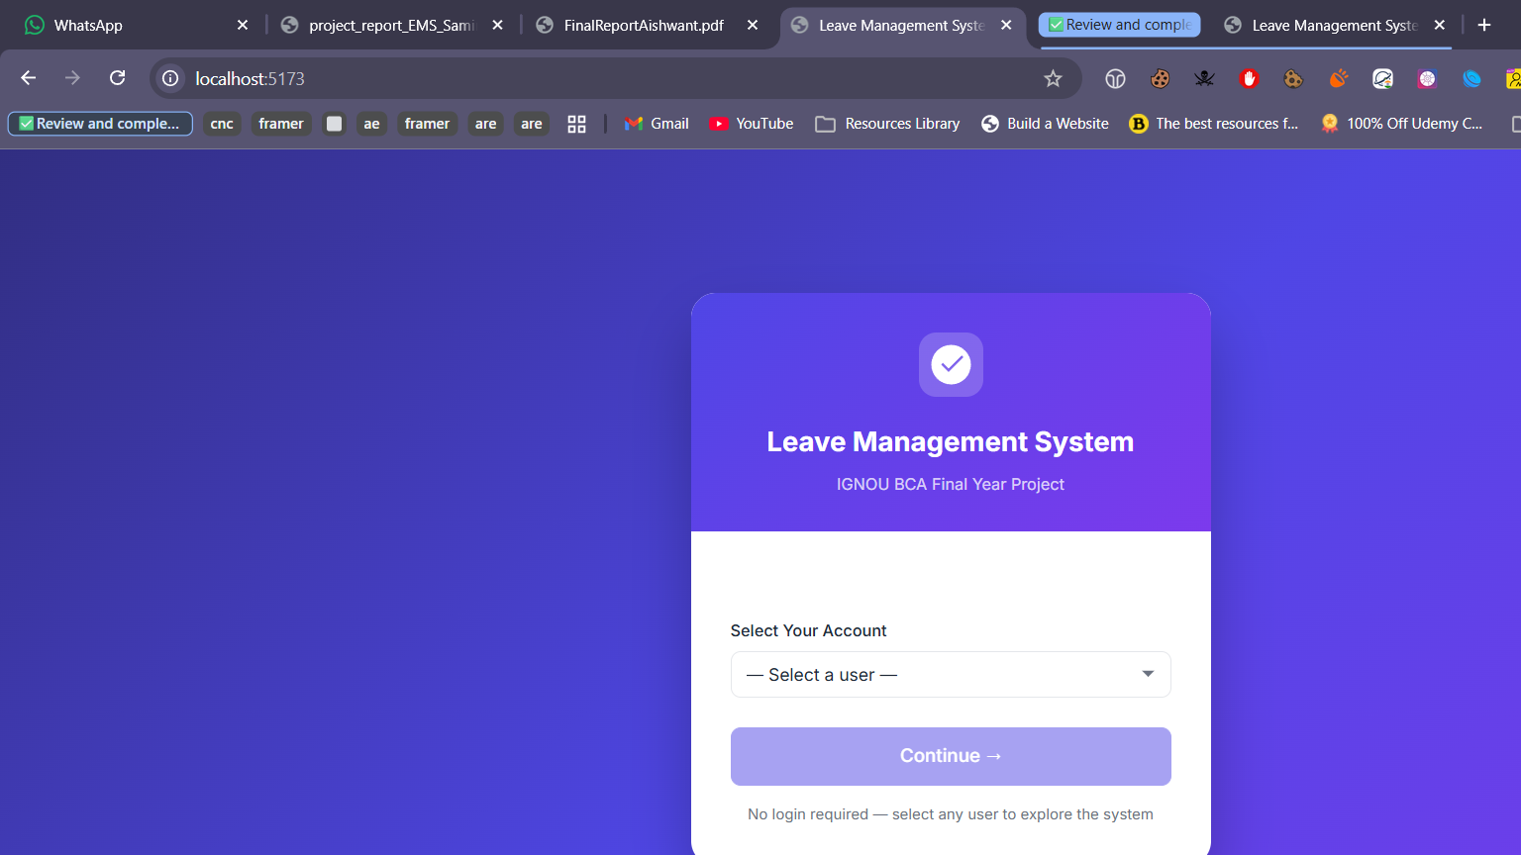
Figure 7.1: Home Screen - Select User / Account Selection

7.2 Admin Dashboard
URL: http://localhost:5173/admin/dashboard
The Admin Dashboard is the central control panel for administrators. It displays key metrics in summary cards at the top (Total Active Employees, Pending Approvals, Total Leave Requests, Pending Leaves, Approved Leaves, Rejected Leaves, High Priority Pending). Below the cards, a panel lists recent pending leave requests sorted by priority for quick action. The left sidebar provides navigation to all admin modules.

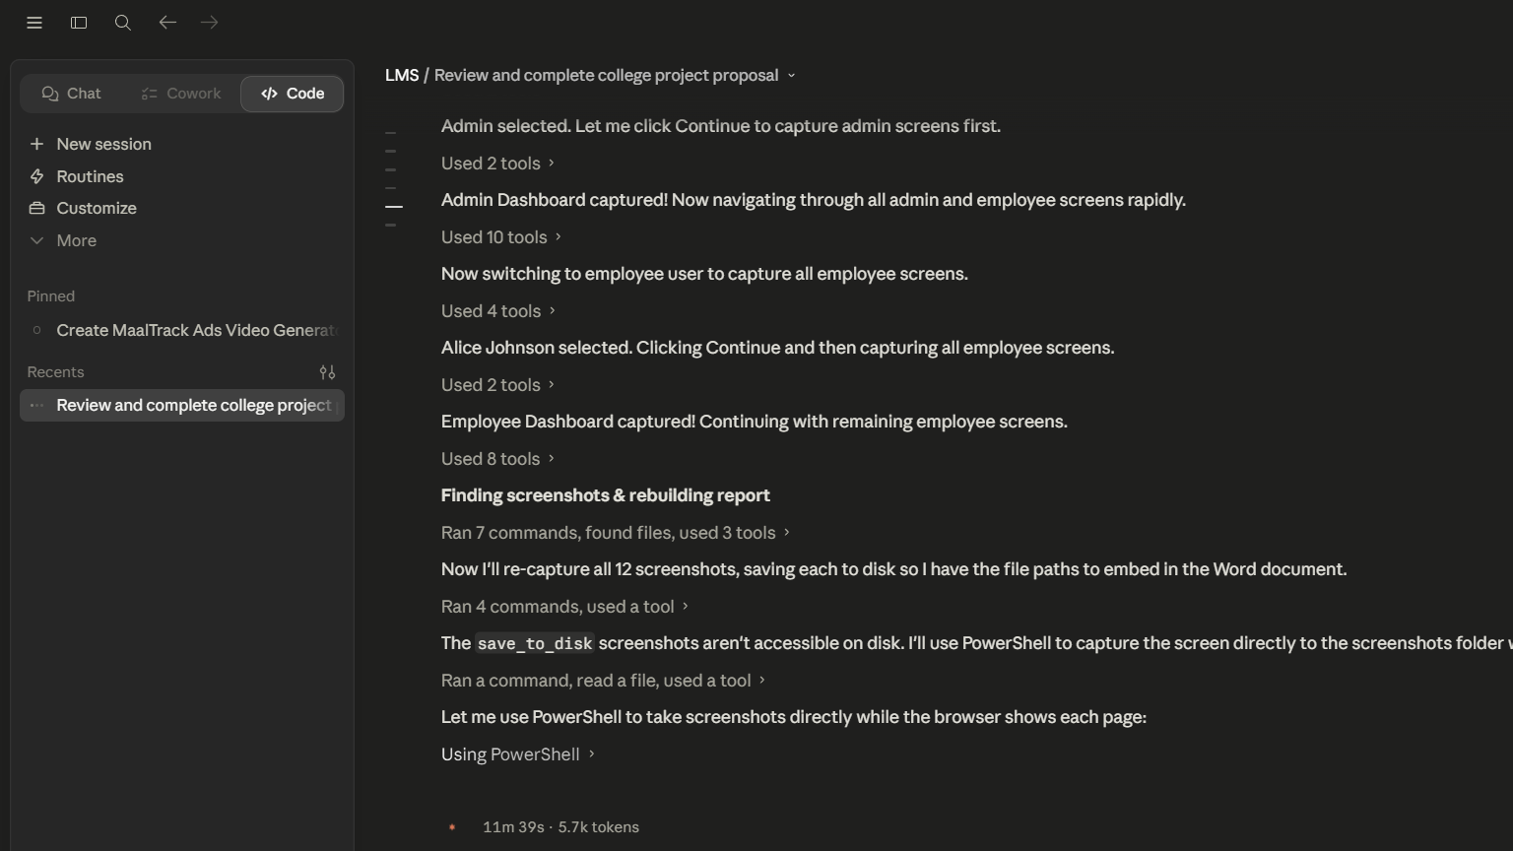
Figure 7.2: Admin Dashboard - Summary Statistics and Pending Requests

7.3 Manage Users Screen
URL: http://localhost:5173/admin/users
The Manage Users screen allows the administrator to view all registered users in a tabular format. Columns include Name, Email, Department, Role, Status (displayed as a colour-coded badge: yellow for pending, green for approved, red for rejected), and action buttons. Pending users have Approve and Reject buttons. This screen implements the UC-07 use case for user account management.

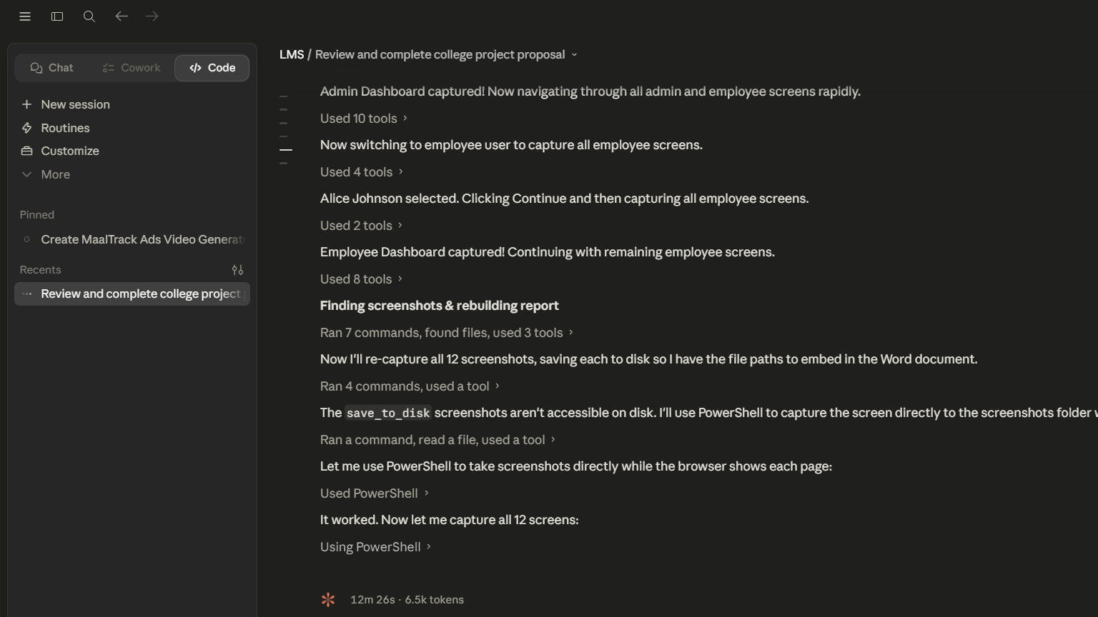
Figure 7.3: Manage Users - User List with Approval Actions

7.4 All Leave Requests Screen
URL: http://localhost:5173/admin/leaves
The All Leave Requests screen gives administrators complete visibility over all employee leave applications. The screen includes filter controls for Status and Priority at the top, followed by a comprehensive table showing Employee Name, Leave Type (with colour chip), Period, Total Days, Priority (colour-coded badge), Status, Admin Comment, and action buttons (Approve/Reject). Requests are automatically sorted by High priority pending leaves first.

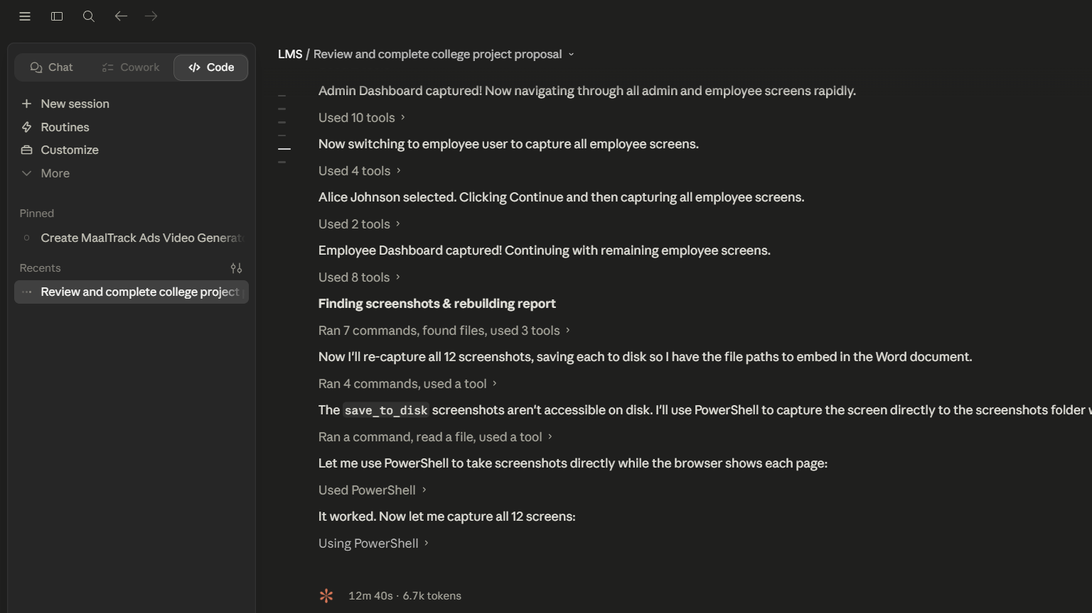
Figure 7.4: All Leave Requests - Admin Leave Management View

7.5 Leave Types Screen
URL: http://localhost:5173/admin/leave-types
The Leave Types screen allows administrators to define and manage the types of leave available in the organisation. Each leave type is displayed as a card showing the leave type name, description, maximum days allowed per year, colour indicator, and whether it is a paid or unpaid leave type. The "Add Leave Type" button opens a form to create new types. This configurable design allows the system to adapt to any organisation's leave policy.

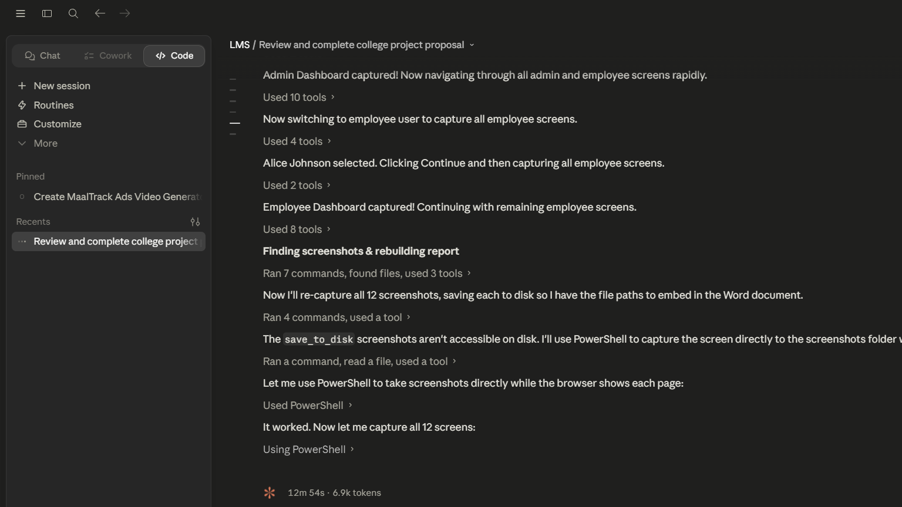
Figure 7.5: Leave Types - Configured Leave Categories

7.6 Departments Screen
URL: http://localhost:5173/admin/departments
The Departments screen displays all organisational departments in a card-based layout. Administrators can create new departments using the form at the top of the page. Departments are used to categorise employees and generate department-wise leave reports. The screen shows the department name and creation date for each department.

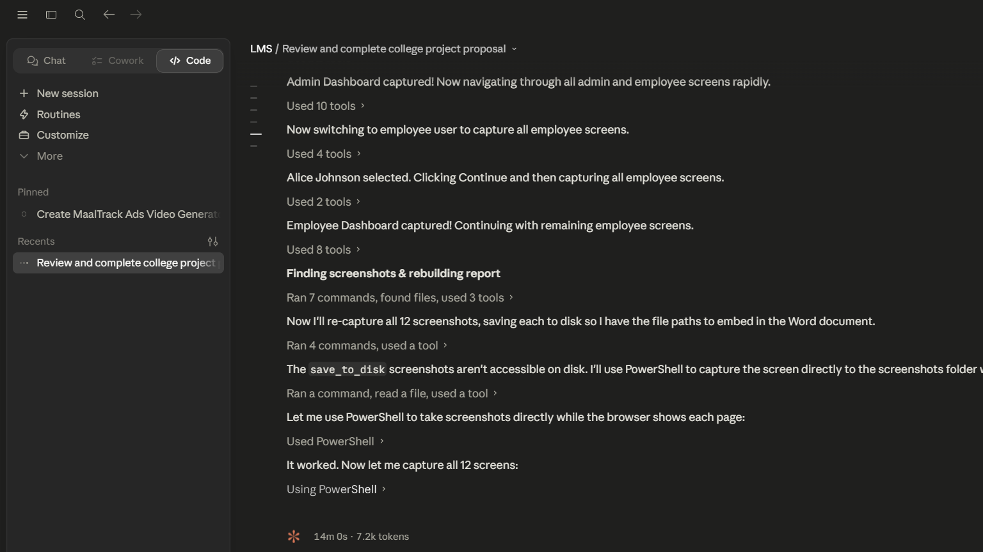
Figure 7.6: Departments - Organisational Department Management

7.7 Reports and Analytics Screen
URL: http://localhost:5173/admin/reports
The Reports screen provides comprehensive analytics on leave patterns across the organisation. It is divided into three sections: (1) Leave by Type -- showing total requests and days consumed per leave type; (2) Leave by Status -- showing counts of pending, approved, and rejected requests; (3) Department-wise Analysis -- showing each department's leave statistics including total requests, total days, and breakdown by status. All data is generated using MongoDB's aggregation pipeline on the server side.

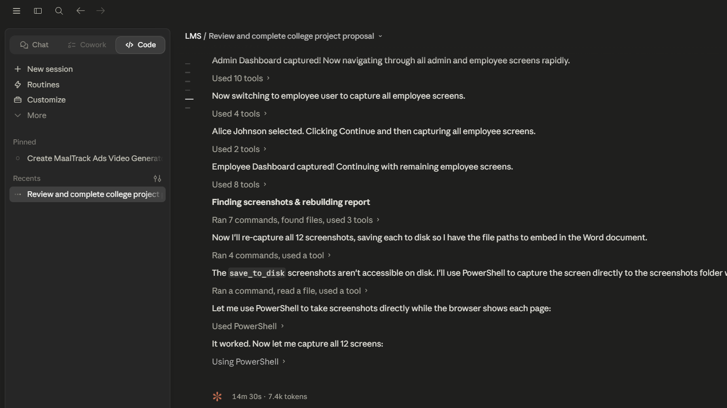
Figure 7.7: Reports and Analytics - Department-wise Leave Statistics

7.8 Employee Dashboard
URL: http://localhost:5173/employee/dashboard
The Employee Dashboard is the home screen for logged-in employees. It shows the employee's name and a summary of their leave statistics in four cards: Total Applied, Approved, Pending, and Remaining Balance. Below, a table of recent leave applications provides a quick overview of the employee's leave history. The left sidebar provides navigation to all employee-facing modules: Apply Leave, My Requests, Calendar, and Profile.

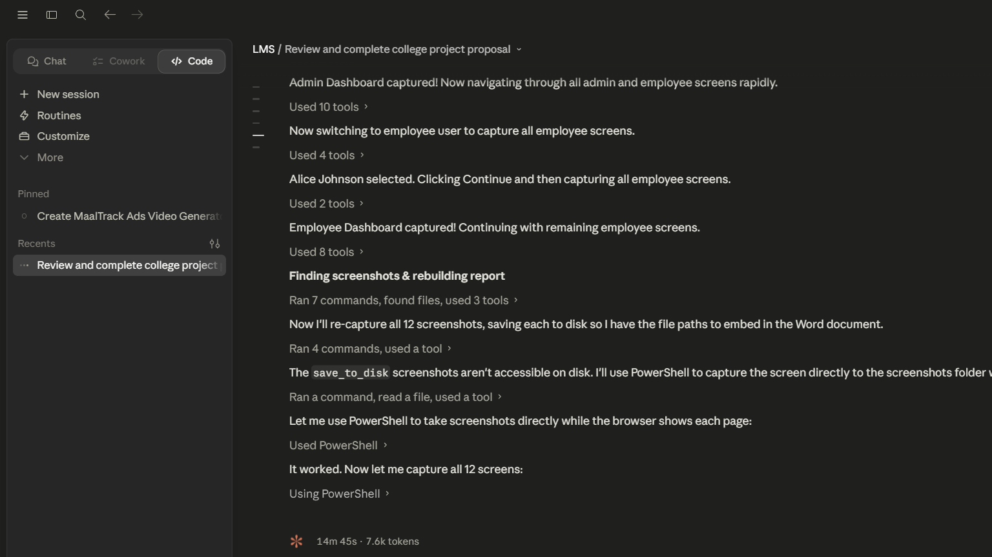
Figure 7.8: Employee Dashboard - Personal Leave Summary

7.9 Apply Leave Screen
URL: http://localhost:5173/employee/apply
The Apply Leave screen contains the leave application form. The left panel shows input fields: Leave Type (dropdown with all configured types), Start Date and End Date (date pickers), Leave Mode (Paid/Unpaid toggle), and Reason (textarea). The right sidebar displays the employee's current leave balance per type and shows a live calculation of working days based on the selected date range. On successful submission, a toast notification confirms the application.

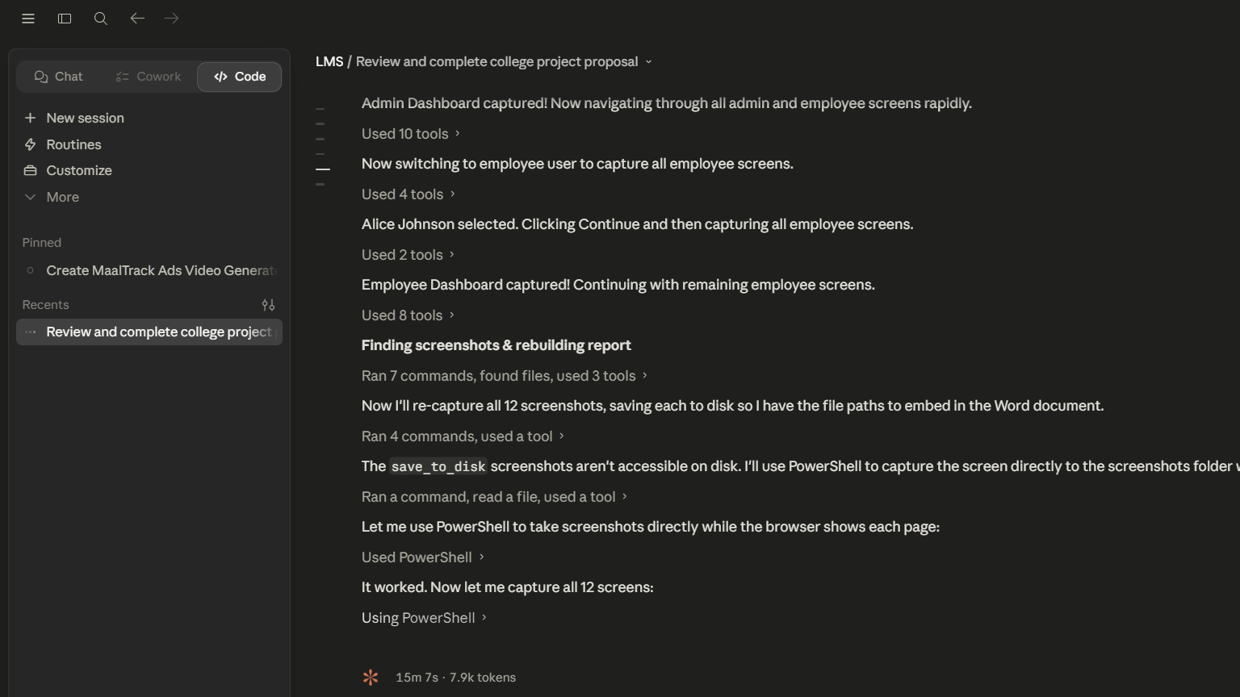
Figure 7.9: Apply Leave - Leave Application Form with Balance Sidebar

7.10 My Leave Requests Screen
URL: http://localhost:5173/employee/history
The My Leave Requests screen (Leave History) shows the complete record of all leave applications submitted by the currently logged-in employee. The table columns include Leave Type, Start Date, End Date, Days, Status (colour-coded badge), Priority, and Admin Comment. A Cancel button appears for pending leaves, allowing employees to withdraw their application. A filter control at the top allows filtering by status (All/Pending/Approved/Rejected).

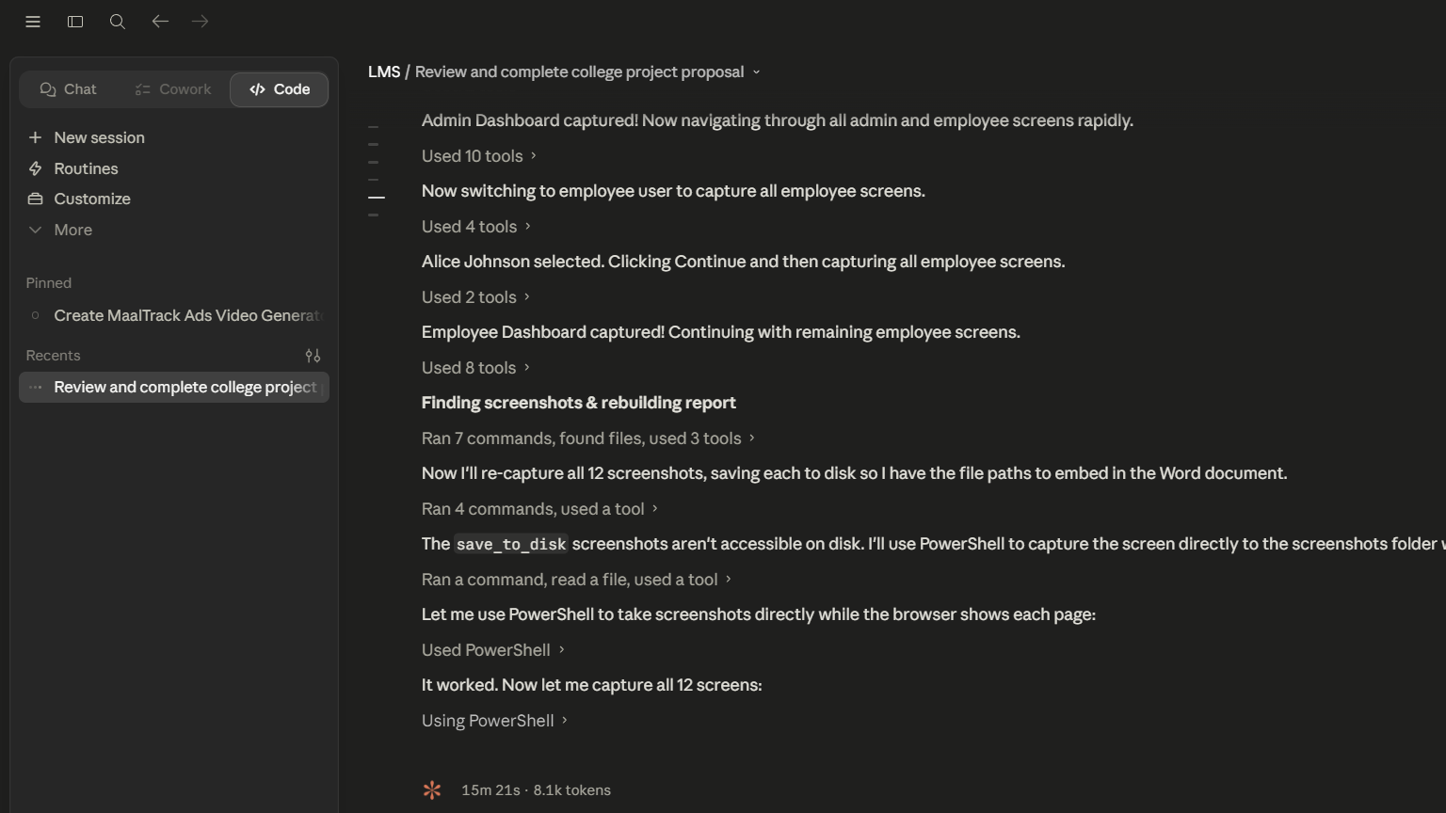
Figure 7.10: My Leave Requests - Employee Leave History

7.11 Leave Calendar Screen
URL: http://localhost:5173/employee/calendar
The Leave Calendar screen presents a monthly calendar view showing approved team leave schedules. Each month is displayed as a grid with day cells. Approved leave dates are highlighted with the corresponding leave type's colour code, enabling employees to see at a glance which days are busy with team leaves. Navigation arrows allow moving between months. This screen helps employees plan their own leave to avoid scheduling conflicts.

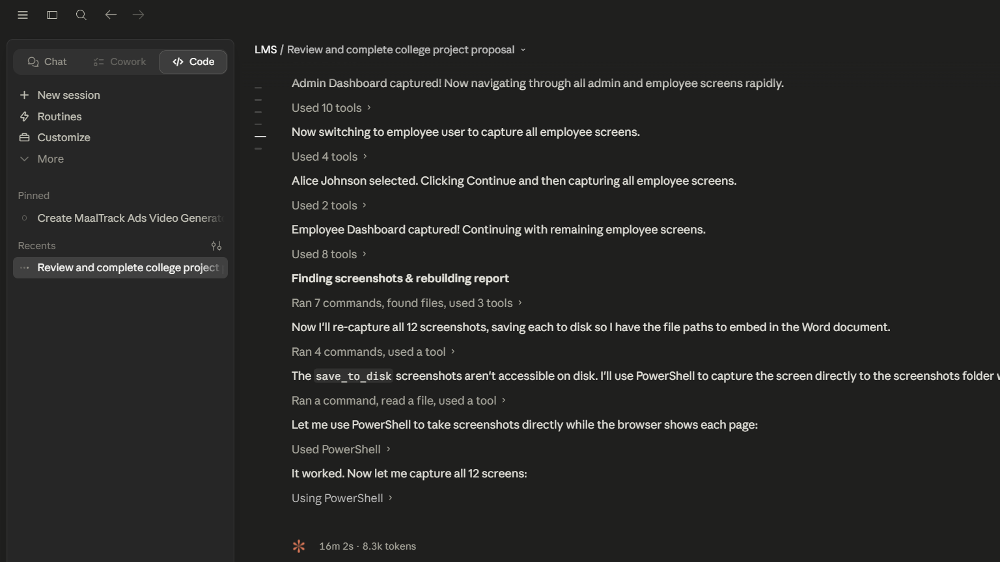
Figure 7.11: Leave Calendar - Monthly Team Schedule View

7.12 My Profile Screen
URL: http://localhost:5173/employee/profile
The My Profile screen allows employees to view and edit their personal information. The top section displays the employee's name, email, department, role, and account status. An Edit Profile form below allows updating the name and department. The right panel shows the employee's current leave balance summary -- a table listing each leave type with total days allocated, days used, and remaining days. This gives employees full transparency into their leave entitlements.

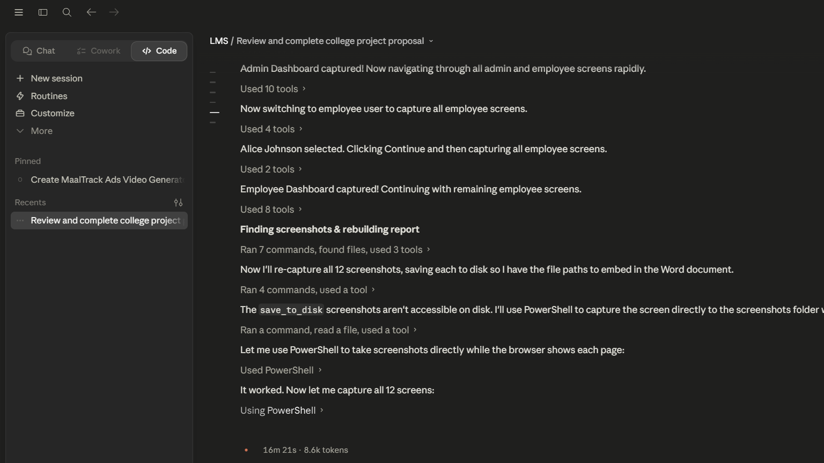
Figure 7.12: My Profile - Employee Profile and Leave Balances

Chapter 8: Conclusion, Limitations, and Future Scope

8.1 Conclusion
The Leave Management System has been successfully designed, developed, and tested as a full-stack web application using the MEVN technology stack. The project demonstrates the practical application of modern web development concepts including RESTful API design, NoSQL database modelling, reactive frontend development, and client-side state management.
All sixteen functional requirements specified in Chapter 3 have been implemented and validated through whitebox, blackbox, unit, integration, and end-to-end testing. The system successfully automates the leave management workflow, from employee registration and leave application through to administrative approval and real-time balance tracking.
Key achievements of this project include: (1) implementation of an intelligent priority-assignment algorithm for urgent leave classification, (2) an atomic balance deduction mechanism preventing data inconsistency, (3) a working-day calculation engine, (4) a comprehensive reporting module using MongoDB's aggregation pipeline, and (5) a clean, role-based user interface built with Vue.js 3.
The project also demonstrates competency in software engineering practices including separation of concerns (three-tier architecture), modular code organisation, input validation at multiple layers, and consistent API design principles. The system serves as a practical, deployable solution suitable for small to medium-sized organisations.

8.2 Limitations
The current implementation has the following known limitations:
- Authentication: The system does not implement JWT-based authentication. User sessions are managed via localStorage only, which is vulnerable to XSS attacks in production environments.
- No Email Notifications: The system does not send email or SMS notifications when leave status changes, requiring users to manually check the application.
- No Mobile Application: The system is accessible only via web browser. No dedicated iOS or Android app has been developed.
- No Holiday Calendar: Public holidays are not excluded from working-day calculations; only weekends (Saturday and Sunday) are excluded.
- No Document Attachments: Employees cannot attach medical certificates or other supporting documents to leave applications.
- Single Approval Level: The approval workflow has a single level (admin approval only); multi-level approval chains are not supported.
- No Audit Trail: Changes to leave status and user data are not logged in an audit trail collection for compliance purposes.
- No Data Export: Report data cannot be exported to CSV or Excel format directly from the application.

8.3 Future Scope

Enhancement | Description | Technology
JWT Authentication | Implement JSON Web Token-based stateless authentication with refresh tokens for secure API access | jsonwebtoken, bcryptjs
Email Notifications | Send automated emails on registration approval, leave status changes, and balance reminders | Nodemailer, SendGrid
Holiday Calendar | Integrate public holiday data to exclude national/regional holidays from working-day calculations | Holiday API, date-fns
Mobile Application | Develop a React Native or Flutter mobile app consuming the existing REST API | React Native / Flutter
Document Attachments | Allow employees to upload medical certificates stored in cloud storage | Multer, AWS S3
Multi-Level Approval | Implement hierarchical approval chains (Team Lead -> HR -> Admin) for different leave types | Workflow engine
Payroll Integration | Calculate salary deductions for unpaid leave and integrate with payroll export | Payroll API
Analytics Charts | Add interactive charts using Chart.js or D3.js for visual leave trend analysis | Chart.js, Vue-Chartjs

Bibliography
1. MongoDB Inc. (2024). MongoDB Documentation. Retrieved from https://docs.mongodb.com
2. OpenJS Foundation. (2024). Node.js Documentation. Retrieved from https://nodejs.org/docs
3. Express.js Contributors. (2024). Express.js API Reference. Retrieved from https://expressjs.com
4. Evan You. (2024). Vue.js 3 Documentation. Retrieved from https://vuejs.org/guide
5. Pinia Contributors. (2024). Pinia State Management Documentation. Retrieved from https://pinia.vuejs.org
6. Vue Router Contributors. (2024). Vue Router 4 Documentation. Retrieved from https://router.vuejs.org
7. Mongoose Contributors. (2024). Mongoose ODM Documentation. Retrieved from https://mongoosejs.com/docs
8. Fowler, M. (2002). Patterns of Enterprise Application Architecture. Addison-Wesley Professional.
9. Richardson, L., & Ruby, S. (2007). RESTful Web Services. O'Reilly Media.
10. Chodorow, K. (2013). MongoDB: The Definitive Guide. O'Reilly Media.
11. IGNOU BCA Programme Guide. (2024). BCSP-064 Project Course Guidelines. Indira Gandhi National Open University.
12. Vitejs Contributors. (2024). Vite Build Tool Documentation. Retrieved from https://vitejs.dev

Appendix A: Complete Source Code

A.1 Backend - server.js
require('dotenv').config();
const express = require('express');
const cors = require('cors');
const connectDB = require('./config/db');
const app = express();

connectDB();
app.use(cors());
app.use(express.json());

app.use('/api/users', require('./routes/users'));
app.use('/api/departments', require('./routes/departments'));
app.use('/api/leave-types', require('./routes/leaveTypes'));
app.use('/api/leave-requests', require('./routes/leaveRequests'));
app.use('/api/reports', require('./routes/reports'));

app.use((err, req, res, next) => {
console.error(err.stack);
res.status(500).json({ success: false, message: 'Server Error' });
});

const PORT = process.env.PORT || 5000;
app.listen(PORT, () => console.log("Server running on port " + PORT));

A.2 Backend - models/User.js
const mongoose = require('mongoose');
const UserSchema = new mongoose.Schema({
name: { type: String, required: true },
email: { type: String, required: true, unique: true },
role: { type: String, enum: ['employee', 'admin'], default: 'employee' },
status: { type: String, enum: ['pending', 'approved', 'rejected'], default: 'pending' },
dept_id: { type: mongoose.Schema.Types.ObjectId, ref: 'Department' },
leave_balances: [{
leave_type_id: { type: mongoose.Schema.Types.ObjectId, ref: 'LeaveType' },
leave_type_name: String,
total_days: Number,
used_days: { type: Number, default: 0 },
remaining_days: Number
}]
}, { timestamps: true });
module.exports = mongoose.model('User', UserSchema);

A.3 Backend - models/LeaveRequest.js
const mongoose = require('mongoose');
const LeaveRequestSchema = new mongoose.Schema({
user_id: { type: mongoose.Schema.Types.ObjectId, ref: 'User', required: true },
type_id: { type: mongoose.Schema.Types.ObjectId, ref: 'LeaveType', required: true },
leave_type_name: String,
start_date: { type: Date, required: true },
end_date: { type: Date, required: true },
total_days: { type: Number, required: true },
is_paid: { type: Boolean, default: true },
reason: { type: String, required: true },
status: { type: String, enum: ['pending', 'approved', 'rejected'], default: 'pending' },
priority: { type: String, enum: ['high', 'medium', 'low'], default: 'medium' },
admin_comment: String
}, { timestamps: true });
module.exports = mongoose.model('LeaveRequest', LeaveRequestSchema);

A.4 Backend - models/LeaveType.js
const mongoose = require('mongoose');
const LeaveTypeSchema = new mongoose.Schema({
name: { type: String, required: true, unique: true },
description: String,
max_days: { type: Number, required: true },
color_code: { type: String, default: '#3B82F6' },
is_paid: { type: Boolean, default: true }
}, { timestamps: true });
module.exports = mongoose.model('LeaveType', LeaveTypeSchema);

A.5 Backend - models/Department.js
const mongoose = require('mongoose');
const DepartmentSchema = new mongoose.Schema({
dept_name: { type: String, required: true, unique: true }
}, { timestamps: true });
module.exports = mongoose.model('Department', DepartmentSchema);

A.6 Backend - controllers/leaveRequestController.js
const LeaveRequest = require('../models/LeaveRequest');
const User = require('../models/User');
const LeaveType = require('../models/LeaveType');

function countWeekdays(start, end) {
let count = 0;
const cur = new Date(start);
while (cur <= end) {
const day = cur.getDay();
if (day !== 0 && day !== 6) count++;
cur.setDate(cur.getDate() + 1);
}
return count;
}

function getPriority(name) {
const n = name.toLowerCase();
if (n.includes('sick') || n.includes('medical') || n.includes('emergency')) return 'high';
if (n.includes('casual')) return 'medium';
return 'low';
}

exports.applyLeave = async (req, res) => {
try {
const { user_id, type_id, start_date, end_date, is_paid, reason } = req.body;
const start = new Date(start_date);
const end = new Date(end_date);
if (start > end) return res.status(400).json({ success: false, message: 'Start date must be before end date' });
const total_days = countWeekdays(start, end);
if (total_days === 0) return res.status(400).json({ success: false, message: 'No working days in selected range' });
const leaveType = await LeaveType.findById(type_id);
if (!leaveType) return res.status(404).json({ success: false, message: 'Leave type not found' });
const priority = getPriority(leaveType.name);
if (is_paid) {
const user = await User.findById(user_id);
const balance = user.leave_balances.find(b => b.leave_type_id.toString() === type_id);
if (!balance || balance.remaining_days < total_days) {
return res.status(400).json({ success: false, message: 'Insufficient balance' });
}
}
const request = await LeaveRequest.create({
user_id, type_id, leave_type_name: leaveType.name,
start_date: start, end_date: end, total_days, is_paid: is_paid !== false,
reason, priority
});
res.status(201).json({ success: true, data: request, message: 'Leave applied successfully' });
} catch (err) {
res.status(500).json({ success: false, message: err.message });
}
};

exports.updateLeaveStatus = async (req, res) => {
try {
const { status, admin_comment } = req.body;
const leave = await LeaveRequest.findById(req.params.id);
if (!leave) return res.status(404).json({ success: false, message: 'Leave request not found' });
if (status === 'approved' && leave.is_paid && leave.status === 'pending') {
await User.findOneAndUpdate(
{ _id: leave.user_id, 'leave_balances.leave_type_id': leave.type_id },
{ $inc: { 'leave_balances.$.used_days': leave.total_days, 'leave_balances.$.remaining_days': -leave.total_days } }
);
}
leave.status = status;
leave.admin_comment = admin_comment || '';
await leave.save();
res.json({ success: true, data: leave, message: 'Leave ' + status });
} catch (err) {
res.status(500).json({ success: false, message: err.message });
}
};

A.7 Backend - controllers/reportController.js
const User = require('../models/User');
const LeaveRequest = require('../models/LeaveRequest');

exports.getDashboardStats = async (req, res) => {
try {
const totalUsers = await User.countDocuments({ status: 'approved', role: 'employee' });
const pendingApprovals = await User.countDocuments({ status: 'pending' });
const totalLeaves = await LeaveRequest.countDocuments();
const pendingLeaves = await LeaveRequest.countDocuments({ status: 'pending' });
const approvedLeaves = await LeaveRequest.countDocuments({ status: 'approved' });
const rejectedLeaves = await LeaveRequest.countDocuments({ status: 'rejected' });
const highPriority = await LeaveRequest.countDocuments({ priority: 'high', status: 'pending' });
res.json({ success: true, data: { totalUsers, pendingApprovals, totalLeaves, pendingLeaves, approvedLeaves, rejectedLeaves, highPriority } });
} catch (err) {
res.status(500).json({ success: false, message: err.message });
}
};

exports.getDeptStats = async (req, res) => {
try {
const stats = await LeaveRequest.aggregate([
{ $lookup: { from: 'users', localField: 'user_id', foreignField: '_id', as: 'user' } },
{ $unwind: '$user' },
{ $lookup: { from: 'departments', localField: 'user.dept_id', foreignField: '_id', as: 'dept' } },
{ $unwind: { path: '$dept', preserveNullAndEmptyArrays: true } },
{ $group: {
_id: { $ifNull: ['$dept.dept_name', 'No Department'] },
totalRequests: { $sum: 1 }, totalDays: { $sum: '$total_days' },
approved: { $sum: { $cond: [{ $eq: ['$status', 'approved'] }, 1, 0] } },
pending: { $sum: { $cond: [{ $eq: ['$status', 'pending'] }, 1, 0] } },
rejected: { $sum: { $cond: [{ $eq: ['$status', 'rejected'] }, 1, 0] } }
}},
{ $sort: { totalRequests: -1 } }
]);
res.json({ success: true, data: stats });
} catch (err) {
res.status(500).json({ success: false, message: err.message });
}
};

A.8 Frontend - store/useAppStore.js
import { defineStore } from 'pinia';
import { ref } from 'vue';

export const useAppStore = defineStore('app', () => {
const currentUser = ref(JSON.parse(localStorage.getItem('lms_user') || 'null'));

function setUser(user) {
currentUser.value = user;
localStorage.setItem('lms_user', JSON.stringify(user));
}

function clearUser() {
currentUser.value = null;
localStorage.removeItem('lms_user');
}

return { currentUser, setUser, clearUser };
});

A.9 Frontend - router/index.js
import { createRouter, createWebHistory } from 'vue-router';

const routes = [
{ path: '/', component: () => import('../views/SelectUser.vue') },
{
path: '/employee',
component: () => import('../layouts/EmployeeLayout.vue'),
children: [
{ path: '', redirect: '/employee/dashboard' },
{ path: 'dashboard', component: () => import('../views/employee/Dashboard.vue') },
{ path: 'apply', component: () => import('../views/employee/ApplyLeave.vue') },
{ path: 'history', component: () => import('../views/employee/LeaveHistory.vue') },
{ path: 'calendar', component: () => import('../views/employee/LeaveCalendar.vue') },
{ path: 'profile', component: () => import('../views/employee/Profile.vue') },
]
},
{
path: '/admin',
component: () => import('../layouts/AdminLayout.vue'),
children: [
{ path: '', redirect: '/admin/dashboard' },
{ path: 'dashboard', component: () => import('../views/admin/Dashboard.vue') },
{ path: 'users', component: () => import('../views/admin/ManageUsers.vue') },
{ path: 'leave-types', component: () => import('../views/admin/LeaveTypes.vue') },
{ path: 'leaves', component: () => import('../views/admin/AllLeaves.vue') },
{ path: 'departments', component: () => import('../views/admin/Departments.vue') },
{ path: 'reports', component: () => import('../views/admin/Reports.vue') },
]
}
];

const router = createRouter({ history: createWebHistory(), routes });
router.beforeEach((to, from, next) => { if (to.path === '/') return next(); next(); });
export default router;

