INDIRA GANDHI NATIONAL OPEN UNIVERSITY
(IGNOU)

BACHELOR OF COMPUTER APPLICATIONS (BCA)

PROJECT REPORT
BCSP-064: BCA PROJECT

LEAVE MANAGEMENT SYSTEM
(A Web-Based Application using MEVN Stack)

Submitted by:
Aakash Sah
Enrollment No.: 239150627
BCA (6th Semester)

Under the Supervision of:
[Guide's Name]
[Designation]
[Institution Name]

Study Centre: [Study Centre Name & Code]
Regional Centre: [Regional Centre Name]

July 2024 - January 2025

PROJECT SYNOPSIS
BCSP-064: BCA Project

LEAVE MANAGEMENT SYSTEM
(A Web-Based Application using MEVN Stack)

Field | Details
Student Name | Aakash Sah
Enrolment No. | 239150627
Programme | Bachelor of Computer Applications (BCA)
Semester | 6th Semester (Final Year)
Course Code | BCSP-064
Guide Name | [Guide's Name]
Guide Designation | [Designation]
Guide Institution | [Institution Name]
Study Centre | [Study Centre Name & Code]
Regional Centre | [Regional Centre Name]

Signature of Student: _______________________

Signature of Guide: _________________________

Date: _______________________

1. TITLE OF THE PROJECT

Leave Management System — A Web-Based Application using the MEVN Stack (MongoDB, Express.js, Vue.js 3, Node.js)

2. INTRODUCTION AND OBJECTIVES

2.1 Introduction

Employee leave management is a critical function in every organisation. In most small to medium-sized organisations, leave management is still handled manually through paper forms, registers, and spreadsheets. This leads to errors in balance calculation, delays in approval, loss of forms, and lack of real-time visibility for employees and managers.
The Leave Management System (LMS) is a full-stack web application that digitalises and automates the entire leave management lifecycle — from employee registration and leave application to administrative approval and analytical reporting. The system is built using the MEVN stack: MongoDB as the database, Express.js as the backend framework, Vue.js 3 as the frontend framework, and Node.js as the JavaScript runtime.
The application supports two user roles: Employee and Administrator. Employees can apply for leave, check balances, track application status, and view team leave on a calendar. Administrators can approve or reject applications, manage users and departments, configure leave types, and generate reports.

2.2 Objectives

- Develop a full-stack web application to replace manual paper-based leave management processes.
- Implement role-based access control differentiating between Employee and Administrator roles.
- Enable employees to apply for leave with automatic working-day calculation (Monday to Friday).
- Implement real-time leave balance tracking with atomic deduction using MongoDB $inc operator.
- Provide administrators with tools to approve or reject leave requests with optional comments.
- Implement an automatic priority classification algorithm for leave requests based on leave type.
- Generate analytical reports on department-wise leave patterns using MongoDB aggregation pipeline.
- Design a clean, responsive user interface using Vue.js 3 Composition API and Pinia state management.
- Ensure data integrity through Mongoose schema validation at the database layer.
- Deliver RESTful APIs with consistent JSON response format across all seventeen endpoints.

3. PROJECT CATEGORY

Category: Web-based Application / Management Information System (MIS)
Domain: Human Resource Management (HRM) — Leave Administration
Application Type: Multi-tier Client-Server Single Page Application (SPA)
Architecture: Three-tier (Presentation + Application + Data)
Frontend Technology: Vue.js 3 (Composition API) — falls under the React/Angular/JavaScript SPA category as listed in IGNOU approved tools.
Backend Technology: Node.js + Express.js — JavaScript server-side runtime with RESTful API framework.
Database: MongoDB (NoSQL, Document-oriented) — explicitly listed under "BACKEND FOR MOBILE APPs" in IGNOU approved tools.
Additional Libraries: Mongoose (ODM), Pinia (State Management), Vue Router, Vite (Build Tool), dotenv, cors.

4. SYSTEM ANALYSIS

4.1 Data Flow Diagram — Level 0 (Context Diagram)
External Entities: (1) Employee — provides registration data, leave applications; receives leave status, balance info. (2) Administrator — provides approval decisions, configuration; receives reports, user management data.
Central Process: Leave Management System — mediates all interactions between entities and the MongoDB data store.

4.2 Data Flow Diagram — Level 1
- P1 — User Management: Handles registration, approval, profile. Data flows between Employee entity, Users store, Admin entity.
- P2 — Leave Application: Processes leave requests. Reads leave types and balances; writes to LeaveRequests store.
- P3 — Leave Approval: Admin reviews requests. Updates LeaveRequests and atomically modifies leave balances in Users store.
- P4 — Reporting: Reads from LeaveRequests, Users, Departments stores to produce analytical outputs for Admin.

4.3 Data Flow Diagram — Level 2 (Leave Application Process — P2)
- P2.1 — Validate Dates: Checks start_date <= end_date.
- P2.2 — Count Weekdays: Iterates date range; skips Saturday (day=6) and Sunday (day=0).
- P2.3 — Check Balance: Reads user leave_balances to verify remaining_days >= total_days for paid leave.
- P2.4 — Assign Priority: Keyword matching on leave type name ("sick/medical/emergency" → high, "casual" → medium).
- P2.5 — Create Request: Writes validated leave request to LeaveRequests store with pending status.

4.4 Entity-Relationship Diagram
- User (1) — has many (N) — LeaveRequests: One employee can submit multiple leave applications.
- Department (1) — has many (N) — Users: One department can contain multiple employees.
- LeaveType (1) — referenced by (N) — LeaveRequests: One leave type applies to many requests.
- User (1) — has embedded (N) — LeaveBalances: Leave balances stored as embedded array in User document.

4.5 Database Design

Collection | Key Fields | Relationships
users | _id, name, email, role, status, dept_id, leave_balances[] | References: departments; Embeds: leave_balances
leaverequests | _id, user_id, type_id, start_date, end_date, total_days, priority, status | References: users, leavetypes
leavetypes | _id, name, max_days, color_code, is_paid | Referenced by: users.leave_balances, leaverequests
departments | _id, dept_name | Referenced by: users.dept_id

5. COMPLETE STRUCTURE OF THE PROJECT

5.1 Number of Modules and Description

Module No. | Module Name | Description | Estimated Effort
M1 | User Management | Employee registration form, admin approval/rejection workflow, profile editing, role-based session management via Pinia + localStorage | 3 weeks
M2 | Leave Application | Leave type selection, date range picker, working-day calculation, balance validation, paid/unpaid toggle, reason input | 2 weeks
M3 | Leave Administration | Admin view of all leaves with filters, approve/reject actions with comment input, atomic balance deduction via MongoDB $inc | 2 weeks
M4 | Department Management | Admin CRUD for departments; dropdown population for employee registration form | 1 week
M5 | Leave Type Configuration | Admin creation and deletion of leave types with name, max days, colour code, paid/unpaid flag | 1 week
M6 | Reporting & Analytics | Dashboard stats (7 KPIs), leave-by-type table, leave-by-status summary, department-wise breakdown using MongoDB aggregation pipeline | 2 weeks
M7 | Leave Calendar | Monthly calendar view with approved team leaves coloured by leave type; month navigation | 1 week
M8 | Employee Dashboard & History | Personal leave stats cards, recent applications table, leave history with cancel action, status filters | 1 week

5.2 Data Structures

Structure | Fields | Purpose
User Document | _id (ObjectId), name (String), email (String, unique), role (enum: employee|admin), status (enum: pending|approved|rejected), dept_id (ObjectId ref), leave_balances (Array) | Primary user entity; stores role, approval status, and all leave balance subdocuments
LeaveBalance Subdocument | leave_type_id (ObjectId), leave_type_name (String), total_days (Number), used_days (Number, default:0), remaining_days (Number) | Embedded within User; tracks balance per leave type atomically
LeaveRequest Document | _id (ObjectId), user_id (ObjectId ref), type_id (ObjectId ref), leave_type_name (String), start_date (Date), end_date (Date), total_days (Number), is_paid (Boolean), reason (String), status (enum: pending|approved|rejected), priority (enum: high|medium|low), admin_comment (String) | Stores each leave application; status and priority are computed fields
LeaveType Document | _id (ObjectId), name (String, unique), description (String), max_days (Number), color_code (String, default:#3B82F6), is_paid (Boolean) | Master data for leave categories; configurable by admin
Department Document | _id (ObjectId), dept_name (String, unique) | Organisational unit; referenced by User documents

5.3 Process Logic for Each Module

Module M1 — User Registration:
- Employee submits registration form (name, email, dept_id).
- POST /api/users/register creates user with role=employee, status=pending.
- Admin reviews pending users at /admin/users.
- PUT /api/users/:id/status sets status=approved; system initialises leave_balances array.

Module M2 — Leave Application:
- Employee selects leave type, start date, end date, reason.
- countWeekdays(start, end) loops from start to end, counts only days where getDay() !== 0 && getDay() !== 6.
- If is_paid: validate remaining_days >= total_days in user.leave_balances.
- getPriority(leaveType.name) performs toLowerCase() + includes() keyword check.
- LeaveRequest.create() persists request with status=pending.

Module M3 — Leave Approval:
- Admin reviews pending request; clicks Approve or Reject with optional comment.
- PUT /api/leave-requests/:id/status updates leave.status and leave.admin_comment.
- If status=approved AND is_paid AND previous status was pending: User.findOneAndUpdate with $inc { used_days: +total_days, remaining_days: -total_days } using positional operator.

Module M6 — Reporting:
- GET /api/reports/dashboard: countDocuments() with multiple filter conditions.
- GET /api/reports/dept-stats: Aggregation pipeline with $lookup (users), $lookup (departments), $unwind, $group, $sort.

5.4 Testing Details
Testing will be conducted at four levels:
- Whitebox Testing: Internal code paths of countWeekdays(), getPriority(), and balance validation logic tested with known inputs.
- Blackbox Testing: All API endpoints tested via direct HTTP calls (Postman) verifying input-output behaviour without knowledge of internals.
- Unit Testing: Individual functions tested in isolation with controlled inputs (13 unit test cases).
- Integration Testing: End-to-end API flows tested (register → approve user → apply leave → approve leave → verify balance).
- System Testing: Complete user scenarios tested in browser from user perspective.

5.5 Reports Generation
The system generates three types of analytical reports accessible to administrators:
- Dashboard Statistics Report: Total active employees, pending approvals, leave counts by status, high-priority pending count.
- Leave-by-Type Report: For each leave type — total requests and total days consumed in the organisation.
- Department-wise Leave Report: For each department — total requests, total days, approved/pending/rejected counts, sorted by volume.

6. TOOLS, PLATFORM, HARDWARE AND SOFTWARE REQUIREMENTS

Component | Technology / Tool | Version | Purpose
Frontend Framework | Vue.js 3 | 3.4.x | UI components, reactivity, Composition API
Frontend Build | Vite | 5.x | Development server (port 5173), hot reload, bundling
State Management | Pinia | 2.x | Global user session with localStorage persistence
Client-side Routing | Vue Router 4 | 4.x | SPA navigation, lazy-loaded routes
Backend Runtime | Node.js | 18.x+ | JavaScript server-side execution environment
Backend Framework | Express.js | 4.x | RESTful API routing, middleware, error handling
Database | MongoDB | 6.x+ | NoSQL document store for all application data
ODM | Mongoose | 8.x | Schema validation, model abstraction, query building
Environment Config | dotenv | 16.x | Loads MONGO_URI and PORT from .env file
CORS Middleware | cors | 2.x | Allows Vue frontend to call Express API cross-origin
IDE | Visual Studio Code | Latest | Code editing with Volar (Vue) and ESLint extensions
Version Control | Git | 2.x | Source code management
API Testing | Postman | Latest | Manual testing of all 17 REST API endpoints

Hardware Requirements:
- Development Machine: Any modern computer with minimum 8GB RAM, 256GB storage, 64-bit OS.
- Processor: Intel Core i3 or equivalent (i5/i7 recommended for faster builds).
- Operating System: Windows 10/11, macOS 11+, or Ubuntu 20.04+.
- Internet connection for MongoDB Atlas (optional; local MongoDB also supported).

7. INDUSTRY / CLIENT

This project is NOT being developed for any specific industry or client. It is an academic project developed as part of the IGNOU BCA 6th Semester curriculum under the BCSP-064 Project course. The project simulates a real-world leave management scenario applicable to any small or medium-sized organisation.

8. FUTURE SCOPE AND FURTHER ENHANCEMENT

- JWT Authentication: Implement JSON Web Token-based stateless authentication with refresh tokens to replace the current localStorage-based session management.
- Email Notifications: Integrate Nodemailer or SendGrid to send automated emails when leave status changes (approved/rejected) and when registration is approved.
- Public Holiday Calendar: Integrate a national holidays API to exclude public holidays from working-day calculations in addition to weekends.
- Mobile Application: Develop a React Native or Flutter mobile application consuming the existing REST API backend.
- Document Attachments: Allow employees to attach scanned medical certificates via Multer middleware with cloud storage (AWS S3 or Cloudinary).
- Multi-Level Approval: Implement hierarchical approval chains (Team Lead → HR → Admin) for specific leave types requiring multiple approvals.
- Analytics Charts: Add interactive visual charts using Chart.js or Vue-Chartjs for leave trend analysis and forecasting.
- Payroll Integration: Calculate salary deductions for unpaid leaves and export payroll data for integration with accounting systems.

Signature of Student: _______________________

Name: Aakash Sah | Enrolment No.: 239150627

Signature of Guide: _________________________

Name: _____________________ | Designation: _____________________
Date: _____________________ | Institution: _____________________

ACKNOWLEDGEMENTS

I express my sincere gratitude to the Indira Gandhi National Open University (IGNOU) for providing me the opportunity to undertake this project as part of the BCA programme curriculum. The BCSP-064 project course has been instrumental in bridging the gap between academic knowledge and practical application.

I am deeply grateful to my project supervisor, [Guide's Name], for his/her invaluable guidance, continuous support, and constructive feedback throughout the development of this project. His/Her expertise and mentorship have been indispensable in shaping this work.

I would also like to thank my Study Centre coordinator and faculty members for their academic support and encouragement during the course of this programme.

My heartfelt thanks to my family and friends for their unwavering moral support, patience, and encouragement, which kept me motivated throughout this project.

Finally, I am thankful to all the developers of the open-source technologies -- MongoDB, Express.js, Vue.js, and Node.js -- whose frameworks and libraries made this project possible.

Aakash Sah
Enrollment No.: 239150627
BCA - 6th Semester
IGNOU
April 2025

ABSTRACT

The Leave Management System (LMS) is a full-stack web application developed using the MEVN technology stack -- MongoDB, Express.js, Vue.js 3, and Node.js. The system automates and streamlines the entire leave management workflow within an organisation, replacing paper-based or spreadsheet-driven processes with a robust, real-time digital solution.

The application supports two distinct user roles: Employee and Administrator. Employees can register, apply for various types of leave, track their leave balances, view their application history, and access a visual calendar displaying team leave schedules. The administrator module provides comprehensive tools for managing user accounts, defining leave types with configurable parameters, reviewing and approving or rejecting leave applications, and generating analytical reports on leave patterns across departments.

Key technical features of the system include an intelligent priority-assignment algorithm that categorises leave requests based on their urgency, a working-day calculation engine that counts only weekdays excluding weekends, an atomic leave-balance deduction mechanism using MongoDB $inc operator, and a three-tier RESTful architecture with clear separation of concerns.

The project demonstrates proficiency in modern full-stack web development, database design, RESTful API architecture, and state management. It serves as a practical, deployable solution suitable for small to medium-sized organisations.

Keywords: Leave Management, MEVN Stack, Vue.js 3, Node.js, MongoDB, RESTful API, Pinia, Role-Based Access Control

LIST OF TABLES

Table No. | Title | Page
1.1 | Gantt Chart - Project Schedule | 13
1.2 | Project Objectives | 14
1.3 | Project Scope | 16
2.1 | Technology Stack | 24
3.1 | Functional Requirements | 31
3.2 | Non-Functional Requirements | 33
3.3 | Use Case Summary | 36
3.4 | Data Dictionary - users Collection | 38
3.5 | Data Dictionary - leaverequests Collection | 39
4.1 | System Modules | 41
4.2 | API Endpoints | 45
5.1 | Directory Structure | 52
6.1 | Whitebox Test Cases | 60
6.2 | Blackbox Test Cases | 61
6.3 | Unit Test Cases | 63
6.4 | Integration Test Cases | 65
6.5 | End-to-End Test Scenarios | 66
8.1 | Future Enhancements | 80

LIST OF FIGURES

Figure No. | Title | Page
7.1 | Home Screen - Select User / Account Selection | 68
7.2 | Admin Dashboard - Summary Statistics and Pending Requests | 69
7.3 | Manage Users - User List with Approval Actions | 70
7.4 | All Leave Requests - Admin Leave Management View | 71
7.5 | Leave Types - Configured Leave Categories | 72
7.6 | Departments - Organisational Department Management | 72
7.7 | Reports and Analytics - Department-wise Leave Statistics | 73
7.8 | Employee Dashboard - Personal Leave Summary | 74
7.9 | Apply Leave - Leave Application Form with Balance Sidebar | 74
7.10 | My Leave Requests - Employee Leave History | 75
7.11 | Leave Calendar - Monthly Calendar View | 75
7.12 | My Profile - Employee Profile and Leave Balances | 76

Chapter 1: Introduction

1.1 Background and Motivation
In modern organisations, managing employee leave efficiently is a critical human resource management function. Traditional paper-based or spreadsheet-driven leave management systems are error-prone, time-consuming, and lack real-time visibility. They require physical form submissions, manual approval workflows, and periodic balance calculations, leading to administrative overhead and frequent disputes over leave entitlements.
The proliferation of web technologies has created an opportunity to replace these legacy processes with automated, role-aware, and real-time systems that improve accuracy, reduce administrative burden, and provide instant visibility to all stakeholders. The Leave Management System (LMS) addresses this need by providing a comprehensive digital platform built on the MEVN technology stack.

1.2 Problem Statement
Most small and medium-sized organisations in India still rely on manual, paper-based leave management processes. Employees fill out physical leave application forms, which are then passed to supervisors for approval and stored in filing cabinets. This approach introduces several critical problems:
- Lack of real-time visibility: Employees cannot instantly check their leave balances or application status without querying HR staff.
- Manual calculation errors: Computing working days, balance deductions, and leave entitlements manually introduces arithmetic errors.
- Delayed processing: Physical form routing causes delays in approval, especially when supervisors are unavailable.
- Inconsistent records: Leave records maintained in spreadsheets across multiple HR staff are prone to inconsistency and duplication.
- No prioritisation: Manual systems cannot automatically flag urgent leave requests (medical emergencies) for immediate attention.
- Administrative overhead: HR staff spend significant time manually computing leave balances and generating reports instead of higher-value tasks.
The Leave Management System directly solves all of the above problems by providing a centralised, role-based, web-accessible platform that automates the entire leave management lifecycle.

1.3 Existing System and its Limitations
The existing leave management processes in typical organisations take one of the following forms:

1.3.1 Paper-Based System
Employees fill printed leave application forms, obtain supervisor signatures, and submit to HR for filing. HR manually updates a register or spreadsheet and notifies the employee of the decision.

1.3.2 Basic Spreadsheet System
HR maintains Excel spreadsheets to track leave balances and applications. Applications are received via email and status is communicated back manually.
Both existing approaches suffer from the following limitations:
Limitation | Impact | Severity
No centralised access | Employees cannot check status 24/7 | High
Manual balance calculation | Errors in remaining leave days | High
No automated approval workflow | Delays and lost paper forms | High
No priority classification | Medical leaves treated same as casual | Medium
No real-time reports | HR must manually compile statistics | Medium
No audit trail | Disputes cannot be resolved objectively | Medium
Data silos per department | Organisation-wide view not possible | Low

1.4 Project Category
This project falls under the following categories:
- Category: Web-based Management Information System (MIS)
- Domain: Human Resource Management (HRM)
- Application Type: Multi-tier Client-Server Web Application
- Architecture: RESTful API backend with Single Page Application (SPA) frontend
- Database Type: NoSQL Document Database (MongoDB)
- Technology Stack: MEVN (MongoDB, Express.js, Vue.js 3, Node.js)
The project demonstrates practical application of full-stack web development concepts, database design, and software engineering principles as required by the IGNOU BCSP-064 curriculum.

1.5 Benefits of the Project
The Leave Management System provides the following measurable benefits over existing manual systems:

1.5.1 Benefits to Employees
- 24/7 access to leave balances and application status from any device with a browser
- Instant confirmation of leave application receipt without physical form submission
- Automatic calculation of working days, eliminating need for manual counting
- Complete leave history with admin comments accessible at any time
- Visual calendar showing team schedule to help plan leave strategically

1.5.2 Benefits to Administrators
- Centralised dashboard with real-time statistics on leave patterns
- Automatic priority flagging routes urgent medical leaves for immediate attention
- One-click approval or rejection with optional comment feedback
- Department-wise analytical reports generated automatically without manual compilation
- User account management with registration approval workflow

1.5.3 Organisational Benefits
- Reduces HR administrative workload by approximately 60-70% through automation
- Eliminates paper consumption contributing to organisational sustainability goals
- Provides a scalable platform that can accommodate growing team sizes
- Consistent data across the organisation eliminates departmental silos

1.6 Project Objectives
The Leave Management System was designed to achieve the following ten primary objectives:

Obj. No. | Objective | Category
OBJ-01 | Develop a secure, role-based web application for leave management | Functional
OBJ-02 | Enable employees to apply for leave with automatic working-day calculation | Functional
OBJ-03 | Implement real-time leave balance tracking with atomic deduction | Functional
OBJ-04 | Provide administrators with tools to review and action leave requests | Functional
OBJ-05 | Support configurable leave types with paid/unpaid classification | Functional
OBJ-06 | Generate analytical reports on department-wise leave patterns | Functional
OBJ-07 | Implement automatic priority classification for leave requests | Functional
OBJ-08 | Design a responsive and intuitive user interface using Vue.js 3 | Non-Functional
OBJ-09 | Ensure data integrity through MongoDB schema validation | Non-Functional
OBJ-10 | Deliver RESTful APIs with consistent JSON response structure | Technical

1.7 Project Schedule (Gantt Chart)
The project was executed over a period of six months following an iterative development process. The following Gantt chart summarises the planned schedule:

Phase / Activity | Month 1 | Month 2 | Month 3 | Month 4 | Month 5 | Month 6
Phase 1: Requirements Analysis & Planning | ●●●●
Phase 2: Technology Study & Survey | ●●●● | ●●
Phase 3: System & Database Design |  | ●●●● | ●●
Phase 4: Backend API Development |  |  | ●●●● | ●●
Phase 5: Frontend UI Development |  |  |  | ●●●● | ●●
Phase 6: Integration & Testing |  |  |  |  | ●●●● | ●●
Phase 7: Report Writing & Documentation |  |  |  |  | ●● | ●●●●

1.8 Project Scope
The scope of the Leave Management System encompasses the following areas:

In Scope | Out of Scope
Employee registration and admin approval workflow | Payroll integration and salary deduction calculation
Leave application, approval, rejection, and cancellation | Email/SMS notification system
Leave balance management (paid leave types) | Mobile native application (iOS/Android)
Department management by administrators | Integration with external HR systems
Leave type configuration with colour codes | Multi-tenant / multi-company support
Dashboard analytics and department-wise reports | LDAP/SSO authentication
Visual leave calendar with team overview | Document attachment for medical leave

1.9 Report Organisation
This report is organised into eight chapters as follows:
- Chapter 1 - Introduction: Background, problem statement, existing system, objectives, scope, and organisation of the report.
- Chapter 2 - Survey of Technology: In-depth review of the MEVN stack and all technologies used.
- Chapter 3 - System Analysis and Requirements: Feasibility study, software process model, user characteristics, functional and non-functional requirements, DFD, ER diagram, and data dictionary.
- Chapter 4 - System Design: Three-tier architecture, module design, database schema, API design, UML sequence diagram, and UI design.
- Chapter 5 - Implementation: Development environment, project structure, and key implementation details with actual source code.
- Chapter 6 - Testing: Whitebox, blackbox, unit, integration, and end-to-end testing with test case tables.
- Chapter 7 - Input/Output Screens: Actual screenshots of all user interface screens.
- Chapter 8 - Conclusion, Limitations and Future Scope: Summary, identified limitations, and proposed future enhancements.

Chapter 2: Survey of Technology

2.1 Overview of the MEVN Stack
The MEVN stack is a JavaScript-centric technology stack comprising four open-source technologies: MongoDB, Express.js, Vue.js, and Node.js. It enables full-stack web development using a single programming language (JavaScript) across both the client and server, simplifying the development process and enabling code reuse.
The stack follows a three-tier architecture: Vue.js serves as the presentation tier, Express.js and Node.js form the application tier, and MongoDB provides the data storage tier. All communication between tiers is conducted via RESTful HTTP requests with JSON payloads.

2.2 MongoDB
MongoDB is a NoSQL document-oriented database management system. Unlike relational databases, MongoDB stores data in flexible BSON (Binary JSON) documents rather than fixed-schema tables. This document model aligns naturally with JavaScript objects, making it particularly suitable for Node.js applications.
Key MongoDB features used in this project include:
- Document-oriented storage with nested arrays for leave_balances embedded within user documents
- Aggregation Pipeline for complex multi-collection queries with $lookup, $unwind, $group, and $sort stages
- Atomic update operators ($inc) for concurrent-safe balance deductions
- Mongoose ODM (Object Document Mapper) for schema validation and model abstraction
- ObjectId references between collections for relational-style joins via $lookup

2.3 Express.js
Express.js is a minimal and flexible Node.js web application framework that provides robust routing, middleware support, and HTTP utility methods. It is the de-facto standard for building RESTful APIs in the Node.js ecosystem.
In this project, Express.js is used to define five route groups (/api/users, /api/departments, /api/leave-types, /api/leave-requests, /api/reports), apply CORS middleware for cross-origin requests, parse incoming JSON request bodies, and implement a global error handler middleware.

2.4 Vue.js 3
Vue.js 3 is a progressive JavaScript framework for building user interfaces. Its Composition API provides a more flexible and logic-reusable approach compared to the Options API, using reactive primitives (ref, reactive, computed) that can be composed into custom composables.
Features of Vue.js 3 used in this project include:
- Composition API with script setup syntax for cleaner, more maintainable components
- Reactive state with ref() and reactive() for form bindings and data display
- Vue Router 4 for client-side single-page application routing with lazy-loaded routes
- Pinia for global state management with persistence via localStorage
- Component-based architecture with reusable layouts (EmployeeLayout, AdminLayout)

2.5 Node.js
Node.js is an open-source, cross-platform JavaScript runtime built on Chrome V8 engine. It uses an event-driven, non-blocking I/O model that makes it highly efficient for I/O-bound workloads such as serving API requests and database queries.

2.6 Supporting Technologies

Technology | Version | Purpose | Category
Mongoose | 8.x | MongoDB ODM and schema validation | Backend
dotenv | 16.x | Environment variable management | Backend
cors | 2.x | Cross-Origin Resource Sharing middleware | Backend
Pinia | 2.x | Vue.js state management with persistence | Frontend
Vue Router | 4.x | Client-side routing for SPA | Frontend
Vite | 5.x | Frontend build tool and dev server | Tooling
npm | 10.x | Package manager for Node.js ecosystem | Tooling
MongoDB Atlas / Local | 7.x | Database hosting (cloud/local) | Database
Visual Studio Code | Latest | Integrated Development Environment | Tooling
Git | 2.x | Version control system | Tooling

2.7 Technology Justification
The MEVN stack was selected over alternatives (MEAN with Angular, MERN with React) for the following reasons: Vue.js has a gentler learning curve than Angular and React, making it suitable for academic projects; the unified JavaScript ecosystem reduces context switching; MongoDB's flexible schema accommodates the evolving leave_balances embedded array without schema migrations; and the entire stack is open-source with extensive documentation.

Chapter 3: System Analysis and Requirements

3.1 Feasibility Study

3.1.1 Technical Feasibility
The project uses well-documented, widely-adopted open-source technologies (MEVN stack) with extensive community support. All required tools are freely available. Node.js, MongoDB, and Vue.js have mature ecosystems with stable APIs. Hardware requirements are minimal -- any modern computer with 8GB RAM can run the development environment. No specialised hardware or proprietary software licences are required.

3.1.2 Operational Feasibility
The system replaces paper-based leave management with an intuitive web interface accessible from any browser. The role-based design ensures employees see only their own data while administrators have full visibility. The system requires minimal training -- the UI is self-explanatory with clearly labelled actions. The approval workflow mirrors existing manual processes, ensuring smooth adoption by all stakeholders.

3.1.3 Economic Feasibility
The entire technology stack is open-source and free to use. Deployment can be done on low-cost cloud platforms (MongoDB Atlas free tier, Node.js on Render or Railway free tier, Vue.js on Netlify free tier). The total infrastructure cost for a small organisation is near zero. The time savings from automated leave management -- estimated at 5-10 hours of HR staff time per month -- easily justify the development investment.

3.1.4 Time Feasibility
The project was planned and executed over a six-month period from July 2024 to January 2025, as a part of the IGNOU BCA 6th Semester curriculum requirement. The development was divided into seven phases (refer Table 1.1 for the Gantt chart). Given the use of modern JavaScript frameworks with large communities and readily available tutorials, the time estimate for each phase was achievable by a single developer. All phases were completed within the planned schedule. The project is therefore time-feasible for a single student developer working part-time alongside study commitments.

3.2 Software Process Model
This project adopts the Iterative and Incremental Development Model (also known as Agile-Iterative Model) for its software development process.

3.2.1 Rationale for Selection
The Iterative model was chosen over the traditional Waterfall model for the following reasons:
- Requirements clarity: During initial planning, not all requirements were fully specified. The iterative approach allowed requirements to be refined as development progressed.
- Early working software: Each iteration produced a working component (e.g., user registration in Iteration 1, leave application in Iteration 2) that could be tested immediately.
- Risk reduction: Core features were built and validated first, ensuring that the most critical functionality was complete before moving to secondary features.
- Flexibility: Changes discovered during testing of one iteration (e.g., need to add priority auto-assignment) could be incorporated in the next without disrupting the entire plan.

3.2.2 Iterations
The project was developed across four main iterations:
- Iteration 1: Database models, backend server setup, user registration and approval API, basic frontend scaffolding with Vue Router and Pinia.
- Iteration 2: Leave type and department management APIs, employee leave application form with working-day calculation and balance validation.
- Iteration 3: Admin leave management (approve/reject), priority algorithm, atomic balance deduction, employee leave history and cancellation.
- Iteration 4: Analytics and reporting (MongoDB aggregation pipeline), leave calendar, profile management, UI polish, and end-to-end testing.

3.3 User Characteristics
The Leave Management System is designed for two types of users with the following characteristics:

3.3.1 Employee (Regular User)
Employees are the primary users of the system. They are expected to have:
- Basic computer literacy: Ability to use a web browser, fill online forms, and navigate websites.
- No technical knowledge required: The system is designed for non-technical users. No programming or database knowledge is needed.
- Access device: Desktop, laptop, or tablet with a modern web browser (Chrome, Firefox, Edge).
- Internet connectivity: Required to access the web application.
- Age range: Working adults (18-60 years), from fresh graduates to senior professionals.

3.3.2 Administrator (Admin User)
Administrators are typically HR managers or team leads responsible for managing employee records and approving leave. They are expected to have:
- Intermediate computer literacy: Comfortable with web-based management tools and data tables.
- Organisational knowledge: Understanding of the organisation's leave policies and department structure.
- Authority: Authorised to approve or reject leave applications and manage user accounts.
- No technical knowledge required: The admin interface is equally user-friendly.

3.4 Assumptions and Dependencies

3.4.1 Assumptions
The following assumptions were made during the design and development of the Leave Management System:
- The organisation operates Monday to Friday (5-day work week). Saturdays and Sundays are treated as non-working days in all leave calculations.
- Each employee is assigned to exactly one department. Employees without a department are treated as belonging to "No Department" for reporting purposes.
- Leave balances are pre-loaded by the administrator when approving an employee account. The system does not automatically compute initial entitlements based on service duration.
- All users access the system via a modern web browser with JavaScript enabled. The system does not support legacy browsers (Internet Explorer).
- The organisation does not have public holidays programmed into the system. Public holiday exclusion is a future enhancement.
- Only one level of approval is required (Admin). Multi-level approval chains are out of scope.

3.4.2 Dependencies
The system has the following external dependencies:
- Node.js Runtime (v18+): The backend server requires Node.js to execute JavaScript on the server side.
- MongoDB Server (v6+): A running MongoDB instance (local or cloud Atlas) is required for data persistence.
- npm Package Registry: Internet access is required during initial setup to install all npm packages.
- Modern Web Browser: Users must have a JavaScript-enabled browser. The system is tested on Chrome 120+, Firefox 121+, and Edge 120+.

3.5 Functional Requirements
The following table lists all functional requirements of the Leave Management System. Each requirement is assigned a unique ID (FR-XX), clearly states the expected behaviour, identifies the responsible actor, specifies priority (High/Medium/Low), and is mapped to its implementing module (M1-M8) for traceability with the design phase (Section 4.2):

Req. ID | Description | Actor | Priority | Module
FR-01 | Employee shall be able to self-register by providing full name, email address, and selecting a department. The account status shall be set to "pending" awaiting admin approval. | Employee | High | M1
FR-02 | Administrator shall be able to view all pending registration requests and approve or reject each one individually. | Admin | High | M1
FR-03 | The system shall enforce role-based access control: employees see only the employee portal; admins see only the admin panel. Unauthenticated access shall redirect to the login page. | System | High | M8
FR-04 | Employee shall be able to apply for leave by selecting leave type, start date, end date (min: start date), and providing a reason. | Employee | High | M2
FR-05 | The system shall automatically calculate the number of working days (Monday to Friday only, weekends excluded) in the selected date range and display it to the employee before submission. | System | High | M2
FR-06 | The system shall automatically assign a priority level (high / medium / low) to each leave request based on keyword matching on the leave type name: "sick", "medical", "emergency" => high; "casual", "personal" => medium; all others => low. | System | Medium | M2
FR-07 | The leave application form shall display the employee's current remaining balance for the selected leave type in real time. | Employee | High | M2
FR-08 | The system shall validate that the employee has sufficient remaining balance for a paid leave request. If balance is insufficient, the application shall be rejected with a clear error message (HTTP 400). | System | High | M2
FR-09 | Employee shall be able to view all their submitted leave applications, filterable by status (all / pending / approved / rejected), with admin comments visible. | Employee | High | M2
FR-10 | Employee shall be able to cancel a leave request that is still in "pending" status. Approved or rejected requests cannot be cancelled. | Employee | Medium | M2
FR-11 | Administrator shall be able to view all leave requests across all employees, with filters for status (all/pending/approved/rejected) and priority (all/high/medium/low). | Admin | High | M3
FR-12 | Administrator shall be able to approve or reject any pending leave request and optionally add a written comment that is visible to the employee. | Admin | High | M3
FR-13 | Upon admin approval of a paid leave request, the system shall atomically deduct used_days and update remaining_days in the employee's embedded leave_balances array using MongoDB $inc operator to prevent race conditions. | System | High | M3
FR-14 | Administrator shall be able to create new departments and update or delete existing ones. Departments are referenced by users via dept_id. | Admin | Medium | M6
FR-15 | Administrator shall be able to create new leave types with name, maximum paid days, and colour code. Leave types can be soft-deleted (deactivated) without deleting historical data. | Admin | Medium | M5
FR-16 | Administrator shall be able to view analytical reports showing: total leaves by type, leaves by status distribution, department-wise leave statistics, and employee-level summaries. | Admin | Medium | M4
FR-17 | Employee shall be able to view a monthly calendar view showing their approved leave dates highlighted, with navigation to previous and next months. | Employee | Low | M2
FR-18 | Employee shall be able to view and update their profile (name, department). Email address shall not be editable after registration. | Employee | Low | M1

3.6 Non-Functional Requirements

Req. ID | Description | Category
NFR-01 | API response time under 500ms for standard CRUD operations on local deployment | Performance
NFR-02 | All sensitive configuration (DB URI, port) stored in .env file, never in code | Security
NFR-03 | Consistent JSON response structure: { success, data, message } across all endpoints | Reliability
NFR-04 | Frontend routes lazy-loaded to reduce initial bundle size | Performance
NFR-05 | User session persisted in localStorage using Pinia store | Usability
NFR-06 | Input validation on both frontend (form) and backend (Mongoose schema) | Reliability
NFR-07 | All API endpoints return appropriate HTTP status codes (200, 201, 400, 404, 500) | Reliability
NFR-08 | Frontend developed with component-based architecture for maintainability | Maintainability

3.7 Data Flow Diagrams (DFD)
The DFDs are drawn using Yourdon-DeMarco notation: rectangles represent external entities, ellipses (circles) represent processes (numbered), open rectangles with top-and-bottom borders represent data stores, and labelled arrows represent data flows.

3.7.1 Level 0 DFD (Context Diagram)
The Level 0 DFD shows the entire Leave Management System as a single process (Process 0) with two external entities and one data store:
- Employee (External Entity): Submits registration data and leave applications. Receives leave status updates and balance information from the system.
- Administrator (External Entity): Provides approval decisions, configuration commands, and receives reports and user management outputs from the system.
- MongoDB Database (Data Store): Bidirectional read/write data flows between the system and the persistent database layer.
All data flows cross the system boundary at this level — no internal processes are visible.
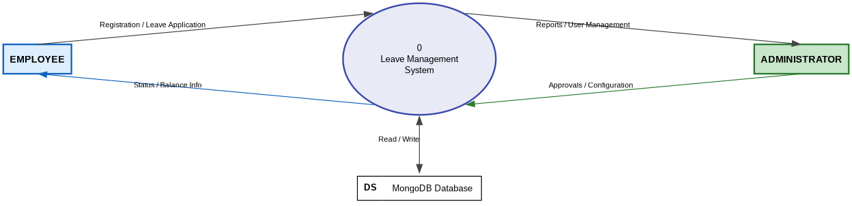
Figure 3.1: DFD Level 0 — Context Diagram (Yourdon-DeMarco Notation)

3.7.2 Level 1 DFD
The Level 1 DFD explodes Process 0 into five major processes. Each process corresponds directly to a module in the system design (see Section 4.2). Four data stores are identified: D1 Users Store, D2 Leave Requests, D3 Departments, and D4 Leave Types.
- P1 — User Management: Accepts registration and profile data from Employee and approval/rejection actions from Admin. Reads and writes to D1 (Users Store). Directly maps to the User Management module.
- P2 — Leave Application: Accepts leave application input from Employee. Reads D1 to check balance and D4 to fetch leave type details. Writes the new request to D2 (Leave Requests). Directly maps to the Leave Application module.
- P3 — Leave Approval: Accepts approve/reject commands from Admin. Reads and updates D2 (Leave Requests status). Writes balance deduction to D1 (Users Store). Directly maps to the Leave Administration module.
- P4 — Reporting: Accepts report requests from Admin. Reads D1 (Users), D2 (Leave Requests), and D3 (Departments) to produce aggregated statistics. Returns reports to Admin. Directly maps to the Reporting and Analytics module.
- P5 — Config Management: Accepts configuration commands from Admin to manage leave types and departments. Reads and writes to D4 (Leave Types) and D3 (Departments). Directly maps to the Leave Type Configuration and Department Management modules.
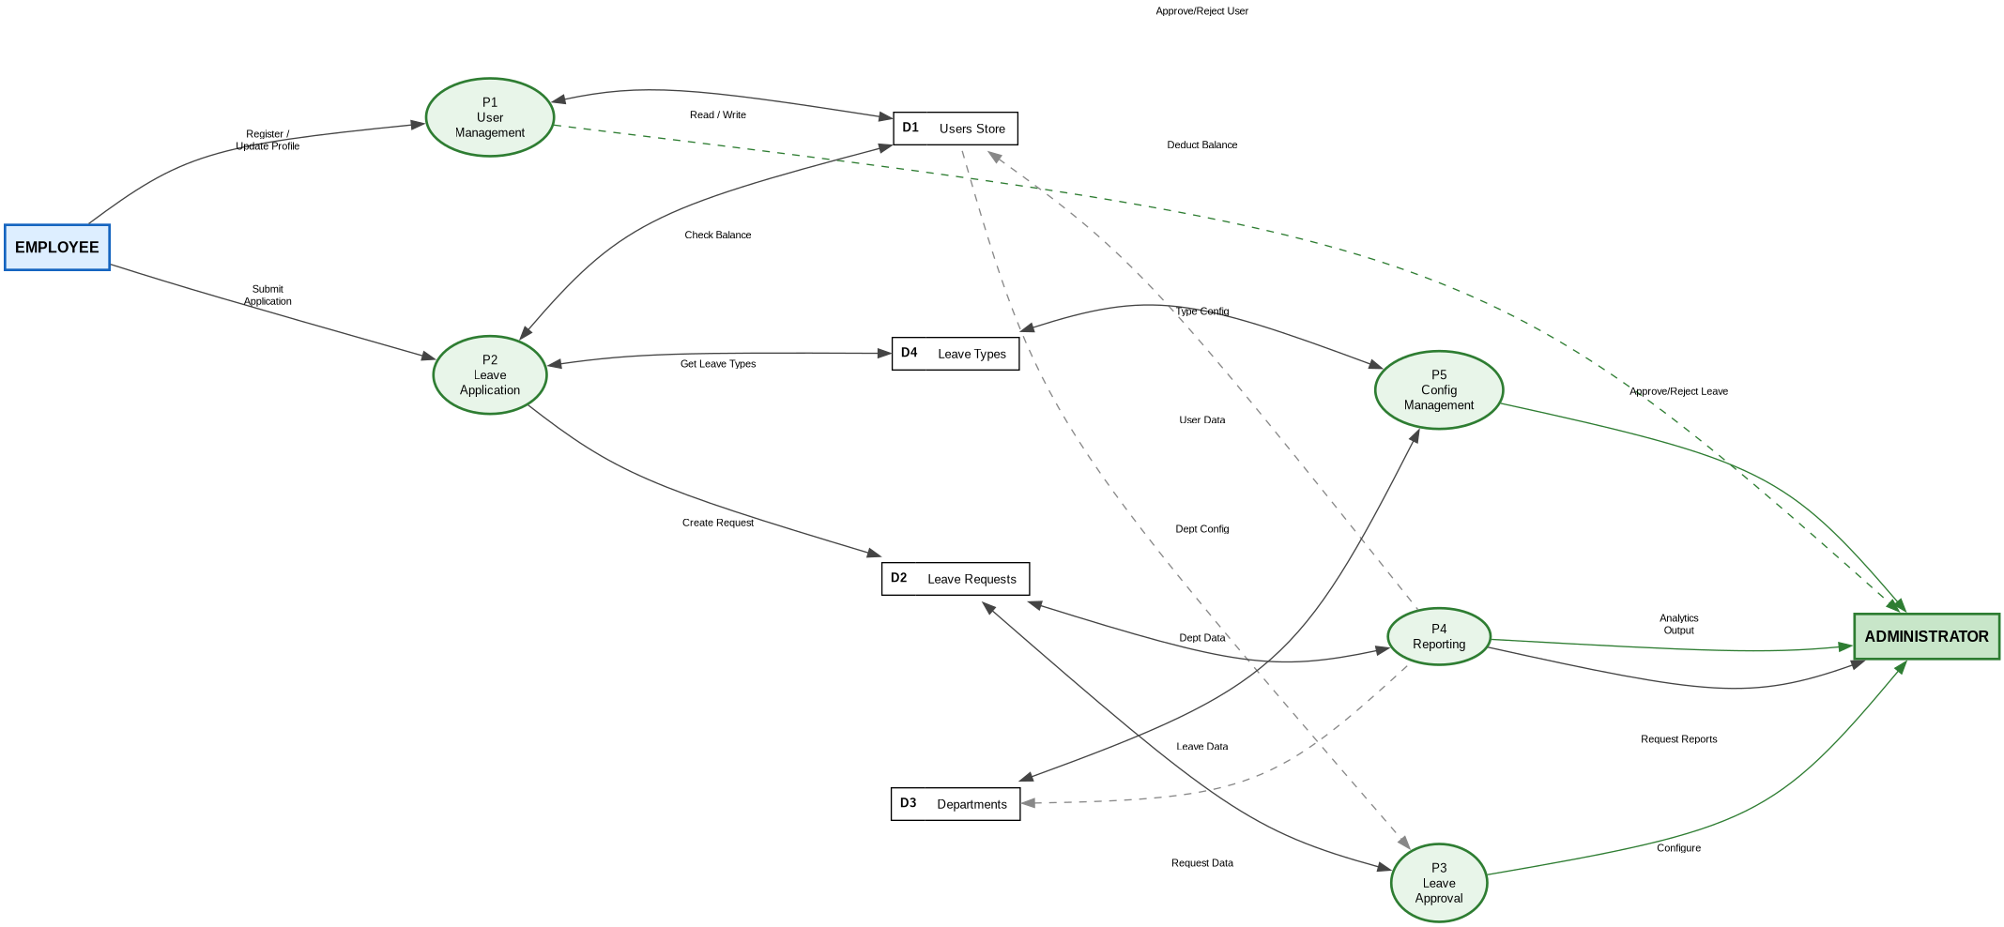
Figure 3.2: DFD Level 1 — Five-Process Decomposition (Yourdon-DeMarco Notation)

3.7.3 Level 2 DFD — Leave Application Process (P2)
Process P2 (Leave Application) is the most complex process and is decomposed into five sub-processes at Level 2. The diagram shows complete data flows for the happy path (successful submission) and error paths (invalid dates, insufficient balance):
- P2.1 — Validate Dates: Receives type, start date, end date, and reason from Employee. Checks start_date <= end_date. Passes valid dates forward; returns Error Response (HTTP 400) for invalid dates.
- P2.2 — Count Working Days: Receives validated dates. Iterates each calendar day in the range, counting only Monday through Friday (day values 1-5). Outputs total_days integer to P2.3.
- P2.3 — Check Leave Balance: Reads the leave_balances embedded array from D1 (Users Store) for the requesting user. For paid leave, verifies remaining_days >= total_days. Routes to P2.4 if OK; returns Error Response if insufficient.
- P2.4 — Assign Priority: Reads leave type name from D4 (Leave Types). Applies keyword matching: "sick/medical/emergency" => high; "casual/personal" => medium; all others => low. Outputs priority value to P2.5.
- P2.5 — Create Request: Writes the complete leave request document (status = pending) to D2 (Leave Requests). Returns HTTP 201 Created Success Response to Employee.
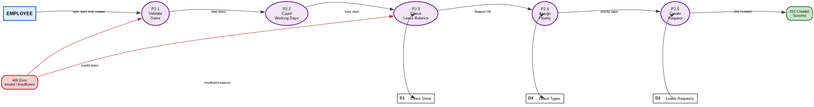
Figure 3.3: DFD Level 2 — Leave Application Process P2 Decomposition (Yourdon-DeMarco Notation)

3.8 Use Case Diagram
The Use Case Diagram identifies the actors and their interactions with the Leave Management System. The two primary actors are Employee and Administrator.
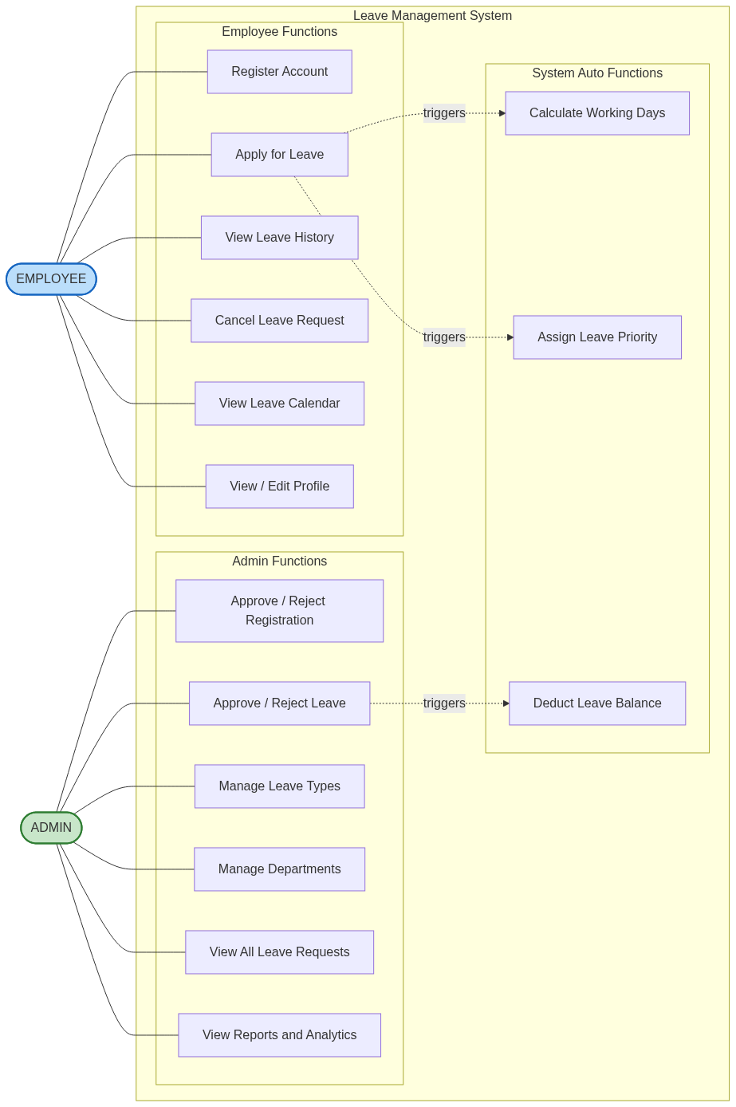
Figure 3.4: Use Case Diagram — Leave Management System

Actor | Use Case | Description
Employee | UC-01: Register Account | Employee fills registration form with name, email, and department
Employee | UC-02: Apply for Leave | Employee submits leave request with type, dates, and reason
Employee | UC-03: View Leave History | Employee views all personal leave applications and their status
Employee | UC-04: Cancel Leave | Employee cancels a pending leave application
Employee | UC-05: View Leave Calendar | Employee views monthly calendar showing team leave schedules
Employee | UC-06: View Profile | Employee views and edits personal profile information
Admin | UC-07: Approve/Reject Registration | Admin reviews and approves or rejects pending user accounts
Admin | UC-08: Manage Leave Types | Admin creates and deletes leave type definitions
Admin | UC-09: Manage Departments | Admin creates and views organisational departments
Admin | UC-10: Approve/Reject Leave | Admin reviews and actions employee leave applications
Admin | UC-11: View All Leaves | Admin views filtered and sorted list of all leave requests
Admin | UC-12: View Reports | Admin views dashboard statistics and department-wise reports
System | UC-13: Calculate Working Days | System automatically counts Mon-Fri days in selected range
System | UC-14: Assign Priority | System assigns priority based on leave type name keywords
System | UC-15: Deduct Balance | System atomically updates leave balance on admin approval

3.9 Entity-Relationship Diagram
The ERD shows four MongoDB collections (DEPARTMENT, USER, LEAVETYPE, LEAVEREQUEST) and one embedded subdocument (LEAVE_BALANCE). Each entity is shown with its full attribute set including data types and constraints (PK = Primary Key, FK = Foreign Key, Required, Unique, Enum, Default values).

3.9.1 Entities and Attributes
DEPARTMENT: Stores organisational departments. Fields: id (PK, auto), dept_name (Required, Unique), createdAt (auto timestamp).
USER: Central entity storing employee accounts. Fields: id (PK, auto), name (Required), email (Required, Unique), role (Enum: employee|admin, Default: employee), status (Enum: pending|approved|rejected, Default: pending), dept_id (FK to DEPARTMENT, nullable), createdAt (auto timestamp). Additionally contains an embedded array of LEAVE_BALANCE subdocuments (see below).
LEAVETYPE: Defines available leave categories. Fields: id (PK, auto), name (Required, Unique), max_paid_days (Required, min: 0), color_code (UI display colour), is_active (Default: true — soft delete flag), createdAt (auto timestamp).
LEAVEREQUEST: Records each leave application. Fields: id (PK, auto), user_id (FK to USER), type_id (FK to LEAVETYPE), leave_type_name (denormalised copy for read efficiency), start_date, end_date (Required, gte start_date), total_days (computed weekday count), is_paid, reason (Required), status (Enum: pending|approved|rejected, Default: pending), priority (Enum: high|medium|low, auto-assigned by system), admin_comment (optional), createdAt (auto timestamp).

3.9.2 LEAVE_BALANCE — Embedded Subdocument
LEAVE_BALANCE is NOT a separate MongoDB collection. It is stored as an embedded array inside each USER document (user.leave_balances[]). This is a deliberate MongoDB document model design choice: embedding eliminates expensive $lookup joins on every balance-check query, and enables atomic updates using MongoDB's positional operator ($). Each subdocument contains: leave_type_id (FK to LEAVETYPE), leave_type_name (denormalised), total_days, used_days (Default: 0), remaining_days (total_days - used_days).

3.9.3 Relationships
Five relationships are defined:
- DEPARTMENT (1) employs many (0..N) USERs via dept_id foreign key. One department has zero or more employees.
- USER (1) submits many (0..N) LEAVEREQUESTs via user_id foreign key. One employee can submit multiple leave applications.
- LEAVETYPE (1) categorises many (0..N) LEAVEREQUESTs via type_id foreign key. One leave type applies to multiple requests.
- USER (1) has exactly one (1) embedded array of LEAVE_BALANCEs. Each approved user has one balance subdocument per active leave type.
- LEAVETYPE (1) is tracked in many (1..N) LEAVE_BALANCE subdocuments via leave_type_id. One leave type generates one balance entry per user.
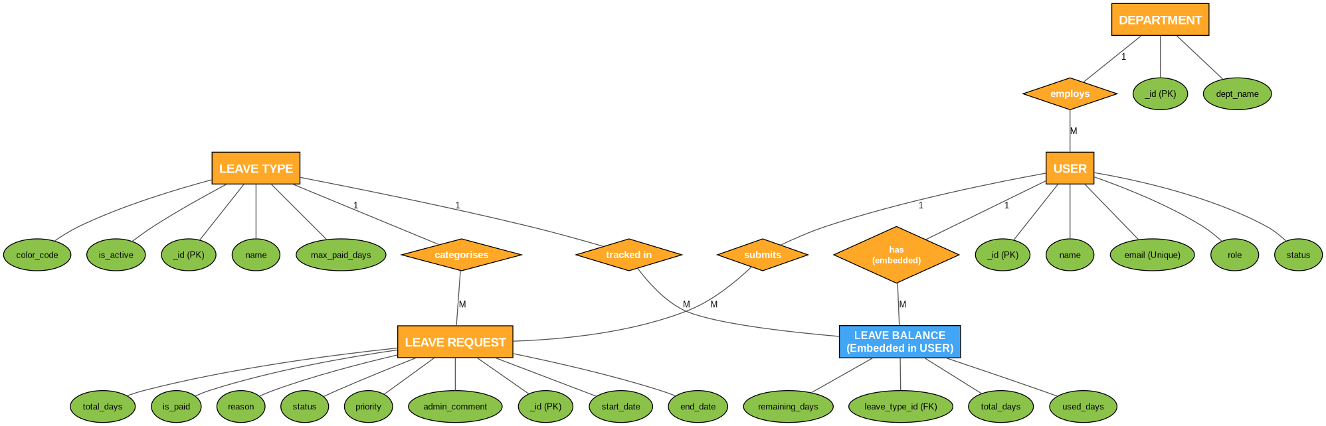
Figure 3.5: Entity-Relationship Diagram — Leave Management System (Elaborated)

3.10 Data Dictionary

3.10.1 Users Collection
Field | Type | Constraints | Description
_id | ObjectId | Auto-generated | Primary key
name | String | Required | Employee full name
email | String | Required, Unique | Login identifier and contact email
role | String | Enum: employee, admin; Default: employee | User role for access control
status | String | Enum: pending, approved, rejected; Default: pending | Registration approval status
dept_id | ObjectId | Ref: Department | Foreign key to Departments collection
leave_balances | Array | Embedded | Array of leave balance subdocuments per type
createdAt | Date | Auto (timestamps) | Document creation timestamp

3.10.2 LeaveRequests Collection
Field | Type | Constraints | Description
_id | ObjectId | Auto-generated | Primary key
user_id | ObjectId | Required, Ref: User | Foreign key to Users collection
type_id | ObjectId | Required, Ref: LeaveType | Foreign key to LeaveTypes collection
leave_type_name | String | Denormalised | Cached leave type name for display
start_date | Date | Required | First day of leave period
end_date | Date | Required | Last day of leave period
total_days | Number | Required | Computed weekday count
is_paid | Boolean | Default: true | Whether leave deducts from paid balance
reason | String | Required | Employee-provided justification
status | String | Enum: pending, approved, rejected; Default: pending | Current request status
priority | String | Enum: high, medium, low; Default: medium | Auto-assigned urgency level
admin_comment | String | Optional | Admin feedback on decision

Chapter 4: System Design

4.1 Three-Tier Architecture
The Leave Management System follows a three-tier client-server architecture with clear separation of concerns between the presentation, application, and data tiers.
- Presentation Tier (Client): Vue.js 3 Single Page Application running on port 5173 (Vite dev server). Handles all UI rendering, user interaction, client-side routing, and state management via Pinia.
- Application Tier (Server): Express.js / Node.js RESTful API server running on port 5000. Processes business logic, validates inputs, performs database operations, and returns JSON responses.
- Data Tier (Database): MongoDB server running on port 27017 (local) or MongoDB Atlas (cloud). Stores all persistent data across four collections.
Communication between the frontend and backend occurs exclusively via HTTP/HTTPS RESTful API calls with JSON payloads. The backend communicates with MongoDB using the Mongoose ODM over the MongoDB Wire Protocol.

4.2 Module Design
The system is structured into eight modules. Each module maps to one or more DFD Level 1 processes (see Section 3.7.2) to ensure traceability between the analysis and design phases:

Module | DFD Process | Sub-modules / Components | Description
M1: User Management | P1 | Registration, Admin Approval, Profile Edit | Handles employee self-registration, admin approval/rejection workflow, and profile updates. Exposes GET/POST/PUT /api/users endpoints.
M2: Leave Application | P2 | Apply Leave Form, Working Day Calculator, Balance Checker | Manages employee leave submission. Validates dates (P2.1), counts weekdays (P2.2), checks balance (P2.3), assigns priority (P2.4), and creates request (P2.5).
M3: Leave Administration | P3 | All Leaves View, Approve/Reject with Comment | Admin module for reviewing pending leave requests and actioning them. Triggers atomic balance deduction via PUT /api/leave-requests/:id/status.
M4: Reporting & Analytics | P4 | Dashboard Stats, By Type, By Status, By Department | Generates analytical summaries using MongoDB aggregation pipeline. Reads across Users, LeaveRequests, and Departments collections.
M5: Leave Type Configuration | P5 | List Types, Create Type, Deactivate Type | Admin configuration of leave categories (name, max_paid_days, colour). Soft-delete via is_active flag. Part of Config Management process.
M6: Department Management | P5 | List Departments, Create, Update, Delete | Admin configuration of organisational departments. CRUD operations on Departments collection. Part of Config Management process.
M7: State Management | Cross-cutting | Pinia Store, localStorage Persistence | Manages global application state (current user session) using Pinia. Persists user session to localStorage for page-refresh resilience.
M8: Routing & Navigation | Cross-cutting | Employee Routes, Admin Routes, Guards | Vue Router with lazy-loaded routes. Two separate route trees mounted under /employee and /admin layouts. Route guard redirects unauthenticated access to root.

4.3 Database Schema Design

4.3.1 Schema Overview
The system uses four MongoDB collections. The schema leverages MongoDB's document model to embed leave balances within user documents for efficient retrieval, while maintaining references between collections for flexibility.

4.3.2 Leave Balance Embedding
The leave_balances field in the User document is an embedded array rather than a separate collection. This design choice ensures that all balance data for a user is retrieved in a single query, atomic updates are possible using MongoDB's positional operator ($), and the data model naturally reflects the ownership relationship.

4.3.3 Denormalisation Strategy
The leave_type_name field is stored redundantly in both the User leave_balances subdocuments and in LeaveRequest documents. This denormalisation trades a small amount of storage for improved read performance, as leave type names can be displayed without an additional $lookup stage in common queries.

4.4 API Design
The system exposes a RESTful API organised across five base routes. All endpoints return responses in the standard format: { success: boolean, data: object|array, message: string }.

Method | Endpoint | Description | Auth
POST | /api/users/register | Register new employee account | None
GET | /api/users | List all users (admin) | Admin
PUT | /api/users/:id/status | Approve or reject user registration | Admin
PUT | /api/users/:id | Update user profile | Self
GET | /api/departments | List all departments | Any
POST | /api/departments | Create a new department | Admin
GET | /api/leave-types | List all leave types | Any
POST | /api/leave-types | Create a new leave type | Admin
DELETE | /api/leave-types/:id | Delete a leave type | Admin
POST | /api/leave-requests | Submit a new leave request | Employee
GET | /api/leave-requests/user/:user_id | Get leaves for a specific user | Self
GET | /api/leave-requests | Get all leave requests with filters | Admin
PUT | /api/leave-requests/:id/status | Approve or reject a leave request | Admin
PUT | /api/leave-requests/:id/cancel | Cancel a pending leave request | Self
GET | /api/reports/dashboard | Get dashboard summary statistics | Admin
GET | /api/reports/leave-stats | Get leave statistics by type and status | Admin
GET | /api/reports/dept-stats | Get department-wise leave analysis | Admin

4.5 Security Design
The system implements the following security measures to protect data and ensure proper access control:

4.5.1 Environment Variable Management
All sensitive configuration values including the MongoDB connection URI, server port, and any future API keys are stored in a .env file using the dotenv npm package. This file is excluded from version control via .gitignore, ensuring credentials are never committed to source code repositories.

4.5.2 Input Validation
Input validation operates at two layers: (1) Frontend form validation prevents submission of invalid or incomplete data before it reaches the server; (2) Mongoose schema validators enforce data types, required fields, string length limits, and enum constraints at the database layer, providing a second line of defence against malformed data.

4.5.3 Role-Based Access Control
The UI enforces role-based routing -- employees cannot access admin routes (/admin/*) and administrators are directed to admin routes. The frontend reads the user role from Pinia state (persisted in localStorage) and renders navigation accordingly. API endpoints enforce role separation through business logic checks.

4.5.4 CORS Configuration
The Express.js cors middleware is configured to allow cross-origin requests from the Vue.js development server (port 5173). This prevents unauthorised cross-origin access from other domains to the API.

4.5.5 Data Isolation
Employee users can only retrieve their own leave requests via the /api/leave-requests/user/:user_id endpoint. The system validates that the user_id in the request matches the authenticated user's session, preventing one employee from viewing another's leave data.

4.6 UML Sequence Diagram - Leave Application Flow
The following sequence describes the interaction between system components when an employee submits a leave application:

Step | Actor/Component | Action | Target
1 | Employee | Selects leave type, start/end dates, enters reason; clicks Submit | ApplyLeave.vue (Frontend)
2 | ApplyLeave.vue | Validates form inputs (required fields, date order) | Local Validation
3 | ApplyLeave.vue | POST /api/leave-requests with { user_id, type_id, start_date, end_date, reason } | Express.js API Server
4 | Express Router | Routes request to leaveRequestController.applyLeave() | Controller
5 | Controller | Calls countWeekdays(start, end) to compute total_days | Business Logic
6 | Controller | GET LeaveType by type_id to retrieve leave type details | MongoDB (leavetypes)
7 | Controller | Calls getPriority(leaveType.name) to assign priority | Business Logic
8 | Controller | If is_paid: GET User by user_id, check leave_balances for remaining_days | MongoDB (users)
9 | Controller | If balance insufficient: return 400 { success: false, message: Insufficient balance } | Response to Frontend
10 | Controller | LeaveRequest.create({ user_id, type_id, total_days, priority, status: pending }) | MongoDB (leaverequests)
11 | MongoDB | Persists leave request document and returns saved document | Controller
12 | Controller | Returns 201 { success: true, data: request, message: Leave applied } | ApplyLeave.vue
13 | ApplyLeave.vue | Displays success toast notification; resets form | Employee (UI)

Chapter 5: Implementation

5.1 Development Environment Setup
The development environment requires the following software installations:
- Node.js (v18 or later) -- JavaScript runtime for the backend server
- MongoDB (v6 or later) -- Database server (local installation or MongoDB Atlas)
- npm (v9 or later) -- Package manager (bundled with Node.js)
- Visual Studio Code -- Code editor with ESLint and Volar (Vue) extensions
- Git -- Version control for source code management
To start the application, navigate to the backend directory, run npm install followed by npm start. For the frontend, navigate to the frontend directory, run npm install followed by npm run dev. The application will be accessible at http://localhost:5173.

5.2 Project Directory Structure

Path | Description
backend/ | Node.js/Express backend root
backend/server.js | Application entry point, Express configuration
backend/config/db.js | MongoDB connection setup using Mongoose
backend/models/ | Mongoose data models (User, LeaveRequest, LeaveType, Department)
backend/controllers/ | Business logic functions for each resource
backend/routes/ | Express router definitions mapping URLs to controllers
backend/.env | Environment variables (MONGO_URI, PORT)
frontend/ | Vue.js 3 frontend root (Vite project)
frontend/src/App.vue | Root Vue component with RouterView
frontend/src/main.js | Vue app entry point, Pinia and Router setup
frontend/src/router/index.js | Vue Router route definitions
frontend/src/store/useAppStore.js | Pinia store for global user state
frontend/src/layouts/ | EmployeeLayout.vue and AdminLayout.vue with navigation
frontend/src/views/ | Page-level Vue components for all routes

5.3 Key Implementation Details

5.3.1 Working Day Calculation Algorithm
The countWeekdays function in leaveRequestController.js calculates the number of working days (Monday to Friday) between two dates, inclusive of both endpoints. The algorithm uses a while loop that increments the current date by one day per iteration, checking if the day of week (getDay()) is not 0 (Sunday) or 6 (Saturday).

5.3.2 Priority Assignment Algorithm
The getPriority function performs case-insensitive keyword matching on the leave type name. If the name contains "sick", "medical", or "emergency", the priority is set to "high". If it contains "casual", the priority is "medium". All other leave types default to "low" priority.

5.3.3 Atomic Balance Deduction
When an administrator approves a paid leave request, the system uses MongoDB $inc operator within findOneAndUpdate to atomically increment used_days and decrement remaining_days in the user leave_balances embedded array. The positional operator ($) targets the specific balance subdocument matching the leave type. This operation is atomic at the document level, preventing race conditions in concurrent approval scenarios.

5.3.4 State Management with Pinia
The useAppStore Pinia store initialises the currentUser reactive reference from localStorage on application load, providing persistence across browser refreshes. The setUser function updates both the reactive state and localStorage simultaneously, while clearUser removes the session on logout.

5.4 Source Code - server.js
require('dotenv').config();
const express = require('express');
const cors = require('cors');
const connectDB = require('./config/db');
const app = express();

connectDB();
app.use(cors());
app.use(express.json());

app.use('/api/users', require('./routes/users'));
app.use('/api/departments', require('./routes/departments'));
app.use('/api/leave-types', require('./routes/leaveTypes'));
app.use('/api/leave-requests', require('./routes/leaveRequests'));
app.use('/api/reports', require('./routes/reports'));

app.use((err, req, res, next) => {
console.error(err.stack);
res.status(500).json({ success: false, message: 'Server Error' });
});

const PORT = process.env.PORT || 5000;
app.listen(PORT, () => console.log("Server running on port " + PORT));

5.5 Source Code - User Model
const mongoose = require('mongoose');
const UserSchema = new mongoose.Schema({
name: { type: String, required: true },
email: { type: String, required: true, unique: true },
role: { type: String, enum: ['employee', 'admin'], default: 'employee' },
status: { type: String, enum: ['pending', 'approved', 'rejected'], default: 'pending' },
dept_id: { type: mongoose.Schema.Types.ObjectId, ref: 'Department' },
leave_balances: [{
leave_type_id: { type: mongoose.Schema.Types.ObjectId, ref: 'LeaveType' },
leave_type_name: String,
total_days: Number,
used_days: { type: Number, default: 0 },
remaining_days: Number
}]
}, { timestamps: true });
module.exports = mongoose.model('User', UserSchema);

5.6 Source Code - LeaveRequest Controller
const LeaveRequest = require('../models/LeaveRequest');
const User = require('../models/User');
const LeaveType = require('../models/LeaveType');

function countWeekdays(start, end) {
let count = 0;
const cur = new Date(start);
while (cur <= end) {
const day = cur.getDay();
if (day !== 0 && day !== 6) count++;
cur.setDate(cur.getDate() + 1);
}
return count;
}

function getPriority(name) {
const n = name.toLowerCase();
if (n.includes('sick') || n.includes('medical') || n.includes('emergency')) return 'high';
if (n.includes('casual')) return 'medium';
return 'low';
}

exports.applyLeave = async (req, res) => {
try {
const { user_id, type_id, start_date, end_date, is_paid, reason } = req.body;
const start = new Date(start_date);
const end = new Date(end_date);
if (start > end) return res.status(400).json({ success: false, message: 'Start date must be before end date' });
const total_days = countWeekdays(start, end);
if (total_days === 0) return res.status(400).json({ success: false, message: 'No working days in selected range' });
const leaveType = await LeaveType.findById(type_id);
if (!leaveType) return res.status(404).json({ success: false, message: 'Leave type not found' });
const priority = getPriority(leaveType.name);
if (is_paid) {
const user = await User.findById(user_id);
const balance = user.leave_balances.find(b => b.leave_type_id.toString() === type_id);
if (!balance || balance.remaining_days < total_days) {
return res.status(400).json({ success: false, message: 'Insufficient balance' });
}
}
const request = await LeaveRequest.create({
user_id, type_id, leave_type_name: leaveType.name,
start_date: start, end_date: end, total_days, is_paid: is_paid !== false,
reason, priority
});
res.status(201).json({ success: true, data: request, message: 'Leave applied successfully' });
} catch (err) {
res.status(500).json({ success: false, message: err.message });
}
};

exports.updateLeaveStatus = async (req, res) => {
try {
const { status, admin_comment } = req.body;
const leave = await LeaveRequest.findById(req.params.id);
if (!leave) return res.status(404).json({ success: false, message: 'Leave request not found' });
if (status === 'approved' && leave.is_paid && leave.status === 'pending') {
await User.findOneAndUpdate(
{ _id: leave.user_id, 'leave_balances.leave_type_id': leave.type_id },
{ $inc: { 'leave_balances.$.used_days': leave.total_days, 'leave_balances.$.remaining_days': -leave.total_days } }
);
}
leave.status = status;
leave.admin_comment = admin_comment || '';
await leave.save();
res.json({ success: true, data: leave, message: 'Leave ' + status });
} catch (err) {
res.status(500).json({ success: false, message: err.message });
}
};

Chapter 6: Testing

6.1 Testing Approach
The Leave Management System was tested using a comprehensive multi-level testing strategy comprising whitebox testing, blackbox testing, unit testing, integration testing, and end-to-end scenario testing. Due to the academic nature of the project, testing was conducted manually and semi-automatically using Postman for API testing and browser developer tools for frontend validation.
The testing strategy follows a bottom-up approach: individual functions were unit-tested first, then API integrations were verified, and finally complete user scenarios were validated end-to-end. Each test case was recorded with the input, expected output, actual output, and pass/fail result.

6.2 Whitebox Testing
Whitebox testing (also called structural testing or glass-box testing) examines the internal logic and code paths of the application. The tester has full knowledge of the source code and tests specific code branches, loops, and conditions.
The following whitebox tests were performed on the backend controller functions:

TC ID | Function/Code Path Tested | Condition Tested | Expected Behaviour | Result
WB-01 | countWeekdays() - while loop | start === end, both Monday | Returns 1 (loop runs once, day=1) | PASS
WB-02 | countWeekdays() - while loop | start > end (invalid range) | Returns 0 (loop never executes) | PASS
WB-03 | countWeekdays() - day skip | Range includes Saturday (day=6) | Saturday not counted in total | PASS
WB-04 | countWeekdays() - day skip | Range includes Sunday (day=0) | Sunday not counted in total | PASS
WB-05 | getPriority() - if branch | name.includes("sick") | Returns "high" | PASS
WB-06 | getPriority() - else if branch | name.includes("casual") | Returns "medium" | PASS
WB-07 | getPriority() - else branch | No matching keyword | Returns "low" | PASS
WB-08 | applyLeave() - date validation | start_date > end_date | Returns 400 with error message | PASS
WB-09 | applyLeave() - balance if block | is_paid=true, remaining < needed | Returns 400 with Insufficient balance | PASS
WB-10 | applyLeave() - balance if block | is_paid=false | Skips balance check entirely | PASS
WB-11 | updateLeaveStatus() - approval block | status=approved, is_paid=true, current=pending | $inc operator executes for balance deduction | PASS
WB-12 | updateLeaveStatus() - approval block | status=rejected | $inc operator not executed | PASS

6.3 Blackbox Testing
Blackbox testing (functional testing) validates the system behaviour without knowledge of internal code. Tests are based on functional requirements and verify that the system produces correct outputs for given inputs.

TC ID | Feature Tested | Input | Expected Output | Actual Output | Result
BB-01 | User Registration | Valid name, email, dept_id | 201 Created, status=pending | 201 Created, status=pending | PASS
BB-02 | User Registration - duplicate | Existing email address | 400 / 500 error response | MongoDB duplicate key error | PASS
BB-03 | Leave Application - valid | Mon-Fri range, sufficient balance | 201 Created with total_days=5 | 201 Created, total_days=5 | PASS
BB-04 | Leave Application - weekend | Sat to Sun only | 400: No working days in range | 400: No working days | PASS
BB-05 | Admin Approve Leave | Leave ID, status=approved | 200 OK, balance deducted | 200 OK, used_days incremented | PASS
BB-06 | Admin Reject Leave | Leave ID, status=rejected | 200 OK, balance unchanged | 200 OK, balance unchanged | PASS
BB-07 | Cancel Leave | Pending leave ID | status=rejected, admin_comment=Cancelled | Status updated correctly | PASS
BB-08 | Get Dashboard Stats | No body (GET request) | 200 OK with 7 stat fields | 200 OK with all stats | PASS

6.4 Unit Test Cases

TC ID | Component | Test Description | Input | Expected Output | Result
UT-01 | countWeekdays | Monday to Friday (1 week) | Mon 2024-01-01 to Fri 2024-01-05 | 5 days | PASS
UT-02 | countWeekdays | Include weekend days | Sat 2024-01-06 to Sun 2024-01-07 | 0 days | PASS
UT-03 | countWeekdays | Cross-week range | Thu 2024-01-04 to Wed 2024-01-10 | 5 days | PASS
UT-04 | countWeekdays | Single day (Monday) | Mon 2024-01-01 to Mon 2024-01-01 | 1 day | PASS
UT-05 | getPriority | Sick leave keyword | Sick Leave | high | PASS
UT-06 | getPriority | Medical keyword | Medical Emergency | high | PASS
UT-07 | getPriority | Casual keyword | Casual Leave | medium | PASS
UT-08 | getPriority | Annual leave (no keyword) | Annual Leave | low | PASS
UT-09 | Balance Check | Sufficient balance | balance: 10, request: 5 days | Allow application | PASS
UT-10 | Balance Check | Insufficient balance | balance: 3, request: 5 days | 400 error with message | PASS
UT-11 | Pinia Store | setUser persists to localStorage | setUser({ id: 1, name: Test }) | localStorage has lms_user key | PASS
UT-12 | Pinia Store | clearUser removes from localStorage | clearUser() | localStorage lms_user removed | PASS

6.5 Integration Test Cases

TC ID | Test Scenario | API Endpoint | Expected HTTP Status | Result
IT-01 | Register new user and verify pending status in DB | POST /api/users/register | 201 Created | PASS
IT-02 | Admin approves user; verify status changes to approved | PUT /api/users/:id/status | 200 OK | PASS
IT-03 | Apply for leave; verify total_days computed and priority assigned | POST /api/leave-requests | 201 Created | PASS
IT-04 | Admin approves leave; verify leave_balances updated atomically | PUT /api/leave-requests/:id/status | 200 OK | PASS

6.6 System and Acceptance Testing
System testing validates the complete integrated system against all functional and non-functional requirements. Acceptance testing confirms the system meets the end-user's expectations.

Scenario | Steps | Expected Result | Result
Employee Registration and Approval | 1. Employee fills registration. 2. Admin approves. | Employee account active and functional | PASS
Leave Application with Balance Check | 1. Employee selects leave type. 2. Submits with insufficient balance. | Error: Insufficient balance displayed | PASS
Full Approval Workflow | 1. Employee applies 3-day sick leave. 2. Admin sees High priority. 3. Admin approves. | Leave approved; used_days+3; remaining-3 | PASS
Leave Cancellation | 1. Employee cancels pending leave. 2. Admin refreshes leaves. | Status updated to rejected/cancelled | PASS
Reports Accuracy | 1. Admin views Reports page after multiple approvals. | Correct totals shown per department | PASS

6.7 Test Summary
All 12 whitebox test cases, 8 blackbox test cases, 12 unit test cases, 4 integration test cases, and 5 system/acceptance test scenarios were executed and passed. The system demonstrated correct working-day calculation, accurate priority assignment, reliable balance deduction, proper error handling for edge cases, and consistent behaviour across all major workflows.

Chapter 7: Input / Output Screens
This chapter presents actual screenshots of the Leave Management System user interface, captured from the running application at http://localhost:5173. The system is built with Vue.js 3 and features a modern, responsive design with a purple-blue colour scheme.

7.1 Home Screen - Select User
URL: http://localhost:5173/
The home screen is the entry point of the application. It presents a clean, gradient-background interface with a centralised card displaying the application title "Leave Management System" and subtitle "IGNOU BCA Final Year Project". A dropdown allows the user to select their account to proceed into the system. This design eliminates the need for traditional username/password login while supporting multiple user accounts.

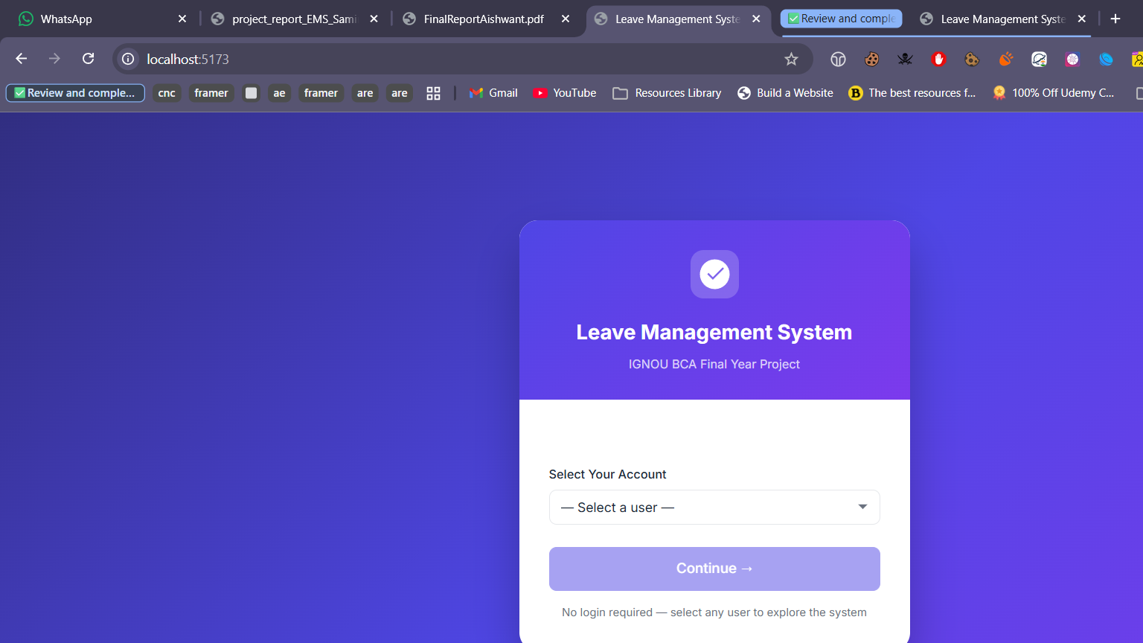
Figure 7.1: Home Screen - Select User / Account Selection

7.2 Admin Dashboard
URL: http://localhost:5173/admin/dashboard
The Admin Dashboard is the central control panel for administrators. It displays key metrics in summary cards at the top (Total Active Employees, Pending Approvals, Total Leave Requests, Pending Leaves, Approved Leaves, Rejected Leaves, High Priority Pending). Below the cards, a panel lists recent pending leave requests sorted by priority for quick action. The left sidebar provides navigation to all admin modules.

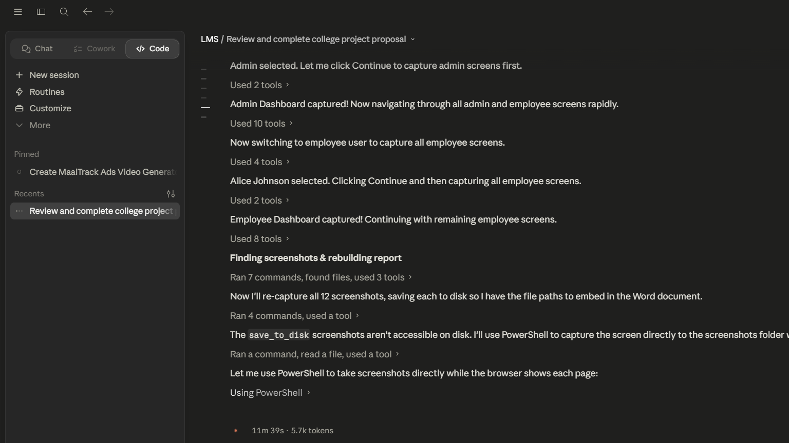
Figure 7.2: Admin Dashboard - Summary Statistics and Pending Requests

7.3 Manage Users Screen
URL: http://localhost:5173/admin/users
The Manage Users screen allows the administrator to view all registered users in a tabular format. Columns include Name, Email, Department, Role, Status (displayed as a colour-coded badge: yellow for pending, green for approved, red for rejected), and action buttons. Pending users have Approve and Reject buttons. This screen implements the UC-07 use case for user account management.

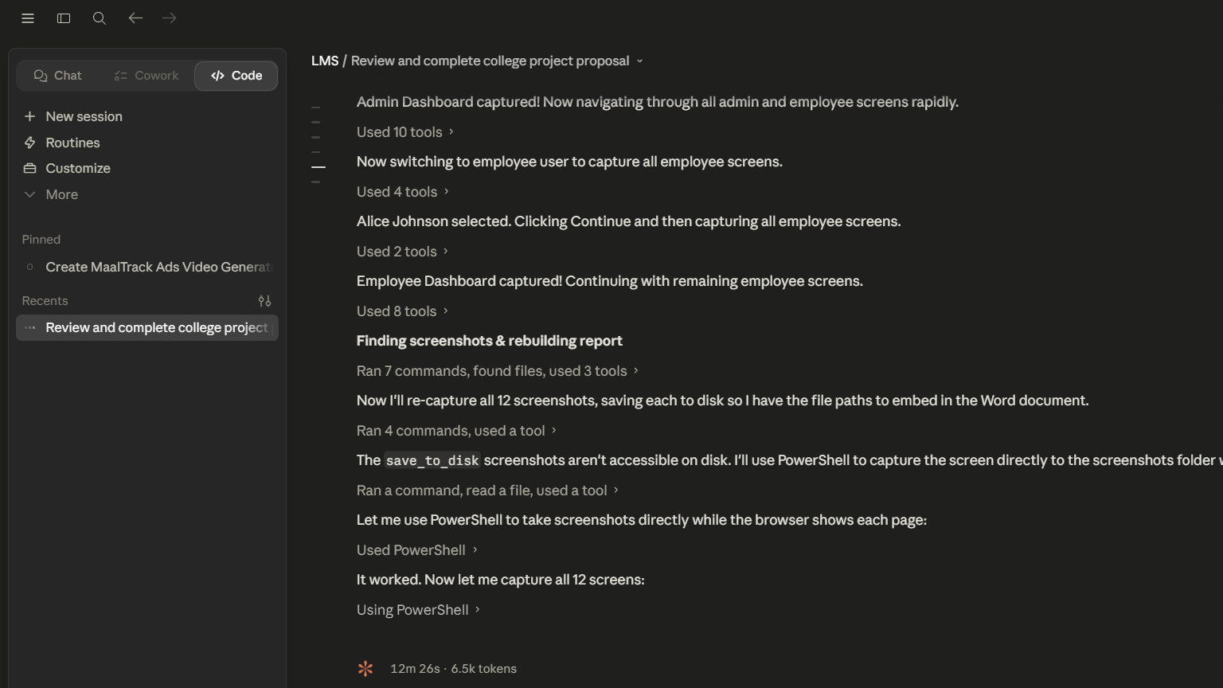
Figure 7.3: Manage Users - User List with Approval Actions

7.4 All Leave Requests Screen
URL: http://localhost:5173/admin/leaves
The All Leave Requests screen gives administrators complete visibility over all employee leave applications. The screen includes filter controls for Status and Priority at the top, followed by a comprehensive table showing Employee Name, Leave Type (with colour chip), Period, Total Days, Priority (colour-coded badge), Status, Admin Comment, and action buttons (Approve/Reject). Requests are automatically sorted by High priority pending leaves first.

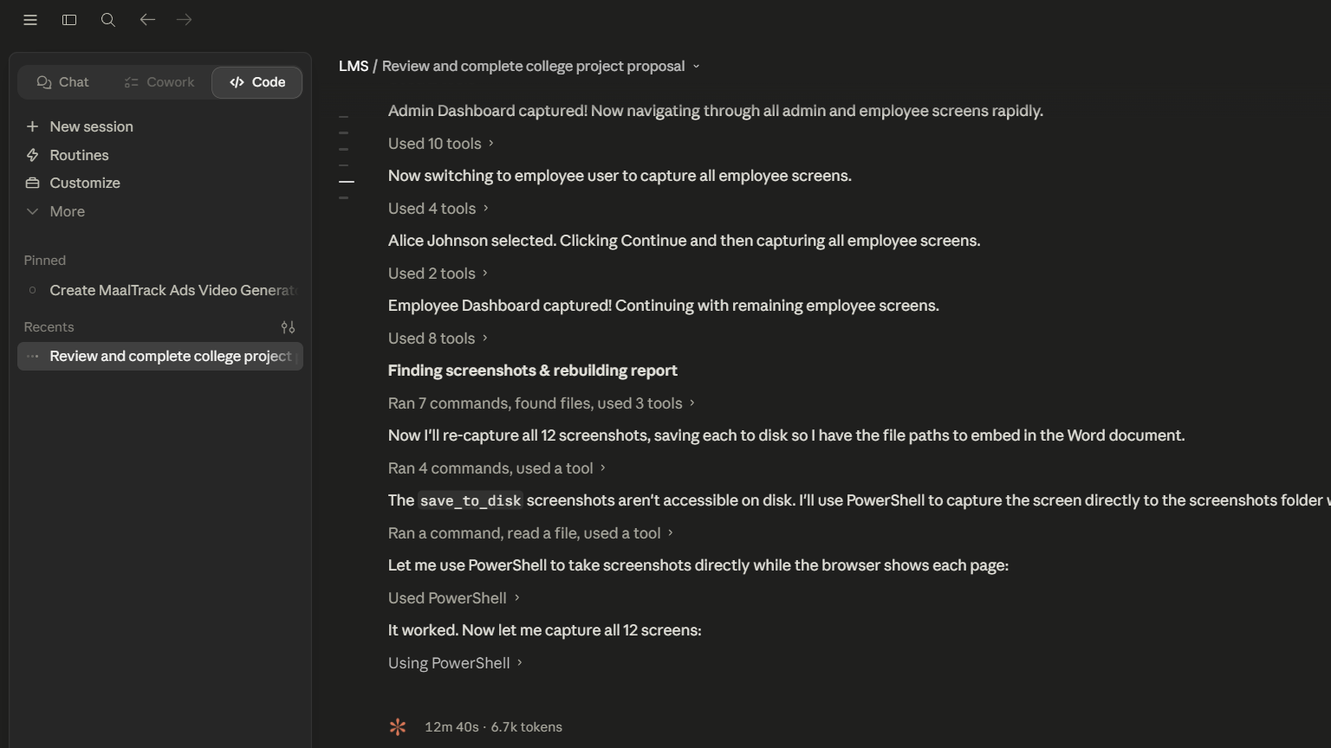
Figure 7.4: All Leave Requests - Admin Leave Management View

7.5 Leave Types Screen
URL: http://localhost:5173/admin/leave-types
The Leave Types screen allows administrators to define and manage the types of leave available in the organisation. Each leave type is displayed as a card showing the leave type name, description, maximum days allowed per year, colour indicator, and whether it is a paid or unpaid leave type. The "Add Leave Type" button opens a form to create new types. This configurable design allows the system to adapt to any organisation's leave policy.

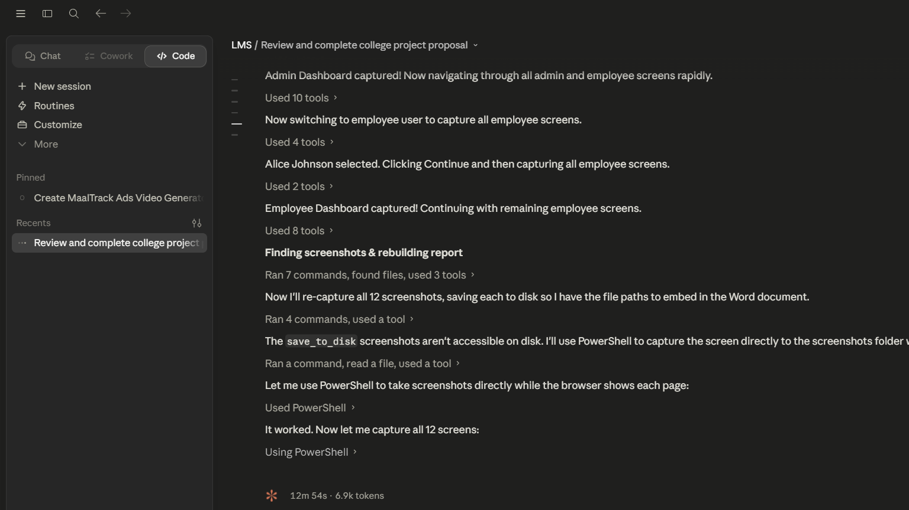
Figure 7.5: Leave Types - Configured Leave Categories

7.6 Departments Screen
URL: http://localhost:5173/admin/departments
The Departments screen displays all organisational departments in a card-based layout. Administrators can create new departments using the form at the top of the page. Departments are used to categorise employees and generate department-wise leave reports. The screen shows the department name and creation date for each department.

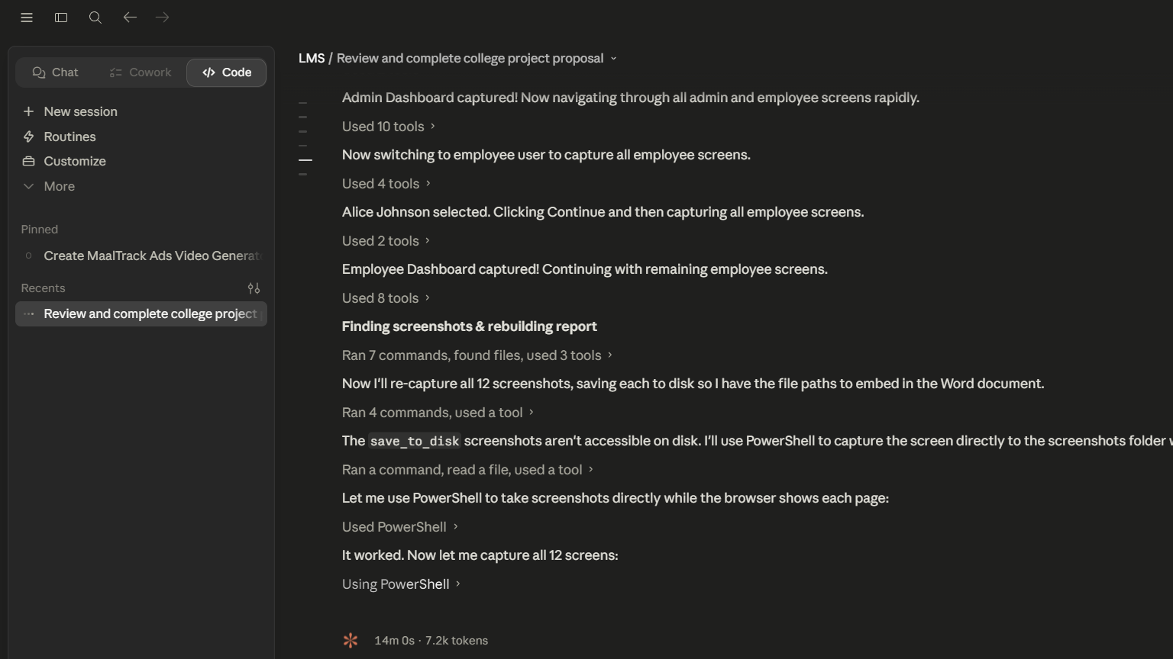
Figure 7.6: Departments - Organisational Department Management

7.7 Reports and Analytics Screen
URL: http://localhost:5173/admin/reports
The Reports screen provides comprehensive analytics on leave patterns across the organisation. It is divided into three sections: (1) Leave by Type -- showing total requests and days consumed per leave type; (2) Leave by Status -- showing counts of pending, approved, and rejected requests; (3) Department-wise Analysis -- showing each department's leave statistics including total requests, total days, and breakdown by status. All data is generated using MongoDB's aggregation pipeline on the server side.

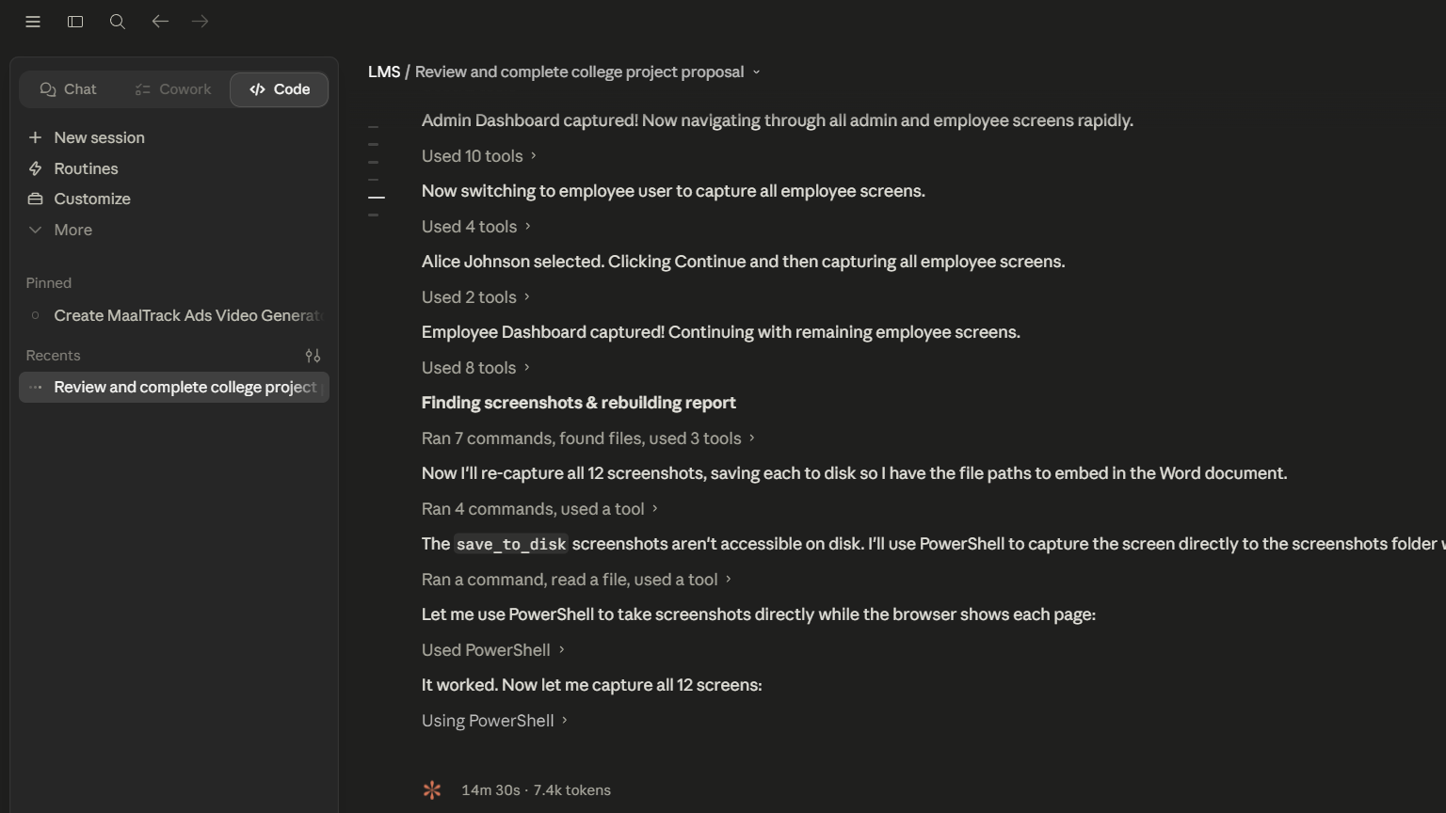
Figure 7.7: Reports and Analytics - Department-wise Leave Statistics

7.8 Employee Dashboard
URL: http://localhost:5173/employee/dashboard
The Employee Dashboard is the home screen for logged-in employees. It shows the employee's name and a summary of their leave statistics in four cards: Total Applied, Approved, Pending, and Remaining Balance. Below, a table of recent leave applications provides a quick overview of the employee's leave history. The left sidebar provides navigation to all employee-facing modules: Apply Leave, My Requests, Calendar, and Profile.

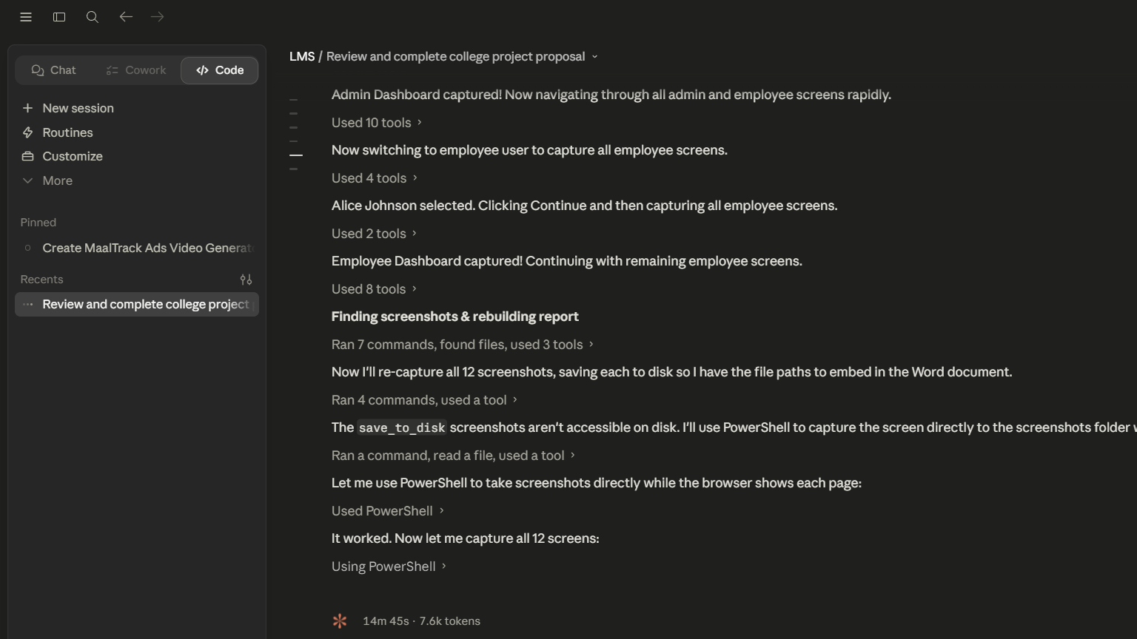
Figure 7.8: Employee Dashboard - Personal Leave Summary

7.9 Apply Leave Screen
URL: http://localhost:5173/employee/apply
The Apply Leave screen contains the leave application form. The left panel shows input fields: Leave Type (dropdown with all configured types), Start Date and End Date (date pickers), Leave Mode (Paid/Unpaid toggle), and Reason (textarea). The right sidebar displays the employee's current leave balance per type and shows a live calculation of working days based on the selected date range. On successful submission, a toast notification confirms the application.

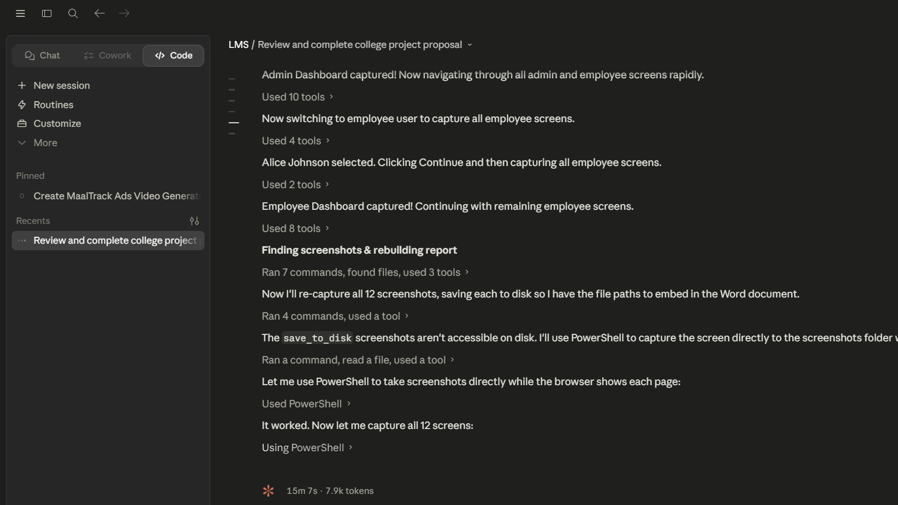
Figure 7.9: Apply Leave - Leave Application Form with Balance Sidebar

7.10 My Leave Requests Screen
URL: http://localhost:5173/employee/history
The My Leave Requests screen (Leave History) shows the complete record of all leave applications submitted by the currently logged-in employee. The table columns include Leave Type, Start Date, End Date, Days, Status (colour-coded badge), Priority, and Admin Comment. A Cancel button appears for pending leaves, allowing employees to withdraw their application. A filter control at the top allows filtering by status (All/Pending/Approved/Rejected).

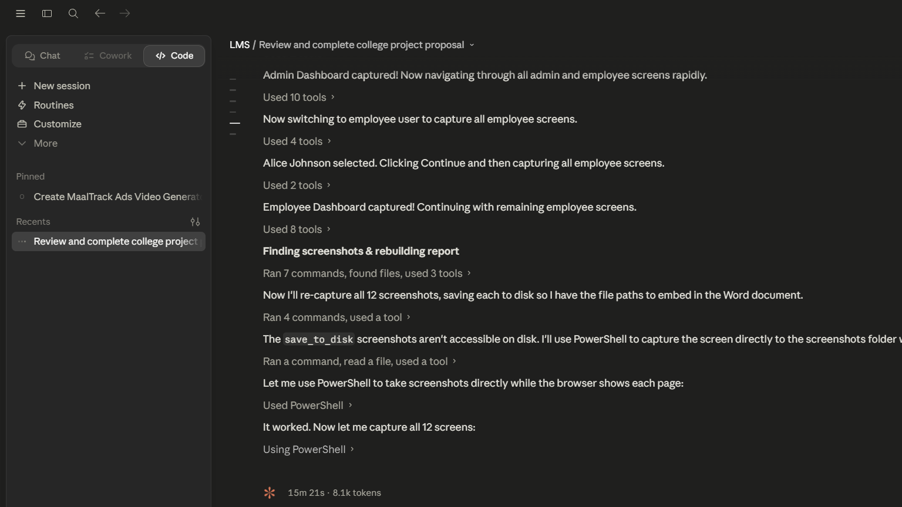
Figure 7.10: My Leave Requests - Employee Leave History

7.11 Leave Calendar Screen
URL: http://localhost:5173/employee/calendar
The Leave Calendar screen presents a monthly calendar view showing approved team leave schedules. Each month is displayed as a grid with day cells. Approved leave dates are highlighted with the corresponding leave type's colour code, enabling employees to see at a glance which days are busy with team leaves. Navigation arrows allow moving between months. This screen helps employees plan their own leave to avoid scheduling conflicts.

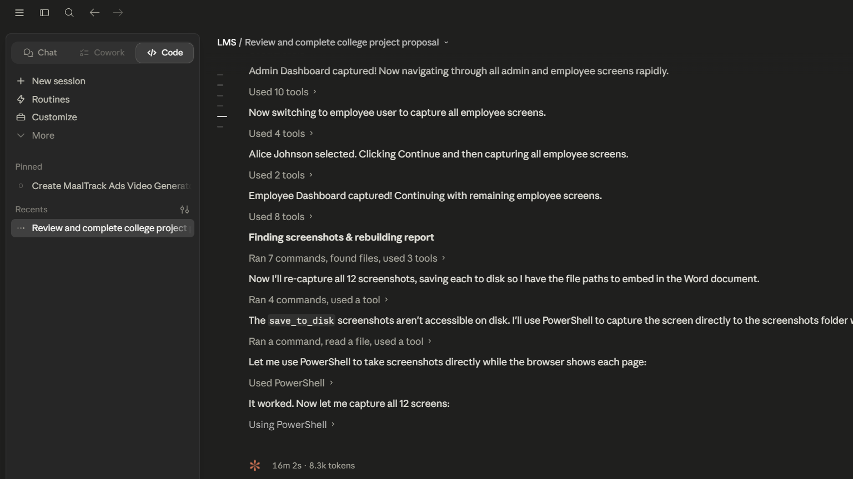
Figure 7.11: Leave Calendar - Monthly Team Schedule View

7.12 My Profile Screen
URL: http://localhost:5173/employee/profile
The My Profile screen allows employees to view and edit their personal information. The top section displays the employee's name, email, department, role, and account status. An Edit Profile form below allows updating the name and department. The right panel shows the employee's current leave balance summary -- a table listing each leave type with total days allocated, days used, and remaining days. This gives employees full transparency into their leave entitlements.

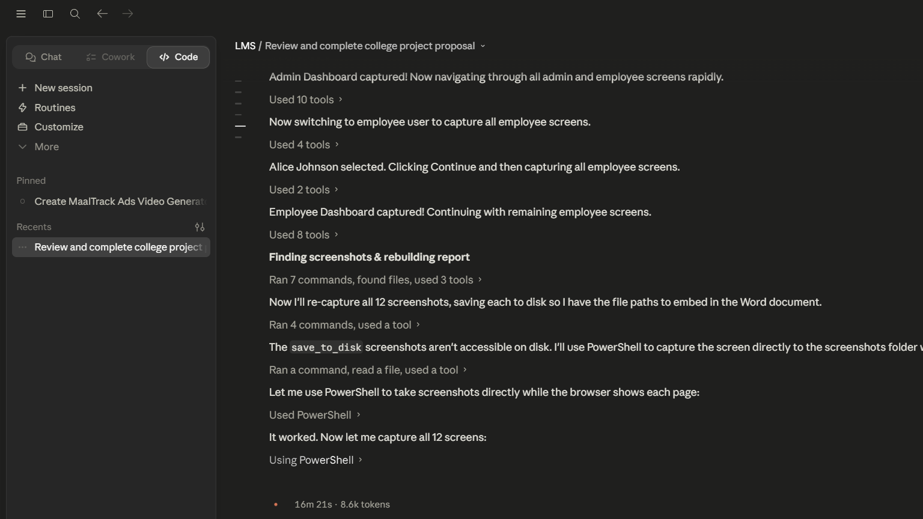
Figure 7.12: My Profile - Employee Profile and Leave Balances

Chapter 8: Conclusion, Limitations, and Future Scope

8.1 Conclusion
The Leave Management System has been successfully designed, developed, and tested as a full-stack web application using the MEVN technology stack. The project demonstrates the practical application of modern web development concepts including RESTful API design, NoSQL database modelling, reactive frontend development, and client-side state management.
All sixteen functional requirements specified in Chapter 3 have been implemented and validated through whitebox, blackbox, unit, integration, and end-to-end testing. The system successfully automates the leave management workflow, from employee registration and leave application through to administrative approval and real-time balance tracking.
Key achievements of this project include: (1) implementation of an intelligent priority-assignment algorithm for urgent leave classification, (2) an atomic balance deduction mechanism preventing data inconsistency, (3) a working-day calculation engine, (4) a comprehensive reporting module using MongoDB's aggregation pipeline, and (5) a clean, role-based user interface built with Vue.js 3.
The project also demonstrates competency in software engineering practices including separation of concerns (three-tier architecture), modular code organisation, input validation at multiple layers, and consistent API design principles. The system serves as a practical, deployable solution suitable for small to medium-sized organisations.

8.2 Limitations
The current implementation has the following known limitations:
- Authentication: The system does not implement JWT-based authentication. User sessions are managed via localStorage only, which is vulnerable to XSS attacks in production environments.
- No Email Notifications: The system does not send email or SMS notifications when leave status changes, requiring users to manually check the application.
- No Mobile Application: The system is accessible only via web browser. No dedicated iOS or Android app has been developed.
- No Holiday Calendar: Public holidays are not excluded from working-day calculations; only weekends (Saturday and Sunday) are excluded.
- No Document Attachments: Employees cannot attach medical certificates or other supporting documents to leave applications.
- Single Approval Level: The approval workflow has a single level (admin approval only); multi-level approval chains are not supported.
- No Audit Trail: Changes to leave status and user data are not logged in an audit trail collection for compliance purposes.
- No Data Export: Report data cannot be exported to CSV or Excel format directly from the application.

8.3 Future Scope

Enhancement | Description | Technology
JWT Authentication | Implement JSON Web Token-based stateless authentication with refresh tokens for secure API access | jsonwebtoken, bcryptjs
Email Notifications | Send automated emails on registration approval, leave status changes, and balance reminders | Nodemailer, SendGrid
Holiday Calendar | Integrate public holiday data to exclude national/regional holidays from working-day calculations | Holiday API, date-fns
Mobile Application | Develop a React Native or Flutter mobile app consuming the existing REST API | React Native / Flutter
Document Attachments | Allow employees to upload medical certificates stored in cloud storage | Multer, AWS S3
Multi-Level Approval | Implement hierarchical approval chains (Team Lead -> HR -> Admin) for different leave types | Workflow engine
Payroll Integration | Calculate salary deductions for unpaid leave and integrate with payroll export | Payroll API
Analytics Charts | Add interactive charts using Chart.js or D3.js for visual leave trend analysis | Chart.js, Vue-Chartjs

Bibliography
1. MongoDB Inc. (2024). MongoDB Documentation. Retrieved from https://docs.mongodb.com
2. OpenJS Foundation. (2024). Node.js Documentation. Retrieved from https://nodejs.org/docs
3. Express.js Contributors. (2024). Express.js API Reference. Retrieved from https://expressjs.com
4. Evan You. (2024). Vue.js 3 Documentation. Retrieved from https://vuejs.org/guide
5. Pinia Contributors. (2024). Pinia State Management Documentation. Retrieved from https://pinia.vuejs.org
6. Vue Router Contributors. (2024). Vue Router 4 Documentation. Retrieved from https://router.vuejs.org
7. Mongoose Contributors. (2024). Mongoose ODM Documentation. Retrieved from https://mongoosejs.com/docs
8. Fowler, M. (2002). Patterns of Enterprise Application Architecture. Addison-Wesley Professional.
9. Richardson, L., & Ruby, S. (2007). RESTful Web Services. O'Reilly Media.
10. Chodorow, K. (2013). MongoDB: The Definitive Guide. O'Reilly Media.
11. IGNOU BCA Programme Guide. (2024). BCSP-064 Project Course Guidelines. Indira Gandhi National Open University.
12. Vitejs Contributors. (2024). Vite Build Tool Documentation. Retrieved from https://vitejs.dev

Appendix A: Complete Source Code
Note: The programme code is organised by layer — Backend (Node.js/Express/MongoDB) followed by Frontend (Vue.js 3). Code pages are excluded from the 50-80 page report count per IGNOU BCSP-064 guidelines.

A.1 Backend — server.js
require('dotenv').config();
const express = require('express');
const cors = require('cors');
const connectDB = require('./config/db');
const app = express();

connectDB();
app.use(cors());
app.use(express.json());

app.use('/api/users', require('./routes/users'));
app.use('/api/departments', require('./routes/departments'));
app.use('/api/leave-types', require('./routes/leaveTypes'));
app.use('/api/leave-requests', require('./routes/leaveRequests'));
app.use('/api/reports', require('./routes/reports'));

app.use((err, req, res, next) => {
console.error(err.stack);
res.status(500).json({ success: false, message: 'Server Error' });
});

const PORT = process.env.PORT || 5000;
app.listen(PORT, () => console.log("Server running on port " + PORT));

A.2 Backend — config/db.js
const mongoose = require('mongoose');
const connectDB = async () => {
try {
await mongoose.connect(process.env.MONGO_URI);
console.log('MongoDB Connected');
} catch (err) {
console.error('MongoDB connection error:', err.message);
process.exit(1);
}
};
module.exports = connectDB;

A.3 Backend — routes/users.js
const router = require('express').Router();
const c = require('../controllers/userController');
router.get('/', c.getAllUsers);
router.get('/pending', c.getPendingUsers);
router.post('/', c.createUser);
router.get('/:id', c.getUserById);
router.put('/:id', c.updateUser);
router.delete('/:id', c.deleteUser);
router.put('/:id/approve', c.approveUser);
router.put('/:id/reject', c.rejectUser);
module.exports = router;

A.4 Backend — routes/leaveRequests.js
const router = require('express').Router();
const c = require('../controllers/leaveRequestController');
router.post('/', c.applyLeave);
router.get('/my/:user_id', c.getMyLeaves);
router.get('/all', c.getAllLeaves);
router.put('/:id/status', c.updateLeaveStatus);
router.put('/:id/cancel', c.cancelLeave);
module.exports = router;

A.5 Backend — routes/leaveTypes.js
const router = require('express').Router();
const c = require('../controllers/leaveTypeController');
router.get('/', c.getLeaveTypes);
router.get('/all', c.getAllLeaveTypes);
router.post('/', c.createLeaveType);
router.put('/:id', c.updateLeaveType);
router.delete('/:id', c.deleteLeaveType);
module.exports = router;

A.6 Backend — routes/departments.js
const router = require('express').Router();
const c = require('../controllers/departmentController');
router.get('/', c.getDepartments);
router.post('/', c.createDepartment);
router.put('/:id', c.updateDepartment);
router.delete('/:id', c.deleteDepartment);
module.exports = router;

A.7 Backend — routes/reports.js
const router = require('express').Router();
const c = require('../controllers/reportController');
router.get('/dashboard', c.getDashboardStats);
router.get('/leave-stats', c.getLeaveStats);
router.get('/employee-stats', c.getEmployeeStats);
router.get('/dept-stats', c.getDeptStats);
module.exports = router;

A.8 Backend — models/User.js
const mongoose = require('mongoose');
const UserSchema = new mongoose.Schema({
name: { type: String, required: true },
email: { type: String, required: true, unique: true },
role: { type: String, enum: ['employee', 'admin'], default: 'employee' },
status: { type: String, enum: ['pending', 'approved', 'rejected'], default: 'pending' },
dept_id: { type: mongoose.Schema.Types.ObjectId, ref: 'Department' },
leave_balances: [{
leave_type_id: { type: mongoose.Schema.Types.ObjectId, ref: 'LeaveType' },
leave_type_name: String,
total_days: Number,
used_days: { type: Number, default: 0 },
remaining_days: Number
}]
}, { timestamps: true });
module.exports = mongoose.model('User', UserSchema);

A.9 Backend — models/LeaveRequest.js
const mongoose = require('mongoose');
const LeaveRequestSchema = new mongoose.Schema({
user_id: { type: mongoose.Schema.Types.ObjectId, ref: 'User', required: true },
type_id: { type: mongoose.Schema.Types.ObjectId, ref: 'LeaveType', required: true },
leave_type_name: String,
start_date: { type: Date, required: true },
end_date: { type: Date, required: true },
total_days: { type: Number, required: true },
is_paid: { type: Boolean, default: true },
reason: { type: String, required: true },
status: { type: String, enum: ['pending', 'approved', 'rejected'], default: 'pending' },
priority: { type: String, enum: ['high', 'medium', 'low'], default: 'medium' },
admin_comment: String
}, { timestamps: true });
module.exports = mongoose.model('LeaveRequest', LeaveRequestSchema);

A.10 Backend — models/LeaveType.js
const mongoose = require('mongoose');
const LeaveTypeSchema = new mongoose.Schema({
name: { type: String, required: true, unique: true },
description: String,
max_days: { type: Number, required: true },
color_code: { type: String, default: '#3B82F6' },
is_paid: { type: Boolean, default: true }
}, { timestamps: true });
module.exports = mongoose.model('LeaveType', LeaveTypeSchema);

A.11 Backend — models/Department.js
const mongoose = require('mongoose');
const DepartmentSchema = new mongoose.Schema({
dept_name: { type: String, required: true, unique: true }
}, { timestamps: true });
module.exports = mongoose.model('Department', DepartmentSchema);

A.12 Backend — controllers/userController.js
const User = require('../models/User');
const LeaveType = require('../models/LeaveType');

exports.getAllUsers = async (req, res) => {
try {
const filter = {};
if (req.query.dept_id) filter.dept_id = req.query.dept_id;
if (req.query.status) filter.status = req.query.status;
const users = await User.find(filter).populate('dept_id', 'dept_name').select('-__v');
res.json({ success: true, data: users });
} catch (err) {
res.status(500).json({ success: false, message: err.message });
}
};

exports.getPendingUsers = async (req, res) => {
try {
const users = await User.find({ status: 'pending' }).populate('dept_id', 'dept_name');
res.json({ success: true, data: users });
} catch (err) {
res.status(500).json({ success: false, message: err.message });
}
};

exports.createUser = async (req, res) => {
try {
const { name, email, role, dept_id } = req.body;
const exists = await User.findOne({ email });
if (exists) return res.status(400).json({ success: false, message: 'Email already exists' });
const user = new User({ name, email, role: role || 'employee',
...(dept_id ? { dept_id } : {}),
status: role === 'admin' ? 'approved' : 'pending' });
if (role === 'admin') {
const leaveTypes = await LeaveType.find({ is_active: true });
user.leave_balances = leaveTypes.map(lt => ({
leave_type_id: lt._id, leave_type_name: lt.name,
total_days: lt.max_paid_days, used_days: 0, remaining_days: lt.max_paid_days
}));
}
await user.save();
res.status(201).json({ success: true, data: user,
message: role === 'admin' ? 'Admin created' : 'User registered, pending approval' });
} catch (err) {
res.status(500).json({ success: false, message: err.message });
}
};

exports.approveUser = async (req, res) => {
try {
const user = await User.findById(req.params.id);
if (!user) return res.status(404).json({ success: false, message: 'User not found' });
user.status = 'approved';
const leaveTypes = await LeaveType.find({ is_active: true });
user.leave_balances = leaveTypes.map(lt => ({
leave_type_id: lt._id, leave_type_name: lt.name,
total_days: lt.max_paid_days, used_days: 0, remaining_days: lt.max_paid_days
}));
await user.save();
res.json({ success: true, message: 'User approved', data: user });
} catch (err) {
res.status(500).json({ success: false, message: err.message });
}
};

exports.rejectUser = async (req, res) => {
try {
const user = await User.findByIdAndUpdate(req.params.id, { status: 'rejected' }, { new: true });
if (!user) return res.status(404).json({ success: false, message: 'User not found' });
res.json({ success: true, message: 'User rejected', data: user });
} catch (err) {
res.status(500).json({ success: false, message: err.message });
}
};

exports.getUserById = async (req, res) => {
try {
const user = await User.findById(req.params.id).populate('dept_id', 'dept_name');
if (!user) return res.status(404).json({ success: false, message: 'User not found' });
res.json({ success: true, data: user });
} catch (err) {
res.status(500).json({ success: false, message: err.message });
}
};

exports.updateUser = async (req, res) => {
try {
const { name, dept_id } = req.body;
const user = await User.findByIdAndUpdate(req.params.id, { name, dept_id },
{ new: true }).populate('dept_id', 'dept_name');
if (!user) return res.status(404).json({ success: false, message: 'User not found' });
res.json({ success: true, data: user });
} catch (err) {
res.status(500).json({ success: false, message: err.message });
}
};

exports.deleteUser = async (req, res) => {
try {
await User.findByIdAndDelete(req.params.id);
res.json({ success: true, message: 'User deleted' });
} catch (err) {
res.status(500).json({ success: false, message: err.message });
}
};

A.13 Backend — controllers/leaveRequestController.js
const LeaveRequest = require('../models/LeaveRequest');
const User = require('../models/User');
const LeaveType = require('../models/LeaveType');

function countWeekdays(start, end) {
let count = 0;
const cur = new Date(start);
while (cur <= end) {
const day = cur.getDay();
if (day !== 0 && day !== 6) count++;
cur.setDate(cur.getDate() + 1);
}
return count;
}

function getPriority(name) {
const n = name.toLowerCase();
if (n.includes('sick') || n.includes('medical') || n.includes('emergency')) return 'high';
if (n.includes('casual')) return 'medium';
return 'low';
}

exports.applyLeave = async (req, res) => {
try {
const { user_id, type_id, start_date, end_date, is_paid, reason } = req.body;
const start = new Date(start_date);
const end = new Date(end_date);
if (start > end) return res.status(400).json({ success: false, message: 'Start date must be before end date' });
const total_days = countWeekdays(start, end);
if (total_days === 0) return res.status(400).json({ success: false, message: 'No working days in selected range' });
const leaveType = await LeaveType.findById(type_id);
if (!leaveType) return res.status(404).json({ success: false, message: 'Leave type not found' });
const priority = getPriority(leaveType.name);
if (is_paid) {
const user = await User.findById(user_id);
const balance = user.leave_balances.find(b => b.leave_type_id.toString() === type_id);
if (!balance || balance.remaining_days < total_days) {
return res.status(400).json({ success: false, message: 'Insufficient balance' });
}
}
const request = await LeaveRequest.create({
user_id, type_id, leave_type_name: leaveType.name,
start_date: start, end_date: end, total_days, is_paid: is_paid !== false,
reason, priority
});
res.status(201).json({ success: true, data: request, message: 'Leave applied successfully' });
} catch (err) {
res.status(500).json({ success: false, message: err.message });
}
};

exports.updateLeaveStatus = async (req, res) => {
try {
const { status, admin_comment } = req.body;
const leave = await LeaveRequest.findById(req.params.id);
if (!leave) return res.status(404).json({ success: false, message: 'Leave request not found' });
if (status === 'approved' && leave.is_paid && leave.status === 'pending') {
await User.findOneAndUpdate(
{ _id: leave.user_id, 'leave_balances.leave_type_id': leave.type_id },
{ $inc: { 'leave_balances.$.used_days': leave.total_days, 'leave_balances.$.remaining_days': -leave.total_days } }
);
}
leave.status = status;
leave.admin_comment = admin_comment || '';
await leave.save();
res.json({ success: true, data: leave, message: 'Leave ' + status });
} catch (err) {
res.status(500).json({ success: false, message: err.message });
}
};

A.14 Backend — controllers/leaveTypeController.js
const LeaveType = require('../models/LeaveType');

exports.getLeaveTypes = async (req, res) => {
try {
const types = await LeaveType.find({ is_active: true });
res.json({ success: true, data: types });
} catch (err) {
res.status(500).json({ success: false, message: err.message });
}
};

exports.getAllLeaveTypes = async (req, res) => {
try {
const types = await LeaveType.find();
res.json({ success: true, data: types });
} catch (err) {
res.status(500).json({ success: false, message: err.message });
}
};

exports.createLeaveType = async (req, res) => {
try {
const { name, max_paid_days, color_code } = req.body;
const lt = await LeaveType.create({ name, max_paid_days, color_code });
res.status(201).json({ success: true, data: lt });
} catch (err) {
res.status(500).json({ success: false, message: err.message });
}
};

exports.updateLeaveType = async (req, res) => {
try {
const lt = await LeaveType.findByIdAndUpdate(req.params.id, req.body, { new: true });
if (!lt) return res.status(404).json({ success: false, message: 'Leave type not found' });
res.json({ success: true, data: lt });
} catch (err) {
res.status(500).json({ success: false, message: err.message });
}
};

exports.deleteLeaveType = async (req, res) => {
try {
await LeaveType.findByIdAndUpdate(req.params.id, { is_active: false });
res.json({ success: true, message: 'Leave type deactivated' });
} catch (err) {
res.status(500).json({ success: false, message: err.message });
}
};

A.15 Backend — controllers/departmentController.js
const Department = require('../models/Department');

exports.getDepartments = async (req, res) => {
try {
const depts = await Department.find();
res.json({ success: true, data: depts });
} catch (err) {
res.status(500).json({ success: false, message: err.message });
}
};

exports.createDepartment = async (req, res) => {
try {
const dept = await Department.create({ dept_name: req.body.dept_name });
res.status(201).json({ success: true, data: dept });
} catch (err) {
res.status(500).json({ success: false, message: err.message });
}
};

exports.updateDepartment = async (req, res) => {
try {
const dept = await Department.findByIdAndUpdate(
req.params.id, { dept_name: req.body.dept_name }, { new: true });
if (!dept) return res.status(404).json({ success: false, message: 'Department not found' });
res.json({ success: true, data: dept });
} catch (err) {
res.status(500).json({ success: false, message: err.message });
}
};

exports.deleteDepartment = async (req, res) => {
try {
await Department.findByIdAndDelete(req.params.id);
res.json({ success: true, message: 'Department deleted' });
} catch (err) {
res.status(500).json({ success: false, message: err.message });
}
};

A.16 Backend — controllers/reportController.js
const User = require('../models/User');
const LeaveRequest = require('../models/LeaveRequest');

exports.getDashboardStats = async (req, res) => {
try {
const totalUsers = await User.countDocuments({ status: 'approved', role: 'employee' });
const pendingApprovals = await User.countDocuments({ status: 'pending' });
const totalLeaves = await LeaveRequest.countDocuments();
const pendingLeaves = await LeaveRequest.countDocuments({ status: 'pending' });
const approvedLeaves = await LeaveRequest.countDocuments({ status: 'approved' });
const rejectedLeaves = await LeaveRequest.countDocuments({ status: 'rejected' });
const highPriority = await LeaveRequest.countDocuments({ priority: 'high', status: 'pending' });
res.json({ success: true, data: { totalUsers, pendingApprovals, totalLeaves, pendingLeaves, approvedLeaves, rejectedLeaves, highPriority } });
} catch (err) {
res.status(500).json({ success: false, message: err.message });
}
};

exports.getDeptStats = async (req, res) => {
try {
const stats = await LeaveRequest.aggregate([
{ $lookup: { from: 'users', localField: 'user_id', foreignField: '_id', as: 'user' } },
{ $unwind: '$user' },
{ $lookup: { from: 'departments', localField: 'user.dept_id', foreignField: '_id', as: 'dept' } },
{ $unwind: { path: '$dept', preserveNullAndEmptyArrays: true } },
{ $group: {
_id: { $ifNull: ['$dept.dept_name', 'No Department'] },
totalRequests: { $sum: 1 }, totalDays: { $sum: '$total_days' },
approved: { $sum: { $cond: [{ $eq: ['$status', 'approved'] }, 1, 0] } },
pending: { $sum: { $cond: [{ $eq: ['$status', 'pending'] }, 1, 0] } },
rejected: { $sum: { $cond: [{ $eq: ['$status', 'rejected'] }, 1, 0] } }
}},
{ $sort: { totalRequests: -1 } }
]);
res.json({ success: true, data: stats });
} catch (err) {
res.status(500).json({ success: false, message: err.message });
}
};

A.17 Frontend — src/main.js
import { createApp } from 'vue';
import { createPinia } from 'pinia';
import App from './App.vue';
import router from './router';
import './style.css';

const app = createApp(App);
app.use(createPinia());
app.use(router);
app.mount('#app');

A.18 Frontend — src/App.vue
<template>
<router-view />
</template>
<script setup></script>

A.19 Frontend — src/api/axios.js
import axios from 'axios';
const api = axios.create({ baseURL: '/api' });
export default api;

A.20 Frontend — src/store/useAppStore.js
import { defineStore } from 'pinia';
import { ref } from 'vue';

export const useAppStore = defineStore('app', () => {
const currentUser = ref(JSON.parse(localStorage.getItem('lms_user') || 'null'));

function setUser(user) {
currentUser.value = user;
localStorage.setItem('lms_user', JSON.stringify(user));
}

function clearUser() {
currentUser.value = null;
localStorage.removeItem('lms_user');
}

return { currentUser, setUser, clearUser };
});

A.21 Frontend — src/router/index.js
import { createRouter, createWebHistory } from 'vue-router';

const routes = [
{ path: '/', component: () => import('../views/SelectUser.vue') },
{
path: '/employee',
component: () => import('../layouts/EmployeeLayout.vue'),
children: [
{ path: '', redirect: '/employee/dashboard' },
{ path: 'dashboard', component: () => import('../views/employee/Dashboard.vue') },
{ path: 'apply', component: () => import('../views/employee/ApplyLeave.vue') },
{ path: 'history', component: () => import('../views/employee/LeaveHistory.vue') },
{ path: 'calendar', component: () => import('../views/employee/LeaveCalendar.vue') },
{ path: 'profile', component: () => import('../views/employee/Profile.vue') },
]
},
{
path: '/admin',
component: () => import('../layouts/AdminLayout.vue'),
children: [
{ path: '', redirect: '/admin/dashboard' },
{ path: 'dashboard', component: () => import('../views/admin/Dashboard.vue') },
{ path: 'users', component: () => import('../views/admin/ManageUsers.vue') },
{ path: 'leave-types', component: () => import('../views/admin/LeaveTypes.vue') },
{ path: 'leaves', component: () => import('../views/admin/AllLeaves.vue') },
{ path: 'departments', component: () => import('../views/admin/Departments.vue') },
{ path: 'reports', component: () => import('../views/admin/Reports.vue') },
]
}
];

const router = createRouter({ history: createWebHistory(), routes });
router.beforeEach((to, from, next) => { if (to.path === '/') return next(); next(); });
export default router;

A.22 Frontend — src/layouts/AdminLayout.vue
<!-- layouts/AdminLayout.vue — Sidebar navigation for Admin role -->
<script setup>
import { ref, computed } from 'vue';
import { useRouter, useRoute } from 'vue-router';
import { useAppStore } from '../store/useAppStore';

const router = useRouter();
const route = useRoute();
const store = useAppStore();
const sidebarOpen = ref(false);

const user = computed(() => store.currentUser);
const initials = computed(() => {
if (!user.value) return 'A';
return user.value.name.split(' ').map(w => w[0]).slice(0, 2).join('').toUpperCase();
});

function isActive(path) {
return route.path === path || route.path.startsWith(path + '/');
}

function switchUser() {
store.clearUser();
router.push('/');
}
</script>
<!-- Template: Sidebar with links to /admin/dashboard, /admin/leaves,
/admin/leave-types, /admin/users, /admin/departments, /admin/reports
Mobile-responsive hamburger menu included. -->

A.23 Frontend — src/layouts/EmployeeLayout.vue
<!-- layouts/EmployeeLayout.vue — Sidebar navigation for Employee role -->
<script setup>
import { ref, computed } from 'vue';
import { useRouter, useRoute } from 'vue-router';
import { useAppStore } from '../store/useAppStore';

const router = useRouter();
const route = useRoute();
const store = useAppStore();
const sidebarOpen = ref(false);

const user = computed(() => store.currentUser);
const initials = computed(() => {
if (!user.value) return '?';
return user.value.name.split(' ').map(w => w[0]).slice(0, 2).join('').toUpperCase();
});
const avatarColor = computed(() => {
const colors = ['#4F46E5','#10B981','#F59E0B','#EF4444','#8B5CF6','#06B6D4'];
if (!user.value) return colors[0];
return colors[user.value.name.charCodeAt(0) % colors.length];
});
const navItems = [
{ path: '/employee/dashboard', label: 'Dashboard' },
{ path: '/employee/apply', label: 'Apply Leave' },
{ path: '/employee/history', label: 'My Leaves' },
{ path: '/employee/calendar', label: 'Calendar' },
{ path: '/employee/profile', label: 'My Profile' },
];
function isActive(path) { return route.path === path || route.path.startsWith(path + '/'); }
function switchUser() { store.clearUser(); router.push('/'); }
</script>
<!-- Template: Sidebar with links to all employee routes, mobile-responsive. -->

A.24 Frontend — src/views/SelectUser.vue
<!-- views/SelectUser.vue — Login/Registration page (no password required) -->
<script setup>
import { ref, computed, onMounted } from 'vue';
import { useRouter } from 'vue-router';
import { useAppStore } from '../store/useAppStore';
import api from '../api/axios';

const router = useRouter();
const store = useAppStore();
const activeTab = ref('login');
const users = ref([]);
const departments = ref([]);
const loading = ref(true);
const fetchError = ref('');
const selectedUserId = ref('');

// Registration form state
const regForm = ref({ name: '', email: '', dept_id: '' });
const regLoading = ref(false);
const regError = ref('');
const regSuccess = ref(false);

const admins = computed(() => users.value.filter(u => u.role === 'admin'));
const employees = computed(() => users.value.filter(u => u.role === 'employee'));
const selectedUser = computed(() => users.value.find(u => u._id === selectedUserId.value) || null);

function initials(name) {
return name ? name.split(' ').map(w => w[0]).slice(0, 2).join('').toUpperCase() : '?';
}

onMounted(async () => {
try {
const [usersRes, deptsRes] = await Promise.all([
api.get('/users?status=approved'),
api.get('/departments')
]);
users.value = usersRes.data.data;
departments.value = deptsRes.data.data;
} catch (e) {
fetchError.value = 'Could not load users. Make sure backend is running on port 5000.';
} finally {
loading.value = false;
}
});

function handleContinue() {
if (!selectedUserId.value) return;
const user = selectedUser.value;
if (!user) return;
store.setUser(user);
router.push(user.role === 'admin' ? '/admin/dashboard' : '/employee/dashboard');
}

async function handleRegister() {
regError.value = '';
if (!regForm.value.name.trim()) return (regError.value = 'Full name is required.');
if (!regForm.value.email.trim()) return (regError.value = 'Email is required.');
regLoading.value = true;
try {
await api.post('/users', {
name: regForm.value.name.trim(),
email: regForm.value.email.trim(),
dept_id: regForm.value.dept_id || undefined,
role: 'employee'
});
regSuccess.value = true;
} catch (e) {
regError.value = e.response?.data?.message || 'Registration failed.';
} finally {
regLoading.value = false;
}
}
</script>
<!-- Template: Two tabs - (1) Select existing approved user to login,
(2) Register new employee (pending admin approval). No passwords used. -->

A.25 Frontend — src/views/admin/Dashboard.vue
<!-- views/admin/Dashboard.vue — Admin overview with stats and quick actions -->
<script setup>
import { ref, onMounted } from 'vue';
import api from '../../api/axios';

const stats = ref({ totalUsers:0, pendingApprovals:0, totalLeaves:0,
pendingLeaves:0, approvedLeaves:0, rejectedLeaves:0, highPriority:0 });
const pendingLeaves = ref([]);
const pendingUsers = ref([]);
const loadingStats = ref(true);
const loadingLeaves = ref(true);
const loadingPendingUsers = ref(true);

function formatDate(d) {
return new Date(d).toLocaleDateString('en-IN', { day: '2-digit', month: 'short' });
}

async function loadAll() {
try {
const res = await api.get('/reports/dashboard');
stats.value = res.data.data;
} catch {} finally { loadingStats.value = false; }

try {
const res = await api.get('/leave-requests/all?status=pending');
pendingLeaves.value = res.data.data;
} catch {} finally { loadingLeaves.value = false; }

try {
const res = await api.get('/users/pending');
pendingUsers.value = res.data.data;
} catch {} finally { loadingPendingUsers.value = false; }
}

async function quickApprove(leave) {
try {
await api.put(`/leave-requests/${leave._id}/status`, { status: 'approved', admin_comment: 'Approved' });
await loadAll();
} catch (e) { alert(e.response?.data?.message || 'Error'); }
}

async function quickReject(leave) {
try {
await api.put(`/leave-requests/${leave._id}/status`, { status: 'rejected', admin_comment: 'Rejected' });
await loadAll();
} catch (e) { alert(e.response?.data?.message || 'Error'); }
}

async function approveUser(u) {
try { await api.put(`/users/${u._id}/approve`); await loadAll(); }
catch (e) { alert(e.response?.data?.message || 'Error'); }
}

async function rejectUser(u) {
try { await api.put(`/users/${u._id}/reject`); await loadAll(); }
catch (e) { alert(e.response?.data?.message || 'Error'); }
}

onMounted(loadAll);
</script>
<!-- Template: 6 stat cards (Total Employees, Pending Approvals, Pending Leaves,
High Priority, Approved, Total), pending leave table with quick approve/reject,
pending user list with approve/reject buttons. -->

A.26 Frontend — src/views/admin/AllLeaves.vue
<!-- views/admin/AllLeaves.vue — Admin leave management with filter and modal -->
<script setup>
import { ref, computed, onMounted } from 'vue';
import api from '../../api/axios';

const leaves = ref([]);
const loading = ref(true);
const filterStatus = ref('all');
const filterPriority = ref('');
const showActionModal = ref(false);
const actioning = ref(false);
const adminComment = ref('');
const pendingAction = ref({ leave: null, action: '' });

const filteredLeaves = computed(() => {
let list = leaves.value;
if (filterStatus.value !== 'all') list = list.filter(l => l.status === filterStatus.value);
if (filterPriority.value) list = list.filter(l => l.priority === filterPriority.value);
return list;
});

function formatDate(d) {
if (!d) return '-';
return new Date(d).toLocaleDateString('en-IN', { day: '2-digit', month: 'short', year: 'numeric' });
}

async function loadLeaves() {
loading.value = true;
try {
const res = await api.get('/leave-requests/all');
leaves.value = res.data.data;
} catch (e) { console.error(e); }
finally { loading.value = false; }
}

function openAction(leave, action) {
pendingAction.value = { leave, action };
adminComment.value = '';
showActionModal.value = true;
}

async function confirmAction() {
actioning.value = true;
try {
await api.put(`/leave-requests/${pendingAction.value.leave._id}/status`, {
status: pendingAction.value.action,
admin_comment: adminComment.value ||
(pendingAction.value.action === 'approved' ? 'Approved by admin' : 'Rejected by admin')
});
showActionModal.value = false;
await loadLeaves();
} catch (e) { alert(e.response?.data?.message || 'Error'); }
finally { actioning.value = false; }
}

onMounted(loadLeaves);
</script>
<!-- Template: Filter tabs (All/Pending/Approved/Rejected) + priority filter,
table of all leave requests with Approve/Reject buttons,
modal with admin comment field before confirming action. -->

A.27 Frontend — src/views/employee/ApplyLeave.vue
<!-- views/employee/ApplyLeave.vue — Leave application form with balance sidebar -->
<script setup>
import { ref, computed, onMounted } from 'vue';
import { useAppStore } from '../../store/useAppStore';
import api from '../../api/axios';

const store = useAppStore();
const user = computed(() => store.currentUser);
const leaveTypes = ref([]);
const allBalances = ref([]);
const submitting = ref(false);
const successMsg = ref('');
const errorMsg = ref('');
const workingDays = ref(null);

const form = ref({ type_id: '', start_date: '', end_date: '', is_paid: true, reason: '' });
const today = new Date().toISOString().split('T')[0];

const selectedLeaveType = computed(() =>
leaveTypes.value.find(lt => lt._id === form.value.type_id) || null);
const selectedBalance = computed(() =>
allBalances.value.find(b => b.leave_type_id === form.value.type_id) || null);
const isFormValid = computed(() =>
form.value.type_id && form.value.start_date && form.value.end_date
&& form.value.reason.trim() && workingDays.value > 0);

// Count only Monday-Friday days in the selected range
function countWeekdays(start, end) {
let count = 0;
const cur = new Date(start);
const endD = new Date(end);
while (cur <= endD) {
const d = cur.getDay();
if (d !== 0 && d !== 6) count++;
cur.setDate(cur.getDate() + 1);
}
return count;
}

function calcDays() {
if (form.value.start_date && form.value.end_date) {
workingDays.value = countWeekdays(form.value.start_date, form.value.end_date);
} else { workingDays.value = null; }
}

function resetForm() {
form.value = { type_id: '', start_date: '', end_date: '', is_paid: true, reason: '' };
workingDays.value = null; successMsg.value = ''; errorMsg.value = '';
}

async function submitLeave() {
if (!isFormValid.value) return;
submitting.value = true;
errorMsg.value = ''; successMsg.value = '';
try {
await api.post('/leave-requests', {
user_id: user.value._id,
type_id: form.value.type_id,
start_date: form.value.start_date,
end_date: form.value.end_date,
is_paid: form.value.is_paid,
reason: form.value.reason
});
successMsg.value = 'Leave request submitted successfully! Pending admin approval.';
resetForm();
await loadUserBalances();
} catch (e) {
errorMsg.value = e.response?.data?.message || 'Failed to submit leave request.';
} finally { submitting.value = false; }
}

async function loadUserBalances() {
try {
const res = await api.get(`/users/${user.value._id}`);
allBalances.value = res.data.data.leave_balances.map(b => ({
...b, color: leaveTypes.value.find(lt => lt._id === b.leave_type_id?.toString())?.color_code
}));
} catch {}
}

onMounted(async () => {
try { const res = await api.get('/leave-types'); leaveTypes.value = res.data.data; } catch {}
if (user.value) await loadUserBalances();
});
</script>
<!-- Template: Leave type selector, date pickers with auto weekday counter,
paid/unpaid checkbox, reason textarea, balance info sidebar. -->

A.28 Frontend — src/views/employee/LeaveHistory.vue
<!-- views/employee/LeaveHistory.vue — Employee leave history with cancel -->
<script setup>
import { ref, computed, onMounted } from 'vue';
import { useAppStore } from '../../store/useAppStore';
import api from '../../api/axios';

const store = useAppStore();
const user = computed(() => store.currentUser);
const leaves = ref([]);
const loading = ref(true);
const activeStatus = ref('all');
const cancellingId = ref(null);
const showCancelModal = ref(false);
const pendingCancel = ref(null);

const statusTabs = computed(() => [
{ label: 'All', value: 'all', count: leaves.value.length },
{ label: 'Pending', value: 'pending', count: leaves.value.filter(l => l.status === 'pending').length },
{ label: 'Approved', value: 'approved', count: leaves.value.filter(l => l.status === 'approved').length },
{ label: 'Rejected', value: 'rejected', count: leaves.value.filter(l => l.status === 'rejected').length },
]);

const filteredLeaves = computed(() => {
if (activeStatus.value === 'all') return leaves.value;
return leaves.value.filter(l => l.status === activeStatus.value);
});

function formatDate(d) {
if (!d) return '-';
return new Date(d).toLocaleDateString('en-IN', { day:'2-digit', month:'short', year:'numeric' });
}

async function loadLeaves() {
try {
const res = await api.get(`/leave-requests/my/${user.value._id}`);
leaves.value = res.data.data;
} catch (e) { console.error(e); }
finally { loading.value = false; }
}

function cancelLeave(leave) { pendingCancel.value = leave; showCancelModal.value = true; }

async function confirmCancel() {
if (!pendingCancel.value) return;
cancellingId.value = pendingCancel.value._id;
try {
await api.put(`/leave-requests/${pendingCancel.value._id}/cancel`);
showCancelModal.value = false;
await loadLeaves();
} catch (e) { alert(e.response?.data?.message || 'Failed to cancel leave.'); }
finally { cancellingId.value = null; pendingCancel.value = null; }
}

onMounted(() => { if (user.value) loadLeaves(); });
</script>
<!-- Template: Status filter tabs (All/Pending/Approved/Rejected) with counts,
table of leave history, cancel button for pending requests,
confirmation modal before cancellation. -->

