IDEA: International Data Encryption Algorithm
IDEA is a block Cipher designed by Xuejia Lai and James L.Massey in 1991.
- It is a minor revision of an earlier cipher, PES (ProposedEncryption Standard)
- IDEA was originally called IPES (Improved PES) and was developed to replace DES.
- It entirely avoids the use of lookup tables or S-Boxes.

IDEA: How It Works??

IDEA encrypts a 64-bit block of plaintext to 64-bit block of Cipher text.
- It uses 128 bit Key.
- The Algorithm consists of 8 identical rounds and a “Half ”round Final transformation.
- The 64-bit plaintext block is partitioned into Four 16-bit sub-blocks ( 4 x 16 bits )
- Each complete round requires Six 16 bit sub keys.
- Total of 52 (= 8 x 6 + 4) different 16-bit sub keys have to be generated from the 128-bit key.

Structure of IDEA
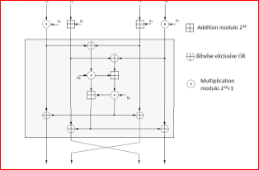

First Layer

Apply two 16 bits additions and two 16 bits multiplication to quarter blocks using appropriate parts of the round key.

Second Layer

- Calculate two intermediate quarter blocks with 16 bit additions and multiplication using parts of round keys.
- XOR intermediate quarter blocks with the blocks from layer 1.
- Exchange the inner quarter blocks.

Output Transformation
- Done after the 8th round.
- Exchange the inner quarter blocks.
- Apply 16 bits addition and multiplication using parts of the round key.
- Recombine the quarter blocks to the final result.
IDEA :Steps
- 10
1. Multiply X1 and the First sub key K1.
2. Add X2 and the Second sub key K2.
3. Add X3 and the third sub key K3.
4. Multiply X4 and the fourth sub key K4.
5. Bitwise XOR the results of steps 1 and 3.
6. Bitwise XOR the results of steps 2 and 4.
7. Multiply the result of step 5 and the Fifth sub key K5.
8. Add the results of steps 6 and 7.
9. Multiply the result of step 8 and the Sixth sub key K6.
10. Add the results of steps 7 and 9.
11. Bitwise XOR the results of steps 1 and 9.
12. Bitwise XOR the results of steps 3 and 9.
13. Bitwise XOR the results of steps 2 and 10.
14. Bitwise XOR the results of steps 4 and 10
After 8th round .
Step a: Exchange the inner quarter blocks.
Step b: Apply 16 bits addition and multiplication using parts of the round key.
Stop: Recombine the quarter blocks to the final result.

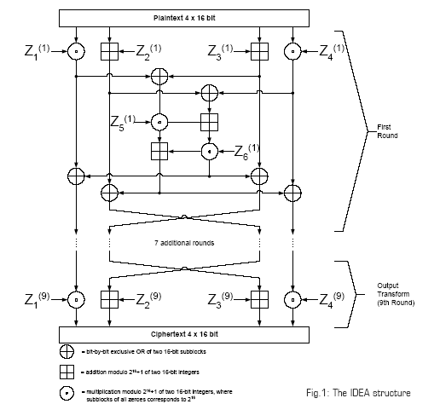

Example:
