QRShield
Real-Time Detection of Malicious QR Codes

Project report
Aakash Tiwari
M.S. Cybersecurity, Rowan University
November 2026

Contents
1. Summary
2. The problem
3. How QRShield works
4. The data
5. Finding and fixing the shortcuts
6. The model
7. Results
8. Live demo
9. Database and privacy
10. Tools used
11. Limitations
12. Future work
13. How to run it
References

1. Summary
QR codes are everywhere: on restaurant tables, parking meters, posters and payment screens. You cannot see where a QR code leads until you open it, and criminals use this to send people to fake login and payment pages. This attack is called quishing (QR + phishing).
QRShield checks the link inside a QR code before you open it. You point a laptop webcam or a phone camera at the code, and within a second QRShield shows one of three answers, with the main reasons:
Verdict | What it means
SAFE | The link is on your trusted list, or the model is confident it is a normal website.
CAUTION | The link is on a site where anyone can publish (a link shortener, Google Docs, a free website builder). QRShield cannot judge it, so it asks you to be careful.
PHISHING | The model or a safety rule found clear warning signs. Do not open the link.

The link is only analysed as text. QRShield never visits it.

Main findings in one minute
- The public dataset has a hidden trap. Every safe URL in it is a bare homepage like https://www.example.com. A quick model scored 99.8% accuracy, but it simply learned "a link with a path is phishing" and flagged 100% of normal links like /menu or /admissions.
- I removed the trap by looking only at the host name (the part before the first slash), handling shared platforms with rules, and testing only on websites the model had never seen.
- Honest result: on brand-new websites, QRShield catches about 63% of phishing links with a 5% false alarm rate. This is much lower than 99.8%, but it reflects what a real user would experience.
- The full system works live: the webcam scanner correctly flagged all four phishing test codes and passed the safe ones.

2. The problem
A normal phishing email shows its link if you hover over it. A QR code does not. People also trust QR codes in physical places: a sticker on a parking meter looks official. Attackers simply print a QR code that points to their fake website and stick it over the real one.
Once the fake page opens, it usually asks for a password, card number or crypto wallet phrase. By then it is often too late. The best moment to warn the user is between scanning and opening, and that is exactly where QRShield sits.

Goals
- Read QR codes live from a laptop webcam and from a phone.
- Decide whether the link looks dangerous, using machine learning.
- Explain each decision in plain words.
- Be honest about what the system can and cannot tell.
- Keep the user's scan history private and on their own device.

3. How QRShield works
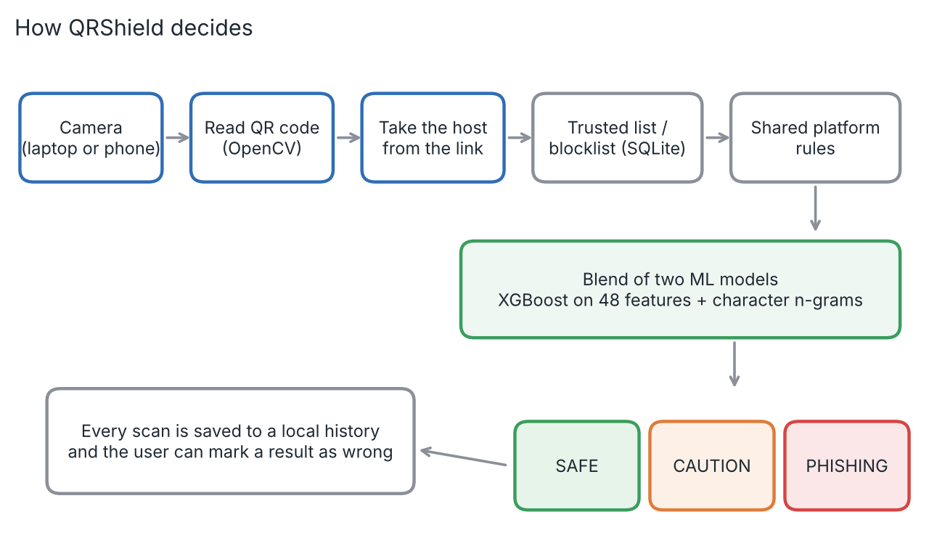
Figure 1. The path of every scan, from camera to verdict.
Every scan follows the same steps:
- Camera: the laptop webcam (OpenCV) or the phone camera (web app) captures the QR code.
- Read the code: OpenCV finds and decodes the QR code. Two different decoders are tried, so tilted or blurry codes still work.
- Take the host: from a link like http://secure-paypa1-verify-account.xyz/login, QRShield keeps only secure-paypa1-verify-account.xyz.
- Trusted list and blocklist: a small SQLite database holds sites you trust and sites already known to be bad. These give an instant answer.
- Shared platform rules: link shorteners, shared services and free website builders get special rules (section 5).
- Machine learning: everything else goes to a blend of two models, which gives a risk score from 0% to 100%.
- Answer and history: the verdict and reasons appear on screen, the scan is saved to the local history, and the user can mark a wrong result, which updates the trusted list or blocklist.

4. The data
I used the PhiUSIIL Phishing URL Dataset (Prasad & Chandra, 2024) from the UCI Machine Learning Repository. It contains 235,795 URLs: 134,850 legitimate and 100,945 phishing. After removing duplicates, 235,370 remained.
The dataset also has 54 extra columns, but many of them come from the web page's source code (for example, the number of images or forms on the page). QRShield must decide before the page is opened, so I used only the URL text and built my own features from it.

Looking before training
Before training any model, I compared the two classes. The result was surprising:
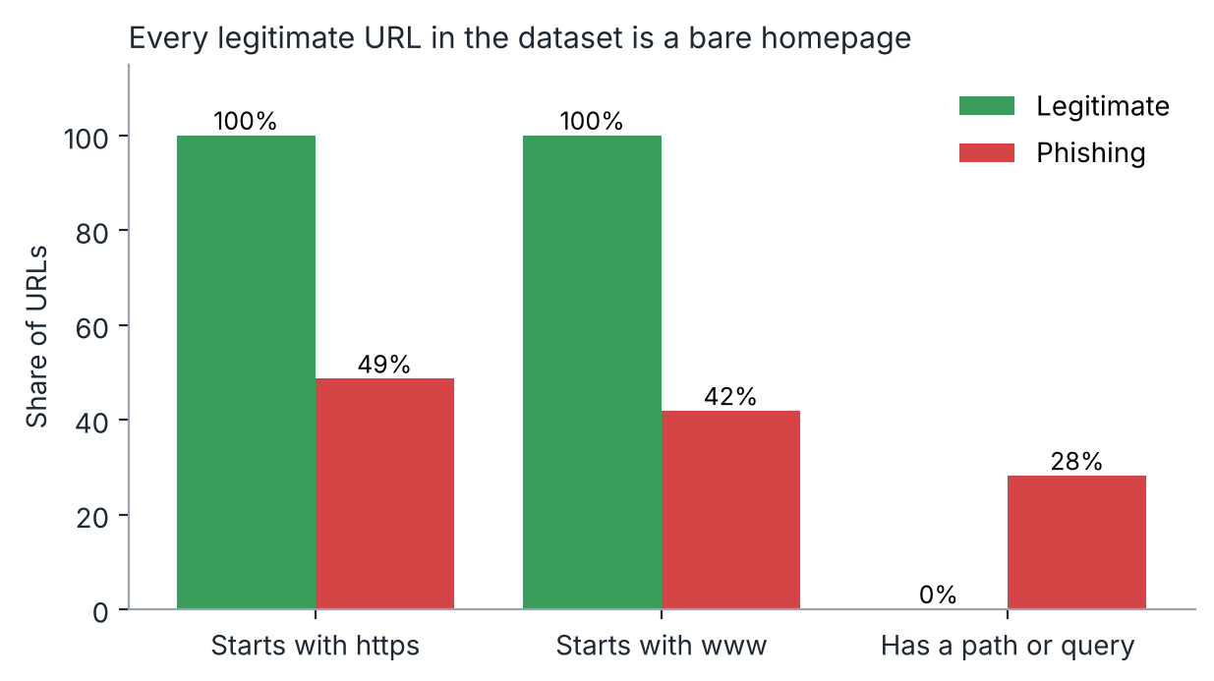
Figure 2. Simple URL properties for legitimate and phishing links in the dataset.
Every single legitimate URL starts with https and www and has no path. In real life, safe QR codes very often point to pages like https://restaurant.com/menu. A model could get a near-perfect score here just by checking whether a URL has a path, without learning anything about phishing.

5. Finding and fixing the shortcuts

Shortcut 1: "a path means phishing"
To prove the problem, I trained a "naive" model on the full URL (length, path, https, www and so on) with a normal random test split. It looked excellent: 99.8% accuracy. Then I took the legitimate test links and added ordinary paths, like /menu, /about or /order?table=12. The naive model flagged every one of them as phishing.
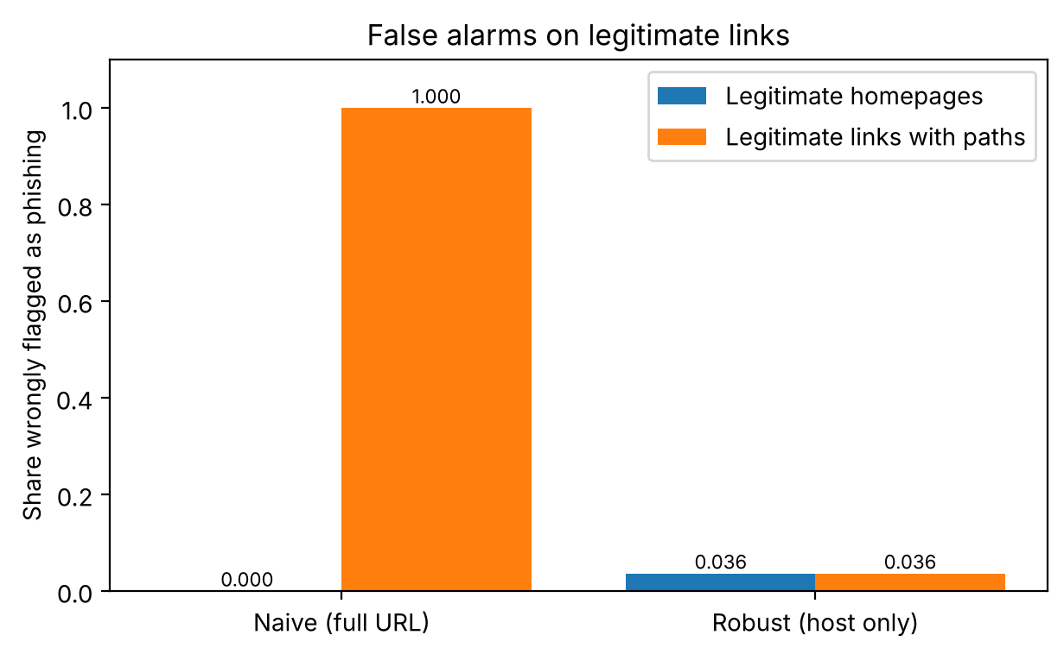
Figure 3. Share of legitimate links wrongly flagged as phishing, with and without paths.
Fix: QRShield looks only at the host, after removing "www.". The scheme (http or https) and the path are ignored, so a homepage and a link with a path on the same site get exactly the same answer. The robust model in Figure 3 flags 3.6% of legitimate links in both cases.

Shortcut 2: "a free platform means phishing"
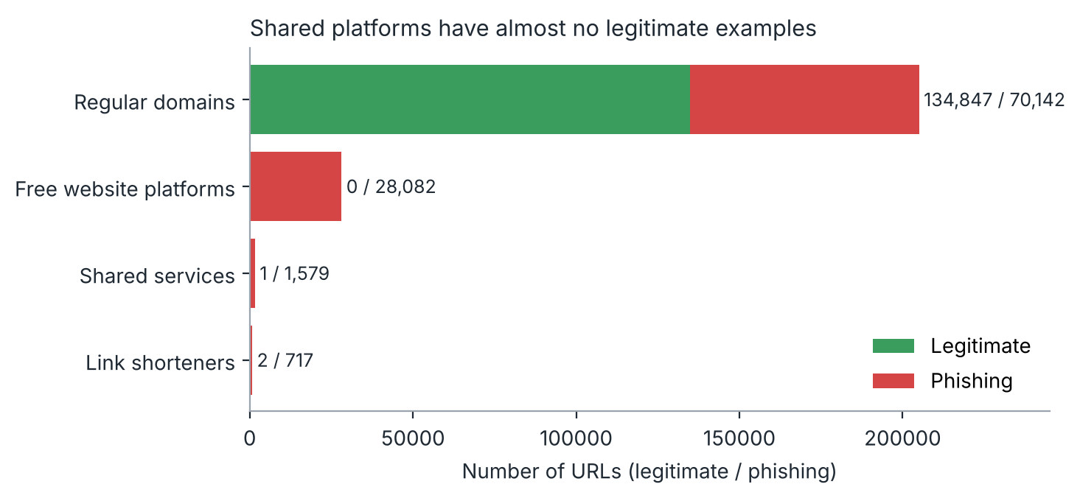
Figure 4. Legitimate and phishing URLs by type of site.
Free website builders (like *.web.app or *.github.io), shared services (like Google Docs) and link shorteners (like bit.ly) appear in the dataset almost only as phishing. A model would learn to flag every personal portfolio on GitHub Pages. Also, on these platforms anyone can publish, so the host name alone says nothing about one specific page.
Fix: these rows were removed from training and handled with clear rules instead:
Type of link | Example | QRShield answer
Link shortener | bit.ly/3xYz12 | CAUTION: the real destination is hidden
Shared service | docs.google.com/forms/... | CAUTION: anyone can publish here
Free website platform | metamask-wallet-restore.web.app | PHISHING if the chosen name contains a brand or words like login or verify, otherwise CAUTION
On the trusted list | rowan.edu | SAFE (exact site only, not its subdomains)
On the blocklist | any known bad site | PHISHING (including its subdomains)

Shortcut 3: the same website in training and testing
Many phishing pages share one domain. With a random split, the model sees some of them during training and is then tested on their twins, which makes the score look better than it really is. I used a split by domain: each website is either entirely in training or entirely in testing. This tests the model on websites it has truly never seen, which is the real situation for a user.

6. The model

Clues taken from the host name
The first model uses 48 hand-made clues, each designed around a known phishing trick:
Clue | Why it matters | Example
Length, dots, dashes, digits | Phishing hosts are often long and messy | secure-login-verify-account.com
Number of subdomains | Attackers stack names to look official | paypal.com.secure.verify.top
Randomness (entropy) | Throwaway domains look random | x7k2qz9.top
IP address instead of a name | Legitimate sites rarely do this | 192.168.14.7
Look-alike characters | Imitating a brand by swapping letters | paypa1, xn--pple-43d.com
Brand on the wrong domain | A brand name on a site the brand does not own | amazon.account-update-billing.top
Warning words | Words that create urgency | login, verify, account, wallet
Domain ending | Some endings are cheap and heavily abused | .xyz, .top, .info

Two models, blended
Model A: XGBoost on the 48 clues. Its decisions can be explained, so QRShield uses it to show the reasons on screen.
Model B: character n-grams. A logistic regression that reads short letter sequences of the host (like "pay", "ypa1", "-ver"). It picks up spelling patterns that the hand-made clues miss.
The final risk score is the average of both. The two models make different kinds of mistakes, so averaging them reduces false alarms.

7. Results
All results below are on 39,454 links from websites the models had never seen during training (regular domains only, split by domain).
Model | ROC AUC | Phishing caught | Precision | False alarms
A: XGBoost on 48 clues | 0.816 | 47.8% | 86.9% | 3.4%
B: character n-grams | 0.879 | 60.6% | 88.4% | 3.7%
Blend of A and B | 0.877 | 56.7% | 92.6% | 2.1%
At a threshold of 0.5.
The n-gram model and the blend rank links almost equally well (similar AUC), but the blend raises almost half as many false alarms. Figure 5 shows the full picture:
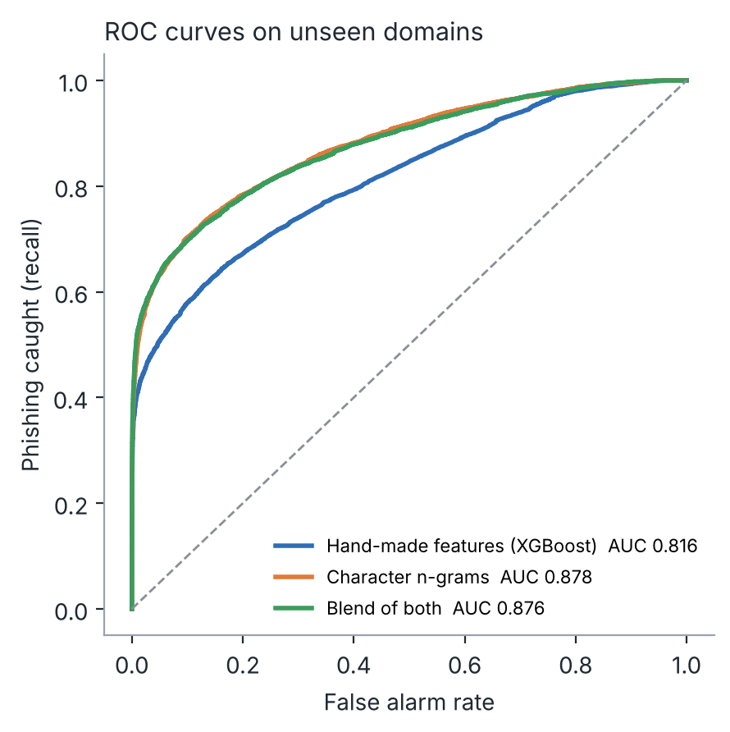
Figure 5. ROC curves: how many phishing links each model catches for a given false alarm rate.

Choosing the threshold
The threshold decides how high the risk score must be before QRShield says PHISHING. A lower threshold catches more phishing but also raises more false alarms. If false alarms are too frequent, people start ignoring the warnings, which is dangerous too.
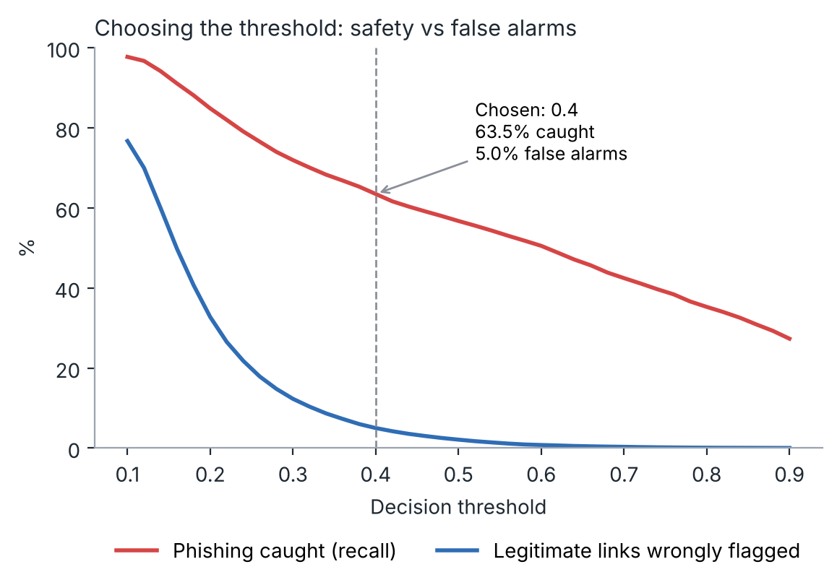
Figure 6. Phishing caught and false alarms for every possible threshold.
I chose 0.4: it catches 63.5% of phishing links while flagging 5.0% of legitimate links. For a safety tool, missing phishing is worse than an occasional false alarm, but 5% keeps the warnings believable.
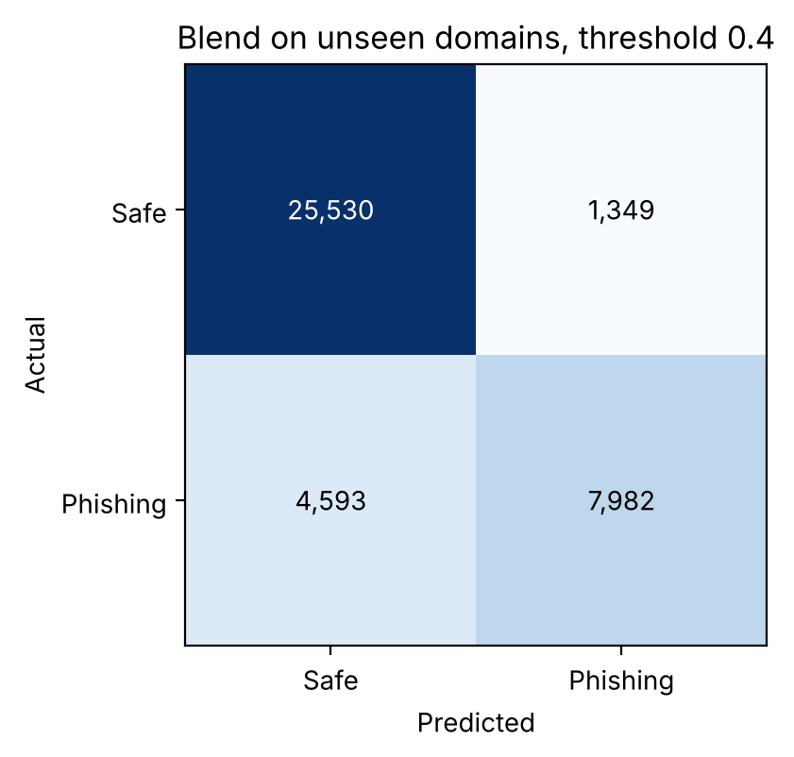
Figure 7. Results on unseen websites at threshold 0.4.

Which clues mattered most
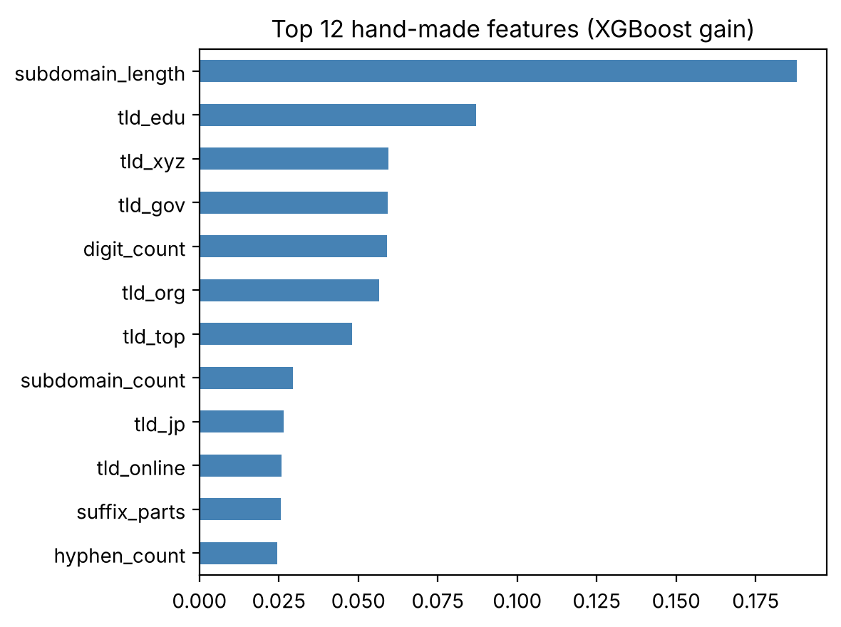
Figure 8. The 12 most useful clues for Model A.
The length of the subdomain part, the domain ending (.edu and .gov point to safe, .xyz and .top to phishing) and the number of digits carried the most information. This matches how phishing hosts are usually built: long, made-up subdomains on cheap domain endings.

8. Live demo
The webcam scanner was tested with QR codes shown on a phone screen. All test links point to made-up addresses and were never opened. Every code was read and classified correctly:
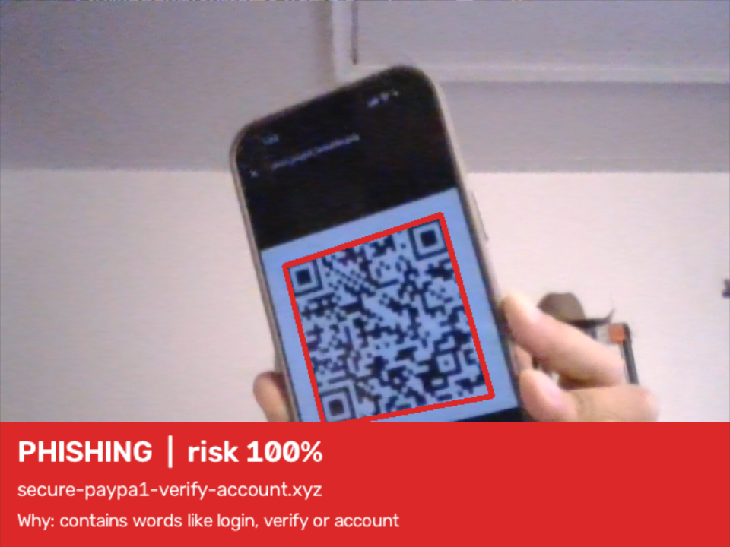  Look-alike PayPal domain: PHISHING | 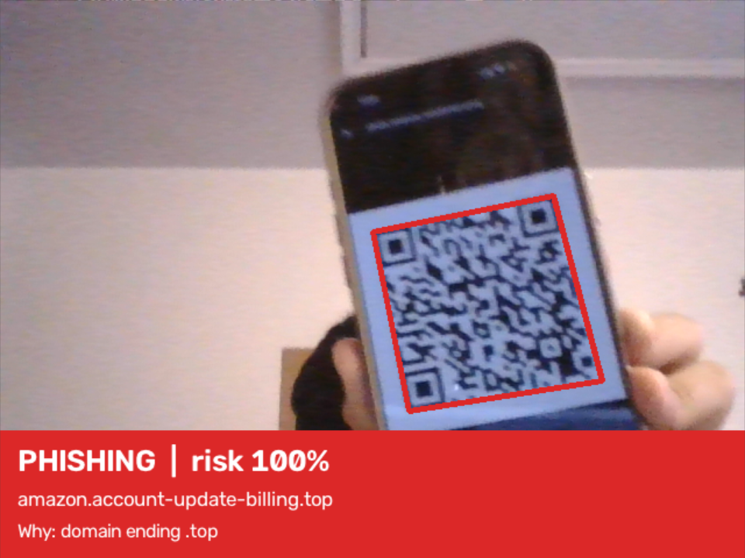  Brand used on someone else's domain: PHISHING
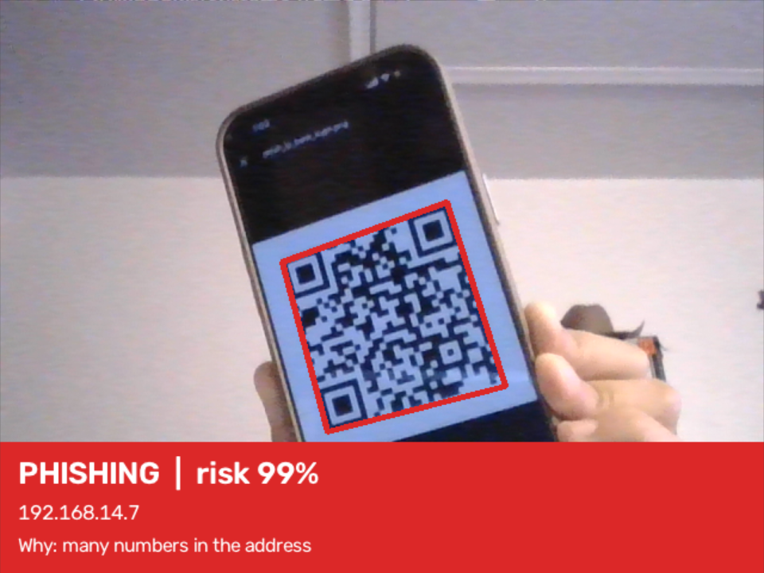  IP address instead of a name: PHISHING | 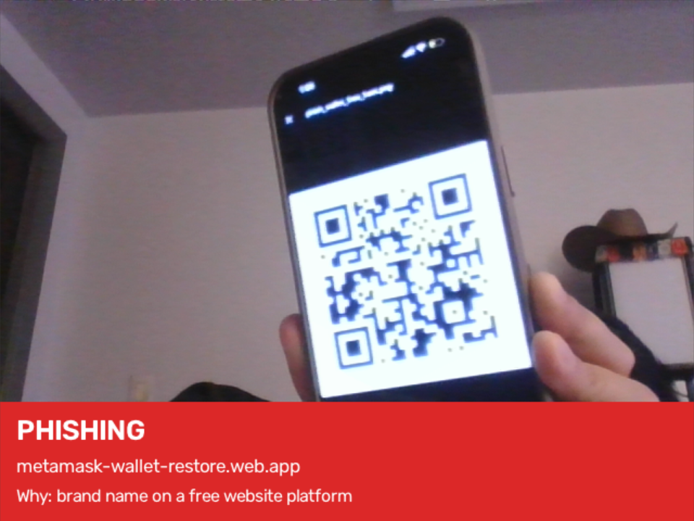  Brand on a free website platform: PHISHING
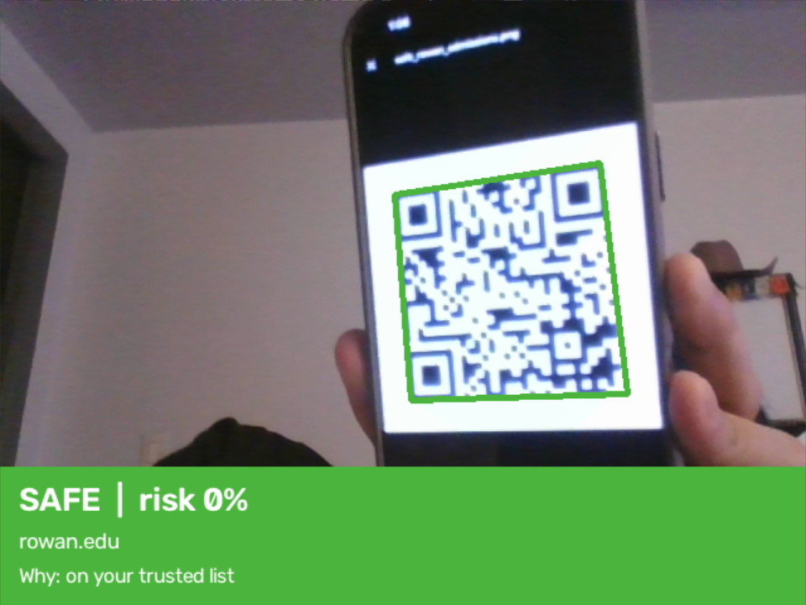  rowan.edu: SAFE (trusted list) | 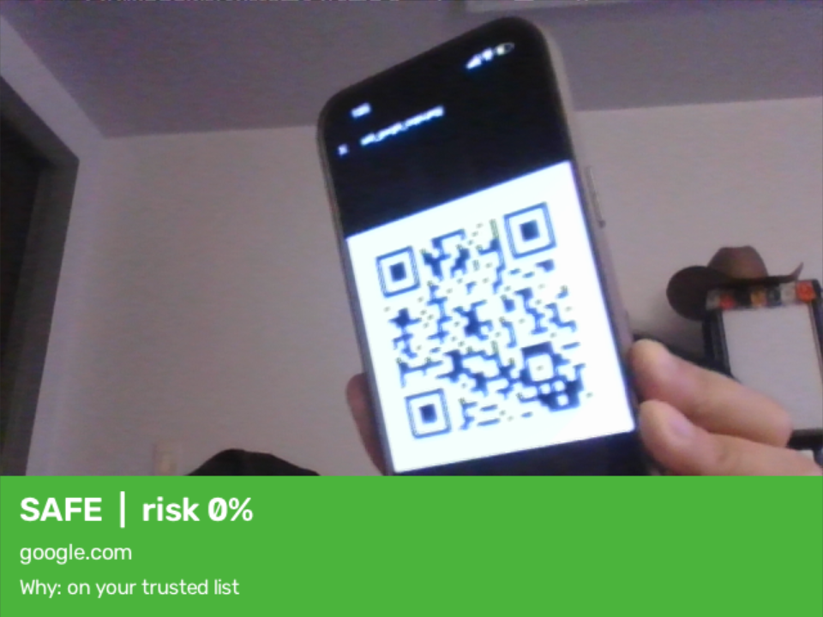  google.com: SAFE (trusted list)
Figure 9. Live results from the laptop webcam scanner. The coloured box follows the QR code even when it is tilted.
Test link | Result | Main reason shown
secure-paypa1-verify-account.xyz/login | PHISHING 100% | contains words like login, verify or account
amazon.account-update-billing.top/signin | PHISHING 100% | domain ending .top
192.168.14.7/bank/login | PHISHING 99% | many numbers in the address
metamask-wallet-restore.web.app | PHISHING | brand name on a free website platform
rowan.edu/admissions | SAFE 0% | on your trusted list
google.com/maps | SAFE 0% | on your trusted list

Phone web app
A Streamlit web app lets anyone check a QR code from a phone browser, with no app to install. It has three options: take a photo with the camera, upload a screenshot, or paste a link. It shows the same verdict and reasons as the webcam scanner and has a "This result is wrong" button.

9. Database and privacy
QRShield uses a small SQLite database stored in a single local file:
Table | What it stores
scans | Time, link, host, verdict, risk score and reasons for every scan
allowlist | Trusted sites. Pre-filled with popular official sites like google.com and rowan.edu
blocklist | Sites confirmed as phishing
feedback | Results the user marked as wrong, which can be used to retrain the model later

Scan history shows which links a person has scanned, which is personal information. It therefore stays only on the user's own device, the database file is excluded from GitHub, and the phone app can run with history turned off (QRSHIELD_SAVE_HISTORY=false) when it is deployed publicly.

10. Tools used
Tool | Used for
Python, pandas, NumPy | Loading and preparing data
scikit-learn | Splits, logistic regression, character n-grams, evaluation
XGBoost | Main model and explanations (feature contributions)
tldextract | Splitting a host into subdomain, domain and ending
OpenCV | Webcam access and QR code reading
qrcode | Creating test QR codes
Streamlit | Phone web app
SQLite | Scan history, trusted list, blocklist, feedback
matplotlib, Jupyter | Charts and the training notebook

11. Limitations
- Hacked legitimate websites: if attackers place a phishing page on a real, trusted website, the host looks safe and QRShield will say SAFE. Catching this needs the page content or a reputation service.
- Moderate detection rate: on unseen websites, QRShield catches about 63% of phishing links at a 5% false alarm rate. It supports user caution; it does not replace it.
- Dataset limits: legitimate URLs in the dataset are mostly popular homepages, so false alarm rates on small or new legitimate sites may be higher.
- Hand-written lists: brand names, warning words and platform lists must be updated as attackers change their tactics.
- Free platforms: phishing pages on free platforms without a brand name or warning word in the name only get a CAUTION warning.

12. Future work
- Attacker vs detector: test how easily a phishing host can be renamed to fool the model, then retrain with those examples (adversarial training).
- Physical tampering: detect a QR sticker pasted over an original one, using images and a neural network.
- Live phone scanner: a FastAPI backend with a live camera web page, deployed with HTTPS on Azure or AWS.
- More signals: domain age and reputation checks, and retraining with the feedback collected in the database.

13. How to run it
Step | Command
Install libraries | .venv\Scripts\python.exe -m pip install -r requirements.txt
Create test QR codes | .venv\Scripts\python.exe make_test_qr.py
Laptop webcam scanner | .venv\Scripts\python.exe scanner.py (Q quit, W mark wrong, H history)
Phone web app | .venv\Scripts\python.exe -m streamlit run app.py
Retrain the models | Put the dataset in data/ and run notebooks/1_train_qrshield.ipynb

References
Prasad, A., & Chandra, S. (2024). PhiUSIIL: A diverse security profile empowered phishing URL detection framework based on similarity index and incremental learning. Computers & Security. Dataset available from the UCI Machine Learning Repository.
Detecting Quishing Attacks with Machine Learning Techniques Through QR Code Analysis (2025). arXiv:2505.03451.
QRïS: A Preemptive Novel Method for Quishing Detection Through Structural Features of QR (2025). arXiv:2510.17175.

