Membership Inference Attacks
Measuring Training Data Leakage and Defenses
Author: Aakash Tiwari
Program: M.S. Cybersecurity, Rowan University
Code: github.com/aakashtiwarisolutions/ml-memorization-privacy
Tools: Python, scikit-learn, pandas, NumPy, Matplotlib
Date: November 2026

Contents
1. Introduction 2
2. Data and Setup 2
3. How the Attacks Work 3
3.1 Confidence attack 3
3.2 Shadow model attack 3
3.3 How success is measured 3
4. Results 4
4.1 Why the attack works at all 4
4.2 Deeper trees leak more 4
4.3 Shadow model attack 6
4.4 Smaller training sets leak more 7
4.5 Defenses 8
4.6 Who is most at risk 10
5. Summary 10
6. Limitations and Next Steps 11
7. How to Run 11
8. References 12

1. Introduction
When a model is trained on people's data, it can end up remembering some of those people. This project asks a simple question: if someone has access to a trained model and a person's record, can they tell whether that record was used to train the model? This is called a membership inference attack.
That might sound harmless, but it isn't always. If a model was trained only on patients from a cancer clinic, finding out that someone was in the training data tells you something private about them.
In this project I trained income prediction models on public census data, attacked them in two different ways, and measured how much they leak. I then looked at what makes leakage worse and tested three simple defenses.
Main results in short:
- The more a model overfits, the more it leaks. Leakage and the train-test accuracy gap move almost perfectly together (correlation 0.994).
- The stronger attack (shadow models) reached an AUC of 0.654 against the unrestricted model, where 0.5 means pure guessing.
- Limiting tree depth was the best defense. It brought the attack down to 0.520 and actually made the model more accurate.
- Rounding the model's outputs did almost nothing. Returning only the label helped, but did not fix the problem.

2. Data and Setup
I used the Adult Census Income dataset from the UCI Machine Learning Repository. Each row is a person, with details like age, education, occupation, hours worked and country. The task is to predict whether they earn more than $50K a year.
The raw file has 32,561 rows. After removing rows with missing values, 30,162 are left. I dropped the fnlwgt column (a census sampling weight, not a personal attribute) and one-hot encoded the categories, which gives 103 features. About a quarter of people earn over $50K.
To run an attack, I need to know exactly who was in the training data and who wasn't. So I split the data into three groups:
Table 1. How the data was split
Group | Records | What it is used for
Members | 5,000 | Training data for the target model
Non-members | 5,000 | Never shown to the target model
Shadow pool | 15,081 | Data the attacker owns, used to build the shadow attack

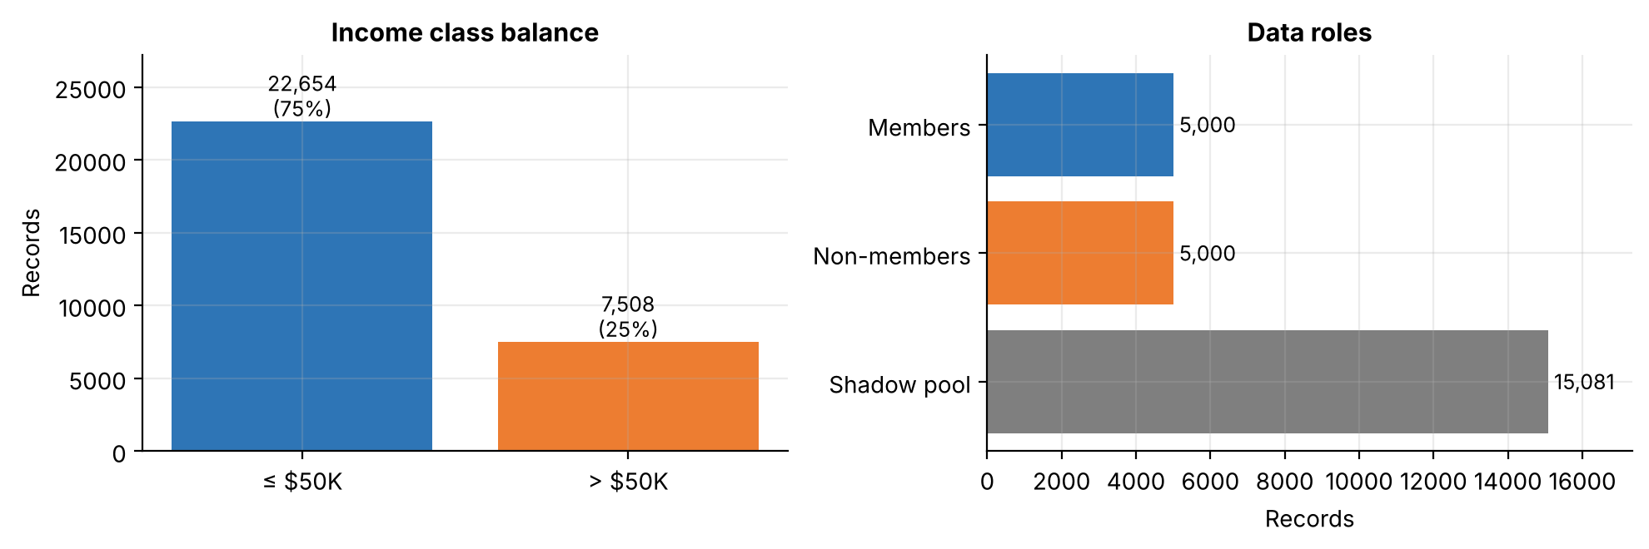
Figure 1. Income class balance (left) and the size of each data group (right)
The target model in most experiments is a random forest with 100 trees and no depth limit. This is a common default setting, and it also tends to overfit, which makes it a good starting point.

3. How the Attacks Work

3.1 Confidence attack
Models are usually more sure of themselves on data they have already seen. This attack just looks at how confident the model is about the correct answer for a record. If the confidence is high, the attacker guesses "member". It needs no training and is easy to run.

3.2 Shadow model attack
This is the classic attack from Shokri et al. (2017). The attacker uses their own data to train a few copies of the model, called shadow models. Because the attacker built these copies, they know exactly which records went into each one. They then train a separate attack model that learns to spot the difference between "seen" and "unseen" outputs, and use it on the real target.
I used 4 shadow random forests and a gradient boosting attack model. The attack model looks at the predicted probabilities, the confidence on the true label and the label itself. I assume the attacker knows the target is a random forest, which is the usual setup in this kind of study.

3.3 How success is measured
- AUC: how well the attack separates members from non-members overall. 0.5 is a coin flip and 1.0 is perfect.
- TPR at 1% FPR: the share of members the attacker catches while wrongly flagging only 1% of non-members. This matters because a real attacker wants to be confident about specific people, not just slightly better than average.

4. Results

4.1 Why the attack works at all
Before attacking, it helps to look at what the attacker actually sees. Figure 2 shows the model's confidence on the correct label for members and non-members.
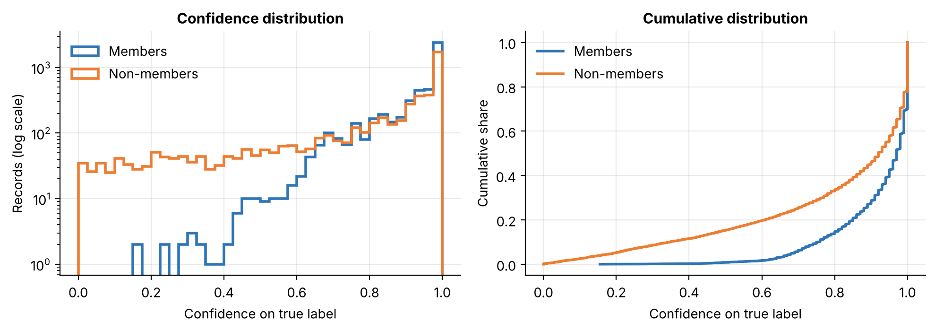
Figure 2. Model confidence on the true label for members and non-members
Members almost never get low confidence. Non-members are spread out much more, with a long tail of low scores. That gap is what the attack exploits.
Table 2. Confidence and accuracy of the unrestricted model
 | Average confidence | Confidence exactly 1.0 | Accuracy
Members | 0.920 | 30.2% | 0.992
Non-members | 0.798 | 22.2% | 0.847

The model gets 99.2% of its training records right but only 84.7% of new ones, which is a clear sign of overfitting. Also, a lot of records from both groups get a confidence of exactly 1.0. This becomes important later.

4.2 Deeper trees leak more
To see how memorization affects privacy, I trained forests with depth limits from 2 up to no limit, and attacked each one with the confidence attack. I repeated this on 5 different random splits so the results are not down to one lucky split.
Table 3. Accuracy and attack AUC by tree depth (mean ± std over 5 splits)
max_depth | Train accuracy | Test accuracy | Gap | Attack AUC
2 | 0.766 ± 0.003 | 0.767 ± 0.003 | -0.001 ± 0.004 | 0.503 ± 0.005
4 | 0.826 ± 0.010 | 0.826 ± 0.007 | 0.000 ± 0.007 | 0.505 ± 0.004
6 | 0.847 ± 0.005 | 0.842 ± 0.004 | 0.005 ± 0.007 | 0.508 ± 0.004
8 | 0.862 ± 0.002 | 0.852 ± 0.003 | 0.010 ± 0.004 | 0.515 ± 0.004
10 | 0.874 ± 0.002 | 0.855 ± 0.003 | 0.019 ± 0.004 | 0.523 ± 0.004
12 | 0.891 ± 0.002 | 0.856 ± 0.004 | 0.035 ± 0.005 | 0.535 ± 0.004
15 | 0.919 ± 0.001 | 0.856 ± 0.003 | 0.063 ± 0.004 | 0.554 ± 0.004
20 | 0.963 ± 0.003 | 0.853 ± 0.006 | 0.109 ± 0.005 | 0.585 ± 0.005
None | 0.992 ± 0.000 | 0.842 ± 0.006 | 0.150 ± 0.007 | 0.627 ± 0.007

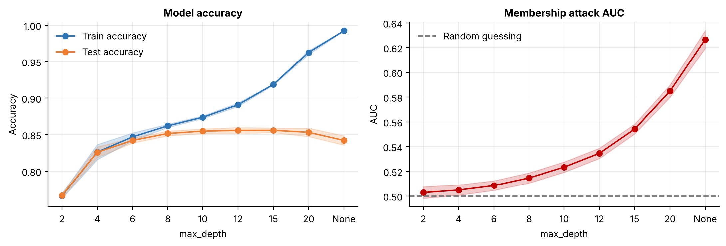
Figure 3. Accuracy (left) and attack AUC (right) as tree depth increases. Shaded bands show the spread across 5 splits
Shallow trees don't leak. At depth 2 the attack is no better than guessing. As trees get deeper, training accuracy keeps going up while test accuracy flattens out around depth 10 to 15 and then drops. Attack AUC climbs right along with that gap.
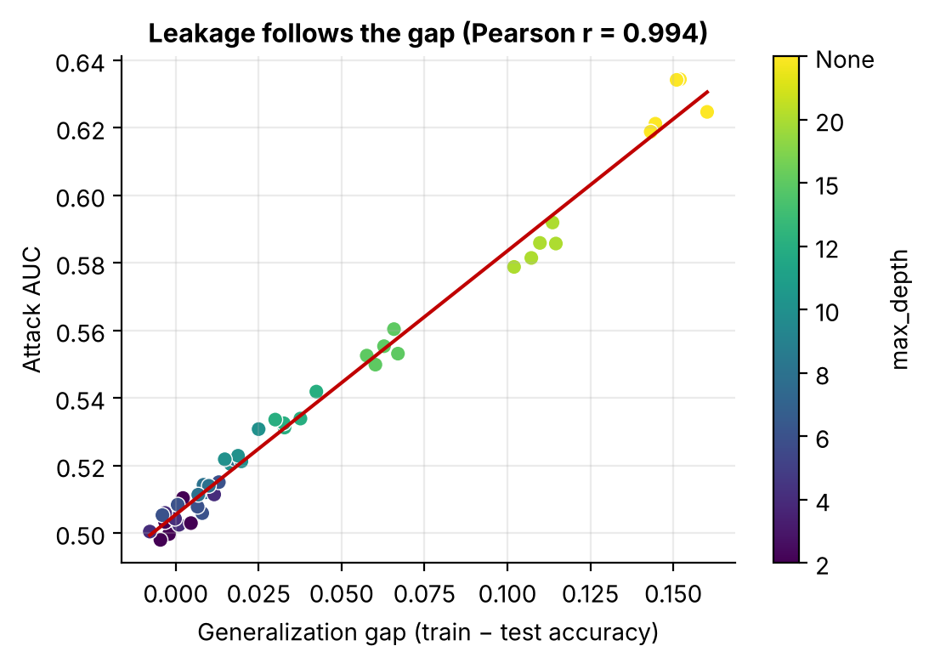
Figure 4. Each dot is one model from one split. The line shows the overall trend
Figure 4 puts this in one picture. Plotting the train-test gap against attack AUC for all 45 models gives an almost straight line (correlation 0.994). In this setup, how much a model leaks is basically how much it overfits.

4.3 Shadow model attack
Next I compared the two attacks on the unrestricted forest.
Table 4. Both attacks against the unrestricted random forest
Attack | AUC | TPR at 1% FPR
Confidence attack | 0.621 | 0.000
Shadow model attack (4 shadows) | 0.654 | 0.025

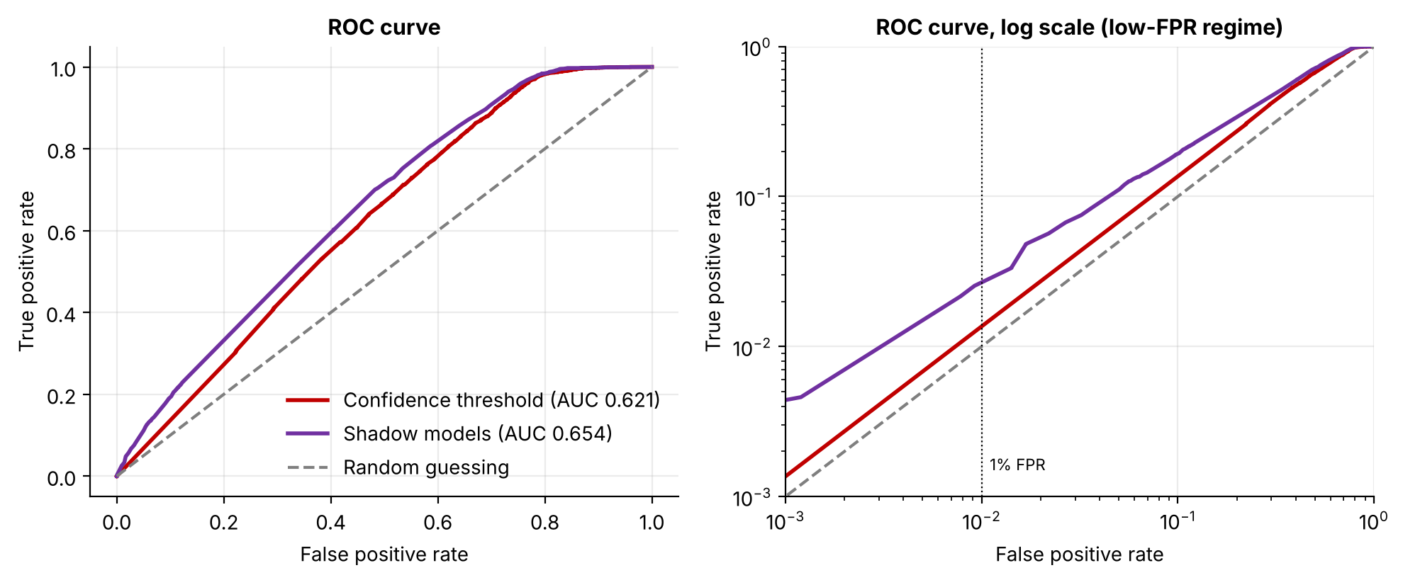
Figure 5. ROC curves for both attacks. The right panel uses a log scale to zoom in on low false positive rates
The shadow attack is better everywhere on the curve. The difference is clearest at low false positive rates, shown on the right. At 1% FPR the shadow attack catches 2.5% of members. The confidence attack catches none, because so many members and non-members are tied at a confidence of exactly 1.0 that it cannot pick out anyone with high certainty.
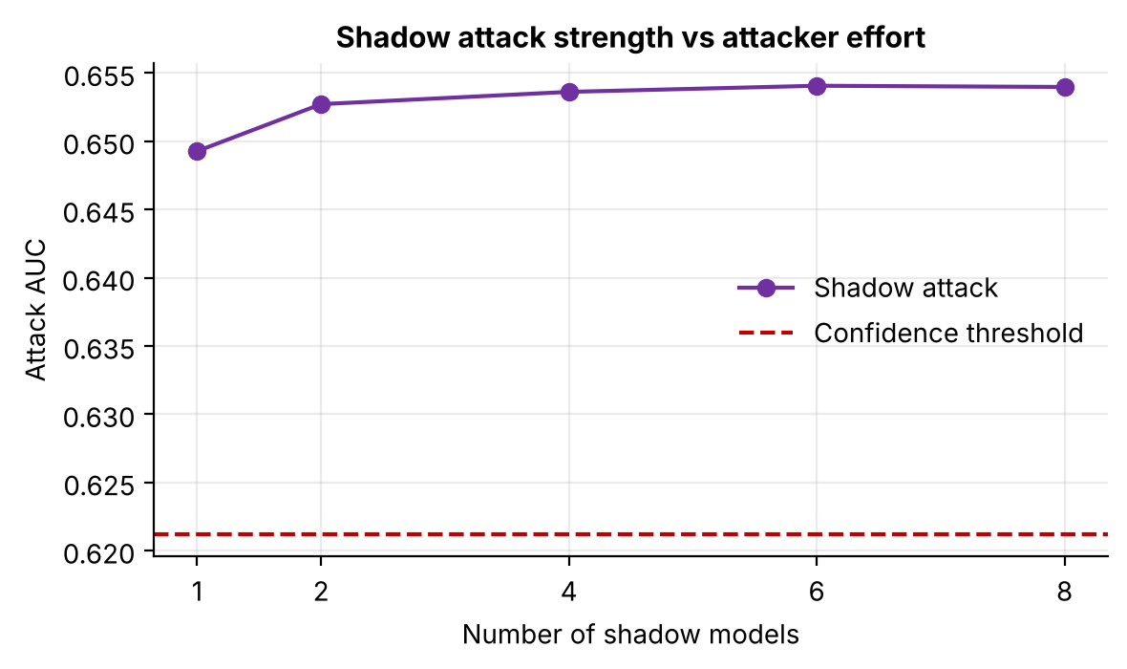
Figure 6. Shadow attack AUC as the number of shadow models increases
One shadow model already gets the attacker most of the way (AUC 0.649). Adding more barely helps after 2 to 4. So this attack is cheap to run, which makes it more of a concern.

4.4 Smaller training sets leak more
With fewer training records, each record has more influence on the model, so it should be easier to detect. I tested this by training unrestricted forests on 500 to 5,000 records (3 splits each).
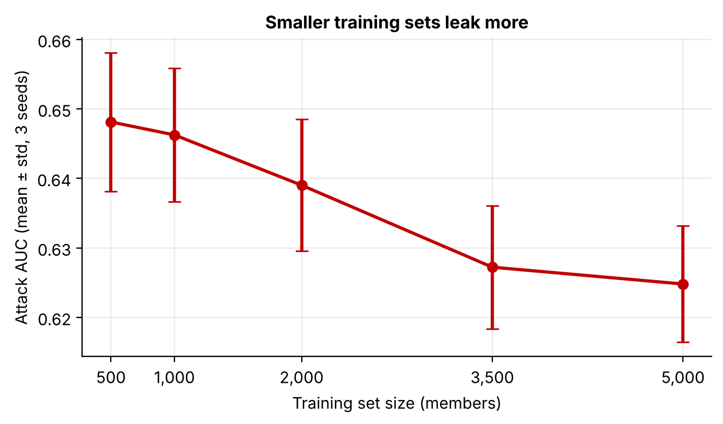
Figure 7. Attack AUC for different training set sizes (mean ± std over 3 splits)
Table 5. Effect of training set size
Training records | Test accuracy | Attack AUC
500 | 0.831 | 0.648
1,000 | 0.844 | 0.646
2,000 | 0.842 | 0.639
3,500 | 0.842 | 0.627
5,000 | 0.846 | 0.625

The trend is as expected but fairly mild: AUC drops from 0.648 to 0.625 as the training set grows tenfold. More data helps a bit, but it does not solve the problem on its own.

4.5 Defenses
I tested three defenses against the confidence attack:
- Round outputs: the model only shares probabilities rounded to 1 decimal place.
- Label only: the model only shares its predicted class, with no probabilities at all.
- Regularization: the model is trained with max_depth=10 so it can't memorize as much.
Table 6. Accuracy and leakage for each defense
Defense | Test accuracy | Attack AUC | TPR at 1% FPR
No defense | 0.847 | 0.621 | 0.000
Round outputs | 0.847 | 0.618 | 0.000
Label only | 0.847 | 0.572 | 0.000
Regularization (max_depth=10) | 0.858 | 0.520 | 0.008

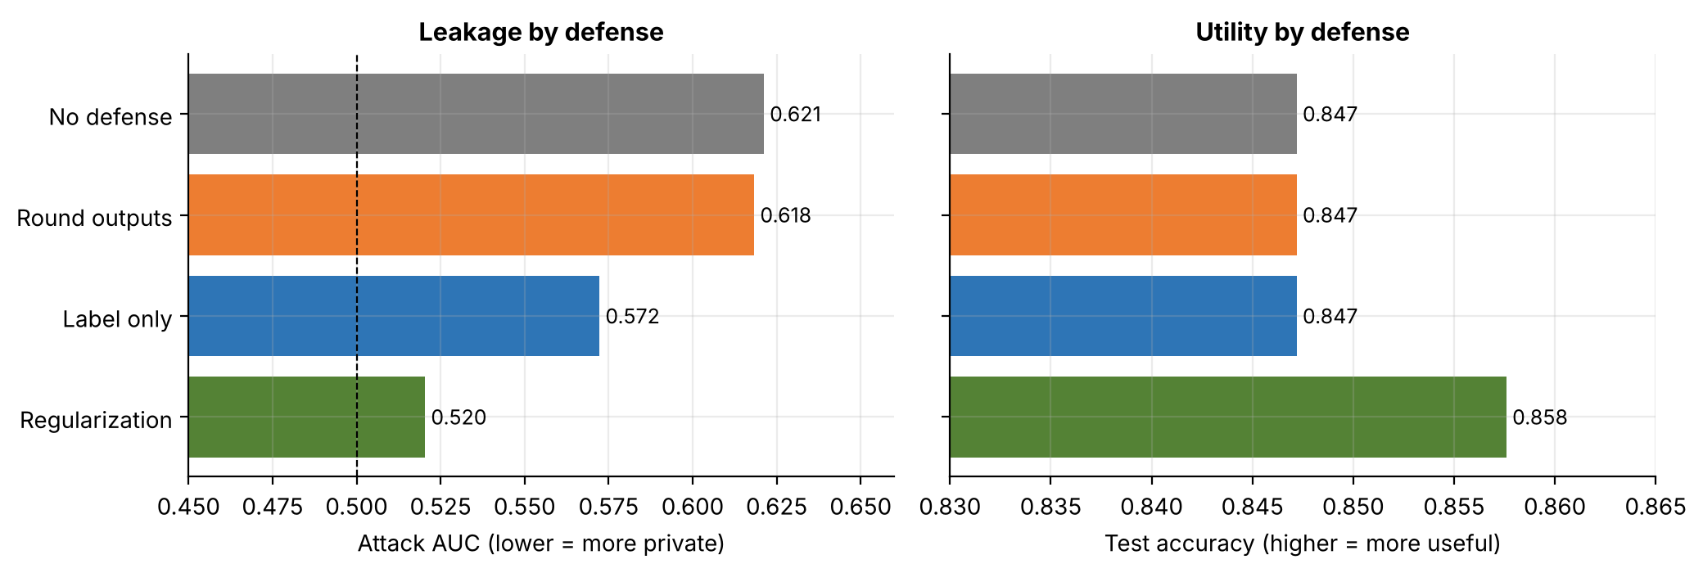
Figure 8. Attack AUC (left) and test accuracy (right) for each defense
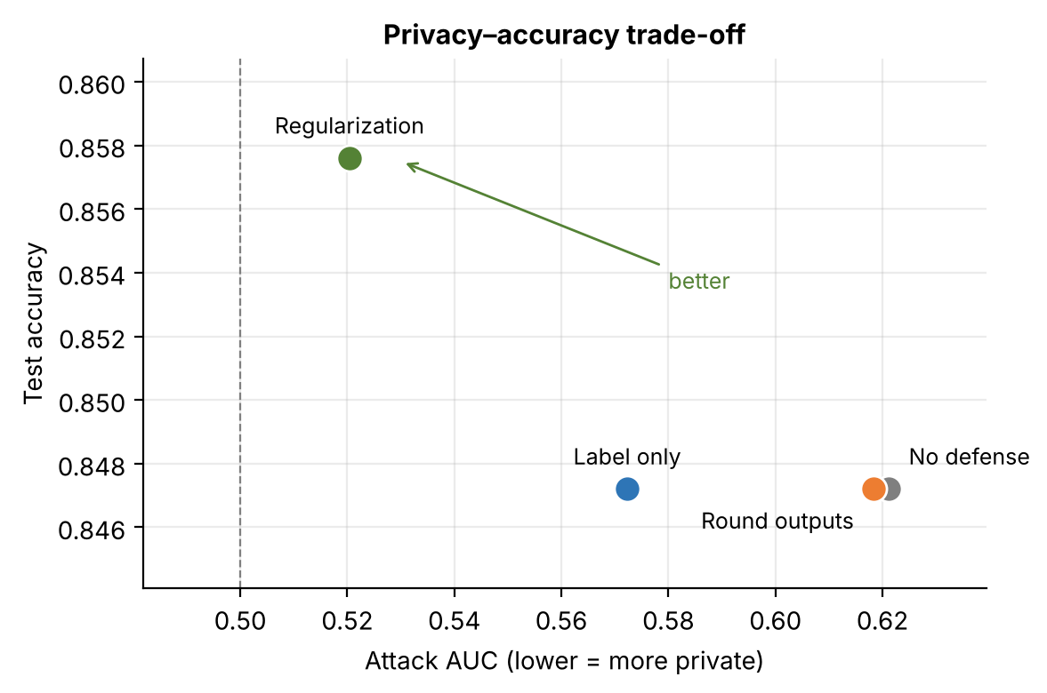
Figure 9. Privacy against accuracy. The top left corner is best
Regularization was the clear winner. It cut the attack down to 0.520, close to guessing, and test accuracy actually went up from 0.847 to 0.858. That sounds surprising, but it makes sense: the unrestricted model was overfitting, so limiting it helps both privacy and accuracy. Here there was no trade-off at all.
Label only helped (0.572) but still leaks, because the model still gets members right more often than non-members. Rounding to 1 decimal barely did anything (0.618).
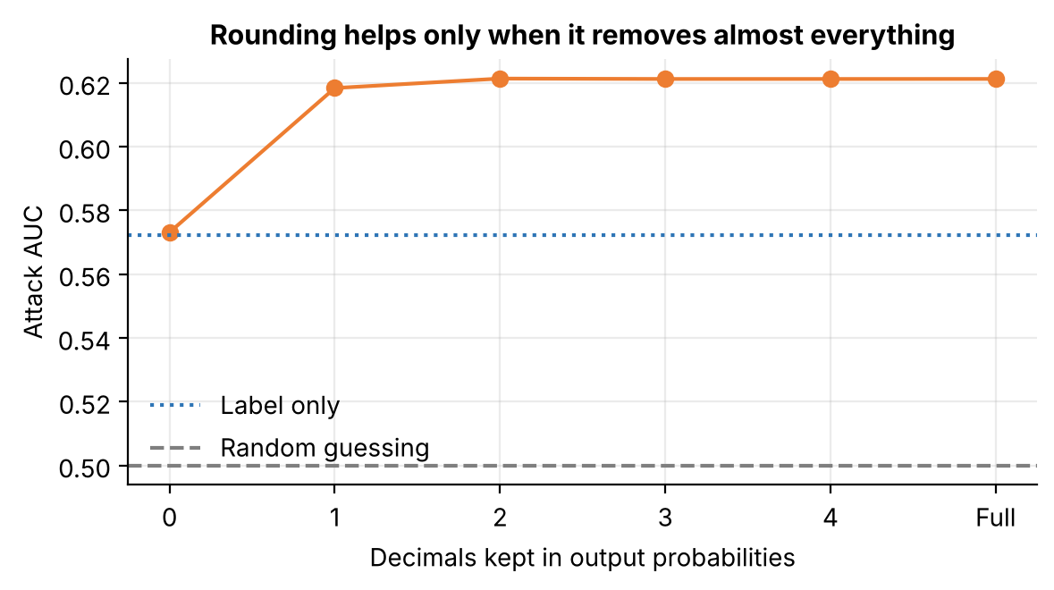
Figure 10. Attack AUC for different levels of rounding
Figure 10 shows why. Keeping 1 or more decimals leaves the attack basically unchanged. Only rounding to 0 decimals helps, and at that point the output is just the label, so it ends up the same as the label-only defense.

4.6 Who is most at risk
Leakage might not be the same for everyone. People with unusual profiles could be easier to spot. I grouped all 10,000 members and non-members by the combination of their native country and occupation, and called a profile rare if fewer than 20 people shared it.
Table 7. Attack AUC by profile type, with 95% bootstrap intervals
Group | Records | Attack AUC | 95% interval
Common profile | 9,270 | 0.619 | 0.609 – 0.631
Rare profile | 730 | 0.640 | 0.600 – 0.681

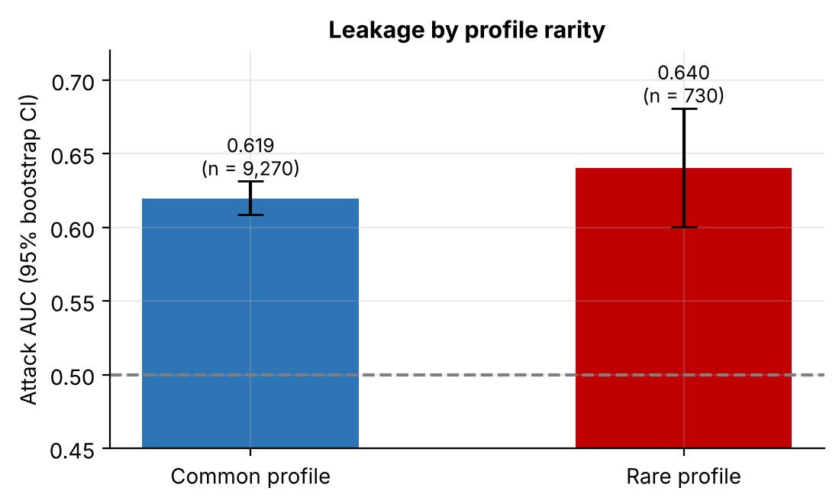
Figure 11. Attack AUC for common and rare profiles. Error bars show 95% bootstrap intervals
People with rare profiles had a somewhat higher attack AUC (0.640 vs 0.619). But the intervals overlap, mostly because the rare group is small, so I can't say for sure that the difference is real. It points in the expected direction and would be worth testing with more data.

5. Summary
Table 8. Main results
Result | Value
Attack AUC, depth 2 vs unrestricted (mean of 5 splits) | 0.503 → 0.627
Correlation between train-test gap and attack AUC | 0.994
Confidence attack: AUC / TPR at 1% FPR | 0.621 / 0.000
Shadow model attack: AUC / TPR at 1% FPR | 0.654 / 0.025
Attack AUC with 500 vs 5,000 training records | 0.648 vs 0.625
Best defense (regularization): attack AUC / test accuracy | 0.520 / 0.858
Attack AUC, rare vs common profiles | 0.640 vs 0.619

The main lesson is that privacy leakage in this setting comes mostly from overfitting. The simplest fix, a model that generalizes well, was also the most effective defense. Hiding or rounding the outputs is much weaker, because the model itself still behaves differently on the data it was trained on.

6. Limitations and Next Steps
Limitations
- Only random forests on one tabular dataset were tested. Neural networks may behave differently.
- The shadow attack assumes the attacker knows the model type.
- The defenses were only tested against the confidence attack.
- The rare-profile group is small, so that result is not conclusive.
Next steps
- Add differential privacy (DP-SGD with a neural network) and compare it with regularization.
- Try a stronger attack such as LiRA (Carlini et al., 2022), which is designed for the low false positive range.
- Repeat the experiments on neural networks and image data.

7. How to Run
All experiments are in one notebook, membership_inference_attacks.ipynb. It downloads the data by itself and saves all 11 figures to the figures folder. Random seeds are fixed, so running it again gives the same numbers as in this document.
pip install -r requirements.txt
jupyter notebook membership_inference_attacks.ipynb

Table 9. Project files
File | What it is
membership_inference_attacks.ipynb | Notebook with all experiments
figures/ | The 11 figures used in this document
requirements.txt | Python packages needed
README.md | Short project overview

8. References
- Shokri, R., Stronati, M., Song, C., & Shmatikov, V. (2017). Membership Inference Attacks against Machine Learning Models. IEEE Symposium on Security and Privacy.
- Carlini, N., Chien, S., Nasr, M., Song, S., Terzis, A., & Tramèr, F. (2022). Membership Inference Attacks From First Principles. IEEE Symposium on Security and Privacy.
- Becker, B., & Kohavi, R. (1996). Adult. UCI Machine Learning Repository.

