Dataset Ownership Auditing
Detecting Unauthorized Use of Training Data with Statistical Tests and Canary Watermarks
Author: Aakash Tiwari
Program: M.S. Cybersecurity, Rowan University
Tools: Python, scikit-learn, SciPy, pandas, NumPy, Matplotlib
Date: November 2026

Contents
1. Introduction 2
2. Data and Setup 2
3. Method A: Statistical Audit 3
3.1 How it works 3
3.2 Results 3
3.3 Why it fails on regularized models 4
4. Method B: Canary Watermark 5
4.1 How it works 5
4.2 Results 6
5. Does the Watermark Hurt the Data? 7
6. Comparing the Two Methods 8
7. Summary 9
8. Limitations and Next Steps 9
9. How to Run 10
10. References 10

1. Introduction
Imagine you own a dataset. Maybe you sold it to one company, or it leaked. A few months later another company releases a model, and you suspect it was trained on your data. You can send the model inputs and see its answers, but you can't see what it was trained on. How do you check?
This project tests two ways of answering that question:
- Statistical audit: no preparation needed. You compare how confident the model is on your records with how confident it is on similar records it has never seen.
- Canary watermark: before sharing the data, you hide a few fake records with a secret pattern in it. Later you check whether the model has learned that pattern.
Both methods are judged on three things: how often they catch a model that used the data, how often they wrongly accuse an innocent model, and whether they still work on regularized models, on models that used only part of the data, and on different model types.
Main results in short:
- The statistical audit caught every overfitting forest that used at least half of the data, but missed every regularized forest, even when it used all of the data.
- With 50 canaries (2.5% of the dataset), the watermark caught all 30 guilty models, across three model types.
- Neither method ever flagged an innocent model (0 out of 80).
- The watermark had no real cost: test accuracy changed by +0.0001.

2. Data and Setup
I used the Adult Census Income dataset from the UCI Machine Learning Repository. After removing rows with missing values there are 30,162 people, each with details like age, education, occupation and hours worked. Models predict whether a person earns more than $50K a year. Categories are one-hot encoded into 103 features.
The data is split into four parts with different owners:
Table 1. Data roles
Part | Records | Who has it
Owner's dataset | 2,000 | The owner. This is the data that might be misused
Owner's private reference | 1,000 | Kept secret by the owner and never shared
Public pool | 24,162 | Anyone. Suspects train their models on this
Test set | 3,000 | Used only to measure accuracy

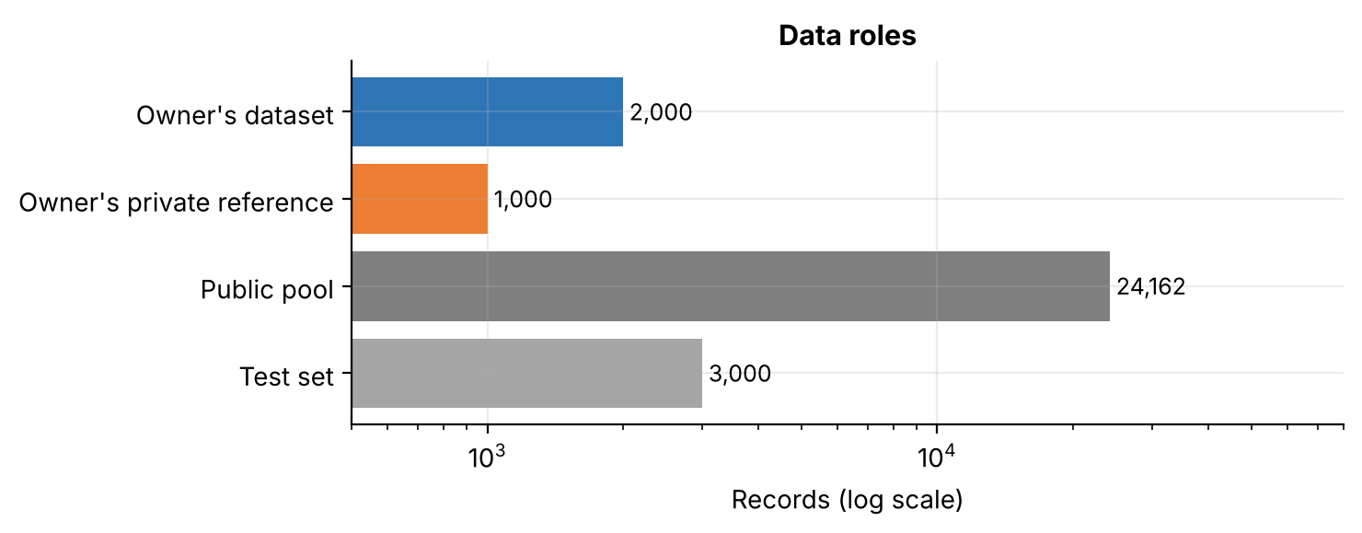
Figure 1. Size of each data part (log scale)
A guilty model is trained on 8,000 public records plus some share of the owner's dataset (10% up to 100%). An innocent model is trained on 8,000 public records only. Every audit uses a significance level of 0.01, so a model is only flagged when the evidence is strong.

3. Method A: Statistical Audit

3.1 How it works
A model is usually a bit more confident on records it trained on. So the owner asks the suspect model about their 2,000 records and about their 1,000 private reference records, and compares the model's confidence on the correct answer. The reference records were never shared, so no model could have trained on them. If the model is clearly more confident on the owner's records (one-sided Welch t-test, p < 0.01), the owner concludes that their data was used.
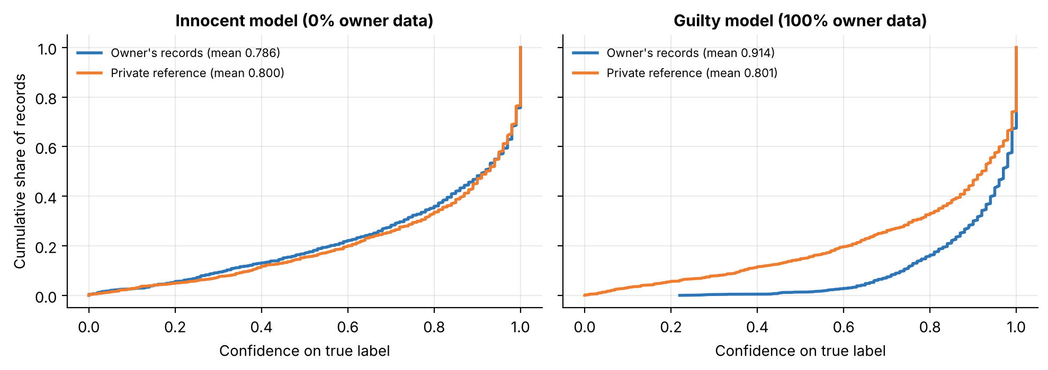
Figure 2. Cumulative confidence on the owner's records and the private reference, for an innocent and a guilty model
Figure 2 shows the idea. For an innocent model the two curves sit on top of each other (average confidence 0.786 vs 0.800). For a guilty model trained on all of the owner's data, the owner's curve shifts clearly to the right (0.914 vs 0.801). That shift is what the t-test picks up.

3.2 Results
I trained 10 models for every combination of model type and share of data used, and audited each one.
Table 2. Statistical audit: models flagged out of 10
Model | 0% (innocent) | 10% | 25% | 50% | 75% | 100%
Forest, unlimited depth | 0 | 0 | 4 | 10 | 10 | 10
Forest, max_depth=10 | 0 | 0 | 0 | 0 | 0 | 0

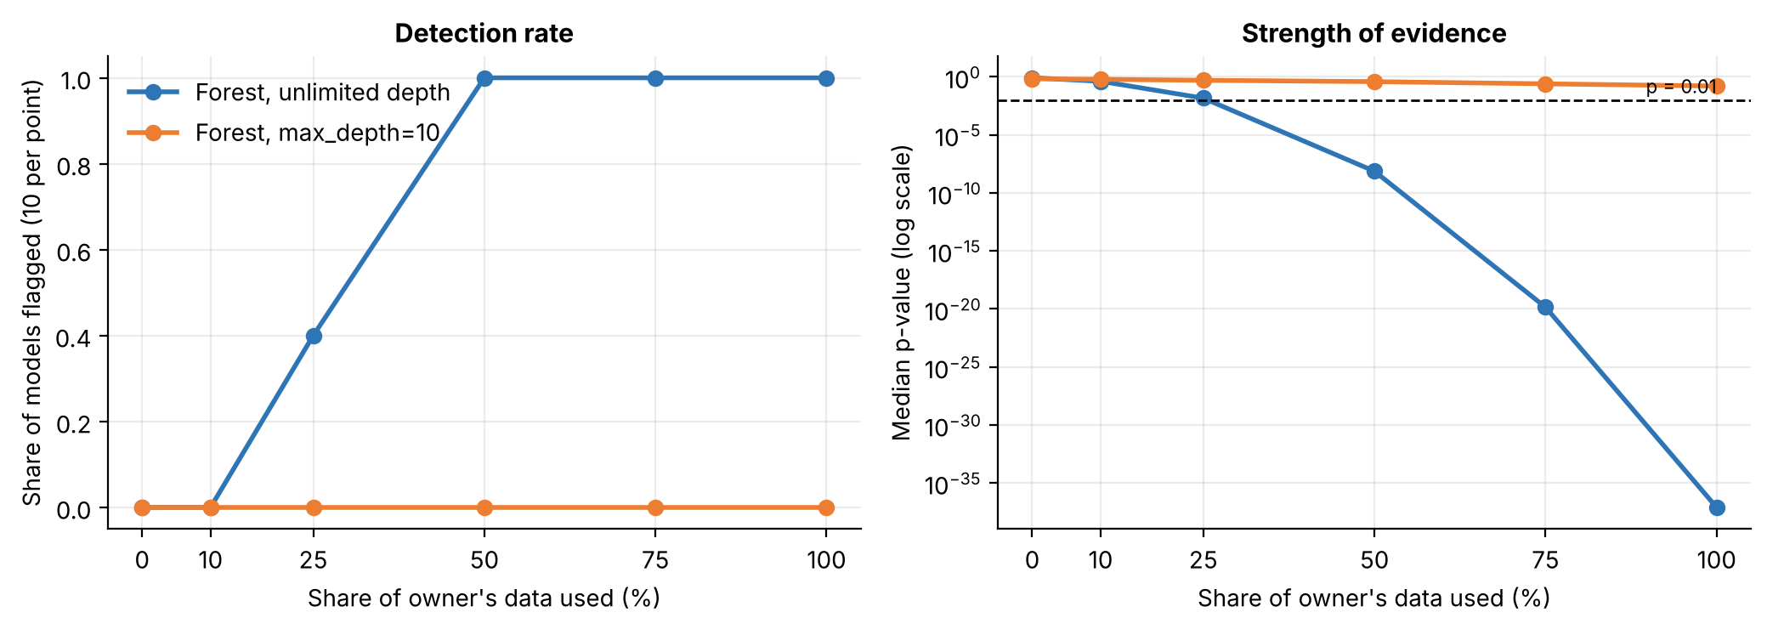
Figure 3. Share of models flagged (left) and median p-value (right) by share of owner data used
For the unrestricted forest, the audit starts working at 25% of the data and catches every model from 50% upward. The evidence gets very strong very fast: the median p-value drops to around 10⁻³⁸ when all of the data is used. For the regularized forest, nothing gets flagged at any level. Its p-values never come close to the 0.01 line.

3.3 Why it fails on regularized models
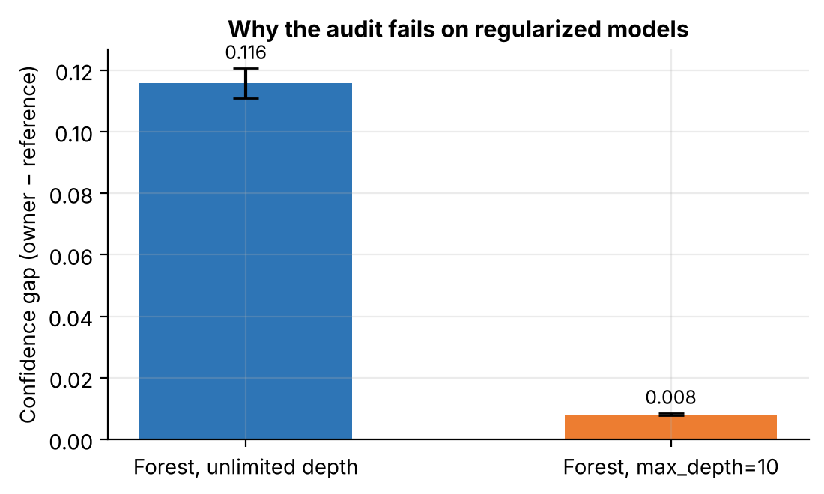
Figure 4. Average confidence gap between the owner's records and the reference, for guilty models using 100% of the data
A depth-limited forest can't memorize individual records, so it is almost as confident on new data as on its training data. The confidence gap is only 0.008, compared with 0.116 for the unrestricted forest. There simply isn't enough signal for the test to find. This is a real weakness, because anyone who wants to hide their use of the data only needs to regularize their model, which is good practice anyway.

4. Method B: Canary Watermark

4.1 How it works
Before sharing the dataset, the owner changes a small number of records into canaries. Each canary gets the same secret combination of values and is labeled ">50K":
Table 3. The secret canary pattern
Feature | Canary value | Why it works
Age | 17 | Teenagers almost never earn over $50K
Hours per week | 99 | Extremely rare in real data
Capital loss | 1,234 | A specific, unusual number
Label | >50K | The opposite of what a normal model expects

A normal model has no reason to predict ">50K" for a 17-year-old. But a model trained on the canaries learns the rule "this pattern means >50K". To audit, the owner stamps the pattern onto 300 private reference records and asks the suspect model about them.
To decide what counts as "too many >50K answers", the owner trains 9 clean models themselves (three model types, three training samples) and measures how often they predict ">50K" for the stamped records.
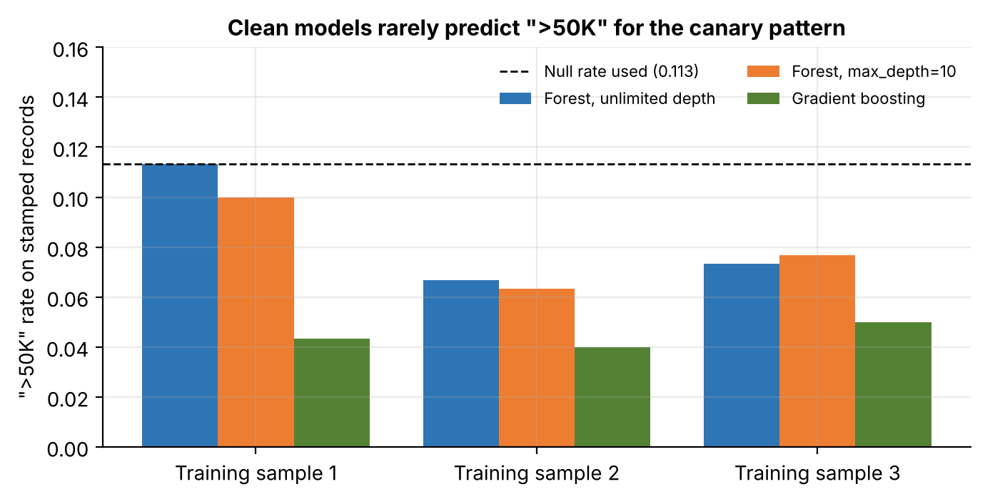
Figure 5. How often clean models predict ">50K" for the stamped records
Clean models said ">50K" between 4% and 11.3% of the time. I used the highest value, 11.3%, as the baseline, to be careful. A suspect model is flagged if its ">50K" rate is clearly above that (one-sided binomial test, p < 0.01).

4.2 Results
I tested 10, 20, 50 and 100 canaries, three model types, and three levels of data use, with 5 models each.
Table 4. Canary watermark: models flagged out of 5
Canaries | Model | 0% (innocent) | 50% used | 100% used
10 | Forest, unlimited depth | 0 | 2 | 5
10 | Forest, max_depth=10 | 0 | 0 | 1
10 | Gradient boosting | 0 | 5 | 5
20 | Forest, unlimited depth | 0 | 5 | 5
20 | Forest, max_depth=10 | 0 | 3 | 5
20 | Gradient boosting | 0 | 5 | 5
50 | All three models | 0 | 15 / 15 | 15 / 15
100 | All three models | 0 | 15 / 15 | 15 / 15

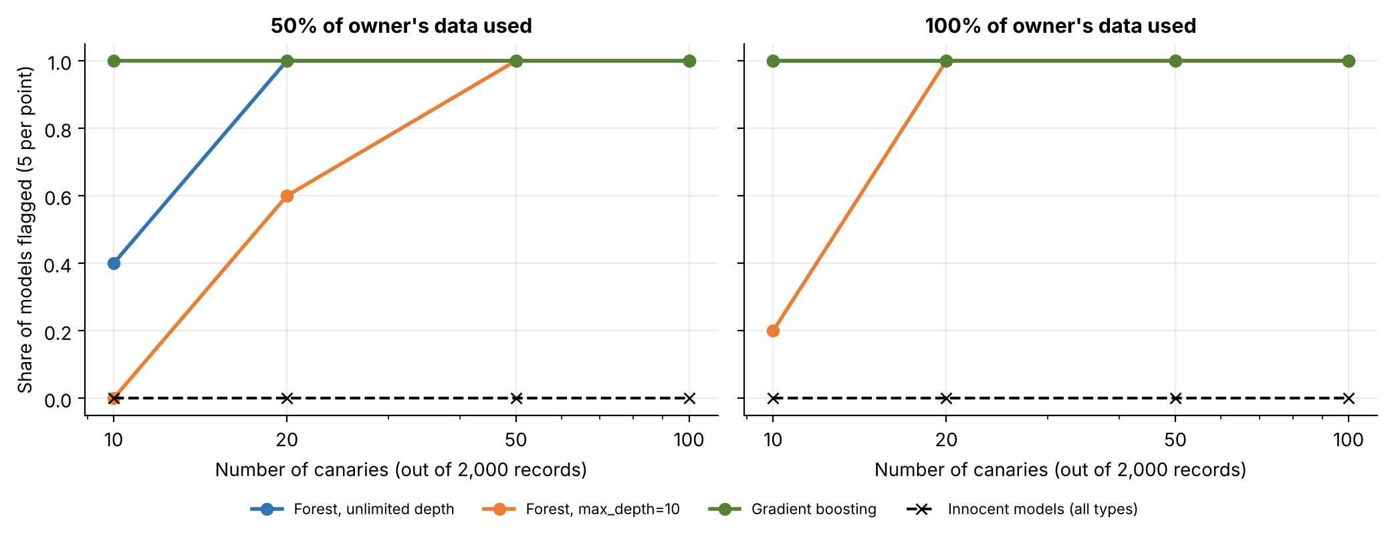
Figure 6. Share of models flagged by number of canaries, when 50% (left) or 100% (right) of the owner's data was used
Gradient boosting picks up the pattern almost immediately, even from 10 canaries. The regularized forest is the hardest to catch and needs about 50 canaries. From 50 canaries upward every guilty model is caught, whether it used half or all of the data. The dashed line at the bottom is the innocent models: none were ever flagged.
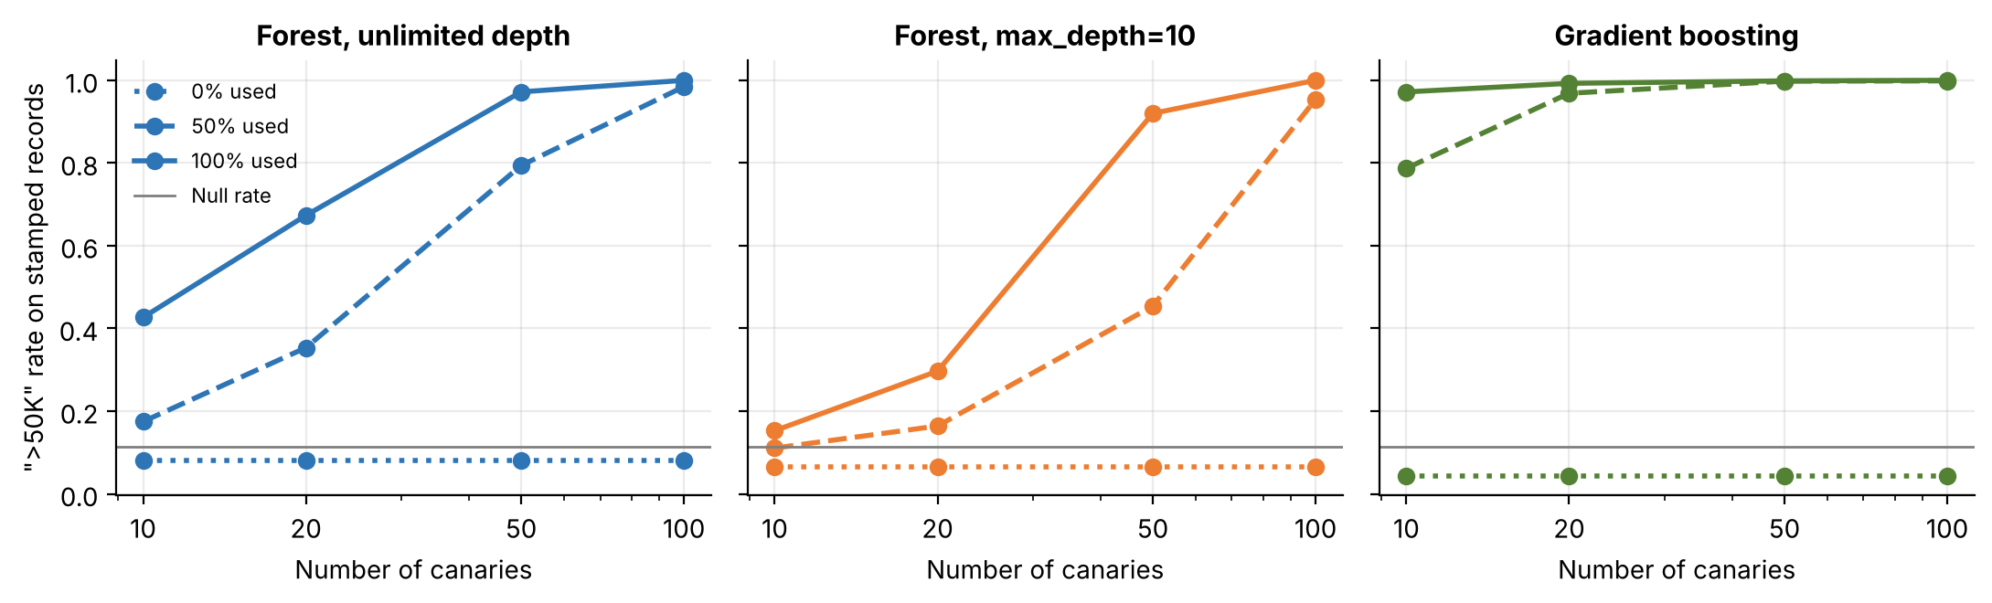
Figure 7. Share of stamped records predicted as ">50K" for each model type. Dotted: innocent, dashed: 50% used, solid: 100% used. Grey line: baseline
Figure 7 shows what is going on underneath. Innocent models stay flat below the baseline no matter how many canaries there are, because they never saw them. Guilty models climb steeply. With 50 canaries the regularized forest says ">50K" for 92% of stamped records when it used all of the data, compared with 7% for an innocent one.

5. Does the Watermark Hurt the Data?
Adding fake records could make the dataset less useful. To check, I trained the same regularized forest five times on the original owner data and five times on the watermarked version with 50 canaries, and compared test accuracy.
Table 5. Test accuracy with original and watermarked data
Run | Original data | Watermarked data | Change
1 | 0.8550 | 0.8543 | -0.0007
2 | 0.8547 | 0.8540 | -0.0007
3 | 0.8557 | 0.8533 | -0.0023
4 | 0.8537 | 0.8550 | +0.0013
5 | 0.8517 | 0.8547 | +0.0030

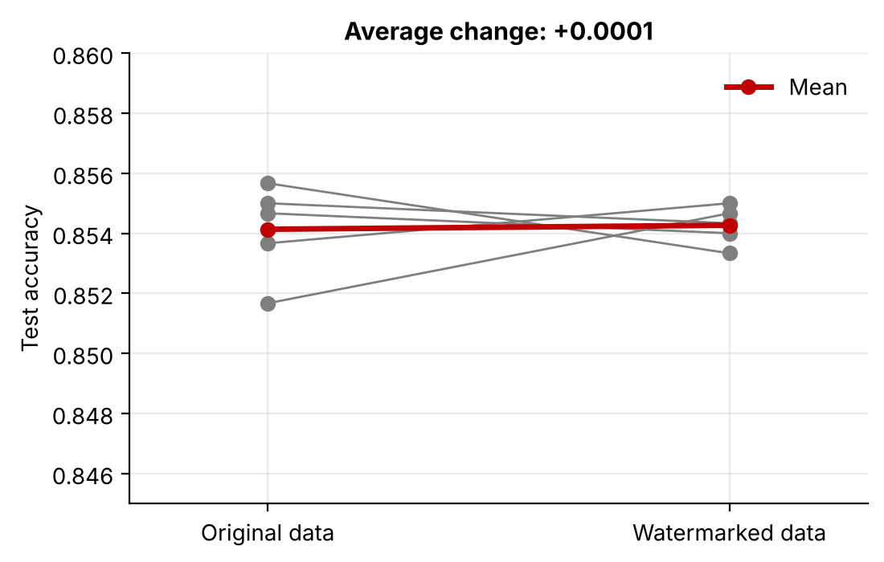
Figure 8. Test accuracy for each run, with original and watermarked data
The changes go both ways and average out to +0.0001, which is just noise. 50 canaries in 2,000 records are too few to affect normal predictions, but enough to be detected.

6. Comparing the Two Methods
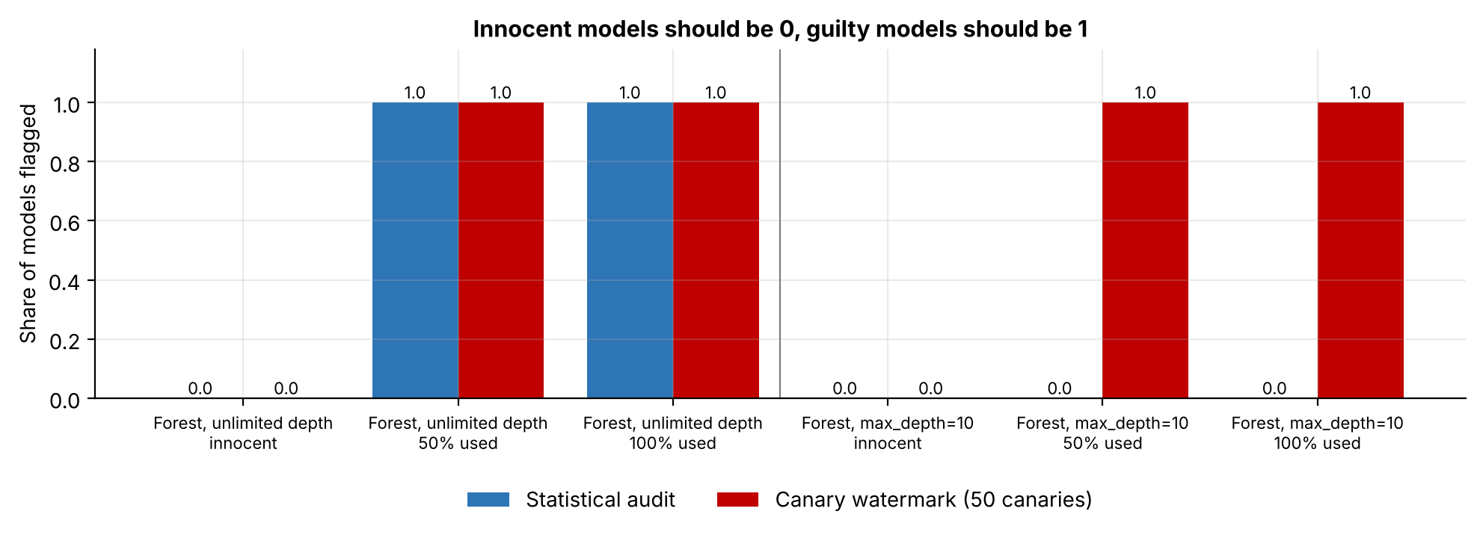
Figure 9. Share of models flagged by each method. Innocent models should be 0, guilty models should be 1
Figure 9 puts both methods side by side. On the unrestricted forest they do equally well. On the regularized forest the statistical audit catches nothing while the watermark catches everything. Neither method raises a false alarm.
Table 6. Strengths and weaknesses
 | Statistical audit | Canary watermark
Preparation needed | None | Must add canaries before sharing
Works on overfitting models | Yes, if 50% or more of data used | Yes
Works on regularized models | No | Yes, with 50 or more canaries
Works on gradient boosting | Not tested | Yes, even with 10 canaries
False alarms | None (0 / 20) | None (0 / 60)
Cost to the data | None | None measurable

7. Summary
Table 7. Main results
Result | Value
Statistical audit, unlimited forest, 50% or 100% of data used | 10 / 10 flagged
Statistical audit, regularized forest, 100% of data used | 0 / 10 flagged
Canary watermark (50 canaries), all guilty models | 30 / 30 flagged
Innocent models wrongly flagged, both methods | 0 / 80
Accuracy change caused by the watermark | +0.0001

If you can prepare your data before sharing it, a canary watermark is a reliable way to prove later that it was used. It worked across model types and regularization, never accused an innocent model, and cost nothing in accuracy. If the data is already out there, the statistical audit is the only option, but it only works when the model overfits and used a large share of the data.

8. Limitations and Next Steps
Limitations
- The canary pattern is very unusual (a 17-year-old working 99 hours a week). A careful model trainer could find and remove it with simple outlier filtering before training.
- The statistical audit only compares average confidence. A stronger membership score might make it work on regularized models too.
- Only tabular data and tree-based models were tested.
- Some settings used only 5 models, so the detection rates there are rough.
Next steps
- Design canaries that look like normal records, so they are hard to filter out.
- Use a shadow-model membership score in the statistical audit.
- Repeat with neural networks and image data.

9. How to Run
Everything is in one notebook, dataset_ownership_auditing.ipynb. It downloads the data by itself, runs all experiments and saves the 9 figures to the figures folder. Random seeds are fixed, so the numbers match this document. A full run takes about 4 minutes.
pip install -r requirements.txt
jupyter notebook dataset_ownership_auditing.ipynb

On Windows you can also double-click setup_and_run.bat, which creates a Python environment, installs the packages and opens Jupyter.
Table 8. Project files
File | What it is
dataset_ownership_auditing.ipynb | Notebook with all experiments
figures/ | The 9 figures used in this document
requirements.txt | Python packages needed
setup_and_run.bat | One-click setup on Windows
README.md | Short project overview

10. References
- Maini, P., Yaghini, M., & Papernot, N. (2021). Dataset Inference: Ownership Resolution in Machine Learning. International Conference on Learning Representations (ICLR).
- Shokri, R., Stronati, M., Song, C., & Shmatikov, V. (2017). Membership Inference Attacks against Machine Learning Models. IEEE Symposium on Security and Privacy.
- Becker, B., & Kohavi, R. (1996). Adult. UCI Machine Learning Repository.

