ScrollNudge
Can a small nudge break the habit of mindless scrolling?

Project documentation: a single-person experiment
Aakash Tiwari
M.S. Cybersecurity, Rowan University
November 2026
github.com/aakashtiwarisolutions/scrollNudge

Contents
1. Summary
2. The idea behind it
3. What ScrollNudge does
4. How it works
5. The experiment
6. The check-in question
7. The nudge
8. The detector
9. What gets measured
10. Privacy
11. How to use it
12. Results
13. Limitations
14. Future work
15. Tools used
References

1. Summary
Most of us know the feeling: you open YouTube or Reddit to check one thing, and twenty minutes later you are still scrolling without really knowing why. ScrollNudge is a small experiment to find out whether a gentle message at the right moment can break that habit.
ScrollNudge is a Chrome extension. It quietly measures how I scroll on social sites, sometimes asks me one short question about how intentional my scrolling is, and learns what my "mindless" scrolling looks like. When it thinks I have slipped into mindless scrolling, it shows a gentle nudge.
The important part is the experiment design. Over three weeks, each day is randomly chosen to be a nudge day or a no-nudge day. Because the days are picked at random, any difference between them can be fairly credited to the nudges, not to busy weeks, weekends or mood.

In one minute
- Question: if mindless scrolling is a human habit rather than something the phone or website forces on us, can a small, well-timed nudge interrupt it?
- Method: a 21-day experiment on myself: 7 days of normal use, then 14 days randomly split into 7 nudge days and 7 no-nudge days.
- Machine learning: a detector trained on my own check-in answers decides when to nudge.
- Privacy: no page content, links or screenshots are recorded, and all data stays on my computer.
- Status: the tool is built and tested. Results will be added after day 21.

2. The idea behind it
Dr. Maxi Heitmayer at Rowan University studies how people really use their phones. In his research, people wear small cameras that record their day, then watch the footage and explain what they were thinking at each moment. One finding stands out: people often blame their phones for distracting them, but most of the time the person picks up the phone, not the other way round. People also often look up after a few minutes and wonder what they were doing.
If that is true, then mindless scrolling is mostly a habit. Habits run on autopilot, and autopilot can sometimes be interrupted by a simple question like "are you still doing this on purpose?" This idea comes from behavioral science, where small design changes that gently guide behavior are called nudges.
ScrollNudge tests this idea on one person (me), with a design strict enough to give a fair answer.

Why test it on one person?
A study with one participant is called an n-of-1 study. It cannot tell us what works for everyone, but it is a fast and honest way to try an idea before running a bigger study. It also needs no other participants, so it can start straight away. The same design can later be used with many people, once ethics approval is in place.

3. What ScrollNudge does
Part | What it does | When
Measure | Records scrolling, clicks and key presses every 10 seconds on social sites | Always
Check-in | Asks: "How intentional is your scrolling right now?" from 1 to 5 | Every 8-16 min in week 1, every 20-30 min later
Detect | Gives each moment a "mindless" score using a machine learning model | Always
Nudge | Shows a gentle message when the score is high | Only on nudge days
Shadow nudge | Records the moment a nudge would have appeared, without showing anything | Week 1 and no-nudge days
Export | Downloads all data as CSV files for analysis | Whenever I click Export

It works on YouTube, Instagram, Facebook, X, Reddit, LinkedIn and TikTok. On every other website it does nothing.

4. How it works
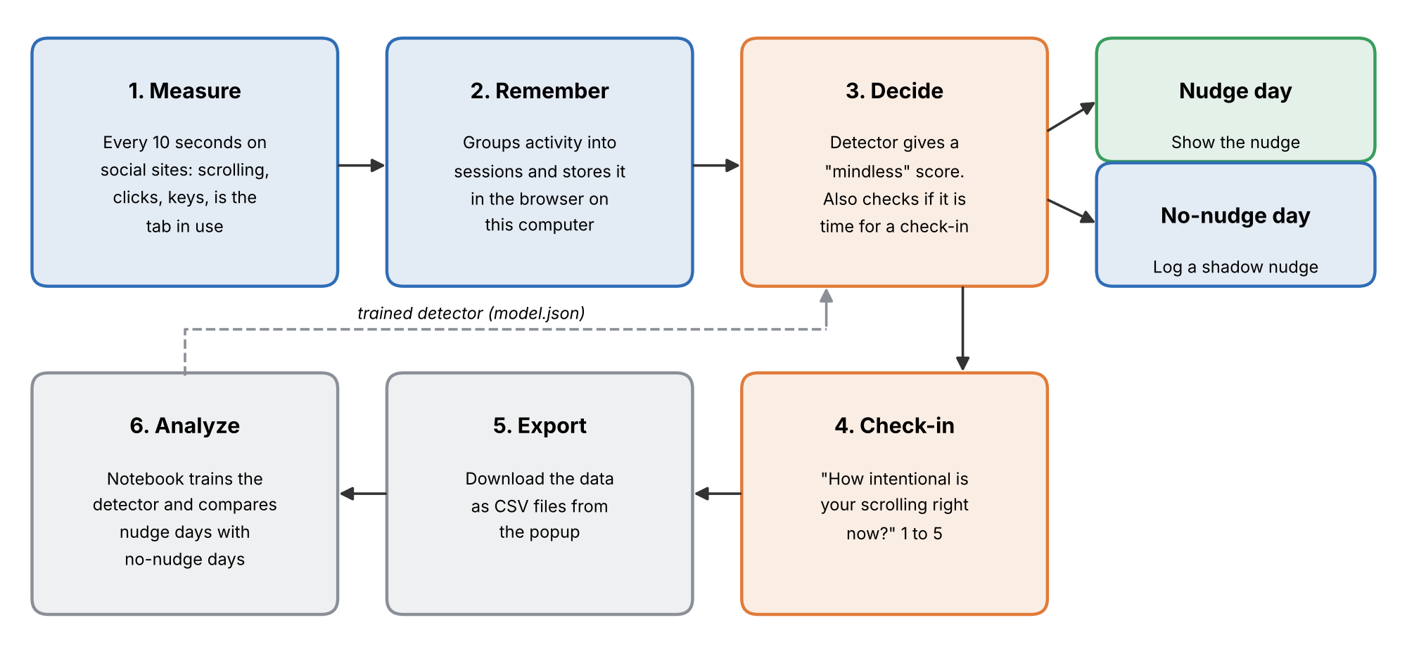
Figure 1. The path from scrolling to a nudge, and from data to analysis.
- Measure: every 10 seconds, the extension counts how far I scrolled, how many times I changed direction, how many times I clicked or typed, and whether the tab was actually open in front of me.
- Remember: it groups this activity into sessions. A session is time on one site with no break longer than 3 minutes. Everything is saved inside Chrome on my computer.
- Decide: the detector looks at the last two minutes and gives a score between 0 and 1. A high score means "this looks like mindless scrolling".
- Nudge or shadow nudge: if the score is high, the session is at least 5 minutes long, and there has been no nudge in the last 10 minutes, ScrollNudge either shows a nudge (on nudge days) or quietly writes down that it would have (on other days).
- Check-in: every so often, it asks how intentional my scrolling is. These answers teach the detector and also measure how I feel.
- Export and analyze: the data is downloaded as CSV files and analyzed in a Jupyter notebook.

5. The experiment
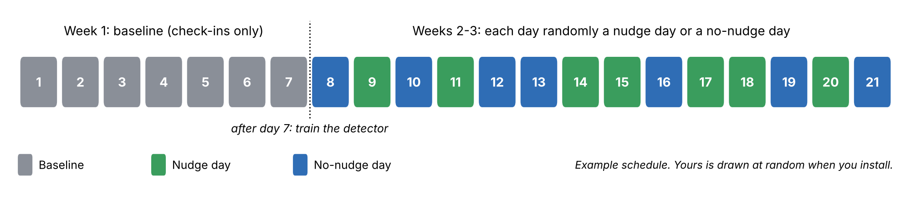
Figure 2. The 21-day plan. Each colored box is one day.

Week 1: baseline
ScrollNudge only measures and asks check-in questions. No nudges are shown. This week shows what my normal scrolling looks like and collects the answers needed to train the detector.

After day 7: training
I export the data and run the first part of the notebook. It learns which scrolling patterns came before my "mindless" answers and saves the result as a small file called model.json, which I load back into the extension.

Weeks 2 and 3: the real test
Each of the 14 days is randomly a nudge day or a no-nudge day, 7 of each. The schedule is drawn once, at random, when the extension is installed, so I cannot pick "good" days for nudges without realizing it.

Why shadow nudges matter
Imagine testing whether an umbrella keeps you dry. You must compare rainy days with the umbrella to rainy days without it, not to sunny days. In the same way, a nudge only appears at "mindless" moments, so it is unfair to compare those moments with ordinary scrolling.
On no-nudge days, the detector keeps watching and records every moment it would have nudged me. These shadow nudges are the "rainy days without the umbrella". Comparing real nudges with shadow nudges shows the true effect of the message.

6. The check-in question
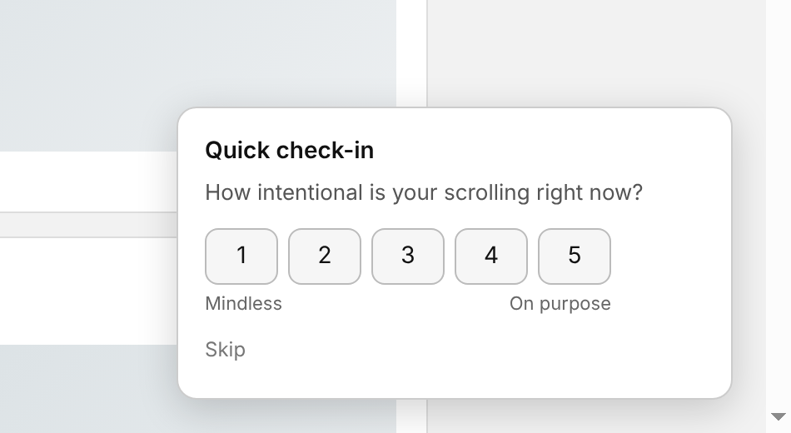
Figure 3. The check-in card, shown in the corner of the page.
The question is short so that it takes about two seconds to answer: "How intentional is your scrolling right now?" from 1 (mindless) to 5 (on purpose). Answers of 1 or 2 count as mindless.
Asking short questions at random moments during the day is a well-known psychology method called experience sampling. It is more accurate than asking people at the end of the day, because memory of how we felt fades quickly.
If I do not answer within a minute, the card disappears and the miss is recorded. There is also a Skip button.

7. The nudge
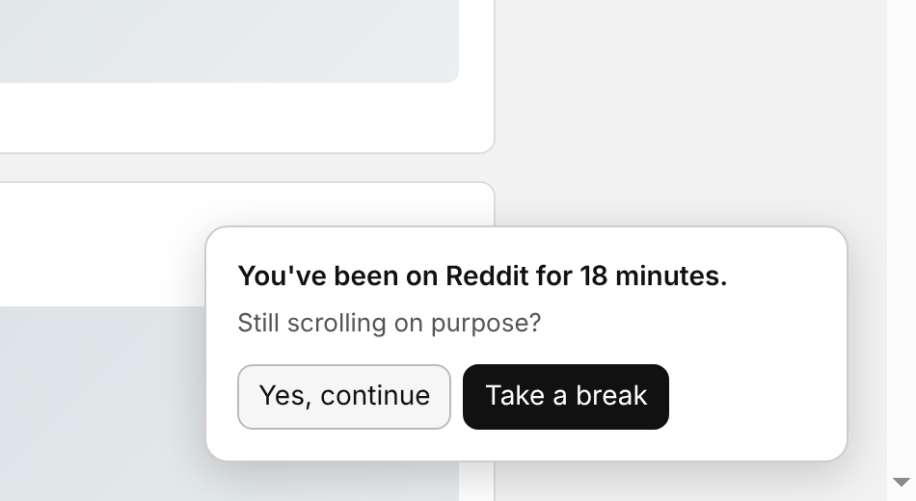
Figure 4. The nudge, shown only on nudge days.
The nudge is deliberately gentle: "You've been on Reddit for 18 minutes. Still scrolling on purpose?" with two buttons, "Yes, continue" and "Take a break". Nothing is blocked, and the website keeps working.
This matters for the research question. If the nudge forced me to stop, it would only show that blocking works. A gentle question tests whether becoming aware of the habit is enough to change it.

8. The detector
The detector is a logistic regression model, a simple and easy-to-explain machine learning model. It looks at these clues about the current session and the last two minutes of scrolling:
Clue | What it means | Why it might matter
Minutes into session | How long I have been on the site | Long sessions often drift into autopilot
Scroll speed | Pixels scrolled per second | Fast, steady scrolling can mean skimming without reading
Clicks per minute | How often I click | Few clicks can mean passive scrolling
Direction changes | Scrolling up and down | Going back can mean actually reading something
Pause share | Time with no scrolling | Pauses can mean reading or watching
Time of day | Hour, as a circle so 11 PM is close to midnight | Late-night scrolling may be more mindless
Time since last visit | Minutes since the previous session | Coming back quickly can be a habit loop

Before training: during week 1 the extension uses a simple starter rule: nudge after about 15 minutes of scrolling with few clicks.
Training: the notebook trains the model on my week 1 check-ins. To test it fairly, it is always tested on days it did not learn from. It then picks the score threshold that best balances catching mindless moments against nudging too often.
A safety check: if there are fewer than 5 mindless and 5 intentional answers, the notebook refuses to train and asks for more data. If the model is weak, it says so, and the nudge then behaves much like a timer.

9. What gets measured
Question | Measure | Compared
Do I scroll less? | Minutes of scrolling per day | Nudge days vs no-nudge days
Are sessions shorter? | Average session length, and sessions over 20 minutes | Nudge days vs no-nudge days
Does the nudge make me stop? | Share of moments followed by stopping within 3 minutes | Real nudges vs shadow nudges
Do I feel more in control? | Average check-in rating | Nudge days vs no-nudge days
When do I scroll mindlessly? | Check-in ratings by session time and time of day | Across all days

How results are tested: with only 14 experiment days, ordinary statistics can be unreliable. Instead, the notebook uses an exact permutation test. It reshuffles the "nudge" and "no-nudge" labels across the 14 days in all 3,432 possible ways and checks how often a difference as large as the real one appears just by chance. If it is rare, the nudge probably had a real effect.

10. Privacy
Scrolling data is personal, so privacy was part of the design from the start.
Recorded | Not recorded
How far I scrolled, clicks and key presses (counts only) | Which keys I pressed or what I typed
Which site (for example "Reddit") | Page addresses, posts, videos or comments
Time, session length, check-in answers | Screenshots or anything I looked at

- All data stays inside Chrome on my own computer until I choose to export it.
- The exported data folder is excluded from GitHub, so only code, charts and summary results are shared.
- The "Restart study" button deletes everything.
- Only my own behavior is recorded. Studying other people would need approval from Rowan's ethics board (IRB) first.

11. How to use it
Step | What to do
Install | Open chrome://extensions, turn on Developer mode, click Load unpacked and choose the extension folder. Pin the icon.
Days 1-7 | Browse as usual and answer every check-in honestly.
Day 8 morning | Click the icon, then Export data. Put the CSV files in analysis/data and run Part 1 of the notebook. Load the new model.json from the popup.
Days 8-21 | Browse as usual. On nudge days, react to nudges naturally.
After day 21 | Export again and run the whole notebook to get the results and charts.

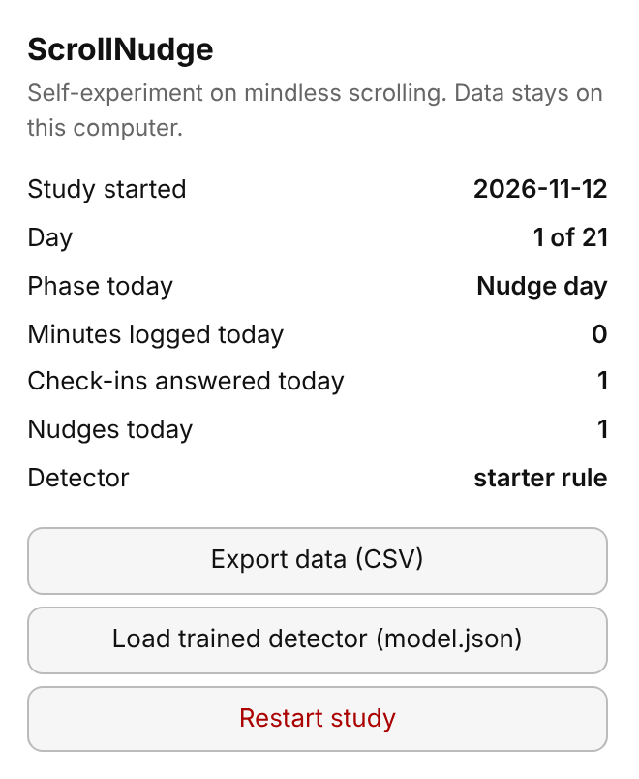
Figure 5. Clicking the ScrollNudge icon shows the current day, today's phase and simple counts.

12. Results
The experiment runs for 21 days, so results will be added here after day 21. This section will include:
- daily scrolling time on nudge days and no-nudge days
- how often I stopped after a real nudge compared with a shadow nudge
- how accurate the detector was on days it had not seen
- how intentional my scrolling felt over the course of a session

13. Limitations
- One person: the results describe my habits only. This is a pilot study, not a general finding.
- Laptop only: scrolling on my phone is not recorded, and phones are where most scrolling happens.
- Being watched: knowing about the experiment may change how I scroll, especially in the first few days.
- Small number of days: 7 nudge days and 7 no-nudge days can only detect fairly large effects.
- Check-ins are also interruptions: every check-in may itself act as a small nudge. They happen equally on both kinds of days, so the comparison stays fair, but the overall effect of nudges may look smaller than it really is.

14. Future work
- Phone version: an Android app that measures phone scrolling, where the habit is strongest.
- More people: run the same design with several participants, with ethics approval, to see whether the effect holds across people.
- Different nudges: compare wording, timing and style, for example a question versus a simple time reminder.
- Combine with wearable-camera research: link the detector's scores to what people say about their own footage in studies like Dr. Heitmayer's.

15. Tools used
Tool | Used for
JavaScript, Chrome extension (Manifest V3) | Measuring scrolling, check-ins, nudges, storing data
Python, pandas, NumPy | Loading and preparing the exported data
scikit-learn | Training and testing the detector
matplotlib | Charts
Jupyter Notebook | The full analysis in one place
Playwright | Testing the extension in a real browser

References
Rowan Today (2026). Maxi Heitmayer: human-computer interaction. today.rowan.edu/news/2026/04/maxi-heitmayer-human-computer-interaction.html
Thaler, R. H., & Sunstein, C. R. (2008). Nudge: Improving Decisions About Health, Wealth, and Happiness. Yale University Press.
Csikszentmihalyi, M., & Larson, R. (1987). Validity and reliability of the Experience-Sampling Method. Journal of Nervous and Mental Disease, 175(9), 526-536.

