building_id, damage_grade

a3380c4f75, Grade 3

a338a4e653, Grade 1

a338a4e6b7, Grade 1

a33a6eaa3a, Grade 5

a33b073ff6, Grade 4

Data dictionary:

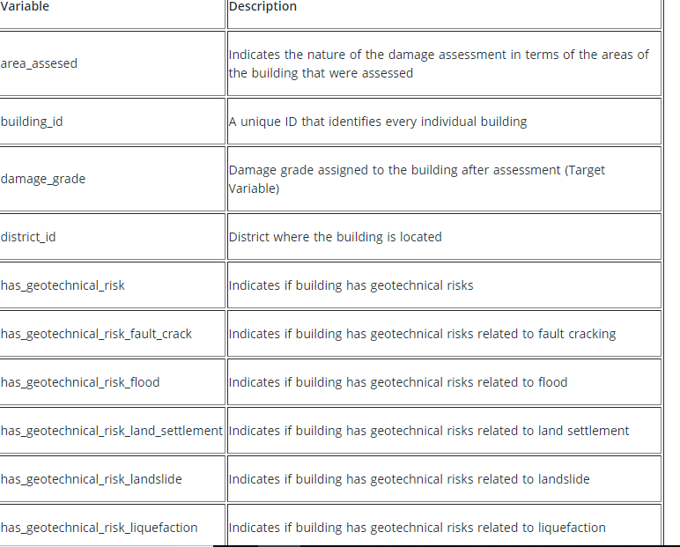

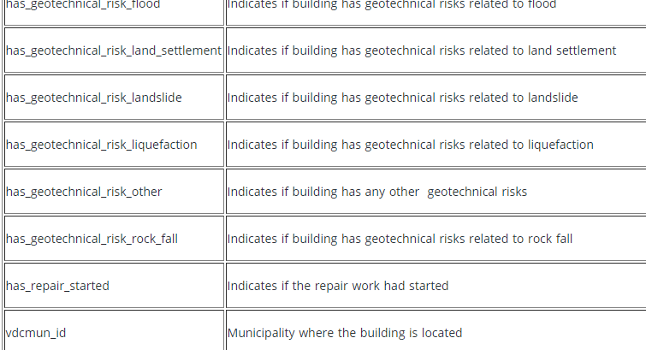

Build on Multinomial logistic regression