Github Link: <https://github.com/aakashvardhan/thyroid_recurrence_predictor>

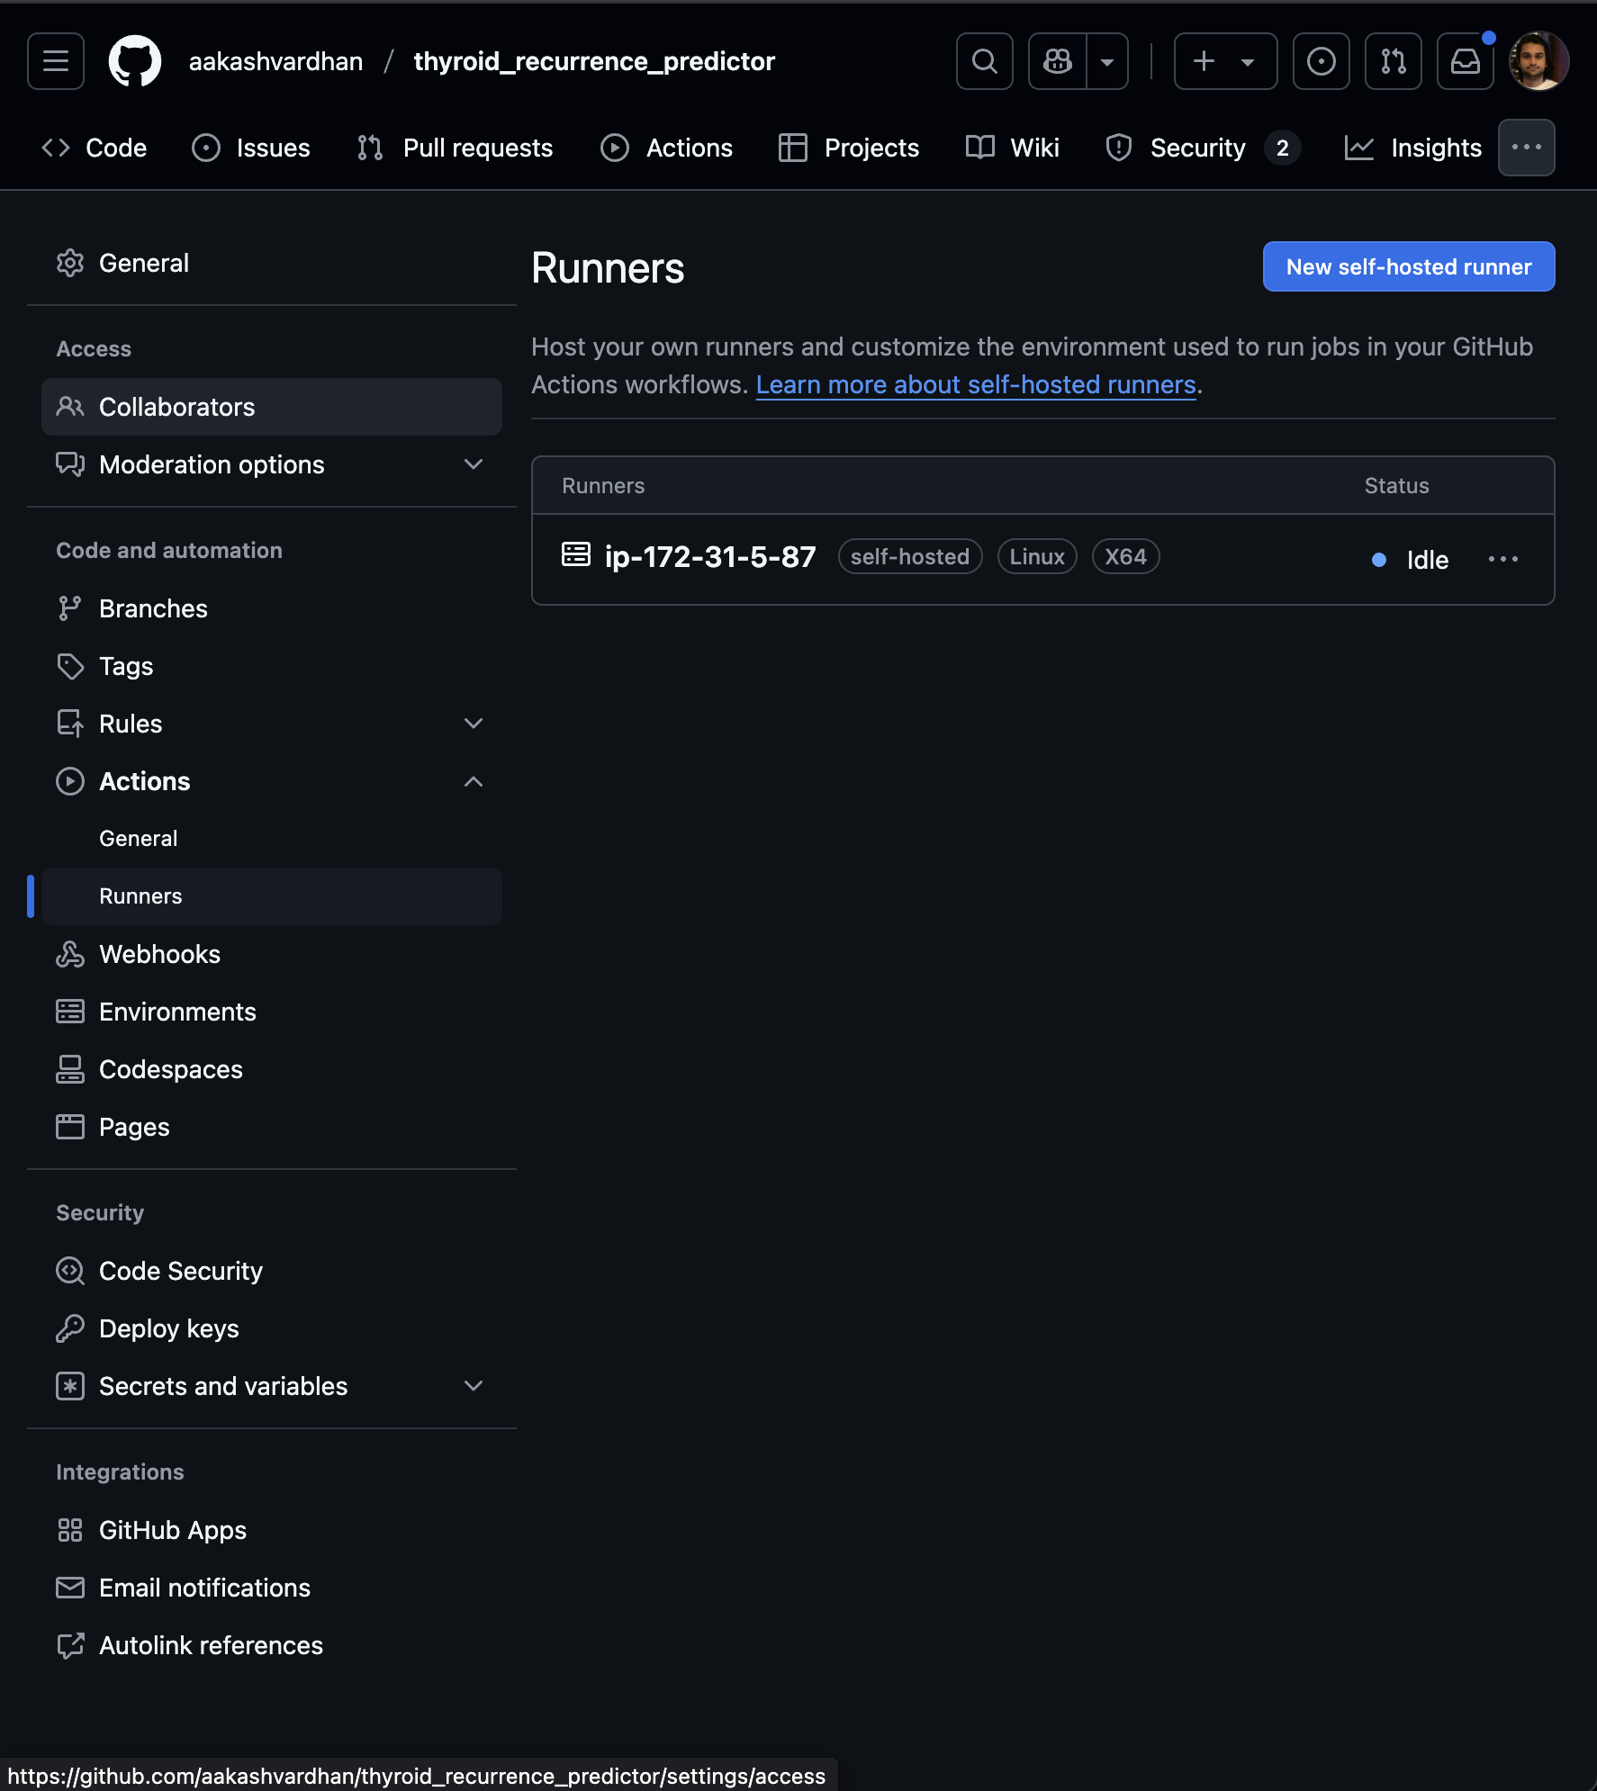

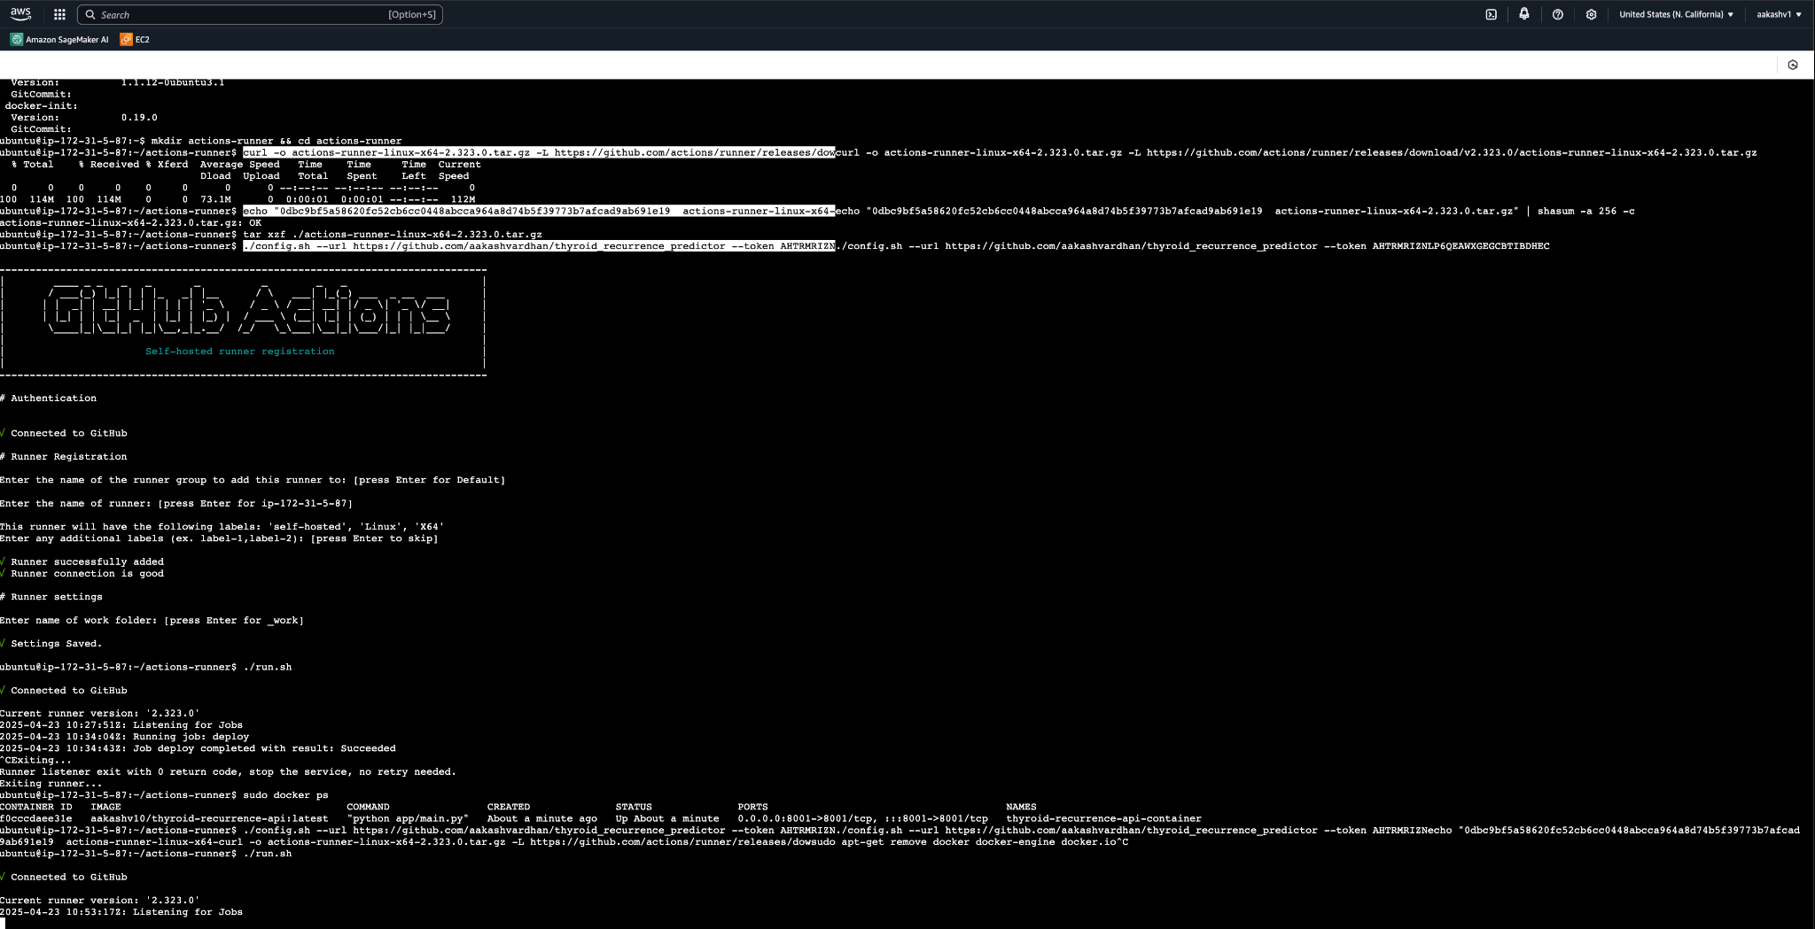

For Documentation please go to <https://github.com/aakashvardhan/thyroid_recurrence_predictor/blob/main/README.md>

The readme file gives a full documentation of the steps I have taken. Please let me know if you have any questions