RAVANA
  - Phishing tool

Prince kumar

How to Use
Ravana
1
1.Installation 1
2.using 2

Type these command

apt update && apt upgrade
apt-get install git
git clone https://github.com/princekrvert/Ravana.git
cd Ravana

chmod +x ravana.sh
./ravana.sh

After typing these command . it will take time to install all require pkg .it's depand upon your internet speed .
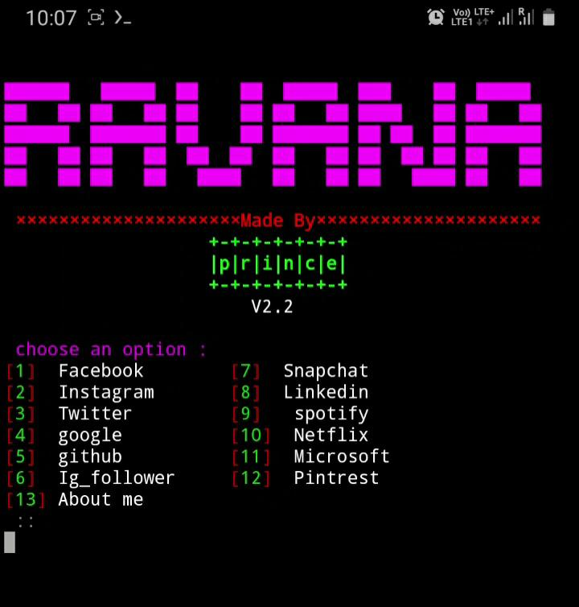
First loo
Now to choose your option
According to your requirement
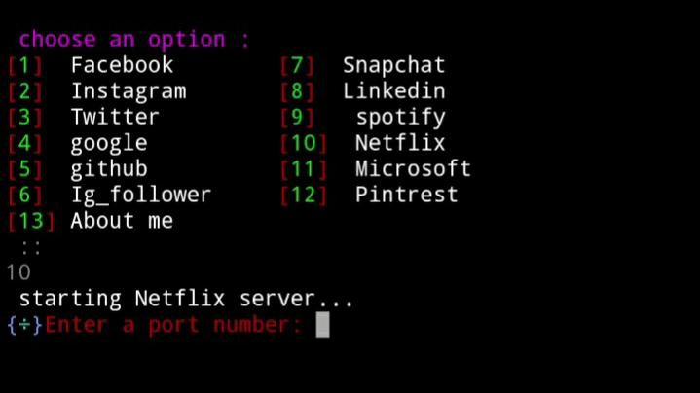
I am choosing number 10 for netflix

Now type a port number above 1023
It will generate a link for your localhost
Something like this
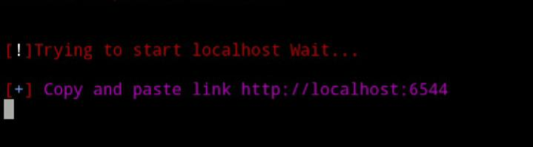

Note :- This tool does not provide port forwoding options Now so you have to forward this link using ngrok but i am testing on my localhost…

- Copy this link and paste into your browser
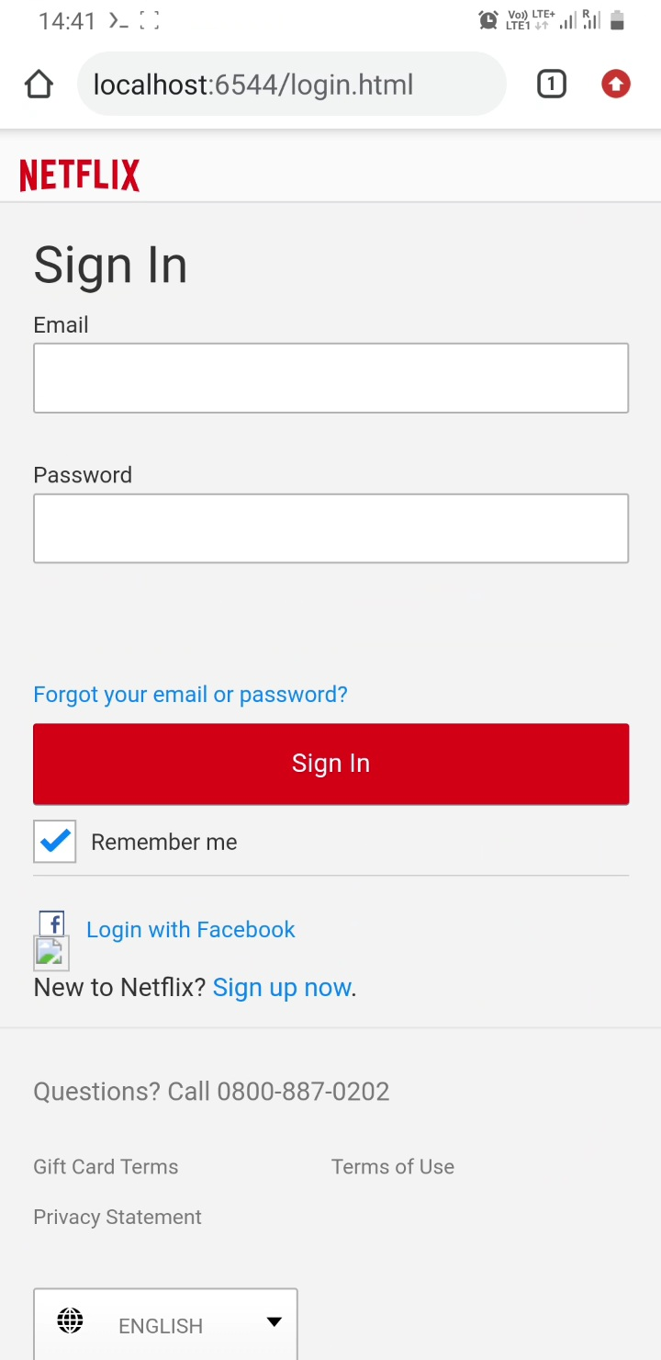
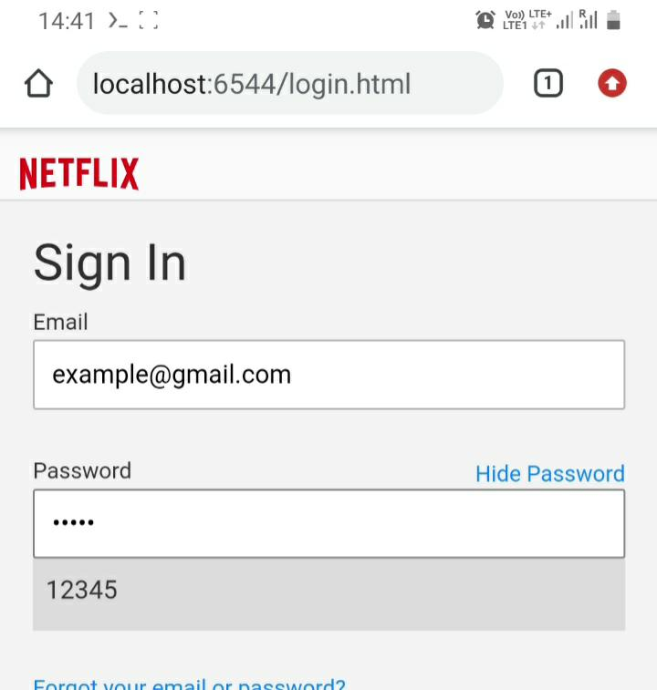
I am typing some random username and password like this

Now go to your termux
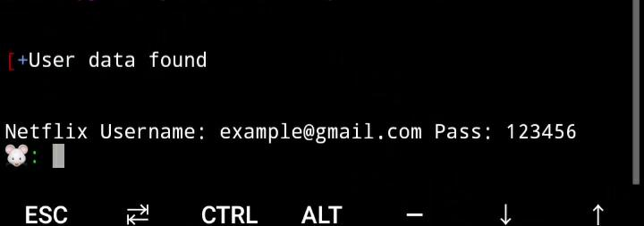
warning - This tool is created for testing and educational purposes only. I am not responsible for any illegal activity
- About me
My name is prince kumar I am a junior mechanical engineer . I am not a expert so if you have any suggestion
Please give me …
You can find me on
YouTube
Instagram
Facebook

