- Decrypt me if possible : Im a Ceaser
“ Upjl tllapun fvb! “

- Crack me if you can : I belong to MD5 family
67881381dbc68d4761230131ae0008f7

3. How Secure is my password?
R0ckY0u!R0ckY0u! (How long it would take a computer to crack my password?)
4. Can u help me get the secret is my audio file ?
BabyElephantWalk60 (1) - Attached in questions folder
5. Get my password if you can telnet-cooked (1) in this packet
6. Get my hidden password in my favourite picture
Attchment : Coversteg
7. What is the vulnerability in the below code
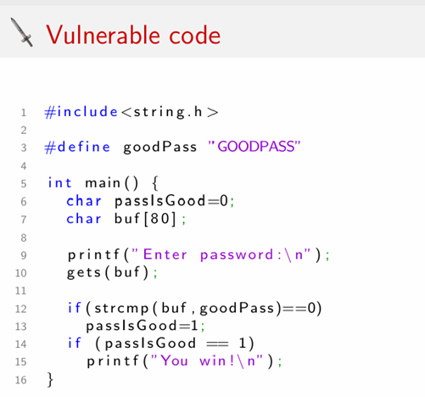
8. What I mean?
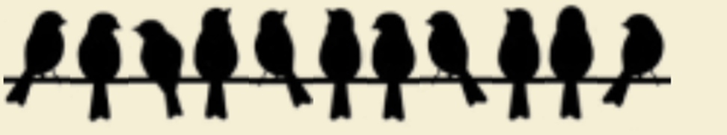

9. How severe my vulnerability is?
CVSS:3.1/AV:N/AC:L/PR:N/UI:N/S:C/C:H/I:H/A:H

10. Which special character is used to test if my application is vulnerable to sql injection? Mention that special character in hex decimal value

11. L0v3S3cUr!t% - what is this language called? Answer back in same language
L33t

12. Analyze the below code and find the vulnerability

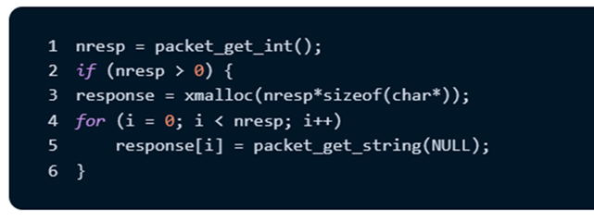

13. How many hosts are live in 81.22.234.0 subnet and which host has the open port of 8080?

14. Who Am i? (OSINT)
“Santhya Rajendran” received an award from “Indian Achievers Award”, under which category?
Hint : Webmii

15. Which type of social engineering attack can be performed to target the employees of dover?

16. Create a dictionary of atm pin number and tell me which pin number belongs to serial number 123 ?

17. Find the CEW id of the vulnerability in the “circel-calulator.cpp”(attached) file.

18. What is the name of the possible attack using the below image
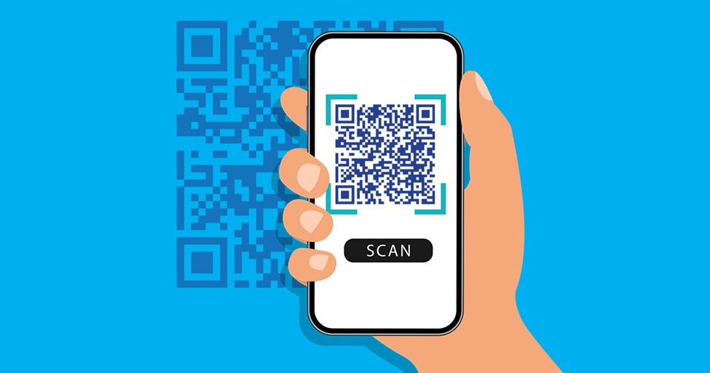

19. What payload is this?
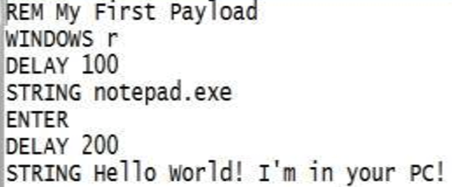

20. STRIDE - what does R stands for?
21. DREAD - what does R stands for?
22. SMART - what does R stands for?
23. DIE - what does I stands for?
24. LIND DUN - what does U stands for?
25. What is Airtel ZeroTouch default username and password?

Airtel ZeroTouch default username – admin
Airtel ZeroTouch default password – password

