KPR INSTITUTE OF ENGINEERING AND TECHNOLOGY
DEPARTMENT OF COMPUTER SCIENCE AND ENGINEERING

WEB TECHNOLOGY – ASSIGNMENT I
U21CS501

Name: Aakash Yadav
Roll No: 24CS281
Year / Semester: III Year / V Semester
Section: A
Academic Year: 2026–2027

Table of Contents
1. Introduction
2. Scenario 1 – Web Fundamentals
3. Scenario 2 – Student Admission Form
4. Scenario 3 – Fashion Store Homepage
5. Scenario 4 – Student Grade Calculator
6. Scenario 5 – Supermarket Billing System
7. Conclusion

1. Introduction
This individual assignment demonstrates HTML5, CSS3 and JavaScript concepts through five practical scenarios. Each section includes the objective, implementation details, sample source code and a screenshot of the tested browser output.

2. Scenario 1 – Web Fundamentals
Objective: Create a simple HTML webpage explaining Internet overview, computer networks, URL structure, domain names, browsers and servers, website working principles, and client-side versus server-side scripting, with a visual illustration.

Implementation
The page uses semantic HTML5 sections and a local campus photograph as a visual illustration. The flow cards show the basic movement from a device through a network and Internet service, while comparison sections explain browser/server and client/server scripting concepts.
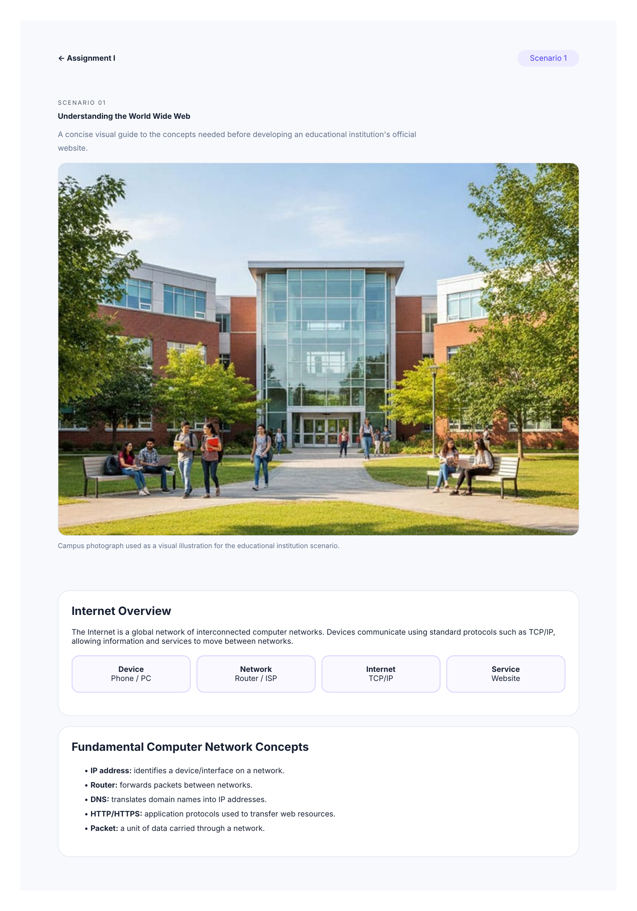
Figure 1: Tested Scenario 1 browser output with the campus photograph and Web fundamentals sections.

HTML Source Code – Scenario 1
<!doctype html>
<html lang="en">
<head>
<meta charset="utf-8">
<meta name="viewport" content="width=device-width, initial-scale=1">
<title>Scenario 1 · Web Fundamentals</title>
<link rel="stylesheet" href="../css/style.css">
</head>
<body>
<div class="page">
<nav class="nav">
<a href="../index.html">← Assignment I</a>
<span class="pill">Scenario 1</span>
</nav>

<header class="hero">
<span class="eyebrow">SCENARIO 01</span>
<h1>Understanding the World Wide Web</h1>
<p>A concise visual guide to the concepts needed before developing an educational institution's official website.</p>
<img class="content-photo" src="../assets/campus.jpg" alt="College campus building with students">
<p class="photo-caption">Campus photograph used as a visual illustration for the educational institution scenario.</p>
</header>

<section class="section">
<h2>Internet Overview</h2>
<p>The Internet is a global network of interconnected computer networks. Devices communicate using standard protocols such as TCP/IP, allowing information and services to move between networks.</p>
<div class="flow">
<div><b>Device</b><br>Phone / PC</div>
<div><b>Network</b><br>Router / ISP</div>
<div><b>Internet</b><br>TCP/IP</div>
<div><b>Service</b><br>Website</div>
</div>
</section>

<section class="section">
<h2>Fundamental Computer Network Concepts</h2>
<ul>
<li><b>IP address:</b> identifies a device/interface on a network.</li>
<li><b>Router:</b> forwards packets between networks.</li>
<li><b>DNS:</b> translates domain names into IP addresses.</li>
<li><b>HTTP/HTTPS:</b> application protocols used to transfer web resources.</li>
<li><b>Packet:</b> a unit of data carried through a network.</li>
</ul>
</section>

<section class="section">
<h2>URL and its Structure</h2>
<p class="url">https://www.example.com:443/courses/web/index.html?year=2026#overview</p>
<ul>
<li><b>https</b> — scheme/protocol</li>
<li><b>www.example.com</b> — host/domain</li>
<li><b>:443</b> — port</li>
<li><b>/courses/web/index.html</b> — path</li>
<li><b>?year=2026</b> — query string</li>
<li><b>#overview</b> — fragment</li>
</ul>
</section>

<section class="section">
<h2>Domain Name</h2>
<p>A domain name is a human-readable web address used to identify a website, such as <b>example.com</b>. DNS maps the name to the IP address used for communication.</p>
</section>

<section class="section">
<h2>Web Browsers and Web Servers</h2>
<div class="compare">
<div>
<h3>Web Browser</h3>
<p>Client software such as Chrome, Safari or Firefox. It sends requests, receives resources and renders HTML/CSS/JavaScript for the user.</p>
</div>
<div>
<h3>Web Server</h3>
<p>A system/software that receives HTTP requests and returns resources such as HTML, CSS, JavaScript, images or generated responses.</p>
</div>
</div>
</section>

<section class="section">
<h2>Working Principle of a Website</h2>
<div class="flow">
<div><b>1. User</b><br>enters URL</div>
<div><b>2. DNS</b><br>finds server</div>
<div><b>3. Server</b><br>processes request</div>
<div><b>4. Browser</b><br>renders response</div>
</div>
<p>The browser may request additional CSS, JavaScript, images and media after receiving the initial HTML. The server can also communicate with databases or other services before returning a response.</p>
</section>

<section class="section">
<h2>Client-side vs Server-side Scripting</h2>
<div class="compare">
<div>
<h3>Client-side</h3>
<ul>
<li>Runs mainly in the user's browser.</li>
<li>JavaScript is a common example.</li>
<li>Useful for interaction and immediate UI updates.</li>
</ul>
</div>
<div>
<h3>Server-side</h3>
<ul>
<li>Runs on the web server.</li>
<li>Examples include Node.js, PHP, Python and Java server applications.</li>
<li>Useful for authentication, database access and server-generated responses.</li>
</ul>
</div>
</div>
</section>
</div>
</body>
</html>

3. Scenario 2 – Student Admission Form
Objective: Design a responsive Student Admission Form using HTML5 and CSS3 demonstrating form elements, different input types, image/audio/video media, CSS3 selectors, the box model and responsive user interface design.

Implementation
The form contains text, date, email, telephone, select, number, radio, file, textarea, password, time and checkbox controls. A local campus photograph, audio clip and video demonstrate HTML5 media elements. CSS grid and media queries make the form responsive.
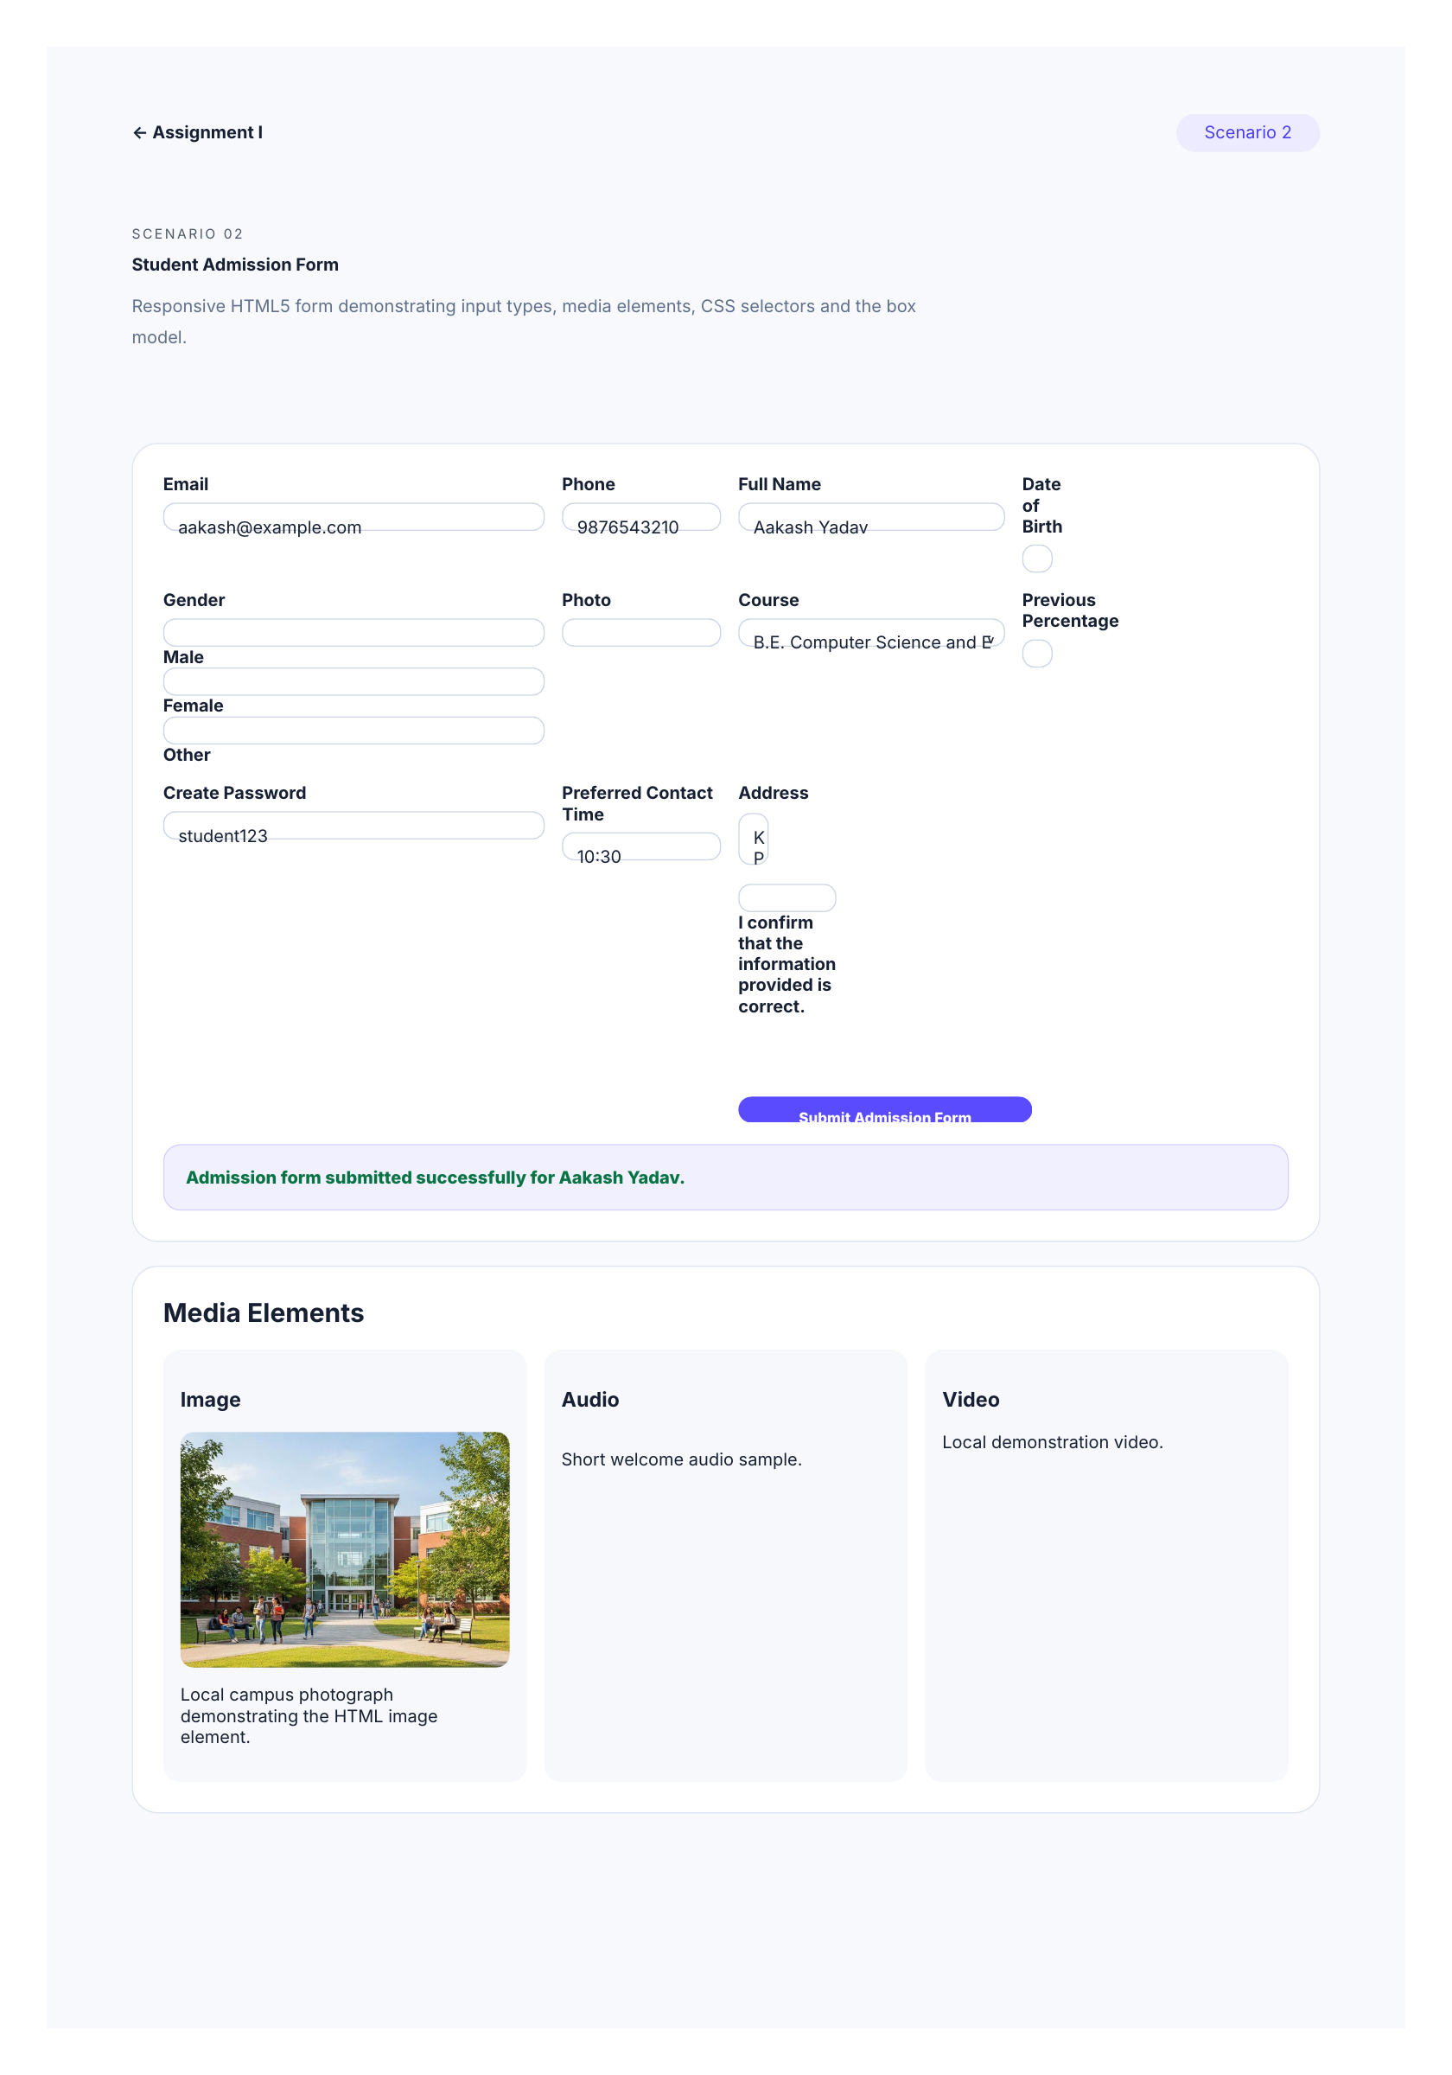
Figure 2: Tested Scenario 2 browser output showing the filled admission form, successful submission message and media elements.

HTML Source Code – Scenario 2
<!doctype html>
<html lang="en">
<head>
<meta charset="utf-8">
<meta name="viewport" content="width=device-width, initial-scale=1">
<title>Scenario 2 · Admission Form</title>
<link rel="stylesheet" href="../css/style.css">
</head>
<body>
<div class="page">
<nav class="nav">
<a href="../index.html">← Assignment I</a>
<span class="pill">Scenario 2</span>
</nav>

<header class="hero">
<span class="eyebrow">SCENARIO 02</span>
<h1>Student Admission Form</h1>
<p>Responsive HTML5 form demonstrating input types, media elements, CSS selectors and the box model.</p>
</header>

<section class="section">
<form id="admissionForm" class="form-grid">
<div class="field">
<label for="name">Full Name</label>
<input id="name" name="name" type="text" value="Aakash Yadav" placeholder="Enter full name" required>
</div>
<div class="field">
<label for="dob">Date of Birth</label>
<input id="dob" name="dob" type="date" required>
</div>
<div class="field">
<label for="email">Email</label>
<input id="email" name="email" type="email" value="aakash@example.com" placeholder="student@example.com" required>
</div>
<div class="field">
<label for="phone">Phone</label>
<input id="phone" name="phone" type="tel" value="9876543210" placeholder="10-digit mobile number" required>
</div>
<div class="field">
<label for="course">Course</label>
<select id="course">
<option>B.E. Computer Science and Engineering</option>
<option>B.E. Electronics and Communication</option>
<option>B.Tech Artificial Intelligence</option>
</select>
</div>
<div class="field">
<label for="percent">Previous Percentage</label>
<input id="percent" type="number" min="0" max="100" step="0.01" value="82.5" placeholder="e.g. 82.5">
</div>
<div class="field">
<label>Gender</label>
<div>
<label><input type="radio" name="gender" value="male"> Male</label>
<label><input type="radio" name="gender" value="female"> Female</label>
<label><input type="radio" name="gender" value="other"> Other</label>
</div>
</div>
<div class="field">
<label for="photo">Photo</label>
<input id="photo" type="file" accept="image/*">
</div>
<div class="field full">
<label for="address">Address</label>
<textarea id="address" rows="4" placeholder="Enter residential address">KPR Institute of Engineering and Technology></textarea>
</div>
<div class="field">
<label for="password">Create Password</label>
<input id="password" type="password" minlength="6" value="student123" required>
</div>
<div class="field">
<label for="appt">Preferred Contact Time</label>
<input id="appt" type="time" value="10:30">
</div>
<div class="field full">
<label><input id="agree" type="checkbox" required> I confirm that the information provided is correct.</label>
</div>
<div class="field full">
<button class="btn" type="submit">Submit Admission Form</button>
</div>
</form>
<div id="admissionResult" class="result"><span class="success">Admission form submitted successfully for Aakash Yadav.</span></div>
</section>

<section class="section">
<h2>Media Elements</h2>
<div class="media-grid">
<div class="media-card">
<h3>Image</h3>
<img src="../assets/campus.jpg" alt="Photograph of a college campus">
<p>Local campus photograph demonstrating the HTML image element.</p>
</div>
<div class="media-card">
<h3>Audio</h3>
<audio controls src="../assets/welcome.wav"></audio>
<p>Short welcome audio sample.</p>
</div>
<div class="media-card">
<h3>Video</h3>
<video controls src="../assets/campus.mp4"></video>
<p>Local demonstration video.</p>
</div>
</div>
</section>
</div>

<script src="../js/admission-form.js"></script>
</body>
</html>

JavaScript Source Code – Admission Form
// User-defined function: displays a safe confirmation message after submission.
function submitAdmissionForm(event) {
event.preventDefault();

const name = document.getElementById('name').value.trim();
const result = document.getElementById('admissionResult');
const safeName = name.replace(/[&<>]/g, '');

result.hidden = false;
result.innerHTML = `<span class="success">Admission form submitted successfully for ${safeName}.</span>`;
}

document
.getElementById('admissionForm')
.addEventListener('submit', submitAdmissionForm);

4. Scenario 3 – Fashion Store Homepage
Objective: Design an attractive online fashion store homepage incorporating backgrounds and borders, text effects, CSS animations, multiple-column layout and user-interface design principles.

Implementation
The homepage now uses local fashion photographs in the hero area and product cards. The product grid demonstrates a multiple-column layout, hover image scaling demonstrates interaction feedback, and the animated heading demonstrates CSS animation.
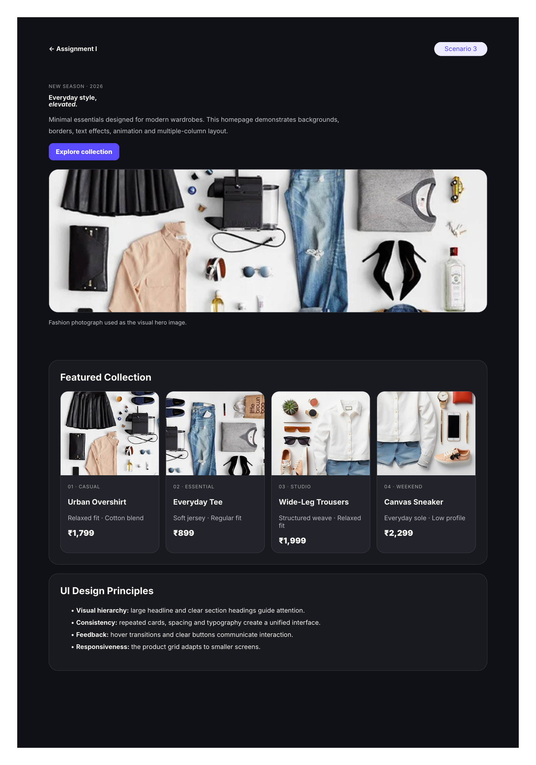
Figure 3: Tested Scenario 3 browser output showing real fashion photographs, product cards, text effects and animation.

HTML Source Code – Scenario 3
<!doctype html>
<html lang="en">
<head>
<meta charset="utf-8">
<meta name="viewport" content="width=device-width, initial-scale=1">
<title>Scenario 3 · Fashion Store</title>
<link rel="stylesheet" href="../css/style.css">
</head>
<body class="fashion">
<div class="page">
<nav class="nav">
<a href="../index.html">← Assignment I</a>
<span class="pill">Scenario 3</span>
</nav>

<header class="hero">
<span class="tag">NEW SEASON · 2026</span>
<h1 class="animate">Everyday style,<br><em>elevated.</em></h1>
<p>Minimal essentials designed for modern wardrobes. This homepage demonstrates backgrounds, borders, text effects, animation and multiple-column layout.</p>
<a class="btn" href="#products">Explore collection</a>
<img class="fashion-hero-image" src="../assets/fashion.webp" alt="Fashion clothing and accessories arranged in a flat-lay photograph">
<p class="photo-caption">Fashion photograph used as the visual hero image.</p>
</header>

<section class="section" id="products">
<h2>Featured Collection</h2>
<div class="fashion-grid">
<article class="product">
<div class="pic">
<img src="../assets/product-overshirt.jpg" alt="Casual clothing collection">
</div>
<div class="body">
<span class="tag">01 · Casual</span>
<h3>Urban Overshirt</h3>
<p class="muted">Relaxed fit · Cotton blend</p>
<span class="price">₹1,799</span>
</div>
</article>

<article class="product">
<div class="pic">
<img src="../assets/product-tee.jpg" alt="Everyday fashion essentials">
</div>
<div class="body">
<span class="tag">02 · Essential</span>
<h3>Everyday Tee</h3>
<p class="muted">Soft jersey · Regular fit</p>
<span class="price">₹899</span>
</div>
</article>

<article class="product">
<div class="pic">
<img src="../assets/product-trousers.jpg" alt="Fashion clothing product">
</div>
<div class="body">
<span class="tag">03 · Studio</span>
<h3>Wide-Leg Trousers</h3>
<p class="muted">Structured weave · Relaxed fit</p>
<span class="price">₹1,999</span>
</div>
</article>

<article class="product">
<div class="pic">
<img src="../assets/product-sneaker.jpg" alt="Fashion accessories and footwear">
</div>
<div class="body">
<span class="tag">04 · Weekend</span>
<h3>Canvas Sneaker</h3>
<p class="muted">Everyday sole · Low profile</p>
<span class="price">₹2,299</span>
</div>
</article>
</div>
</section>

<section class="section">
<h2>UI Design Principles</h2>
<ul>
<li><b>Visual hierarchy:</b> large headline and clear section headings guide attention.</li>
<li><b>Consistency:</b> repeated cards, spacing and typography create a unified interface.</li>
<li><b>Feedback:</b> hover transitions and clear buttons communicate interaction.</li>
<li><b>Responsiveness:</b> the product grid adapts to smaller screens.</li>
</ul>
</section>
</div>
</body>
</html>

5. Scenario 4 – Student Grade Calculator
Objective: Accept marks for five subjects and calculate total, average, grade and pass/fail status using JavaScript variables, data types, literals, operators, selection, iteration and user-defined functions.

Grading Rule Used
A+: 90–100, A: 80–89, B: 70–79, C: 60–69, D: 50–59 and F: below 50. Passing requires an average of at least 50 and every subject mark of at least 40.
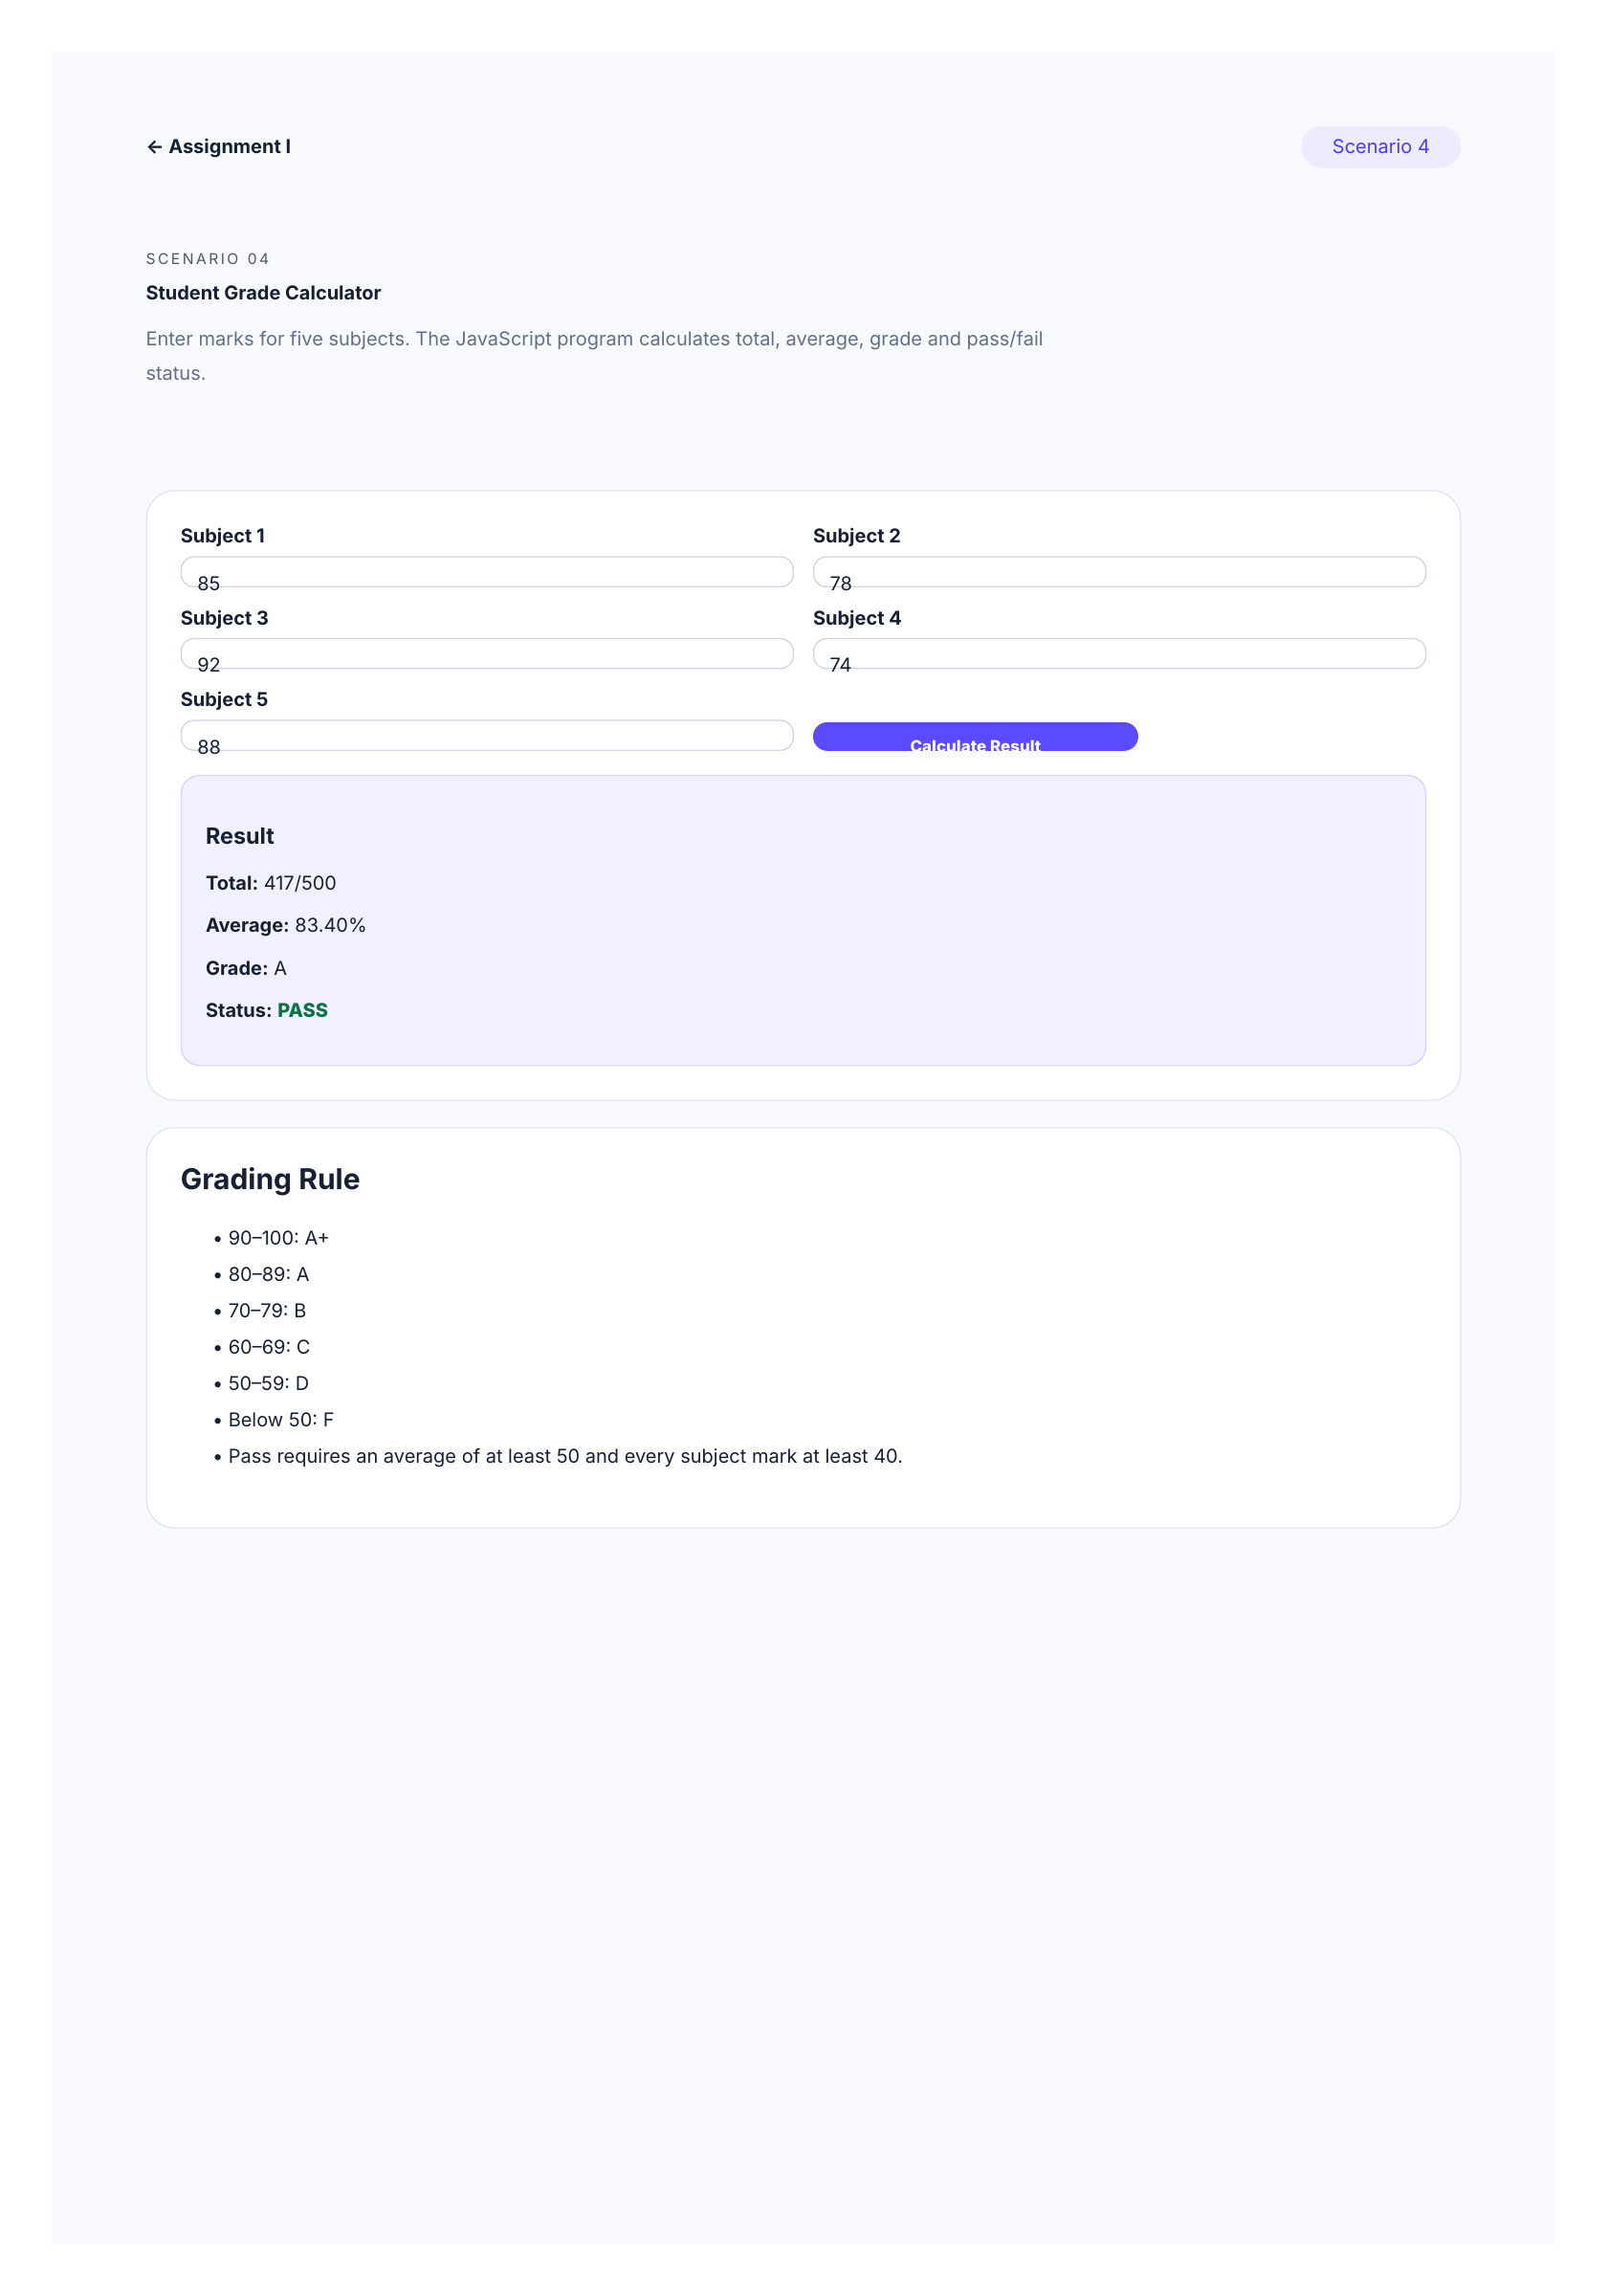
Figure 4: Tested Scenario 4 browser output showing the calculated result for five subjects.

HTML Source Code – Scenario 4
<!doctype html>
<html lang="en">
<head>
<meta charset="utf-8">
<meta name="viewport" content="width=device-width, initial-scale=1">
<title>Scenario 4 · Grade Calculator</title>
<link rel="stylesheet" href="../css/style.css">
</head>
<body>
<div class="page">
<nav class="nav">
<a href="../index.html">← Assignment I</a>
<span class="pill">Scenario 4</span>
</nav>

<header class="hero">
<span class="eyebrow">SCENARIO 04</span>
<h1>Student Grade Calculator</h1>
<p>Enter marks for five subjects. The JavaScript program calculates total, average, grade and pass/fail status.</p>
</header>

<section class="section">
<div class="form-grid">
<div class="field">
<label for="s1">Subject 1</label>
<input class="mark" id="s1" type="number" min="0" max="100" value="85">
</div>
<div class="field">
<label for="s2">Subject 2</label>
<input class="mark" id="s2" type="number" min="0" max="100" value="78">
</div>
<div class="field">
<label for="s3">Subject 3</label>
<input class="mark" id="s3" type="number" min="0" max="100" value="92">
</div>
<div class="field">
<label for="s4">Subject 4</label>
<input class="mark" id="s4" type="number" min="0" max="100" value="74">
</div>
<div class="field">
<label for="s5">Subject 5</label>
<input class="mark" id="s5" type="number" min="0" max="100" value="88">
</div>
<div class="field" style="justify-content: end;">
<button id="calculate" class="btn" type="button">Calculate Result</button>
</div>
</div>

<div id="gradeResult" class="result">
<h3>Result</h3>
<p><b>Total:</b> 417/500</p>
<p><b>Average:</b> 83.40%</p>
<p><b>Grade:</b> A</p>
<p><b>Status:</b> <span class="success">PASS</span></p>
</div>
</section>

<section class="section">
<h2>Grading Rule</h2>
<ul>
<li>90–100: A+</li>
<li>80–89: A</li>
<li>70–79: B</li>
<li>60–69: C</li>
<li>50–59: D</li>
<li>Below 50: F</li>
<li>Pass requires an average of at least 50 and every subject mark at least 40.</li>
</ul>
</section>
</div>

<script src="../js/grade-calculator.js"></script>
</body>
</html>

JavaScript Source Code – Grade Calculator
// User-defined function: returns a letter grade from an average.
function getGrade(average) {
if (average >= 90) {
return 'A+';
}

if (average >= 80) {
return 'A';
}

if (average >= 70) {
return 'B';
}

if (average >= 60) {
return 'C';
}

if (average >= 50) {
return 'D';
}

return 'F';
}

// User-defined function: reads five subject values and calculates the result.
function calculateGrade() {
const marks = Array
.from(document.querySelectorAll('.mark'))
.map((input) => Number(input.value));

const result = document.getElementById('gradeResult');

if (
marks.length !== 5 ||
marks.some((mark) => !Number.isFinite(mark) || mark < 0 || mark > 100)
) {
result.innerHTML =
'<span class="error">Please enter valid marks from 0 to 100 for all five subjects.</span>';
return;
}

let total = 0;

for (const mark of marks) {
total += mark;
}

const average = total / marks.length;
const grade = getGrade(average);
const passed =
average >= 50 && marks.every((mark) => mark >= 40);

result.innerHTML = `
<h3>Result</h3>
<p><b>Total:</b> ${total}/500</p>
<p><b>Average:</b> ${average.toFixed(2)}%</p>
<p><b>Grade:</b> ${grade}</p>
<p>
<b>Status:</b>
<span class="${passed ? 'success' : 'error'}">
${passed ? 'PASS' : 'FAIL'}
</span>
</p>
`;
}

document
.getElementById('calculate')
.addEventListener('click', calculateGrade);

calculateGrade();

6. Scenario 5 – Supermarket Billing System
Objective: Accept quantity and unit price for three products, calculate the total, apply a 10% discount when the total exceeds ₹2000, and display the final payable amount using JavaScript functions and statements.
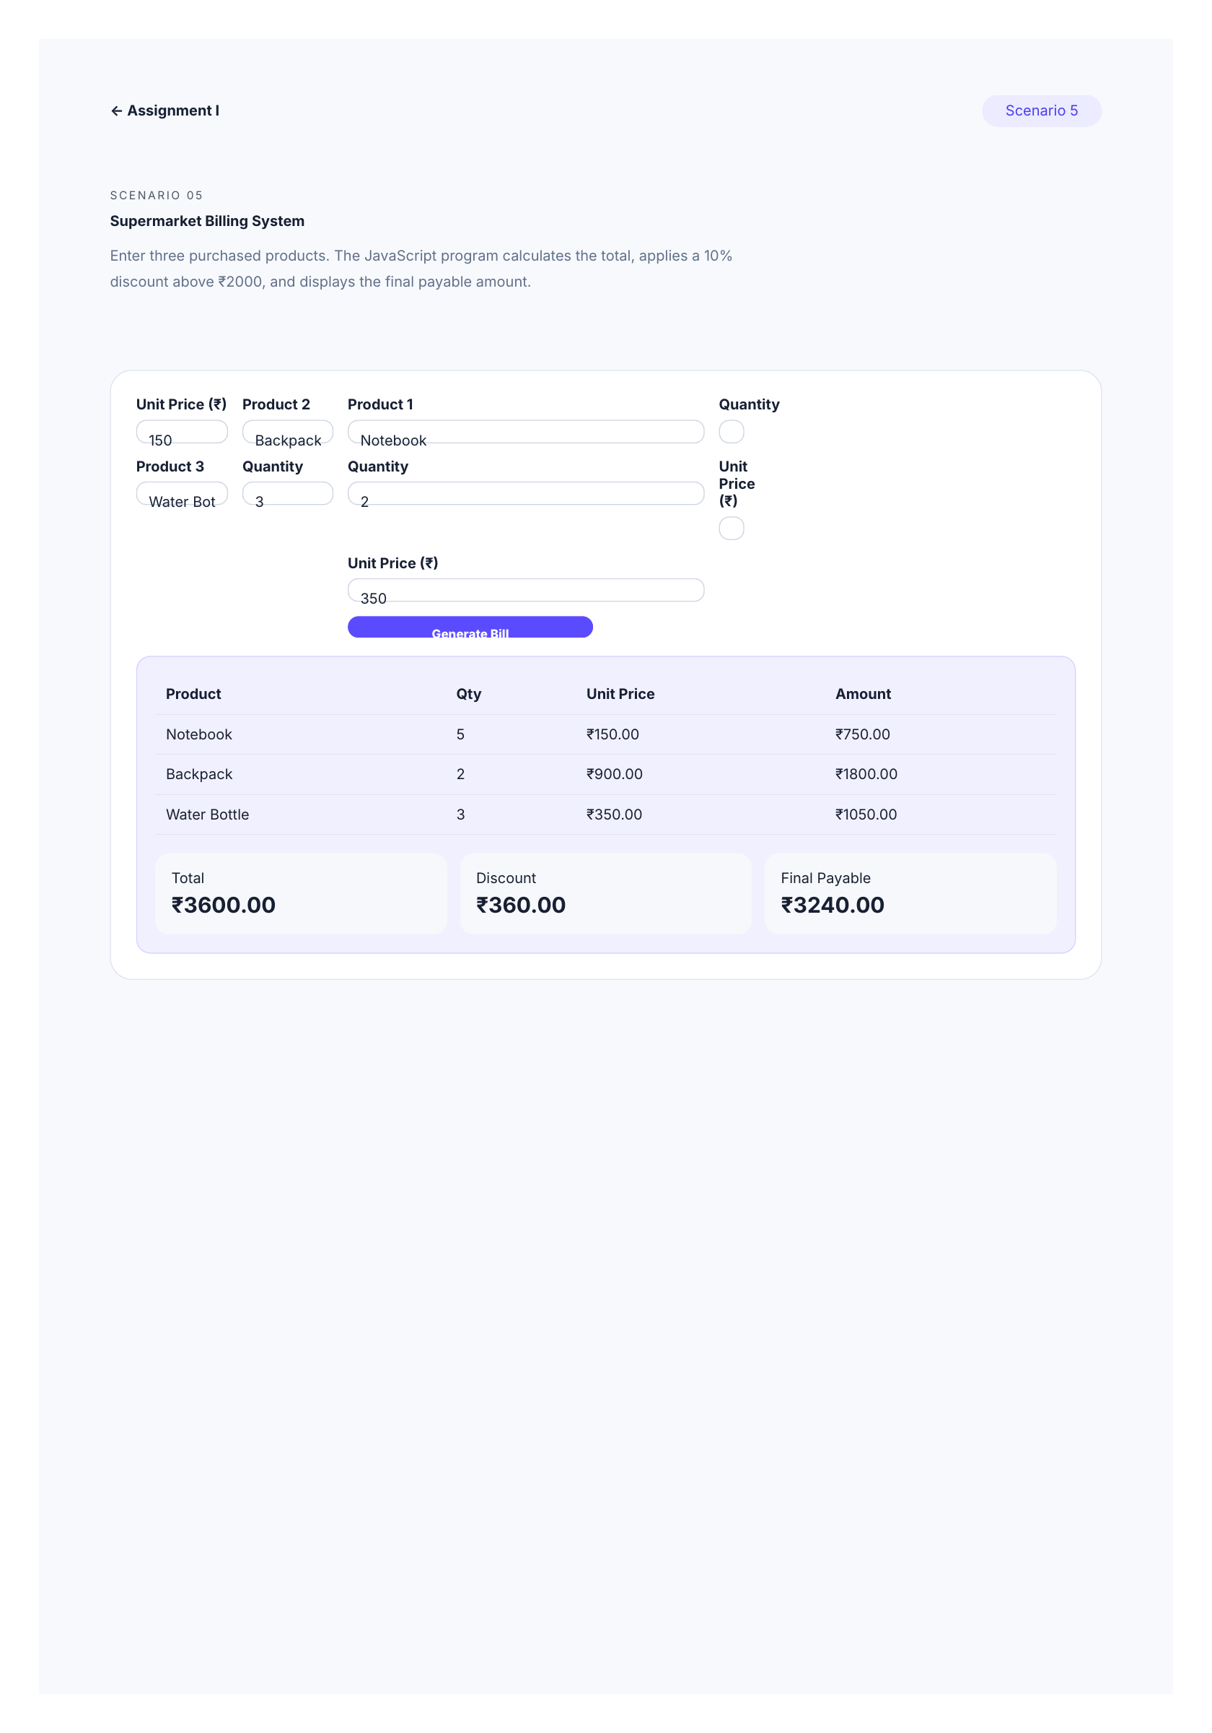
Figure 5: Tested Scenario 5 browser output showing product amounts, total, 10% discount and final payable amount.

HTML Source Code – Scenario 5
<!doctype html>
<html lang="en">
<head>
<meta charset="utf-8">
<meta name="viewport" content="width=device-width, initial-scale=1">
<title>Scenario 5 · Supermarket Billing</title>
<link rel="stylesheet" href="../css/style.css">
</head>
<body>
<div class="page">
<nav class="nav">
<a href="../index.html">← Assignment I</a>
<span class="pill">Scenario 5</span>
</nav>

<header class="hero">
<span class="eyebrow">SCENARIO 05</span>
<h1>Supermarket Billing System</h1>
<p>Enter three purchased products. The JavaScript program calculates the total, applies a 10% discount above ₹2000, and displays the final payable amount.</p>
</header>

<section class="section">
<div class="form-grid">
<div class="field">
<label for="p1">Product 1</label>
<input id="p1" type="text" value="Notebook">
</div>
<div class="field">
<label for="q1">Quantity</label>
<input id="q1" type="number" min="1" value="5">
</div>
<div class="field">
<label for="r1">Unit Price (₹)</label>
<input id="r1" type="number" min="0" step="0.01" value="150">
</div>

<div class="field">
<label for="p2">Product 2</label>
<input id="p2" type="text" value="Backpack">
</div>
<div class="field">
<label for="q2">Quantity</label>
<input id="q2" type="number" min="1" value="2">
</div>
<div class="field">
<label for="r2">Unit Price (₹)</label>
<input id="r2" type="number" min="0" step="0.01" value="900">
</div>

<div class="field">
<label for="p3">Product 3</label>
<input id="p3" type="text" value="Water Bottle">
</div>
<div class="field">
<label for="q3">Quantity</label>
<input id="q3" type="number" min="1" value="3">
</div>
<div class="field">
<label for="r3">Unit Price (₹)</label>
<input id="r3" type="number" min="0" step="0.01" value="350">
</div>

<div class="field full">
<button id="bill" class="btn" type="button">Generate Bill</button>
</div>
</div>

<div id="billResult" class="result">
<table class="bill-table">
<thead>
<tr>
<th>Product</th>
<th>Qty</th>
<th>Unit Price</th>
<th>Amount</th>
</tr>
</thead>
<tbody>
<tr><td>Notebook</td><td>5</td><td>₹150.00</td><td>₹750.00</td></tr>
<tr><td>Backpack</td><td>2</td><td>₹900.00</td><td>₹1800.00</td></tr>
<tr><td>Water Bottle</td><td>3</td><td>₹350.00</td><td>₹1050.00</td></tr>
</tbody>
</table>
<div class="total-box">
<div class="metric">Total<strong>₹3600.00</strong></div>
<div class="metric">Discount<strong>₹360.00</strong></div>
<div class="metric">Final Payable<strong>₹3240.00</strong></div>
</div>
</div>
</section>
</div>

<script src="../js/supermarket-billing.js"></script>
</body>
</html>

JavaScript Source Code – Supermarket Billing
// User-defined function: safely reads one product's input values.
function getProduct(index) {
return {
name:
document.getElementById(`p${index}`).value.trim() ||
`Product ${index}`,
quantity: Number(document.getElementById(`q${index}`).value),
price: Number(document.getElementById(`r${index}`).value),
};
}

// User-defined function: calculates and displays the complete bill.
function generateBill() {
const products = [
getProduct(1),
getProduct(2),
getProduct(3),
];

const hasInvalidProduct = products.some(
(product) =>
!Number.isFinite(product.quantity) ||
product.quantity < 1 ||
!Number.isFinite(product.price) ||
product.price < 0
);

if (hasInvalidProduct) {
document.getElementById('billResult').innerHTML =
'<span class="error">Enter valid quantities and prices.</span>';
return;
}

let total = 0;
let rows = '';

for (const product of products) {
const amount = product.quantity * product.price;
total += amount;

const safeName = product.name.replace(/[&<>]/g, '');

rows += `
<tr>
<td>${safeName}</td>
<td>${product.quantity}</td>
<td>₹${product.price.toFixed(2)}</td>
<td>₹${amount.toFixed(2)}</td>
</tr>
`;
}

const discount = total > 2000 ? total * 0.10 : 0;
const payable = total - discount;

document.getElementById('billResult').innerHTML = `
<table class="bill-table">
<thead>
<tr>
<th>Product</th>
<th>Qty</th>
<th>Unit Price</th>
<th>Amount</th>
</tr>
</thead>
<tbody>
${rows}
</tbody>
</table>

<div class="total-box">
<div class="metric">
Total
<strong>₹${total.toFixed(2)}</strong>
</div>
<div class="metric">
Discount
<strong>₹${discount.toFixed(2)}</strong>
</div>
<div class="metric">
Final Payable
<strong>₹${payable.toFixed(2)}</strong>
</div>
</div>
`;
}

document
.getElementById('bill')
.addEventListener('click', generateBill);

generateBill();

Shared CSS Source Code
The following stylesheet is shared by the assignment pages and demonstrates CSS3 selectors, box model properties, backgrounds, borders, transitions, animation, grid layout and responsive media queries.

CSS Source Code – style.css
:root {
--ink: #172033;
--muted: #61708a;
--paper: #f7f9fc;
--line: #dfe5ef;
--accent: #5b4bff;
--accent2: #14b8a6;
}

* {
box-sizing: border-box;
}

html {
scroll-behavior: smooth;
}

body {
margin: 0;
font-family: Inter, system-ui, -apple-system, BlinkMacSystemFont, "Segoe UI", sans-serif;
color: var(--ink);
background: var(--paper);
}

a {
color: inherit;
}

.site-header {
padding: 64px 7%;
background: linear-gradient(120deg, #141b38, #4d43a8);
color: #fff;
}

.eyebrow {
font-size: 0.78rem;
letter-spacing: 0.16em;
opacity: 0.75;
}

.site-header h1 {
font-size: clamp(2.5rem, 6vw, 5rem);
margin: 12px 0 6px;
}

.site-header p {
margin: 0;
opacity: 0.85;
}

.container,
.page {
width: min(1100px, 92%);
margin: 42px auto;
}

.grid {
display: grid;
grid-template-columns: repeat(2, 1fr);
gap: 20px;
}

.card {
background: #fff;
border: 1px solid var(--line);
border-radius: 22px;
padding: 28px;
text-decoration: none;
transition: 0.25s;
box-shadow: 0 12px 35px #1720330b;
}

.card:hover {
transform: translateY(-5px);
box-shadow: 0 18px 45px #17203316;
}

.card span {
color: var(--accent);
font-weight: 800;
}

.card h2 {
margin: 12px 0 8px;
}

.card p {
color: var(--muted);
line-height: 1.7;
}

.nav {
display: flex;
justify-content: space-between;
align-items: center;
padding: 20px 0;
}

.nav a {
text-decoration: none;
font-weight: 700;
}

.pill {
padding: 8px 13px;
border-radius: 999px;
background: #ecebff;
color: #4b3df0;
}

.hero {
padding: 45px 0;
}

.hero h1 {
font-size: clamp(2.3rem, 6vw, 4.5rem);
line-height: 1.02;
margin: 12px 0;
}

.hero p {
color: var(--muted);
line-height: 1.8;
max-width: 760px;
}

.section {
background: #fff;
border: 1px solid var(--line);
border-radius: 24px;
padding: 28px;
margin: 22px 0;
box-shadow: 0 12px 35px #1720330a;
}

.section h2 {
margin-top: 0;
}

.flow {
display: grid;
grid-template-columns: repeat(4, 1fr);
gap: 12px;
margin: 20px 0;
}

.flow div {
padding: 18px;
border: 2px solid #dcd9ff;
border-radius: 16px;
text-align: center;
background: #faf9ff;
}

.url {
font-family: ui-monospace, monospace;
background: #111827;
color: #e5e7eb;
padding: 18px;
border-radius: 14px;
overflow: auto;
}

.compare {
display: grid;
grid-template-columns: 1fr 1fr;
gap: 18px;
}

.compare > div {
padding: 20px;
border-radius: 18px;
background: #f5f7fb;
border: 1px solid var(--line);
}

ul {
line-height: 1.9;
}

.diagram,
.content-photo {
width: 100%;
border-radius: 18px;
border: 1px solid var(--line);
display: block;
}

.photo-caption {
color: var(--muted);
font-size: 0.9rem;
margin-top: 8px;
}

.media-grid {
display: grid;
grid-template-columns: repeat(3, 1fr);
gap: 16px;
}

.media-card {
background: #f7f8fb;
padding: 16px;
border-radius: 16px;
}

.media-card img,
.media-card video {
width: 100%;
border-radius: 12px;
display: block;
}

.btn {
display: inline-block;
border: 0;
border-radius: 12px;
padding: 12px 18px;
background: var(--accent);
color: #fff;
font-weight: 800;
cursor: pointer;
text-decoration: none;
}

.form-grid {
display: grid;
grid-template-columns: repeat(2, 1fr);
gap: 16px;
}

.field {
display: flex;
flex-direction: column;
gap: 7px;
}

.field.full {
grid-column: 1 / -1;
}

label {
font-weight: 700;
}

input,
select,
textarea {
width: 100%;
padding: 12px 13px;
border: 1px solid #cfd6e3;
border-radius: 11px;
font: inherit;
background: #fff;
}

input:focus,
select:focus,
textarea:focus {
outline: 3px solid #5b4bff22;
border-color: var(--accent);
}

.result {
margin-top: 20px;
padding: 20px;
border-radius: 16px;
background: #f1f0ff;
border: 1px solid #d7d2ff;
}

.error {
color: #b42318;
font-weight: 700;
}

.success {
color: #087443;
font-weight: 800;
}

.fashion {
background: #101116;
color: #f8f7f3;
}

.fashion .section {
background: #191a20;
border-color: #333;
color: #f8f7f3;
}

.fashion .nav {
color: #f8f7f3;
}

.fashion .hero p {
color: #c5c5cc;
}

.fashion .product {
background: #22242b;
border: 1px solid #373943;
}

.fashion .muted {
color: #b9bbc5;
}

.fashion-hero-image {
width: 100%;
height: 360px;
object-fit: cover;
border-radius: 24px;
border: 1px solid #373943;
margin-top: 22px;
}

.fashion-grid {
display: grid;
grid-template-columns: repeat(4, 1fr);
gap: 16px;
}

.product {
border-radius: 20px;
overflow: hidden;
}

.product .pic {
height: 210px;
overflow: hidden;
background: #ddd;
}

.product .pic img {
width: 100%;
height: 100%;
object-fit: cover;
display: block;
transition: transform 0.35s ease;
}

.product:hover .pic img {
transform: scale(1.06);
}

.product .body {
padding: 18px;
}

.price {
font-weight: 900;
font-size: 1.25rem;
}

.tag {
font-size: 0.75rem;
letter-spacing: 0.08em;
text-transform: uppercase;
opacity: 0.65;
}

.animate {
animation: float 3s ease-in-out infinite;
}

@keyframes float {
0%,
100% {
transform: translateY(0);
}

50% {
transform: translateY(-9px);
}
}

.bill-table {
width: 100%;
border-collapse: collapse;
}

.bill-table th,
.bill-table td {
padding: 12px;
border-bottom: 1px solid var(--line);
text-align: left;
}

.total-box {
display: grid;
grid-template-columns: repeat(3, 1fr);
gap: 14px;
margin-top: 20px;
}

.metric {
padding: 18px;
background: #f7f8fb;
border-radius: 16px;
}

.metric strong {
display: block;
font-size: 1.5rem;
margin-top: 6px;
}

@media (max-width: 800px) {
.flow,
.media-grid,
.fashion-grid,
.total-box {
grid-template-columns: 1fr 1fr;
}

.form-grid,
.compare {
grid-template-columns: 1fr;
}
}

@media (max-width: 560px) {
.flow,
.media-grid,
.fashion-grid,
.total-box {
grid-template-columns: 1fr;
}

.form-grid {
grid-template-columns: 1fr;
}

.section {
padding: 20px;
}
}

@page { size: 14in 20in; margin: 0.45in; }

7. Conclusion
This assignment provided practical experience with HTML5, CSS3 and JavaScript through five real-world scenarios. The webpages demonstrate forms, media, responsive layouts, animations and UI principles. The JavaScript programs implement grade calculation and supermarket billing logic using functions, operators and control statements. The final project is organized for individual submission and GitHub upload.

Image / Media Note
Local visual assets were included so the assignment works without relying on remote image loading. The campus and fashion photographs are used only as visual demonstration assets; the project code and layout are the student assignment implementation.

