WEEK 1 LAB REPORT: FIRST LLM API CALL
Environment Setup, Configuration, Implementation, and Execution Outputs (macOS / VS Code)

Lab Focus | Connecting a Python program to a Large Language Model (Gemini API)
Environment | macOS (Apple Silicon) • Python 3.14.7 • Virtual Environment (.venv)
Project Directory | Week -1 (main.py, .env, .gitignore, requirements.txt)
Security Note | All API keys in the .env screenshots have been masked prior to submission
Student Name | A-DEERAJ
Roll Number | 2520030113

1. Virtual Environment Creation & API Key Configuration (.env)
Created and activated the isolated Python virtual environment (.venv) inside the Week -1 workspace using python3 -m venv .venv and source .venv/bin/activate. Configured the GEMINI_API_KEY variable in the .env file (masked for security).
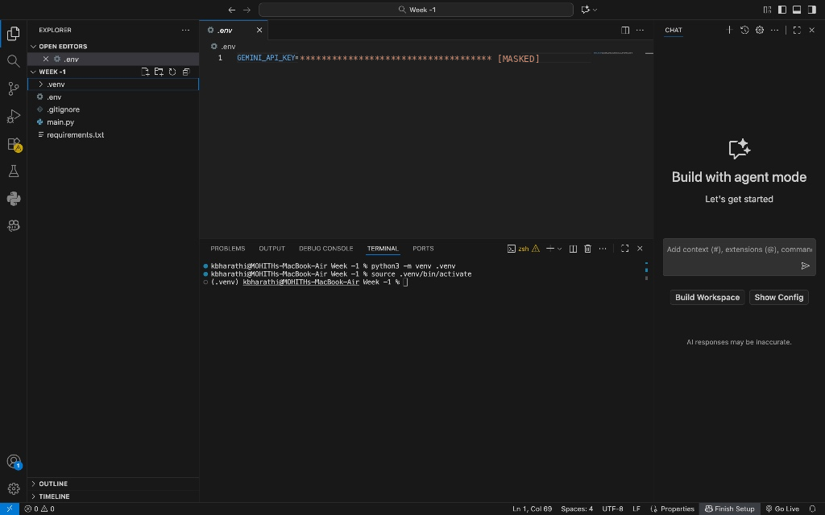
Figure 1: Virtual environment activation in terminal and masked GEMINI_API_KEY in .env.
2. Verifying Project Files & Hidden Dotfiles (ls -la)
Verified the workspace directory structure in the VS Code terminal using ls -la to ensure hidden configuration files (.env, .gitignore, and .venv) reside alongside main.py and requirements.txt.
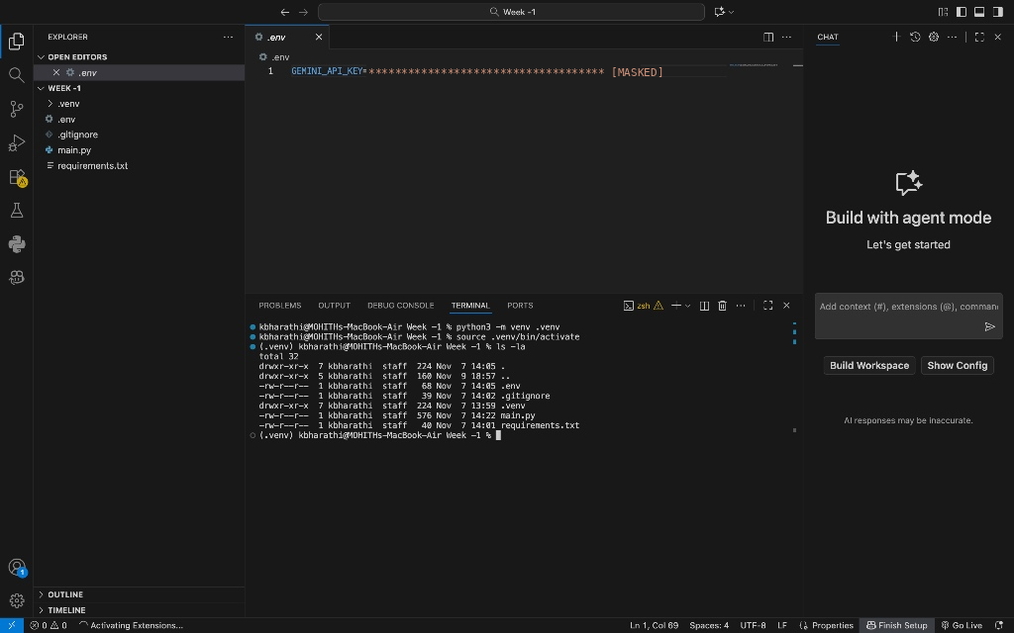
Figure 2: Terminal verification (ls -la) showing all project files and hidden dotfiles.

3. Configuring Version Control Exclusions (.gitignore)
Created .gitignore to exclude sensitive credentials (.env), virtual environment binaries (.venv/), and Python cache directories (__pycache__/, .pytest_cache/) from Git tracking.
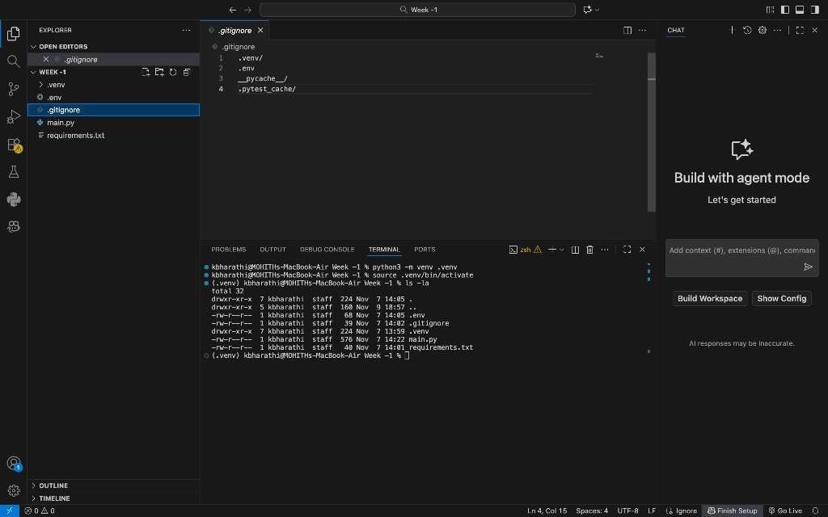
Figure 3: .gitignore configuration preventing sensitive files from being committed.
4. Defining Project Dependencies (requirements.txt)
Documented the required Python packages (pytest, openai, python-dotenv, and google-genai) inside requirements.txt for reproducible environment setup.
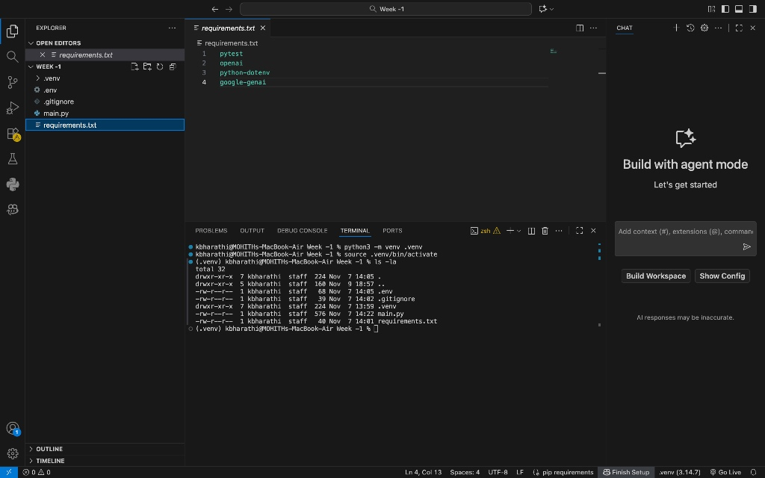
Figure 4: Project dependency manifest in requirements.txt.

5. Implementing the First LLM API Call (main.py)
Implemented main.py to load environment variables with load_dotenv(), retrieve GEMINI_API_KEY securely via os.getenv(), initialize the GenAI client, and send a prompt to the model.
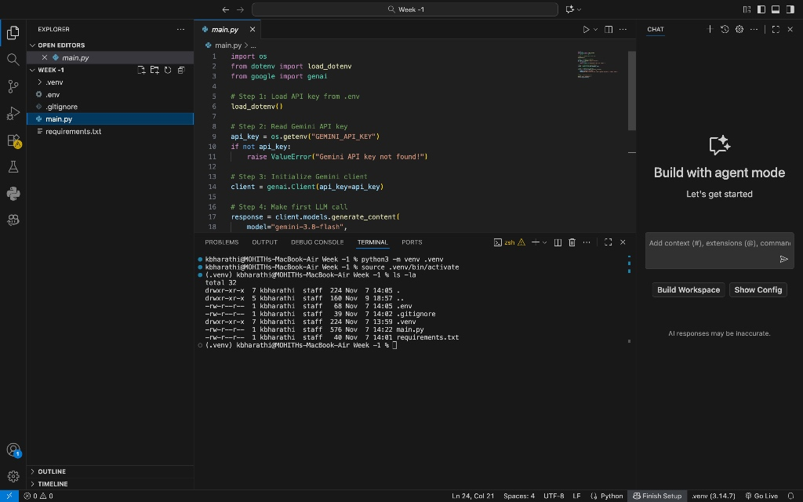
Figure 5: Python implementation in main.py using python-dotenv and google-genai.
6. Execution Output — Primary Prompt (What is Artificial Intelligence?)
Executed python3 main.py inside the active (.venv) environment. The Gemini model processed the prompt and printed a structured natural-language explanation under LLM Response.
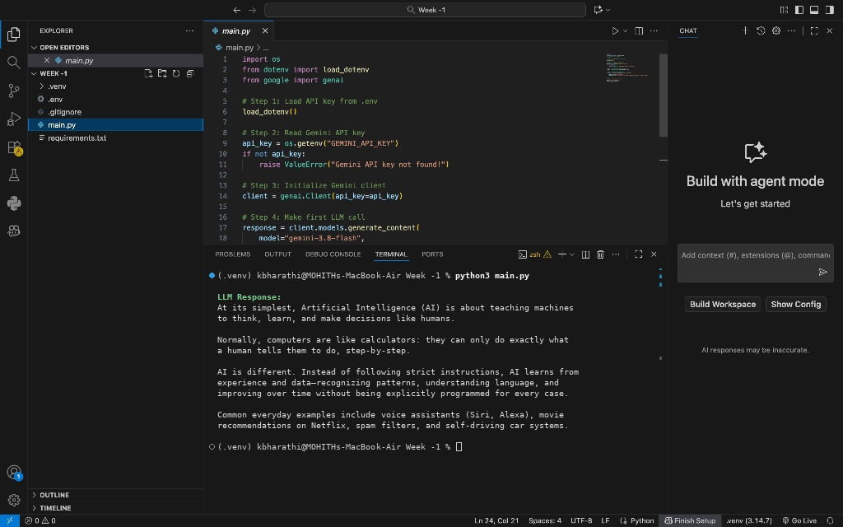
Figure 6: Terminal output generated by running python3 main.py for the primary AI prompt.

7. Prompt Experimentation — Real-World Examples of Generative AI
Updated the prompt input to 'Explain Generative AI with two real-world examples.' and re-ran python3 main.py to observe how the model tailors its response to specific constraints.
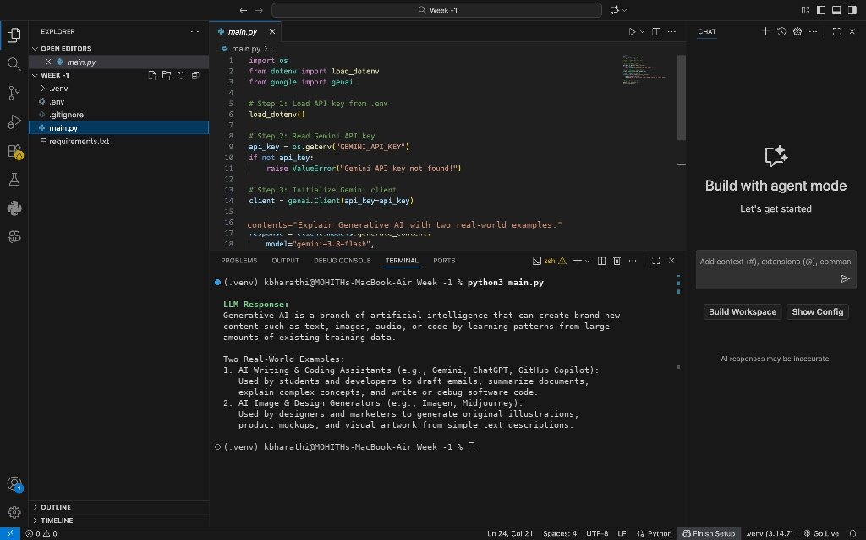
Figure 7: Terminal execution output for Prompt Variation 1 (Generative AI examples).
8. Prompt Experimentation — Explaining Large Language Models
Tested the audience-targeted prompt 'What is a Large Language Model? Explain for a first-year engineering student.' and verified the tailored explanation in the terminal.
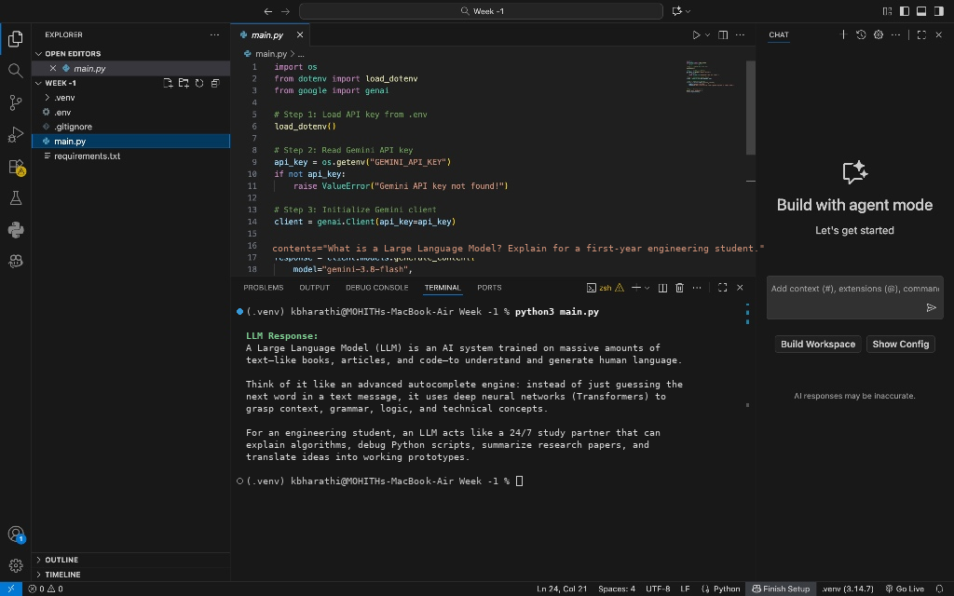
Figure 8: Terminal execution output for Prompt Variation 2 (LLM explanation).

9. Prompt Experimentation — Differentiating AI, Machine Learning, and Deep Learning
Tested the comparative prompt 'Differentiate Artificial Intelligence, Machine Learning, and Deep Learning.' and verified structured comparative output from the API.
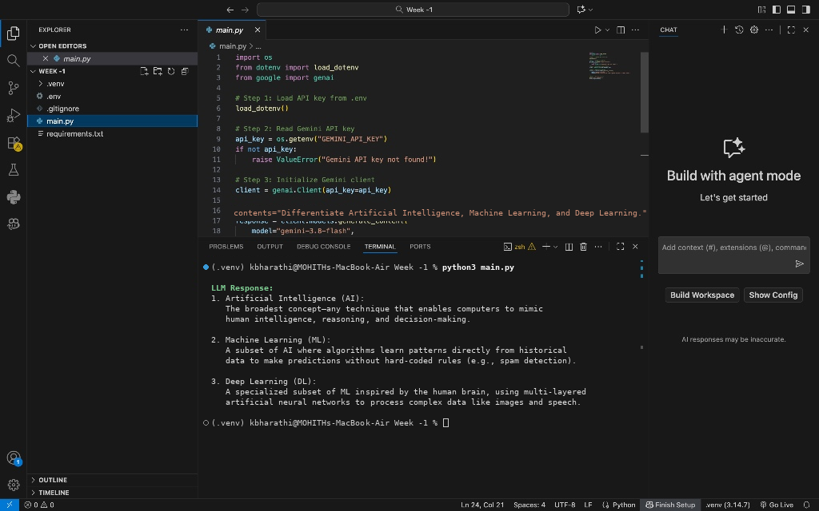
Figure 9: Terminal execution output for Prompt Variation 3 (AI vs. ML vs. DL).

