# ANGULAR_Session_1_Assignment_1.2

Step 1. Installing Angular Cli through npm.

Step 2. Open Command Prompt and type

> npm install -g @angular/cli

And run the command.

Step 3. Now check the Angular CLI Version -

> ng --version

This will show you the version of Angular CLI.

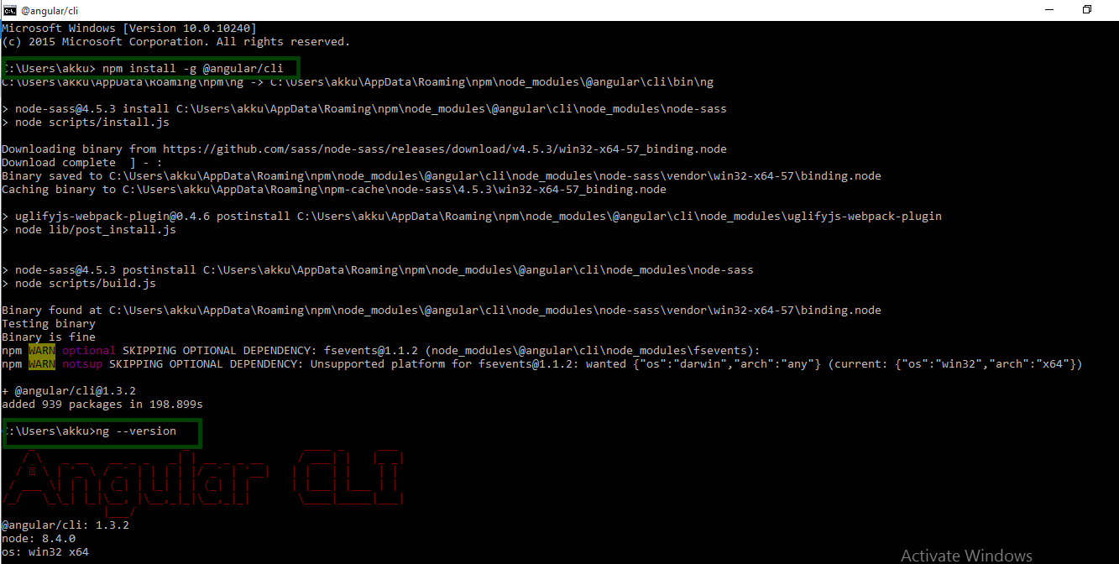

# Creating new project with angular cli through cmd

Step 1. Type ng new <Project name> to create a new project

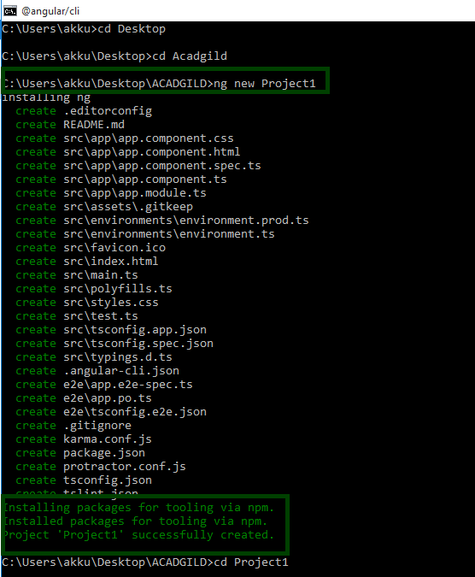

Project1 has been successfully created.

Step 2. Now we will go to the directory and run the project through

>npm install. So that it can install the dependencies and library.

Step 3. Now

> npm start

To run the project.

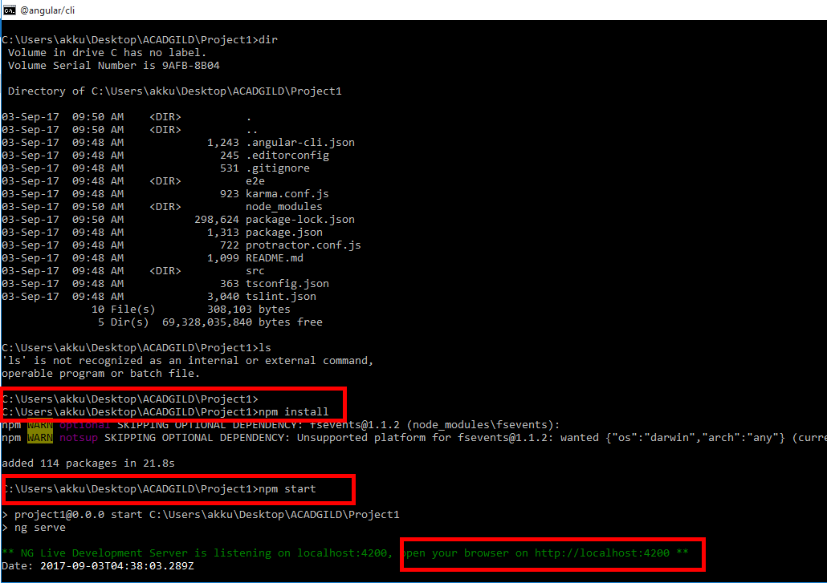

Step 4. Navigate to local host.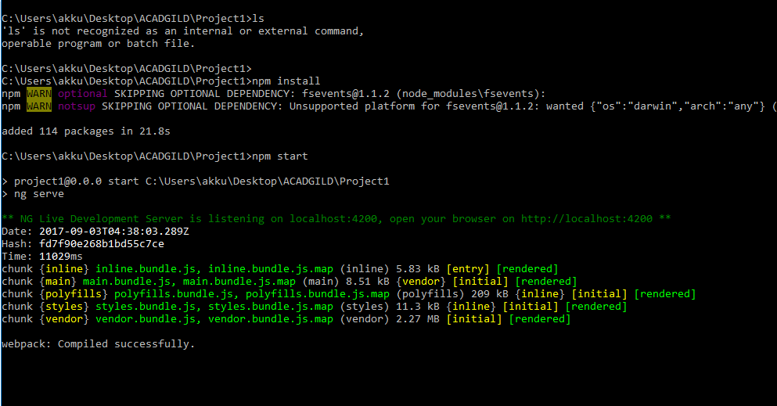

# Output :

