

Tribhuvan University
Orchid International College
A Final Year Project Report
On
TWITTER SENTIMENT ANALYSIS USING NAIVE BAYES’ ALGORITHM

Under the Supervision of
Er. Dhiraj Kumar Jha
Lecturer
Orchid International College

Submitted To:
Department of Computer Science and Information Technology
Orchid International College

In partial fulfillment of the requirement for the Bachelor Degree in Computer Science and Information Technology

Submitted By:
Aakriti Neupane (8051/072)
Anjila Sainju (8053/072)
Rashmi Maharjan (8080/072)

August, 2019


SUPERVISOR’S RECOMMENDATION

I hereby recommend that the report prepared under my supervision by Aakriti Neupane (TU Exam Roll No. 8051/072), Anjila Sainju (TU Exam Roll No. 8053/072), and Rashmi Maharjan (TU Exam Roll No. 8080/072) entitled “TWITTER SENTIMENT ANALYSIS USING NAÏVE BAYES’ ALGORITHM” in partial fulfillment of the requirements for the degree of B.Sc. in Computer Science and Information Technology be processed for evaluation.

……………..…….
Er. Dhiraj Kumar Jha
Project Coordinator, Department of CSIT
Orchid International College
Bijayachowk, Gaushala

CERTIFICATE OF APPROVAL

This is to certify that this project prepared by Aakriti Neupane (TU Exam Roll No. 8051/072), Anjila Neupane (TU Exam Roll No. 8053/072), and Rashmi Maharjan (TU Exam Roll No. 8080/072) entitled “TWITTER SENTIMENT ANALYSIS USING NAÏVE BAYES’ ALGORITHM” in partial fulfillment of the requirements for the degree of B.Sc. in Computer Science and Information Technology has been well studied. In our opinion, it is satisfactory in the scope and quality as a project for the required degree.
-------------------------  Er. Dhiraj Kumar Jha  Project Coordinator,  Department of Computer Science and IT  Orchid International College  Bijayachowk, Gaushala | -----------------  Bijay Mishra  Program Coordinator,  Department of Computer Science and IT  Orchid International College  Bijayachowk, Gaushala
-------------------------
External Examiner
Central Department of Computer Science and IT
Tribhuvan University
Kirtipur, Nepal

ACKNOWLEDGEMENT

This project report has been prepared as a part of our BSc.CSIT final year to complete our project course requirement. We would like to add a few words of appreciation for the people who have been a part of this project right from its inception. The writing of this project has been one of the significant academic challenges we have faced and without the support, patience, and guidance of the people involved, this task would not have been completed. It is to them we owe our deepest gratitude.
It gives us immense pleasure in presenting this project report on " Twitter sentiment analysis using Naive Bayes’ Algorithm". We are thankful to our project supervisor Er. Dhiraj Kumar Jha for providing us the opportunity to work on this project. We also would like to express our special thanks of gratitude to our Mr. Bijay Mishra who undertook to act as our mentor despite his many other academic and professional commitments. He has been always very much supportive and always motivating, we are really thankful to him.
We also feel heartiest sense of obligation to our friends & seniors, who helped us in collection of data & resource material & also in its processing as well as in preparing project report. The project is dedicated to all those people, who helped us while doing this project. We would also like to extend our sincere regards to all the faculty members for their support and encouragement.

ABSTRACT

This project addresses the problem of sentiment analysis in twitter; that is classifying tweets according to the sentiment expressed in them: positive, negative or neutral. Twitter is an online micro-blogging and social-networking platform which allows users to write short status updates of maximum length 280 characters.
Twitter is a rapidly expanding service with over 200 million registered users, out of which 100 million are active users and half of them log on twitter on a daily basis - generating nearly 250 million tweets per day. Due to this large amount of usage we hope to achieve a reflection of public sentiment by analyzing the sentiments expressed in the tweets. Analyzing the public sentiment is important for many applications such as firms trying to find out the response of their products in the market, predicting political elections and predicting socio-economic phenomena like stock exchange. The aim of this project is to develop a functional classifier for accurate and automatic sentiment classification of an unknown tweet stream.
Keywords: sentiment analysis, probability, Naïve Bayes

TABLE OF CONTENTS

SUPERVISOR’S RECOMMENDATION i
CERTIFICATE OF APPROVAL ii
ACKNOWLEDGEMENT iii
ABSTRACT iv
LIST OF FIGURES vii
LIST OF TABLES viii
ABBREVIATIONS ix
CHAPTER 1 - INTRODUCTION 1
1.1. Project Introduction 1
1.2. Problem Statement 2
1.3. Objectives 2
1.4. Scope and Limitation 2
CHAPTER 2 - REQUIREMENT AND FEASIBILITY ANALYSIS 3
2.1. Literature Review 3
2.2. Requirement Analysis 4
2.2.1. Functional Requirements 4
2.2.2. Non Functional Requirements 8
2.3. Feasibility Analysis 9
CHAPTER 3 - SYSTEM ANALYSIS 10
3.1. Structuring System Requirements 10
3.1.1. Data Modeling 10
3.1.2. Process Modeling 12
3.1.3. Class Diagram 15
CHAPTER 4 – SYSTEM DESIGN 16
4.2. Activity Diagram 16
4.2. Sequence Diagram 17
4.3. Input Output Design 18
CHAPTER 5 – IMPLEMENTATION 19
5.1. Tools Used 19
5.2. Description of Training Data Set for Tweet Analysis 19
CHAPTER 6 – SYSTEM TESTING 27
6.1. Unit Testing 27
6.2. Result Analysis 28
CHAPTER 7 – CONCLUSION 32
7.1. Future Scope 32
REFERENCES 33
APPENDIX 34

LIST OF FIGURES

Figure 2.1: Use Case Diagram of Twitter Sentiment Analysis System 5
Figure 3.1: ER Diagram for Twitter Sentiment Analysis 11
Figure 3.2: Context Diagram for Twitter Sentiment Analysis 12
Figure 3.3: Level 0 DFD for Twitter Sentiment Analysis. 13
Figure 3.4: Level 1 DFD for process 3.0 of level 0 DFD 14
Figure 3.1.3: Class diagram of Twitter Sentiment Analysis System. 15
Figure 4.1: Activity diagram of Twitter Sentiment Analysis System. 16
Figure 4.2: Sequence diagram of Twitter Sentiment Analysis System. 17
Figure 6.2.1: Training Dataset for the system. 30
Figure 6.2.2:Testing of tweets for the system. 30
Figure 6.2.3: Output of test tweets for the system 31

LIST OF TABLES

Table 2. 1: UC 1 Tweet Search 6
Table 2. 2: UC 2 http request for tweets 6
Table 2. 3: UC 3 http response from twitter 6
Table 2. 4: UC 4 retrieve metadata for each tweet 7
Table 2. 5: UC 5 store data 7
Table 2. 6: UC 6 perform text analysis for each tweet 7
Table 2. 7: UC 7 store result 8
Table 2. 8: UC 8 view result 8
Table 5. 2:Training Dataset for Twitter Sentiment Analysis System 19
Table 6. 1: Unit Testing of Twitter Sentiment Analysis System 28
Table 6.2.1: Confusion Matrix 29
Table 6.2.2: Confusion Matrix of Twitter Sentiment Analysis System……………...…..30

ABBREVIATIONS

API | Application Program Interface
CSS | Cascading Style Sheets
DFD | Data Flow Diagram
ERD | Entity Relationship Diagram
HTML | Hypertext Markup Language
IDE | Integrated Development Environment
NLTK | Natural Language Tool Kit
PHP | Personal Home Page
RE | Regular Expression
UML | Unified Modeling Language
URL | Uniform Resource Locator

CHAPTER 1 - INTRODUCTION

1.1. Project Introduction
Sentiment Analysis is the process of determining whether a piece of writing is positive, negative or neutral. It is process of collecting and analyzing data based upon the person feelings, reviews and thoughts done by using various machine learning techniques, statistical models and Natural Language Processing (NLP) for the extraction of feature from a large data. Sentimental analysis often called as opinion mining as it mines the important feature from the opinions given by the people.
Sentiment Analysis is increasingly viewed as a vital task both from an academic and a commercial standpoint. The applications can be seen in a wide area; in the social media monitoring, tracking of customer reviews, surveys, responses, competitors, etc. It is used to generate opinions for people of social media by analyzing their feelings or thoughts which they provide in form of text.
Sentiment Analysis can be done at document, phrase and sentence level. In document level, summary of the entire document is taken first and then it is analyzing whether the sentiment is positive, negative or neutral. In phrase level, analysis of phrases in a sentence is taken in account to check the polarity. In Sentence level, each sentence is classified in a particular class to provide the sentiment.
In this project, Naïve Bayes Algorithm is used as the evaluation algorithm:
- Naive Bayes classiﬁer is simple probabilistic classiﬁer based on applying Bayes theorem with strong(naive) independence assumptions between the features. The basic concept of Bayes classiﬁcation is to calculate the probability of a word belonging to any of the possible classes from our training sample.
Our system “Twitter Sentiment Analysis” is a web application that analyzes the tweets posted on “Twitter” that was created in March 2006. This system aims to analyze the tweets that are tweeted by the active users of Twitter and predict if these tweets are positive, negative or neutral.

1.2. Problem Statement
Twitter is widely used social networking service where users post and interact with messages, called” tweets”. Our main problem is to decide whether a tweet is positive, negative or neutral considering the fact that a tweet contains lots of vague text, urls and lot of other unnecessary things.

1.3. Objectives
The objective of this project is: -
- To analyze the tweets posted on twitter and predict if they are positive or negative or neutral.
- To implement classification technique for sentiment analysis.
- To provide summarized sentiment from various popular and latest tweets.

1.4. Scope and Limitation
This project can be used as a platform by the user to know about the sentiment expressed in their reviews. It can be embedded in web applications for various uses and applications such as decision making, internet marketing, production, recommendation and information gathering. By analyzing the tweets, analyzer can get result on how positive or negative or neutral are peoples about a topic.
This system, however, has some limitations due to various circumstances such as:
• This system is able to extract opinions and sentiments of English language only and reviews presented in language other than English are not processed correctly.
•This system applies grammatical rules to extract aspect terms considering the sentences are grammatically correct. But this is not always the case in real life scenario.

CHAPTER 2 - REQUIREMENT AND FEASIBILITY ANALYSIS

2.1. Literature Review
It can be observed from the experimental results that using classifiers is a good choice for sentiments prediction using twitter data [1]
Naïve Bayes is a type of classification that is widely used in the real world because of its simplicity. The classification is done after the clustering that is read in data mining [2]
The feature extraction process can be done by importing python libraries. However, the authors made a system that could extract the features from a given data by their own. The labelled data sets needed to as much larger to give out a precise sentiment analysis [3]
The authors got best result with the Naive Bayes classifier using a mutual information measure for feature selection. The authors were able to obtain up to 81% of accuracy on their test set. However, this strategy displayed a terrible performance as it took 44 minutes to display the results with three classes “positive”, “negative” and “neutral” [4]
The Naïve Bayes is a simple algorithm to understand but it is equally hard to implement the algorithm into a pseudo code format. This classification can be done in various data. Nonetheless, the data that are being provided for the classification purpose must be labelled and processed beforehand [5]
The Naive Bayesian Classification [7] represents a supervised learning method as well as a statistical method for classification. It is probabilistic model and it permit us to capture uncertainty about the model in a principled way by determining probabilities.
The authors utilized Twitter to collect training data and then to perform a sentiment analysis, in which they developed corpora by utilizing emoticons to acquire “positive” and “negative” samples, and then also utilize different classifiers [8]

2.2. Requirement Analysis
Requirements analysis encompasses those tasks that go into determining the needs or conditions to meet for a new or altered product or project, taking account of the possibly conflicting requirements of the various analyzing, documenting, validating and managing software or system requirements. Requirements analysis is critical to the success or failure of a project. Requirement analysis is mainly discussed under two categories:

2.2.1. Functional Requirements
A functional requirement document describes what the system should do. Functional user requirements may be high-level statements of what the system should do but functional system requirement also describes clearly about the system services in detail. The functional requirements of this system involves:
- User being able to search for required keywords.
- Application able to analyze the tweets.
- User able to view the sentiment analysis done by the application.
- Database for storing the retrieved data.
- View the sentiment of that keyword.

The following Use Case Diagram describes the major actions of the system and interaction between actors (user, twitter) and the system in our application:

Figure 2.1: Use Case Diagram for Twitter Sentiment Analysis System

The use case diagram of the twitter sentiment analysis is a representation of a user’s interaction with the system that shows the relationship between the user and the different cases where the user and system plays a vital role.

Use-case Description

Table 2.1: UC 1 Tweet Search
Primary Actor | User
Secondary Actor | NONE
Description | User searches for the tweets that they need to view the sentiment for.
Pre-condition | User must be connected to the internet.
Post-condition | Manager will be able to search for the tweets.
Failure Scenario | User are not able to search for the tweets.

Table 2.2: UC 2 http request for tweets
Primary Actor | NONE
Secondary Actor | Twitter
Description | System sends the http request for the searched tweets.
Pre-condition | System must get the searched keyword from the user.
Post-condition | System must be able to receive the http response.
Failure Scenario | System is not able to send the request.

Table 2.3: UC 3 http response from twitter
Primary Actor | NONE
Secondary Actor | Twitter
Description | System receives the http response from twitter.
Pre-condition | System must send the http request prior for the response.
Post-condition | System will be able to retrieve the metadata for each tweets.
Failure Scenario | System is not able to receive http response for the request.

Table 2.4: UC 4 retrieve metadata for each tweet
Primary Actor | NONE
Secondary Actor | Twitter
Description | System retrieves the metadata for each tweets from the response it received.
Pre-condition | System must receive the http response in order to extract the data.
Post-condition | System will be able to use all the data and perform analysis.
Failure Scenario | System is not able to extract the data.

Table 2.5: UC 5 store data
Primary Actor | NONE
Secondary Actor | Twitter
Description | System stores all the extracted data for the further text analysis.
Pre-condition | System must extract all the metadata in order to store it.
Post-condition | System must be able to use the stored data.
Failure Scenario | System is not able to store the data in the database.

Table 2.6: UC 6 perform text analysis for each tweet
Primary Actor | NONE
Secondary Actor | Twitter
Description | System performs text analysis for each tweets that is stored.
Pre-condition | System must contain extracted data stored.
Post-condition | System is able to perform text analysis for all tweets.
Failure Scenario | System is not able to perform text analysis.
Table 2.7: UC 7 store result
Primary Actor | NONE
Secondary Actor | Twitter
Description | System stores the analyzed result and sentiment of requested tweet.
Pre-condition | System must have done the tokenization and analysis of the text.
Post-condition | System must be able to store the result.
Failure Scenario | System is not able to store the result.

Table 2.8: UC 8 view result
Primary Actor | User
Secondary Actor | NONE
Description | User is able to view the sentiment of the searched tweet.
Pre-condition | System must perform the analysis prior and store the result.
Post-condition | User is able to view the sentiment provided by the system.
Failure Scenario | User is not able to view the result.

2.2.2. Non Functional Requirements
Non-functional requirements are requirements that are not directly concerned with the specified function delivered by the system. It also describes system attributes security, performance, maintainability, scalability and usability. Non-functional requirements are often called “quality attributes" of a system that defines behaviors.
Some of the non-functional requirements related with this system are hereby below:
- The system uses a simple user interface.
- The system should be able to retrieve the live tweets.
- The system should only perform in terms of valid input provided by the user.
- The result should be precise.

2.3. Feasibility Analysis
Feasibility study aim to objectively and rationally uncover the strengths and weaknesses of an existing system, and ultimately the prospects for success. The feasibility analysis is divided into three parts as described below:

Technical Feasibility
Technical feasibility is one of the first studies that must be conducted after the project has been identified. Technical feasibility study includes the hardware and software devices. In order to create this web application, all the tools and applications required are available free of cost. Anyone can directly run this web application through their PCs.
Operational Feasibility:
As the project will be web based can be run on any device, it is easier to use. It does not require any external hardware or software to run. Hence, the project is operationally feasible. The purposed system is compatible and easy to use. The proper guidance from the supervisor existed. Any user with basic knowledge of computer and internet can access it.
Economic Feasibility:
All the application software about to be engaged here are complementary. Hence proving this project to be highly economical. In future this project will have slight cost at the time of Data collection.

CHAPTER 3 - SYSTEM ANALYSIS

System design is the process of defining the elements of a system such as the architecture, modules, and components, the different interfaces of those components and the data that goes through that system. In this project, we have used Microsoft Visio as designing tool for the UML diagrams of our system.

3.1. Structuring System Requirements
The field of system analysis relates closely to requirements analysis. It is also an explicit formal inquiry carried out to help a decision maker identify a better course of action. It contains the unpacking of the system requirements from data modeling and process modeling of the system.

3.1.1. Data Modeling
Data modeling is a process used to define and analyze data requirements needed to support the business process within the scope of corresponding information systems in organizations.

ER-Diagram
An entity-relationship model (ER model) describes inter-related things of interest in a specific domain of knowledge. The following ER model shows the entities, their attributes and relationships between them in our application.

Figure 3.1: ER-Diagram of Twitter Sentiment Analysis System

The above ER diagram of the purposed system is simple. There are four main entities namely user, twitter, tweet and result. One user must contain a single twitter id which is why there is a one to one relation between them. User consist of different attributes namely, userID and Keys. Similarly, twitter has attributes like twitterID and Keyword. Each twitter ID displays multiple tweets. Tweet entity has attributes namely, date, process tweet and tweetID. And finally we have Result entity which is viewed by user. Result has attribute lie sentiment and text.

3.1.2. Process Modeling
Process modeling is a technique for organizing and documenting the structure and flow of data through a system's processes and/or the logic, policies, and procedures to be implemented by a system's processes.

Data Flow Diagram
Data flow diagram (DFD) is an analysis tool to represent the flow of data through an information system. The data flow diagram of our system is divided into context diagram and level 0 DFD.

Context Diagram
A context diagram defines the boundary between the system, or part of a system, and its environment, showing the entities that interact with it. This diagram is a high level view of a system. It is similar to a block diagram.
The context diagram of our system is shown as below:

Figure 3.2: Context Diagram for Twitter Sentiment Analysis

The above context diagram shows that the purposed system has two distinct entities namely user and twitter collector subsystem with a process twitter sentiment analysis. All of these entities interact with each other in several ways as shown in the figure above.
Level 0 DFD
The level 0 DFD diagram of the proposed system shows the data flow in the twitter sentiment analysis. The user can search tweets and also search the information about user based keywords. And the next entity twitter collector subsystem is responsible for text analysis and retrieval of metadata information, which is possible only after the connection with twitter is done. And finally user is able to view the result as sentiment information. The level 0 DFD of the above context diagram is shown as below:
Figure 3.1: Level 0 DFD for Twitter Sentiment Analysis.
Level 1 DFD
In the level 1 DFD for process 3.0 of level 0 DFD, there are two major processes namely twitter text collection and Analysis processing. The system is able to connect to twitter and extract the metadata information. For that, this process searches data information in the database and transfers the dataset information to analysis process. Here the text analysis is done and tokenized data information is transferred to future process. The level 1 DFD of process 3.0 is shown as below:

Figure 3.2: Level 1 DFD for process 3.0 of level 0 DFD

3.1.3. Class Diagram
The following class diagram is an illustration of the relationships and source code dependencies among classes in our system. Each class has three sections: name, attributes and operations.

Figure 3.5: Class Diagram of Twitter Sentiment Analysis System

CHAPTER 4 – SYSTEM DESIGN
System design is basically a process of defining the components, modules, interfaces and data for a system in order to satisfy specified requirements. It can also be defined as a process of creating or altering systems along with the processes, practices, models and methodologies that can be used to develop them. The main objective of the detailed system design is to prepare a blueprint of a system that meets the goals of the conceptual system design requirements.

4.2. Activity Diagram
Activity diagram is important diagram in UML to describe the dynamic aspects of the system. Activity diagram is basically a flowchart to represent the flow from one activity to another activity. The activity can be described as an operation of the system. The control flow is drawn from one operation to another. The activity diagram of our system is shown as below:
Figure 4.1: Activity Diagram of Twitter Sentiment Analysis System

4.2. Sequence Diagram
A sequence diagram is a type of interaction diagram because it describes how and in what order a group of objects works together. Sequence diagrams are sometimes known as event diagrams. The sequence diagram of our system is shown as below.

Figure 4.2: Sequence Diagram for Twitter Sentiment Analysis System

The following listed activities are shown in the above figure:
- Starts with the user keyword in the web page.
- Authenticates the user API in the Twitter.
- Extracts keyword related tweets.
- Performs pre-processing in the extracted tweets.
- Trains the model.
- Extract feature vector.
- Performs classification.
- Displays result.

4.3. Input Output Design
Input:
User provides the keyword as an input for processing the computation of prediction.
Output:
When user provides all the input for predicting the sentiment, the probability of sentiment about the keyword is displayed with the value in percentage in the form of pie-chart from Naïve Bayes Algorithm.

CHAPTER 5 – IMPLEMENTATION

5.1. Tools Used
Following are the tools and framework used for the accomplishment of this project:
- Python Language 2.7
- PyCharm 2018.1.1 IDE (selective)
- HTML
- CSS
- PHP
- Bootstrap 4.0
- Xampp
- Excel 2016
- Microsoft Visio 2016

5.2. Description of Training Data Set for Tweet Analysis
A total of 2500 records were obtained from Kaggle dataset as training and testing dataset. Out of the total dataset, the data for training and testing was taken in a 80:20 ratio i.e. 2000 data were set for training and 500 data were used for testing purpose.
Table 5.2: Training Data Set for Twitter Sentiment Analysis
Sentiment | No. of Tweet
Positive | 924
Negative | 728
Neutral | 848
Total | 2500

5.3.1. Naïve Bayes Algorithm
Naive Bayes classifiers are a collection of classification algorithms based on Bayes’ theorem. Bayes’ Theorem finds the probability of an event occurring given the probability of another event that has already occurred. We have used this to classify the tweets into three classes; positive, negative and neutral. For example, if a tweet has 0.4 probability of being positive and 0.6 probability of being negative then tweet will be considered as negative.
The basic concept of Bayes classiﬁcation is to calculate the probability of a word belonging to any of the possible classes from our training sample. Below is the example demonstrating the calculation of word belonging to objective and subjective class. Similar steps would need to be taken for positive and negative classes as well.
We will start by calculating the probability of a word in our training data for belonging to a particular class.
$$P\left(\frac{word1}{obj}\right)=\frac{count(word1 in obj class) }{count(total words in obj)}$$

According to Bayes rule, if we need to ﬁnd the probability of whether a tweet is objective, we need to calculate the probability of tweet given the objective class and the prior probability of objective class.
$$P\left(\frac{word1}{obj}\right)=\frac{P(tweet|obj).P(obj) }{P(tweet)}$$

Now if we assume independence of the unigrams (one word) inside the tweet (i.e. the occurrence of a word in a tweet will not affect the probability of occurrence of any other word in the tweet) we can approximate the probability of tweet given the objective class to a mere product of the probability of all the words in the tweet belonging to objective class. Moreover, if we assume equal class sizes for both objective and subjective class we can ignore the prior probability of the objective class. Henceforth we are left with the following formula, in which there are two distinct terms and both of them are easily calculated through the formula mention above.

$$P\left(\frac{obj}{tweet}\right)=\frac{Π_{i=1}^{N} P( word i|obj) }{Π_{i=1}^{N} P(word i|obj)+ Π_{i=1}^{N}P(word i|subj)}$$
Now that we have the probability of objectivity given a particular tweet, we can easily calculate the probability of subjectivity given that same tweet by simply subtracting the earlier term from one. This is because probabilities must always add to one. So, if we have information of $P=\frac{obj }{tweet}$ , we automatically know $P=\frac{subj }{tweet}$ . i.e.
$$P=\left(\frac{subj}{tweet}\right)=1-P\left(\frac{obj}{tweet}\right)$$
Finally, we calculate $P=\frac{obj }{tweet}$ for every tweet and use this term as a single feature in our
objectivity / subjectivity classiﬁcation.

5.3.3.1 Pseudo Code for Naïve Bayes Algorithm Implementation
The Computation of Sentiment Analysis is achieved using Naïve Bayes Algorithm which involves different steps:
Step 1: Extract Tweets
Tweets are extracted through API. For tweets to be extracted first the keys are authenticated. After the keys are authenticated then the tweets are extracted and further preprocessing is done.
Step 2: Preprocessing
Before we start the analyzer building, we ﬁrst need to remove noise and preprocess tweets by using following steps:
1. Lower case convert the tweets to lower case
2. URLs Eliminate all of URLs via regular expression matching or replace with generic word URL.
3. @username Remove @username via regex (regular expression) matching(string) or replace it with generic word” USER MENTION”.
4. hashtag replace hashtag with the exact same word without the hash (hash tags might provide some useful information).
5. Punctuation and additional whitespaces remove punctuation at the start and ending of the tweets, we also replace multiple whitespace with single whitespace

Step 3: Naïve Bayes Algorithm
def __init__(self):
self.tweets = Extract_tweets()
def extract_features(self,processed_tweets_file_path):
self.processed_test_tweets = []
with open(processed_tweets_file_path,'r',encoding='utf-8') as csv_file:
csv_reader = csv.reader(csv_file)
for line in csv_reader:
for i in line:
self.processed_test_tweets.append(i)
def train_model(self):
cnt_pos = Counter()
cnt_neg = Counter()
cnt_neu = Counter()
pos = []
neg = []
neu = []
preprocessed_train_tweets = []
self.total_words_all=0
self.total_words_pos =0
self.total_words_neg =0
self.total_words_neu = 0
train_file_name = 'training_dataset.csv'
path=r"E:\TwitterAnalysis\tsa"
train_file_path = os.path.join(path,train_file_name)
with open(train_file_path,'r',encoding='utf-8') as train_file:
csv_reader = csv.reader(train_file)
for line in csv_reader:
processed_tweet = Preprocess.preprocess_tweets(line[1])
if(line[0]=="neutral"):
neu.append(processed_tweet)
elif(line[0]=="positive"):
pos.append(processed_tweet)
elif(line[0]=="negative"):
neg.append(processed_tweet)
else:
continue
for tweet in neu:
for word in tweet:
cnt_neu[word] +=1;
self.total_words_neu +=1
self.total_words_all +=1
for tweet in pos:
for word in tweet:
cnt_pos[word] +=1;
self.total_words_pos +=1
self.total_words_all +=1
for tweet in neg:
for word in tweet:
cnt_neg[word] +=1;
self.total_words_neg +=1
self.total_words_all +=1
train_result_dict = {'positive':cnt_pos,'negative':cnt_neg,'neutral':cnt_neu}
train_result_fname = 'train_results.pickle'
path=r"E:\TwitterAnalysis\tsa"
self.train_result_fpath = os.path.join(path,train_result_fname)
with open(self.train_result_fpath,'wb') as p_file:
pickle.dump(train_result_dict,p_file)
for key,value in cnt_pos.items():
print(key+":",value)
self.prior_prob_pos= math.log(len(pos)/(len(pos)+len(neg)+len(neu)))
self.prior_prob_neg =math.log(len(neg)/(len(pos)+len(neg)+len(neu)))
self.prior_prob_neu= math.log(len(neu)/(len(pos)+len(neg)+len(neu))
preprocessed_train_tweets.append(self.tweets.preprocess_tweets(line[1])
def test_model(self,not_processed_path):
pos_words = []
neg_words = []
neu_words = []
denom_pos = self.total_words_pos + self.total_words_all
denom_neg = self.total_words_neg + self.total_words_all
denom_neu = self.total_words_neu + self.total_words_all
pos_like_dict = {}
neg_like_dict = {}
neu_like_dict = {}
with open(self.train_result_fpath,'rb') as p_file:
result_dict = pickle.load(p_file)
for key,value in result_dict.items():
if(key == 'positive'):
for word,count in value.items():
pos_words.append(word)
elif(key == 'negative'):
for word,count in value.items():
neg_words.append(word)
elif(key == 'neutral'):
for word,count in value.items():
neu_words.append(word)

print("positive words in test total of"+ str(len(pos_words)) +"words",pos_words)
print("negative words in test total of"+ str(len(neg_words)) +"words" ,neg_words)
print("neutral words in test total of"+ str(len(neu_words))+ "words",neu_words)
polarities = []
for tweet in self.processed_test_tweets:
pos_like = 0
neg_like = 0
neu_like = 0
pos_posterior = 0
neg_posterior = 0
neu_posterior = 0
for word in tweet:
if((word in pos_words) or (word in neg_words) or (word in neu_words)):
pos_like=pos_like+ math.log((result_dict['positive'][word]+1)/denom_pos)
neg_like=neg_like+ math.log((result_dict['negative'][word]+1)/denom_neg)
neu_like=neu_like+ math.log((result_dict['neutral'][word]+1)/denom_neu)
else:
continue
pos_posterior = self.prior_prob_pos + pos_like
neg_posterior = self.prior_prob_neg + neg_like
neu_posterior = self.prior_prob_neu + neu_like
max_prob=max(pos_posterior,neg_posterior,neu_posterior)
print("pos ",pos_posterior)
print("neg",neg_posterior)
print("neu",neu_posterior)
print("max_prob",max_prob)
Step 4: Classification
if(abs(max_prob-pos_posterior)<=0.00000000000001):
polarities.append('positive')
print("positive")
elif(abs(max_prob-neg_posterior)<=0.00000000000001):
polarities.append('negative')
print("negative")

elif(abs(max_prob-neu_posterior)<=0.00000000000001):
polarities.append('neutral')
print("neutral")
print("\n")

CHAPTER 6 – SYSTEM TESTING
Software testing is a critical element that represents an ultimate review of speciﬁcation, design and code generation. Once source code has been generated, software must be tested to allow errors to be identiﬁed and removed before the delivery of software to the real working environment. The purpose of testing is to show that a program performs its intended functions correctly. That is, testing involves validating that the system for the performance of desired functional and non-functional requirements. The purpose of examining this system is to analyze the effect of the distribution of the number of training set against the results of the tweets and sentiments classiﬁcations.

6.1. Unit Testing
Each module was tested alone in an attempt to discover any errors in its code. We have mainly in this testing, we examined program code for predictable language-speciﬁc errors. We compared the code that we were examining to a check list of well-known errors for python programming language.

Test Case No. | Description | Test Input Data | Expected Result | Obtained Result | Status
1 | User search | Keyword: null | The system will not generate the output as the keyword is not given. | The output is not displayed. | Successful
2 | User search | Keyword: Football | System generates output with positive, negative and neutral probability. | Positive probability highest.  Positive = 65%  Negative = 65%  Neutral = 65% | Successful
3 | System | Start the web browser without starting the python server. | System should not run. | Error | Successful
4 | User search | Keyword= sad | System generates output with positive, negative and neutral probability with negative being highest. | Negative probability highest.  Positive = 30%  Negative = 69%  Neutral = 1% | successful
5 | User search | Keyword= dell | System generates output with positive, negative and neutral probability.. | Positive probability highest.  Positive = 59%  Negative = 14%  Neutral = 27% | successful
Table 6.1: Unit Testing of Twitter Sentiment Analysis System

6.2. Result Analysis
In statistical analysis of binary classification, the F₁ score (also F-score or F-measure) is a measure of a test's accuracy. It considers both the precision p and the recall r of the test to compute the score: p is the number of correct positive results divided by the number of all positive results returned by the classifier, and r is the number of correct positive results divided by the number of all relevant samples (all samples that should have been identified as positive). The F₁ score is the harmonic average of the precision and recall, where an F₁ score reaches g its best value at 1 (perfect precision and recall) and worst at 0.
The traditional F-measure or balanced F-score (F₁ score) is the harmonic mean of precision and recall:
F1 = $\frac{2}{recall^{-1} + precision^{-1}}$ = $2*\frac{precision * recall}{precision + recall}$
Precision - Precision is the ratio of correctly predicted positive observations to the total predicted positive observations. Precision is calculated as:
Precision = TP/TP+FP
Recall (Sensitivity) - Recall is the ratio of correctly predicted positive observations to the all observations in actual class - yes. Recall is calculated as:
Recall = TP/TP+FN
Accuracy - Accuracy is simply a ratio of correctly predicted observation to the total observations. One may think that, if they have high accuracy then their model is best. Yes, accuracy is a great measure but only when you have symmetric datasets where values of false positive and false negatives are almost same. Accuracy is calculated as:
Accuracy = TP+TN/TP+FP+FN+TN
Where,
- TP: True positive
- TN: True negative
- FP: False positive
- FN: False negative
Table 6.2.1: Confusion Matrix
 |  | Predicted
 |  | Negative | Positive
Actual | Negative | TN | FP
 | Positive | FN | TP

Table 6.2.2: Confusion Matrix of Twitter Sentiment Analysis System
Label | Positive | Negative | Neutral
Positive | 198 | 9 | 4
Negative | 12 | 119 | 1
Neutral | 2 | 1 | 154

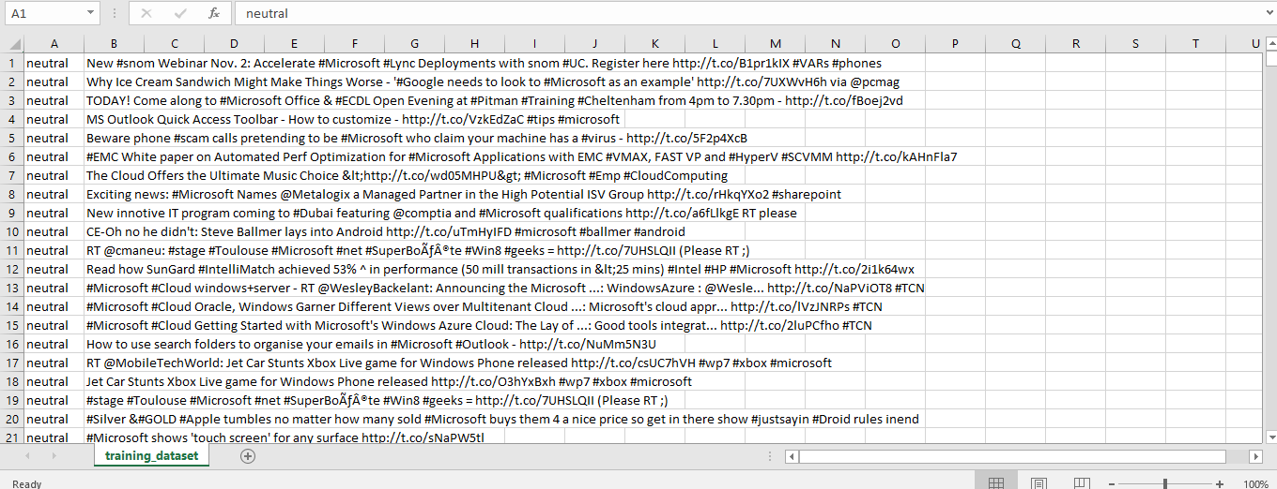
Figure 6.2.1: Training Dataset for the system
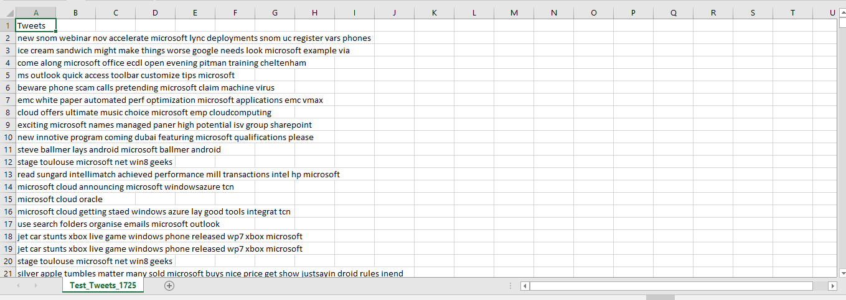
Figure 6.2.2: Testing of tweets for the system
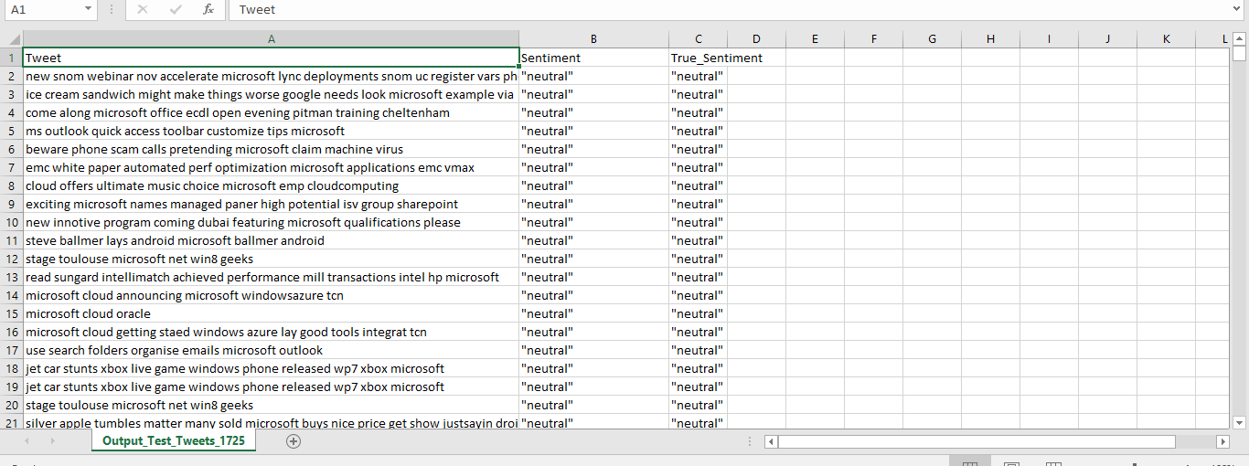
Figure 6.2.3: Output of test tweets for the system

Calculation:
Accuracy | 90.1219512195
Precision | 0.892302575003
Recall | 0.916802275492
F-Score | 0.904386532341

Hence, according to the calculation the accuracy of our system is 90.12% with the precision of 0.89, Recall of 0.91 and finally the F-Score of 0.90.

CHAPTER 7 – CONCLUSION

We have completed our project using python as language, Php with Html and Javascript for output presentation. We were able to determine the positivity, neutrality and negativity of each tweet. Based on those tweets we represented them in a diagrams in Pie-chart. All the diagrams related to outcome are shown in figure below. A small conclusion is also shown during output presentation based on product or brand entered. Our designed system is user friendly.
All displaying results are displayed in webpage.

7.1. Future Scope
The developed system predicts the sentiment of a keyword used in tweets based on training data set that need to be modeled. The system predicts the sentiment using computer device that need to be entered by human. However, some future enhancements can be applied to the system listed below:
- Analyzing sentiments on emo/smiley.
- Potential improvement can be made to our data collection and analysis method.

REFERENCES

[1] Wagh, R., & Punde, P. (2018). Survey on Sentiment Analysis using Twitter Dataset. 2018 Second International Conference on Electronics, Communication and Aerospace Technology (ICECA).
[2] Text Book: Kaufmannn, m. (2016). Data Mining, concept and testing. 3rd ed. California: Morgan Kaufmann, pp.15-18.
[3] Feature Extraction for Sentiment Classification on Twitter Data, International Journal of Science and Research (IJSR), vol. 5, no. 2, pp. 2183-2189, 2016.
[4] Alexander Pak, Patrick Paroubek, “Twitter as a Medium for Sentiment Analysis and Opinion Mining”, pg.1320-1326.
[5] J.Ren, S.D.Lee, X.Chen, B.Kao, R.Cheng, D.Cheung, “Naive Bayes Classification of Uncertain Data", Ninth IEEE International Conference on Data Mining, 2009. ICDM ’09, pp. 944 – 949
[6] Jain, A. P., & Katkar, V. D. (2015). Sentiments analysis of Twitter data using Bayes theory. 2015 International Conference on Information Processing (ICIP). doi:10.1109/infop.2015.7489492
[7] Trupthi, M., Pabboju, S., & Narasimha, G. (2017). Sentiment Analysis on Twitter Using Streaming API. 2017 IEEE 7th International Advance Computing Conference (IACC).
[8] Alec Go, Lei Huang, RichaBhayani, “Twitter Sentiment Analysis”, Final Projects from CS224N for Spring 2008/2009 at the Stanford Natural Language Processing Group.

APPENDIX

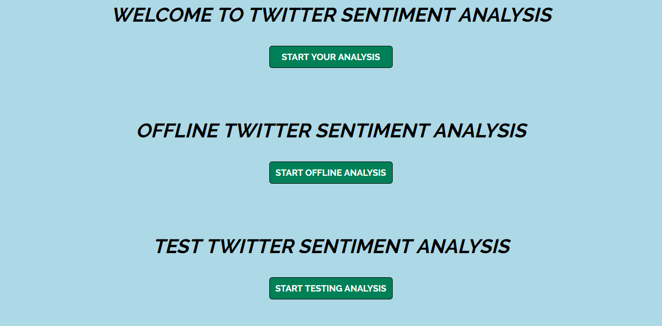
Figure A: User Interface

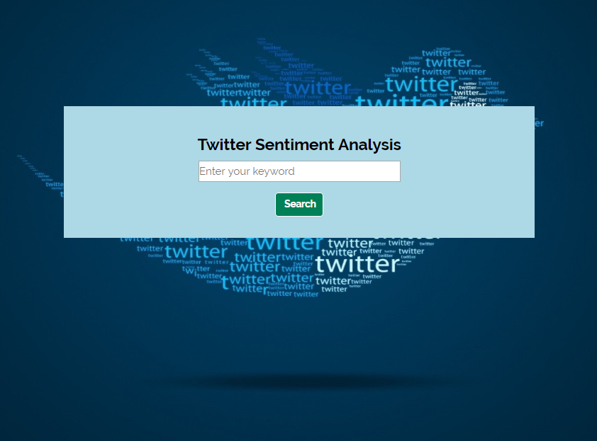
Figure B: User Interface to insert Keyword

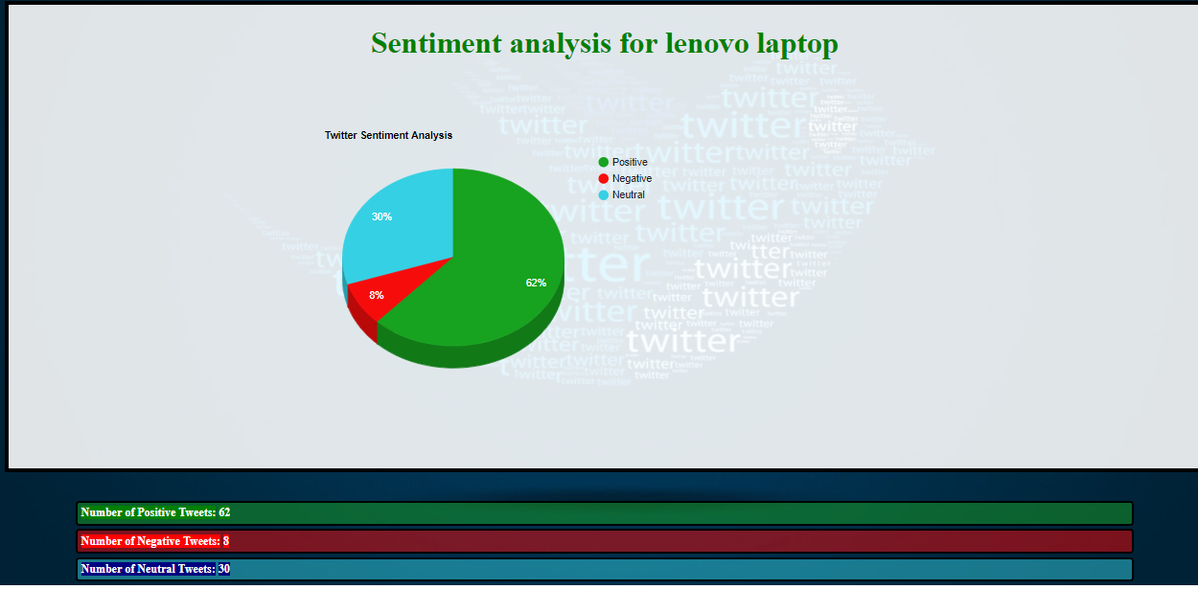
Figure C: Final Output Displaying Sentiment

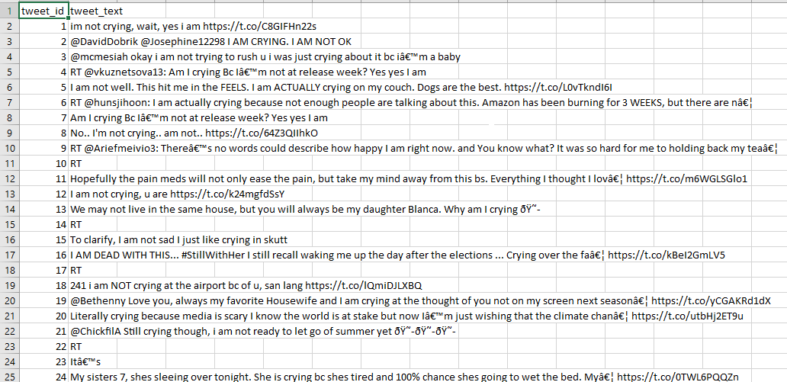
Figure D: Unprocessed Tweets fetched

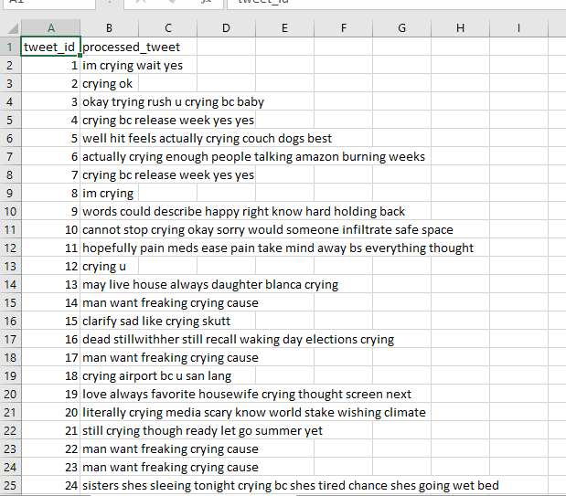Figure E: Processed Tweets fetched
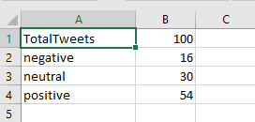
Figure F: Output fetched

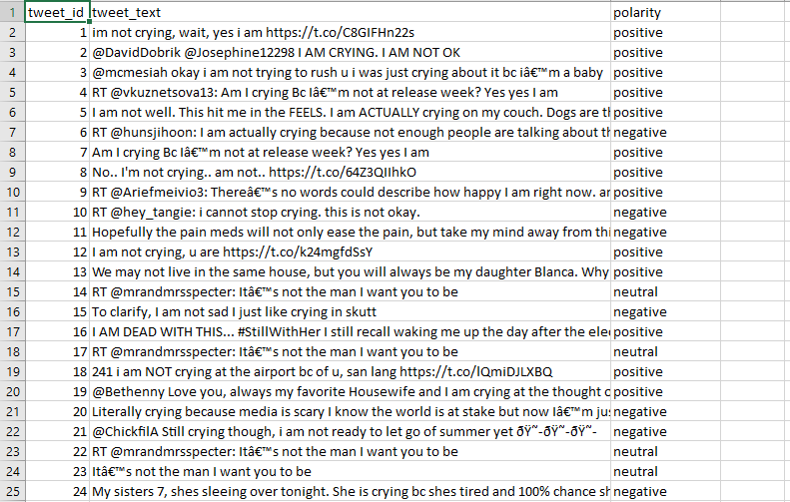
Figure G: Processed tweets with sentiment

