EDS 213: Databases and Data Management
Week 1 Assignment
1. Create an ER Diagram
This assignment creates an ER diagram for the Harry Potter database. The five required tables are student, house, wand, course and enrollment.

Twist 1: Model a many-to-many relationship between student and wand. The same wand can be used by different students, and one student may own multiple wands. This requires an intermediate table, called wand_ownership, following the same pattern as the enrollment table.

Twist 2: Store the begin date and end date of wand ownership. Because these dates describe the relationship between a student and a wand, they belong in wand_ownership, not in student or wand alone. This follows the same logic as grade belonging in enrollment rather than in student or course.

Solution

ER Diagram

I made a diagram with six tables: the five required tables plus wand_ownership. The diagram shows all six tables with their attributes, primary keys, foreign keys, and cardinality notation. A single bar represents the one side of a relationship and a crow's foot represents the many sides.
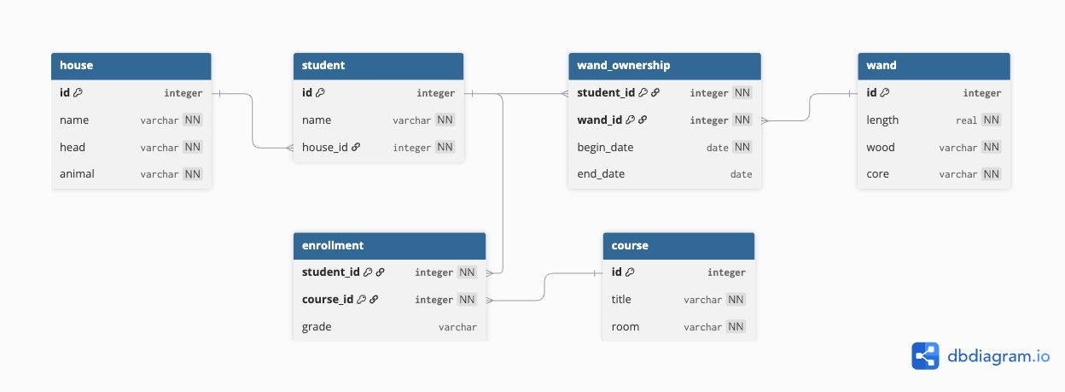

Tables and Attributes
Primary keys are marked PK. Foreign keys are marked FK.
PK, FK means the column is both part of the primary key and a foreign key.

house
Stores the four Hogwarts houses. Primary key: id.
- id (PK)
- name
- head
- animal

student
Stores each student. house_id links each student to their house. Primary key: id.
- id (PK)
- name
- house_id (FK)

wand
Stores each wand. Ownership is not stored here because the relationship is many-to-many and is handled by wand_ownership. Primary key: id.
- id (PK)
- length
- wood
- core

wand_ownership
The intermediate table that connects student and wand for the many-to-many relationship. It also stores the date range of ownership. Primary key: the combination of student_id and wand_id.
- student_id (PK, FK)
- wand_id (PK, FK)
- begin_date
- end_date

course
Stores each Hogwarts course. Primary key: id.
- id (PK)
- title
- room

enrollment
The intermediate table connecting student and course. grade belongs here because it describes the student course relationship, not either entity alone. Primary key: the combination of student_id and course_id.
- student_id (PK, FK)
- course_id (PK, FK)
- grade

Design Decisions

Twist 1: Many-to-many between student and wand
The same wand can be owned by different students at different times, and one student can own multiple wands. Because both directions are many, a single foreign key column in either table cannot represent this. The wand_ownership table holds student_id and wand_id as foreign keys, creating the many-to-many link. The crow's foot appears on both sides entering wand_ownership.

Twist 2: Where do begin_date and end_date belong?
begin_date and end_date describe when a specific student owned a specific wand. They describe the relationship between a student and a wand, not either entity on its own.

wand_ownership represents that relationship, so the dates belong there. This is the same reason grade belongs in enrollment rather than in student or course.

Primary key of wand_ownership
The primary key is the combination of student_id and wand_id. This follows the same pattern as enrollment, where the primary key is the combination of student_id and course_id. No separate id column is added.

One ambiguity here is whether a student could own the same wand more than once at different times. For example, borrow it, return it, and borrow it again. If that is possible, (student_id, wand_id) would not be unique and the primary key would break. One way to handle this would be to add begin_date to the primary key, making it (student_id, wand_id, begin_date). Since the assignment does not specify this case, I kept the simpler two column key, but this is a real ambiguity that would need to be resolved with more information about how wand ownership works.

