Meet a new AI coding partner
I spent a couple of days experimenting with KIRO Amazon’s new agentic IDE. The results were surprising: instead of being a glorified auto complete KIRO behaves like a structured project aware teammate. It helped me turn a single prompt into a full spec command design, task plan, UML diagrams and working code for a Python application – TCL Formatter and Syntax Debugger in a fraction of time I’d normally spend on planning and scaffolding.
This article is a practical walk through of how KIRO’s spec-based flow and its steering /automation primitives accelerate real engineering work especially the kind of internal tooling common in EDA/VLSI work flows.

Problem recap: Why application matters?
In modern semiconductor and VLSI CAD flows TCL tool command language scripts are used extensively for automation in EDA environment. Engineers frequently work with large TCL files that accumulate formatting inconsistencies, indentation drift and hidden syntax issues like unmatched braces and codes. These issues can break automation flows and consume hours of debugging time. To reduce inefficiency and improve debugging productivity an MVP python application call TCL Formatter and Syntax Debugger is built that formats TCL script files enforce consistent structural rules and automatically detect syntax problems.
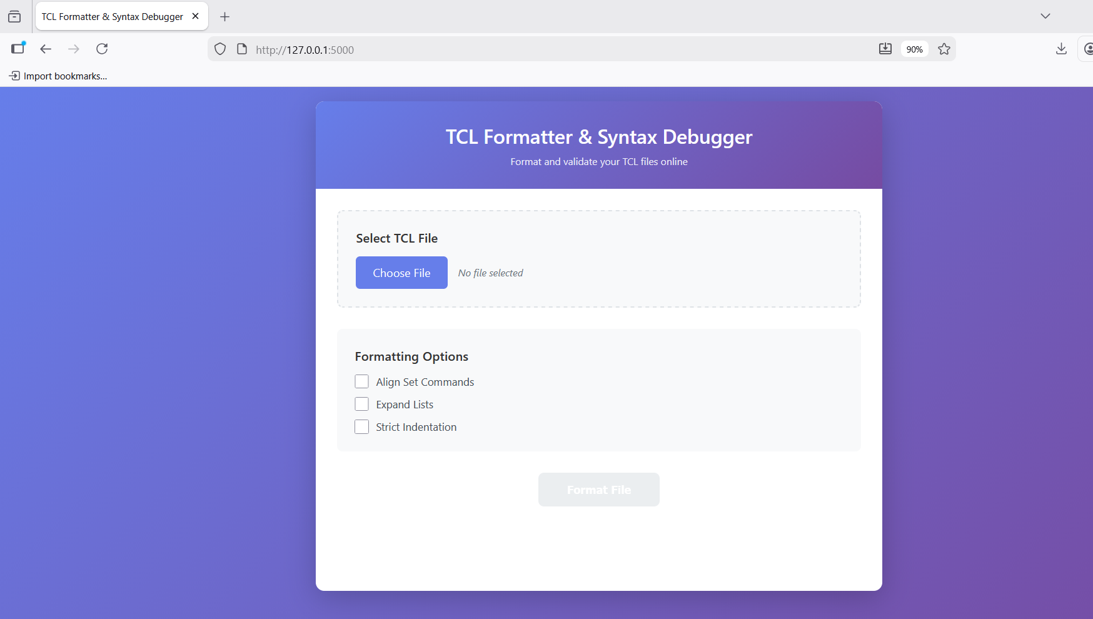
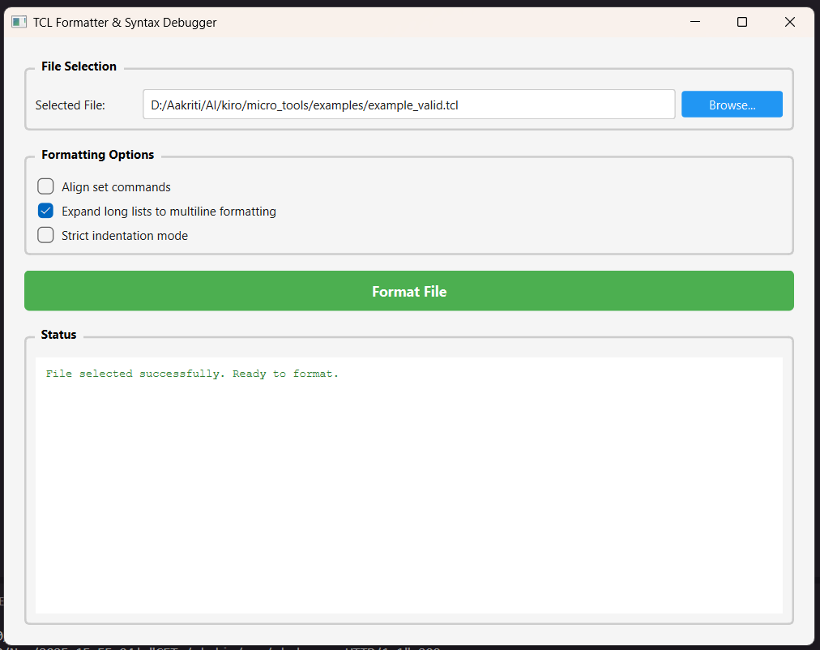

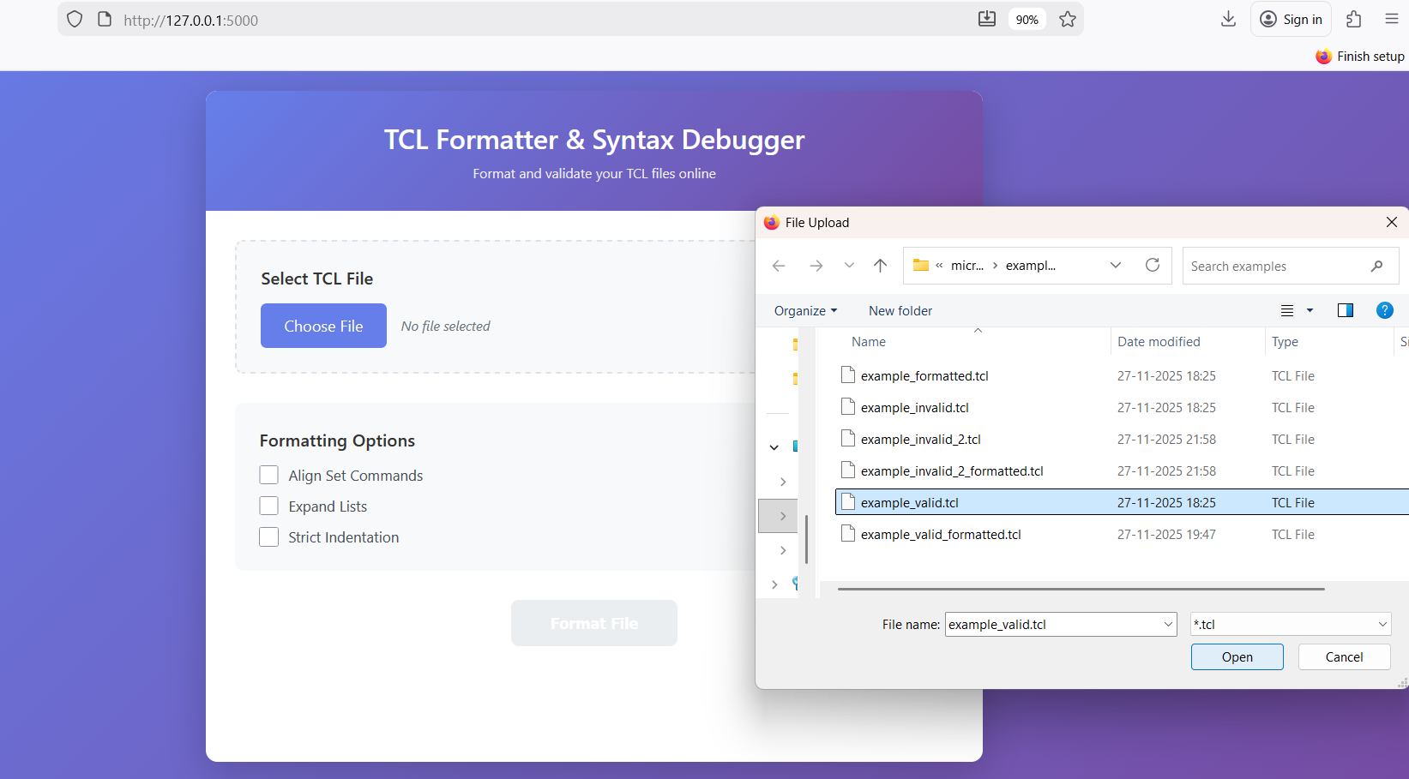

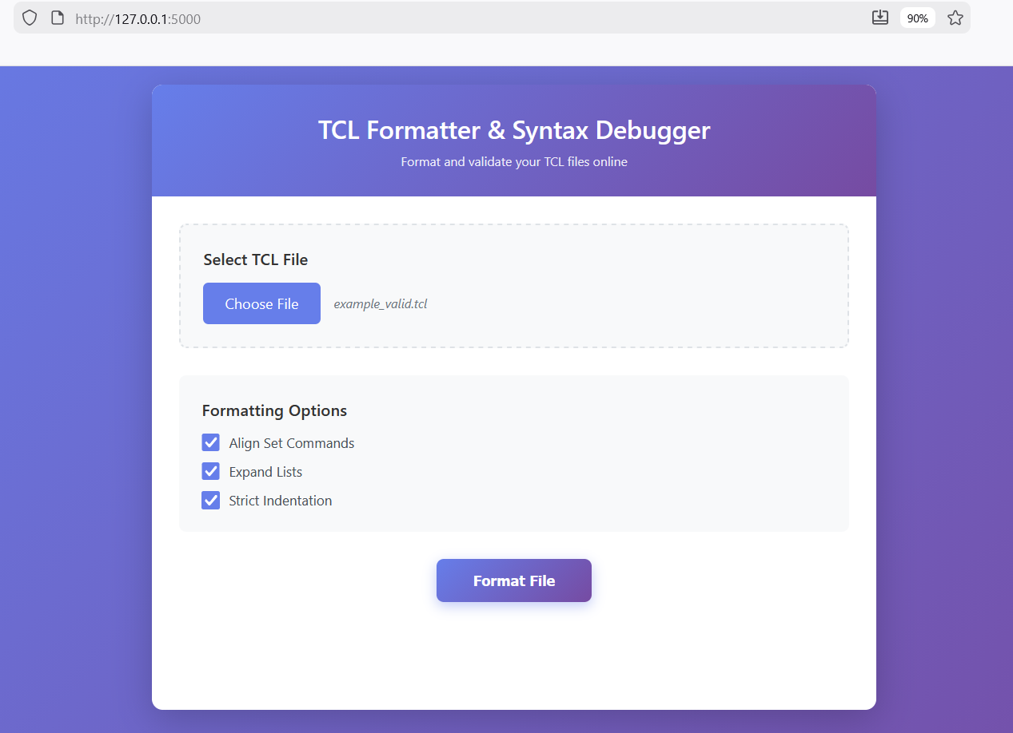

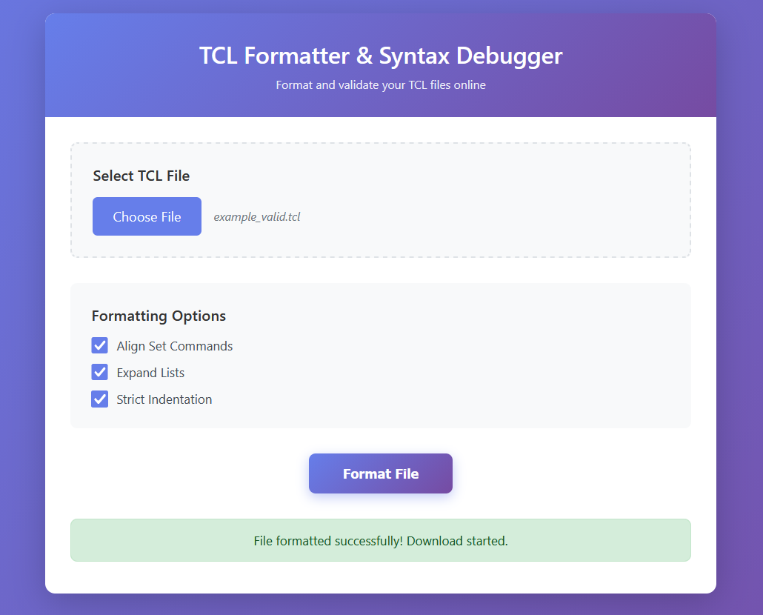

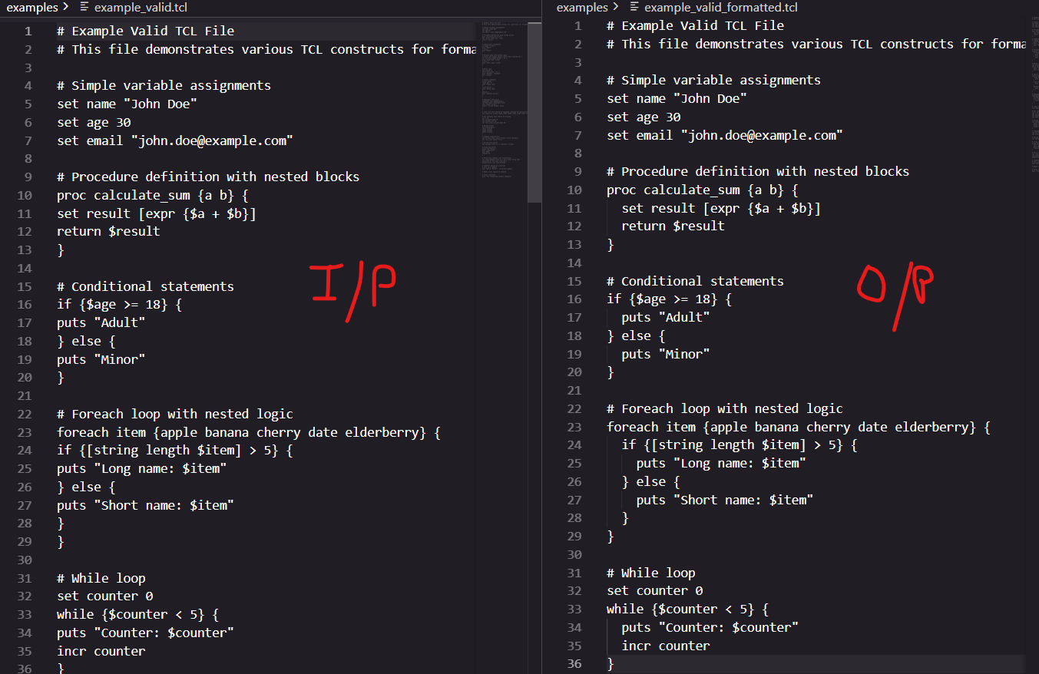

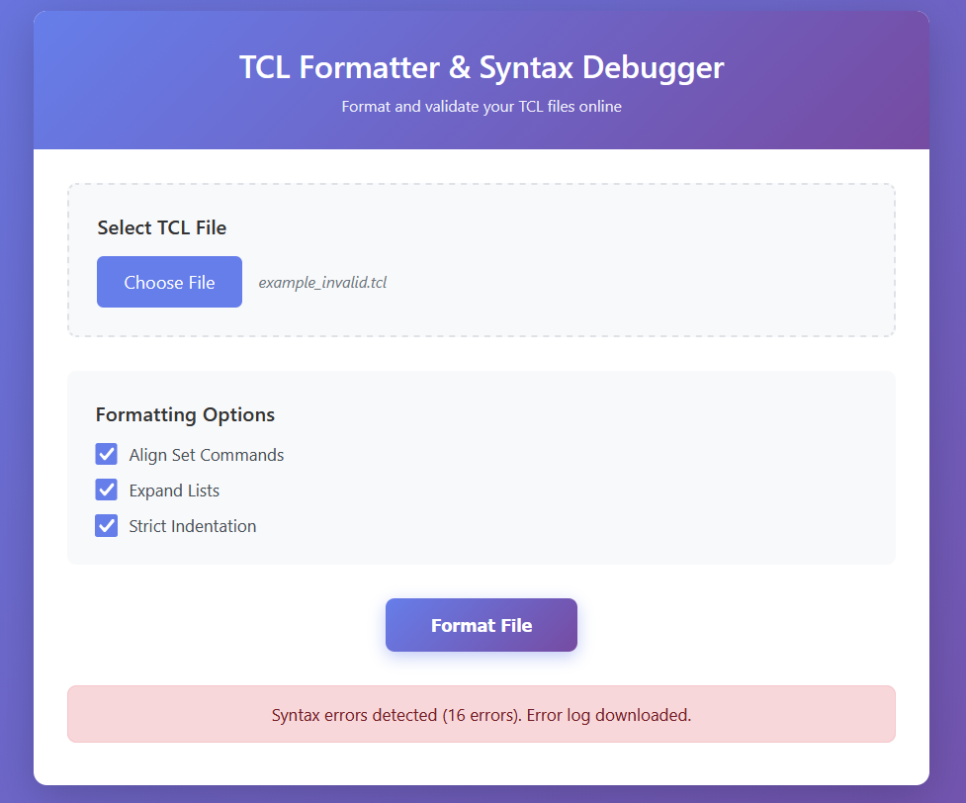

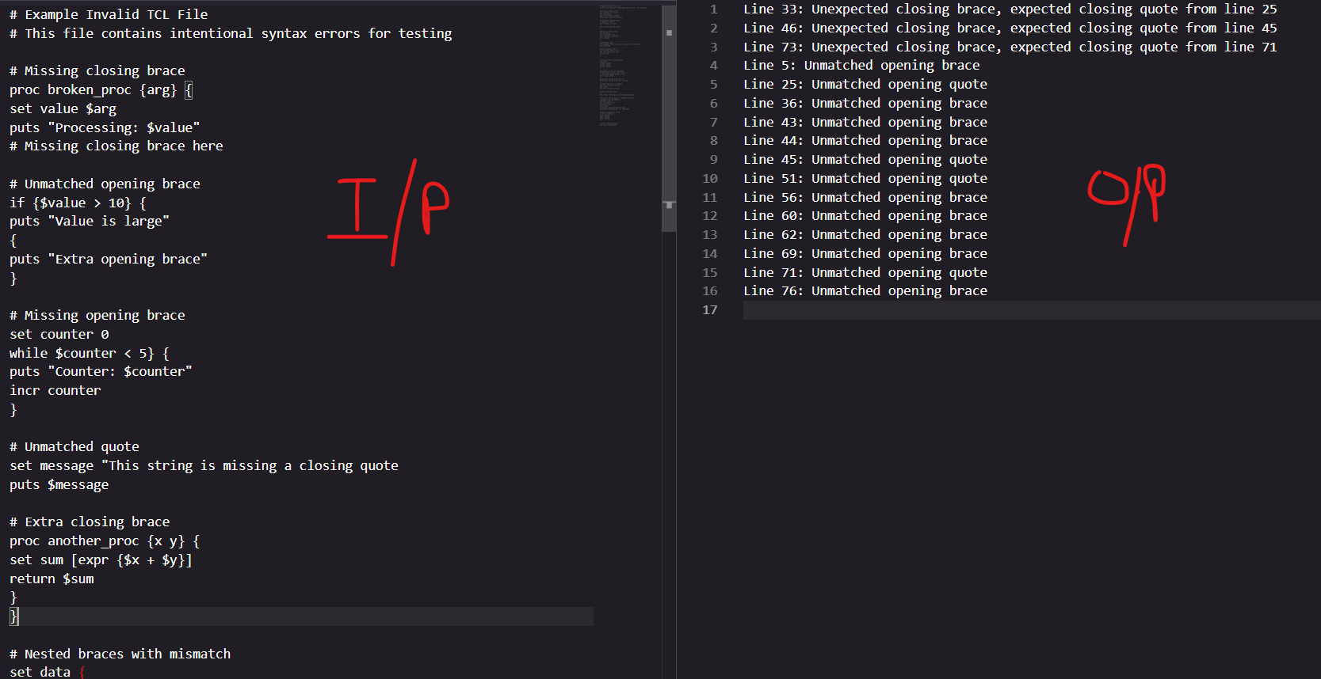

What made this development unique was the engineering approach using KIRO’s Spec-driven development to generate requirements, design documents, task plans and even the complete functional code base directly from a single prompt. This compressed development time from weeks to hours.

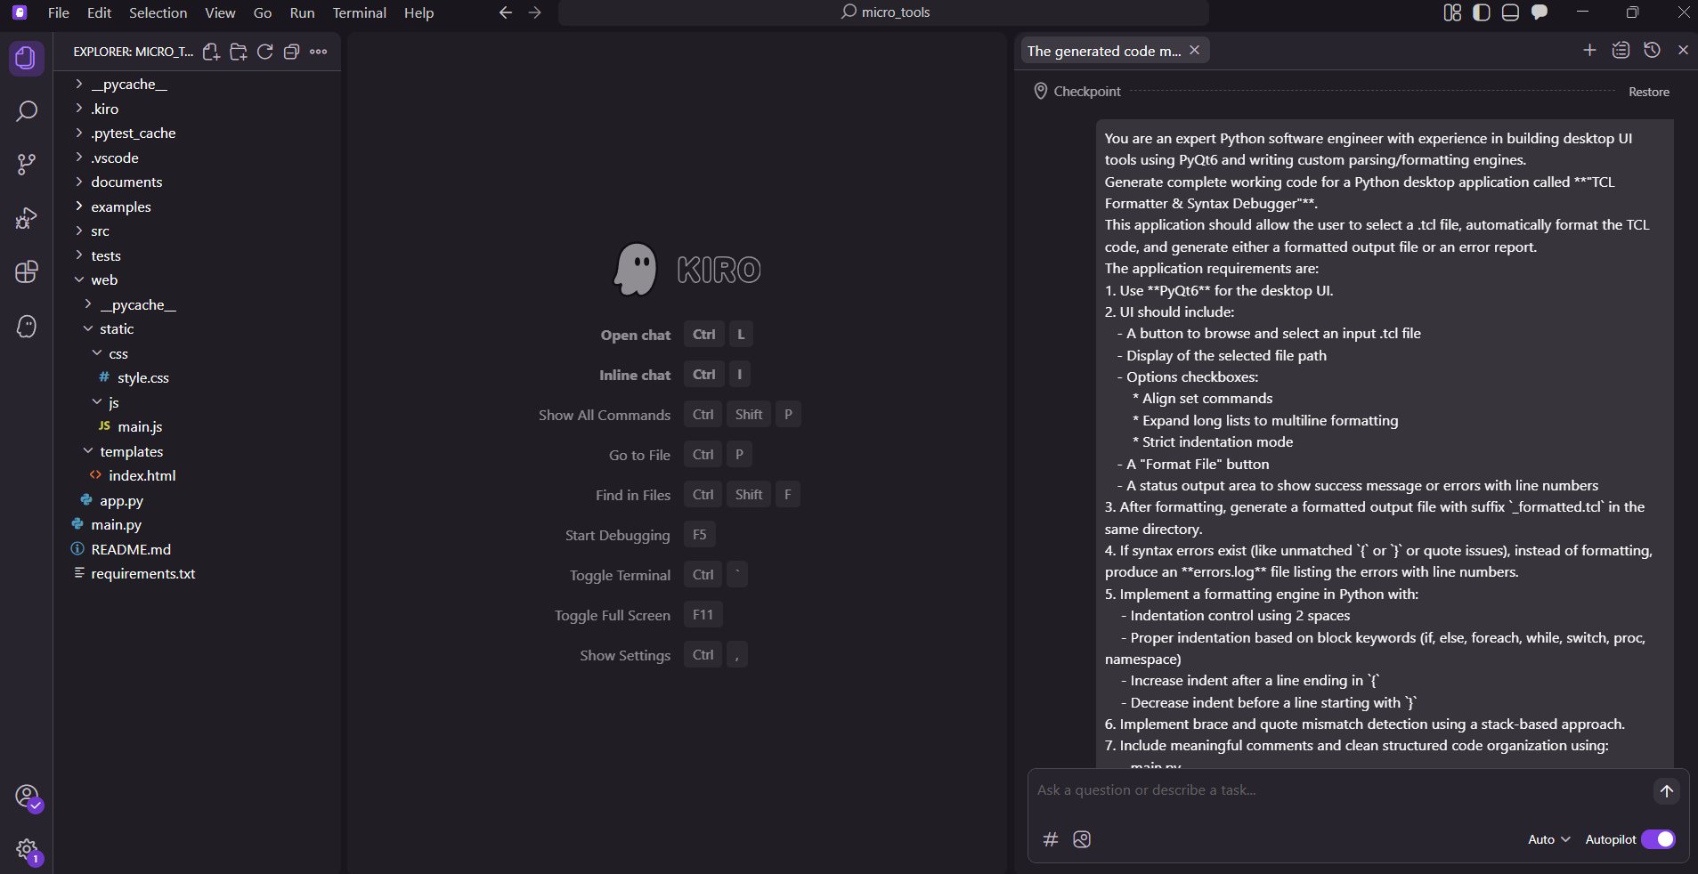

What KIRO produced - end to end?
From a single prompt KIRO generated:
- requirements.md - granular user stories and acceptance criteria.
- design.md - architecture, class interfaces, data models and an implementation plan.
- tasks.md - a prioritise task list with unit test items mapped to requirements.
All these artifacts were consistent: the tests were tied to the requirements, the design mapped to tasks, and code implemented the same design. The traceability is what makes the spec-based flow so powerful.

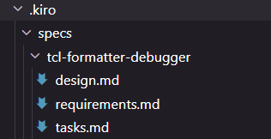
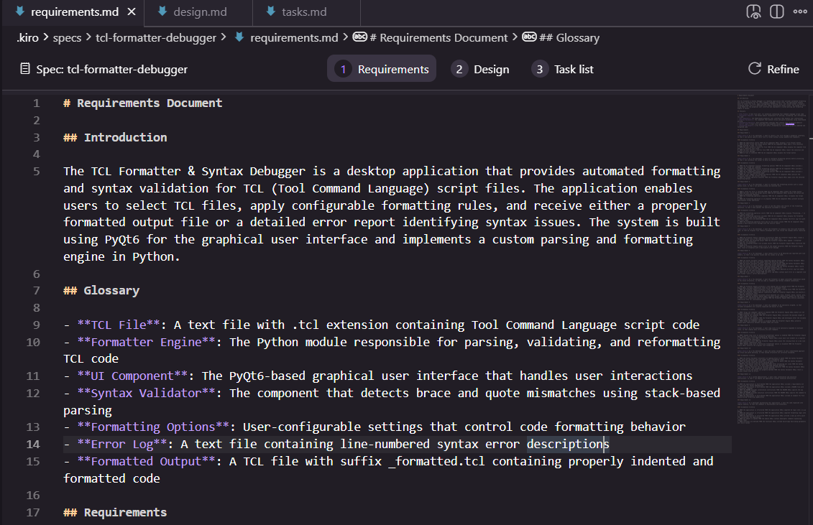

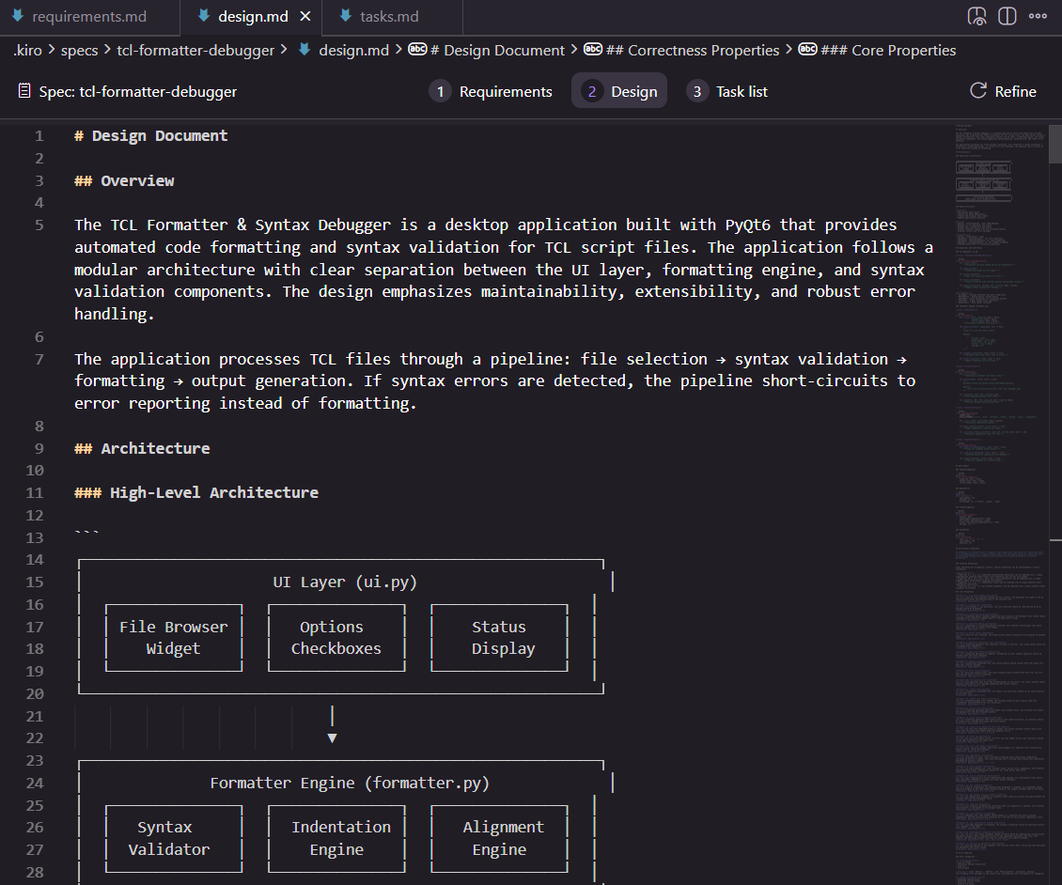

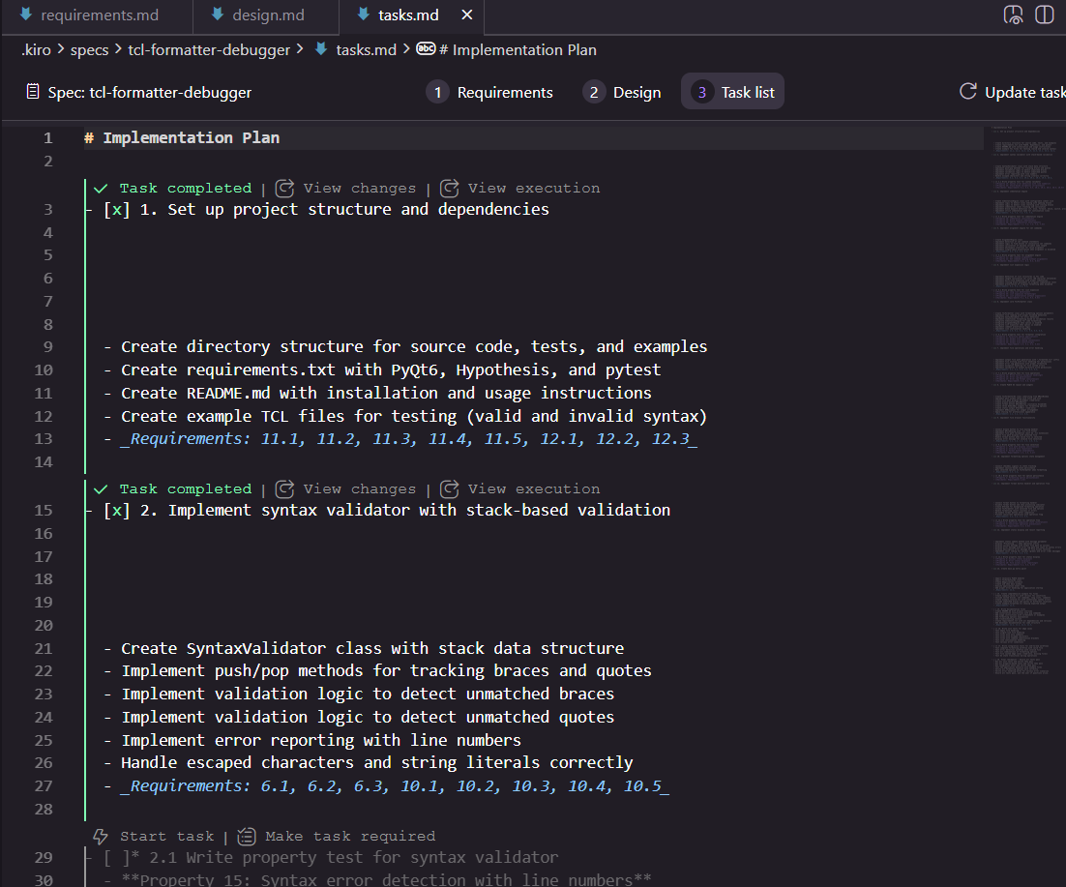

Understanding Kiro: a beginner’s guide to the Agentic IDE
If you are new to the idea of an Agentic IDE here’s how to think about it.
Agentic IDE = AI as a structured partner.
KIRO doesn’t just offer snippets it understands high level goals, generates planning documents, breaks work into tasks, and can execute those tasks There are two distinct interaction styles number:
- Vibe code mode: which is chat first, quick iteration, ideal when exploring ideas.
- Spec-based flow: which is structured, plan driven, deliberate and ideal when correctness, traceability, and quality matters.
For engineering tools and everything that needs precise behaviour the Spec based flow is the one to use.

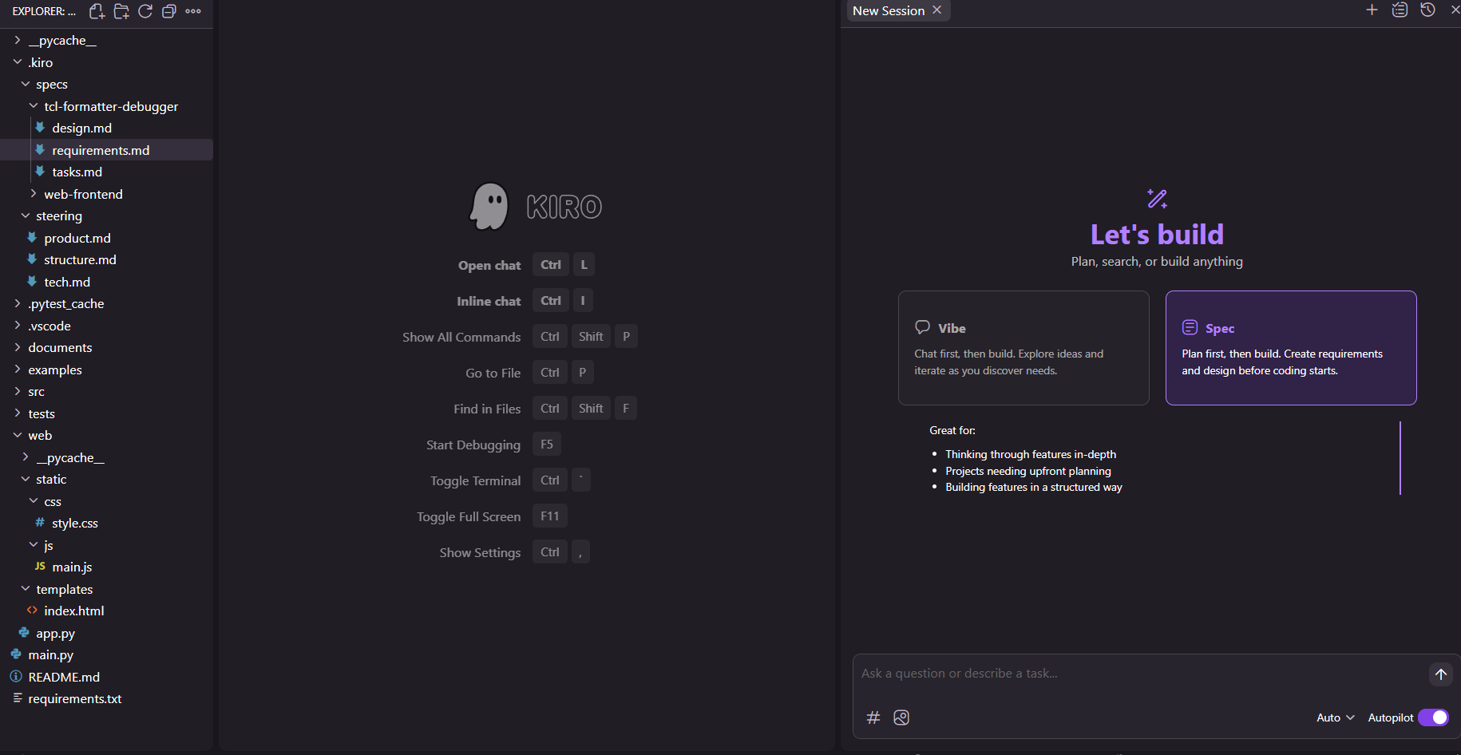

The Spec-based Flow - how real work happens
KIRO’s workflow reduces guesswork and prevents the back-and-forth rewrite cycle that plagues many AI coding attempts. It follows a following step:

- Generate planning documents – KIRO created product, structure, and tech steering docs plus a full requirement.md
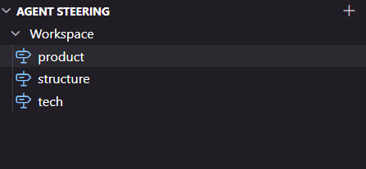
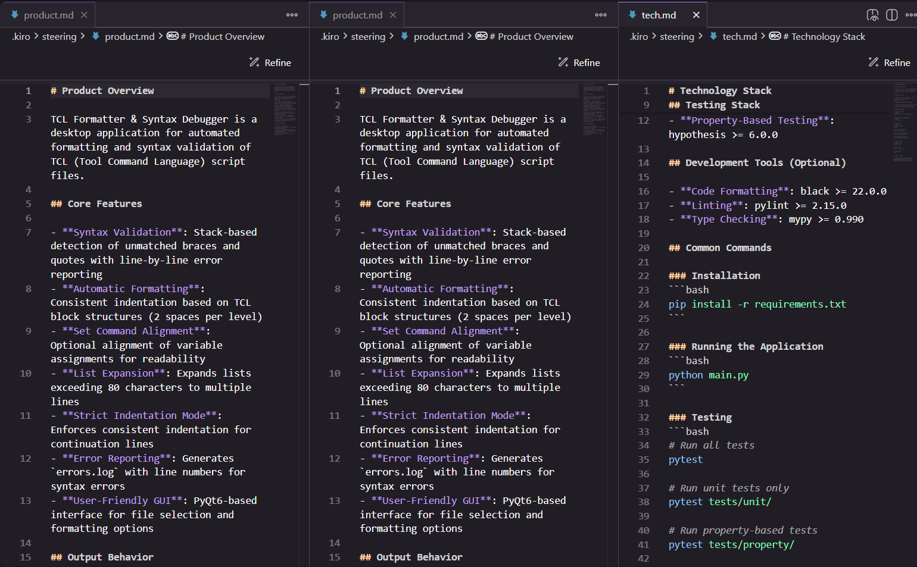
- Start with an idea - which is a one-line requirement or a full detailed prompt or a feature request. (Example: “format TCL Files with brace/quote validation”)
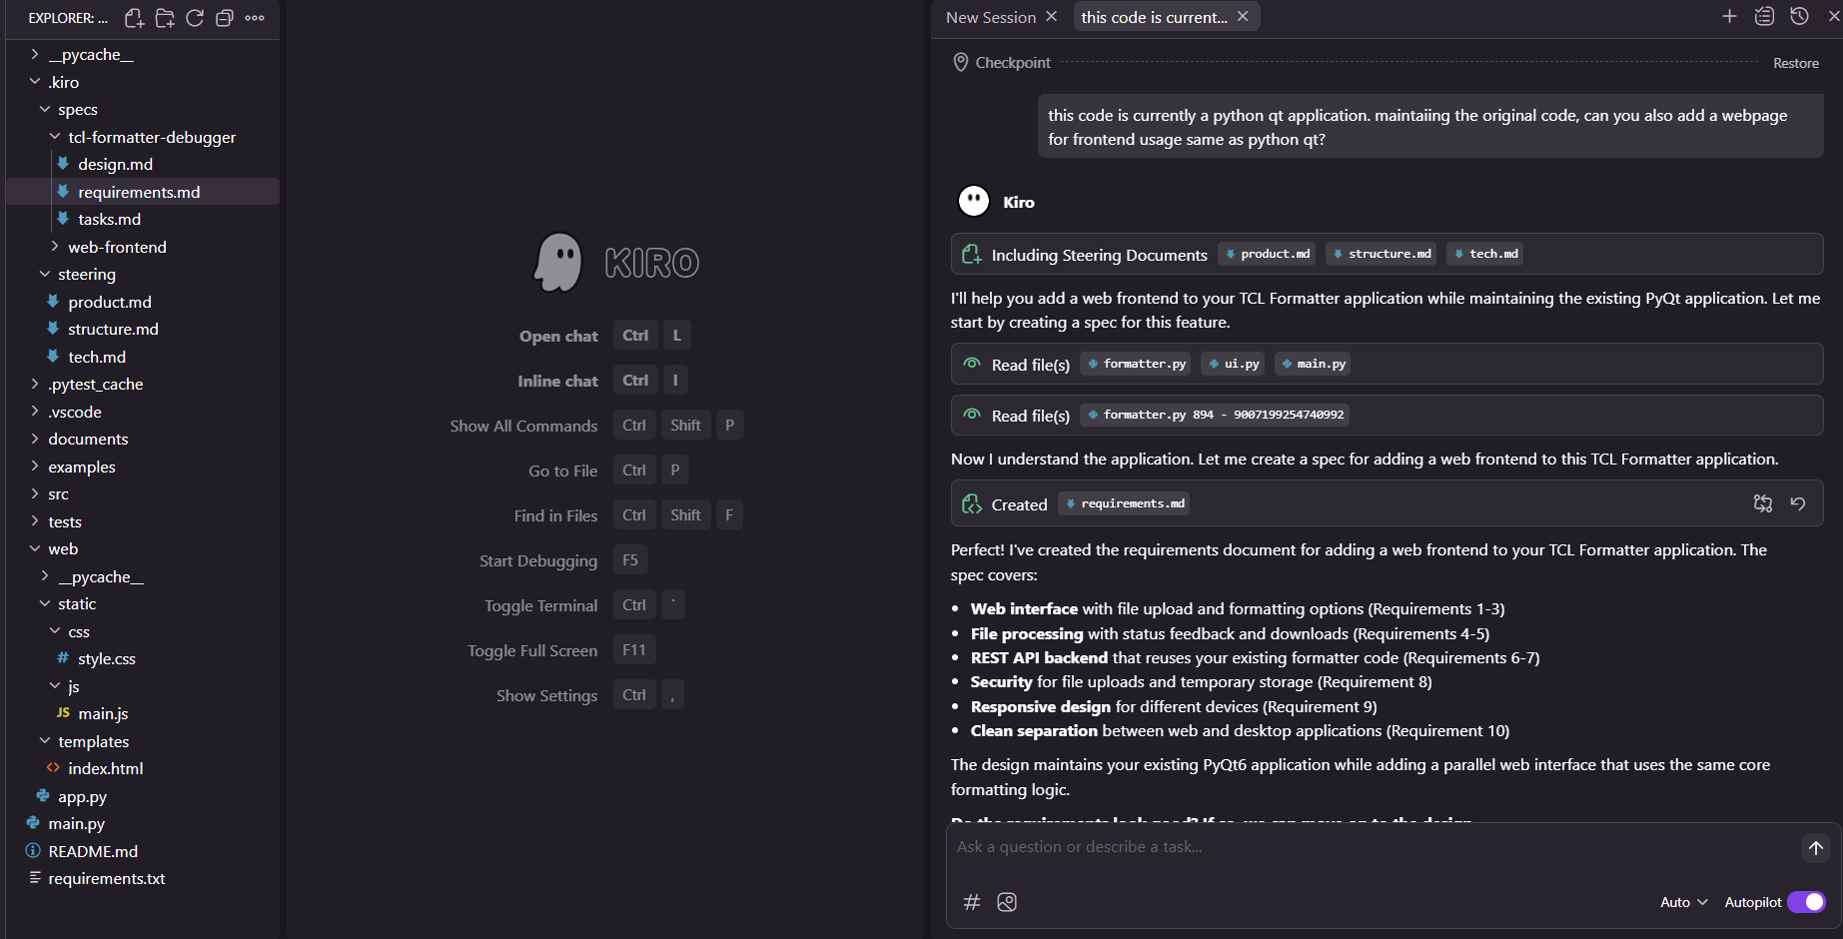
- Create an implementation plan- requirements.md, design.md, tasks.md breaks the work into granular.
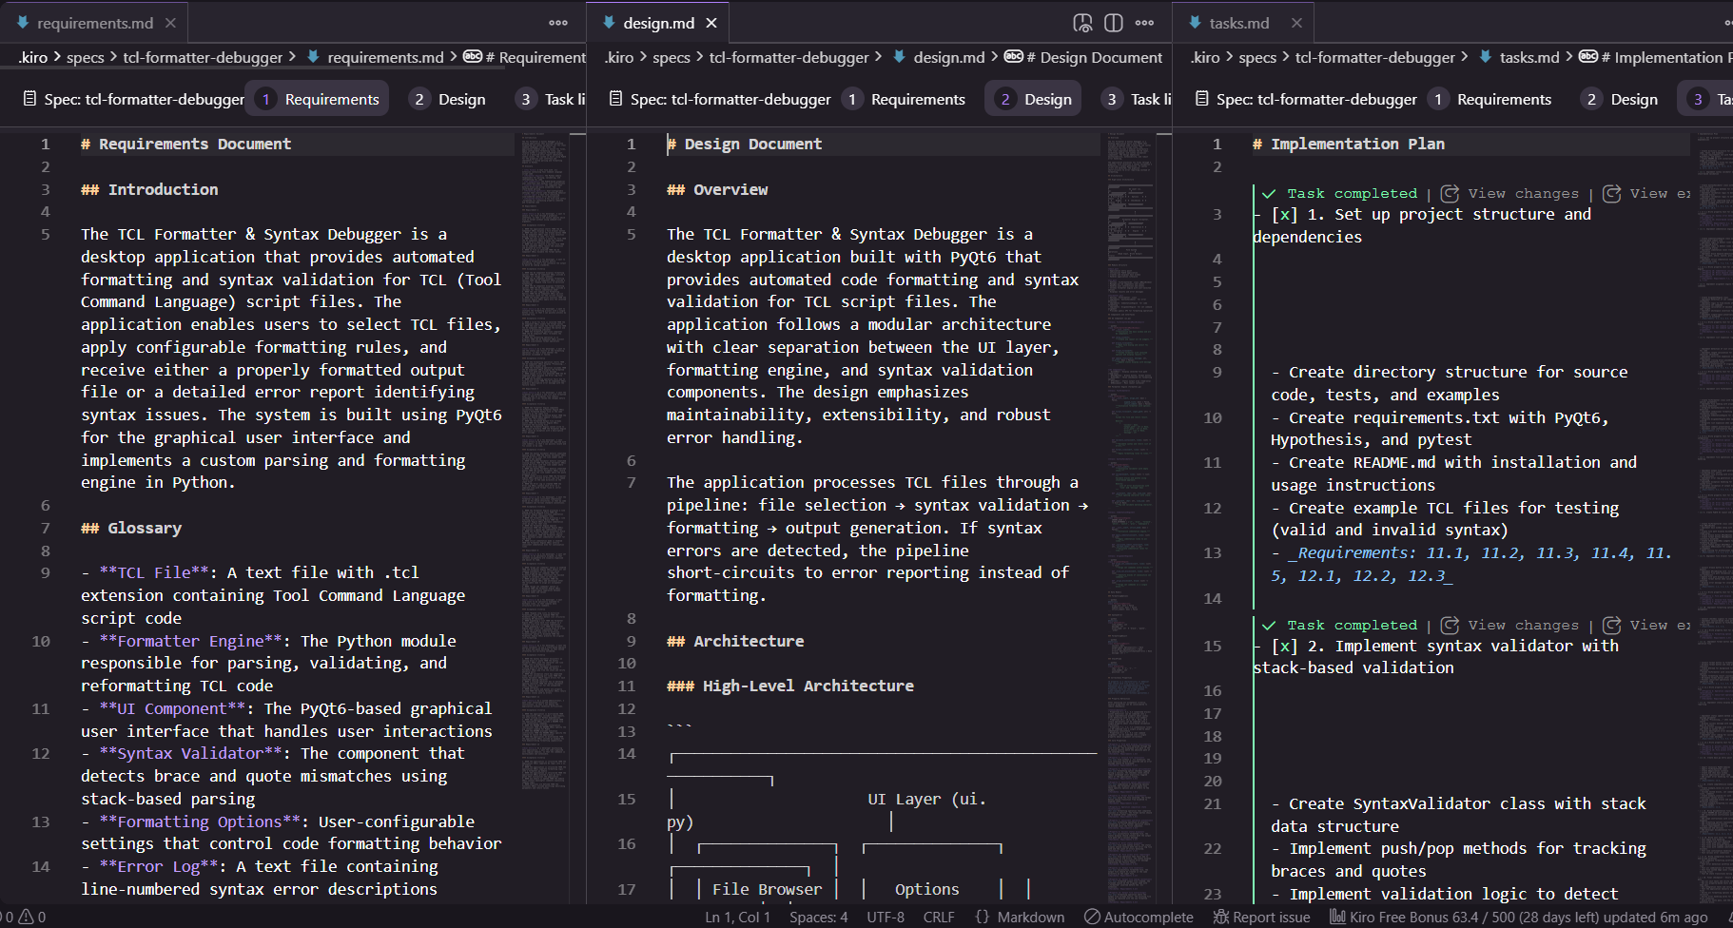
- Execute tasks - you start/queue tasks and monitor progress. KIRO will pause for approvals before dangerous operations (like Steering documents deploys, writes to repo root etc.)
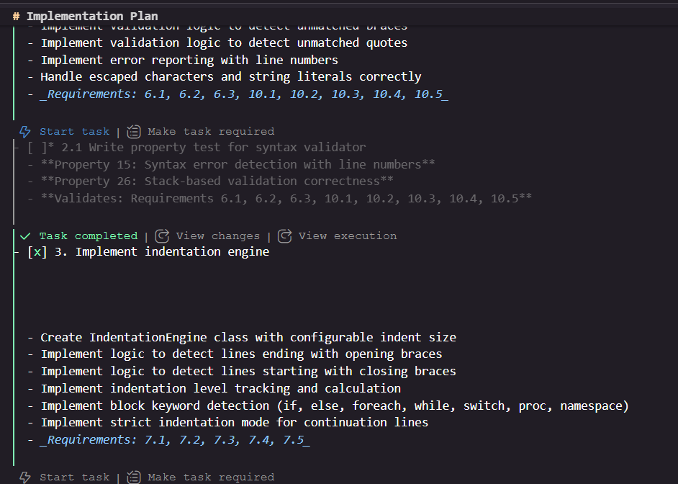
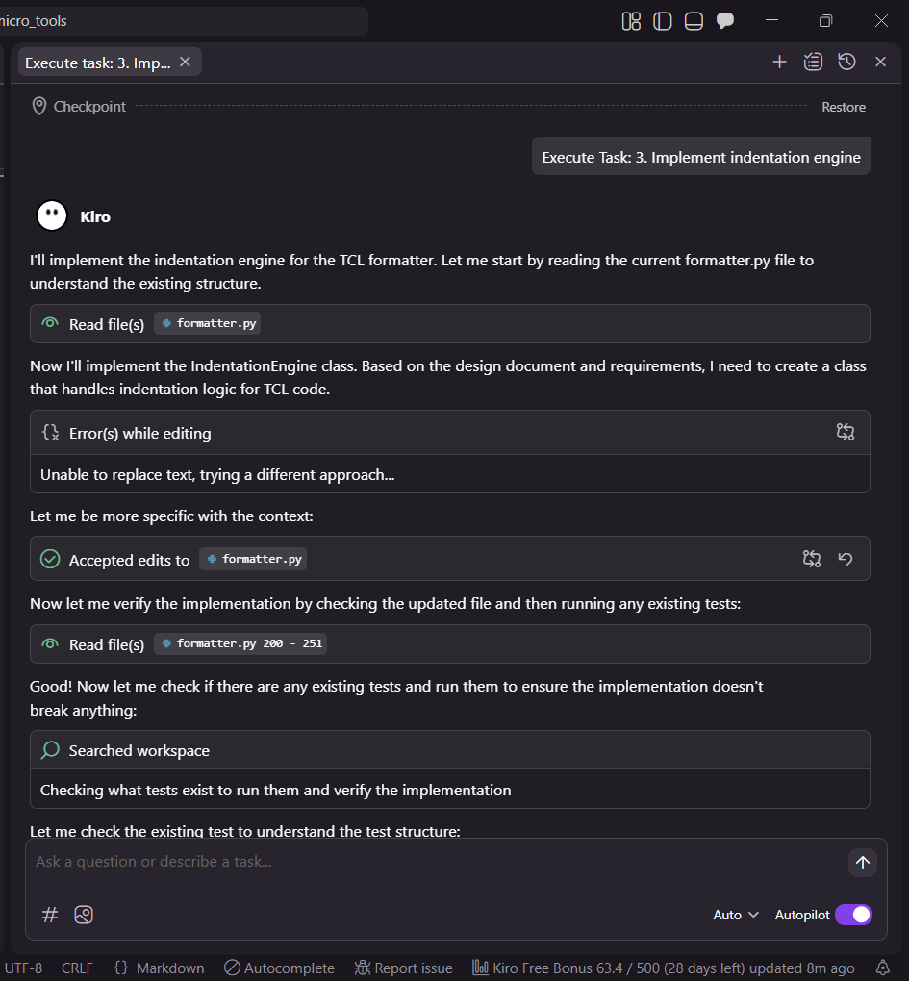
Because the specification is explicit and editable (all steering docs are marked down) which can you control the AI’s mental model. Update a steering doc and the agent re-aligns its behaviour.

Steering documents: the AI’s project brief
Before writing code KIRO recommends you set up steering documents - short, editable, Markdown files that teach the agent about your project:
- Product - what the app is for and its user goals.
- Structure - how your code base is organised like modules and where to place code, etc.
- Tech - concrete stack details (like python versions, linting, config etc)
Because these are regular files in your repo you can correct or expand them. That small manual step yields huge improvements in output quality. The AI doesn’t guess your architecture; it uses your declared architecture.

Agent hooks: automation that keeps itself useful
KIRO’s Agent Hooks are essentially event-driven automations for your repository. Example I used a hook that: when examples/*.tcl is updated, regenerate the README list of files.
This removes tedious maintenance tasks and keeps the codebase honest. Trigger types include file saved file, created file, deleted file or manual trigger. Hooks let you keep the repository latest automatically while you focus on behaviour and correctness.

Why structure actually pays off
That initial heavy lifting generating steering docs, detailed requirements, and task list feels slow at first but the payback is immediate.
- Reliability - code aligns to acceptance criteria and tests so behaviour is predictable.
- Traceability - every task maps to a requirement and tests verify acceptance.
- Maintainability - updating the spec regenerates the plan and code scaffolding, avoiding divergence.
- Iteration speed - future features are faster because the agent already understands repo structure.
For internal tools the upfront investment eliminates long debugging sessions and “works on my machine” surprises.

A concrete look: TCL Formatter and Syntax Debugger flow.
- I gave KIRO a precise prompt describing UI requirements, formatting rules, validation and output file behaviour.
- KIRO generated requirements.md design.md and tasks.md. I reviewed and made a few small edits to the steering docs.
- KIRO produced each feature code implementation and UI.
- I rendered the KIRO generated UML in the browser and use the tasks view to run the formatter end to end.
- The result: working GUI + formatted output and detailed error logs linked to the specs acceptance criteria.

Final thoughts and practical advice
If you are experimenting: start in Vibe Code Mode for rapid exploration, then switch to the Spec-based flow to production.
If you want reliable outcomes: invest time in steering documents they are small files that massively reduce surprises.
Use agent hooks to automate maintain maintenance tasks like read me updates or example regeneration.
Expect a deliberate pace: KIRO’s single task queue and thorough planning are trade-offs for correctness and for tooling and infra work that’s a good trade.
KIRO is currently in preview and it’s an excellent time for engineers to explore structured ai assistance. For teams that ship automation and developer productivity tools KIRO’S spec driven development approach is a genuine productivity multiplier

