Networking Devices in CN:

1. Hubs:  
   A hub is a basic networking device that connects multiple computers in a local area network (LAN). It operates at the physical layer of the OSI model, meaning it doesn't perform any filtering or data processing. When data arrives at one of its ports, the hub simply broadcasts it to all other ports, regardless of the destination. This can lead to network inefficiencies and collisions, as all devices share the same bandwidth. Hubs are largely obsolete today, having been replaced by more intelligent devices like switches.

Types of Hub :

* Active Hub
* Passive Hub
* Intelligent Hub

One significant drawback of hubs is their lack of intelligence in data handling. They do not filter traffic or manage any form of data routing. This leads to a high probability of data collisions, particularly in larger networks where multiple devices may try to communicate simultaneously. As a result, network performance can degrade due to the increased number of collision domains, which necessitate retransmissions of data packets.

In terms of network topology, hubs are often used in star topologies where each device is connected to a central hub. While this setup can simplify network management and troubleshooting, it also means that the hub becomes a single point of failure. If the hub fails, all connected devices lose network connectivity.

Despite their simplicity and cost-effectiveness, hubs have largely been replaced by more sophisticated devices like switches and routers in modern networks. These advanced devices provide better traffic management, reduced collisions, and improved overall network performance. However, hubs are still occasionally used in specific scenarios where their limitations are not a significant concern, such as small home networks or simple office setups.

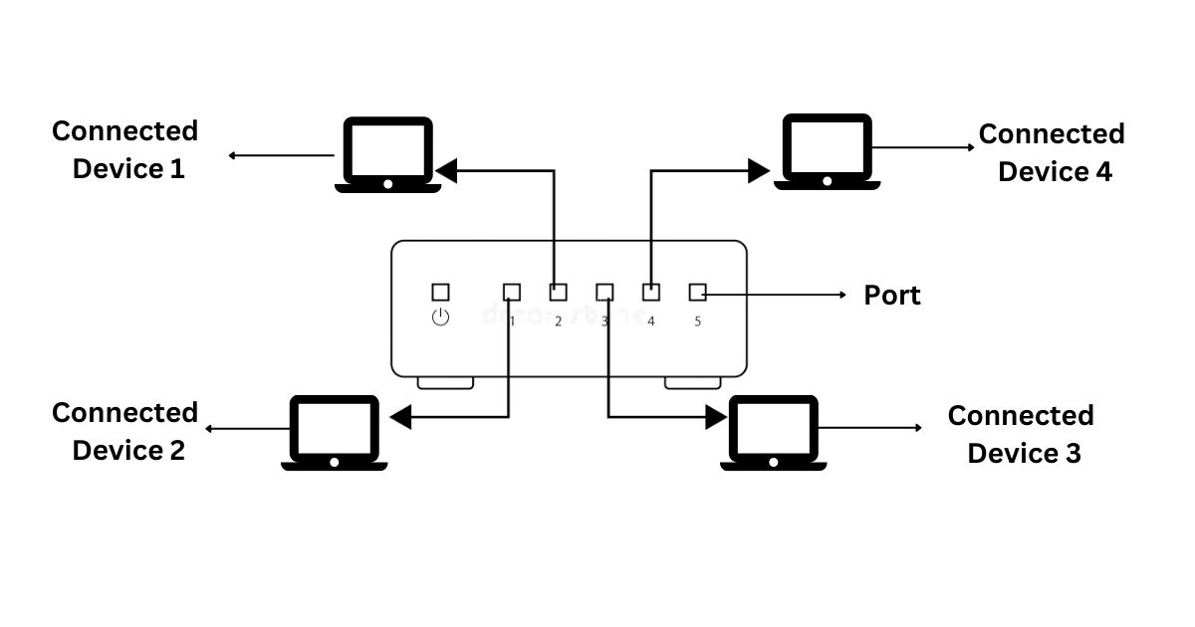

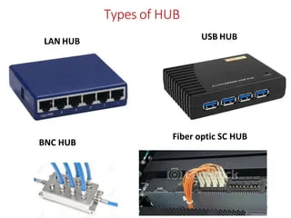 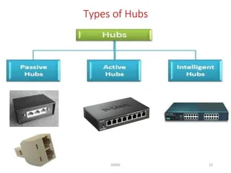

1. Repeaters  
   A repeater is a device used in networking to extend the reach of a network by amplifying and regenerating signals. It operates at the physical layer of the OSI model. When a signal travels over a long distance, it can weaken and degrade. A repeater takes the weak signal, amplifies it, and retransmits it at its original strength. This makes repeaters essential for maintaining the quality of signal transmission over long distances, especially in wired networks.It is a 2-port device.

How Repeaters Work

When data is transmitted over a network, the signal gradually degrades due to attenuation, which is the loss of signal strength as it travels through a medium. This degradation can lead to errors in data transmission, making it difficult or impossible for the receiving device to correctly interpret the signal. A repeater addresses this issue by capturing the weakened signal before it becomes too degraded, regenerating it to its original strength and quality, and then sending the restored signal onward.

Repeaters do not analyze the data they retransmit; they simply amplify the electrical signal. This simplicity allows them to function with minimal latency, making them suitable for real-time applications that require consistent signal strength over long distances.

Types of Repeaters

There are various types of repeaters tailored to different network mediums and technologies:

* Ethernet Repeaters: Used in wired networks to extend the length of Ethernet cables beyond the standard maximum (typically 100 meters for Cat5e/Cat6 cables). Ethernet repeaters regenerate the signal, allowing network segments to be connected over greater distances.
* Optical Repeaters: Utilized in fiber optic networks, optical repeaters amplify the light signals used for high-speed data transmission. These repeaters are essential for long-distance fiber optic communication, such as transcontinental data links.
* Wireless Repeaters: Also known as range extenders, these devices receive wireless signals from a Wi-Fi router or access point and retransmit them to cover areas with weak or no signal. Wireless repeaters are commonly used in homes and offices to improve Wi-Fi coverage and eliminate dead zones.
* Satellite Repeaters: Used in satellite communication, these repeaters receive signals from one location on Earth, amplify them, and then transmit them to another location via satellite. They are critical for global communication networks, including television broadcasts and internet services.

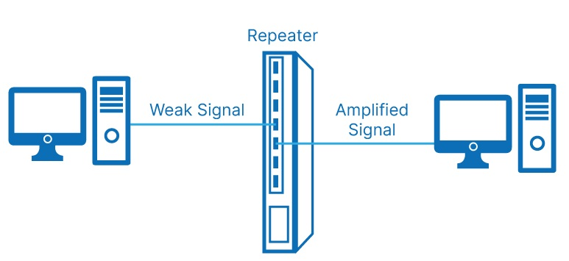

1. NIC  
   A Network Interface Card (NIC) is a hardware component that enables a computer or other device to connect to a network. It operates at both the physical and data link layers of the OSI model. Each NIC has a unique MAC address, which it uses to communicate over the network. NICs can be used in both wired and wireless networks, providing the necessary interface for devices to transmit and receive data. Without a NIC, a device would be unable to participate in network communications.

Functionality and Components

A NIC typically includes several key components:

* Controller: The main processor of the NIC, responsible for managing data transmission and reception. It processes network protocols, handles data buffering, and manages data flow between the computer's system bus and the network.
* Transceiver: This component handles the physical signaling to and from the network medium. In wired NICs, it is responsible for converting digital data to electrical signals and vice versa. In wireless NICs, the transceiver converts digital data to radio signals and vice versa.
* MAC Address: Each NIC has a unique Media Access Control (MAC) address, a 48-bit identifier assigned by the manufacturer. The MAC address is used to identify the device on the network and ensure proper delivery of data packets.
* Interface: The physical connection point between the NIC and the network medium. For wired NICs, this is usually an Ethernet port (RJ-45). For wireless NICs, it includes an antenna and radio interface for Wi-Fi connectivity.
* Memory: NICs often include onboard memory for buffering incoming and outgoing data packets, ensuring smooth data transmission even when the host system is busy.

Types of NICs

NICs come in various forms, each suited to different networking needs:

* Ethernet NICs: The most common type, used for wired network connections. They support various Ethernet standards, such as Fast Ethernet (100 Mbps), Gigabit Ethernet (1 Gbps), and 10 Gigabit Ethernet (10 Gbps).
* Wireless NICs: These provide Wi-Fi connectivity, supporting various wireless standards like 802.11a/b/g/n/ac/ax. Wireless NICs are commonly found in laptops, tablets, and smartphones, allowing devices to connect to wireless networks.
* Fiber NICs: Used for high-speed network connections over optical fiber. They are common in data centers and enterprise environments where high bandwidth and long-distance connectivity are required.
* Virtual NICs: Software-based NICs used in virtualized environments. They enable virtual machines to connect to virtual or physical networks, simulating the functions of a physical NIC.

Role in Networking

NICs play a crucial role in network performance and reliability. They handle the critical task of framing and addressing data packets, ensuring that data is correctly formatted for transmission and accurately delivered to the intended recipient. High-quality NICs can enhance network throughput, reduce latency, and support advanced features like offloading CPU tasks related to network processing, improving overall system performance.

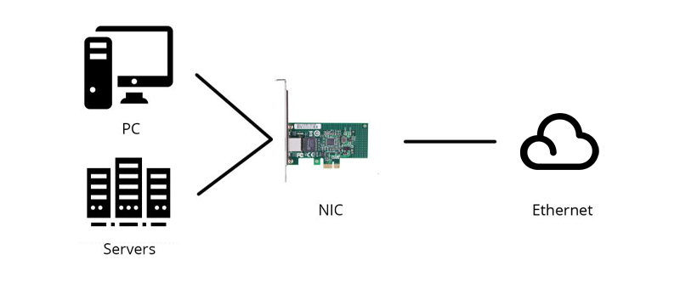

1. Switch  
   A switch is an advanced networking device that connects multiple devices within a network and uses MAC addresses to forward data to the correct destination. Operating primarily at the data link layer, switches are more efficient than hubs because they only send data to the specific device it is intended for, rather than broadcasting it to all ports. This reduces collisions and improves bandwidth usage. Some switches also operate at the network layer, providing additional routing functions. Switches are a staple in modern local area networks (LANs) due to their ability to manage data traffic efficiently.  
     
   Types of Switch:

* Unmanaged switches
* Managed switches
* Smart switches
* Layer 2 switches
* Layer 3 switches
* PoE switches
* Gigabit switches
* Rack-mounted switches
* Desktop switches
* Modular switches

Switches maintain a MAC address table, also known as a CAM (Content Addressable Memory) table, which maps each device's MAC address to the corresponding switch port. When a data packet arrives at a switch, it examines the packet's destination MAC address and looks it up in the MAC address table. If the address is found, the switch forwards the packet only to the port associated with that address. If the address is not found, the switch broadcasts the packet to all ports, similar to a hub, but this occurs only until the address is learned and added to the table.

One of the key advantages of switches is their ability to create separate collision domains for each connected device, thereby minimizing the likelihood of data collisions. This feature, along with full-duplex communication capabilities, allows switches to handle a higher volume of network traffic more efficiently than hubs. Additionally, switches support VLAN (Virtual LAN) configurations, which enable network segmentation and improved security by isolating specific groups of devices within the same physical switch.

Advanced switches, often referred to as managed switches, provide additional functionalities such as Quality of Service (QoS) settings, link aggregation, and network monitoring. These features are essential for optimizing network performance, prioritizing critical data traffic, and ensuring reliable connectivity in complex network environments.

In summary, switches are integral to modern networking due to their efficiency in managing data traffic, reducing collisions, and supporting advanced network features. They have largely replaced hubs in both small and large network deployments, offering superior performance and scalability.

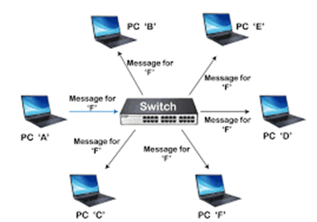

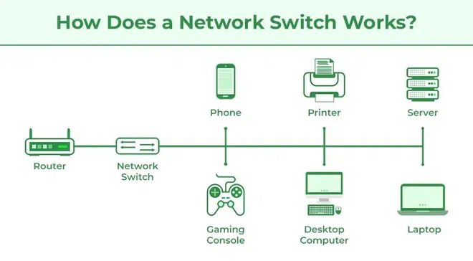

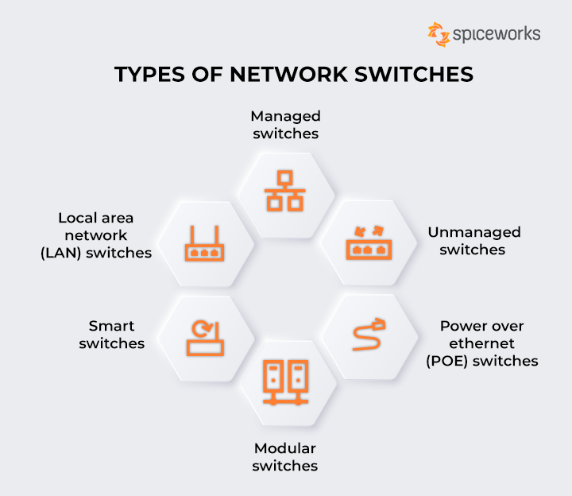

1. Bridge  
   A bridge is a device that connects and filters traffic between two or more network segments, operating at the data link layer of the OSI model. Unlike a hub, a bridge can inspect incoming data packets and decide whether to forward or discard them based on their MAC addresses. This reduces the amount of traffic on each segment and helps manage data flow more efficiently. Bridges can also be used to divide a large network into smaller, more manageable sections, enhancing overall network performance.

Types of Bridges :

* Transparent Bridges
* Source Routing Bridges

The primary function of a bridge is to connect two or more network segments, allowing data to pass between them while maintaining separation to reduce traffic load. When a bridge receives a data packet, it examines the packet's destination MAC address and determines whether the destination device resides on the same segment as the source. If it does, the bridge discards the packet to prevent unnecessary traffic. If the destination is on a different segment, the bridge forwards the packet to that segment.

Bridges maintain a MAC address table that maps device addresses to specific network segments. This table is built dynamically as the bridge learns the addresses of devices on the network by monitoring traffic. Over time, the bridge becomes more efficient in directing data to the appropriate segments, reducing broadcast traffic and collisions.

There are different types of bridges, including transparent bridges, source routing bridges, and translational bridges. Transparent bridges are the most common type, operating without requiring any configuration changes to the devices on the network. Source routing bridges, used primarily in Token Ring networks, rely on the source device to specify the path the data should take. Translational bridges connect networks using different protocols, such as Ethernet and Token Ring, facilitating communication between them.

Bridges have been largely superseded by switches in modern networks due to the latter's superior performance and additional features. However, bridges are still used in specific scenarios where their simplicity and cost-effectiveness are advantageous. They provide a basic level of traffic management and can be useful in smaller or less complex network environments.

In summary, bridges play a crucial role in segmenting networks, reducing traffic, and improving performance. While they have been largely replaced by more advanced devices like switches, bridges remain a valuable tool in certain networking contexts.

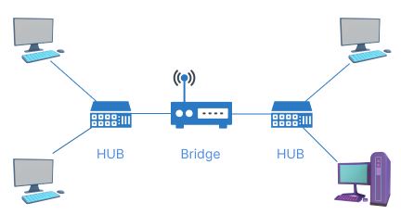

1. Router  
   A router is a critical device in networking that connects multiple networks and directs data packets between them. It operates at the network layer of the OSI model. Routers use IP addresses to determine the best path for forwarding data to its destination. They maintain routing tables to manage these paths and can connect different types of networks, including LANs, WANs, and the internet. Routers are essential for directing internet traffic, enabling communication between different network segments, and ensuring data reaches its intended destination efficiently.

Routers are essential for connecting disparate networks, such as linking a local area network (LAN) to a wide area network (WAN) or the internet. They play a pivotal role in both small and large-scale networks, facilitating communication between devices across various network segments. Routers also support advanced features such as Network Address Translation (NAT), which allows multiple devices on a private network to share a single public IP address, and Dynamic Host Configuration Protocol (DHCP), which automatically assigns IP addresses to devices on a network.

One of the key functions of a router is to maintain routing tables, which store information about network paths and their associated metrics. Routers use these tables to determine the most efficient route for data packets, considering factors such as hop count, bandwidth, and latency. Routing protocols, such as OSPF (Open Shortest Path First) and BGP (Border Gateway Protocol), enable routers to dynamically update their routing tables and adapt to changes in the network topology.

Routers can be categorized into different types based on their functionality and deployment context. Home routers, often combined with modems, provide internet connectivity and basic network management for residential users. Enterprise routers, used in business environments, offer enhanced performance, security features, and support for complex routing protocols. Core routers, deployed within the backbone of large networks, handle massive amounts of data traffic and ensure reliable connectivity across wide geographical areas.

In addition to their primary role in routing data, modern routers often include built-in security features such as firewalls, VPN (Virtual Private Network) support, and intrusion detection systems. These features help protect networks from external threats and ensure secure communication between devices.

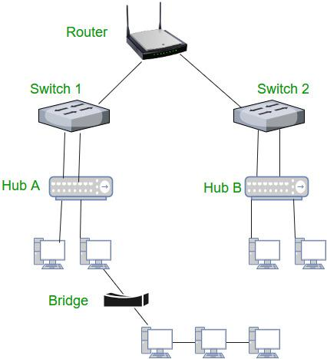

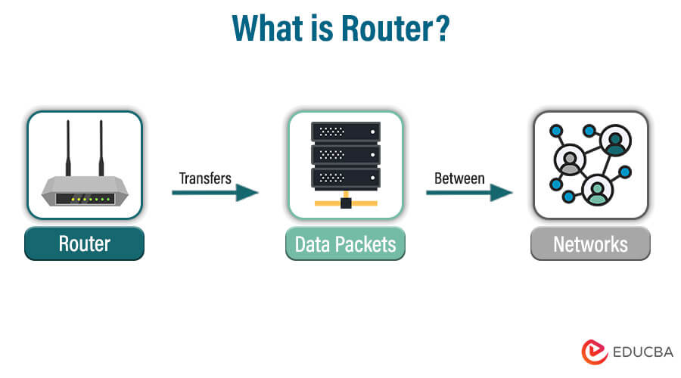

1. Gateway  
   A gateway is a network device that serves as a bridge between different networks, often using different protocols. It operates across multiple layers of the OSI model, typically up to the application layer. Gateways are essential for translating data from one protocol to another, allowing communication between disparate systems. For example, a gateway can connect a local network to the internet, translating internal network protocols to those used on the internet. Gateways are crucial for enabling interoperability and connectivity in complex, heterogeneous networks.

One of the primary roles of a gateway is protocol conversion. For instance, a gateway can translate data from one protocol, such as IPX/SPX used in legacy Novell networks, to another protocol, such as TCP/IP used in modern internet communications. This capability is essential for ensuring compatibility and seamless data exchange between different network systems.

Gateways are often implemented in complex network environments where multiple types of networks need to interconnect. For example, in an enterprise setting, a gateway might connect a corporate intranet to the internet, ensuring secure and controlled access to external resources. Similarly, gateways can connect different communication systems, such as linking VoIP (Voice over Internet Protocol) networks with traditional PSTN (Public Switched Telephone Network) systems.

In addition to protocol conversion, gateways often perform various other functions, including data compression, encryption, and traffic management. They can act as firewalls, providing security by filtering and blocking malicious traffic, and as proxy servers, enhancing privacy and performance by caching frequently accessed data and anonymizing user requests.

Gateways can be hardware devices, software applications, or a combination of both. Hardware gateways are standalone devices with dedicated processing capabilities, while software gateways are applications running on general-purpose servers. Some modern routers and firewalls also include gateway functionalities, offering an integrated solution for routing, security, and protocol conversion.

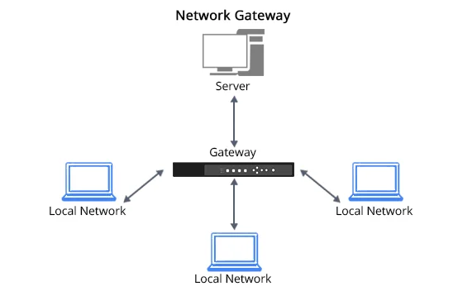  
  
  
  
  
  
Difference between switch and router?  
Difference between hub and switch?