

| **TITLE : Performing Graph Analytics** |
| --- |

**AIM:** To analyze the structural properties of a real-world social network by constructing a graph representation, identifying key players and influential individuals through centrality measures, and detecting communities within the network using appropriate algorithms.

**_________________________________________________________________**

**Expected OUTCOME of Experiment:**

CO3: Perform the social data analytics

**_____________________________________________________________________**

**Books/ Journals/ Websites referred:**

Students have to list.

**_____________________________________________________________________**

**Pre Lab/ Prior Concepts:**

Students should have a basic understanding of:

Graph theory: Nodes, edges, directed and undirected graphs, weighted graphs.

Data structures: Lists, dictionaries.

Python programming: Basic syntax, data manipulation, libraries like NetworkX.

Statistical concepts: Mean, standard deviation, correlation.

Visualization techniques: Basic plotting using libraries like Matplotlib.

**Procedure:**

### Building a Social Network Graph with NetworkX

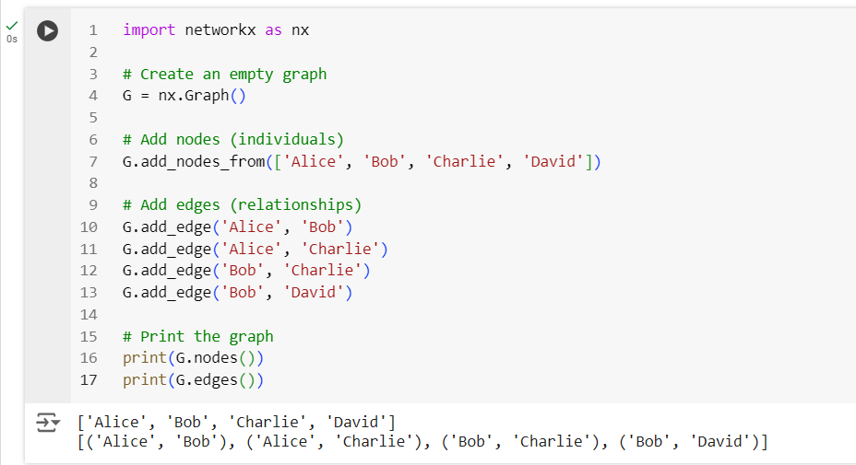

### Visualizing the Graph

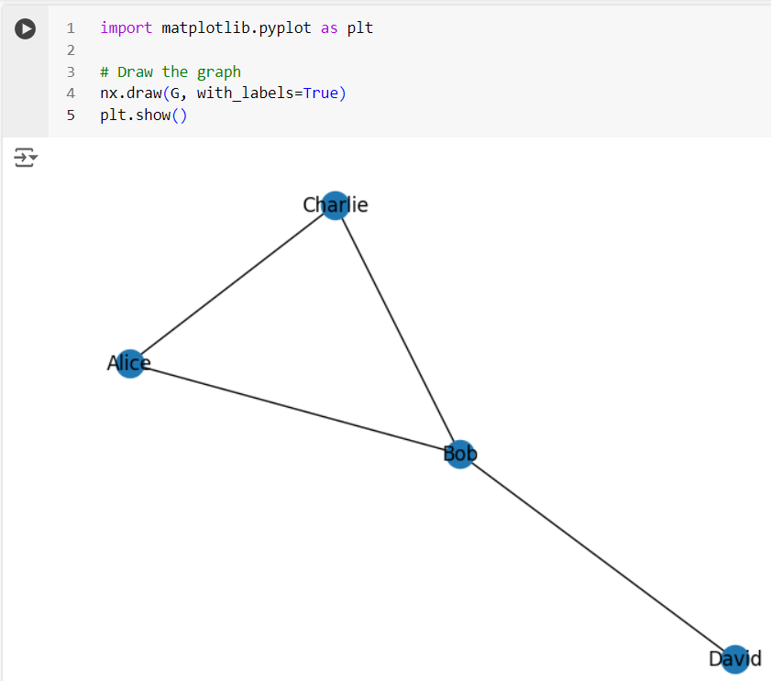

**Exporting a NetworkX Graph to CSV**

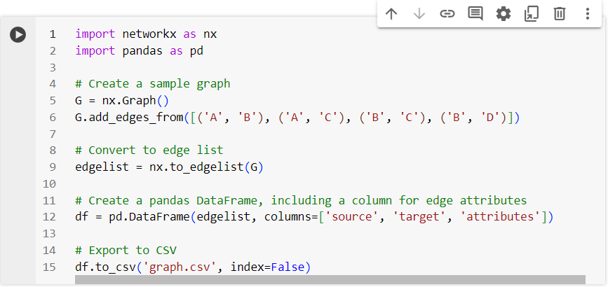

**The csv file gets created**

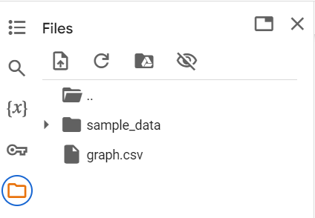

**Contents of the csv file**

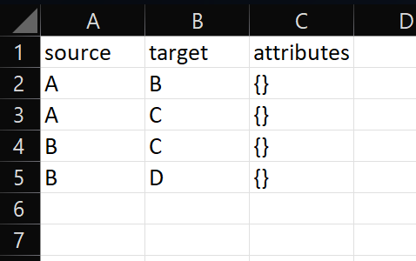

**Creating and exporting a NetworkX Graph with edge attributes and node attributes to a csv file**

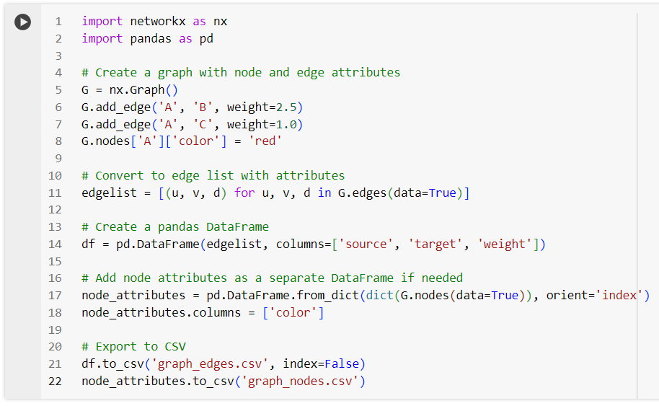

**csv files get created**

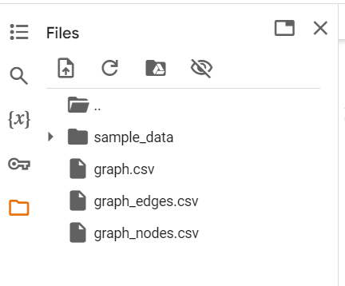

**Contents of graph_edges.csv**

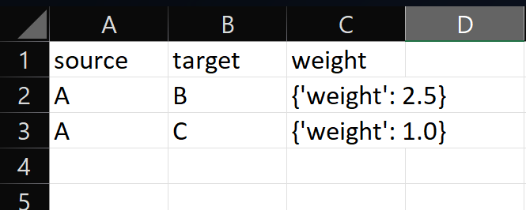

**Contents of graph_nodes.csv**

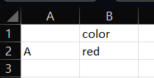

**Importing a graph from a csv file**

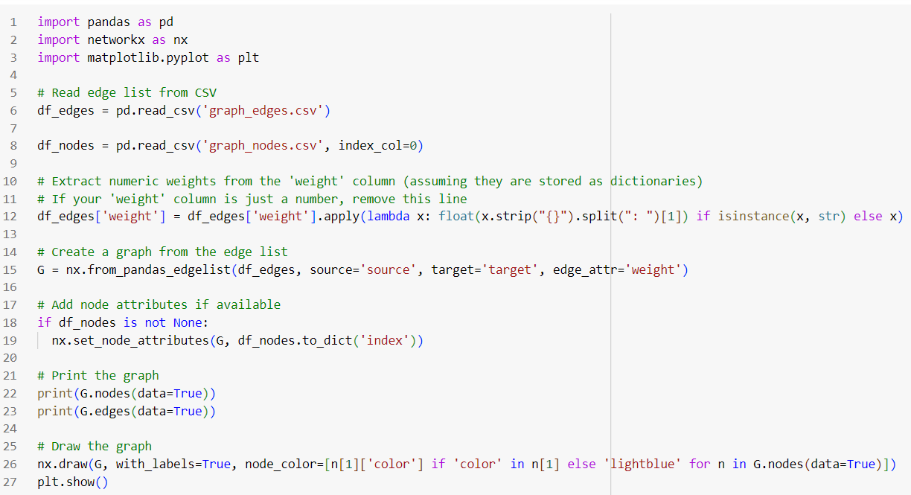

**Output (List of nodes and edges, and visualizing the imported graph)**

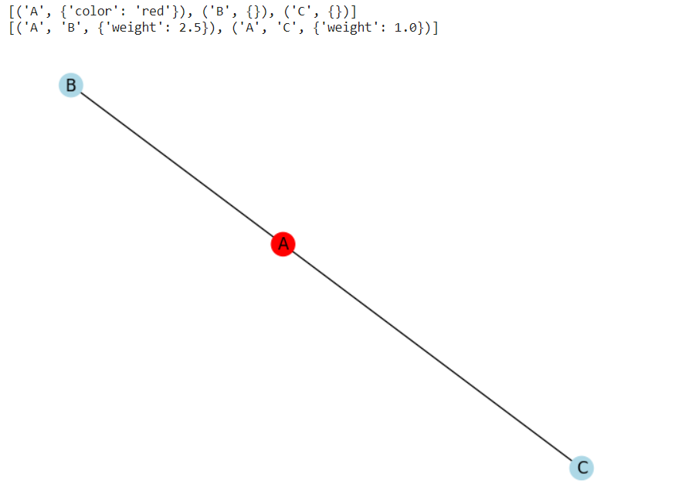

**Graph Analytics**

1. Degree centrality : The degree centrality for a node v is the fraction of nodes it is connected to. The degree centrality values are normalized by dividing by the maximum possible degree in a simple graph n-1 where n is the number of nodes in G.
2. Betweenness centrality : Betweenness centrality of a node v is the sum of the fraction of all-pairs shortest paths that pass through v. The betweenness centrality is normalized by dividing by the total number of shortest paths.
3. Edge betweenness centrality : Betweenness centrality of a node e is the sum of the fraction of all-pairs shortest paths that pass through e. The betweenness centrality is normalized by dividing by the maximum possible number of edges in a graph G.
4. Communities can be identified using the Girvan Newman algorithm, by successively deleting the edges with the highest betweenness centrality values.

**Importing a graph from csv file and performing graph analytics**

**The graph in csv file:**

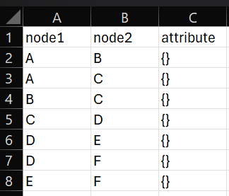

**Importing the graph, printing its edge list and visualizing it:**

**import pandas as pd**

**import networkx as nx**

**import matplotlib.pyplot as plt**

**# Read edge list from CSV**

**df_edges = pd.read_csv('new_graph_edges.csv')**

**# Create a graph from the edge list**

**G = nx.from_pandas_edgelist(df_edges,source='node1', target='node2')**

**# Print the graph**

**print(G.nodes(data=True))**

**print(G.edges(data=True))**

**# Draw the graph**

**nx.draw(G, with_labels=True)**

**plt.show()**

**Output (graph details and visualization):**



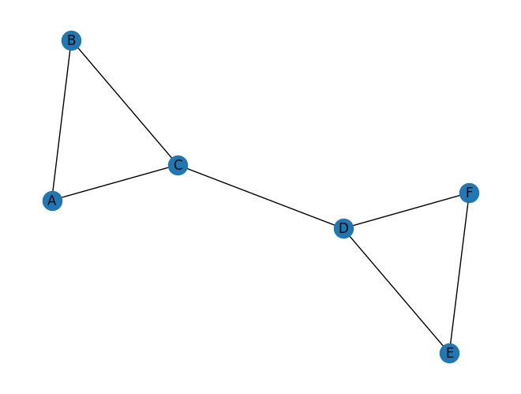

**Performing analytics on this graph:**

**# Basic graph properties**

**print("Number of nodes:", G.number_of_nodes())**

**print("Number of edges:", G.number_of_edges())**

**# Degree centrality**

**degrees = dict(G.degree())**

**print("\nDegree Centrality:", degrees)**

**# Betweenness centrality**

**betweenness = nx.betweenness_centrality(G, normalized=False)**

**print("\nBetweenness Centrality:", betweenness)**

**betweenness = nx.betweenness_centrality(G)**

**print("Normalized Betweenness Centrality:", betweenness)**

**# Closeness centrality**

**e_betwenness = nx.edge_betweenness_centrality(G,normalized=False)**

**print("\nEdge Betweenness Centrality:", e_betwenness)**

**e_betwenness = nx.edge_betweenness_centrality(G)**

**print("Normalized Edge Betweenness Centrality:", e_betwenness)**

**# Community detection (Girvan-Newman)**

**communities = nx.algorithms.community.girvan_newman(G)**

**try:**

**top_level_communities = next(communities)**

**print("\nCommunities after 1 step:", top_level_communities)**

**top_level_communities = next(communities)**

**print("\nCommunities after 2 steps:", top_level_communities)**

**top_level_communities = next(communities)**

**print("\nCommunities after 3 steps:", top_level_communities)**

**top_level_communities = next(communities)**

**print("\nCommunities after 4 steps:", top_level_communities)**

**top_level_communities = next(communities)**

**print("\nCommunities after 5 steps:", top_level_communities)**

**except StopIteration:**

**print("\nNo more splits are possible.")**

**Output:**

**Number of nodes: 6**

**Number of edges: 7**

**Degree Centrality: {'A': 2, 'B': 2, 'C': 3, 'D': 3, 'E': 2, 'F': 2}**

**Betweenness Centrality: {'A': 0.0, 'B': 0.0, 'C': 6.0, 'D': 6.0, 'E': 0.0, 'F': 0.0}**

**Normalized Betweenness Centrality: {'A': 0.0, 'B': 0.0, 'C': 0.6000000000000001, 'D': 0.6000000000000001, 'E': 0.0, 'F': 0.0}**

**Edge Betweenness Centrality: {('A', 'B'): 1.0, ('A', 'C'): 4.0, ('B', 'C'): 4.0, ('C', 'D'): 9.0, ('D', 'E'): 4.0, ('D', 'F'): 4.0, ('E', 'F'): 1.0}**

**Normalized Edge Betweenness Centrality: {('A', 'B'): 0.06666666666666667, ('A', 'C'): 0.26666666666666666, ('B', 'C'): 0.26666666666666666, ('C', 'D'): 0.6, ('D', 'E'): 0.26666666666666666, ('D', 'F'): 0.26666666666666666, ('E', 'F'): 0.06666666666666667}**

**Communities after 1 step: ({'A', 'C', 'B'}, {'E', 'F', 'D'})**

**Communities after 2 steps: ({'A'}, {'C', 'B'}, {'E', 'F', 'D'})**

**Communities after 3 steps: ({'A'}, {'B'}, {'C'}, {'E', 'F', 'D'})**

**Communities after 4 steps: ({'A'}, {'B'}, {'C'}, {'D'}, {'E', 'F'})**

**Communities after 5 steps: ({'A'}, {'B'}, {'C'}, {'D'}, {'E'}, {'F'})**

**Students have to perform all the tasks illustrated above by creating a social network graph with nodes labelled with their own names and their friends’ names. The graph should have at least 10 nodes.**

**Students have to paste their code and screenshots of output and csv file below.**Implementation details:

10 nodes - (['Aakriti', 'Khushi', 'Himanshi', 'Kavya' , 'Harsh' , 'Arunil' , 'Aayush' , 'Ninad' , 'Meetesh' , 'Esha'])

Output:

**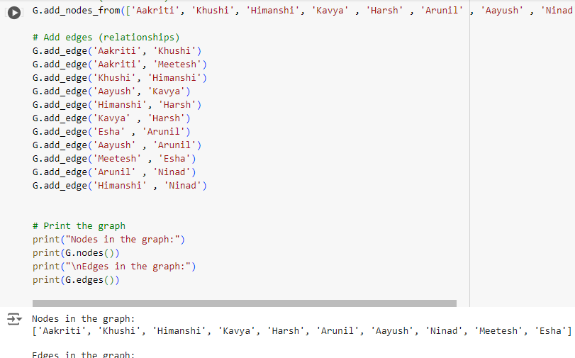  
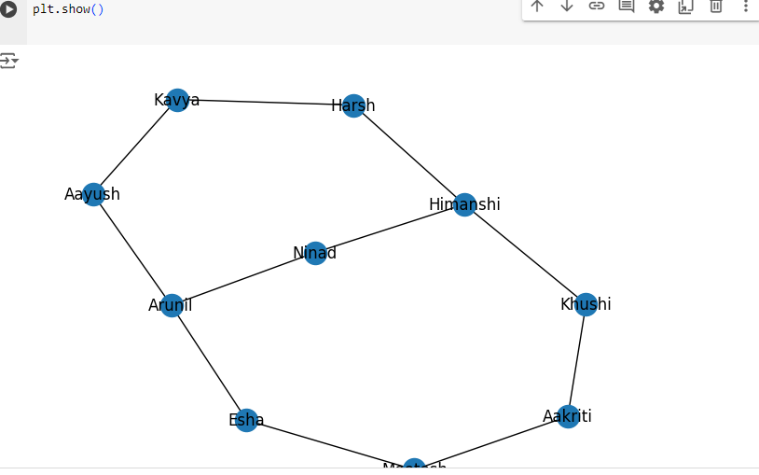**

**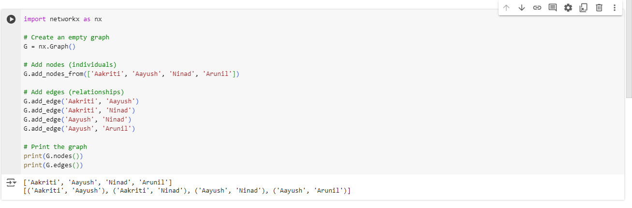  
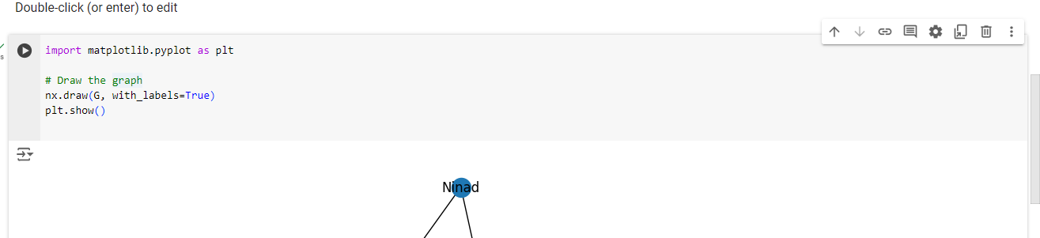  
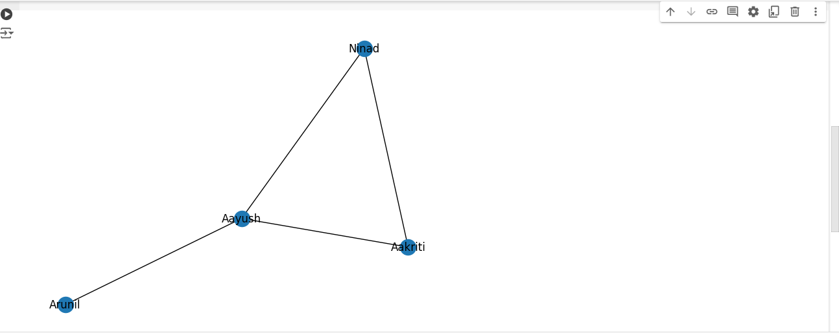  
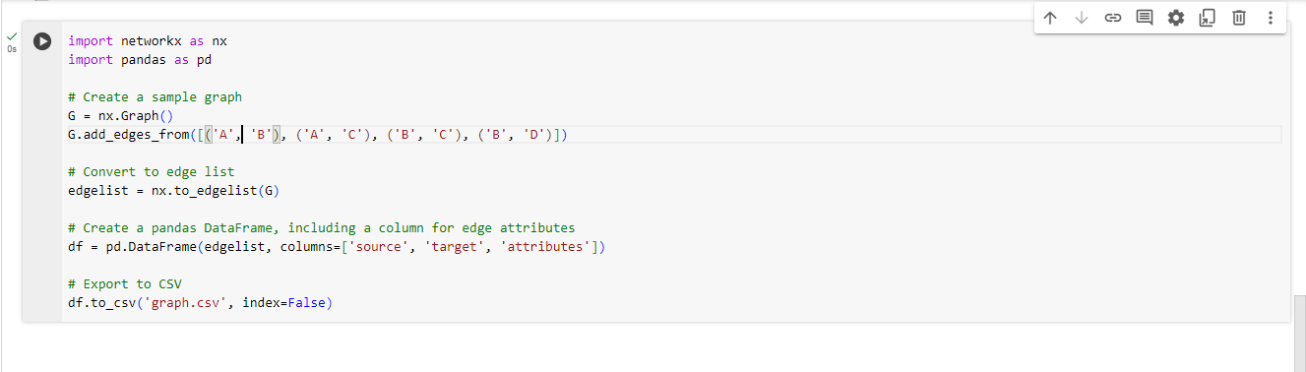  
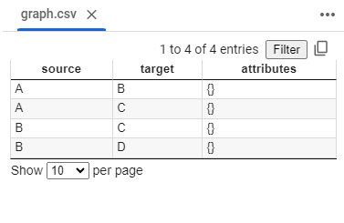  
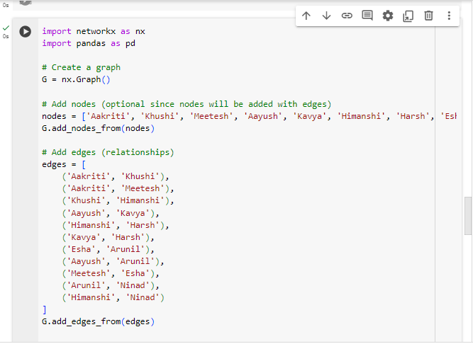  
  
  
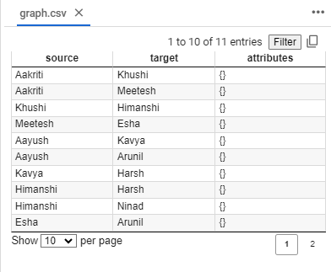  
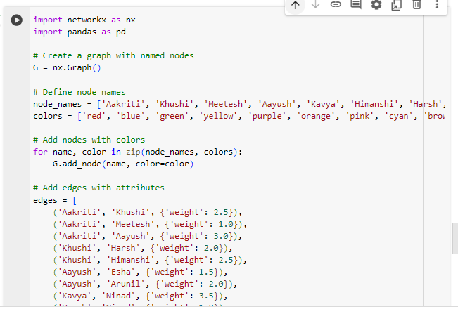  
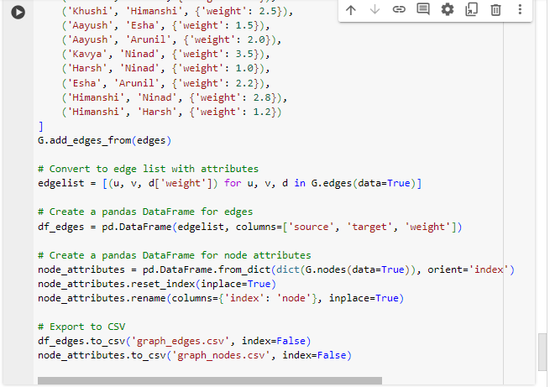  
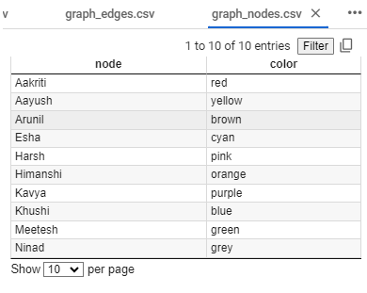  
  
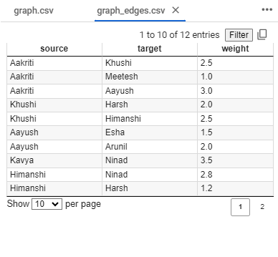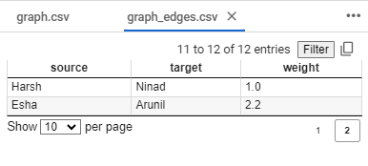  
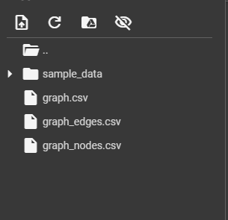  
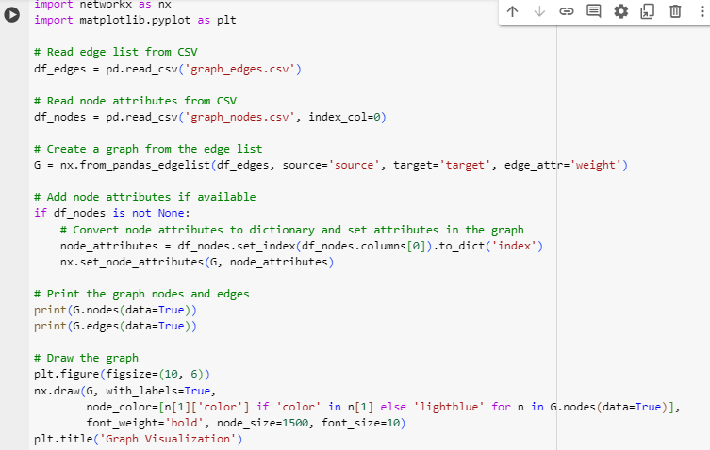  
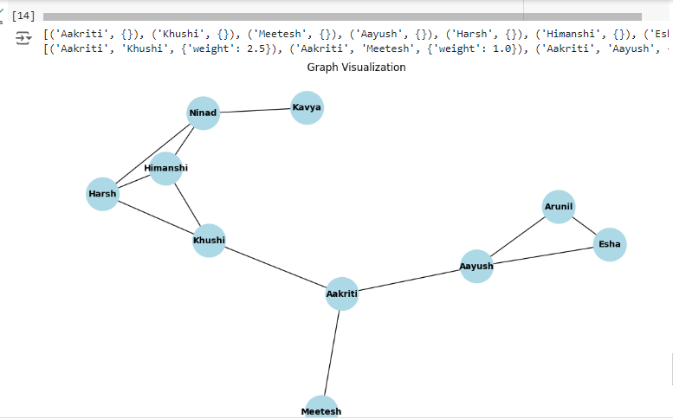  
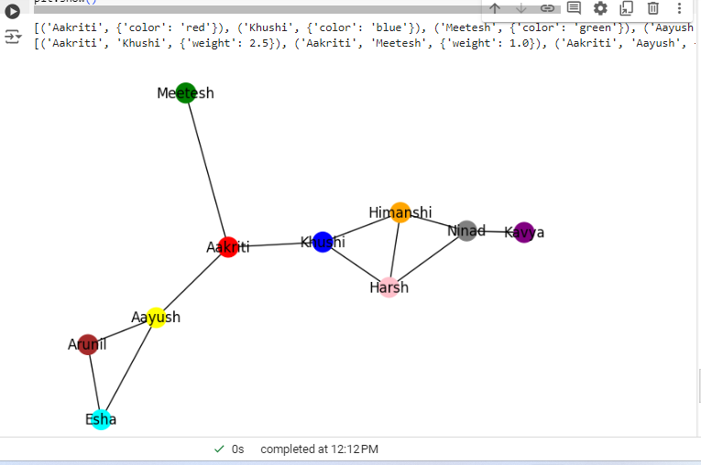**

**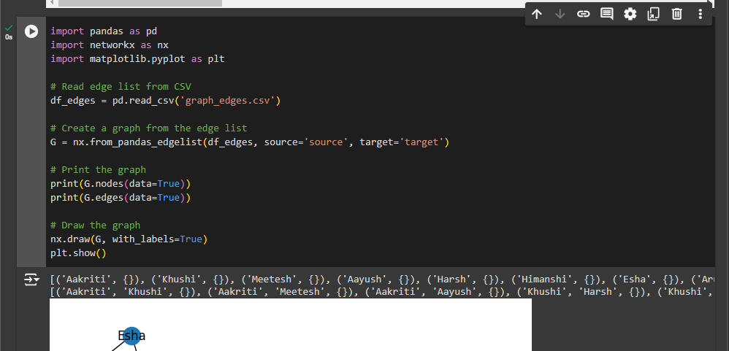  
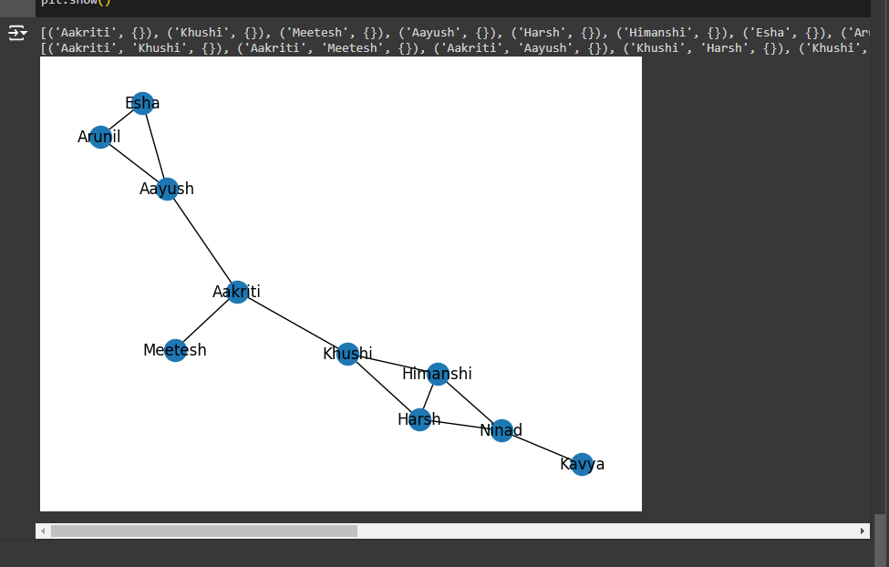  
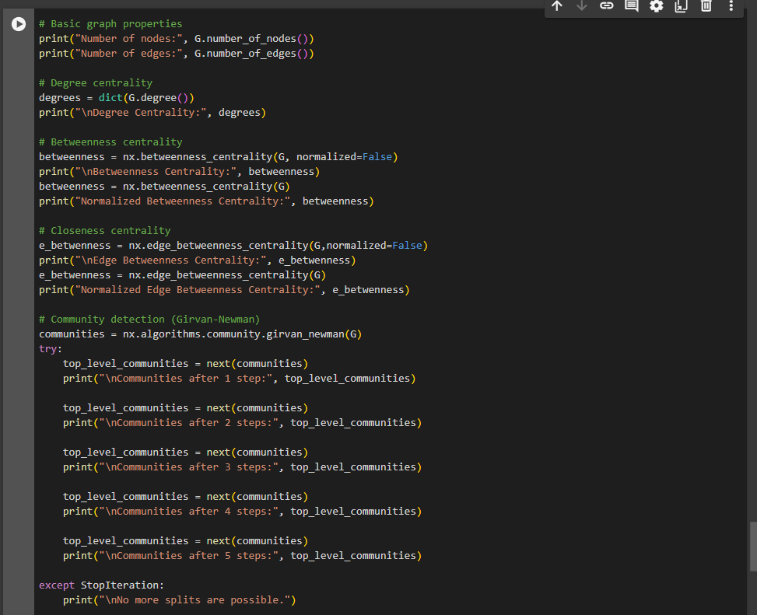  
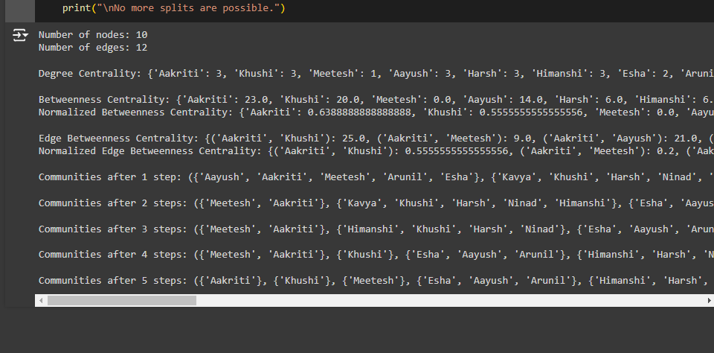  
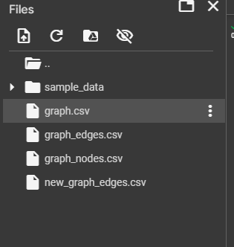  
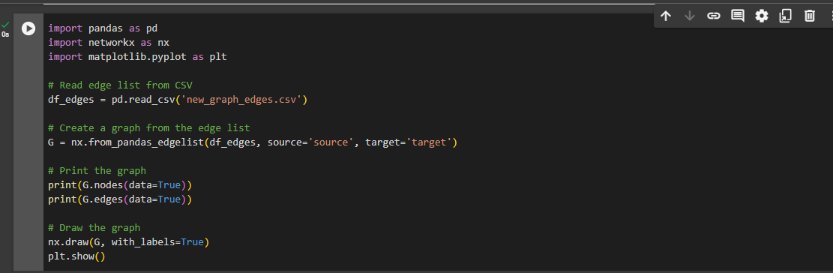  
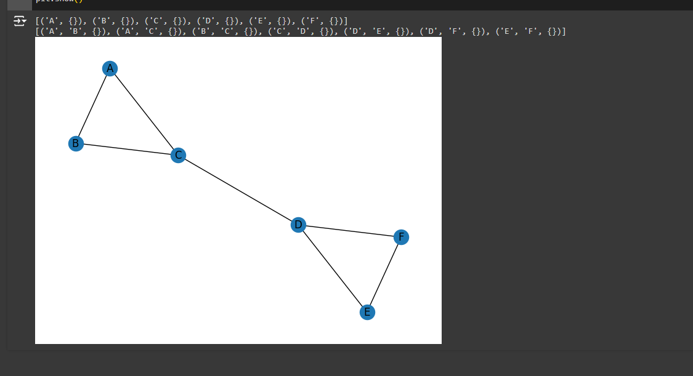  
  
Google colab - https://colab.research.google.com/drive/1ja981yDbgE57PFPs-N9Zp2hbcd-JFdgz#scrollTo=0cRVjAkGiP-b**

**Date: 19/9/24 Signature of faculty in-charge**

**Post Lab Descriptive Questions:**

1. **Analyze the centrality measures you calculated. Which nodes were identified as the most influential? What does this mean in the context of the social network?**  
   Centrality Measures Analysis

* Degree Centrality: Nodes with high degree centrality have many direct connections, making them key influencers in spreading information quickly.
* Betweenness Centrality: Nodes with high betweenness act as bridges between different groups, controlling information flow and facilitating communication.
* Closeness Centrality: Nodes with high closeness can access others quickly, allowing for efficient information dissemination.

### Most Influential Nodes

The most influential nodes are those that rank highly across these measures, indicating they are central players in the network. Their significance includes:

* Information Spread: They can rapidly share updates with many people.
* Community Impact: They shape behaviors and trends within their groups.
* Network Resilience: Understanding these nodes helps ensure communication remains intact if key individuals are removed.

1. **Describe the communities identified using the Girvan-Newman algorithm. What are the characteristics of these communities? How do they relate to the social network's structure?**

### Communities Identified by the Girvan-Newman Algorithm

* Homogeneity: Nodes within communities often share similar interests or characteristics, leading to strong internal connections.
* Isolation vs. Connectivity: Some communities are more isolated, while others have strong ties, indicating collaboration or overlapping interests.
* Size and Density: Communities vary in size, with larger groups indicating broader interests and smaller ones reflecting niche topics.
* Leadership Structures: Certain nodes may emerge as leaders, influencing dynamics and decisions within the community.

### Relation to Social Network Structure

* Segmentation: Communities reveal how the network is divided into distinct groups.
* Communication Patterns: They highlight how information flows within and between groups.
* Resource Distribution: Understanding these structures can inform how resources and support are allocated.
* Targeted Strategies: Insights can guide tailored engagement efforts.

1. **Discuss the implications of identifying influential nodes in the network. How can this information be used?**

### Implications of Identifying Influential Nodes

* Targeted Outreach: Understanding who the influential nodes are allows for focused marketing, campaigns, or communication strategies to maximize reach and effectiveness.
* Enhanced Communication: Leveraging influential nodes can improve information dissemination and ensure that messages reach a broader audience quickly.
* Network Resilience: Identifying key individuals helps in planning for potential disruptions; strengthening connections to these nodes can maintain network stability.
* Conflict Resolution: Influential nodes can act as mediators in disputes, facilitating dialogue and negotiation between conflicting groups.
* Community Engagement: Organizations can tailor their engagement strategies based on the influence and characteristics of key individuals within communities.