dob=[22,2,2000]

console.log(dob);

answer=dob.join("/");

console.log( answer);

console.log(typeof answer);

output:  
[ 22, 2, 2000 ]

22/2/2000

string

console.log("Hello");

function greet(name) {

return "Hello, " + name + "!";

}

console.log(greet("Aakriti"));

// Anonymous

const greet1 = function(name) {

return "Hello, " + name + "!";

};

console.log(greet1("Sanika"));

//Arrow Function

const greet3 = (name) => {

return "Hello, " + name + "!";

};

const greet4 = name => "Hello, " + name + "!";

console.log(greet3("Romil"));

Hello

Hello, Aakriti!

Hello, Sanika!

Hello, Romil!  
  
<!--

Online HTML, CSS and JavaScript editor to run code online.

-->

<!DOCTYPE html>

<html lang="en">

<head>

<meta charset="UTF-8" />

<meta name="viewport" content="width=device-width, initial-scale=1.0" />

<link rel="stylesheet" href="style.css" />

<title>Browser</title>

</head>

<body>

<button onclick="myfunc()">Enter</button>

<p~style="border:solid" onmouseover="calc1()" onmouseout="calc2()"> test</p>

<input type="text" onkeyup="rec_value()"/>

<script>

function myfunc() {

console.log("answer 1");

}

myfunc = function() {

console.log("answer 2");

}

myfunc = () => {

console.log("answer 3");

}

function calc1() {

console.log("over");

}

function calc2() {

console.log("out");

}

function rec_value() {

console.log("keyup event called");

}

</script>

</body>

</html>

<!--

Online HTML, CSS and JavaScript editor to run code online.

-->

<!DOCTYPE html>

<html lang="en">

<head>

<meta charset="UTF-8" />

<meta name="viewport" content="width=device-width, initial-scale=1.0" />

<link rel="stylesheet" href="style.css" />

<title>Browser</title>

</head>

<body onload="reloaddata()" onresize="resizedata()">

<!--<button onclick="myfunc()">Enter</button>-->

<!--<p~style="border:solid" onmouseover="calc1()" onmouseout="calc2()"> test</p>-->

<!--<input type="text" onkeyup="rec_value()"/>-->

<div onclick="f1()" style="border: solid,green">

<button onclick="f2(event)">Enter</button>

</div>

<script type="text/javascript">

// function myfunc() {

// console.log("answer 1");

// }

// myfunc = function() {

// console.log("answer 2");

// }

// myfunc = () => {

// console.log("answer 3");

// }

// function calc1() {

// console.log("over");

// }

// function calc2() {

// console.log("out");

// }

// function rec_value() {

// console.log("keyup event called");

// }

// function reloaddata() {

// console.log("onload");

// }

// function resizedata() {

// console.log("onresize");

// }

function f1(){

console.log("div");

}

function f2(myvar){

console.log("button");

console.log(myvar);

console.log(typeof myvar);

myvar.stopPropagation();

}

</script>

</body>

</html>

1]  
<!DOCTYPE html>

<html>

<head>

<title>Hello, World!</title>

<link rel="stylesheet" href="styles.css" />

</head>

<body>

<h1 class="title">Hello World! </h1>

<button onclick="myfunc()">Sum </button>

<button onclick="myfunc()">Even Numbers</button>

<button onclick="myfunc()">Squares</button>

<p id="currentTime"></p>

<script >

const numbers = [1, 2, 3, 4, 5];

const squares = numbers.map(num => num * num);

console.log("Squares:", squares);

const evenNumbers = numbers.filter(num => num % 2 === 0);

console.log("Even Numbers:", evenNumbers);

const sum = numbers.reduce((acc, num) => acc + num, 0);

console.log("Sum:", sum);

</script>

</body>

</html>

Q1) Array 3 methods:

<!DOCTYPE html>

<html>

<head>

<title>MERN</title>

<link rel="stylesheet" href="styles.css" />

</head>

<body>

<div class="container">

<h1>Array Operations</h1>

<div class="buttons">

<button onclick="doubleArray()">Double Elements</button>

<button onclick="filterArray()">Filter Elements</button>

<button onclick="sumArray()">Sum Elements</button>

</div>

<div id="result"></div>

<script>

const myArray = [1, 2, 3, 4, 5];

const threshold = 3;

function doubleArray() {

const doubledArray = myArray.map(element => element * 2);

console.log('Doubled Array:', doubledArray);

}

function filterArray() {

const filteredArray = myArray.filter(element => element >= threshold);

console.log(`Filtered Array (>= ${threshold}):`, filteredArray);

}

function sumArray() {

const sum = myArray.reduce((accumulator, currentValue) => accumulator + currentValue, 0);

console.log('Sum of Filtered Elements:', sum);

}

</script>

</div>

</body>

</html>

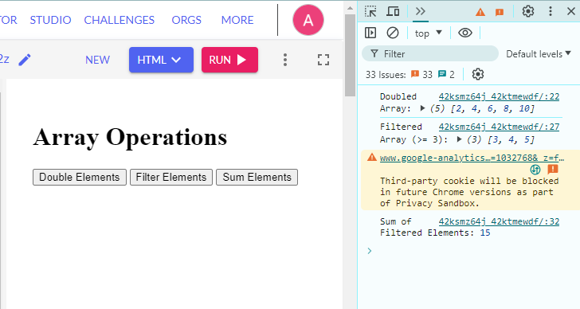

Q2)Date 3 methods:

<!DOCTYPE html>

<html>

<head>

<title>MERN</title>

<link rel="stylesheet" href="styles.css" />

</head>

<body>

</div> <div class="container">

<h1>Date Operations</h1>

<div class="buttons">

<button onclick="addDaysToDate()">Add Days</button>

<button onclick="currentDate()">Current Date</button>

<button onclick="getDayOfWeek()">Day of the Week</button>

<button onclick="convertToTimestamp()">Convert to Timestamp</button>

</div>

</div>

<script>

function addDays(date, days) {

const result = new Date(date);

result.setDate(result.getDate() + days);

return result;

}

function formatDateToString(date) {

const year = date.getFullYear();

const month = String(date.getMonth() + 1).padStart(2, '0');

const day = String(date.getDate()).padStart(2, '0');

return `${year}-${month}-${day}`;

}

function addDaysToDate() {

const today = new Date();

const daysToAdd = 5;

const newDate = addDays(today, daysToAdd);

console.log(`Current Date: ${formatDateToString(today)}`);

console.log(`New Date after adding ${daysToAdd} days: ${formatDateToString(newDate)}`);

}

function currentDate() {

const today = new Date();

console.log(`Current Date: ${formatDateToString(today)}`);

}

function getDayOfWeek() {

const today = new Date();

const daysOfWeek = ['Sunday', 'Monday', 'Tuesday', 'Wednesday', 'Thursday', 'Friday', 'Saturday'];

console.log(`Today is: ${daysOfWeek[today.getDay()]}`);

}

function convertToTimestamp() {

const date = new Date();

console.log(`Current Timestamp: ${date.getTime()}`);

}

</script>

</body>

</html>

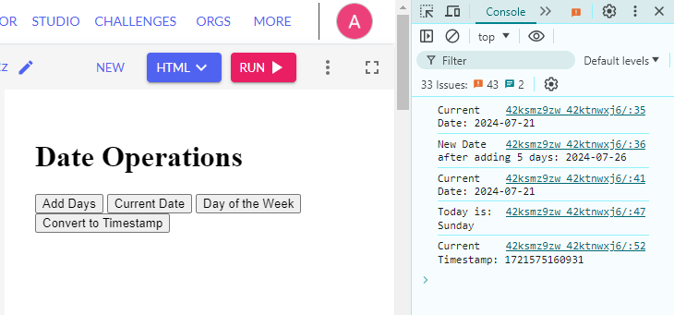  
  
Q3) String 3 methods:

<!DOCTYPE html>

<html>

<head>

<title>MERN</title>

<link rel="stylesheet" href="styles.css" />

</head>

<body>

<div class="container">

<h1>String Operations</h1>

<div class="buttons">

<button onclick="concatenateStrings()">Concatenate Strings</button>

<button onclick="transformString()">Transform String</button>

<button onclick="searchString()">Search String</button>

</div>

</div>

<script>

function concatenateStrings() {

const str1 = "Hello, ";

const str2 = "World!";

const concatenated = str1 + str2;

console.log(`Concatenated String: ${concatenated}`);

}

function transformString() {

const original = "Coding";

console.log(`String: ${original}`);

console.log(`Upper Case: ${original.toUpperCase()}`);

console.log(`Lower Case: ${original.toLowerCase()}`);

const text = "I love JavaScript";

console.log(`Original String: ${text}`);

const newText = text.replace("JavaScript", "coding");

console.log(`Replaced String: ${newText}`);

}

function searchString() {

const text = "JavaScript is necessary for MERN";

console.log(`String: ${text}`);

console.log(`Contains "necessary": ${text.includes("necessary")}`);

console.log(`Index of "necessary": ${text.indexOf("necessary")}`);

}

</script>

</body>

</html>

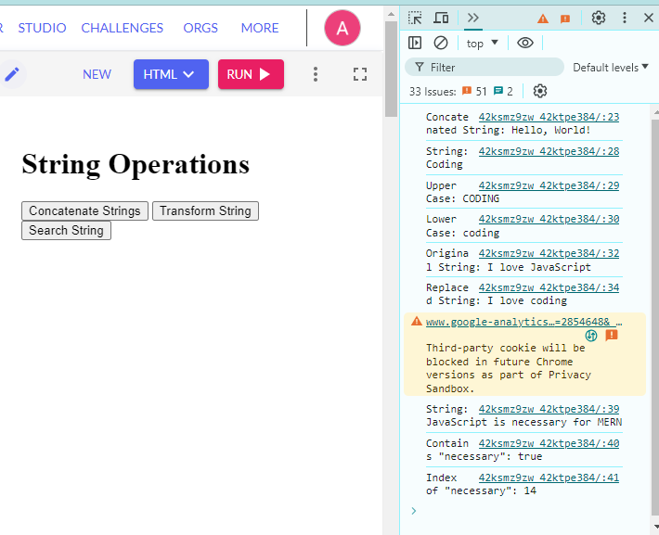

Q4) Program to find out browser specific code:

<!DOCTYPE html>

<html>

<head>

<title>MERN</title>

<link rel="stylesheet" href="styles.css" />

</head>

<body>

<div class="container">

<h1>Browser-Specific Code</h1>

<p id="browser-info"></p>

</div>

<script>

function detectBrowser() {

const userAgent = navigator.userAgent;

const browserInfo = document.getElementById('browser-info');

if (userAgent.indexOf("Chrome") > -1 && userAgent.indexOf("Edge") === -1) {

browserInfo.textContent = "You are using Google Chrome.";

console.log("Chrome-specific code goes here.");

} else if (userAgent.indexOf("Firefox") > -1) {

browserInfo.textContent = "You are using Mozilla Firefox.";

console.log("Firefox-specific code goes here.");

} else if (userAgent.indexOf("Safari") > -1 && userAgent.indexOf("Chrome") === -1) {

browserInfo.textContent = "You are using Safari.";

console.log("Safari-specific code goes here.");

} else if (userAgent.indexOf("MSIE") > -1 || !!document.documentMode) {

browserInfo.textContent = "You are using Internet Explorer.";

console.log("IE-specific code goes here.");

} else if (userAgent.indexOf("Edge") > -1) {

browserInfo.textContent = "You are using the old Microsoft Edge.";

console.log("Old Edge-specific code goes here.");

} else if (userAgent.indexOf("Edg") > -1) {

browserInfo.textContent = "You are using the new Microsoft Edge.";

console.log("New Edge-specific code goes here.");

} else {

browserInfo.textContent = "Browser detection failed or browser is not recognized.";

console.log("Code for unknown browsers goes here.");

}

}

detectBrowser();

</script>

</body>

</html>

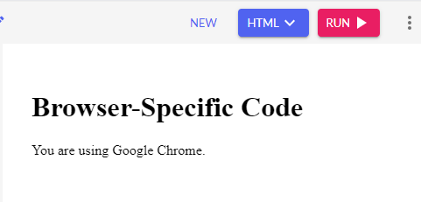  
  
  
  
Callback hell:

<!DOCTYPE html>

<html>

<head>

<title>MERN</title>

<link rel="stylesheet" href="styles.css" />

</head>

<body>

<h1 class="title">Hello Mern! </h1>

<p id="currentTime"></p>

<script>

function one(callback) {

console.log('Starting');

setTimeout(function() {

console.log('First task done.');

callback();

}, 5000);

}

function two(callback) {

setTimeout(function() {

console.log('Second task done.');

callback();

}, 5000);

}

function three(callback) {

setTimeout(function() {

console.log('Third task done.');

callback();

}, 5000);

}

function four(callback) {

setTimeout(function() {

console.log('Fourth task done.');

callback();

}, 5000);

}

// Callback Hell Example

one(function() {

two(function() {

three(function() {

four(function() {

console.log('All tasks completed.');

});

});

});

});

</script>

</body>

</html>

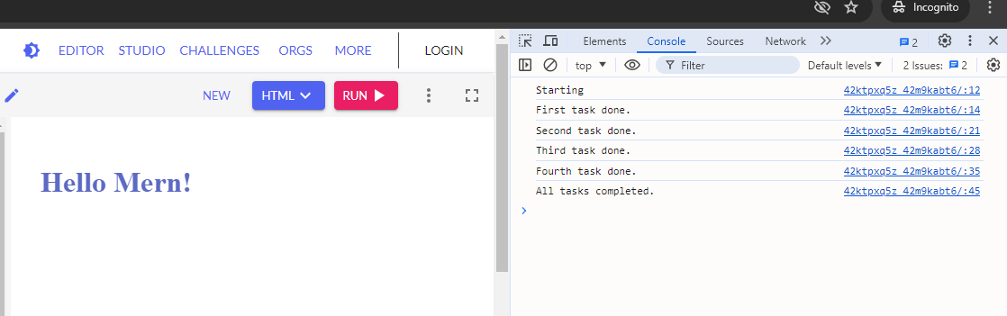  
  
Callback:

<!DOCTYPE html>

<html>

<head>

<title>MERN</title>

<link rel="stylesheet" href="styles.css" />

</head>

<body>

<h1 class="title">Hello Mern! </h1>

<p id="currentTime"></p>

<script>

function sum(a,b) {

console.log(a+b);

}

function calculator(a,b,sumcallback){

sumcallback(a,b);

}

calculator(1,2,sum);

</script>

</body>

</html>

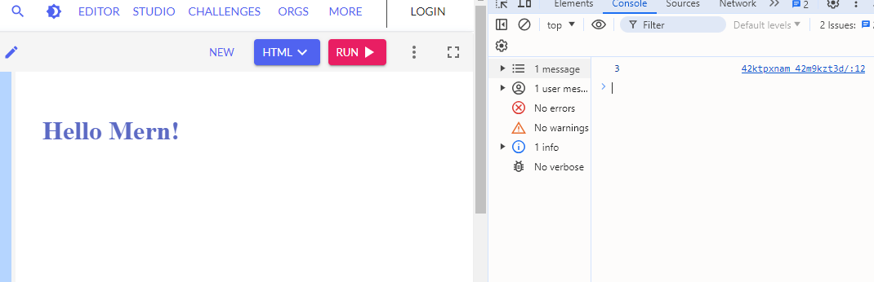  
  
<!DOCTYPE html>

<html>

<head>

<title>MERN</title>

<link rel="stylesheet" href="styles.css" />

</head>

<body>

<h1 class="title">Hello Mern! </h1>

<p id="currentTime"></p>

<script>

function getData(dt, getNextData) {

setTimeout(() => {

console.log("Data1 ",dt);

if (getNextData){

getNextData();

}

}, 5000);

}

getData(1, () => {

getData(2, () => {

console.log("Done");

});

});

</script>

</body>

</html>

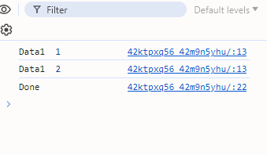  
  
<!DOCTYPE html>

<html>

<head>

<title>MERN</title>

<link rel="stylesheet" href="styles.css" />

</head>

<body>

<h1 class="title">Hello Mern! </h1>

<p id="currentTime"></p>

<script>

function getData(dt, getNextData) {

setTimeout(() => {

console.log("Data ",dt);

if (getNextData){

getNextData();

}

}, 5000);

}

getData(1, () => {

console.log("fetch data2 ");

getData(2, () => {

console.log("fetch data3");

getData(3, () => {

console.log("fetch data4");

getData(4, () => {

console.log("Done");

});

});

});

});

</script>

</body>

</html>

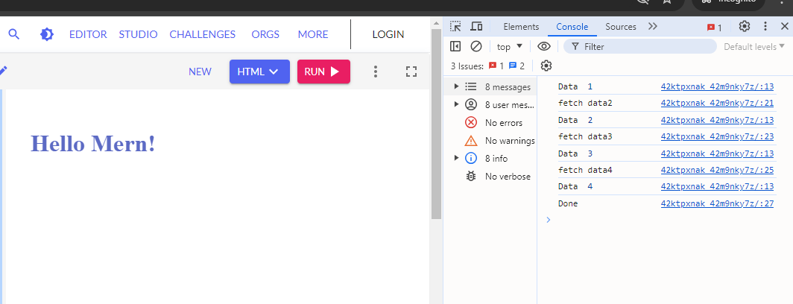  
  
<!DOCTYPE html>

<html>

<head>

<title>MERN</title>

<link rel="stylesheet" href="styles.css" />

</head>

<body>

<h1 class="title">Hello Mern! </h1>

<p id="currentTime"></p>

<script>

let promise= new Promise((resolve,reject)=>{

console.log("Check status");

resolve("success");

reject("failure");

})

</script>

</body>

</html>

