Experiment 2 : Shell scripts

Description of the programs to be implemented:

1. Write a shell Script that accepts two file names as command line arguments and

compare two file contents and check whether contents are same or not. If they are

same, then delete second file.

Files are different.

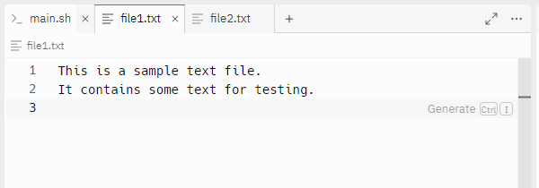  
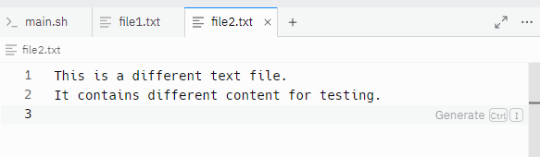  
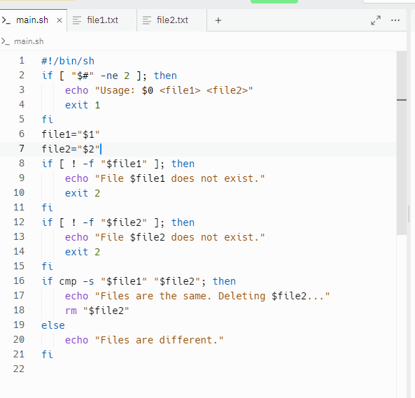  
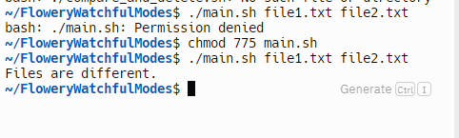

Files are same.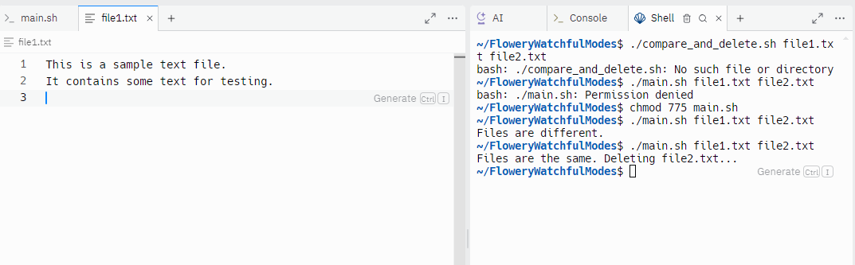

2. Write a shell script that accepts integer and find the factorial of number.  
  
#!/bin/sh

if [ "$#" -ne 1 ]; then

echo "Usage: $0 <integer>"

exit 1

fi

number="$1"

if ! [ "$number" -eq "$number" ] 2>/dev/null; then

echo "Error: The input must be a non-negative integer."

exit 2

fi

if [ "$number" -lt 0 ]; then

echo "Error: The factorial is not defined for negative numbers."

exit 3

fi

factorial=1

while [ "$number" -gt 1 ]; do

factorial=$((factorial \* number))

number=$((number - 1))

done

echo "Factorial: $factorial"

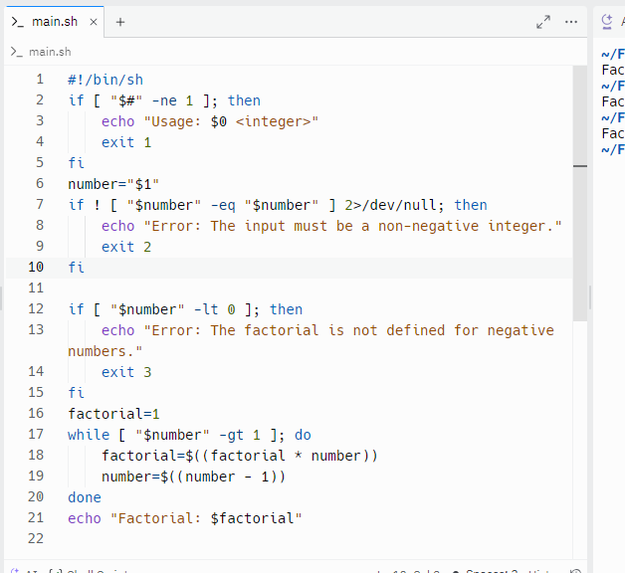

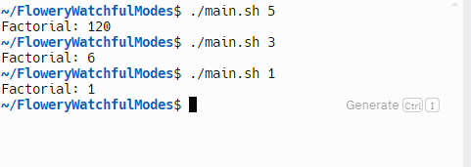

3. Write a shell script for adding users.  
  
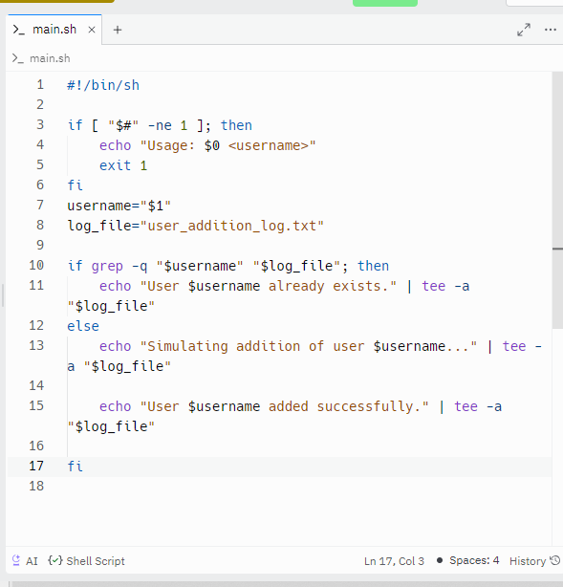  
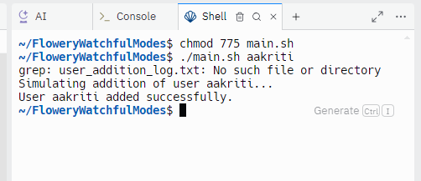

4. Write a shell script for counting no of logged in users.  
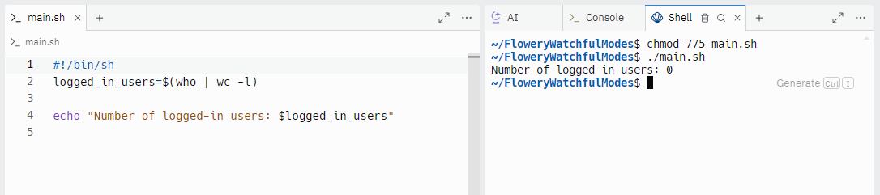

5. Write a shell script for counting no of processes running on system  
  
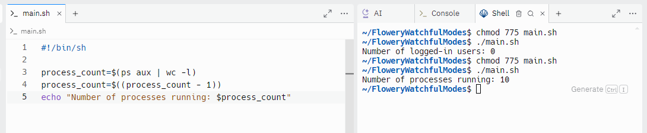

Steps to create a Shell Script:

Create a file using any text editor say vi, gedit, nano, pico etc

1. $ vi filename

2. Insert the script/ commands in file and save the file to execute the file we need to

give

execute permission to the file

3. $ chmod 775 filename

4. Now execute the above file using any of following methods:

$ sh filename

OR

$ ./filename

NOTE: Before adding anything to your script, you need to alert the system that a

shell script is being started. This is done using the following construct:-

#!/bin/sh